





Project
ASCEND
:

A
pplying
S
cholarship to
C
reate and
E
valuate
N
ext
D
evelopments in Special Education

The contents of this presentation were developed under a grant from the US Department of
Education, #H325D120036.

However, those contents do not necessarily represent the policy of
the US Department of Education, and you should not assume endorsement by the Federal
Government.

Project Officer, Celia
Rosenquist
.

Information Session

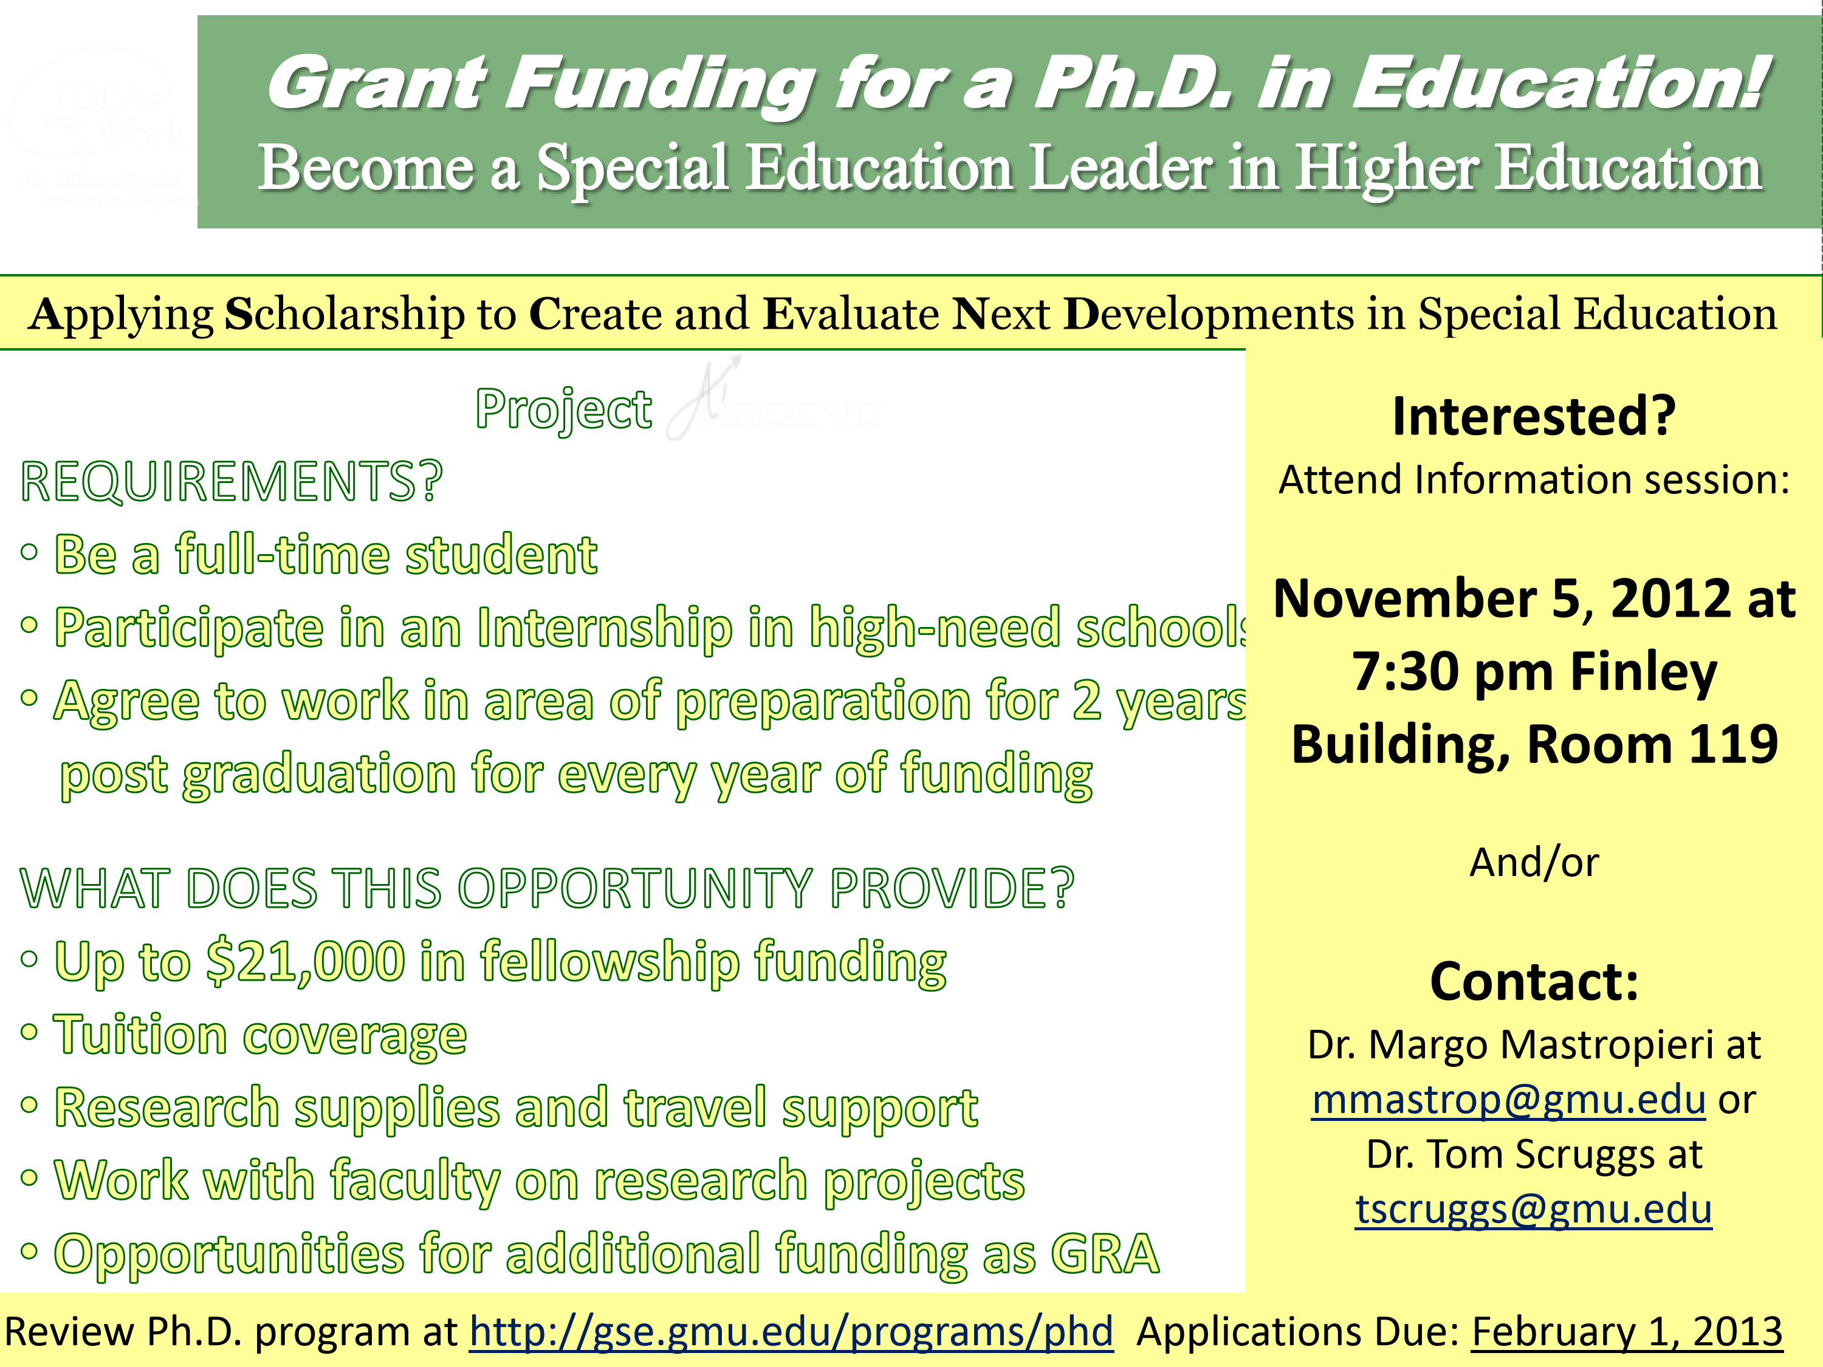
Information Session Agenda


Introductions


Purpose of PhD in High Incidence Disabilities


Purpose of Project ASCEND

○
Success of Previous Sp Ed Graduates


Components of Project ASCEND

○
Required Courses


Benefits of Project ASCEND


Requirements of Project ASCEND


Application Process


Questions and Answers

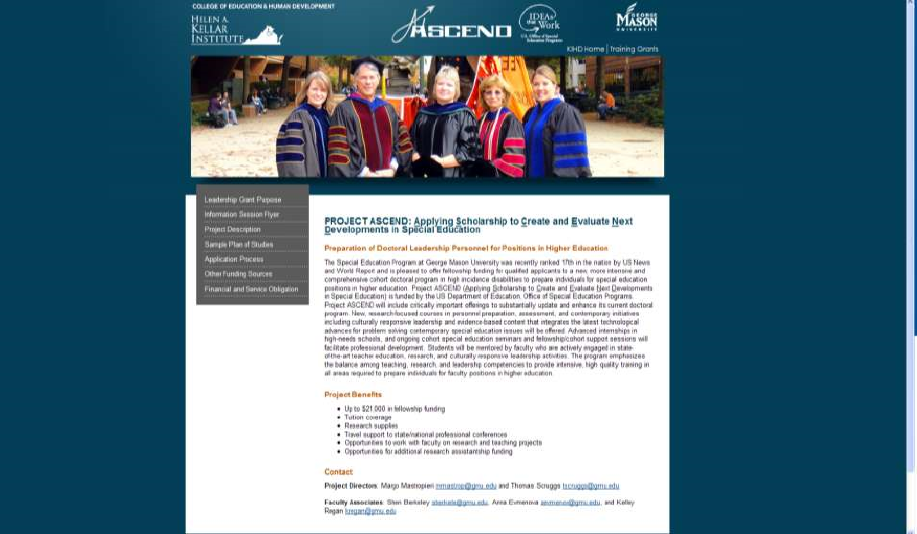

Introductions


Project Faculty:

○
Margo Mastropieri, PhD, Co
-
PI

○
Tom Scruggs, PhD, Co
-
PI

○
Sheri Berkeley, PhD

○
Anya
Evmenova
, PhD

○
Kelley Regan, PhD

Experience of Project Faculty
- Extensive backgrounds in teaching, research, and service in Special Education
- Some of the top scholars and educators in the field.
- Editors of Exceptional Children, the flagship journal of the Council for Exceptional Children (CEC)
- National Award Recipients (CEC Research; AERA
Sp Ed SIG Research; SCHEV Virginia Outstanding
Faculty; Student Dissertation Awards
- Recipients of numerous Research and Training Grants (over Millions of dollars)

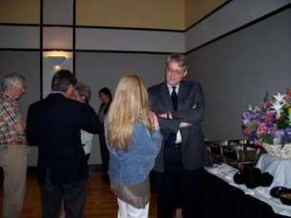
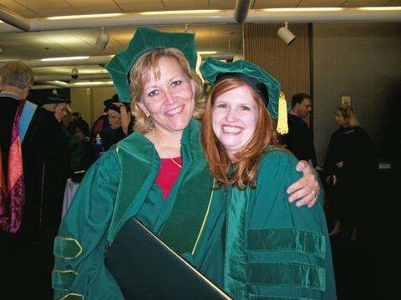
What is the Ph.D. in Education?

•
Highest Academic Degree

•
Focus on research and research methods

•
Follows Master’s Degree

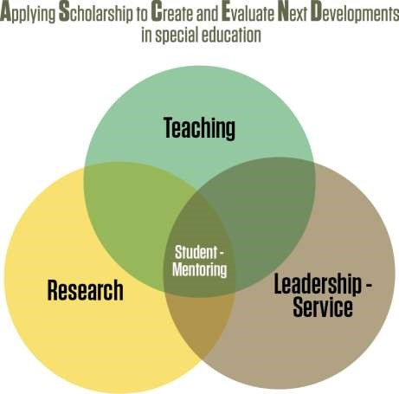
What is the Purpose of the PhD in ASCEND?

Project ASCEND Will Prepare Leaders for


Higher Education Faculty Positions


Emphasis in High Incidence Disabilities


Excellence in Research

○
Collaborate with faculty on research projects


Presentations and Publications


Excellence in Teaching

○
Collaborate with faculty on teaching


Co
-
teaching classes


Excellence in Leadership/Service

Where Are Previous GMU Sp Ed PhD Graduates?
- Higher Education Positions
  - Illinois State University, Johns Hopkins University, Millersville University, James Madison University,
University of Massachusetts – Amherst, Utica College,
Liberty University, Texas Woman’s University, United
Arab Emirates, George Mason University
- Leadership Positions
  - School District Leadership positions, Principals, Assistant
Principals, District Supervisors, Teacher Mentors,
Professional Organizations, Federal Agencies
What are the Data on Previous Students?


Data on Students Enrolled from 2007
-
2012

who worked with project faculty:

○
23
Graduates


19
hold prominent positions in special education


2
work in private practice


1
retired


1
seeking full
-
time employment

○
14
Working on dissertation research now

○
3
in final stages of dissertation research


One holding defense this Wednesday!

What Recognition Have Previous Students Received who have worked with Project Faculty?
- 2 AERA-Special Ed SIG Outstanding Student
Dissertation Research
- 3 Outstanding Academic-Dissertation Awards at
GMU;
- 3 Outstanding Dissertation Awards at Purdue;
- 3 CEC-DDD Herbert Prehm Research Awards;
- 2 Student Initiated Grants from USDOE OSEP;
- 1 CEC-DLD Outstanding Dissertation

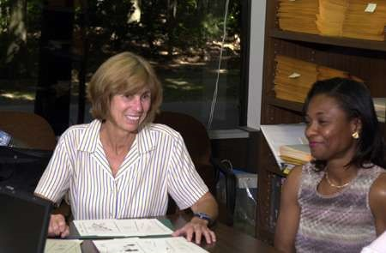
What are the requirements?

•
44
-
53
credit hours of coursework

•
12
credit hours of dissertation

•
56
-
65

total credit hours


What are the components of the

Ph.D
. Program?

•
3

credits
Foundations Course

•
12

credits

Research Methods

•
24

credits Specialization (major)

•
3
-
12

credits

Secondary
Concentration

•
12
credits

Dissertation

56
-
65

total beyond a master’s degree

Foundation
Classes
(6)


EDUC 800: Ways of Knowing (3) (Epistemology;
1
st

semester)


EDRS 810: Problems and Methods in Education
Research (3) (before end of 2
nd

semester)

Required Research Classes
- EDRS 811: Quantitative Methods (3)
- EDRS 812: Qualitative Methods (3)
- EDRS 82*: Advanced methods: qualitative, quantitative, single subject, mixed methods, evaluation, etc. ( - select additional course relevant to dissertation methods)
- EDUC 998: Dissertation Proposal (3)
- EDUC 999: Dissertation Research (9)
Specialization Classes (
24)
sample
:


6
,
doctoral
-
level courses in specialization area (
18)


1
independent study
(3)


EDUC 994: Internship (3)

100
hours in relevant setting over at least 6 weeks:
high needs schools
,
university, professional
organization, research center

PROJECT ASCEND New Courses
EDSE 841: Intervention Research in Special Education (3 credits).
EDSE 842: Application of Research Methodology in Special Education (3 credits)
EDSE 84xx1: Personnel Preparation Programs in Special Education (3 credits)
EDSE 84xx2: Assessment, Evaluation, and
Instrumentation in Special Education (3 credits)
EDSE 8xx3: Problem Solving for Contemporary Initiatives in Special Education (3 credits)

EDUC 994: Advanced Internship in Education:
Leadership Positions in High-Need Schools (3 credits)
EDSE 794 I: Special Topics: Special Education Seminar 13 (1 credit, ongoing):

Cohort Seminars: Mentoring Support
- EDSE 794-1 over 2 semesters: Cohort Seminar:
Introduction to Special Education Research/Reporting
Research Synthesis in Special Education (Year 1)
- EDSE 794-2 over 2 semesters: Cohort Seminar:
Enhancing Personnel Preparation in Special
Education/Secondary Data Analyses (Year 2)
- EDSE 794-3 over 2 semesters: Cohort Seminar:
Reporting on Problem Solving for Contemporary
Initiatives in Special Education/Leadership
Experiences (Year 3)

Project ASCEND Benefits: Mentoring Model
- Work closely with faculty
  - Engage in ongoing research projects with faculty
    - Assist with data collection, data scoring and analyses
    - Work as members of research teams assuming more leadership over time
    - Collaborate on scholarly presentations at professional meetings (e.g. CEC, AERA)
    - Collaborate on writing for publications
  - Collaborate in co-teaching with faculty
  - Participate in cohort with peers
    - Assume mentee roles initially
    - Gradually move into mentorship role with more novice students

Project ASCEND: Financial Benefits


Fellowships $21,000 per year


Tuition coverage


Travel support to present at national
conferences


Research supplies support

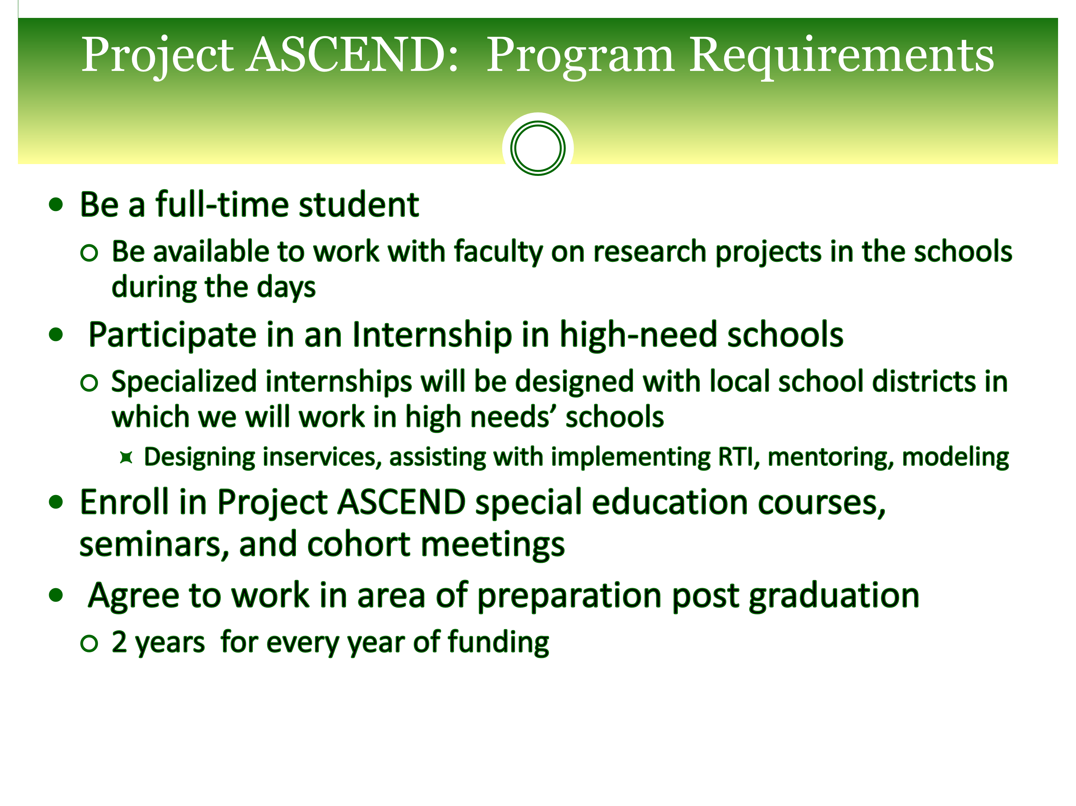

Federal Government Service Obligation
- Recipients of Project ASCEND Funding,
(including Fellowships, Tuition, Travel, etc)
  - Must sign an agreement to work in a field related to the preparation (e.g., related education field) for two years for every year of funding received
    - Ideally higher education in high incidence disabilities
  - If this does not happen, you will have to reimburse the federal government
- Project staff complete forms indicating follow-up positions and addresses of all funded scholars
Application Process

Two
-
Step Application Process:


First, apply and be accepted into the CEHD
PhD Program


Second, apply to Project ASCEND for
fellowship funding and cohort position

CEHD PhD Program Applications


Application deadlines are September 1 and February 1
of each calendar year.


Applicants must submit:

○
GRE Scores (Verbal, Quantitative, Writing)

○
Transcripts of previous academic work

○
Three references

○
Goal statement

○
Application form


Requirements:

○
Masters degree (or equivalent) in special education or related
field

○
Three years' relevant teaching experience (or equivalent)

Attend a CEHD
Phd

Information Session

Ph.D. in Education Information (Fairfax campus):
Session

11/15/2012

7:30
pm
-

9:00
pm

Johnson Center
327

-

Meeting Room C

For additional information please check our website at:
http://gse.gmu.edu/programs/ph
d

For additional information about the
Ph.D

program
watch video. All details for applying to the CEHD PhD
program available: at
http://gse.gmu.edu/programs/ph
d

APPLY for PROJECT ASCEND Funding

- Complete application (on line)  Qualifications:
  - Admittance to the CEHD PhD Program
  - Minimum of three years successful special education teaching experience (or comparable experience)
  - Commitment to be a full-time student
  - Commitment to study high incidence disabilities as major
  - Commitment to complete an Internship in high-need schools
  - Highly motivated to learn and participate in teaching and research activities with faculty
  - Agreement to work in area of preparation 2 years post graduation for every year of funding
- We are seeking applications for all highly qualified individuals, including those with disabilities and those from culturally and linguistically diverse backgrounds.

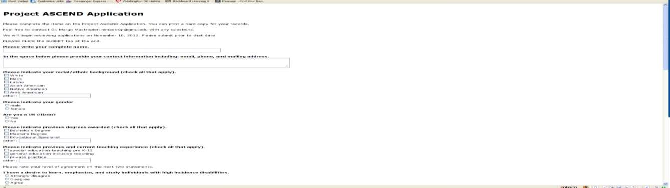
http://kihd.gmu.edu/training/ascend/

http://websurvey.gmu.edu/preview.jsp?surveyId=1351161463
585
&url=http://websurvey.gmu.edu/survey/entry.jsp?id
=135
1161463585

Click SUMBIT when finished!

Common Questions


Can I transfer classes and credits in the program?


How Long Does it Take?


Are there other types of assistantships available?


Can I go part
-
time to the Sp Ed doctoral Program?


Will the service obligation really require me to pay
back all funds?


What types of employment will cover the service
obligation?

Questions and Answers


Can I transfer classes and
credits in the program?

○
Yes, up to 12 hours if
taken no more than 6
years prior to
admissions and


Not part of previous
degree


600
level and higher
typically


Committee approval


How Long Does it Take?

○
Full
-
time can be done in
3
to 4 years


If enrolled during
summers

○
Part
-
time will take
longer and


Depends on number of
courses taken each
semester

Questions and Answers


Are there other types of
assistantships available?

○
Yes, you can apply for
these as well


Research grant positions


Research assistantships
paid for by CEHD


Can I go part
-
time to the
Sp Ed doctoral Program?

○
Yes, many students
enroll part
-
time and
work full
-
time

○
But, Project ASCEND is
recruiting full
-
time
students

Questions and Answers


Will the federal service
obligation really require
me to pay back all funds?

○
Yes, the federal
government will require
you to pay back any
funds received through
this grant if you have
not met the service
obligations.


What types of
employment will cover
the service obligation?

○
Positions in higher
incidence disabilities or
related areas

○
Higher education
preferably

○
Other related positions
will also qualify

