Title:
LIGHTS! CAMERA! CAPTIONS!: THE EFFECTS OF PICTURE AND/OR WORD
CAPTIONING ADAPTATIONS, ALTERNATIVE NARRATION, AND
INTERACTIVE FEATURES ON VIDEO COMPREHENSION BY STUDENTS WITH
INTELLECTUAL DISABILITIES

by

Anna S. Evmenova
A Dissertation
Submitted to the
Graduate Faculty of
George Mason University in Partial Fulfillment of
The Requirements for the Degree of
Doctor of Philosophy
Education

Committee:

___________________________________________ Chair

___________________________________________

___________________________________________

___________________________________________ Program Director

___________________________________________ Dean, College of Education
and Human Development

Date: _____________________________________ Spring Semester 2008
George Mason University Fairfax, VA
i

Lights! Camera! Captions!: The Effects of Picture and/or Word Captioning Adaptations, Alternative Narration, and Interactive Features on Video Comprehension by Students with Intellectual Disabilities

A dissertation proposal submitted in partial fulfillment of the requirements for the degree of Doctor of Philosophy at George Mason University

By

Anna S. Evmenova
Master of Arts in Education
East Carolina University, 2003
Master of Arts
Saratov State University, Russia, 2001 Bachelor of Arts
Saratov State University, Russia, 2001

Director: Michael M. Behrmann, Professor
Graduate School of Education

Spring Semester 2008
George Mason University Fairfax, VA
Copyright 2008 Anna S. Evmenova All Rights Reserved

DEDICATION

This is dedicated to my loving husband, Boris, without whom this whole venture would never be possible; my mom, Tatyana, my sister, Julia, and my niece, Sasha, for their endless encouragement and patience. Your tremendous support provided me with strength and perseverance I needed to pursue my dream and complete this work.

ACKNOWLEDGEMENTS

Pursuing a PhD degree, with all the hard work and excitement that it implies, was always my dream. But never in a million years had I envisioned doing it in a foreign country, in a foreign language. There are many people who made it all possible and no words can express my true appreciation to them. First and foremost, my sincere gratitude goes to my dissertation chairperson, Dr. Michael Behrmann. Only four years ago I was reading an article by Dr. Behrmann, not even dreaming about meeting the author. It was the greatest honor to be accepted as one of his PhD students and work alongside with such a renowned expert in the field of assistive technology. The world of opportunities offered to me was indescribable and each venture enriched me tremendously. This research project would not have been completed without Dr. Behrmann‟s exceptionally valuable expertise, guidance and support. Thanks for persevering with me through endless hours during the day, night, and especially on the weekends. I thank you for accepting all my complaints, seeing me through all my struggles, cheering me when I needed motivation the most, and pushing me beyond my own expectations!
My appreciations also go to my other committee members: Dr. Margo Mastropieri and Dr. Pam Baker. They have generously given me their time and expertise. Their excitement about research and academia was truly contagious and inspirational. I thank them for their contribution and incredible support throughout the process. It was a true privilege to work with such amazing professionals and role models.
I wish to thank the Kellar institute for Human disAbilities and all special education faculty for believing in me and my research activities, and choosing me as a Kellar Institute Fellow. This was more than the generous financial assistance that truly helped me in completing my dissertation research. Their decision provided me with priceless emotional support which enabled me to persevere towards achieving the goal.
Very special thanks go to the LIFE program, including each and every student and their parents for believing in this project and devoting their personal time to me (often during lunch!) I cherish every second I was given with them. It was a sincere privilege to work with these incredible people. While I was the one in the position to educate them, they taught me so many lessons I will always remember and hope to apply in my career and life.
My gratitude goes to my wonderful expert panel, Dr. Heidi Graff and Karen Ingram, for their priceless feedback, at times on a very short notice. Only with your knowledge, support and encouragement, the success of this research endeavor was possible. Many special thanks go to Heidi Graff and Mrs. June Behrmann for helping me brainstorm this project. I would never have finalized my ideas if it was not for you.
My sincere gratitude goes to Dr. Raisa Nazarova, the Dean of the Foreign Languages Department at the Saratov State University, for always believing in me and launching my academic career in the United States. I also wish to thank Dr. Sandra Warren and Dr. Tara Jeffs of East Carolina University for inspiring and encouraging me to pursue a doctoral degree in special education and assistive technology. I would not have reached for my dreams if it was not for your reassurances.
I deeply appreciate the welcome and encouragement I have received at the Kellar Institute for Human disAbilities. From my first day you were my family, patiently listening to my countless complaints and sharing all my happy moments. Special thanks go to Pam Vogel, Emily Gibson, Jancy Templeton, Elaine Miller, Amy Fulcher, Susan Miller, Ala Showers, Andrea Bankoski, Attika Ishtiaq, BJ D‟Urso, Carmen Rioux-Bailey,
Clare Talbert, Jackie Petersen, Kelley Regan, Kim Kalthoff, Lori Jackman, Shuangbao Wang, Terry Werner, Yoosun Chung, and the entire GMU T/TAC staff. You all are wonderful, and this is absolutely the best environment to learn and to work in.
While dissertation writing is an isolating experience, it never happens in isolation. My gratitude goes to my fellow doctoral student, Brianna Stegall, for all the support, especially at the beginning of my journey, and for not letting me quit. Thanks to Marci Kinas Jerome for graciously sharing her knowledge and invaluable insight. Special thanks go to Cindy George for spending many hours on helping me make this work better and more readable. I can never repay the enormous debt of gratitude for each proof-read version of this dissertation. I never could have completed this work without the support of my fellow doctoral student and dearest friend, Kristine Neuber. Going through the program together was the most remarkable and rewarding experience that gave me a new appreciation for the meaning and importance of friendship. Thank you for pushing me to continue when I wanted to give up and for always being happy for all my achievements. I hope that this is just the beginning of a life-long friendship and a fruitful collaboration.
The process of dissertation writing is a very unique experience that put strains on so many people around the candidate. Many thanks go to all my friends both in the United States and in Russia for sharing happy and stressful times, for being patient and supportive. Of course, I would not be where I am today without the love and support of my family. My sincere gratitude goes to my mom, Tatyana, for always believing in me. My achievements would not be possible without your sacrifices. Thank you for devoting yourself to me and my education and providing me with valuable experiences that have made me who I am today. Many thanks go to my loving sister, Julia, for always pushing me to do better and being an amazing role model. You have inspired me more than you can ever imagine. My sincere gratitude goes to my sister‟s family: her husband, Raoul, and my niece, Sasha, for their support and encouragements. Through the distance and time differences I thrived on the idea of sharing this moment with my family.
There are no words to express my appreciation to my loving husband, Boris, for many sleepless nights of video development and of comforting me through all the stages of this grueling process. This is your degree as much as mine and I am thankful to have such a wonderful companion and best friend in my life. Thank you for always being there to share the many laughs, tears, uncertainties, and challenges. Thank you for always being proud and supportive of my work and initiatives, though at times insane.

TABLE OF CONTENTS

Page
List of Tables ................................................................................................................... x
List of Figures ................................................................................................................. xi Abstract ......................................................................................................................... xiii
- Introduction .................................................................................................................1
Statement of the Problem ............................................................................................1
Background of the Problem ........................................................................................4
Research Questions ...................................................................................................11
Definition of Terms...................................................................................................14
- Literature Review......................................................................................................17
Academic Instruction for Students with Intellectual Disabilities .............................18
Access to Academic Instructional Activities ............................................................18
Participation in High-stakes Testing .........................................................................22
Students with Intellectual Disabilities and Comprehension .....................................24
Video-based Instruction ............................................................................................26
Pilot Study .................................................................................................................28
Integration of Videos with Students with Intellectual Disabilities ...........................31
Video modeling ....................................................................................................46
Video prompting and priming ..............................................................................50
Video simulations ................................................................................................52
Video self-modeling.............................................................................................53
Video feedback ....................................................................................................56
Interactive video instruction ................................................................................57
Anchored Instruction ................................................................................................61
Anchored instruction for students with intellectual disabilities ...........................67
Characteristics of Students with Intellectual Disabilities and Video Features .........68
Closed Captioning for Students with No Hearing Impairments ...............................70
Closed Captioning for Beginning Readers and Adults .............................................72
Closed Captioning for Foreign Language Learners ..................................................73
Closed Captioning for Students with Different Abilities and Needs ........................75
Characteristics of Closed Captioning ........................................................................78
Picture-based Symbols ..............................................................................................80
Picture Symbol Systems ...........................................................................................81
Picture Symbols and Literacy Development.............................................................82
Picture Symbols as Support ......................................................................................84
Cognitive Load Theory of Multimedia Learning......................................................86
Cognitive Overload in Multimedia Instruction .........................................................88 Video Recordings versus Still Images ......................................................................93
Descriptive Videos ....................................................................................................95
Universal Design for Learning..................................................................................97
Single-subject Research Methodology ...................................................................102
Multiple Baseline Design ........................................................................................104
Alternating Treatments Design ...............................................................................105
Combined Design....................................................................................................107
Percent of Non-overlapping Data ...........................................................................108
Statistical Analysis ..................................................................................................109
Randomization tests ...........................................................................................110
Social Validity ........................................................................................................112
Literature Review Summary ...................................................................................115
3. Methodology ...........................................................................................................120
Sample ....................................................................................................................120
Protection of Human Participants and Informed Consent ......................................120
Research Study Participants ....................................................................................121
Pilot Testing Members ............................................................................................135
Setting .....................................................................................................................136
Research Design......................................................................................................137
Validation of Interventions .....................................................................................138
Expert panel .......................................................................................................139
Pilot testing ........................................................................................................140
Experiments 1 and 2................................................................................................141
Independent Variables for Experiment 1 in the Primary Study ..............................145
Motion video with highlighted text captioning (V-HT) ....................................145
Static images with highlighted text captioning (I-HT) ......................................145
Independent Variables for Experiment 2 in the Primary Study ..............................146
Motion video with picture/words-based captioning (V-P/W) ...........................146
Static images with picture/word-based captioning (I-P/W) ...............................146
Independent Variables for Experiments 1 and 2 in the Counterbalancing Study ...146
Dependent Variables ...............................................................................................148
Data Collection System ..........................................................................................152
Comprehension accuracy ...................................................................................152
Latency ...............................................................................................................153
Prior knowledge .................................................................................................153
Reliability ................................................................................................................154
Fidelity of treatment ...........................................................................................154
Interobserver reliability ......................................................................................155
Validity of partially correct responses ...............................................................156
Social Validity ........................................................................................................157
Materials .................................................................................................................157
Baseline Condition ..................................................................................................163
Treatment Condition ...............................................................................................164
Altering video narration .....................................................................................165 Captions .............................................................................................................166
V-HT and I-HT conditions .................................................................................168
V-P/W and I-P/W conditions .............................................................................169
Video searching for answers ..............................................................................170
Multiple choice Level 2 questioning..................................................................171
Procedures ...............................................................................................................171
Independent Observer(s) Training ..........................................................................172
Participants Training ...............................................................................................172
Random Assignment of Participants .......................................................................173
Phase I: Initial Baseline Procedures ........................................................................175
Phase II: First Treatment Procedures ......................................................................177
Phase III: Second Baseline Procedures ...................................................................181
Phase IV: Second Treatment Procedures ................................................................181
Phase V: Maintenance Procedures ..........................................................................182
Social Validity ........................................................................................................183
Data Analysis ..........................................................................................................184
Visual Analysis .......................................................................................................184
Percent of Non-overlapping Data (PND) ................................................................186
Randomization Tests ...............................................................................................186
Qualitative Analysis ................................................................................................190
4. Results .....................................................................................................................191
Explanation of Graphic Representation of Data ....................................................192
Adapted and Interactive Videos and Content Comprehension ...............................195
Factual Comprehension: Experiment 1 ...................................................................196
Individual factual comprehension results for participants in Experiment 1 ......202
Factual Comprehension: Experiment 2 ...................................................................208
Individual factual comprehension results for participants in Experiment 2 ......215
Factual Comprehension Based on Multiple Choice Responses ..............................220
Inferential Comprehension: Experiment 1 ..............................................................224
Inferential Comprehension: Experiment 2 .............................................................233
Inferential Comprehension Based on the Multiple Choice Responses ...................240
Highlighted Text versus Picture/Word-based Captions ..........................................243
Motion Videos versus Static Images.......................................................................248
Social Validity Results ............................................................................................252
Supplementary Analysis .........................................................................................254
Response Latency ...................................................................................................254
Prior Knowledge .....................................................................................................256
5. Discussion ...............................................................................................................262
Adapted and Interactive Videos and Content Comprehension ..............................264
Alternative Narration and Captioning Adaptations ................................................266
Factual comprehension ......................................................................................267
Inferential comprehension .................................................................................268
Prior knowledge .................................................................................................269
Additional Interactive Features ...............................................................................272 Adapted and Interactive Videos and Content Comprehension Summary ..............276
Highlighted Text versus Picture/Word-based Captions ..........................................276
Motion Videos versus Static Images.......................................................................279
Additional Findings Related to Previous Research ................................................281
Latency ...................................................................................................................281
Novelty of Treatment ..............................................................................................283
Randomization Tests ...............................................................................................284
Social Validity ........................................................................................................286
Educational Implications and Recommendations ...................................................288
Universal Design for Learning (UDL) ....................................................................288
Academic Instruction ..............................................................................................290
Students with Intellectual Disabilities and Their Abilities .....................................291
Recommendations for Classroom Implementation .................................................292
Limitations ..............................................................................................................296
Recommendations for Future Research ..................................................................298
Summary and Conclusions .....................................................................................301
Appendix A: Informed Assent and Consent Forms ......................................................303
Appendix B: Sample Video Scripts and Questions ......................................................309
Appendix C: Expert Panel Checklist ............................................................................312
Appendix D: Intervention Script ...................................................................................313
Appendix E: Data Collection Sheet ..............................................................................328
Appendix F: Prior Knowledge Rubric ..........................................................................330
Appendix G: Fidelity of Treatment Checklist ..............................................................331
Appendix H: Interview Questions ................................................................................334
Appendix I: Reference List of Unitedstreaming Videos ..............................................335
Appendix J: Description of Camtasia Studio Screen Recorder Software ....................338
Appendix K: Description of Writing with Symbols 2000 Software ..............................339
Appendix L: Sample Level 2 Multiple Choice Materials .............................................340
Appendix M: Random Assignment of Students ...........................................................344
Appendix N: Data Collection Schedule ........................................................................346
Appendix O: Adjustments to Design 3 Randomization Test ........................................347
References .....................................................................................................................348
LIST OF TABLES

Table Page
1. Video-based Instruction for Individuals with Intellectual Disabilities:
Published Research between 1990 and 2007 ......................................................……33 2. Demographic Data on Participants ..........................................................................123
- Independent Variables across Experiments and Studies ..........................................147
- Summary of Video Sequence, Topic Category, Readability Level, and
Alignment with SOL Standards ...............................................................................158 5. Video Adaptations Used by the Participants in the Maintenance Phase V ..............183 6. Summary of Randomization Tests for Factual Comprehension Accuracy
in Experiment 1 ........................................................................................................202
- Means, Standard Deviations, and PND Scores for Factual Comprehension
Accuracy Measured by 3 Oral Factual Questions in Experiment 1 ..........................203
- Means, Standard Deviations, and PND Scores for Factual Comprehension
Accuracy Measured by 3 Oral Factual Questions in Experiment 2 ..........................214
- Means, Standard Deviations, and PND Scores for Inferential Comprehension
Accuracy Measured by 3 Oral Inferential Questions in Experiment 1 .....................225 10. Summary of Randomization Tests for Inferential Accuracy in Experiment 1 ......232
- Summary of Randomization Tests for Inferential Accuracy in Experiment 2 ......238
- Means, Standard Deviations, and PND Scores for Inferential Comprehension
Accuracy Measured by 3 Oral Factual Questions in Experiment 2 ........................239
- Means, Standard Deviations of Students‟ Factual Comprehension of Adapted
Motion Videos and Adapted Static Images across Research Phases ......................250
- Means, Standard Deviations of Students‟ Inferential Comprehension of
Adapted Motion Videos and Adapted Static Images across Research Phases .......251
- Latency of Students‟ Oral Responses to Combined Factual and Inferential
Comprehension in Seconds .....................................................................................255
- Latency of Students‟ Multiple Choice Responses to Combined Factual and
Inferential Comprehension in Seconds ...................................................................256 LIST OF FIGURES

Figure Page
1. Logic Model for research study including participants, research designs, independent and dependent variables.. .............................................................……144 2. Example of a questioning video screen. ...........................................................……164
- Example of a video with highlighted text captioning. ..............................................168
- Example of a video with picture/word-based captioning. ........................................169
- Example of a searching video screen after both captioning conditions. ...................170 6. Example of graphic representation of data across all questioning levels
for one study participant.. .........................................................................................193 7a. Example of graphic representation of data for oral Level 1 responses for one study participant with the same baseline data as in Figure 7b.. .................194
7b. Example of graphic representation of data for oral Video Searching responses for one study participant with the same baseline data as in Figure 7a.. ..................194 8. Example of graphic representation of data for multiple choice Level 2 responses for one study participant. ........................................................................195
9a. Accuracy of oral Level 1 responses to factual comprehension questions
by students in Experiment 1 across the research phases. ........................................199 9b. Accuracy of oral Video Searching responses to factual comprehension questions by students in Experiment 1 across the research phases. ........................200 10a.Accuracy of oral Level 1 responses to factual comprehension questions
by students in Experiment 2 across the research phases. .......................................211 10b.Accuracy of oral Video Searching responses to factual comprehension questions by students in Experiment 2 across the research phases. .......................212
11. Accuracy of multiple choice Level 2 responses to factual comprehension questions by students in Experiment 1 across the research phases. .......................222 12. Accuracy of multiple choice Level 2 responses to factual comprehension questions by students in Experiment 2 across the research phases. .......................223
13a.Accuracy of oral Level 1 responses to inferential comprehension questions by students in Experiment 1 across the research phases. .......................................226 13b.Accuracy of oral Video Searching responses to inferential comprehension questions by students in Experiment 1 across the research phases. .......................227
14a.Accuracy of oral Level 1 responses to inferential comprehension
questions by students in Experiment 2 across the research phases. .......................234 14b.Accuracy of oral Video Searching responses to inferential comprehension questions by students in Experiment 2 across the research phases. ........................235
15. Accuracy of multiple choice Level 2 responses to inferential comprehension questions by students in Experiment 1 across the research phases. ........................241 16. Accuracy of multiple choice Level 2 responses to inferential comprehension questions by students in Experiment 2 across the research phases. ........................242
17. Comparison of HT and P/W captions for students‟ factual comprehension
based on the averaged oral Level 1 responses. .......................................................244 18. Comparison of HT and P/W captions for students‟ factual comprehension based on the averaged oral Video Searching responses..........................................245
19. Comparison of HT and P/W captions for students‟ inferential comprehension based on the averaged oral Level 1 responses. .......................................................245 20. Comparison of HT and P/W captions for students‟ inferential comprehension based on the averaged oral Video Searching responses..........................................246 21. Incidences among factual oral Level 1 responses by students in Experiment 1 when prior knowledge on the video topic was reported . .......................................258 22. Incidences among factual oral Level 1 responses by students in Experiment 2 when prior knowledge on the video topic was reported . .......................................259
- Incidences among inferential oral Level 1 responses by students in
Experiment 1 when prior knowledge on the video topic was reported . .................260
- Incidences among inferential oral Level 1 responses by students in
Experiment 2 when prior knowledge on the video topic was reported . .................261 25. Effects of adapted videos on factual and inferential video comprehension by students with intellectual disabilities . ...............................................................301

ABSTRACT

LIGHTS! CAMERA! CAPTIONS!: THE EFFECTS OF PICTURE AND/OR WORD
CAPTIONING ADAPTATIONS, ALTERNATIVE NARRATION, AND
INTERACTIVE FEATURES ON VIDEO COMPREHENSION BY STUDENTS WITH
INTELLECTUAL DISABILITIES

Anna S. Evmenova, Ph.D.

George Mason University, 2008

Dissertation Director: Dr. Michael M. Behrmann

This rigorous single-subject research study investigated the effects of alternative narration, highlighted text, picture/word-based captions, and interactive video searching features for improving comprehension of non-fiction academic video clips by students with intellectual disabilities. Two experiments combining multiple baseline across participants, alternating treatments, and elements of ABAC single-subject research designs across the primary and counterbalancing studies were employed to evaluate factual and inferential comprehension by 11 postsecondary participants with intellectual disabilities. Comprehension was measured by the number of correct oral (Level 1) and multiple choice (Level 2) responses after watching regular, non-adapted videos in the baseline phases, as well as after watching adapted videos and after searching videos for answers via hyperlinks in the treatment and maintenance phases. All adaptations were validated by existing research, a pilot study, and expert panel reviews. Visual analyses of data, percents of non-overlapping data, and statistical analyses via randomization tests were conducted. The major findings included: (a) the participants significantly improved their factual comprehension as well as showed relative but more modest increases in their inferential comprehension of non-fiction video content after viewing videos modified with alternative narrations and various captioning adaptations, which significantly improved further after students had an opportunity to search the video for answers and adjust their original oral responses; (b) adapted and interactive videos enabled students to provide the correct oral responses more frequently than with non-adapted videos, eliminating the need for a more concrete multiple choice questioning format; (c) the majority of participants performed equally well regardless of the type of the captions (highlighted text or picture/word-based); and (d) there was no significant difference in comprehension measures between motion videos and static images taken from the video for any of the participants. Subsequently, social validity interviews were conducted to determine participants‟ perceptions towards usefulness and effectiveness of various video adaptations. Additional findings are discussed with respect to the importance of randomization procedures and tests in single-subject research, study limitations, implications and recommendations for both practical implementation and future research. Overall, adapted videos offer innovative, universally designed solutions for legally required access and active participation of students with intellectual disabilities in grade and subject-linked academic general education curriculum (Agran, Cavin, Wehmeyer, &
Palmer, 2006; Browder et al., 2007; Dymond & Orelove, 2001; IDEIA, 2004; NCLB,
2001; Wehmeyer, Lance, and Bashinski, 2002).

1. Introduction

An effective educational system serving students with disabilities should maintain high academic achievement standards and clear performance goals for children with disabilities, consistent with the standards and expectations for all students in the educational system, and provide for appropriate and effective strategies and methods to ensure that all children with disabilities have the opportunity to achieve those standards and goals (Individuals with Disabilities Education Improvement Act [IDEIA], 2004).
The current study investigated the effectiveness of alternative captioning adaptations, alternative narration, and interactive features on the content comprehension of non-fiction academic video clips by students with intellectual disabilities. This was an effort to explore alternative venues for successful inclusion of students with intellectual disabilities into standards-based general education curriculum.
Statement of the Problem
Recently there has been a consensus between two major laws on educational provisions for students with disabilities. Both the No Child Left Behind Act (NCLB, 2001) and the Individuals with Disabilities Education Improvement Act (IDEIA, 2004) mandate full access and active participation of students with disabilities, including those with intellectual disabilities, in the general education curriculum. No longer is it enough to just bring students with disabilities along and place them in the back of the regular education classrooms. They are expected to receive content-based instruction and make progress in academics (Browder, Flowers, Ahlgrim-Denzell, Karvonen, Spooner, & Algozzine, 2004; Dymond & Orelove, 2001).
The stipulation of challenging content-based academic instruction for students with disabilities is sustained by further regulations to include them in high-stakes testing. Schools are held accountable for academic performance of all students, including those with intellectual disabilities, which is measured by the adequate yearly progress (AYP) in reading, math and science (Browder, Wakeman, Shawnee, & Flowers, 2006; Browder, Wakeman, Spooner, Ahlgrim-Delzell, & Algozzine, 2006; NCLB, 2001). Even those students who cannot participate in the standardized evaluation procedures due to their disabilities and are pursuing an alternate assessment option must target academic curriculum. They are assessed on the modified, yet still challenging, goals appropriate for their abilities and needs and carefully aligned with local and statewide standards in all subject areas (Cushing, Clark, Carter, & Kennedy, 2005; McLaughlin & Thurlow, 2003).
Under the pressure of quickly adjusting to new mandates, some educators express reservations about the feasibility and efficiency of such content-based instruction, especially for students with low-incidence disabilities (Agran, Alper, Wehmeyer, 2002; Wehmeyer & Agran, 2006). To address this issue, limited research demonstrates the capability of students with intellectual disabilities to participate, succeed, and benefit from various activities in the general education curriculum (Agran, Cavin, Wehmeyer, &
Palmer, 2006; Browder, Wakeman, Spooner, Ahlgrim-Delzell, Algozzine, 2006; McDonnell, Johnson, Polychronis, & Risen, 2002; Turner & Alborz, 2003; Wehmeyer, Lattin, & Agran, 2001). In particular, these studies demonstrate promising trends in students‟ performances in reading and listening comprehension, as well as in acquiring factual information in various content areas (e.g., Collins, Hall, Branson, & Holder, 1999). In effort to raise expectations and learning outcomes, educators are searching for new evidence-based, effective instructional strategies to include their students with intellectual disabilities into meaningful academic education (Agran et al., 2006; Browder,
Wakeman, Flowers, Rickelman, Pugalee, & Karvonen, 2007; Wehmeyer, 2006).
For the last three decades, professionals in various fields worked diligently to provide support to students with disabilities through the use of assistive technology (AT) items and services. Designed to increase, maintain, or improve functional capabilities of individuals with disabilities (IDEIA, 2004 [§ 1401 (1)]), AT includes items and computer-based programs that provide necessary accommodations and opportunities for students with special needs to participate in the general education curriculum along with their peers (Hasselbring & Glaser, 2000; Wehmeyer, Smith, & Davies, 2005). However, the use of AT with students with more moderate intellectual disabilities has been somewhat limited to the devices and solutions that provide learners with access to educational environments and assist in activity performance (Wissick, Gardner, & Langone, 1999). Among those who have access to a computer, a majority of students with intellectual disabilities are reported to use it for educational purposes (Wehmeyer, 1999). Nonetheless, a majority of existing AT products for content-based (e.g., literacy) instruction appears to be either too complex or age inappropriate, especially for older students with intellectual disabilities (Wehmeyer, 1998; Wehmeyer, Smith, & Davies). This may cause a problem, given that students are expected to be engaged in the same grade-level academic activities as their peers, utilizing materials typically used in general education (Browder et al., 2007; Flowers, Browder, & Ahlgrim-Delzell, 2006; Wehmeyer, 2006). Furthermore, while AT will always have a role in accommodating the personal needs of individuals with disabilities, educators need to consider designing curriculum materials and activities, so that they incorporate salient supports for all students, not only those with intellectual disabilities (Hitchcock & Stahl, 2003; Wehmeyer, Smith, & Davies).
Through multiple means of representation, expression, and engagements, universally designed instruction (UDL) ensures access and participation in appropriate challenging curriculum for all students without the need to create individual modifications (Orkwis, 1999; Rose & Meyer, 2000; Spooner, Dymond, Smith, & Kennedy, 2006). Overall, the principles of UDL are built on the redundancy effect allowing for clarity and easier comprehension of instruction (Rose, Meyer, & Hitchcock, 2005). This effect can be achieved by providing content in the form of text, still images, dynamic motion videos, voice, and opportunities for active interaction combined in one instructional system, known as multimedia (Mayer, Moreno, Boire, & Vagge, 1999;
Weller, 1996).
Background of the Problem
Due to the increased availability and familiarity, television and video have become probably the most frequently used technologies in the classroom. Regardless of whether they are used to replace or supplement the instruction, educators utilize video widely for teaching various behaviors and skills to students with different abilities and needs (Schreibman, Whalen, & Stahmer, 2000; Wetzel, Radtke, & Stern, 1994). Multiple qualitative reviews and quantitative meta-analyses exist in the literature summarizing the effectiveness of video-based instruction. Based on 63 studies, McNeil and Nelson (1991) determined that interactive video can be a relatively effective form of instruction with the overall mean achievement effect of .53. Secondary students with learning disabilities demonstrated significant improvements with videodisk technologies, ranging between 1 and 2.1 in overall achievement effect (Maccini, Gagnon, & Hughes, 2002). Moreover, interactive video formats appeared to result in greater advances in “soft skill areas” such as humanities and social studies (Cronin & Cronin, 1992). Modeling and self-modeling techniques utilizing linear video for students with autism spectrum disorders (Bellini &
Akullian, 2007; Dowrick, 1999), as well as students with other disabilities (Hitchcock, Dowrick, & Prater, 2003) showed to be effective in acquisition, maintenance, and generalization of various social, behavioral, and functional skills. According to McCoy and Hermansen (2007), video modeling interventions are generally effective for individuals with autism, especially if self and/or peer models are used in the videos. Mechling (2005) qualitatively summed the use of instructor-created video recordings, incorporated in various formats for teaching students with different disabilities. Another qualitative review looked at overall video instruction for students with autism, reporting its positive effects on teaching various complex skills (Ayres & Langone, 2005).
However, the aforementioned summaries and meta-syntheses are limited focusing on one format of video delivery at a time or on one group of students with specific characteristics. Thus, a broader literature review on video-based instruction in all formats, specifically for students with intellectual disabilities has been conducted and is presented in the next chapter.
Video instruction for students with intellectual disabilities involves several formats of video delivery: video modeling (e.g., Kroeger, Schultz, & Newsom, 2007), prompting and priming (e.g., Cannella-Malone, Sigafoos, O‟Reilly, de la Cruz, Edrisinha, & Lancioni, 2006; Schreibman, Whalen, & Stahmen, 2000), simulations (e.g., Alberto, Cihak, & Gama, 2005), self-modeling (e.g., Hitchcock, Prater, & Dowrick, 2004), video feedback (e.g., Neisworth & Wert, 2002), and interactive computer-based video programs (e.g., Mechling & Ortega-Hurndon, 2007). In summary, the video medium is used for teaching social, functional, communication, behavioral, daily living, and self-help skills (Maione & Mirenda, 2006; Nikopoulos & Keenah, 2007; Norman, Collins, & Schuster,
2001; Whitlow & Buggey, 2003). Consistent with the dual channeling theory (Paivio, 1986), visual and auditory stimuli lead to enriched and improved learning outcomes.
Indeed, the capacity of video features to focus students‟ attention on relevant stimuli, repetitiveness, controllability, and intrinsic motivation provided by video-based instruction were determined to positively affect the acquisition and maintenance of various skills by students with intellectual disabilities (Charlop-Christy, Le, & Freeman,
2000; Hine & Wolery, 2006; Mechling, Gast, & Cronin, 2006; Reagon, Higbee, & Endicott, 2006; Sherer, Pierce, Paredes, Kisacky, Ingersoll, & Schreibman, 2001).
Some other researchers relied on combining the scientifically proven, effective
video medium with the potential reinforcers, interactive elements. Students with intellectual disabilities demonstrated an improved performance in purchasing and job acquisition skills, by making selections in the task sequences on the computer screen. Paying bills, selecting photographs of the appropriate job steps, and moving through the store required individuals to interact with on-screen elements embedded into video-based computer programs (Ayres & Langone, 2002; Ayres, Langone, Boone, & Norman, 2006;
Mechling, 2004; Mechling, Gast, & Langone, 2002; Mechling & Gast, 2003; Mechling & Ortega-Hurndon, 2007; Wissick, Lloyd, & Kinzie, 1992). Thus, research, although limited, supports the integration of interactive multimedia programs into teaching students with disabilities. Active engagement adds an additional dimension of action to icons and words already existing in video format. This provides three forms (actions, icons, and words) of representation of the same material essential for successful computer learning and instruction, resulting in increased video value (Bruner, 1966; Presno, 1997).
However, the educational objectives, targeted in most video-based instruction research, included primarily acquisition of imitative concrete behaviors and functional skills (Maione & Mirenda, 2006). Basic academic skills (e.g., word recognition) were introduced only to students with mild developmental disabilities and younger learners (Greenberg, Buggey, & Bond, 2002; Hitchcock, Prater, & Dowrick, 2004; Kinney, Vedora, & Stromer, 2003; Lee & Vail, 2005). While demonstrating the potential to benefit students with intellectual disabilities, these studies emphasize the lack of research on the integration of video interventions into content-based education. The union of grade-level content and interactive video-based instruction is possible through another strategy called anchored instruction (AI). AI, conceptualized by the Cognition and Technology Group at Vanderbilt University, incorporates elements of situated learning and cognitive apprenticeship (CTGV, 1990, 1992a, 1992b, 1993a, 1996). Designed around video-based anchors, AI requires learners to generate and solve realistic problems presented in the authentic video narrative format. When the character faces a complex dilemma, students are encouraged to generate sub-problems and then solve them by searching for all necessary information embedded in the video. Existing research provides evidence that AI can be efficient and effective in developing complex problem formulation, planning, and problem solving skills by students with and without highincidence disabilities (Bottge, Rueda, Serlin, Hung, & Kwon, 2007; CTGV, 1992c;
Kinzer, Gabella, & Rieth, 1994; Rieth et al., 2003; Van Haneghan, Barron, Young, Williams, Vye, & Bransford, 1992; Xin & Rieth, 2001). Moreover, one study demonstrated the superiority of an interactive video that utilized AI compared to an introductory linear video clip on the mastery of scientific concepts (Goldman et al., 1996). The present study extended existing research comparing linear non-adapted videos with interactive segments of adapted clips, engaging students in active interaction with the video content.
A couple of studies explored applications of AI with students with intellectual disabilities. Elements of AI were incorporated into instructional strategies aiming for acquisition of social and functional skills. They provided individuals with meaningful contexts allowing interaction with the environment (Ayres & Langone, 2002; Mechling & Langone, 2000; Simpson, Langone, & Ayres, 2004). AI was not used in complex macro projects for teaching academic skills. The lack of research on using AI for teaching academic content to students with intellectual disabilities may be attributed to its complexity. Based on the existing literature, it is possible to hypothesize that these students may be able to participate and benefit from AI or other interactive video instruction in subject areas, if the presentation and content are adapted to address their abilities and needs.
One of the most commonly used strategies for improving comprehension and retention of video content is closed captioning. While originally designed for individuals with hearing impairments, captioning is now widely used for teaching reading and listening skills to children, adults, and foreign language learners (Griffin & Dumestre, 1993; Huang & Eskey, 1999; Linebarger, 2001; Milone, 1993; Neuman & Koskinen,
1992; Nugent, 1983; Rickelman, Henk, & Layton, 1991; Shea, 2000; Smith & Shen, 1992; Weasenforth, 1994). Despite the argument of distractibility, closed captioning was also determined to be an effective and, in most cases, unobtrusive strategy for teaching reading to students at risk and/or with learning disabilities (Koskinen, Wilson, Gambrell, & Jensema, 1987; Koskinen, Wilson, Gambrell, & Neuman, 1993; Meyer & Lee, 1995). In the current study, closed captioning was used to support the comprehension of video content, instead of enhancing reading abilities as it had been more commonly used (Jones,
Long, & Finlay, 2007; Kirkland, 1995; Koskinen, Wilson, Gambrell, & Jensema, 1986).
The benefit of redundancy in the presentation of content via visual (e.g., captioning) and auditory (e.g., soundtrack) stimuli may be enhanced more when combined with highlighting of the captions synchronized with the narration. This strategy acted to focus learners‟ attention on the words (Hecker, Burns, Elkind, Elkind, & Katz, 2002; Pisha & Coyne, 2001). Moreover, since students with intellectual disabilities may experience difficulties reading even simplified text, captions were further adapted to include picture symbols associated with each word. Picture symbols have been successfully used for providing access to printed materials to those individuals with severe reading difficulties (Bishop, Rankin, & Mirenda, 1994; Detheridge & Detheridge, 2002; Jones, Long, & Finlay; 2007; Slater, 2002). Therefore, picture/word-based captions have the potential to support students with intellectual disabilities, anchoring their factual and inferential comprehension of the video content in easy to understand line drawings (Walker, Munro, & Richards, 1998).
However, with multiple visual enhancements, learning from adapted videos may become hindered by cognitive overload (Mayer & Moreno, 2003). Research shows that multiple inputs presented through the same channel (visual or auditory) can result in a split-attention effect (Chandler & Sweller, 1992; Mayer & Moreno, 1998; Mousavi, Low, & Sweller, 1995; Paivio, 1986). Thus, presenting a motion video clip along with closed captioning simultaneously may provide twice the demand on the visual channel and may exceed the cognitive capabilities of students. Few existing studies compared responses of students with intellectual disabilities to static images versus motion videos (Alberto,
Cihak, & Gama, 2005; Cuvo & Klatt, 1992; Cihak, Alberto, Taber-Doughty, & Gama, 2006). While all existing studies concluded equal efficiency and effectiveness of static images and motion video clips, the limited attentional stimuli in the form of images supposedly promoted students‟ attention and memory abilities. Thus, further research is needed to determine how the cognitive processing load can be affected when using closed captioning over motion videos as apposed to over static images of the essential portions of the video.
Overall, highlighted text and picture/word-based captions added to videos or static images may contribute to focusing students‟ attention on the essential elements.
They may act to anchor their comprehension and aid in the retention of the video content. In addition, active interaction with the motivating video format, while searching clips for answers in response to prompting, allows students to be more involved and inspired by their learning. Thus, adaptations in this study expanded possibilities of universally designed evidence-based solutions for incorporating academic content into the instruction to students with intellectual disabilities (Spooner, Baker, Harris, Ahlgrim-Delzell, & Browder, 2007). This was the first attempt to examine the impact and effectiveness of interactive video clips enhanced with various adaptations on students‟ acquisition of factual and inferential information. The goal was to assess whether adapted video techniques could be included as an appropriate strategy to ensure access and active participation of students with intellectual disabilities in the general education curriculum.
Research Questions
The purpose of the current study was to determine the effects of various types of captioning (highlighted text and picture/word-based captioning), alternative narration, and prompted interactive video searching on comprehension (factual and inferential) of the non-fiction academic video clips by students with intellectual disabilities. In addition, this study investigated whether there was a difference in efficacy between the motion video clips and the still images taken from the video as they were accompanied by captioning adaptations. The specific research questions in this study included:
- Do alternative narration and captioning adaptations impact video content comprehension by students with intellectual disabilities?
  - Does students‟ factual recall of video content increase when clips are
enhanced with alternative narration and various captioning adaptations?
  - Does students‟ inferential comprehension of video content increase when clips are enhanced with alternative narration and captioning adaptations?
- Do students with intellectual disabilities further improve video content comprehension after prompted interactive video searching for answers?
  - Does the number of factual comprehension questions answered correctly increase after prompted searching the video for answers?
  - Does the number of inferential comprehension questions answered correctly increase after prompted searching the video for answers?
- Do two different captioning adaptations produce differential effects on video content comprehension by students with intellectual disabilities?
  - Does the addition of picture/word-based captioning improve factual recall of the video content in the students with intellectual disabilities?
  - Does the addition of picture/word-based captioning improve inferential comprehension of the video content in the students with intellectual disabilities?
  - Does the addition of highlighted text captioning improve factual recall of
the video content in the students with intellectual disabilities?
  - Does the strategy of addition of highlighted text captioning increase inferential comprehension of the video content in the students with intellectual disabilities?
- What effects do motion videos versus static images taken from the clip have on video content comprehension by students with intellectual disabilities?
- Of the two variations (motion videos with picture/word-based captions versus static images with picture/word-based captions), which adaptive procedure will result in the most efficient factual recall of the video content by students with intellectual disabilities?
- Of the two variations (motion videos with picture/word-based captions versus static images with picture/word-based captions), which adaptive procedure will result in the most efficient inferential comprehension of the video content by students with intellectual disabilities?
- Of the two variations (motion videos with highlighted text captions versus static images with highlighted text captions), which adaptive procedure will result in the most efficient factual recall of the video content by students with intellectual disabilities?
- Of the two variations (motion videos with highlighted text captions versus static images with highlighted text captions), which adaptive procedure will result in the most efficient inferential comprehension of the video content by students with intellectual disabilities?
5. What are students‟ perceptions of various video adaptations?
Definition of Terms
Intellectual Disabilities (ID): a disability that originates before the age of 18 and is characterized by significant limitations both in intellectual functioning and in adaptive behavior as expressed in conceptual, social, and practical adaptive skills. For the purposes of the current study, the term included specific intellectual disabilities such as mental retardation, Down syndrome, autism, multiple disabilities, and significant learning disabilities focusing on students with IQ test scores of approximately 70 (standard error = 5, so no more than 75) or below (http://www.aamr.org).
Universal Design for Learning (UDL): educational framework developed by the Center for Applied Special Technology (CAST) to guide the design of flexible instructional goals, methods, materials, and assessments to meet the needs of students with various abilities, needs, learning preferences, and styles (Orkwis, 1999; Rose, Meyer, & Hitchcock, 2005).
Anchored Instruction (AI): teaching and learning activities situated or anchored in complex meaningful macro contexts presented via video multimedia formats (CTGV, 1990).
Motion video: dynamic visual presentations combined with auditory information in the form of narration or other sounds (Wetzel, Radtke, & Stern, 1994).
Static images: not animated, still picture (Mayer & Moreno, 2003). In the current study static images were created from video screenshots to represent essential visual
elements of the video clip.
Closed captioning: converted audio content of a television, webcast, film, video, CDROM, DVD, live event, and other productions into text that can be displayed on a screen or monitor if needed (Captioned Media Program, 2006).
Highlighted text captioning: a unique to the current study format of captions that involved highlighting text in the closed captioning window in yellow, word-byword, as it was spoken.
Picture symbols: pictorial symbols associated with words that are used for communication and/or for support of printed materials (Detheridge & Detheridge, 2002). Several picture symbols systems exist as described later in Chapter 2. In the current study, Mayer-Johnson‟s Picture Communication Symbols and Rebus
graphics were used.
Picture/word-based captioning: unique to the current study type of captioning that incorporated picture symbols associated with each word in the captions. Corresponding picture symbols were located above each word. Thus, the participants saw text and pictures in the captioning window.
Factual comprehension questions: literal comprehension measures that assess whether students can recognize and remember the information explicitly stated in text/video clip (McCormic, 1992).
Inferential comprehension questions: require interpretation of ideas through combining previous knowledge and information provided in text. The answers to inferential comprehension questions are not presented in text in a straightforward fashion.
Rather, students are expected to identify implicit information (McCormic, 1992).
Searching video for answers: one of the principles of AI when students go back and forth in the video looking for the embedded information necessary for the successful problem solving (CTGV, 1992b). In the current study, after a partially correct, incorrect, or no oral Level 1 response in the treatment and maintenance phases participants with intellectual disabilities were able to go back to and view the video segment containing the correct answer in response to the researcher‟s prompting.
2. Literature Review

The purpose of this chapter is to provide an overview of issues and research related to video instruction for individuals with intellectual disabilities as well as possible adaptations utilized to make video accessible to people with different abilities and needs. Specifically, this chapter reviews the literature addressing the current ways students with intellectual disabilities participate in general academic curriculum, the various modes of video integration into instruction, including interactive anchored instruction available to students with and without disabilities, as well as the specific purposes of video in teaching students with intellectual disabilities. Video adaptations proposed for this study are explored and justified by the existing research on closed captioning for persons with no hearing impairments, on the support provided by picture symbols for students with various disabilities, and on the applications of the theory of cognitive overload in multimedia instruction. The relevance of descriptive videos and the significance of Universal Design for Learning are also discussed. Furthermore, the description and explanation of the single-subject design methodology employed in this research study involving postsecondary students with intellectual disabilities are provided. Finally, the necessity for social validation of intervention and various data analysis techniques for single-subject studies, including randomization tests within a research paradigm, are presented.
Academic Instruction for Students with Intellectual Disabilities
For many years students with intellectual disabilities were denied content-based academic instruction. It seemed that they could not benefit from such instruction (Agran
& Wehmeyer, 1999; Hitchcock, Meyer, Rose, & Jackson, 2002; Turner & Alborz, 2003). The evolution of societal and curriculum perspectives on individuals with severe disabilities started from the development model, where educational needs of students were focused on mental age. In the 1970s, the developmental model was replaced by the focus on the individual‟s functioning and contribution to the community. Age appropriate functional curriculum in four domains (community, recreation, domestic and vocational) individualized for each student through an Individualized Educational Plan (IEP) was succeeded by the focus on activities and skills relevant for each individual based on the environments in which he/she performed. This ecological approach evolved first into social integration (Scruggs & Mastropieri, 1996) and later into content inclusion of students with severe disabilities into general education curriculum (Browder et al., 2004; Dymond & Orelove, 2001). Still, in the late 1990s, fewer than 10 percent of investigations examining the effectiveness of various interventions focused particularly on academic skills of students with severe disabilities across content areas (Nietupski,
Hamre-Nietupski, Curtin, & Shrikanth, 1997).
Access to Academic Instructional Activities
Today, inclusion of students with disabilities into content-based general education is no longer a preference. It is mandated by recent legislation: the No Child Left Behind (NCLB, 2001) Act and the Individuals with Disabilities Education Improvement Act (IDEIA, 2004). These mandates emphasize an access to the general education curriculum for students with disabilities and their participation in yearly statewide assessments. Force of these laws ensures active participation of students with disabilities in general curriculum activities alongside peers with and without disabilities as well as appropriate attainment of annual goals aligned with general curriculum standards. According to
IDEIA regulations, the general education curriculum means the “same curriculum as for nondisabled children” (§ 300.320(a)(1)(i)). With requirements for challenging curriculum and high expectations, little research has been conducted on facilitating these requirements (Agran, Cavin, Wehmeyer, & Palmer, 2006; Dymond & Orelove, 2001; Wehmeyer, Lance, and Bashinski, 2002). Few studies investigated the effects of specific instructional manipulations on the performance of students with intellectual disabilities in general education settings (Agran, Cavin, Wehmeyer, & Palmer, 2006; Freeman & Alkin, 2000; Erickson & Koppenhaver, 1995; Logan & Malone, 1998; McDonnell, Johnson,
Polychronis, & Risen, 2002; Ryndak & Alper, 2003). For example, the Self-Determined Learning Model of Instruction (SDLMI) appeared to increase performance of three students with moderate to severe disabilities in physical science, geography, and life science classes (Agran et al.). Participants utilized student-directed learning strategies, such as goal setting, self-monitoring, and self-instruction to promote their access to and success in general education curriculum. Employing the SDLMI produced immediate improvements in targeted skills selected by the participants for themselves and were maintained over time. Thus, students with intellectual disabilities acquired academic skills aligned with school and state standards in corresponding content areas. Several resources were published to suggest methods for augmenting typical classroom curriculum, including task analysis, chaining, errorless learning, cue redundancy, shaping, prompts, cues, fading, and time delay (Giangreco & Doyle, 2000; Ryndak & Alper, 2003). Meta-analysis of research on reading instruction for individuals with significant cognitive disabilities demonstrated an increase in evidence-based practices for teaching reading in response to NCLB (2001; Browder et al., 2006). The authors noted the prevalence of studies on acquisition of sight words, specifically functional sight words. Teaching comprehension also carried a functional application (e.g., reading a recipe). Only 14 percent of studies focused on instruction in phonics and phonemic awareness. Despite that, Browder et al. concluded that students with severe cognitive disabilities can be successful in learning sight words, picture identification, phonics, phonemic awareness instruction, and comprehension.
McDonnell et al. (2002) demonstrated the effectiveness of embedded instruction for teaching various academic skills to four students with moderate and severe disabilities integrated in general middle and high school activities. Reading and providing definitions for cooking, health, and computer words represented skills included in the general education curriculum. With constant time delay, error correction, and social reinforcement, all students acquired the targeted skills that were maintained across word groups. These findings are corroborated by the research study on the effectiveness of embedded instruction on general education skill acquisition by students with disabilities in general elementary classrooms (Wolery, Anthony, Snyder, Werts, & Katzenmeyer,
1997). Moreover, a single-subject research study conducted by Collins, Hall, Branson,
and Holder (1999) suggests that students with intellectual disabilities can learn from more common strategies employed by general education teachers in their instruction. It is often not feasible to provide students with disabilities individualized direct instruction in general education classrooms (Dore, Dion, Wagner, & Brunet, 2002). The setting requires that the instruction be in a lecture format without prompting, constant feedback and reinforcement. In Collins‟ et al. study, two high-school students with moderate mental retardation received factual information in the context of a general education classroom. While conducting an English class in accordance with the standard curriculum, the general education teacher presented related and unrelated factual information. Information related to the English class included punctuation and grammar facts. The titles and names of government officials represented unrelated facts. The teacher stated one of the related or unrelated facts while making comments about students‟ work. Participants were never asked to respond to the fact and did not receive any consequences if they did. At the end of the study, one student could state all three sets of related and unrelated facts, while the second one learned two out of three sets. Furthermore, the special education teacher was able to document participations and improvements of students in the English classes resulting in “distinguished” ratings on their alternative assessments. This research provides promising implications suggesting that in addition to content-based individualized instruction; students with intellectual disabilities can learn factual information and benefit from instructional formats common in general classrooms. Unfortunately, evidence exists that students with intellectual disabilities continue to be educated outside the general education curriculum (Agran et al., 2006; Wehmeyer
& Agran, 2006; Wehmeyer, Lance & Bashinski, 2002). Aforementioned research, although limited, speaks of the feasibility of participation of students with intellectual disabilities in content-based general education curriculum. However, it also points out that educators may require assistance in designing instructional activities appropriate for students‟ abilities and needs to foster their access to the general education curriculum and academic instruction (Agran et al.; Browder et al., 2007). In an exploratory study on the ways students with moderate to severe disabilities were educated in general curriculum, 84 special education teachers were surveyed in the state of Iowa. While 81 percent of these teachers indicated that their students were included in general education classes, few efforts appeared to be made to include those students into the actual general education curriculum. In fact, academic skills were ranked as one of the least important areas for access to the general education curriculum. A majority of participants in the study did not think that access to the general education curriculum was important for students with severe disabilities (Agran, Alper, & Wehmeyer, 2002). Regardless of attitudes and perceptions of the legislation, it is important to remember that students with intellectual disabilities are capable of making meaningful progress over time and across subject areas (Turner & Alborz, 2003). Thus, there is a continuous need for researchbased interventions that support general curriculum instruction for student with intellectual disabilities.
Participation in High-stakes Testing
With the recent mandates, education of all students should target challenging academic standards. While educators are allowed to develop alternate achievement standards for students with disabilities who are unable to participate in regular testing even with accommodation and modifications, those standards should still be connected to grade-level academic content and provide access to the general education curriculum (Browder et al., 2007). In fact, the law does not specify where and when students with disabilities should be provided with access to the general education curriculum (Dymond & Orelove, 2001). Nonetheless, it requires educators to develop alternate standards aligned with state standards in language arts, math, and science. Not surprisingly, many states experience difficulties with aligning alternate performance indicators with academic and functional standards. Browder et al. (2004) found that a majority of states‟ alternate assessments used a blend of academic and functional skills often labeling the latter as language arts and math skills, thus producing only a “cosmetic change” (p. 218). However, there are few states (e.g., South Dakota, Colorado, & Arizona) that closely align alternate assessment requirements with general academic tasks in language arts and math. This study demonstrates that it is feasible to align standards and provide students who have disabilities with content-based general education curriculum.
In addition, many educators are still reserved about the practicability and benefits on including students with disabilities into general curriculum and statewide accountability systems, despite legislative requirements (Agran, Alper, & Wehmeyer, 2002; Kleinert, Kennedy, and Kearns, 1999). Based on the preliminary study conducted by the Educational Policy Reform Research Institute (Nagle, Yunker, & Malmgren, 2006), some educators expressed serious reservations about the possible success of all students while others supported participation of learners with disabilities in assessments to increase expectation levels for them. Interviews from 35 individuals from state educational agencies and 44 individuals from local education agencies, triangulated by site visits, focus groups and document reviews, generated two major themes demonstrating the impact of annual yearly progress (AYP) requirements for students with disabilities. On one hand, students with disabilities were provided with increased access and new opportunities as a result of participation in state assessments. On the other hand, participation requirements created incentives to exclude students with disabilities in order to protect the higher performance scores. Even when educators support the importance of providing all students with access to state standards, they are sometimes unaware as to how this is achieved. More research is needed on teaching grade-linked academic content through the use of materials typically used in general education. In addition, inclusion of students with intellectual disabilities could be increased by research on their achievement in higher order thinking skills as compared to the basic cognitive level (e.g., recall;
Browder et al., 2007; Flowers, Browder, & Ahlgrim-Delzell, 2006)
Students with Intellectual Disabilities and Comprehension
Several researchers concluded that reading and comprehension by students with intellectual disabilities is less impaired than their other linguistic abilities. Studies conducted in many countries and languages corroborated the findings that children with intellectual disabilities, specifically Down syndrome, demonstrated higher than expected reading skills exceeding the ability to read just a few words (Byrne, MacDonald, &
Buckley, 2002; Fletcher & Buckley, 2002; Law, Boyle, Harris, Harkness, & Nye, 2000;
Verucci, Menghini, & Vicari, 2006). Moreover, language comprehension was shown to increase with chronological age (Turner & Alborz, 2003; Seung & Chapman, 2004). In their meta-analysis, Browder, Wakeman, Spooner, Ahlgrim-Delzell, and Algozzine (2006) determined that a majority of studies addressed comprehension by using sight words in functional activities (e.g., Mechling & Gast, 2003) or through word-to-picture matching (e.g., Rehfeldt, Latimore, & Stromer, 2003). However, students with intellectual disabilities appear to be receptive to instruction on more advanced levels of comprehension across subject areas. Thus, van den Bos, Nakken, Nicolay, and van Houten (2007) assigned 38 participants with intellectual disabilities (IQ<70) to an intervention program with elements of reciprocal teaching in individual or small group formats based on their preferences. Four comprehension strategies, including summarizing, questioning, clarifying, and predicting were directly taught through the intervention program using expository (informative) and narrative texts. Based on the pre- and post-test multiple choice questions, the proficiency in each comprehension strategy was identified. All participants, including those with the lowest reading ability levels, successfully developed strategies for reading comprehension that were further transferred and generalized to reading comprehension performance on different tests. Although both direct individualized instruction and group instruction enhanced with dialogues and discussions were almost equally effective, one of the main points made by the research study was that individuals with intellectual disabilities could and should be taught comprehension strategies. In addition to the improvement in reading comprehension, the participants appeared to demonstrate an increased cognitive alertness as well as were pleased and proud of their progress.
However, it is unknown how well students with intellectual disabilities can attend and comprehend academic content across different subject areas. In addition, existing research seems to concentrate on reading comprehension, leaving questions about auditory and visual comprehension by students with intellectual disabilities unanswered.
Video-based Instruction
From the early development of television and video technology, educators have been fascinated with the opportunities provided to students with various abilities and needs. For a long time lecture-type educational programs enhanced with visually dynamic images represented the only video capacity in the general education curriculum (CTGV, 1993a; 1993b). Today, the world of video-based instruction has become more multifaceted and interactive. Some alternative video applications include interactive computer-based programs with embedded video clips to represent ideas and contexts
(Arnone & Grabowski, 1992; Brungardt & Zollman, 1995; Chambers, Slavin, Madden,
Cheung, & Gifford, 2004; Chambers, Cheung, Madden, Slavin, & Gifford, 2006; Levin, 1991; Simsek & Hooper, 1992; Woodward & Gerstenm, 1992); video simulations as tools for teaching complex scientific concepts (Jackson, 1997; Leonard, 1992); and programs as alternatives to using animals (Kinzie, Strauss, & Foss, 1993; Strauss &
Kinzie, 1994). Various video segments available on videotapes, DVDs, and/or over the Internet are widely integrated for introducing and/or reviewing topics in various subject areas (Boster et al., 2006; Harwood & McMahon, 1997; Hayles & Shaw, 1995; Lalley, 1998; Linebarger, Kosanic, Greenwood, & Doku, 2004).
Undoubtedly, video format is vivid and interesting. Learners need little effort to incorporate information presented in dynamic, moving cues into mental models (Xin & Rieth, 2001). Video involves moving graphic representations and provides rich sources of information that facilitate comprehension and longer retention of even the most complex contexts (Boone, Higgins, & Williams, 1997; Bransford, Sherwood, Hasselbring, Kinzer, & Williams, 1990; CTGV, 1993c; Moore, Rieth, & Ebeling, 1993). Consistent with the
Paivio‟s (1986) dual channeling theory discussed later in this chapter, video-enhanced instruction utilizes both visual and auditory cues resulting in improved learning outcomes. Some learners succeed in processing visual information while others benefit more from sound or text. Video delivers content via text, graphics, video, audio, and animation, thus addressing various learning needs and preferences (Hoffer, Radke, & Lord, 1992). Video instruction can be a great supplement for all students but is proven to augment instruction for students with disabilities who may not respond to traditional text-based modes of instruction (Kinzer, Gabella, & Rieth, 1994; Wise & Groom, 1996). Furthermore, research reveals increases in students‟ interest, alertness, attentiveness, and curiosity during multimedia presentations when compared with instructor lectures without the use of multimedia (Lehman & Brickner, 1996; Wise and Groom).
Beneficial features of video medium and the latest developments in video streaming technology further promote acceleration of video integration in general education curriculum. Access to video over the Internet, watching without downloading, searchable by keyword, topic, and frequently by academic standards databases of clips, make video instruction more accessible, manageable, and realistic to use (Boster et al.,
2006; Van Horn, 2001). However, it is still unknown what prevents teachers from using video technology for academic instruction, especially in special education classrooms.
The inability to find answers in the literature prompted a qualitative pilot study.
Pilot Study
In an attempt to clarify teachers‟ experiences and perceptions on video integration in content-based academic instruction with students with intellectual disabilities, the researcher conducted a qualitative pilot study in the Fall semester of 2007. In the pilot study, four special education teachers were interviewed. Purposefully selected participants met the following stratification criteria: a) must be a teacher of students with intellectual disabilities; b) must use video for the instruction in academic/content areas; and c) must use video regularly (at least once a month, preferably more frequently). Recruiting these special educators involved disseminating an invitation to participate through three listserv groups. Members of listserv groups represented former and current George Mason University students in various special education areas. The total number of members on all three listserv was more than 1,000 people. However, at the time of the study, not all of listserv members actually taught students, especially students with intellectual disabilities. Therefore, those who received the invitation were further asked to forward the invitation to other teachers who might meet the criteria. Only 4 teachers responded and agreed to participate in the pilot study. Several plausible explanations for the low number of responses included: teachers not having had the time for a 60-minute interview- or not choosing to respond for reasons such as spring break vacation. However, it is also possible to presume that there were no additional teachers who used video for teaching academics to students with intellectual disabilities even in such a large pool of educators.
Thus, the data for this pilot study were generated from semi-structured interviews with four special education teachers, who taught students with intellectual disabilities and used video on a regular basis in content area instruction. Individual one-hour long interviews took place during dates and times selected by the participants and in three out of four cases were conducted over the telephone. The researcher did not know three of the four participants prior to the study. The data were analyzed using the constant comparative analysis method (Merriam, 1998).
The overarching themes emerged from the data showed that these educators used video for teaching students with intellectual disabilities in all academic areas, including literacy, math, science, and social studies. All participants used videos to introduce an academic topic or to “launch instruction.” In addition, every teacher stressed the necessity to stop the video at times to review content. This finding was corroborated by the research on video use with students with high-incidence disabilities (Serafino & Cicchelli, 2003). The major difference was in the length of the video segment shown before discussions occurred. While students with less severe learning disabilities (LD) can attend to longer video clips (Xin & Rieth, 2001), teachers in this study preferred to use shorter clips.
Another outcome of the interviews was that it became apparent that teachers preferred to supplement video clips with paper-based and hands-on activities. Those activities took place either during or right after the video clip. One participant said,
“I might make a little worksheet. Make it something interesting. Word search or
fill out, crossword; something easy that they can handle.”
Despite the supplementary nature of video instruction, all participants agreed that students with intellectual disabilities benefited from the use of video in instruction. Video is “a hook” to get their attention.
However, there were barriers reported by the teachers that could contribute to the limited use of academic video with this student population. It became obvious that regardless of grade level, teachers were always searching and in most cases struggling to find short, purposeful, understandable, age and developmentally appropriate videos.
Teachers expressed frustration with the process of having to download longer video clips.
One teacher commented:
“These kids cannot take much information for that long, so they tire of it. And what do you do with it? Unless you can get the segments and have some control
over it, it is useless.”
A criterion for choosing videos was “so they would be able to understand it.” It appeared to be critical to find materials that would not talk “about things beyond their vocabulary.” With this population it is important to ensure that “film has a purpose.” However, “it is hard to find a video that holds their attention that is also age appropriate for a child in a high school aged body.” It is interesting that age appropriateness seemed to be more important to three out of the four participants. However, that may be due to the fourth teacher working with students in kindergarten and 1st grade at the time of the study. She may not have had a problem with videos being “too childish.”
Overall, the pilot study elucidated information on some challenges that special
education teachers may experience when using video in content-based instruction for students with intellectual disabilities. The unavailability of clear, age and developmentally appropriate videos that teachers can download in segments may be one of the reasons why this medium is not widely used in academic instruction. While the findings of this study cannot be generalized due to limitations, including the sample size, the existing research presented below corroborates the conclusion that academic videos are underutilized with students with intellectual disabilities.
Integration of Videos with Students with Intellectual Disabilities
One of the earliest published studies using video for educational purposes with students with disabilities is dated back 35 years (Guldager, 1972). The most recent video research with persons with intellectual disabilities, between 1990 and 2007, is focused on integration of video in preparing individuals of different ages for more independent and successful lives. Different formats of video instruction have been used for teaching appropriate social behaviors (e.g., Kroeger, Schultz, Newsom, 2007); receptive and expressive language (e.g., Reagon, Higbee, & Endicott, 2007); contextually appropriate social communication skills (e.g., Maione & Mirenda, 2006); imaginative pretend play (e.g., Nikopoulos & Keenah, 2007); perspective-taking skills (e.g., LeBlanc, Coates,
Daneshvar, Charlop-Christy, Morris, & Lancaster, 2003); and daily living skills (e.g.,
Cihak, Alberto, Taber-Doughty, & Gama, 2006), including grocery shopping (e.g., Ayres,
Langone, Boone, & Norman, 2006), cooking skills (e.g., Van Laarhoven, Van
Laarhoven-Myers, 2006), and employment tasks (e.g., Mechling & Ortega-Hurndon,
2007); self-help skills (e.g., Norman, Collins, & Schuster, 2001); and on-task behaviors (e.g., Clare, Jenson, Kehle, & Bray, 2000). Although limited, video-based instruction has also been integrated in teaching younger students with developmental disabilities sight word recognition (Lee & Vail, 2005), reading fluency, comprehension (Greenberg,
Buggey, & Bond, 2002; Hitchcock, Prater, & Dowrick, 2004), and generative spelling (Kinney, Vedora, & Stromer, 2003). Particularly, video was shown to be effective in teaching students with moderate to severe intellectual disabilities to read grocery store aisle signs (e.g., Mechling, 2004) and other community-based sight words (e.g., Kuhl, Alper, & Sinclair, 1999), as well as training them in photograph recognition required for the successful use of augmentative and alternative communication devices (Mechling & Langone, 2000). The summary of published research between 1990 and 2007 on video instruction for persons with intellectual disabilities clustered by the video format is provided in Table 1.

33

Table 1
Video-based Instruction for Individuals with Intellectual Disabilities: Published Research between 1990 and 2007
Study | Sample | Setting | Research Design | Targeted Skills | Dependent Variable | Results | Social Validity
Modeling  Apple,  Billingsley,  & Schwarts  (2005)  Buggley  (2005)  Buggey,  Toombs,  Gardner, &  Cervetti  (1999)  Charlop-  Christy, Le,  & Freeman  (2000) | 5 children,  4.1–5.9, autism  5 students, ages 5–11, autism  3 children,  8.9–11.3, autism  5 children,  7.2–11.3, autism | School  (integrated preschool  classroom)  School  Participants‟ homes  Therapy room; public places | MB across  subjects  MB across behaviors & subjects  MB across  subjects  MB across subject &  types | Social-com.: compliment & social  initiations  Social-com.: language, initiations, tantrums, &  aggression  Social-com.: appropriate verbal responses in  dialogs  Functional & social: (emotions, play, selfhelp, etc.) | Number of  compliments  Verbalizatationsfrequency; tantrum-rate & duration; pushing speaking  Number of correct responses to questions in a typical play interactions  Number of appropriately performed behaviors (in vivo vs. video) | Increased responding;  initiations after  self-management  Initiation gains; decreased tantrum, pushing; no increase in  speaking  Increases number of appropriate verbal responses, slight decrease  after withdrawal  Faster acquisition of the behavior & generalization with video modeling | Parents teachers quest-ire  reports  none  Parents identify behavior to be changed  none
Table 1 (continued)
34

Study | Sample | Setting | Research Design | Targeted Skills | Dependent Variable | Results | Social Validity
Charlop &  Milstein  (1989)  D‟Ateno, Mangiapanell o, & Taylor  (2003)  Gena,  Couloura, &  Kymissis  (2005)  Hine &  Wolery  (2006)  Kinney,  Vedora, &  Stromer 2003  Kroeger,  Schultz,  Newsom  (2007) | 3 children, 6.10–7.10, autism  1 child, 3.8, autism  3 prescholars  3.11–5.7, autism  2 children  2.6–3.7, autism  1 child,  8, autism  25 children,  4–6, autism | After-school  outdoors;  home  Learning facility  (conference  room)  Participants‟ homes  Preschool  program  Home  Unknown | MB across  subjects  MB across play sequences  MB across subjects + return to  baseline  MP across subjects &  behaviors  AB design  A vs. B (pre/post test) | Social-com.; Conversatio nal skills  Social: imaginative play sequences  Social-com.: appropriate affective response  Social: toyplay skills  Academic: generative  spelling  Social: appropriate social behaviors | Scripted conversations on  the toy topics  Number of un- + scripted verbal & un- + modeled  motor responses  Correct verbal & facial responses congruent with  context/scenarios  Number of  modeled actions  Number of correctly spelled  words  Frequency, duration and nature of social interactions | Acquired speech; non-modeled  questions-answers  Rapid acquisition of verbal and motor responses  (more modeled)  Increased appropriate affective  behaviors  Acquired new play behaviors in  3 out of 4 sets  Learned to spell three sets of  words  Significant gains with video modeling vs. play activities | Subjecti ve rating  of effect  none  none  Subjecti ve ratings  none  N/A
Table 1 (continued)
35

Study | Sample | Setting | Research Design | Targeted Skills | Dependent Variable | Results | Social Validity
Lasater &  Brady (1995)  LeBlanc et  al. (2003)  MacDonald,  Clark,  Garrigan, &  Vangala  (2005)  Maione &  Mirenda  (2006)  McGregor,  Whiten, &  Blackburn  (1998) | - students,  14–15,  DD  - children,  7–13, autism  2 children,  4–7, autism  1 child, 5.7, autism  5 adults, 22-39 & 5 youth, 1317, autism | Participants‟  home  After-school  program  School, specialized preschool  classroom  Participant‟s  home  School or  workplace | MB across tasks  MB across tasks  MP across  play sets  MB across play activities  One group pre- and  post-test | Functional: self-help  skills  Social:  perspectivetaking skills  Social: thematic pretend play  skills  Social-com.: language use during  play  Social: false beliefs tasks | # of independent steps; time; # of prompt; interfere behaviors  Perspectivetaking correct  answers  Number of scripted verbalizations &  play actions  # & frequency of un- & scripted verbalizations; initiations &  responses  # of memory, reality, false belief questions answered correct | Increased task fluency generalized to  other tasks  All participants  mastered the task  Quickly acquired sequences of verbalizations &  play actions  Increases after modeling for 2 of 3; 3rd activity increased after  video feedback  Significant improvement after video modeling | Anecdot  al records  none  none  none  N/A
Table 1 (continued)
36

Study | Sample | Setting | Research Design | Targeted Skills | Dependent Variable | Results | Social Validity
Nikopoulos  & Keenah  (2004)  Nikopoulos  & Keenah  (2007)  Reagon,  Higbee, &  Endicott  (2006)  Reagon,  Higbee, &  Endicott  (2007)  Scattone  (2008) | 3 children,  7–9, autism  - 3 child,  6.5–7  - 1 child, 7.5, autism  1 child,  4, autism  3 prescholars  3.5–4.5, autism  1 child,  9,  Asperger | School  Special  school  Preschool program;  home  Preschool  classroom  Medical center | MB across  subjects  a. MB across subjects b. AB  design  AB design replicated across play  scenarios  Alternating  treatments  MB across behaviors | Social:  initiation & reciprocal  play skills  Social: complex behaviors  during play  Social: pretend play  skills  Expressive labeling of  common  food items  Social:  interactions | Latency of social  initiation; duration of  reciprocal play  Latency of social initiation & imitative response; length  of reciprocal play  % of modeled behaviors & statements; spontaneous  words frequency  Correct response in respond to the stimuli  % of intervals containing eye contact, smiling, initiations | Increased latency  and duration  Decreased time for initiation and response, increased play time  Increased number of actions; un- &  scripted behaviors  Learned to label objects; impact of embedded text vs. no text is unclear  Increased number of eye contact & initiations but not smiling | none  Subjecti ve ratings from outside  Parent satisfac. survey; sibling  reports  none  none
Table 1 (continued)
37

Study | Sample | Setting | Research Design | Targeted Skills | Dependent Variable | Results | Social Validity
Schreibman,  Whalen, &  Stahmer 2000  ShipleyBenamou,  Lutzker, &  Taubman,  (2002)  Taylor, Levin,  & Jasper  (1999)  Van  Laarhoven &  Van  LaarhovenMyers (2006)  Watkins,  Sprafkin, &  Krolikowski  (1990) | 3 children,  3.3–6.5, autism  3 children  5.1–5.5, autism  - 1 child, age 6,  - 1 child,  9, autism  3 youth,  17–19,  DD  35 students  5.8–21.6,  MR | Individual home; mall  public place  Testing room school;  homes  Home  School or  participants‟ homes; novel  settings  School | MB across  subjects  MP across tasks &  subjects  MP across  activities  Adapted alternating treatments  design  Repeated measures (pre/post test) | Social: disruptive  behaviors  Functional daily living (juice, letter, table, fish  bowl, cat)  Social-com.: play-related says toward  siblings  Functional: daily living skills  (cooking,  cleaning)  Spoken and manually signed lexical items | % of intervals with disruptive  behaviors  # of times a daily task completed via appropriate  task analysis  - % of scripted  - # of scripted and unscripted  play statements  % for levels of assistance; % of correct answers; # of prompts & sessions  Correct oral and/or sign  response | Reduced tantrum behaviors during transition  Mastery tasks completion,  replicated at home  - Increased scripted says;  - un- & scripted  comments  All conditions effective; model + prompt more  effective for 2 of  3 participants  Significant increase with all 3 video & therapist + video higher | none  Parents chose target  tasks  none  Informal intervie ws with  parents  N/A
Table 1 (continued)
38

Study | Sample | Setting | Research Design | Targeted Skills | Dependent Variable | Results | Social Validity
Watkins,  Sprafkin, &  Krolikowski  (1993)  Prompting  Cihak,  Alberto,  TaberDoughty, &  Gama (2006)  Graves,  Collins, &  Schuster  (2005)  LeGrice &  Blampied  (1994)  Sigafoos et al. (2005) | 88 students,  6.8–21,  MR  2groups of  3 students,  11–15, moderate  MR  - students, 16-20, moderate  disabilities  - youths,  13–18, ID  3 adults,  34–36,  DD | School  Resource classroom; grocery  store  Resource classroom in  high school  Teaching room in the special  school  Kitchen in vocational program | Treatment- 47 vs.  control-41  (pre/post)  Adapted alternating treatments, counterbal  ancing  MP across behaviors & subjects  AB design replicated across  subjects  MP across  subjects | Expressive & receptive vocabulary  of signs  Functional:  ATM  machine, purchasing  two items  Functional: cooking  skills  Functional: technology  operation  Functional: daily living skills | Correctly signed and identified words  % of correct responses, # of errors, # of sessions to  criteria  Number of times task performed correct or  incorrect  Number of steps performed  correctly  Independent completion of each step of task | Significant increase in sign production and  understanding  Prompting &  static pictures equally effective & efficient for  both skills  2 out of 3 tasks correctly performed (3rd not introduced)  All subjects reached acquisition  criteria  Rapid increase in popcorn making for 2 of 3 men | N/A  none  none  none  Teacher favored video
Table 1 (continued)
39

Study | Sample | Setting | Research Design | Targeted Skills | Dependent Variable | Results | Social Validity
Simulations  Alberto,  Cihak, &  Gama (2005)  Alcantara  (1994)  Branham et  al. (1999)  Cuvo & Klatt  (1992) | 8 students, 11-15, moderate  ID  3 children,  8–9.11, autism  3 youths,  14–20, moderate  MR  6 students, 13–17.10, mild & moderate  MR | Resource classroom; local grocery  store  Library; classroom; meeting  room; stores  Selfcontained classroom; post office,  bank, streets  Special ed. classroom; school grounds: stores | Alternating  treatments  MB across settings  MP across  behaviors  MB across  subjects | Functional: daily living skills  (ATM; debit  card)  Functional: grocery purchasing skills  Functional: community  skills (mail, cash, street  crossing)  Functional: communityreferenced words and phrases | % of correct responses and errors; # of sessions to  acquisition  Correct and incorrect steps; total shopping time  Tasks correctly  completed  Number of correct  anticipations | 4 out of 8 subjects performed better with static pictures; 7 out of  8 - equal results  Increase in unprompted  correct steps; in  vivo was required  All effective; classroom simulation + CBI  the most efficient  Rapid acquisition of words and phrases regardless with video, flash cards, & CBI | none  none  none  Most  frequent. used words
Table 1 (continued)
40

Study | Sample | Setting | Research Design | Targeted Skills | Dependent Variable | Results | Social Validity
Kyhl, Alper,  & Sinclair  (1999)  Self-modeling  Bernad-  Ripoll (2007)  Buggey  (1995)  Clare,  Jenson,  Kehle, &  Bray (2000)  Greenberg,  Buggey, &  Bond (2002) | 3 young adults,  ages 16 – 19, MR  1 child, age 9.8,  Asperger  3 prescholars 4.2-5, DD  3 students, 9-11, severe LD  & EBD  3 students, 3rd grade, at-risk | Classroom; grocery  store  Home  Self contained preschool  classroom  Selfcontained  classroom  School | MB across  subjects  AB design  MB across  subjects  MB across subjects  MB across  subjects | Functional: communitybased sight words  Social: emotions  Communica tion: contractible  copula  Behavioral: On-task  behavior  Academic:  Oral reading fluency | Number of correctly identified word  % of labeled emotions; responses &  explanations  % of occurrences of contractible copula  On-task behavior  at 10-s interval  Words correct  per minute | Acquisition of sight words generalized to the  community  Increased number  of correct  emotions  Increased occurrence; no  mastery  Substantial and immediate increase of ontask behaviors  Increased oral  reading fluency | Parents‟, teacher  opinions  none  none  Satisfact ion survey  none
Table 1 (continued)
41

Study | Sample | Setting | Research Design | Targeted Skills | Dependent Variable | Results | Social Validity
Hepting &  Goldstein  (1996)  Hitchcock,  Prater, &  Dowrick  (2004)  Wert,  Neisworth  (2003)  Whitlow &  Buggey  (2003)  Feedback  Embregts  (2000)  Embregts  (2002) | - prescholars  4.5, DD  - students,  6.4–7.4 LD, DD,  at-risk  4 children,  4.0–5.6, autism  1 girl, 4.6, language delays  6 youth,  14–18, mild MR  5 youths, 14.2–17.8, mild ID | Nursery room;  classroom  School  Participants‟ homes;  school  Home  Residential  facility  Residential  facility | MB across  subjects  MB across  behaviors  MB across  subjects  ABCD  design  N-C MB  across  subjects  Reversal  baseline | Social-com.:  linguistic structures (requesting)  Academic: reading fluency & comprehen.  Social-com.: spontaneous  requests  Plural – s use; length  of utterance  Social:  inappropriat  e behaviors  Social: in- + appropriate behaviors | Number of  targeted requests  # of correct words per minute; # of  correct responses  Frequency of independent  requests  # of plural-s uses,  MLU  # of interactions inappropriate (individualized)  # of appropriate and inappropriate social behaviors | All subjects started expressing  linguistic  structures  Increased reading fluency &  comprehension  Increased frequency of  requesting  100% use of  plural-s, age  appropriate MLU  Decreased social inappropriate  behaviors  High appropriate; inconsistent inappropriate | Parents, teachers focus  groups  none  none  none  Staff & residents  ratings  Staff & residents ratings
Table 1 (continued)
42

Study | Sample | Setting | Research Design | Targeted Skills | Dependent Variable | Results | Social Validity
Embregts  (2003)  Neisworth &  Wert (2002)  Thiemann &  Goldstein  (2001)  Interactive Ayres,  Langone,  Boone, &  Norman 2006  Ayres &  Langone  (2002)  Lee & Vail  (2005) | 6 youths, 13.11-15.7  mild MR  - students,  4–5, autism  - students,  6.6–12.2, autism  4 students,  14, ID  - students,  6.9–10.6, moderate,  mild ID  - boys,  6.0–7.10,  DD | Residential  facility  Home  Media room in a school  library  Selfcontained classroom;  store  Selfcontained classroom; store  Special education classrooms | MB across  subjects  MB across subjects  MB across skills &  triads  MB across subjects  MP across subjects &  word sets  MP across word sets & subjects | Social: exter- &  internalizing  Communica tion:  requesting  Social-com.:  language  Functional: shopping  (dollar plus  strategy)  Functional: shopping  Academic: sight word recognition | % of appropriate and inappropriate behaviors  Rate of spontaneous  requesting  In- & appropriate social language  measures  Accuracy of response to a purchasing task; duration  # of trials  performed  correctly  % of correct  responses | Significant gains for externalized,  not internalized  Increased rate of spontaneous  requesting  Consistent rates of appropriate  social interactions  Increased responses for 3  out of 4 students  Improvements, no mastery due to  time constrains  Acquired all word sets & incidental information | none  Subjecti ve ratings  none  Surveys; intervie ws with  teachers  none  none
Table 1 (continued)
43

Study | Sample | Setting | Research Design | Targeted Skills | Dependent Variable | Results | Social Validity
Mechling  (2004)  Mechling &  Gast (2003)  Mechling,  Gast, &  Langone  (2002)  Mechling &  Langone  (2000)  Mechling,  Pridgen, &  Cronin  (2005) | 3 students, 13-19, moderate,  mild ID  - students, 11.8–18.7, moderate,  mild ID  - students,  9.5–17.7, moderate  ID  - students,  11–24 with severe ID  - students, 17.1–20.2, moderate/ severe ID | Participants‟ homes; grocery  store  Researcher office; grocery  store  Therapy, test room; office;  stores  Private center for persons with  disabilities  Library in high school; fast food restaurants | MP design subject  MP across word sets & subjects  MP across word sets & subjects  MP across photo sets & subjects  MP design across  subjects | Functional: read aisle sign words;  locate items  Functional: locate items  in a store  Functional: reading of words on  aisle sings  Photo recognition  for AAC  use  Functional: responses to questions; purchasing | Fluency reading aisle signs and locating items  without list  % of correctly located 9 items  from the list  Entering the correct aisle and locating items  correctly  # of photos correctly selected  Correct verbal and motor responses; # of trials to criteria | 100% of located items in less time (increased  fluency)  Increase in  matching words  on a list and aisle  Increased # of aisle and items located; increased efficiency  Substantial  increases  All responded correctly; completed motor  skills to get items | Parents identify  words  Families intervie  ws  Intervie ws before & after  none  none
Table 1 (continued)
Research Targeted Dependent Social
44

Study Sample Setting Design Skills Variable Results Validity
Mechling &  OrtegaHurndon  (2007)  Mechling,  Gast, &  Cronin  (2006)  Simpson,  Langone, &  Ayres (2004)  TardifWilliams et  al. (2007)  Wissick,  Lloyd, &  Kinzie (1992) | 3 youths, moderate  ID  2 students,  13.2–14.4,  MR & autism  4 students, 5-6, autism  39 high school students,  ID  3 students,  12–17, moderate  disabilities | Office; job  site  Selfcontained  classroom  Special education  classroom  Community  agency  School; convenience stores | MP across tasks &  subjects  ABAB  replicated across  subjects  MP across  behaviors  Repeated measures  MB across  subjects | Functional: multi-step jobs-plants,  mail, towels  Behavioral: task completion  Social:share directions,  greetings  Social: human  rights  awareness  Functional: locating and purchasing items | Correctly completed steps  of each task  Task duration  and task errors  Engaging in behaviors during  small groups  Identify violations, nature of violations, & solutions  # of extra actions to locate item; % of assistance, # of correct steps | All participants none  learned to perform 3 tasks  Quickest task none completion with low errors after video recordings  Unprompted N/A  behaviors gains for 3 of 4 subjects  Significant Intervie  increase with both ws with methods (video people vs. standard) around  Decrease # of Function extra actions and al, age-  assistance appropri  ate
Table 1 (continued)
45

Study | Sample | Setting | Research Design | Targeted Skills | Dependent Variable | Results | Social Validity
Comparison of video formats  CannellaMalone et  al. (2006)  Norman,  Collins, &  Schuster  (2001)  Sherer et al.  (2001) | 6 adults,  27–41,  DD  3 students,  8.1–12.3,  MR  5 students, 3.11–11.2, autism | Kitchen &  living area (vocational  center)  Selfcontained  classroom  Home;  research laboratory | MP across subjects; alternating  treatments  MP across behaviors & subjects  MB &  alternating treatments | Functional: daily living skills (table,  groceries)  Functional: self-help (sunglasses, wrist watch,  jacket)  Communica tion:  conversatio n skills | Each step of the  task correctly  completed  % of steps performed correctly; time to  complete the task  Correctly answered questions about home and school | Video promoting is effective while modeling is  ineffective  All students reached the criteria while the fluency increased.  1 increased with self- & 1- with modeling; 3 – with neither | none  none  none
Note: MR = Mental Retardation; ID = Intellectual Disabilities; DD = Developmental Disabilities; LD = Learning Disabilities;
EBD = Emotional and Behavioral Disorders; MB = Multiple Baseline; N-C MB = Non-concurrent Multiple Baseline; MP = Multiple Probes; Social-com. = Social Communication; CBI = Community-based Instruction; % = Percentage; #
= Number; MLU = Mean Length of Utterance.

Each of the video formats from Table 1 is described in detail below.
Video modeling. The world of video-based instruction is never boring. To address various abilities and needs of students with intellectual difficulties, video has been used in many different formats. One of the most commonly used formats of video instruction is video modeling. During video modeling participants view a model performing a task, skill or engaging in the target behavior on the screen. Thus, a girl with autism spectrum disorder learned to spell 15 words by viewing video recordings of the adult model writing words on an easel. Zooming to capture the spelling was followed by playful videos employed for word introduction as well as reinforcement (Kinney, Vedora, & Stromer, 2003).
Videotapes depicting how to position hands for producing sign language were used to improve expressive and receptive vocabulary by students with mental retardation. The first study compared three instructional methods: therapist only, therapist plus video, and video only controlled by novel words in terms of acquisition of spoken and manually signed words (Watkins, Sprafkin, & Krolikowski, 1990). All strategies resulted in increased production of spoken and signed words with therapist and therapist plus video conditions being more effective. The receptive vocabulary did not visibly improve. The relative infectiveness of video alone was attributed to the minimal instruction on how to sign without the overt directions to practice signing. In the subsequent study, the video intervention group significantly outperformed the control group on the production and understanding of 29 manual signs (Watkins, Sprafkin, & Krolikowski, 1993). In this case, characters from Sesame Street explicitly demonstrated the signs and encouraged participants to imitate them. Beyond such positive results, other students incidentally learned enough sign language to be able to communicate with the participants of the studies.
Besides teaching skills, video modeling is also widely used for demonstrating appropriate behaviors and tasks, so that individuals with intellectual disabilities can imitate and practice them. Students with autism not only acquired but also maintained and generalized their conversational skills to untrained topics following a video modeling treatment. In addition, the number of unmodeled appropriate questions, responses, and elaborations increased for all three participants (Charlop & Milstein, 1989).
When compared to the in vivo training, several researchers established the superiority of video modeling for teaching various skills to persons with intellectual disabilities (Langone, Shade, Clees, & Day 1999). Charlop-Christy, Le, and Freeman (2000) demonstrated that video modeling produced quicker skills acquisition in four out of five participants with both low- and high-functioning autism and more importantly allowed for the generalization of the results unlike in vivo modeling. The target behaviors were individualized for each of the participants and included identifying emotions, independent play, spontaneous greetings, conversational speech, self-help skills, oral comprehension, cooperative and social play. In further research, while the small number of participants hindered the comparison of video and in vivo modeling, both strategies were found to be effective in acquisition and generalization of appropriate verbal and facial responses of appreciation, sympathy, and disapproval emitted by children with autism during pretend play (Gena, Couloura, & Kymissis, 2005). In addition, the cost efficiency of video modeling was lower than in vivo modeling.
More research exists to corroborate the effectiveness of video modeling by adult, peer, and/or sibling models in teaching appropriate social and verbal initiations and responses to children with autism (D‟Ateno, Mangiapanello, & Taylor, 2003; Hine & Wolery, 2006; Reagon, Higbee, & Endicott, 2006). This video-modeling intervention resulted in the increased number of scripted and unscripted verbalizations during imaginative play across different play sequences. In more advanced complex play activities, the number of scripted play actions and the length of reciprocal play also increased (MacDonald et al., 2005; Nikopoulos & Keenah, 2004; Taylor, Levin, & Jasper, 1999). When using a sibling as a model, the positive developments in social play activities were accompanied by improvements of family interactions that were further maintained and generalized (Reagon, Higbee, & Endicott). Some distinguishing variations exist among the aforementioned studies. Instead of collecting data directly following the model viewing in the treatment phase, D‟Ateno, Mangiapanello, & Taylor measured modeled and unmodeled actions as well as scripted and unscripted statements after a 1-hour delay. Therefore, it is evident that video-based instruction can be effective in various instructional arrangements of classroom activities. Nikopoulos and Keenah used an additional treatment session to utilize simplified video recordings. In another study, two girls with autism learned modeled play behaviors through viewing tapes presenting the participants‟ viewing perspective (or subjective viewpoint) without actually seeing a model (Hine & Wolery). Thus, it is clear that, while video modeling is an effective intervention, especially for children with autism, it also can be easily adapted to specific abilities and needs of the participants.
Video modeling interventions were also determined to positively impact the development of various functional skills. Shipley-Benamou, Lutzker, and Taubman
(2002) found it to be effective for acquisition of daily living skills, such as setting a table, cleaning a fish bowl, or mailing a letter by children with autism. Adults with developmental disabilities also benefited from video-based instruction in daily living skills, such as taking care of clothes, cleaning, and cooking (Van Laarhoven & Van
Laarhoven-Myers, 2006).
At the same time, video modeling alone does not always lead to task/skill mastery. In the case of a more complex task and/or skill, video instruction had to be supplemented by additional interventions, such as in vivo training (Alcantara, 1994), self-management strategies (Apple, Billingsley, & Schwartz, 2005; Embregts, 2000), or social stories (Bernad-Ripoll, 2007; Scattone, 2008). In his study, Alcantara supplemented videotaped modeling performed by one of the researchers with on-site instructional prompting and reinforcement to improve grocery purchasing skills by students with autism. As a result, 32 steps of the purchasing skill sequence in the natural setting were enhanced across different settings and participants. However, in vivo training was required to introduce four steps not learned from the videotapes alone. Self-management devices, including Wrist Score Keeper and a checklist were added to the video modeling condition in order to improve the compliment-giving initiations and responses by children with highfunctioning autism (Apple, Billingsley, & Schwartz). Thus, it is apparent that a video modeling technique is more successful when it is integrated in other educational activities and interventions (Apple, Billingsley, & Schwartz; Brown & Middleton, 1998; Charlop & Milstein, 1989). In fact, LeBlanc et al. (2003) encouraged researchers to continue searching for additional instructional strategies that will further enhance the generalization of skills successfully acquired from video modeling by students with disabilities.
The effectiveness of video modeling is subjected to certain criteria. Based on Strokes and Baer (1977), the video modeling is successful in acquisition of generalized behaviors and skills only when sufficient training exemplars are provided. Indeed, the studies that used multiple video clips instead of using one video repetitively demonstrated more significant increases in participants‟ appropriate social responses (Apple,
Billingsley, & Schwartz, 2005; Gena, Couloura, & Kymissis, 2005; Maione & Mirenda, 2006), as well as the generalization of results to novel settings and conditions. Still, it is unclear whether the requirement of multiple exemplars is equally crucial when using more interactive, informative video clips in various content areas.
Video prompting and priming. One of the forms of video modeling includes video prompting. Video prompting incorporates videotapes featuring a model completing the task. However, the participant is shown one individual step of the task analysis at a time rather than the recording of the entire task (Alberto, Cihak, & Gama, 2005). Prompting videos are usually designed to include still video frames to allow the participant to compete the step before going to the next step. Video prompting is often used for teaching participants with disabilities to perform such complex tasks as cooking. Thus, Grave, Collins, and Schuster (2005) used video prompting to examine how secondary students with moderate disabilities completed a cooking task on a stove, in a microwave, and on the countertop after viewing the video segments of steps involved in completing the task. Adults were taught a 10-step cooking skill using video prompting in Sigafoos‟ et al. study (2005). Four young people with intellectual disabilities successfully learned to operate educational technology: personal computers or video recorders through a 20-step video prompting procedure. Besides, the participants could perform a step after just one viewing of the video. The skills were maintained and transferred to new environments (LeGrice & Blampied, 1994).
Often video modeling and video prompting are used simultaneously. Thus, participants first preview the entire task, so they have clear expectations, followed by visual prompts for one step at a time. The self-help skills: cleaning sunglasses, putting on a wrist watch, and zipping a jacket were successfully taught to 3 students with mental retardation using video modeling and prompting in a group setting. Learning each subsequent behavior, participants required fewer sessions to reach the criteria (Norman, Collins, & Schuster, 2001). However, when compared, Cannella-Malone et al. (2006) discovered that video promoting was more effective in teaching daily living tasks to adults with developmental disabilities than video modeling. This finding may be attributed to the complex nature of task analyses used in the study. Another explanation may be the short length of each segment in video prompting which allows individuals with attention deficits to stay focused on the video. Video modeling seems to demand increased cognitive processing.
Thus, the distinguishing feature of video prompting involves modifying stimuli so
that it is more salient and makes discrimination easier (LeGrice & Blampied, 1994). While the aforementioned research achieves the salience by breaking longer clips into shorter segments, the possibility of using other features to augment and enhance video recordings are unknown. For example, supplementary video captioning could potentially focus participants on the critical content, thus prompting and assisting them in acquisition of new content.
Another variation of video modeling, video priming, was used by Schreibman, Whalen, and Stahmer (2000) for reducing disruptive behaviors among three children with autism during transition into new environments. Video recordings of upcoming environments (e.g., outside the house, in the mall) created predictability of events, thus, making transitions easier for those students.
Video simulations. Many researchers distinguish a great value of video recordings for classroom simulation training of various community-based skills (Alberto, Cihak, &
Gama, 2005; Ayres et al., 2006; Branham et al., 1999; Cuvo & Klatt, 1992; Kuhl, Alper, & Sinclair, 1999; Mechling, Pridgen & Cronin, 2005). Such instruction involves training in an alternative setting using the materials that simulate targeted environments
(Nietupski, Hamre-Nietupski, Clancy, & Veerhusen, 1986; Mechling, Gast, & Langone, 2002). It is considered to be a successful technique, especially in those situations where there is no easy access to the natural community-based environment. Video simulations may be the only alternative in these cases when community-based instruction is subjected to obstacles such as funding, transportation, and time (Alcantara, 1994; Branham et al.; Mechling & Gast, 2003; Wissick, Lloyd, & Kinzie, 1992). Both video modeling and video prompting formats are appropriate for this task. Videos usually taken from the subjective viewpoint are used to demonstrate the task followed by its simulation; first in the classroom and then in the community. It was suggested that a subjective viewpoint may be more appropriate for tasks involving fine motor skills, while watching a model at a distance may be more appropriate for tasks involving gross motor skills (Graves,
Collins, & Schuster, 2005). Thus, Alberto, Cihak, and Gama (2005) and Cihak et al. (2006) explored the efficacy of video simulations and static picture prompts for teaching students with moderate disabilities to use a debit card to withdraw money from an ATM and purchase two items in a store. All participants demonstrated improvements in these functional skills important for independent and successful living in the community.
Regardless of whether the simulation was presented individually (Alberto, Cihak, & Gama) or in small group settings (Cihak et al.), both strategies were equally effective and efficient in generalizing the skill to the natural settings. Kuhl, Alper, and Sinclair used video recordings of words as they were displayed in the grocery store, zooming in on the target. The words were selected based on the most frequently used words when shopping in a grocery store. Three students with mental retardation acquired 24 words and were able to read them in the local grocery store immediately after and five months following intervention.
Video self-modeling. Video self-modeling technique was first used in 1970s (Creer & Miklich, 1970) and has received much attention and application, especially in recent years. The rationale for the effectiveness of self-modeling, as well as for video modeling, is based on observational learning (Bandura, 1986), where an observer learns new behaviors by watching somebody else perform them. Video self-modeling facilitates self-efficacy and the behavior change by repeatedly viewing oneself performing the exemplar behaviors (Bray & Kehle, 1998; Dowrick & Dove, 1980). Thus, self-modeling videotapes edited to demonstrate students speaking fluently dramatically decreased words stuttered across participants of different ages (Bray & Kehle, 1996, 1998). The participants maintained more natural and fluent speech and generalized the skill across various social settings. Self-modeling is also proven to be an effective intervention for students with autism. In one study, three children with autism and developmental delays in cognition, language, and attending skills improved their appropriate verbal responses to questions in various social conversational settings following the viewing of videotapes, where they performed the targeted behavior at a more advanced and appropriate level (Buggey et al., 1999). Neisworth and Wert (2002) further demonstrated the positive changes in spontaneous requests by four children with autism after video self-modeling intervention.
Self-modeling requires extensive video editing to display the skills being completed on the advanced level. Two techniques are commonly used in video selfmodeling. The first, positive self-review, involves removing all the errors, thus entitling a person to view only positive performances (Buggey et al., 1999; Dowrick, 1999). This can be achieved by asking students to read cue cards or repeat verbal prompts (Sherer et al., 2001). Greenberg, Buggey and Bond (2002) chose a goal passage for each student, videotaped students reading the passage, and edited any help given by the researcher, so that the final product depicted students fluently reading the passage. Based on timed oral fluency probes, video self-modeling was effective for improving oral reading fluency for all three at-risk participants. The effects remained dramatic even when the intervention was withdrawn. Moreover, videotapes edited to remove the prompts, resulted in acquisition of new linguistic structures enhancing normal requests and conversation by preschoolers with developmental disabilities (Hepting & Goldstein, 1996) and language delays (Buggey, 1995; Whitlow & Buggey, 2003).
The second technique is feedforwarding. This technique consists of a video recording that portrays a person performing a skill that has not been achieved yet. In this case, subskills are usually videotaped and combined into a complete task (Dowrick, 1999; Mechling, 2005). Thus, when one of the five participants with autism was unable to participate in an imitating role-play, Buggey (2005) videotaped student‟s behavior over 3 days to create a short video clip of the appropriate social behavior. Furthermore, in order to produce video recording of positive language behaviors, the researcher was forced to extract single words from the footage and use them to form appropriate sentences.
Hitchcock, Prater, and Dowrick (2004) utilized the video self-modeling technique within video segments to promote reading fluency and comprehension by students with reading difficulties. Using one videotape showing a student reading a book fluently and another showing a student successfully answering comprehension questions accompanied by a community partner, tutoring increased reading fluency and reading comprehension skills for all students. Subsequently, parents and teachers recommended this intervention to others. Video self-modeling can be an effective strategy for increasing on-task behavior, thus improving academic performance. The percentage of on-task behaviors of three students with severe learning and emotional disorders substantially and immediately improved following the video self-modeling intervention. Importantly, the on-task behaviors remained in the range of the participants‟ peers during the follow-up probes (Clare, Jenson, Kehle, & Bray, 2000).
Self-modeling also appeared to be a successful intervention for teaching self-help functional skills to adolescents with developmental disabilities (Lasater & Brady, 1995) and social skills, such as spontaneous requests, to students with autism (Wert & Neisworth, 2003). In all aforementioned self-modeling studies, participants enjoyed the intervention and were excited to see themselves correctly perform a task or skill. Interestingly, when compared, video modeling and self-modeling appeared to be equal in effectiveness and efficiency. Sherer et al. (2001) utilized an alternating treatments design to compare video modeling by peers and self-modeling on enhancing conversation skills for five students with autism. Two participants improved either with video modeling or self-modeling treatment. The other three students did not show a preference. Moreover, two of the three did not reach acquisition criteria in either video condition. Thus, due to the complexity of editing and producing self-modeling videotapes, the authors declared a slight advantage to video modeling procedures. However, it is still unclear whether either method is superior for teaching behaviors such as academic knowledge acquisition.
Video feedback. The use of video when a participant is videotaped during baseline condition and shown the recording as is, without editing to demonstrate improved performance, is usually referred to as video feedback. Embregts (2000, 2002, 2003) used the videotapes of young people with mental retardation interacting with peers and staff members in a residential facility. The participants then watched the videotapes and evaluated their own behaviors using self-management instruments. As a result, this video feedback intervention showed a decrease in socially inappropriate behaviors among the participants and other people in the setting. It appears important for teachers to co-review videotapes with their students or to use various self-evaluation rubrics (Maione & Mirenda, 2006; Thiemann & Goldstein, 2001). When enhanced with other strategies, such as social stories with textual and pictorial cueing, video feedback can increase the appropriate social interactions between children with autism and their peers (Thiemann & Goldstein). Thus, video feedback is probably the easiest and equally effective way of integrating video into instruction. It provides reinforcement and motivation to students without spending hours on preparing scripts or editing videos (Lasater & Brady, 1995).
Interactive video instruction. Aforementioned body of research proves the efficacy of video instruction in teaching various behaviors and skills to students with intellectual disabilities pertinent to repetitive yet motivating practice and learning without needing to read text (Goforth, 1992; Mechling, Gast, & Langone, 2002). Teachers affirm the appropriateness of video instruction for its ease of use and production (Alberto, Cihak, & Gama, 2005). Furthermore, the majority of studies report a longer maintenance period for a learned task through video (Alcatara, 1994; Charlop & Milstein, 1989).
With all the advantages of video instruction, one of the less frequently used video formats with this population of students includes interactive computer-based video programs. Apparently, it is more difficult to develop such programs. Indeed, educators always look for practical applications that are not too complex to replicate. However, those few studies that have integrated interactive videos with students who have intellectual disabilities prove to be effective. Ayres and Langone (2002) and Ayres et al. (2006) explored the use of video simulation embedded into an interactive multimedia program to provide community-based instruction for middle school students with intellectual disabilities. In the first study, participants learned the „dollar plus purchasing strategy‟ through a video enhanced computer-based program. In the video clip the cashier announced the total for the purchase. Students were then expected to respond by touching the dollar bills on the bottom of the computer screen. The program was relatively effective, however, due to time constraints, neither mastery nor generalization of newly acquired skills was demonstrated.
In a consecutive study, the participants learned to pay for uneven dollar amounts through the use of the computer and generalized those skills into the community (Ayres et al., 2006). A federally funded multimedia program (Project Shop CD-ROM) was used to enhance and augment community-based instruction as well as table-top classroom simulations. The program featured a hand holding a stack of dollar bills over the counter. The initiation of the hand putting the money on the counter was activated by clicking on it. This simulation program with embedded video clips was designed to provide specific feedback based on the participants‟ selection as well as to model the correct response. In case of further incorrect responses, the participants were prompted by the computer program by highlighting the targets representing correct responses. Thus, in all cases students responded correctly before moving to the next trial. Thus, the topography of the correct behavior was reinforced (Ayres et al.).
Investigations of multimedia computer programs advancing to the next screen based on participants‟ response were conducted to determine their effectiveness for teaching functional skills to individuals with intellectual disabilities. Young people with moderate intellectual disabilities were taught to perform a multi-step job tasks using computer-based video program (Mechling & Ortega-Hurndon, 2007). Participants selected job steps by touching the photographs presented at the bottom of the screen. In case of the correct selection representing the appropriate sequence, young people were presented with video recordings from the subjective viewpoint. As a result, all three students learned three tasks: to water plant, deliver mail, and change paper towels in the bathroom and these were generalized to job sites. Wissick, Lloyd, & Kinzie (1992) utilized an interactive computer-based simulation to teach students with moderate disabilities to purchase items in a convenience store. With the video simulation program, students completed the shopping sequence by touching the screen and moving through the store to select an item.
Mechling and colleagues conducted a series of experiments using computer-based instruction on shopping skills by students with moderate intellectual disabilities
(Mechling, 2004; Mechling, Gast, & Langone, 2002; Mechling & Gast, 2003). Participants were taught to identify the aisle by reading the words on aisle signs and to locate items in the grocery store. Correct selection on the screen prompted a video segment of the item being placed into a shopping bag. Interactive multimedia simulation was found to be effective with a dramatic increase in the number of correctly located items (Mechling, Gast, & Langone). The authors suggested the incorporation of further interactive features, such as additional remediation trials and prompting features for independent learning. Interestingly, the program where students were not asked to make a selection and/or interact with a computer produced less impressive results (an average of 85.2 percent of correctly selected items; Mechling & Gast). Subsequently, higher interactivity through advancing to another screen based on the choice of a hyperlink/button and providing controlling prompts (e.g., matching aisle sign word on the bottom of the screen) promoted participants to locate 100% of items in less amount of time (Mechling). The favorable effects of interactive videos were replicated in a study where three young people with moderate to severe intellectual disabilities learned to verbally respond to questions and make purchases in fast food restaurants (Mechling, Pridgen, & Cronin, 2005). Participants in all studies were able to generalize their new skills to real-life settings.
Lee and Vail (2005) used video segments from children‟s movies and cartoons that presented definitions and actions of sight words for teaching reading to students with developmental disabilities. Videos were embedded into an interactive computer program that allowed various branching based on students‟ responses. The use of the computer program resulted in improved reading of sight words for all four participants that were generalized to other instructional materials (e.g., storybooks). Moreover, along with functional and social skills, video segments facilitated incidental learning of word definitions. Thus, video instruction employing active attention and interaction proves successful for teaching some academic skills to students with disabilities.
The summary of existing research on video-based instruction for individuals with intellectual disabilities suggests that increased interactivity of computer-based materials results in improved performances in various skill areas. With that being said, research on interactive video instruction with this population specifically in academic areas is still very limited. Further investigations are required to determine the application of multiple exemplars (Strokes & Baer, 1977) to academic-based instruction examining the value of presenting multiple content video clips on the same topic. Video instruction appears to be effective for teaching new behaviors to students with intellectual disabilities (CharlopChristy, Le, & Freeman, 2000). It is unclear whether this statement transfers to academic behaviors. The existing research is sufficient to consider video instruction in multiple formats as an evidence-based intervention and to recognize the power of videos for teaching mostly functional and social skills. However, the research needs to be expanded to examine the application of video in content-based instruction (Kinney, Vedora, &
Stromer, 2003).
Anchored Instruction
Video instruction was greatly transformed following the development and increased interest in “anchored instruction.” This new approach to learning was conceptualized by the Cognition and Technology Group at Vanderbilt University and was founded on situated cognition as well as cognitive apprenticeship (CTGV, 1990, 1992a, 1992b, 1993a, 1996). Anchored instruction (AI) aimed to alter traditionally high-factual instruction that generated unavailable inert knowledge into spontaneous solving real-life problems (Whitehead, 1929). The new concept suggested interactive learning situated in realistic and meaningful macro contexts. Macro contexts offered complex, authentic environments and experiences that could be shared by teachers and students and explored on many different levels from multiple perspectives (CTGV, 1993b, 1993c). The idea of AI was similar to authentic tasks, theme-based learning, case-based approaches, and inquiry-based learning (Brown, Collins, & Duguid, 1989; Dewey, 1933; Gragg, 1940; Schwab, 1962) with a difference in the presentation medium. Visual multimedia formats were suggested as anchors. Interactive video clips were deliberately selected to support students‟ pattern recognition skills through authentic representations of a problem in the context. Learners easily created mental models of problems and situations that engaged and motivated them to search for the solutions. Random access capabilities of video technology allowed for easier interaction with the content.
AI started with two programs: (a) The Young Sherlock Program for literacy and social studies and (b) The Adventures of Jasper Woodbury problem solving series that primarily focused on math with cross-curricular links. Since then, the Jasper series emerged into 12 video-based adventures. These and other programs designed with the concept of AI in mind incorporate seven design principles: (a) video-based format; (b) narrative format with realistic problems; (c) generative format, where students generate the problems to be solved; (d) embedded data design, with all the data necessary for successful resolution embedded into video; (e) problem complexity; (f) pairs of relative adventures to carry over from one context to another; and (g) links across the curriculum (CTGV, 1992a; Young, 1993). These design principles indicate the sequence of typical instructional activities that can be observed in AI classrooms. The instruction begins with a large group watching a 10-15 minute main story that ends in a major problem. Learners are then expected to generate the sub-problems comprising the overall dilemma and search the video for the necessary information to solve it. The latter activities are usually conducted in small cooperative groups. After students present and justify their solution ideas, they may watch a conclusion of the adventure to discover how the character solved the same problem. It is recommended to use analogs, “what-if” problems, as well as extension problems integrated in other subject areas to support the development of higher order thinking skills and successful transfer of the acquired skill to novel environments (CTGV, 1992c, 1993b). Some researchers also noted the value of other student generated projects, such as hands-on (Bottge, 1999; Bottge, Heinrichs, Chan, & Serlin, 2001; Bottge, Heinrichs, Metha, & Hung, 2002; Bottge, Rueda, Serlin, Hung, & Kwon, 2007), publishing (CTGV, 1993a; Kinzie, 1991), and/or research projects (Kinzer, Gabella, & Rieth, 1994; Rieth et al., 2003) to enhanced AI.
After the baseline studies with college students and above-average in mathematics six graders, the researchers concluded that even learners who demonstrated excellent skills in traditional word problem solving were unable to resolve complex authentic dilemmas offered in anchored videos (CTGV, 1992b, 1993c, 1996). The subsequent study with fifth-grade above-average students compared an experimental group who received instruction in solving Jasper’s problems with a control group of students who viewed the video but underwent an instruction in traditional problem solving (CTGV, 1992b, 1993c; Van Haneghan et al., 1992). The results demonstrated that both groups performed relatively well when asked to solve the traditional word problems, although students in the experimental group did not receive explicit instruction in solving word problems. More importantly, unlike the control group, the Jasper students were able to handle and solve complex AI as well as transfer problems demonstrating their superior ability in problem identification and formulation. These results were replicated with 739 fifth and sixth graders from 11 school districts across nine states (CTGV, 1992b). Once again, while both experimental and control groups improved on traditional math tests, AI students demonstrated superiority in planning and sub-goal comprehension of more complex problems. Furthermore, the Jasper groups showed significantly improved attitudes and less anxiety toward mathematics.
Goldman et al. (1996) developed and implemented Scientists-in-Action series to explore AI in science. Two experiments involving 45 fifth graders and 49 nine graders respectively were conducted comparing the AI treatment group and a network news group who received traditional instruction enhanced with a short video of network news at the beginning of the science unit. Overall, students engaged in exploring science through anchored video-based instruction showed greater increases in the number of correctly answered content questions, demonstrating higher mastery of concepts presented in the AI videos. The comparison suggests that introductory linear video segments were insufficient to significantly affect students‟ knowledge. The second experiment involved a third group of students who watched the AI video but did not solve its problems. The performances of those students on both the content and transfer tests were better than the network news group but lower than the AI Solve group. Thus, this study further corroborates the positive impact of interactive engagement in solving AI problems on the increased performance in various subject areas including science.
Improvements in acquisition of science vocabulary by students with LD further corroborate the possible effectiveness of video-based AI over the traditional instruction (Xin & Rieth, 2001).
Further advantages of AI over not-anchored instruction were also detected in literacy (CTGV, 1990; 1993a). Two fifth-grade classrooms participated in the Young Sherlock Holmes project where they were taught either through AI macro contexts or traditional instruction situated in a variety of printed stories. As a result, students in the anchored group spontaneously used targeted vocabulary more frequently, produced stories that contained many more story elements, learned more about the history of
Sherlock‟s times, and were more likely to use historical information throughout further
discussions (CTGV, 1990).
Some other studies anchored the instruction into existing movies (Blanton, Robin,
& Kinzie, 1991; Kinzer, Gabella, & Rieth, 1994; Sherwood, Kinzer, Bransford, & Franks,
1987; Rieth et al., 2003; Xin & Rieth, 2001). Rieth et al. successfully utilized the film To Kill the Mockingbird as an anchor for literacy and social studies instruction with 62 nine graders, including 14 students with LD. When using a conventional film, teachers can freeze frames for analysis and allow students to search the video for multiple purposes just like in specifically designed AI programs. Sometimes researchers even developed their own AI programs to offer this type of instruction to learners in other countries. Students in Taiwan benefited from utilizing AI series Mathematics in Life regardless of their math and science abilities (Shyu, 1999, 2000; Shih, Shyu, & Chen, 1997).
Brian Bottge and his colleagues further developed the concept of AI, proposing
Enhanced Anchored Instruction (EAI) for students with diverse abilities (Bottge, 1999, 2001). Thus, regular AI is enhanced by engaging, applied, hands-on projects completed by students upon the instruction via an anchor. These researchers also produced simplified versions of EAI programs designed specifically for lower-achieving students with and without disabilities and conducted a series of studies with them (Bottge et al., 2001; Bottge et al., 2002; Bottge, Heinrichs, Chan, Mehta, & Watson, 2003). In the most recent study, Bottge et al. (2007) investigated the effectiveness of EAI on the math performance of 128 seventh-grade students with various abilities and needs, including 13 students with LD. Two EAI programs were used: Kim’s Komet and Fraction of the Cost. After the instruction via video anchor, the participants participated in hands-on projects building pentathlon competition tracks and a skateboard ramp. Students in pre-algebra, typical, and inclusive math classes benefited from EAI instruction, especially higherachieving pre-algebra students. Interestingly, while scoring below other groups, the improvements among students with LD from pre- to post-tests appeared much larger than among other groups. This study suggests that AI may provide a solution for reducing the achievement gap between students with and without disabilities (Deshler et al., 2001). Indeed, studies conducted exclusively with students with LD revealed drastic improvements in students‟ performance in various subject areas following the contextualized AI (Bottge & Hasselbring, 1993; Xin & Rieth, 2001).
Whether it is taught through direct instruction, structured problem solving, or
“guided generation” model, AI promotes a transfer to new analogous problems, partially analogous, “what if” perturbations of the original problem, outside the classroom context, and to efficient learning (CTGV, 1992c, 1993a). As can be concluded from the above, AI has been implemented in all subject areas and proven to be effective for students with and without disabilities. Regardless of the subject affiliation, this interactive video-based instruction emphasizes the importance of learning experiences that contribute not only to content acquisition but also to the development of higher order thinking processes and creative problem solving skills that easily transfer to new situations (Bransford et al., 1990; CTGV, 1993b; Moore, Rieth, & Ebeling, 1993).
Anchored instruction for students with intellectual disabilities. Despite the fact that anchored instruction is used predominantly for teaching students with and without mild disabilities, a few studies explored the use of video anchors in computer-based programs for students with intellectual disabilities. Mechling and Langone (2002) studied effects of video anchors embedded into computer-based program on the photograph recognition by students with severe disabilities. Videos depicted objects and activities served as anchors to introduce the concept that prompted augmentative communication across participants. Simpson, Langone, and Ayres (2004) explored how elements of AI embedded into interactive computer-based program can enhance social behaviors by students with autism. The video modeling interventions in this study were incorporated in a computer-based program that included the definition of each of the three behaviors: sharing, following the teacher directions, and social greetings; video examples by peers without disabilities; and the opportunity to answer questions about social behaviors. The effectiveness of intervention was determined by the number of times students engaged in target behaviors. Satisfying the characteristics of AI, the last video frame in the sequence presented a still picture summary of each of the previously presented video clips. Participants were then allowed to click on each picture and watch the embedded movie as an additional chance to view the models. Thus, even when AI is not used in complex macro projects for teaching academic skills, it can create meaningful contexts and rich environments for students with various abilities and needs. Furthermore, using AI framework with multiple video exemplars may further promote generalization of skills and behaviors (Ayres & Langone, 2002). Further investigations are essential to determine the prospect of employing AI elements in content teaching with students with intellectual disabilities.
Characteristics of Students with Intellectual Disabilities and Video Features
Overall, the effectiveness of video instruction is sometimes attributed to its ability to compensate for children‟s stimulus overselectivity, the tendency to focus on irrelevant stimuli (Lovaas, Koegel, & Schreibman, 1979). Children, especially with such developmental disabilities as autism, may have difficulty with the multiple cues found in natural environments. Video recordings are efficient for prompting children by zooming in on the relevant cues of targeted behaviors. (Dowrick, 1991; Charlop-Christy, Le, & Freeman, 2000; Maione & Mirenda, 2006). Furthermore, children are focused on a television screen hearing only minimum language, preventing the influence of extraneous features that can interfere with learning (Hine & Wolery, 2006; Sherer et al., 2001; Shipley-Benamou et al., 2002). In support, Kroeger, Schultz, and Newsom (2007) compared direct teaching via video modeling and unstructured play activities on increasing pro-social behaviors among children with autism. Twenty-five 4-6 year-olds were matched and randomly assigned to two conditions and were measured on frequency, duration, and nature of social interactions prior and following interventions. While both instructional strategies produced a significant increase from pre- to posttests, participants‟ gains after video modeling were statistically better as compared to the play activities group.
A video format allows multiple and redundant repetitions that are consistent throughout an intervention (Hepting & Goldstein, 1996; Hine & Wolery, 2006; Reagon, Higbee, & Endicott, 2006). It also provides students with an option to interact with a computer rather than a teacher. Thus, video entails predictable, controllable, and routine environments, which can be significant for some students with intellectual disabilities and can provide means to prevent inappropriate behaviors (Charlop & Milstein, 1989;
Norman, Collins, & Shuster, 2001; Reagon, Higbee, & Endicott, 2007; Watkins, Sprafkin, & Krolikowski, 1990). In addition, the video medium builds on visual learning abilities and tendencies of children to imitate the video content (Kroeger, Schultz, & Newsom, 2007). Another important attribute of a video format is the intrinsic motivation it promotes. Children of all ages, abilities and needs find television, video, and computers to be enjoyable, naturally reinforcing, and associated with recreation (Dowrick, 1986;
Schreibman, Whalen, & Stahmer, 2000; Sherer et al., 2001; Tardif-Williams et al., 2007; Watkins, Sprafkin, & Krolikowski, 1993). Thus, two students with autism demonstrated improvements in completing tasks when high-preference stimuli presented on video were used as reinforcers as compared to tangible items (Mechling, Gast, & Cronin, 2006). Another feature is the interactive elements that transform passive video viewing, facilitating and empowering students‟ active engagement in learning (Lee & Vail, 2005). Finally, a crucial feature of multimedia instruction is that it allows information to be presented to students without relying heavily on text, which in turn, can facilitate learning of more complex concepts (Tardif-Williams et al.).
Nonetheless, it is still unclear whether additional supports embedded into clips can further enhance the effectiveness of video for teaching students with intellectual disabilities. In a recent study, Reagon, Higbee, and Endicott (2007) attempted to combine two strategies that had been widely used by children with autism: video instruction and textual prompts. Textual prompts were expected to reinforce the video representation. Participants were randomly assigned to two experimental conditions: video with and without embedded text. Teaching three preschoolers with autism to expressively label common food items, the authors once again concluded the effectiveness of video instruction for teaching language procedures to young children. However, the impact of embedded text into video recordings was unclear. Thus, more research is needed to determine the effectiveness of text and other supplementary strategies to further enhance video instruction for students with disabilities. Several suggestions for video adaptations are discussed further.
Closed Captioning for Students with No Hearing Impairments In the last decade, the synchronized on-screen transcripts of television audio soundtracks have become more common. Closed captioning offers a textual representation of audio information presented to the viewers. Most frequently text appears at the bottom of the screen and can be activated as needed. As described by Jensema, McCann, and Ramsey (1996), the first television program featuring closed captioning during a cooking show was shown in 1972 in Boston. Since then, the majority of television programs are now accessible to people with hearing impairments through captioning. According to the Television Decoder Circuitry Act of 1990, each television set with a screen larger than 13 inches must have a closed-captioned television decoder built-in (Captioned Media Program, 2006; Kirkland, 1999; Linebarger, 2001). Despite the fact that closed captioning was originally designed to provide access to audio and video materials for people who are deaf and/or hard of hearing, it has found alternative applications in introducing and reinforcing reading skills to young children, adults,
English language learners, and students with LD (Bowe & Kaufman, 2001; National Captioning Institute, 2007; Neuman & Koskinen, 1992; Nugent, 2001; Rickelman, Henk, & Layton, 1991).
The success of closed-captioning in these alternative venues is determined by the entertaining and motivational value of television, facilitating learning by virtue of issues and events relevant to learners‟ lives (King, 2002). In turn, captions add invaluable support for viewing and understanding video content. Based on experiments conducted with native and non-native English speakers, bimodal presentation through sound and text as compared to sound or text alone enhances word recognition and recognition memory (Bird & Williams, 2002). Indeed, print and television can complement each other creating multi-sensory environments for motivational learning through auditory, visual, and written cues (Koolstra & Beentjes, 1999; Kothari, Takeda, & Ashok, 2002;
Neuman & Koskinen, 1992).
Closed Captioning for Beginning Readers and Adults
The key objection to the value of closed captioning in literacy instruction by opponents is its distractibility (Bowe & Kaufman, 2001). However, research shows that regardless of viewers‟ characteristics, abilities and needs, captions become unobtrusive with accumulating experiences (Milone, 1993; Vanderplank, 1988). As a matter of fact, repeated exposure to video captioning was found to be a useful and effective intervention for building basic reading skills in younger children. Linebarger (2001) tested 80 students after the second grade on word recognition, oral reading rate, comprehension, and memory of the video. Those in the captioning condition outperformed students watching regular video clips. In fact, comprehension measures, such as free recall and cued recall questions, demonstrated that captions had a focusing effect on the participants. While participants in no-captions condition remembered more distracting elements, students with captioning concentrated on the important elements of the story. Thus, comprehension of video content can be enhanced by concurrent integration of captions and narration.
Captioning has somewhat similar effects on adults receiving literacy instruction.
Watching television with captioning was proven to significantly increase participants‟ sight vocabulary (Bean & Wilson, 1989). Interestingly, despite overall positive attitudes, learners with higher reading skills were less optimistic about using closed-captioned television for reading instruction. Similarly, adult ESL learners with more advanced language levels also preferred uncaptioned television (Weasenforth, 1994). Further investigations may elucidate the possible impact of learner characteristics on the effectiveness and preference of instruction via closed-captioning.
The positive effects of closed captioning, however, were partially disputed in a study conducted by Koskinen, Knable, Markham, Jensema, and Kane (1996).
Comparison of science video segments presented with or without captions to 72 inmates in a correctional facility demonstrated no significant differences in word recognition, sentence anomaly, and word meaning measures. Another adult population consisting of enlisted NAVY sailors was asked to view captioned television programs without audio to promote low-cost reading practices (Griffin & Dumestre, 1993). Thus, regardless of the outcomes, there are creative ways to use captioned TV to encourage and enhance reading activities among children and adults.
Closed Captioning for Foreign Language Learners
The conclusions about the effectiveness of closed-captioning in foreign language instruction are more unified. Captions over video provide sufficient context necessary for language learning (Koolstra & Beentjes, 1999). Bimodal auditory and visual representation of words improved word recognition, decoding and vocabulary acquisition skills among English language learners (Koolstra, van der Voort & van der Kamp, 1997; Markham, 1999; Price, 1984; Smith, 1990). Subject specific vocabulary and conceptual knowledge in science of 129 bilingual 7th and 8th graders were positively influenced by the captioned television in the absence of any formal vocabulary instruction (Neuman & Koskien, 1991, 1992). Multiple modalities of presentation in the target language also allowed closed captioning to positively affect listening comprehension and retention of video content by younger children and adults (Garza, 1991; Huang & Eskey, 1999; Markham, 1989; Price, 1983; Shea, 2000; Smith & Shen, 1992; Weasenforth, 1994). In a componential analysis, Guillory (1998) compared key-word and full-text captioning. While the presence of captioning in French second-language instruction resulted in superior video comprehension, full-text captions insignificantly exceeded key-word ones. Furthermore, comparison of increased comprehension among 37 advanced and 34 intermediate ESL students revealed significantly better recall of information in programs with low audio/video correlation, when the audio was only mildly supported by visual images. However, more research is required before the recommendation on specific attributes of captioning can be provided.
While closed captioning provides text in the same language as audio, subtitles are often used to provide learners with the translation of the foreign audio soundtrack into native language. Much the same as closed captioning, subtitles in the first language along with narration in the foreign language were found to be successful in vocabulary acquisition, improvements in comprehension and subsequent production of foreign language among different populations (Borras & Lafaette, 1994; d‟Ydewalle & Pavakanun, 1995, 1997; Pavakanun & d‟Ydewalle, 1992). In fact, comparing the effects of Spanish, English, and no subtitles with a Spanish language soundtrack, intermediate university-level Spanish as a Foreign Language learners performed better on the listening comprehension measures with the English subtitles (Markham, Peter, & McCarthy, 2001; Markham & Peter, 2003; Stewart & Pertusa, 2004). However, the variations of text enhanced television continue to emerge. So called reverse subtitling with text in foreign and audio in native languages were used for enhancing grammar instruction (Van Lommel, Laenen, & d‟Ydewalle, 2006). While 62 students in the reverse subtitling along with 174 students in the standard subtitling condition did not acquire grammar rules from the movie alone without the direct instruction, this study offers an interesting alternative of using textual representation of audio information in teaching foreign language.
Closed-Captioning for Students with Different Abilities and Needs
Video, auditory, and textual contexts provided simultaneously enable support for students with various abilities, needs, learning styles and preferences (Spanos & Smith, 1990). Despite the argument of distractibility, several researchers employed closed captioning for teaching students at-risk and/or with learning disabilities. Koskinen, Wilson, Gambrell, and Neuman (1993) used video captions as guided reading materials to supplement a basic reading instructional program. Despite favorable effects on the performance of two students with reading difficulties, the authors cautioned educators about captioning limitations possibly due to discrepancies between the audio and written text. Another study conducted by Meyer and Lee (1995) demonstrated improvements in reading comprehension and retention by 140 at-risk elementary students following the captioned video intervention as compared to the instruction via traditional printed materials. The participants, including 78 students with reading deficiencies, 52 with learning disabilities, and 10 students with behavioral disorder, were randomly assigned to captioned video and no video conditions. Within the treatment condition, the authors compared averaged-paced and slow-paced captions. When the narration was replaced with background music, forcing participants to read text on the screen, students retained more information and demonstrated broader content knowledge depicted in the video after being exposed to the slow-paced captions. Thus, it may be crucial to consider slower captioning rates to guarantee sufficient time for individuals of all abilities to read and benefit from captions (Captioned Media Program, 2006).
Research has shown that students with identified learning disabilities also benefit from video captioning. The performance in sight word vocabulary, comprehension, and oral reading fluency was measured for 77 students with LD after introducing them to television with captions, with captions and no sound, conventional television, and reading printed text of captions (Koskinen, Wilson, Gambrell, & Jensema, 1986). Participants demonstrated significant improvements in word recognition in the captioned television with sound condition. This finding corroborates the principles of the dual coding theory (Paivio, 1986) discussed later in this chapter confirming the benefits of utilization of both auditory and visual channels in content instruction. Both conventional and captioned television programs were effective in increasing comprehension.
Video instruction for 317 students, including 68 with LD and other special needs was enhanced by closed captioning and advance organizer strategies (Kirkland, 1995). Advanced organizers consisted of questions asked by the teacher to guide half of the participants who were randomly assigned, through the video content. Captions were presented in three levels: standard (near verbatim 150-160 words per minute), edited (120 words per minute), and highlighted. The latter was edited for slower rate and included emphasized key concepts in uppercase letters. Closed captioning provided significant comprehension supports that were reduced after captioning was withdrawn. The results also indicated that special education students benefited and preferred captions, while general education students reported easier understanding with uncaptioned videos. In addition, students with disabilities did not benefit from advanced organizers superimposed into closed captioning adaptations. The author suggests that learners may have experienced verbal overload between the captions and advanced organizer questions leading to such outcomes (Kirkland). Interestingly, standard captions were associated with better performance results followed by highlighted and only then edited captions. However, it is unknown whether highlighting only key concepts and/or using uppercase letters for this purpose influenced the end results. It may be noteworthy to explore a different format of highlighting as an additional support for captioned video instruction. Closed captioning also appeared to have a favorable impact on auxiliary behaviors of students with learning difficulties. Aside from the fact that comprehension, vocabulary, and word analysis skills of high school students in remedial reading program significantly improved as a result of closed captioning, the intervention also positively affected students‟ increased time on task, motivation, and class attendance (Goldman & Goldman, 1988). Koskinen, Wilson, Gambrell, and Jensema (1987) reported high motivation by 45 students with LD to use reading lessons integrating captioned programs. Objective evaluations by the trained observers indicated the increased interest and ontask behaviors. Teachers reported the promises of closed captioning in vocabulary instruction. Students self-reported the effectiveness of intervention in learning new words. In fact, even studies that did not find a significant difference between closed-captioning and alternative conditions reported participants‟ preferences of closed captioning as demonstrated by the attitude measures (Shea, 2000; Spath, 1990).
Despite quite positive results described above, the research on incorporation of closed captioning with persons with more severe disabilities is non-existent. In fact, in
Linebarger‟s study (2001) data were excluded for one child with Down syndrome. Based on the survey of 359 randomly selected special educators across 45 states, a majority (86%) of teachers believed in the potential value of using closed-captioning in teaching students with no hearing impairments. However, only 16 percent would consider using this strategy with students with mental retardation (Bowe & Kaufman, 2001). While regular video instruction has proven to be effective in teaching students with intellectual disabilities (as discussed above), it is unknown how these students would react on the explicit, redundant information presented through the use of various modalities (Neuman & Koskinen, 1992). It is uncertain how closed-captioning, especially if it is adapted to meet the needs of students (e.g., via slower rate, word-to-word highlighting, or picture symbols), may affect the listening comprehension of postsecondary students with intellectual disabilities.
Characteristics of Closed-Captioning
A series of studies were conducted to determine the dimensions and characteristics of existing closed-captioning. Thus, Kirkland (1999) conducted a twophase study using student and adult volunteers with hearing impairments to determine their preferences toward the stylistic and technical features of captions. The study indicated that participants preferred the complete sentence captions in white letters presented by turning on and off. In addition, the students preferred mixed case letters on the semitransparent gray box, while the adult participants selected upper case letters in the opaque black box. However, the various captioning features did not produce a significant affect on participants‟ comprehension.
Further research studies analyzed a sample of 205 programs. It was established that a majority of these programs were captioned 100 percent verbatim, while the most heavily edited programs reduced the number of words captioned to 81 percent (Jensema, McCann, & Ramsey, 1996). The majority of edits included simplifying the sentence structures without altering the content in order to prevent obscuring onscreen actions. The captioning speed across programs averaged at 141 words per minute. However, the children‟s educational programs were captioned at a speed of 124 words per minute. Interestingly, when compared across 578 subjects with different hearing abilities, the hearing participants preferred slower captioning speeds. This preference was explained by the limited experiences of persons without disabilities with captioned television
(Jensema, 1998). Much earlier, Braverman and Hertzog (1980) determined that rates of 60, 90, 120 words per minute did not affect reading comprehension, while language level was significantly important for promoting comprehension. In the subsequent study, Jensema, Danturthi, and Burch (2000) examined the eye movements of 23 persons while watching captioned video segments and concluded that 84 percent of the time subjects looked at the captions, 14 percent at the video, and 2 percent off the video. Thus, the researchers confirmed that with closed captioning, viewing the television becomes primarily a reading task. Specifically, English language learners may spend almost all their time reading the captions (Jensema, Sharkawy, Danturhi, Burch, & Hsu, 2000). In conclusion, the reviewed literature on closed captioning supported the development of appropriate captioning adaptations for the purposes of the present research study.
Picture-based Symbols
Symbols can be found throughout environments everywhere. They guide and support the understanding and navigation through familiar and novel surroundings. There exists a plethora of symbol systems widely used in educational settings which serve two main purposes: to provide access to alternative and augmentative communication (AAC) and to support learning, especially in inclusive settings (Detheridge & Detheridge, 2002). The first function appears to be the most apparent when individuals with speech difficulties use picture symbols for expressive and receptive language utterances. Thus, Picture Exchange Communication System (PECS) was specifically designed to increase functional communication skills of individuals with autism spectrum disorders (ASD). It begins with training a participant to exchange a picture for a highly motivating tangible product, and then gradually progresses to verbal responding and commenting (Bondy & Frost, 1994, 1998, 2001). The existing research corroborates the positive impact of PECS on the development of expressive language by students with complex communication needs. After being used with various groups of students with autism, PECS resulted in evident increases in length and complexity of words and phrases (Ganz & Simpson,
2004); communication initiation, responding and social interactions (Carr & Felce, 2007a,
2007b); spontaneous natural speech (Charlop-Christy, Carpenter, LeBlanc, & Kellet, 2002; Kravits, Kamps, Kemmerer, & Potucek, 2002); as well as generalization of newly acquired communication patterns to untrained language functions (training in requesting increased performance in commenting; Schwartz, Garfinkle, & Bauer, 1998). Moreover, PECS was successfully used to teach self-initiated communication to a child with autism in his second language (Chong, 2006).
Picture Symbol Systems
Existing picture symbol systems represent a continuum from simple pictorial representations closely resembling the concept of a word to abstract images requiring manipulation of symbols to create meaningful units (Jones, Long, & Finlay, 2007). Some of the examples described by Detheridge and Detheridge (2002) include Rebus and Makaton symbols that incorporate both pictorial and abstract representations of words and are widely used for both communication and literacy support. Picture Communication Symbols (PCS) developed by Mayer-Johnson introduce images somewhat similar to Rebus and Makaton symbols, however are more pictorial in some instances, and thus easier to comprehend. Pictogram Ideogram Communication (PIC) symbols are probably the most representational white images on a black background and easily convey the meaning, avoid abstract icons, and thus have a potential for users with more severe cognitive disabilities (Detheridge & Detheridge). While all aforementioned symbol systems include at least some abstract drawings to convey abstract ideas and concepts, Blissymbols represent the other end of the picture symbol continuum to the fullest. When using Blissymbols, individuals manipulate a limited number of basic shapes in order to create meaningful symbols (Fuller & Lloyd, 1992; Raghavendra & Fristoe, 1995; Schlosser & Lloyd, 1993). Such complexity makes Blissymbols cognitively demanding and in most cases not suitable for literacy activities. In fact, some research exists to support the iconicity hypothesis stating that the more symbols resemble their referents, the easier it is to learn and remember them (Fuller & Stratton, 1991; Mirenda, 2003). Evidence suggests that individuals with and without cognitive disabilities of various ages experienced less cognitive demands and memory constrains in acquiring and recalling pictorial symbols such as Rebus, PCS, and PIC symbols as compared to Blissymbols (Goossens, 1984; Hurlbut, Iwata, & Green, 1982; Mizuko, 1987; Mizuko & Reichle, 1989). Furthermore, Mirenda and Locke (1989) tested the hierarchy of symbol transparency. Based on the performance of individuals with mental retardation and/or autism, symbol systems were arranged in the following order from the easiest to most difficult: objects, color photographs, black-and-white photographs, miniature objects, line drawings (PCS, PIC, Rebus), Blissymbols, and written words. However, regardless of the complexity and abstractness, participants with disabilities still discriminate and learn symbol systems better than printed words or manual signs (Brady
& McLean, 1996; LePage & Mills, 1990; Mirenda, 2003).
Picture Symbols and Literacy Development
All symbol systems discussed above provide means for communication for individuals with language delays (Ganz & Simpson, 2004; Kravitz, Kamps, Kemmerer, & Potucek, 2002; Rotholtz, Berkowitz, & Burberry, 1989). However, besides obvious communicative value, picture symbols may also provide means for literacy instruction for students with severe learning needs. Just like road signs guide drivers, picture symbols guide and clue readers to the meaning of words. It seems that for some individuals, picture symbols provide academic opportunities otherwise impossible. However, there seems to be little unison between researchers who support the use of picture symbols in literacy instruction and those who caution that this strategy can be useless and even detrimental to students‟ learning.
The proponents of the opinion that symbol cues prevent transfer of word recognition from pictures to actual written words, and thus should never be used for teaching individuals with learning difficulties, ground their believes in the assumption of a blocking effect. The research has shown that when young children are taught to recognize words accompanied by symbols in isolation, the compound stimuli of the latter tend to hinder learners‟ acquisition of words. Regardless of whether the picture was presented alone, was large in size and on top of the word, or small in size and at the bottom of the word, students with LD and mild to moderate mental retardation were more likely to reach the criteria when words were presented alone without extra compound stimuli (Didden, de Graaff, Nelemans, Vooren, & Lancioni, 2006; Didden, Prinsen, & Sigafoos, 2000; Rose & Furr, 1984; Singh & Solman, 1990; Solman & Singh, 1992). Providing pictures as feedback subsequent to the initial presentation of a word alone has been suggested as an alternative to overcome this blocking effect (Wu & Solman, 1993; Solman & Wu, 1995). Some other suggested venues for facilitating word recognition through picture symbols by students with LD include new handle and morphing images techniques, where words and symbols are incorporated rather than presented separately (Sheehy, 2002, 2005; Sheehy & Howe, 2001). However, it is critical to realize that one common feature of the aforementioned studies is teaching a specific academic skill: word recognition in isolation. While it is important, the present study focused on a different dimension of picture symbols supporting unfamiliar words in reading and listening comprehension. Some research discussed below suggests a difference in picture symbol efficiency when used in longer passages as compared to separate words (Slater, 2002). In addition, almost in each study at least one student benefited from compound stimuli, thus suggesting that students‟ characteristics may influence the results.
The dispute continues with the results of a study conducted by Biemiller and Siegel (1997). Students taught with the Bridge reading instructional program incorporating visual pictures and icons in simple sentences for reading and writing outscored those using traditional whole language reading instruction. Word identification measures for 125 first graders support the conviction of picture symbols‟ great potential in literacy instruction. However, no significant impacts of the Bridge program were found for decoding and reading comprehension. The authors‟ conclusions introduce the complementary nature of symbol supports. Indeed, using picture symbols as an alternative to augment and complement rather than replace other means of instruction seems to be unrecognized in aforementioned research (Biemiller & Siegel; Dethridge & Detheridge, 2002). Additional research is needed to elucidate the role of picture symbols on the continuum of literacy supports, especially for students with more severe cognitive challenges.
Picture Symbols as Support
While the impact of pictures on the development of beginning reading skills such as word recognition is controversial, symbols can be successfully used to facilitate literacy by making content accessible (Bishop, Rankin, & Mirenda, 1994; Detheridge &
Detheridge, 2002). Picture symbols provide the bridge for developing literacy as it connects concrete pictures with abstract print. When reading materials were adapted and presented for over two years to 10 students with significant delays in language and cognition, the following outcomes were obtained. Learners‟ word identification scores were higher when reading text without pictures, silent reading comprehension increased in both conditions (adapted with and without pictures), and listening comprehension drastically improved with picture symbol supports. Overall, using symbols along with text enabled students to participate in the classroom reading activities previously unavailable (Slater, 2002). In another study, picture symbol pre-reading activities as compared to the traditional ones positively influenced preschool children‟s attitudes towards books and reading (LePage & Mills, 1990). Furthermore, underachieving students appear to improve both in literal and inferential comprehension when using pictorial material in conjunction with written text (Walker, Munro, & Richards, 1998).
Shifting from reading to listening comprehension, Preis (2006) examined the presentation of verbal commands associated with or without picture symbols to five young children with autism. While both supported and non-supported commands and requests resulted in an identical number of participants‟ responses, interventions including picture symbols allowed children to easily generalize their improved performance into new environments. In addition, visual supports also assisted learners in long-term retention of newly acquired skills.
While picture symbols can be used to enhance instruction and performance of individuals with various abilities and needs in listening, reading, and writing, not everyone responds to this strategy in similar ways. In their study, Jones, Long, and Finlay (2007) determined that participants with lower reading comprehension levels appeared to benefit more from picture symbols than stronger readers. Among 19 adults with mild and borderline LD, only lower-achieving readers as well as those who had previous experience with picture symbols significantly benefited from Widgit Rebus symbols accompanying individual written words. The results of this study might be altered by the fact that symbols were added only to concrete words. The participants struggled deciphering more abstract words that did not incorporate picture symbol support. In fact, several levels of symbolization exist. The possibilities include symbolizing each word, key words only, separated symbols and text, and symbolizing key ideas as a reminder. The strategy of symbolizing each word appears to have an advantage in enhancing literacy materials for students with disabilities because it makes all information accessible word-by-word (Detheridge & Detheridge, 2002).
In conclusion, limited research on picture symbol allowed hypothesizing their effectiveness for students with intellectual disabilities. In the present study, picture symbols were used to provide sufficient assistance in clarifying the meaning and triggering the information recall of content-based informative videos.
Cognitive Load Theory of Multimedia Learning
Multimedia surrounds us in many facets and applications. Multimedia in business during the day is succeeded by multimedia for recreation at night. Not surprisingly, multimedia has found its way into education as well. The main characteristic of multimedia instruction requires information to be presented in multiple forms, such as verbal and visual formats (Mayer, Moreno, Boire, & Vagge, 1999). Printed or spoken words enhanced by static or dynamic illustrations are utilized to create deeper understanding and foster all students‟ learning (Wetzel, Radtke, & Stern, 1994). While students are trying to build connections between verbal and visual representations of information, they engage in substantial cognitive processing that in some cases can exceed the learner‟s cognitive capacity (Mayer & Moreno, 2003).
Several theories in cognitive science informed the cognitive theory of multimedia learning (Mayer, 1997). The dual coding theory developed by Paivio (1986) suggests two separate channels for information processing. An auditory channel is responsible for processing verbal input, while a visual channel processes pictorial representations. Thus, the dual presentation of information may increase the working memory resources and decrease the cognitive load by utilizing two channels instead of one (Mayer & Moreno, 2003; Mousavi, Low, & Sweller, 1995). The dual coding theory supports the conclusions about the effectiveness of presenting instructional materials using both channels and avoiding the utilization of one channel for processing two different inputs. Animation presented with on-screen text theorized to produce a split-attention effect (Chandler & Sweller, 1992) that may result in the loss of valuable information. Providing the same information in verbal narration supported by non-verbal visual animation is proven to reduce competition between two visual inputs, thus increasing learning outcomes
(Moreno & Mayer, 1999). Similarly, Baddeley‟s theory of working memory (1986) corroborates the benefits of presenting information in multiple modalities suggesting that working memory consists of a central executive, a phonological loop, and a visuospatial sketch pad. The phonological loop and visuospatial sketch represent modality-specific auditory and visual working memory respectively (Seung & Chapman, 2004).
Subsequently, each working memory has a limited capacity which may result in cognitive overload if presented with exceeding amounts of information (Chandler & Sweller, 1992; Mayer & Moreno, 1998; Sweller, 1988, 1989). Not surprisingly, meaningful learning requires substantial cognitive processing. Absorbing material presented in multiple modalities, organizing it, and integrating information with existing knowledge involves a considerable load on the processing system (Wittrock, 1989; Mayer, 1999, 2000).
Cognitive Overload in Multimedia Instruction
Based on the dual channels, the limited capacity, and the active processing assumptions, the demands on cognitive processing of information may go beyond the capacity of the processing system, thus causing a cognitive overload (Mayer & Moreno, 2003). Mayer and Moreno distinguish three cognitive demands necessary for successful processing of new information: essential processing, incidental processing, and representational holding. Total processing is represented by those three demands combined. Thus, the amount of essential processing may be increased, and subsequently, the amount of cognitive overload may be decreased, by limiting the processing of extraneous and irrelevant material, as well as designing verbal and visual inputs in simultaneous formats. To guide designers and educators towards developing instruction sensitive to the cognitive load on students, Richard Mayer and colleagues conducted a series of experiments over 12 years to offer practical suggestions on reducing cognitive processing in multimedia learning (Mayer, et al., 1999; Mayer & Moreno, 1998; Mayer,
Moreno, & Boire, 1999; Moreno & Mayer, 1999, 2000, 2002; Moreno, Mayer, Spires, & Lester, 2001). The continuous research suggests that when using animation, it is less demanding to offer words as narration rather than onscreen text. Thus, animation will be processed by the visual working memory while narrated text will be treated by the verbal channel. This is a preferable alternative to overloading a visual channel through animation and printed text. Consistent with the dual processing theory, undergraduate students learning about the formation of lightning and car braking systems performed better on retention, matching, and transfer tests with simultaneous narrations and animations as compared to simultaneous on-screen text and animations (Moreno & Valdez, 2005). In their study, Mousavi, Low, and Sweller (1995) discovered that different modality presentations resulted in increased acquisition of diagrams by students who learned with an auditory narration presented simultaneously with corresponding paper-based diagram illustrations. Such a notion is corroborated by the fact that an auditory presentation almost always results in higher recall than visual presentation of text alone (Penney, 1989).
Moreno & Mayer (2002) discovered that verbal and visual presentation of the redundant material positively affects students‟ performance. Redundant verbal and onscreen messages increased students‟ retention and transfer of knowledge presenting the same text in visual and auditory form. Words presented in multiple modalities enhanced retention and learning. Such conclusion is corroborated by the existing research on closed captioning for beginning readers and English language learners (Danan, 1992; Plass, Chun, Mayer, & Leutner, 1998). Moreover, Plass et al. discovered that visualizers produced more correct translation of German language words when they were using visual cues, while verbalizers benefited more from verbal cues. However, this finding was dependent upon the absence of dynamic graphics along with text. When animations were provided, redundancy impaired students‟ learning pertinent to the split-attention effect between animations and on-screen text (Mayer, Heiser & Lonn, 2001). Thus, it is unknown whether learners with intellectual disabilities can benefit from redundant presentation of auditory narration supported by on-screen text when static illustrations rather than dynamic images are present. Aforementioned findings suggest promising applications of multimedia instruction to individuals with various abilities, needs, and learning preferences.
Mayer, Moreno, Boire, and Vagge (1999) further determined that students receiving corresponding words and pictures concurrently significantly outperformed those who viewed successive large chunks of information. However, if it is not feasible to provide verbal and visual inputs concurrently, the successive presentation of information in small bites that do not exceed working memory capacity has also proven to be significantly better than the large bites group. Thus, it is important to provide learners with simultaneous visual and verbal representations of the same information. Further investigations demonstrated that learners were able to select relevant information, build connections, and integrate it with the previous knowledge significantly better when words and pictures were presented contiguously not only in time but also in space (Moreno & Mayer, 1999). When visual representations require printed text, they need to be physically integrated regardless of whether the material is offered on paper or on the computer (Mousavi, Low, & Sweller, 1995). A temporal-contiguity effect, referring to a synchronization of visual and spoken materials, and spatial-contiguity effect, presenting physical proximity of text and animation, call for designing integrated on-screen text with supporting animations rather than presenting text separate from animations. In the second part of this study, students in the simultaneous narration groups scored higher than in sequential narration, while students with succeeding text performed better than with simultaneous text. Thus, it is crucial to provide learners with opportunities to attend to both animation and text to avoid the loss of valuable information. This can be achieved by allowing students to read a statement, hold it in working memory, and then attend to animation in order to integrate it with a text (Moreno & Mayer, 1999). It is unknown whether presenting visual information in the form of static images at a slower pace would allow learners time to read the captioning sentence and attend to the static illustration without missing important elements of dynamic animation. In this, one or two sentences are unlikely to overload working memory (Moreno & Mayer).
Participants‟ performance on retention of verbal material, matching of pictorial and verbal material, and problem-solving transfer significantly decreased with extraneous sounds, background music, and illustrations (Mayer, Heiser & Lonn, 2001; Mayer, 1999). The entertaining elements, aimed to increased attention to a presentation, resulted in poorer retention and knowledge transfer in college students learning about the lightning and braking systems. However, in the first experiment of the Moreno & Mayer‟s study (2000), adding relevant environmental sounds associated with the rest of the material did not influence students‟ understanding of the lightning process. Thus, the sufficient amount of irrelevant materials seems to overload auditory working memory and impede students‟ learning (Harp & Mayer, 1998). Designers and educators need to remember to keep instructional materials clean and simple without detrimental „bells and whistles.‟
The theory of cognitive load in multimedia learning is limited to the research conducted with undergraduate students without disabilities. There are no studies that examine the effect of cognitive load and overload on the cognitive processing of students with disabilities, including those with intellectual disabilities. However, predicted by the aforementioned dual processing theory of working memory, the narrated video clips may be capable of producing increased content comprehension by students with intellectual disabilities. While research suggests that animations should be accompanied by auditory narration rather than on-screen text (Mayer & Moreno, 1998), it is unclear whether the same requirement applies to the static illustrations. In fact, some research has offered evidence for benefits of presenting short captions or text summaries with textbook illustrations (Mayer, 1997; Mayer, Steinhoff, Bower, & Mars, 1995; Mayer & Moreno, 1998).
As cited by LeeSing and Miles (1999), “students retain 10 percent from what they read, 20 percent from words they hear, 30 percent from pictures they see, and 50 percent from watching something being done or viewing an exhibit” (p. 212). Thus, the present study is an attempt to demonstrate that students with intellectual disabilities may retain up to 60% of information from what they read, hear, and see when video and static illustrations are accompanied by narration and alternative captioning adaptations. The retention is then enhanced by active interaction and program manipulation while searching the video.
Video Recordings versus Still Images
While video appears to be effective, especially for individuals with developed visual skills (Schreibman, Whalen, & Stahmer, 2000; Sherer et al., 2001), several studies on multimedia learning of various skills by students with intellectual disabilities utilized still images instead of video recordings of events. A reason for this may be that individuals with cognitive disabilities are known to have attention and memory deficits (Matson & Smiroldo, 1999), so they may demonstrated greater improvements after interacting with instructional procedures with fewer attentional stimuli (Cannella-Malone, et al., 2006). Thus, Langone, Shade, Clees, and Day (1999) investigated the effectives of computer-based simulated instruction on independent shopping skills by students with moderate to severe intellectual disabilities and generalization of those skills to real-life situations. The computer-based interactive program included still photographs of different cereal boxes that students were asked to find. Students were prompted to make selections from a set that included an actual photograph and several distractors. The results indicated that multimedia computer simulations could potentially be an effective tool for teaching students with intellectual disabilities match-to-sample skills that further generalize to novel grocery stores. Students identified more cereal boxes in short periods of time following the intervention. The potential ceiling effect did not allow for conclusions regarding the effect of the computer-based instruction on post-intervention computer-based probes. However, the fourth participant showed improvement and thus supported the effectiveness of the computer-based instructional program on computerbased performance.
High levels of interactivity may be inappropriate for students with cognitive disabilities as they may interfere with the ability to focus on critical information (Christensen & Gerber, 1990). Thus, the cognitive overload theory in multimedia learning is corroborated by the results of those studies that compared static prompts with videos (Alberto, Cihak, & Gama, 2005; Cuvo & Klatt, 1992; Cihak, Alberto, TaberDoughty, & Gama, 2006). Some researchers alternated between static prompts and video recordings while teaching students such functional skills as withdrawing money from the ATM machine and purchasing an item using the debit card (Alberto, Cihak, & Gama; Cihak et al.). Others introduced functional academic skills such as community-referenced sight word recognition utilizing videotapes, flash cards, as well as naturally occurring signs in the community (Cuvo & Klatt).
Interestingly, all existing studies demonstrate equal effectiveness and efficiency of static images and video clips in improving performances of students with intellectual disabilities. However, it is suggested that designing static images to show only relevant stimuli may prevent distraction, thus maintaining attention to task by students with disabilities. Students with intellectual disabilities who may have difficulty focusing on the crucial elements may perform better when the static images prompting the targeted information are used (Alberto, Cihak, & Gama; Lee & Vail, 2005). This may be even more relevant to situations when students have additional visual stimuli on the computer screen in the form of captioning. Thus, it is unknown whether students with intellectual disabilities can benefit from the static images or animated video segments enhanced with closed captioning.
Descriptive Videos
Just like closed-captioning is used to provide access to media resources for people with hearing impairments, descriptive videos have been developed to assist those with visual impairments. Videos with such accommodations are enhanced with audio descriptions of the visual elements inserted into pauses in the original narration (Fels, Udo, Diamond, & Diamond, 2006). Descriptive videos offer obvious benefits by providing otherwise inaccessible visual information such as: descriptions of landscapes, appearances, facial expressions, sources of sound effects, positions, and internal emotions (Piety, 2004). The concept of descriptive videos was conceived and implemented in 1990 by The WGBH Educational Foundation followed by the development of the Descriptive
Video Service (Ely, Emerson, Maggiore, Rothberg, O‟Connel, & Hudson, 2006; Schmeidler & Kirchner, 2001).
Besides obvious benefits as the only source of visual information, some researchers also examined the value of video descriptions as a tool for increasing listening comprehension of video content. Emerging research reports that comprehension dramatically improved while the viewers found video descriptions enjoyable (Pettitt, Sharpe, & Cooper, 1996; Schmeidler & Kirchner, 2001). The research also states that viewers could recall significantly more facts about the video compared to those watching them without descriptions (Ely et al., 2006; Peli, Fine, & Labianca, 1996). These conclusions were corroborated by a study conducted with sighted students wearing goggles to reduce visual acuity. As with individuals who have vision loss, the participants showed increased comprehension of the video content (Katz & Turcotte, 1993).
Furthermore, some studies demonstrated that students with visual impairments utilizing descriptive videos scored similar if not better than sighted students (Frazier & CoutinhoJohnson, 1995; Peli, Fine, & Labianca).
Presenting video descriptions as post-productions, Ely et al. (2006) noted the restrictions imposed by existing dialogue. Viewers can have access only to limited information that could fit into the available gap in the soundtrack, thus hindering comprehension. The researchers evaluated the potential of extended video descriptions offering detailed information. Fifteen fourth graders with visual impairments participated in two studies. The participants used general education materials in their health curriculum. The videos were paused to insert extended descriptions. Students performed evidently better on multiple-choice content tests for material that included extended descriptions than for material with only standard narration. The effects were stronger when descriptions were placed prior to the relevant material in a video.
While developed to support students with visual impairments, video descriptions may have great potential for other populations of students in educational settings. Thus, specifically designed video descriptions may be used to focus students‟ attention on crucial stimuli. Indeed, according to existing research, the older adults with normal vision demonstrated better comprehension of separate segments after watching television programs with descriptions. It surmised that descriptions helped cue the participants to features of the program that were the focus of the questions. Moreover, viewers reported the unobtrusive nature of descriptions (Rabbitt & Carmichael, 1994).
Following the principles of universal design, video materials with inserted
descriptions may be applicable to students with many difficulties in the classroom, including those with LD and attention difficulties (Curry, Cohen, & Lightbody, 2006). They may help students focus on essential information (Behrmann & Jerome, 2002). It may become an important element of video adaptations for students with intellectual disabilities, who have been known for paying attention to irrelevant parts of the video, missing the important information (Cannella-Malone, et al., 2006; Matson & Smiroldo,
1999). While video descriptions are not commonly available at this time (Fels, Udo, Ting, Diamond, & Diamond, 2006), there is a promise that they will continue to develop and will find wider applications in the near future.
Universal Design for Learning
In light of increasing expectations toward active participation of all learners in the general education curriculum, educators constantly search for potential venues to provide quality academic education to their students, including those with intellectual disabilities (Browder, Spooner, Ahlgrim-Delzell, Flowers, Algozzine, & Karvonen, 2003; Dymond, et al., 2006; Kortering, McClannon, & Braziel, 2005; Spooner et al., 2007). The individualized nature of traditional special education services appears to hinder opportunities for students with disabilities to cognitively engage and succeed in general education activities. Thus, there is a demand for reshaping instruction, modified to meet the needs of a wide spectrum of learners, conducive to the development of a new curriculum framework (Hitchcock & Stahl, 2003; Rose, 2001; Rose, Meyer, & Hitchcock, 2005). Universal Design for Learning (UDL) emerged to support general and special educators in designing their instruction to provide enough variation and alternatives for students with a variety of abilities, needs, learning styles and preferences. UDL allows teachers to actively engage students in challenging curriculum without lowering expectations (Orkwis, 1999: Rose & Meyer, 2000).
The theory of UDL originated from the concept of universal design in architecture aiming to provide all people with accessible environments without the need for specific adaptations (Bremer, Clapper, Hitchcock, Hall, & Kachgal, 2002). IDEIA (2004) stipulates the integration of universally designed technologies to support and “maximize accessibility to the general education curriculum for children with disabilities” (61(e)(2)(C)(v)). Based on UDL principles, curriculum is considered to be universally designed when students are provided with multiple representations, as well as expressions and engagement modes throughout instruction (Rose, Meyer, & Hitchcock, 2005; Wehmeyer, 2006). Thus, UDL information is presented in multiple formats: textual, visual, auditory, and/or kinesthetic to ensure that each learner, regardless of his/her abilities or needs, acquires the content without special accommodations (Blamires, 1999). Moreover, students are provided with multiple means to demonstrate their skills and knowledge. Alternative instructional mediums such as computer or video-based activities help to ensure learners‟ motivation and engagement. One of the obvious curriculum enhancements employing UDL principles is anchored instruction (Hitchcock & Stahl, 2003). It is possible to hypothesize that students with intellectual disabilities may benefit from content-based video instruction utilizing such UDL principles as video and auditory presentation of content that is enhanced with textual and visual modalities, as well as active engagement and interaction when viewing and searching within videos.
UDL curriculum focuses on appropriate and challenging goals, as well as flexible materials, methods, and assessments (Hitchcock, Meyer, Rose, & Jackson, 2002; Rose & Meyer, 2002). A single case study of a high school science class can be used as an exemplar of UDL curriculum. Dymond et al. (2006) explored the process of redesigning instruction in an inclusive science class and qualitatively analyzed the experiences of those involved. This study was an attempt to determine how UDL can be used to help students with disabilities, including those with significant cognitive disabilities, participate in the high school‟s general education curriculum. Prior to the beginning of the study, typical class activities involved journal writing, individual note taking from the text, class discussions, and independent worksheet activities. With help from the researchers, five classroom components were redesigned, including changes to materials, student participation, instructional delivery, assessment, and curriculum. UDL materials included large print, highlighted information, games, construction materials, laptop computers with Internet access, etc. Hands-on team projects provided students with active engagement. Students were given a choice of how to receive information (e.g., listen, read, explore interactive software, or work with partner) promoting studentdirected instruction delivery. Based on teachers‟ interviews, students without disabilities demonstrated improvements in class participation, personal responsibility, completion of work, and even grades on end-of-the-year assessments. While acquisition of science content by students with cognitive disabilities was not directly mentioned, they were reported to engage in frequent conversations about the science class. In addition, whilst strategically grouped with peers, participants with disabilities developed appropriate social and interaction skills. All students learned to work together and enjoyed UDL interventions. As can be seen from this example, one of the essential qualities of UDL is that the instruction becomes accessible, effective, and beneficial not only for students with disabilities but other students as well (Scott, McGuire, & Shaw, 2003). Research investigating the empirical effectiveness of UDL on improvements in students‟ performance is virtually non-existent, although there is research on areas such as AI, which incorporates elements of UDL. A few researchers have attempted to determine the effectiveness of UDL based on students‟ and teachers‟ perceptions and other qualitative data (Abell & Lewis, 2005; Acrey, Johnstone, & Milligan, 2005). Kortering, McClannon, & Braziel (2005) conducted a study with 320 students in two high schools, including 40 with high-incidence disabilities. Students received instruction integrating UDL principles in algebra and biology classes. The types of UDL activities included: PowerPoint presentations; projected software programs; learning algebraic concepts using game format; students‟ teaching a class on a specific topic; web pages with notes, test reviews, and other information. Following intervention, students were asked to complete a survey evaluating the UDL interventions. Students reported high levels of effectiveness, utility, and satisfaction with UDL as compared to their traditional academic activities. A majority of students (90%) reported their interest in receiving more UDL interventions. Another study, involving the application of UDL in online learning, was explored by Engleman (2006). The reactions of 36 college students in response to a unit incorporating principles of UDL were surveyed and analyzed. Results showed that participants enjoyed having a variety of choices and that these choices created more engagement and flexibility. UDL practices appealed to students‟ performance and confidence. In both cases, students‟ self-evaluations proved the efficacy of UDL. However, it is important to note that empirical data is needed to demonstrate how such interventions may affect students‟ performance on both criterion-referenced and standardized tests (Dymond et al., 2006).
Designing instruction that incorporates UDL principles instead of changing or modifying existing, traditional lessons is one of the main requirements of the UDL framework (Bowe, 2000; Dymond et al., 2006; Hitchcock, 2001). This proactive approach facilitates a variety of instructional options that benefit all students in the classroom, regardless of learning abilities or styles. Thus, it is crucial to train current and prospective teachers to be comfortable and knowledgeable about the principles of UDL and its alternatives. For these purposes, Spooner et al. randomly assigned 72 graduate and undergraduate students to control and intervention groups that received a 1-hour lecture on UDL. In response to a scenario about a student with mild and/or severe cognitive disabilities for general and special education teachers respectively, the college students from the intervention outperformed the control group on developing lesson plans that incorporated principles of UDL. After just a 1-hour treatment the prospective teachers were able to incorporate principles of multiple representations, expressions, and engagements in their lesson plans. However, while educators can be successfully trained on the ideas of UDL, the need exists for more evidence-based practices that would provide the current and potential teachers with new ideas of integrating students in the general education curriculum. Thus, more data-driven research is needed to focus on how UDL may affect active participation and performance of students with disabilities in the general education curriculum (Spooner et al., 2007).
Overall, the principles of UDL are built on a redundant effect allowing for clarity and easier comprehension of instruction (Rose, Meyer, & Hitchcock, 2005). This UDL framework suggests that students with intellectual disabilities may benefit from visual, auditory, and kinesthetic modalities when working with classroom materials such as adapted videos. Designed to provide multiple alternatives for interaction and learning as suggested by the framework, certain features of adapted video clips may prove to be effective for individuals with particular characteristics. Thus, the current study is an attempt to expand the evidence-based body of research on universally designed curriculum interventions by presenting the adapted non-fiction video clips as a potential venue for providing content-based instruction to individuals with intellectual disabilities.
Single-subject Research Methodology
Emerging from the early work of Skinner (1938) on individual behaviors of organisms, single-subject research methodology has naturally found a wide application in educational and behavioral sciences. Skinner‟s work later evolved into behavior analysis, which exhibited four essential characteristics: (a) refraining from formal development and testing of theories; (b) studying a few subjects intensively; (c) visual inspection of the variables of interest instead of statistical analysis; and (d) emphasizing the fact that behavior is important in itself (Poling, Methot, & LeSage, 1995). Single-subject research methodology provides opportunities not possible through other quantitative and qualitative methods. Advantages of this alternative research paradigm include the ability to experiment with small numbers of heterogeneous participants, measure the process of change over time, and explore the effectiveness of treatment for each individual participant (Franklin, Allison, & Gorman, 1996; Michael, 1993). As outlined by Horner, Carr, Halle, McGee, Odom, and Wolery (2005) single-subject methodology is especially appropriate and valuable for identifying evidence-based practices in special education due to its (a) focus on the individual case; (b) analysis of those who did as well as those who did not respond to treatment; (c) analysis of relationship between an educational intervention and outcomes; (d) appropriateness for natural educational conditions; (e) appropriateness for predicting conditions when the change occurs; and (f) costeffectiveness for identifying evidence-based interventions.
In single-subject research, an individual is the center of attention (Barlow & Hersen, 1984). The effectiveness of an educational or any other type of intervention can be determined for one individual case serving as its own control (Richards, Taylor, Ramasamy, & Richards, 1999). Thus, it is especially applicable to special education settings, where the numbers of homogeneous subjects with the same characteristics are usually quite small (Denenberg, 1982; Garmezy, 1982; McReynols & Kearns, 1983). Furthermore, unlike control groups in experimental research, all subjects are allowed to receive treatment in single-subject research methodology (Barlow & Hersen). Another important characteristic of this methodology is that performance is continuously assessed over time. The functional relation between the targeted behavior and intervention is established through repeated introduction and manipulation of a particular treatment. It is critical to assess overt behaviors that are easily observable and measurable. When the effectiveness of the treatment is established and extraneous influences are ruled out, the intervention effect needs to be replicated within and/or across subjects and conditions (Kazdin, 1982a, 1982b, 1998; Horner et al., 2005; Richards et al.).
It is not a surprise that most of the studies examining the use of video-based instruction for students with intellectual disabilities, discussed in this chapter, employed single-subject research methodology. Multiple baseline across the participants was the most frequently used design (e.g., Schreibman, Whalen, & Stahmer, 2000). It was mostly used for determining the effectiveness of one video format at a time (e.g., video modeling). In those cases, when the researchers attempted to compare two or more interventions (e.g., motion videos and static pictures), the alternating treatments design was used (Cihak et al., 2006).
Multiple Baseline Design
Multiple baseline design allows evaluation of intervention through the examination of behaviors across baseline and treatment phases replicated within the same study (Richards et al., 1999), and thus is one of the most powerful single subject designs. The established functional relation between dependent and independent variables can be replicated across subjects, behaviors, or settings (Baer, Wolf, & Risley, 1968). The collection of baseline data starts simultaneously for all the participants. When a stable and predictable baseline is obtained for the first participant, the researcher introduces him/her to an intervention, leaving the rest of the participants in the baseline. When a preestablished mastery criterion is reached or intervention effects are apparent for the first participant, the implementation of intervention begins with the next subject. At this time the first one proceeds with the treatment condition. The process continues, so that each subsequent participant is introduced to the treatment in a staggered fashion. Experimental control is established when the performance of each participant improves only when the intervention is introduced, and the performance of the untaught participants remains on the same baseline level (Cooper, Heron, & Heward, 1987; McReynolds & Kearns, 1983; Poling, Methot, & LeSage, 1995). Multiple baseline design is recommended for situations when more than one participant needs an intervention, when the withdrawal of intervention in the reversal design is unethical, or when the achieved target behavior cannot be reversed (Alberto & Troutman, 1999; Baer, Wolf, & Risley; Kennedy, 2005). Multiple baseline was an appropriate design for the present study as it allowed the researcher to explore whether adapted videos improved students‟ performance as compared to regular videos (Franklin, Gorman, Beasley, & Allison, 1996). The three- or more-baseline design should be conducted to establish a stronger functional relation and determine effectiveness of treatment (Hersen & Barlow, 1976; Kazdin, 1998; Sidman,
1960).
Alternating Treatments Design
Alternating treatments design is used to examine two or more interventions in quick alternation in order to compare their relative effectiveness (Barlow & Hayes, 1979; Franklin, Allison, & Gorman, 1996; Richards et al., 1999). Participants receive alternating exposure to each treatment (Ulman & Sulzer-Azaroff, 1975). However, it is recommended to limit the number of alternating treatments to two or three (Kazdin &
Hartmann, 1978). The similar variations of alternating treatments design include multielement design, multiple-schedule design, simultaneous treatments design or concurrent schedule design, and adapted alternating treatments design (Browning & Stover, 1971; Ulman & Sulzer-Azaroff; Kazdin & Hartmann; Hersen & Barlow, 1976; Sindelar, Rosenberg, & Wilson, 1985). The rapid alternation between the treatments can occur within sessions, across times of the day, or across days (Cooper, Heron, & Heward, 1987). The presentation of each treatment is determined by a counterbalancing schedule to determine possible carry over effects (Barlow & Hayes, 1979; Sidman, 1960). While it does not require the collection of baseline data, Neuman and McCormick (1995) pointed out that whenever possible baseline data still should be collected.
Three types of the alternating treatments exist: without baseline, baseline followed by alternating treatments, and a baseline followed by alternating treatments with a final treatment phase (McReynolds & Kearns, 1983). In video-based instruction research, alternating treatments design has been mostly used in those few studies that compared the effectiveness of video instruction versus other interventions (e.g., static images) or different video delivery formats (video modeling versus video self-modeling; Alberto, Cihak, & Gama, 2005; Cannella-Malone et al., 2006; Sherer et al., 2001; Van Laarhoven & Van Laarhoven-Myers, 2006). The alternating treatments design is an efficient methodology for rapidly determining the positive effects of educational treatments. By using this design, a determination of the most advantageous treatment for an individual may be ascertained in an efficient matter (Tawney & Gast, 1984). Thus, alternating treatments design was one of the single-subject designs combined in the current study to determine the effectiveness of each video format (motion videos or static images) replicated across different participants. The baseline data were collected to establish a stronger functional relation between the dependent and independent variables.
Combined Design
Often single-subject research designs are used in combinations providing multiple ways to demonstrate a stronger functional relation (Kennedy, 2005). Instead of asking a general question whether an independent variable can change a behavior, researchers can explore what features of the variable are responsible for a change. The possibilities of combinations are endless and depend on the researchers‟ creativity. Thus, multiple baseline design in conjunction with alternating treatments can be used to encourage indepth analysis of the variables, their components and variations.
Two studies in the video-based instruction with individual with intellectual disabilities research employed combined multiple baseline and alternating treatments designs. Cannella-Malone et al. (2006) used a variation of multiple baseline, multiple probe design (Horner & Baer, 1978) enhanced by alternating treatments. First, this combination enabled authors to demonstrate whether video-based instruction was effective in increasing performances of six adults with developmental disabilities on various daily living tasks (e.g., setting the table, putting away the groceries). Then, alternating treatments design was used to compare relative effectiveness of video prompting and video modeling. In addition, when the visual analysis of alternating conditions indicated superiority of video prompting, another phase was added to the original design, where only prompting was used across all subjects and tasks. Thus, the authors concluded that video-based instruction, specifically video prompting, had a great potential for teaching functional skills to individuals with intellectual disabilities.
Sherer et al. (2001) also employed multiple baseline and alternating treatments designs. The participants were introduced to video-based intervention in a staggered fashion rotating between video modeling and self-modeling on alternative days in the treatment phase. The results evidenced equal effectiveness and efficiency of two videobased instructional formats on enhancing conversational skills in five children with autism. Similarly, multiple baseline and alternating treatments single-subject designs combination was used in the present study. It allowed determining whether video adaptations could be an effective strategy to provide students with intellectual disabilities with academic content, and if so, which adaptation was superior (if any).
Percent of Non-overlapping Data
Visual analysis is the pivotal characteristic of single-subject research methodology (Baer, 1977; Kazdin, 1982b; Skinner, 1938). As implied from the name, the conclusions about the effectiveness of intervention are made based of the visual inspection of graphed data points (most frequently in a line graph) within and across the phases (Horner et al., 2005; Richards et al., 1999). However, other techniques also exist to examine the single-subject research data. Percent of non-overlapping data (PND) is a nonparametric method for analyzing data in single-subject research studies developed by Scruggs, Mastropieri, and Casto (1987). The PND score is calculated to compare data points between phases (Kazdin, 1998; Richards, et al.) Thus, the number of treatment data points exceeding the highest (or lowest) point in the baseline are divided by the total number of observations in the treatment phase and multiplied by 100. Higher percentage of treatment data that do not overlap with the baseline indicates higher effectiveness of the intervention (Campbell, 2004; Scruggs, Mastropieri, & Casto; Faith, Allison, &
Gorman, 1996). This technique is widely used for the meta-synthesis of a range of studies
(Scruggs, 1992), and thus has been beneficial for comparing the results of two experiments in the primary and counterbalancing studies of the present research project.
Statistical Analysis
One may say that visual analysis is not the most valid way to evaluate the empirical effectiveness of the treatment, when, on the contrary, a debate continues about the relevance and value of statistical tests in single-subject research. Indeed, in some cases visual inspection is sufficient for demonstrating the systematic change in performance after the introduction of intervention. This is especially true when the effect is large and immediately apparent (Franklin et al., 1996; Scruggs, 1992; Todman & Dugard, 2001). However, visual analysis may result in different conclusions when conducted by various individuals (Gottman & Glass, 1978; Park, Marascuilo, & GaylordRoss, 1990; Scruggs). Thus, statistical analysis can be a beneficial supplement in those cases when visual analysis is inconclusive and cumbersome due to the variability of data, when it is impossible to establish a stable baseline, or when a new treatment is being evaluated (McReynold & Kearns, 1983; Kazdin, 1982b; Park, Marascuilo, & GaylordRoss; Scruggs, Mastropieri, & Regan, 2006). Parametric statistic tests (e.g., ANOVA), time-series analysis, and randomization tests are just few techniques that have been used to establish statistical significance of the treatment in single-subject research design
(Gorman & Allison, 1996, Kazdin, 1984, 1998).
Only a few studies in the plethora of existing research on video integration with individual with intellectual disabilities have addressed statistical analysis of treatments. Embregts (2000, 2003) used time-series analysis to find statistical significance of video feedback intervention along with a self-management package on the occurrence of socially inappropriate behaviors and appropriate interactions. However, time-series analysis requires complex computations and a substantial number of observations within baseline and treatment (more than 50) in order to be reliable (Ferron & Ware, 1995; Park, Marascuilo, & Gaylord-Ross, 1990; Scruggs, 1992; Scruggs, Mastropieri, & Regan, 2006). In turn, the use of conventional parametric tests is criticized due to the fact that several important assumptions cannot be met in single-subject research, including normal distribution, and non-independent, carryover residual effects (Gorman & Allison, 1996; Poling, Methot, & LeSage, 1995; Scruggs). Thus, when the assumptions of other statistical tests are not substantiated, nonparametric randomization tests are proposed as a valid statistical procedure in single-subject research studies (Aaron, 1998; Ferron & Ware; Franklin et al., 1996; Gorman & Allison; Todman & Dugard, 2001). Randomization tests. Randomization tests are based on the randomization procedures within the design that can be employed to various conditions in the experiment (Edgington, 1992; Edgington & Onghena, 2007; Hersen & Barlow, 1979). Randomization methods include: random assignment of treatments to measurement times, random assignment of interventions within a measurement sequence, and random assignment of interventions to phases (Ferron & Ware, 1995; Ferron & Onghena, 1996).
The null hypothesis for randomization tests is that there will be no differences in measurements regardless of the randomly assigned order or times of treatments (Aaron, 1998; Edgington, 1987; Regan, 2005). Besides random assignment, the randomization tests‟ assumptions include the same shape and variance of each treatment‟s distribution and autocorrelation (Gorman & Allison, 1996). The statistics of randomization tests is based on rearrangements of raw scores and the differences between the means that these arrangements produce. The statistic test is first computed for the actual data set followed by the statistic calculations for the randomly generated permutations of data. The proportion of data permutations with a test statistic greater or equal to a test statistic for the actual data is considered to be the P-value (Edgington, 1995). The one-tailed test utilizes the proportion that is exclusively greater than, while two-tailed test accepts the data arrangements with a statistic that is greater than or equal to the statistic for the actual data (Gorman & Allison). Thus, the statistical significance is determined based on the calculations of baseline-treatments mean differences of the actual data supplemented with randomly selected arrangements of that data (Todman & Dugard, 2001; Scruggs, Mastropieri, & Regan, 2006). It is assumed that a sample of 1000-2000 arrangements provides an adequate power and ensures the validity of the statistic (Edgington &
Onghena, 2007; Manly, 1997).
Two randomization tests used for the data analysis in the present study were AB Multiple Baseline (Design 3) and Single case – 2 Randomized Treatments (Design 5a) as described in Chapter 3. The randomization assumption for the Multiple Baseline (Design 3) test is that the time of initiation of treatment must be assigned at random. The requirement for Single case - 2 Randomized Treatments (Design 5a) test is the random assignment of obsertation periods to treatment conditions (Todman & Dugard, 2001). Another important point is that visual and statistical analyses should and were used conjointly, and the decision about the effectiveness of interventions in the present study was made only if there was an agreement between both analyses (Park, Marascuilo, &
Gaylord-Ross, 1990).
Social Validity
The effectiveness of any intervention, even if it is statistically significant, makes virtually no difference if it is not socially important. Social validity of a behavior change is as essential as the change itself (Fawcett, 1991; Kazdin, 1977; Kennedy, 2002; Wolf, 1978). In order to guide professionals toward collecting subjective data in a rigorous applied behavioral analysis field, Wolf suggested validation on three levels. He suggested ensuring significance of behavioral goals to the society and those around the participant; acceptance of the procedures of the intervention by the participants and those involved; and social importance of the results as expressed by the consumers‟ satisfaction.
Two most commonly used ways to determine social validity of the intervention are subjective evaluation and social comparison methods (Kazdin, 1977; McReynolds & Kearns, 1983; Poling et al., 1995). Subjective evaluation is based on the perceptions and opinions of the participants of the study and those who interact with them. Besides the direct recipients of intervention and indirect consumers who are strongly affected by it, Scwartz and Baer (1991) also suggested including members of the immediate and extended communities into these evaluations. Surveys, interviews, and other qualitative data are collected to evaluate consumers‟ satisfaction with the goals, procedures, and outcomes of the treatment (Armstrong, Ehrhardt, Cool, & Poling, 1997; Poling & LeSage,
1995; Van Houten, 1979).
In the existing research on video integration with students with intellectual disabilities, quite a few studies established social validity of video interventions via interviews and questionnaires with parents, teachers, and other professionals working with individuals (Apple, Billingsley, & Schwarts, 2005; Buggey, 1995; Cannella-Malone et al., 2006; Hitchcock, Prater, Dowrick, 2004; Mechling, Gast, & Langone, 2002;
Mechling & Langone, 2000; Van Laarhoven & Van Laarhoven-Myers, 2006; Wissick, Lloyd, & Kinzie, 1992). In a series of studies conducted by Embregts (2002, 2003), direct recipients of the intervention were asked for explicit feedback; while Reagon, Higbee, and Edicott (2006) included participants‟ siblings in the social validity measures, partially because they participated in the video modeling intervention. Subjective ratings of the video intervention effects on increasing appropriate behaviors (Thiemann & Goldstein, 2001), on development of toy play skills (Hine & Wolery, 2006), and on acquisition of complex behaviors during play (Nikopoulos & Keenah, 2007) were completed by the independent outside observers. In a majority of cases, those observers watched video recordings of participants interacting after the video treatment and evaluated their performances.
However, subjective evaluation is based on the self-reporting measures, and while in some cases it is the best possible method (Finney, 1991), in other situations it can be biased and inaccurate. In addition, some researchers note the questionable ability of persons with severe cognitive disabilities to evaluate the goals, procedures, and results of interventions (Poling & LeSage, 1995). Thus, social comparisons are used to compare participants‟ behaviors to the established behavior norms or behaviors of typically developing peers (Carr, Austin, Britton, Kellum, & Bailey, 1999; Poling, Methot, & LeSage, 1995). The treatment resulting in a normative range behavior is considered successful (Van Houten, 1979). Bray and Kehle (1998) used the speech naturalness scale to determine how normal the speech was among students with stuttering disorders after the video self-modeling intervention. In some studies, parents determine the relevance of words, skills, and behaviors that were addressed with the video treatment. Parents chose appropriate daily living skills that were functional for their children (Shipley-Benamou, Lutzker, & Taubman, 2002). Parents determined significant words that were then taught and practiced via video-based instruction (Mechling & Gast, 2003). Moreover, the most frequently used words were chosen for teaching recognition of community-based sight words (Kyhl, Alper, & Sinclair, 1999). Finally, parents identified behaviors to be changed in Buggey‟s et al. study (1999).
Several researchers in the video-based instruction research literature noted the need for continuous exploration of social validity in future studies. Alberto, Cihak, and
Gama (2005) suggested exploring teachers‟ preferences when it comes to the effectiveness and efficiency of motion videos versus static pictures. Future examinations of social validity of video interventions could consider the improvements in quality of life of the participants and their families (Lasater & Brady, 1995). Unfortunately, the existing research shows that social validity is assessed and reported only in a fraction of published single-subject research (Armstrong et al., 1997; Carr et al., 1999; Hester, Baltodano, Gable, Tonelson, & Hendrickson, 2003).
Thus, the aspect of social validity is still in its infancy and continues to evolve. Just recently Kennedy (2002) suggested an alternative method of determining social validity of interventions, examining the maintenance of a behavior change. Regardless of the methods, scientific significance combined with social acceptance and importance of the intervention ensures the complete understanding of the functional relation between the treatment and improvements in the targeted behavior or skill (Kennedy; Richards et al., 1999).
Summary
The review of literature presented in this chapter summarizes the germane areas of research that guide and support the present study. Existing research, although limited, asserts the ability of students with intellectual disabilities to participate and succeed in content-based general education curriculum. In view of recent mandates by federal education laws, more evidence-based strategies are needed to ensure and enhance meaningful learning for students with disabilities in all subject areas.
A plethora of studies exists to support the effectiveness of video for teaching various behaviors and skills to students with intellectual disabilities. Consistent with the dual channeling theory, visual and auditory stimuli of the video medium generally account for enriched and improved learning outcomes. Moreover, enhanced videos designed to incorporate interactive elements appear to contribute even more to increases in students‟ achievement. In fact, few studies suggest that students‟ performance improves as the levels of interactivity and physical engagement within the video-based program increase. Research suggests that students with intellectual disabilities have demonstrated their ability to select appropriate stimuli and use hyperlinks to complete the required sequences of various tasks on the screen. The present study expanded existing research by comparing linear non-adapted videos with interactive clips engaging students in searching and manipulating the segments via hyperlinks.
However, it is evident that a majority of research with this population of students utilized video for teaching primarily concrete behaviors and functional skills. Those few studies that explored video integration in teaching academics were conducted with either students with mild developmental disabilities or younger learners. In any case, while supporting the potential of employing video in a general education curriculum, the participants in those studies were taught basic academic skills such as word recognition and spelling. Accordingly, no research could be found on utilizing video as a supplementary material for content-based instruction with students with intellectual disabilities.
Investigations of the effectiveness of AI further support the importance of the interactive elements in video-based instruction. In fact, the AI program proved to be more valuable than linear video clips introducing the topic at the beginning of the unit. The current study presented the first attempt to determine whether students with intellectual disabilities could and would benefit from AI environments and teaching modes. While the present research activities did not include problem solving in complex situations, they incorporated some critical elements of AI design. First, the study endeavored to determine whether the participants with intellectual disabilities would be able to interact and benefit from the academic video-based format. Since authentic environments play an important role in the AI framework, using realistic non-fiction videos based on the current events and trends in the society addressed that requirement. While participants did not have to generate solutions using the embedded in the video information, they demonstrated whether they would be able to select appropriate hyperlinks, search videos for an answer, and produce a correct response afterwards. Furthermore, the study mimicked AI principles by investigating whether this population of students was able to develop not only factual but also conceptual understanding of the video content. Thus, the results contributed greatly to the further discussion and understanding of whether students with intellectual disabilities could work and navigate in AI environments when supported with certain adaptations.
Successful implementation of closed captioning, picture symbols, and descriptive videos in scaffolding reading and comprehension practices for individuals with and without disabilities had shown promises as potential video adaptations for the current study. Several researchers noted that incorporation of closed captions transforms video viewing into a reading task. Nonetheless, it was noteworthy to investigate the impact of captioning on enhancing comprehension of video content by students with intellectual disabilities. All the more so, captions were beneficial when video narration and synchronized transcript were altered to the comfortable reading level of the participants, when captions were presented at a slower rate, and the words were highlighted as they were spoken out loud. Furthermore, while not the purpose of this study, it could trigger the future research in using captioning for improving reading skills with this population of students.
Despite various researchers‟ disagreement on their benefits, the value of picture symbols in providing access to reading materials for students with disabilities is undoubted. The negative results due to the blocking effect are apparent only in teaching discrete word recognition skills. These findings were not essential for the current study, since picture symbols were used to support students in reading captions and cognitive processing of video content by enhancing unfamiliar words. Thus, picture symbols added a subsidiary value to the interactive video intervention that incorporated all three representation forms essential for successful computer learning and instruction: actions, icons, and words.
Overall, closed captioning, picture symbols, and carefully designed narration were used as an anchor for students‟ attention, comprehension, and retention of the essential elements of video content, representing a different aspect of AI. These new dimensions of video instruction were hypothesized to adapt the content of video clips to meet participants‟ abilities and needs and prompt the enhanced performance. However, it was critical to consider the suggestions on how to make instruction sensitive to the cognitive capacity of learners, which had been supported by the theory of cognitive overload in multimedia learning. While the specifics of cognitive capacity to process multimedia information by students with intellectual disabilities were unknown, the suggested adaptations could become overpowering. On one hand, these students could have benefited from the redundant verbal and written content supported by the visual representations that enhanced learning and retention. Alternatively, students‟
achievement could have been hindered due to the split-attention effect between animation and on-screen text. Thus, it was hypothesized that adapted videos would be less cognitively demanding for students with intellectual disabilities if dynamic, motion clips were substituted with static images taken from the video to illustrate the essential visual information. This adaptation ensured that students had enough time to look at the pictures and read the captioning without missing the important information in either stimulus. The present study contributed to the existing comparisons of static images versus video recordings utilized for introducing and acquisition of various cognitive skills. Up until now, both strategies were found to be equally effective and efficient. However, it was unknown how closed captioning would affect such conclusions.
Video, especially enhanced by interactive elements, has shown to be an effective medium of instruction. Designed incorporating principles of UDL, the adapted videos may become an alternative method for supporting students with various abilities, needs, learning preferences and styles. Video and auditory presentations of content, enhanced with textual and visual modalities, as well as active engagement in viewing and searching the videos are built on the universally designed redundancy effect for clarity and easier comprehension of information. These adaptations have the potential to equip teachers with evidence-based strategies to create age and developmentally appropriate academic content materials for teaching students with disabilities. Adapted videos may enhance and reinforce high-quality content-based general education instruction for students with intellectual disabilities.
3. Methodology

This chapter presents the methodology for the research study examining the effectiveness of alternative narration, alternative captioning adaptations, and interactive features on the comprehension of non-fiction video content by students with intellectual disabilities. The descriptions of the human participants protection and informed consent; participants and setting; research designs and validation of interventions; dependent variables and independent variables for two concurrent and analogous experiments; data collection systems; research materials and procedures for the baseline, treatment, and maintenance phases of the primary and the counterbalancing studies; reliability of treatment and scoring; social validity; and the proposed data analyses are included.
Sample
This section addresses the protection of human participants, description of the participants and the research setting. The term participants in the proposed study implied individuals who were direct subjects of the research procedures. Others involved were called based on their profession and/or the nature of their engagement in the study and included: pilot testing members, expert panel members, instructors, and independent observer(s).
Protection of Human Participants and Informed Consent
All methods and procedures in this research study were subjected to careful consideration by the Human Subjects Review Board at George Mason University (GMU) to ensure the rights and welfare of the study participants. After all the necessary authorizations were obtained (Protocol # 5357), participants and their parents and/or guardians were introduced to the project and informed on how they might be involved. Participants were provided with the Informed Assent form and their parents and/or guardians were provided with the Informed Consent form to grant permission to participate in the study (see Appendix A). Only subjects who indicated both the personal assent and their parent‟s consent were permitted to participate in the research activities examining the effectiveness of adapted video clips.
Research Study Participants
Students from the Learning into Future Environments (LIFE) program at GMU were offered opportunity to participate in this research study. LIFE is a postsecondary program designed for young adults with intellectual disabilities. LIFE incorporates academic instruction in literacy, math, and other content areas with practical training in functional employment and independent living skills. The instruction is geared towards students‟ individual needs and goals. Students in the LIFE program vary greatly in their abilities and needs. A majority of the LIFE students did not complete high school with a standard diploma due to their cognitive difficulties. Students were chosen to participate in the study based on the following criteria: (1) males or females between the ages of 19-25, who were identified as having an intellectual disability; (2) students enrolled in the LIFE program during the 2007-2008 academic year; and (3) students who agreed to participate by providing the personal informed assent as well as informed consent granted by their parents and/or guardians. Furthermore, participants‟ prerequisite skills for participation in the study included: (a) attention to a task for at least 15 minutes (estimated time to view the video and complete comprehension questions); (b) ability to orally respond to a question; (c) visual ability to view video images; (d) auditory ability to hear questions and follow verbal directions given by the researcher; and (e) motor ability to select hyperlinks in the program using a standard mouse. The recruitment of participants was conducted by the researcher based on the aforementioned selection criteria.
The LIFE program‟s enrollment in the 2007-2008 academic year included 16 students. Thirteen students with intellectual disabilities expressed their interest to participate in the research study. Two of those students did not meet the selection criteria, thus bringing the final number of study participants to 11. To support their interest and for other ethical reasons, the two students who did not qualify for the study participated in all research activities along with the study participants. However, as was determined prior to the beginning of the study, their data was not considered for the data analysis. The 11 actual study participants were randomly assigned to two groups in order to participate in two concurrent single-subject experiments (Experiment 1 and Experiment 2). As described later in the chapter, the participants in both groups followed the same research procedures varying only in the order in which they received specific video adaptations. The 11 study participants included 5 male and 6 female students with intellectual disabilities. Students‟ individual demographic information including their gender, age, ethnicity, description of primary and ancillary (when applicable) disabilities, cognitive level, as well as functional level in reading are presented in Table 2.
Table 2
Demographic Data on Participants
Participants | Gender | Age | Ethnicity | Primary Disability | Ancillary Disability | IQ | Reading level GE
Experiment 1  Student V  Student N  Student G  Student C  Student K  Experiment 2  Student J  Student L  Student A  Student R  Student T  Student E | F  M  M  F  F  F  F  M  M  M  F | 23.1  24.8  19.9  24.8  19.3  19.3  22.0  21.8  19.7  19.3  20.8 | WH  WH  WH  WH  AA  WH  WH  WH  WH  WH  WH | DS  DS  DS  Multiple  SLD  DS  DS  Autism  MR  DS  DS | ADD/SLI  SLI  SLI  SLI  ADD/SLI  SLI  SLD  SLI  ADD/SLI  SLI | 62**  40*  53**  52**  72**  44*  46***  67**  50**  51***  56*** | 3  K  5.5  2  7.5  5  4  8  K  5.5  6.5
Note: Age = at the beginning of the study; IQ = Full Scale Intelligence Quotient; GE =
Grade Equivalent; WH = White; AA = African American; DS = Down syndrome; SLD =
Specific Learning Disabilities; Multiple = Multiple disabilities; ADD = Attention Deficit
Disorder; APD = Auditory Processing Disorder; SLI = Speech Language Impairments;
* = Stanford-Binet Intelligence Scale; ** = Wechsler Adult Intelligence Scale;
*** = Wechsler Intelligence Scale for Children.
As shown in Table 2, participating students demonstrated a wide array of reading ability levels ranging from non-readers to those reading at the middle school level. Fluency and comprehension rates varied just as widely within these two groups of students. The individual description of each participant based on the information available to the researcher through the LIFE records is as follows.
Student V. At the beginning of the study Student V was 23 years of age,
Caucasian female student with a primary disability identified as Down syndrome (DS). She was also diagnosed with Attention Deficit Disorder (ADD), which she received medication for; indistinct articulation problems; and slight hearing loss in the left ear. Student V received mainstreamed and resource special education services as well as occupational and speech therapy services and graduated from high school with a certificate of completion from a special education program. This was her fourth year with the LIFE program.
Student V was a very alert and affectionate participant trying to please the researcher as much as possible. Student‟s V reading abilities were leveled at approximately 3rd grade level for word recognition and K level for reading comprehension. Her Full scale score on the Wechsler Adult Intelligence test was 62 (mild mental retardation; Verbal IQ = 51; Performance IQ = 60). Student V was very friendly, cooperative, and responsive. She had no difficulty understanding directions but at times was inclined to ask irrelevant questions and/or make irrelevant comments. While Student V expressed her fondness of the videos, she was often seemed to grow tired or bored and had hard time staying on task. Varied, shorter videos incorporating kinesthetic learning activities addressed the distractibility concerns. In addition, computer was noted to be a great motivator for Student V, and thus this research project incorporated the introduction of new information with the rewarding value of computer-based videos.
Student N. It was Student‟s N fourth and last year at Mason. Almost 25 years of age, he was diagnosed with Down syndrome, speech language impairments, diabetes, and congenital heart issues. His deficits in receptive and expressive language became apparent in following oral directions, articulation problems, and speech intelligibility due to omission, distortion, and substitution of sounds. He was not readily understood until familiarity with his speech patterns was established. Student N was introduced to academic instruction when he was 12 years of age. In school he received special education services in self-contained settings with reduced level of instruction, as well as speech and occupation therapy services.
In school Student N was eager to please his teachers as long as they were not overly friendly with him. He performed better with high and clear expectations.
According to Stanford-Binet Intelligence Scale, Student‟s N Full scale IQ was 40 (moderate mental retardation level). Visual discrimination was reported as a relative strength for Student N, thus encouraging his participation in the video-based instruction. Student N knew most of the letters but was not consistent recognizing them. His reading skills were reported at kindergarten level, indicating his ability to read a few (about 15) sight words. He had limited experience working with a computer but had no difficulty using a mouse, which had been one of the prerequisites for the current research study. Student N was also one of the participants who had some experience with picture symbols and Writing with Symbols 2000 software. Student‟s N behaviors were characterized by high distractibility and necessity for prompting and redirecting. Adapted videos with prompting interactive feature may be beneficial for Student N.
Student G. At age of almost 20 years, it was Student‟s G first year at the LIFE program. He was diagnosed with Down syndrome and congenital heart defect which was corrected during the open heart surgery. He also had difficulty with enunciating words clearly and required time to get familiar with his speech patterns. Student G was noted to fatigue easily, have a short attention span, and at time be lethargic in class. In high school, Student G had extensive experience with various AT software programs to improve his performance in reading, writing, and math. He received special education services for math and reading and spent the rest of the time in the general education classrooms receiving modified curriculum instruction. He also received speech and occupational therapy services and graduated with IEP diploma.
Student G is really outgoing and has a great sense of humor. He had always put his best effort forward during the study. Student G was reported to be able to read and write without assistance. His Full scale IQ score on the Wechsler Adult Intelligence Scale was 53 (mild mental retardation). His oral reading skills were averaged at approximately
5.5 grade level, with reading comprehension at 4th grade level. However, it was noted that
Student‟s G listening comprehension was deficient. Based on the psychological evaluation, Student G was predicted to have difficulty with abstract concepts even after repeated exposure and practice. He exhibited relatively stronger visual recall of information, and could thus benefit from visual representation of non-fiction academic content in this study.
Student C. Student C was almost 25 years of age at the beginning of the research study. She was at her third year at Mason LIFE. She was identified with multiple disabilities, including cognitive disability, speech language impairment (speech intelligibility) and other health impairments (Type II Diabetes). Student C exhibited auditory processing deficit, expressive/pragmatic language difficulties, mild hearing loss and weak vision. During the research project, she preferred one-, two-word statements conveying her message and was often asked to elaborate on her oral responses, especially if had provided words associated with the correct answer. Student C received speech therapy, occupational therapy services, and special education services in self-contained classrooms while in high school.
Student C was always eager to please the researcher and demonstrated curiosity about various videos. It was reported that Student C really enjoys working on the computer, so she was very motivated to participate in this study on computer-based video instruction. Her Full scale IQ score on the Wechsler Adult Intelligence Scale test was 52 (mild mental retardation range; Verbal IQ = 56; Performance IQ = 57). However,
Student‟s C parents noted her ability scores being much higher when tested using nonverbal language. Her reading and listening comprehension skills were averaged at 1st-2nd grade levels. She was able to read short passages at primer level and retell the content. However, it was recommended to provide Student C with reading materials using simplified language. She had experience and success with highlighted text-to-speech AT programs, and thus was expected to benefit from highlighted text captions.
Student K. Nineteen year-old Student K was a freshman in the LIFE program identified with Specific Learning Disabilities. She participated in general education and resource classes and graduated from high school with modified standard diploma and with honors. In general education curriculum activities, she received assistance from a special education teacher because of her deficits in reading comprehension. Student K was planning on attending a community college for one-two classes at a time but did not qualify based on the English placement exam.
Student K is a quiet, considerate, thoughtful, and very respectful person. She always came to the setting ready to work and consistently expressed how much new information she had learned from the videos. Student‟s K Wechsler Adult Intelligent Scale revealed 72 Full scale IQ score (Verbal IQ = 74; Performance IQ = 74). However her Verbal Comprehension score was 70. Despite her high ability levels, Student K was chosen to participate in this research study due to her processing disorder. Her reading comprehension skills were characterized as erratic and averaged at approximately 6th level. As a matter of fact, Student K continuously expressed her willingness to learn how to “understand what she reads.” It was noted that she best learned from multi-modal (combined verbal, visual, and hands-on) fashion suggesting possible success with video instruction. With that, Student K was very concerned with doing poorly on comprehension questions and mentioned that sometimes she needed to watch the video (regular, non-adapted) several times in order to be able to answer questions.
Student J. Student J, a first-year LIFE student identified with Down syndrome and
ADD, was 19.3 years of age at the beginning of the research project. She exhibited slight language impairment with articulation difficulties and stuttering, which did not prevent her from always sharing her opinions and thoughts. At the time of the study, she also wore glasses but did not express any difficulty following the videos and/or captions. In high school Student J received special education services mostly in inclusion settings along with speech therapy and tutoring in math and English. She graduated with a special diploma receiving reduced length and complexity of assignment and increased time accommodations while in high school.
Student J demonstrated positive attitudes towards learning and video viewing. She was always on time and independent in navigating the environment. Student‟s J difficulty with distractibility was observed during the data collection and at times was noted by herself (e.g., “I am sorry. I was yawning and did not pay attention”). Also, she sometimes needed gentle reminders to remain on the topic when answering questions. One year prior to the project Student J demonstrated Full Scale IQ score of 44 on the Stanford-Binet
Intelligence Scale test (moderate mental retardation level; Verbal IQ = 44; Nonverbal IQ
= 50). She demonstrated high reading abilities having no difficulty reading chapter books
(5th grade equivalent). However, her reading comprehension averaged at approximately 2nd grade level and difficulties with retrieving read text were noted. Student J was described as a visual learner, and thus was a perfect candidate for the video-based intervention research.
Student L. In her third year at Mason LIFE, Student L just turned 22 years old as the project started. She was diagnosed with Down syndrome with corrected AV Canal
Variant and congenital hear defect as well as speech-language impairments. It was noted that Student L benefited from “wait time” to process what was said to her. In the research study, she often required prompting for elaboration to reach an understandable answer due to a high number of one-word responses. Student L received special education services in mainstreamed classes, participated in Virginia Alternate Assessment, and graduated from high school with IEP diploma.
Student L is a very cooperative, cheerful, and friendly young lady. She was sociable and self-motivated during the project. According to the Wechsler Intelligence Scale for Children, her Full scale, Verbal, and Performance IQ scores were 46 (moderate mental retardation range). The difficulty with comprehension was apparent on all conceptual tasks and corresponded with the previous evaluation reports. Student L demonstrated quite high word identification reading skills at approximately 4th grade level. However, her ability to understand what she read was much weaker, at approximately 1st grade level. Student L preferred to learn through modeling, so she was expected to benefit from video-based instruction. She was also noted to prefer testing in multiple choice format which was provided as one of the response options during this research study.
Student A. In his third year in the LIFE program, Student A entered this project at almost 22 years of age. He was diagnosed with high-functioning autism, pervasive developmental disorder (PDD), learning disabilities, and auditory processing disorder. He had limited ability to initiate and sustain conversations and was always very concise in his responses. He was reported to have receptive, expressive, and pragmatic language deficits frequently requiring repetitions and verbal prompting to evoke responses. Being serviced in the mainstreamed placements, Student A required modified instruction in all academic areas to address deficits in oral language/information processing and graduated from high school with modified standard diploma.
Student A was always very punctual and eager to try his best when watching videos. He had great interest in music and movies, and thus was highly motivated by the video-based instruction. According to the Wechsler Adult Intelligence Scale, Student‟s A
Full scale IQ score was 67 (mild mental retardation level; Verbal IQ = 68; Performance IQ = 72). He demonstrated weaknesses in reading and listening comprehension, especially on those items that involved general background knowledge and concept formation. He sometimes needed redirection to a question to stay focused. Student‟s A significant educational needs required content material adapted and chunked in order for him to learn it, which was provided by short adapted video clips.
Student R. Student R started the research project at 19.7 years of age and during his second year in the LIFE program. He was identified as having a mental retardation.
He also had intestinal deletion of the long arm of chromosome 7. In high school, Student R received special education services in self-contained classes in reading, English, math, transitions, and religion and graduated with a certification of completion. He had an extensive experience of working with AT software programs in various subjects. He was included in some general education classes, where he enjoyed socializing with his peers. Student R, a charming young man with a big smile, was shy but very pleasant and cooperative becoming increasingly more comfortable with the researcher and the procedures. He exhibited slow movements and low voice levels, so at times it took him longer to sound out the answer as compared to other students. His Full scale IQ score was 50 (Verbal IQ = 56; Performance IQ = 53). With his abilities in the moderate mental retardation range, Student R demonstrated below 1st percentile performance in all academic areas. Thus, both his reading word identification and comprehension skills were at kindergarten level. Student‟s R preferred format of learning was one-on-one, so his learning preferences were addressed within this research project.
Student T. During his first year at Mason LIFE, Student T was a 19.3 year-old young man of a pleasant demeanor. He was diagnosed with Down syndrome and Attention Deficit Disorder (ADD). He had mild articulation disorder and delays in receptive and expressive language skills. In school he greatly benefited from inclusion opportunities. He received speech and occupational therapy services while in high school. With the modified academic curriculum, Student T graduated with special education diploma.
Student T was always very enthusiastic about watching videos and quickly established rapport with the researcher. He was a very affectionate and well-behaved participant, always arriving to the research site on time. Based on Wechsler Intelligence Scale for Children, Student T demonstrated Full scale IQ score of 51 (borderline between moderate and mild mental retardation; Verbal IQ = 56; Performance IQ = 54). His strength was reported in short term auditory memory, while weakness was in verbal comprehension. His reading skills were averaged at approximately 5.5 grade level, while passage comprehension did not go above 4th grade level. Student‟s T weaknesses in reading, listening comprehension, and remaining focus were addressed with motivational videos presenting content information in easier visual format.
Student E. At the beginning of the study Student E was almost 21 years of age. It was her second year in the LIFE program. Student E was diagnosed with Down syndrome, hypothyroid, low hear rate, and celiac disease. In spite a slight speech and language impairment with articulation errors and speech dysfluencies, Student‟s E speech was intelligible and she did not have any difficulty communicating her needs and interacting with the researcher and her peers. Always educated in inclusive environments, Student E was noted to be a great self-advocate and a role model. She received speech therapy services in school.
Student E was very organized and self-motivated young lady who expressed a strong desire to participate in the study. She was a very pleasant, well-mannered student, articulated and determined about her dreams and expectations. Her Full scale IQ score was 56 on the Wechsler Intelligence Scale for Children (mild mental retardation level;
Verbal IQ = 64; Performance IQ = 55). Student‟s E strength in reading was her ability to decode words which allowed her to read fluently, very quickly, and softly at approximately 6.5 reading level. While auditory processing was her relative strength, Student E continued to have difficulty in retrieving information from prior knowledge and demonstrating comprehension of the reading materials (approximately 3rd grade level). Student E was more successful applying memorized acts than generalizing them, unless tasks were modeled. Thus, video representation of facts may be beneficial not only for her literal comprehension but for inferential as well.
For several reasons described below, LIFE students represented an appropriate
sample for the proposed research study. Due to a wide array of abilities, LIFE students utilized a range of accommodations to support classroom learning. Some of the students used various text-to-speech software programs when reading text on a computer screen. Many students also enjoyed using electronic talking books to decrease the pressure of reading and decoding text by themselves. Many of the students at various literacy levels appeared to benefit from hearing the text in an auditory format as opposed to reading it independently.
In addition, while LIFE students were engaged and could benefit from academic content instruction, the nature of the postsecondary program provided more flexibility in terms of instruction and learning experiences than a K-12 school system guided by the testing requirements. Furthermore, the technology was interwoven throughout all the aspects of the LIFE program. Students expanded their knowledge of technology in specifically designated classes, demonstrating familiarity with basic skills of using common technologies such as cell phones, video cameras, computers, and various software programs. Thus, students easily adjusted to the conditions of this research study, where they were expected to view and interact with computer-based video clips.
Moreover, much of the commercially available software currently used in the LIFE program is too complex for successful independent use by individuals with intellectual disabilities. It is common that LIFE faculty adapt traditional software to meet the abilities and needs of their students (Jerome, Neuber, Stegall, Evmenova, & Behrmann, 2007). Thus, this study contributed to the exploration of possible researchbased adaptations for both video clips and various computer programs appropriate for the LIFE students. The LIFE instructors did not directly participate in the proposed research study but they were indirectly affected by it. Since LIFE instructors were represented by graduate and undergraduate GMU students enrolled in special education and other disability-related areas, they benefited from this knowledge for their future careers working with students with intellectual disabilities as was informally expressed by the
instructors.
Pilot Testing Members
In order to validate the intervention materials and procedures, former LIFE students were asked to participate in the pilot testing. The LIFE students who graduated from the program in May 2007 and their parents and/guardians were contacted by electronic mail with the invitation to participation. Three graduates who (a) were available in August-September of 2007; (b) were able to come to GMU campus for at least one session according to their schedule, (c) granted the informed assent and parents‟/guardians‟ informed consent (forms can be found in Appendix A); and (d) demonstrated the same prerequisite skills described for the research study participants (details are provided in the Research Participants section on p. 121) participated in the pilot testing. Two female and one male LIFE graduates representing a wide range of abilities, mirroring characteristics of the research study participants, tested five adapted and/or regular video clips each. Pilot testing members were asked to share their feedback and comments about the videos and the research procedures. Based on the feedback, changes were made to the videos and the research procedures as described later in the
Validation of Interventions section on p. 138.
Setting
The study was conducted in the LIFE postsecondary program for young adults with intellectual disabilities at GMU. The LIFE program provides young adults with intellectual disabilities a higher education experience in a supportive environment. The program is located on the GMU Fairfax campus. It is designed to be a four-year program. Classes in the LIFE program follow the GMU academic calendar schedule with the exclusion of the summer semester. Students attend classes from 8:00 am until 3:00 pm,
Monday through Friday. Classrooms in several university buildings are allocated for the
LIFE program classes. It is the students‟ responsibility to independently travel between classes and buildings. The selection of the LIFE program was based on its receptiveness and commitment to providing the research opportunities.
All intervention sessions were conducted in the separate room with the researcher monitoring the process and administering comprehension tests. The room (approximately 8 ft x 10 ft) contained a desk with the laptop computer. During data collection, an individual student was sitting at computer watching video clips. The researcher was situated to the right from the student in close proximity in order to be able to operate the computer during the video searching phase of the study. An individual 15-minute time period was allocated for each student to participate in the research procedures either before classes or during lunch, according to their availability and personal preferences. If arrived early, participants awaited their turn in the hallway. The closed doors kept them from previewing the videos prior to their treatment phase. In order to avoid glare on the computer screen, the room‟s lighting was adjusted to enhance the images on the screen.
Research Design
This research study employed two single-subject research designs: multiple baseline and alternating treatments. In addition, conducting the counterbalancing study allowed the return to baseline and introduction of another treatment phase after the completion of the primary study, following principles of the ABAC single-subject design. The combined design was selected to establish experimental controls, and thus answer specific research questions by demonstrating multiple functional relations between dependent and independent variables (Kennedy, 2005).
Multiple baseline design. Multiple baseline across participants research design was used to demonstrate a functional relation between the introduction of adapted video clips and increase in the number of correctly answered factual and inferential comprehension questions. Thus, it allowed determining the effectiveness of adapted video clips on participants‟ comprehension of video content in general without specification of adaptation. Graphed data points in each baseline phase were compared to the combined data points in the corresponding treatment phase across the subjects. Direct and systematic replication across participants was used to control for any extraneous variables and to establish stronger functional relations between the variables.
Alternating treatments design. Allowing for a more in-depth analysis, alternating treatments design during each treatment phase was used to compare the relative effectiveness of specific video formats (e.g., adapted motion videos versus adapted static images with narration taken from the video) in increasing video content comprehension by students with intellectual disabilities. Available video formats and the order in which they were introduced to each student were randomly assigned to the participants. Each participant received a rotating exposure to one of two video formats adapted with various captioning conditions across days (Ulman & Sulzer-Azaroff, 1975).
ABAC design. The primary single-subject study was designed so that participants in Experiment 1 tested the effectiveness of highlighted text captions, while participants in Experiment 2 trialed the picture/word-based captions (AB). Conducting the counterbalancing study, where participants in each experiment received the reversed interventions (e.g., Experiment 1 – picture/word-based and Experiment 2 – highlighted text captions) enabled the comparison of two captioning conditions for each individual student. Also, return to baseline and advancement to the second treatment in the counterbalancing study (AC) allowed establishing stronger functional relation between the dependent and independent variables through direct replication within each participant (Alberto & Troutman, 2006; Kennedy, 2005).
The combination of all these single-subject research designs allowed exploring the effects of different video formats as well as captioning and interactive adaptations on the targeted behavior within and across the participants. In turn, replicated and staggered baseline conditions, randomized exposure to alternating treatments, and return to baseline strengthened the power and experimental control in this research study.
Validation of Interventions
In order to determine the accuracy and credibility of research intervention tools and procedures, the content validity was established (Creswell, 2005). The two-tiered validation process of the adapted video clips and research procedures was conducted prior to the beginning of the research study.
Expert panel. The validation of the intervention‟s format and content was established by two experts in the field: the LIFE program director and coordinator. Both experts were familiar with the LIFE students and their characteristics. These experts were asked to read the original and altered (simplified) video scripts and corresponding comprehension questions for each of 44 videos titles used in the study (sample scripts can be found in Appendix B). For 45 percent of those videos they completed a written review using the Expert Panel Checklist (see Appendix C). The experts reviewed the appropriateness of the video content and comprehension questions to the LIFE students‟ abilities and needs. First, they had been inquired about the readability levels of the altered narration scripts. Based on the averaged reading abilities of the study participants, the readability level was limited to below the 6th grade level. The readability level was determined using the readability statistics feature of the Microsoft Word and FleschKincaid reading grade level. As was observed, Microsoft Word statistic greatly depended on the number of sentences per paragraph, considerably altering the readability level. Due to the fact that captions in the video were displayed one sentence at a time, sentences in alternative (simplified) scripts were also presented one per line. Thus, while the readability level was determined for all sentences combined, the paragraph‟s length bias was controlled.
Further, the experts had been asked to consider (a) whether comprehension questions‟ format, style, and vocabulary match materials commonly used by the LIFE students; (b) whether the altered, simplified script conveyed essential information from the original narration script; (c) whether factual recall questions were based on the information explicitly stated in both scripts; and (d) whether inferential comprehension questions could be implied from both the original and altered scripts. Thus, the validity of video narrations and questions was determined.
In cases of disagreement between two members of the expert panel, GMU instructor in the area of severe disabilities provided an additional review serving as the final decision maker. The few changes to the scripts and comprehension questions made based on the experts‟ feedback can be described under the following categories:
1. Gear videos to address LIFE students‟ identity and facilitate their attention, substituting words like „kids‟ and „teenagers‟ by „young adults‟; 2. Avoid slang and jargon words that can be difficult to understand; and
3. Minor word changes to provide familiar vocabulary.
Pilot testing. The second stage of the validation process involved a pilot testing of videos and research procedures with LIFE graduates. Three LIFE students who graduated from the program in May 2007 agreed to review a total of 15 video clips (30% of research videos) and provide feedback. The LIFE graduates were asked to come to campus to watch five video clips each and answered comprehension questions within the same setting, conditions and following the same procedures as were proposed for the actual research study. Researcher‟s directions and prompting followed the pre-established intervention script for the research study (available in Appendix D). Piloted videos were representative of various topics and research conditions. Furthermore, in order to determine the ultimate narration rate, videos for the pilot testing were created with 60, 80, and 100 words per minute (wpm) narration. Each member in the pilot testing had an opportunity to trial videos with various rates to determine their preferences. Thus, the validity and appropriateness of videos and intervention procedures were established for the subsequent research study.
All piloting sessions were videotaped for further analysis. Changes to the videos and/or research procedures were made based on graduates‟ questions and comments emerged during the process as well as on observations made during videotape reviews.
Based on their opinions, the following alternations were incorporated into the study:
- Change the captioning position to be located on the top of the screen;
- Increase the text size of captions to 28-size font;
- Use 80 wpm narration rate (based on the preferences of 2 out of 3 graduates); 4. Limit video duration to 1.5-2 minutes;
- Allow questions to be asked by the researcher instead of embedding them into the video;
- In addition to the oral responses (Level 1), allow students to choose the correct response from the multiple choice format (Level 2) for those questions that were partially correct, incorrect, or had no response.
Experiments 1 and 2
In order to determine the effectiveness of alternative narration and two types of alternative captioning (highlighted text and picture/word-based), two separate multiple baseline and alternating treatments studies were conducted simultaneously. The rationale for constructing two separate multiple baseline and alternating treatments studies was based on the large number of participants (n=11) and the staggered nature of the multiple baseline research design. In pursuit of time efficient study, where the last participant would not stay in a baseline condition for an unethically lengthy period of time, students were randomly divided into two groups. In addition, with the two simultaneously conducted studies, participants alternated between two adaptations during each treatment phase as compared to the maximum of four. That allowed more trials with each adaptation. The study was completed during the Fall semester of 2007. Conducting two studies simultaneously allowed for the longer baseline and treatment phases, while all available adaptations were explored across the primary and the counterbalancing studies.
In both experiments, specific conditions were created to establish controlled baselines of participants‟ performance level (Kennedy, 2005). The specific conditions entailed watching existing, non-adapted video clips to answer factual and inferential comprehension questions afterwards. Likewise, in both experiments, the multiple baselines across participants were established to determine the effectiveness of a specific type of alternative captioning which was reversed in the counterbalancing study.
Experiment 1. Experiment 1 involved five randomly assigned participants (Students V, N, G, C, and K). The multiple baseline across participants examined the effectiveness of alternative narration, various captioning, and interactive video searching features on video content comprehension by these students with intellectual disabilities. After watching regular, non-adapted videos in the initial baseline (Phase I), participants advanced to the first treatment phase (Phase II) in a staggered fashion. During the first treatment phase (Phase II), participants alternated between motion video clips with highlighted text captioning and narrated static images taken from the video with highlighted text captioning. After quick return to the second baseline condition (Phase III) with regular videos (starting in Session 25), students in Experiment 1 probed motion videos and static images with the opposite, picture/word-based captions in the counterbalancing treatment phase (Phase IV). Also in both treatment phases (Phases II and IV), students had an opportunity to search videos for correct answers using hyperlinks following a partially correct, incorrect answer or when there was no response.
Experiment 2. The other 6 students (Students J, L, A, R, T, and E) randomly assigned to Experiment 2, explored the effectiveness of alternative narration and picture/word-based captioning on video content comprehension across participants in the primary study and highlighted text captioning in the counterbalancing study. Just like in Experiment 1, participants in Experiment 2 viewed regular videos followed by factual and inferential comprehension questions in the initial baseline (Phase I). During the first treatment phase in the primary study (Phase II), participants alternated between the motion video clips with picture/word-based captioning and narrated static images taken from the video with picture/word-based captioning. The second baseline in the counterbalancing study (Phase III) was succeeded by the second treatment phase (Phase
IV), where students tested motion videos and static images with highlighted text captions. Once again, in the treatment phases (Phases II and IV), students had an opportunity to use hyperlinks to search videos for an answer after partially correct, incorrect or no response answers. Figure 1 illustrates the Logic Model for the overall design of the research study.
All elements represented in the Figure 1 are discussed in detail further in the chapter.

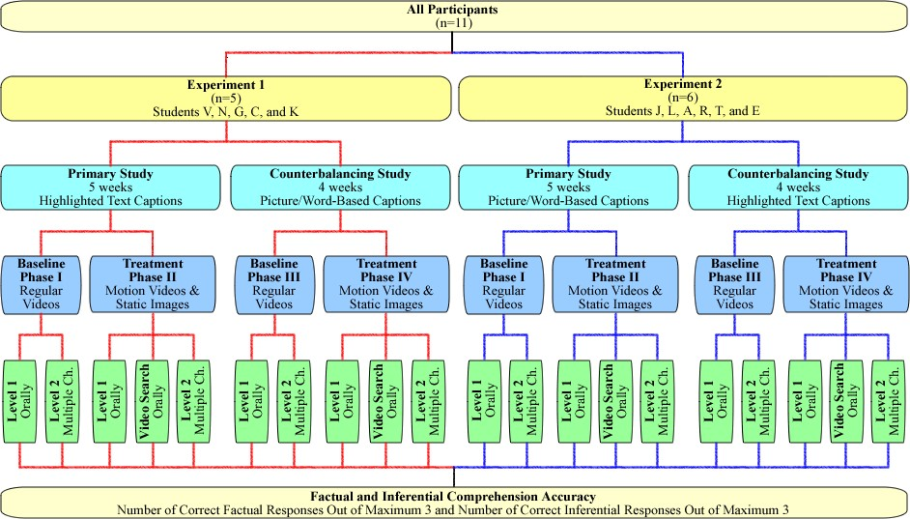
144

Figure 1. Logic Model for research study including participants, research designs, independent and dependent variables.
144

Independent Variables for Experiment 1 in the Primary Study
Across both experiments and studies, the primary independent variables in this research study consisted of original and adapted short video clips followed by three factual and three inferential comprehension questions. The detailed description of the specific baseline and treatment conditions appears in the Materials section on pages 157171. In short, baseline conditions in both experiments and studies (Phases I and III) engaged participants in watching the original, non-adapted video clips. For treatment conditions in both experiments the narration of all video clips was altered and simplified to address the abilities and needs of the participants. Additional adaptations representative of each experiment in the primary 5-week study are discussed below. Motion video with highlighted text captioning (V-HT). Along with the altered narration, participants in Experiment 1 were offered motion video clips with highlighted text captioning located at the top of the screen in the primary study (treatment Phase II). When compared to typical closed captioning options, it was anticipated that the highlighted text captions might have the potential to better attract students‟ attention and increase comprehension, especially of those students who could read (Hecker et al., 2002; Pisha & Coyne, 2001; Wehmeyer, Lance, & Bashinski, 2002).
Static images with highlighted text captioning (I-HT). In pursuance of the theory of cognitive overload (Mayers & Moreno, 2003), the alternative adaptation in the primary treatments phase (Phase II) of Experiment 1 entailed narrated static images taken from the video with highlighted text captioning positioned at the top of the screen. Providing static images as compared to the animated motion videos had potential to decrease the cognitive load, thus allowing students to focus more on the highlighted text captioning.
Independent Variables for Experiment 2 in the Primary Study
The independent variables for the baseline conditions in Experiment 2 also included original, non-adapted video clips. In addition to the altered narration, adaptations in the primary study for Experiment 2 include the following: Motion video with picture/words-based captioning (V-P/W). One of the adaptations offered to the participants in Experiment 2 in the primary study (Phase II) were motion video clips with picture/word-based captioning at the top of the screen.
Picture symbols are used widely to support various reading materials (Jones, Long, & Finlay, 2007; Slater, 2002). They often incorporate the textual representation of a word accompanied by a corresponding picture depicting its meaning. Thus, picture/wordsbased captioning might provide the necessary support for comprehension to those students with intellectual disabilities who are low- and/or non-readers.
Static images with picture/word-based captioning (I-P/W). To avoid cognitive overload with animated motion videos accompanied with picture/word-based captioning, participants in Experiment 2 in the primary treatment phase (Phase II) alternated videos with narrated static images taken from the video and supported with picture/word-based captioning. Having moving visual stimuli from the videos and pictures in the captioning may hinder students‟ attention, create a distraction, and potentially interfere with students‟ comprehension of the content. Provision of static images had a potential to minimize such effect.
Independent Variables for Experiments 1 and 2 in the Counterbalancing Study
Following the first 24 Sessions taken place during the first five weeks of the primary research study, the counterbalancing study was conducted when participants alternated between the reversed independent variables described in detail above. Thus, participants in Experiment 1 tested V-P/W and I-P/W adaptations, while participants in Experiment 2 were introduced to V-HT and I-HT conditions in the second treatment phase in the counterbalancing study (Phase IV). Conducting both primary and counterbalancing studies enabled each participant to explore every available captioning adaptation along with alternative narration and interactive video searching amalgamated for both studies. The independent variables are summarized in Table 3.

Table 3
Independent Variables across Experiments and Studies
 | Primary Study |  | Counterbalancing Study
Experiment | Independent Variables | Starting Session | Independent Variables | Starting Session
Experiment 1  Students V, N, G, C, K | Regular videos  V-HT; I-HT | Session 1  Session 6 | Regular videos  V-P/W; I-P/W | Session 25  Session 28
Experiment 2  Students J, L, A, R, T, E | Regular videos  V-P/W; I-P/W | Session 1  Session 6 | Regular Videos  V-HT; I-HT | Session 25  Session 28
Note. V-HT = motion videos with highlighted text captions; I-HT = static images with highlighted text captions; V-P/W = motion videos with picture/word-based captions;
I-P/W = static images with picture/word-based captions.
Dependent Variables
Comprehension of video content by students with intellectual disabilities signified the primary dependent variable of interest in this research study. The effects of various video adaptations alternated across participants and sessions were determined. The comprehension was measured by the number of factual and inferential questions correctly answered by students after viewing the video clip (adapted or not). In addition, inferential comprehension questions allowed determining the impact of adapted video clips on critical thinking skills by participants with intellectual disabilities. Accuracy counts were used as dimensional quantities of the behavior in this research study. They allowed measuring the acquisition level of performance (Alberto & Troutman, 2006). The data on three factual and three inferential questions were collected and graphed separately from each other. There were three questioning levels that provided opportunities to participants with diverse abilities and needs to demonstrate their comprehension of the video content.
Oral Level 1 questions. The participants were asked to orally produce the answer in response to questions presented by the researcher after they viewed videos in all baseline and treatment phases (Phases I – IV). These Level 1 responses given orally eliminated the chance of guessing correct answers. The possible variations in participants‟ responses to comprehension questions included:
Correct Level 1 response: The participant correctly orally answered a comprehension question asked by the researcher within 30 seconds of the stimuli. Partially correct Level 1 response: The participant provided an oral answer that was partially accurate, similar to the correct answer but not clearly stated, or entailed an accurate idea but did not match a predetermined correct answer to a comprehension question asked by the researcher within 30 seconds of the stimuli.
Incorrect Level 1 response: The participant incorrectly orally answered a comprehension question asked by the researcher within 30 seconds of the stimuli. Cases where participants verbally expressed that they did not know the answer were counted as an incorrect response.
No Level 1 response: The participant did not orally answer a comprehension question asked by the researcher within 30 seconds of the stimuli.
Video Searching level questions. One of the video adaptations offered to students during both treatment phases (Phase II and IV) was an opportunity to go back in the video using active hyperlinks and view video segments containing correct answers for those questions that were orally answered partially correctly, incorrectly, or were not answered during oral Level 1 questioning. Students searched the video in response to the researcher‟s prompting (see details in Procedures on pp. 171-184). The rationale for this feature was based on the combined research indicating the effectiveness of both active interaction with the video-based materials (e.g., Mechling & Ortega-Hurndon, 2007) and video prompting format of video instruction for students with intellectual disabilities (e.g., Cihak, Alberto, Taber-Doughty, & Gama, 2006). Following students‟ oral Level 1 responses, the researcher offered the participants an opportunity to check some of the answers. Students were asked to select and activate the correct hyperlinks in response to the researcher‟s prompting. After viewing the segment, they were expected to orally produce the answer to questions presented by the researcher. Video Searching level was excluded from both baseline conditions (Phases I and III). The possible responses included:
Correct response after searching the video: The participant selected the appropriate link after being prompted by the researcher to search for the answer. The link took the participant back to video segment that featured the correct response. The question was repeated. The participant then correctly orally answered the question asked by the researcher within 30 seconds after the stimuli.
Partially correct response after searching the video: The participant provided an oral answer that was partially accurate, similar to the correct answer but not clearly stated, or entailed an accurate idea but did not match a predetermined correct answer to a repeated comprehension question asked by the researcher within 30 seconds of the stimuli, following the process of searching the video for the answer.
Incorrect response after searching the video: The participant chose an incorrect link after being prompted by the researcher to search for the answer or incorrectly orally answered the repeated question asked by the researcher within 30 seconds after the stimuli, following the process of searching the video for the answer.
No response after searching the video: The participant did not give an oral answer to the repeated question asked by the researcher within 30 seconds after the stimuli, following the process of searching the video for the answer.
Multiple choice Level 2 questions. In order to provide participants with additional supports necessary for them to answer questions correctly, Level 2 responses were provided in a multiple choice format. It is often that a teacher moves from the basic question-answer sequence to other formats, where the response alternatives available to students are limited providing the latter with more concrete response opportunities. Thus, multiple choice questions are considered to be a highly supportive format (Gable & Warren, 1993). In baseline phases (Phase I and III) multiple choice Level 2 questions were asked after inaccurate oral Level 1 responses, while in treatment phases (Phase II and IV) multiple choice Level 2 questions were asked after inaccurate oral Video searching responses (see Procedures pp. 171-184). Overall, while all participants received the same instruction in grade-level content, the various achievement levels were measured to address their different abilities and needs (Browder et al., 2007). The possible responses were:
Correct Level 2 response: The participant selected the correct answer to a comprehension question asked by the researcher out of 4 multiple choice options within 30 seconds of the stimuli.
Partially correct Level 2 response: The participant chose the correct answer to a comprehension question asked by the researcher out of 4 multiple choice options but was unable to read all and/or any words from the selected response within 30 seconds of the stimuli.
Incorrect Level 2 response: The participant selected an incorrect answer to a comprehension question asked by the researcher out of 4 multiple choice options within 30 seconds of the stimuli.
No Level 2 response: The participant did not choose any of 4 multiple choice answers to a comprehension question within 30 seconds of the stimuli.
Thus, in two baseline conditions (Phase I and III), participants in both experiments were tested on oral questions Level 1 followed by multiple choice Level 2 comprehension questions. In turn, in both treatments and maintenance phases (Phases II,
IV, and V), the participants went through oral Level 1 questioning to oral Video
Searching and then to multiple choice Level 2 questioning (see Figure 1 on p. 144).
Data Collection System
The data for each target behavior and stimuli were collected via the observational recording system to determine the effects of interventions.
Comprehension accuracy. The data were collected on a trial-by-trial basis during all observational sessions in both baseline, treatment, and maintenance phases (Alberto &
Troutman, 2006). The simple observational code focused on the accuracy of students‟ responses to both factual and inferential questions out of the maximum 3 correct answers. The observational code followed a simple design to avoid a complexity that may affect the reliability of data collected (Alberto & Troutman). Direct measures were used to observe and sample behaviors and stimuli (Kennedy, 2005). The data collection procedure appropriate for discrete behaviors examined in this study contained event recording to document correct (+), partially correct (/), incorrect (–), and no (0) responses to oral Level 1, oral Video Searching, and multiple choice Level 2 comprehension questions based on the video content. At all questioning levels, each time a student generated a correct, partially correct, incorrect, or no response, the instance was recorded. The instances were recorded separately for factual and inferential comprehension questions. In addition, the recording system contained separate entry fields for events during oral Level 1 questioning, for oral responses after Video Searching for answers, and during multiple choice Level 2 questioning (see Appendix E). Thus, at the end of the observation period, the exact number of correctly answered questions was calculated separately to determine factual and inferential comprehension of the video content by students at different questioning levels.
Latency. The latency data was collected for supplementary analysis. The amount of time between the moment students heard the question and the occurrence of a response at all questioning levels was determined. Latency between the question asked by the researcher and the answer added an interesting dimension to the establishment of the functional relation between the variables. It was important to examine the changes in time that elapsed between a factual and/or inferential comprehension question and a student‟s oral Level 1, oral Video Searching, and multiple choice Level 2 response. Thus, the latency of the responses was collected using the stopwatch and documented on the recording system. The data recording system can be found in Appendix E.
Prior knowledge. One more variable considered for supplementary analysis was defined as participants‟ prior knowledge on the topic displayed in the video. Since different videos were used for each session, collecting data on prior knowledge enabled analysis of this extraneous variable. At the end of each session, students were asked what if anything they had known about the video topic prior to watching the video. This data were collected at the end of the session based on the body of research conducted with students with learning disabilities that demonstrated that activation of prior knowledge inquiry prior to the session had shown to impact students‟ comprehension, thus confounding the results (e.g., Carr & Thompson, 1996). The researcher then rated such self-reported information as extensive, medium, none, or irrelevant prior knowledge using the Prior Knowledge Checklist (Appendix F).
Reliability
Data for evaluating both implementation reliability (fidelity of treatment) and reliability of scoring (interobserver reliability) were collected simultaneously by the independent observer during 33 percent of randomly selected sessions. Reliability checks of whether the scoring was consistent as well as whether the treatment was conducted as intended were equally distributed across participants and conditions. The observer was positioned approximately 3 feet from the participant remaining discreet and unobtrusive but within range to hear and observe all participants‟ responses and actions. Prior to the data collection, the independent observer was trained following the procedures described later in the chapter on page 172.
Fidelity of treatment. The integrity of interventions was sustained by maintaining the consistency of the video content across the participants and conditions. In each observational session, all participants used the same video clip (see Table 4 on pp. 158162). Thus, the video content remained constant with the alteration in narration, captioning adaptations, and interactive features. Furthermore, among various treatments, the altered and simplified narration remained identical to provide experimental control for determining the impact of captioning adaptations on video content comprehension by students with intellectual disabilities.
The researcher also used pre-established intervention scripts for the participants‟ training and prompting students during the session (see Appendix D). The independent observer compared the researcher‟s actions to the intervention scripts to establish the consistency of treatment implementation. The independent and dependent variables were operationally defined prior to the data collection and the observer had an access to both the scripts and the Fidelity of Treatment Checklist (see Appendix G). The observer recorded and evaluated the following researcher‟s behaviors: (a) introducing the video and providing the task directions according to the script; (b) presenting each student an opportunity to view a video clip (adapted or not), according to the schedule; (c) waiting
30 second for initiation of response for each comprehension question across the phases; (d) providing students an opportunity to search the video for an answer in the treatment phase after partially correct, incorrect, or no responses; (e) allowing students to choose the correct response from the list of 4 multiple choice options; (f) delivering general and specific attentional cues according to the script, as well as delivering nonspecific verbal praise. Procedural reliability was derived by dividing the number of observed researcher‟s behaviors by the number of provided opportunities to execute the behaviors multiplied by 100. The fidelity of treatment was determined at 100%.
Interobserver reliability. The interobserver reliability was established to ensure appropriate data collection and to prevent researcher drift and bias (Kennedy, 2005). The independent observer collected the data on participants‟ responses independently and simultaneously with the primary researcher (Alberto & Troutman, 2006). Prior to reliability checking, the observer was introduced to the common descriptions, operational definitions of target behaviors and stimuli, as well as to the recording system (details on p. 172). During 33 percent of randomly selected sessions, the researcher and the observer independently and silently scored students‟ responses. The scoring was compared using the point-by-point method (Alberto& Troutman). To calculate the occurrence of the event agreement between the observers, the total agreement formula was used. Both observers calculated the total number of questions answered correctly, partially correctly, incorrectly, or not answered and use the formula: S ÷ L x 100%, where S is a smaller total and L is a larger total of response occurrences. Thus, the coefficient of agreement was determined.
The accuracy of occurrences was calculated across factual and inferential questions. The coefficient of agreement between the researcher and observer was 87% for oral Level 1 questions, 92% for oral Video Searching level, and 98% for multiple choice Level 2 questions, averaging at 92% across all questioning levels. In order to avoid reactivity, the observer was naïve to the main hypothesis of the study. Furthermore, to avoid expectancy, the observer was unfamiliar with specific characteristics of the students so that she did not portray preconceived notions about students based on their past experiences (Alberto & Troutman, 2006).
Validity of partially correct responses. Throughout the data collection, each student‟s answer considered by the researcher to be partially correct during oral Level 1 and oral Video Searching questioning levels was documented verbatim. At the end of the study a list of partially correct responses was compiled for the final expert panel review to establish the agreement on the value of each response. The experts were given a question, an expected answer, and a student‟s response. They were asked to review each student‟s answer, compare it to the expected one, and determine to which category it should belong (correct, partially correct, or incorrect). Upon the consensus between the expert panel members, only 56 percent of the responses originally considered to be partially correct across all 11 participants remained in the partially correct category. Seven percent of the responses originally coded as partially correct were re-identified as incorrect and 37 percent of those partially correct responses moved up into the correct answers category.
Social Validity
At the end of the study, semi-structured interviews were conducted with the direct recipients of the intervention. Participants from both experiments were interviewed and asked for their perceptions of usefulness and effectiveness of various video adaptations (see Appendix H for interview questions). Their perceptions of the video without adaptations were also inquired to allow comparisons. Students were encouraged to share feedback on how they had reacted to interventions. Thus, the social impact of the intervention regarding participants‟ perceptions of the research procedures and outcomes were determined. Participants were asked about their likes and dislikes of each type of alternative captioning and interactive video searching features. Upon the permission, the interviews were audiotaped and transcribed for further data analysis. Thus, qualitative data provided more attention to the social relevance of the researched intervention.
Materials
The primary materials in this study included academic non-fiction video clips.
Video clips were compiled from the unitedstreaming service by the Discovery Channel (see Appendix I for the video references). Unitedstreaming service offers a large selection of web-based educational videos that are correlated with state standards in all academic areas. Videos selected for this research study were aligned with the Virginia Standards of Learning (SOLs), topics covered in the LIFE courses, and based on the current trends in society (e.g. global warming, presidential elections, obesity, etc.). Table 4 presents the list of all videos with a description of how they align with aforementioned criteria.

Table 4
Summary of Video Sequence, Topic Category, Readability Level, and Alignment with
SOL Standards

Video Title Date Topic Readability Level Virginia SOL
(mm/dd/ Standards yy) Regular Altered
script script

Hurricane Season 2007 | 9.24.07 | SW | 9.3 | N/A | VA.6.6.1.  VA.ES.13.17.
Requirements for  Becoming a President | 9.25.07 | PE | 8.8 | N/A | VA.CE.6.b.1. VA.CE.7.a.1.
Industrialization, Fossil  Fuels, and Global  Warming | 9.26.07 | GW | 9.8 | N/A | VA.6.2.1.  VA.6.2.4.  VA.6.6.5.
Texting while Driving | 9.27.07 | TECH | 8.8 | N/A | VA.RB.6.4.a.  VA.CHW.8.5.  VA.KS.9.1.
Finding Terrorists with Technology | 9.28.07 | TECH | 7.2 | N/A | VA.WG.10.a.2  VA.WG.10.c.1  VA.WG.12.b.7

Table 4 (continued)

Video Title
 | yy) |  | Regular script | Altered script
Thinking Green | 10.01.07 | GW | 7.2 | 4.2 | VA.6.8.7.  VA.LS.11.3.
Katrina Overview | 10.02.07 | SW | 8.6 | 4.8 | VA.ES.11.20.  VA.ES.13.14.  VA.ES.13.17.
Technology Concerns | 10.03.07 | TECH | 9.1 | 4.1 | VA.RB.6.4.a.  VA.CHW.8.5.  VA.KS.9.1.
Presidential Candidates Debate | 10.04.07 | PE | 9.3 | 4.9 | VA.CE.6.b.1. VA.CE.7.a.1.
How Hurricanes Form | 10.05.07 | SW | 8.1 | 4.9 | VA.6.6.1.  VA.ES.11.20.  VA.ES.13.14.
Tech in the Classroom | 10.09.07 | TECH | 8.9 | 4.9 | VA.C/T. 6.8.8  VA.C/T.9.12.9  VA.C/T.9.12.5
Greenhouse Effect | 10.10.07 | GW | 9.2 | 4.6 | VA.6.2.1.  VA.6.3.3.  VA.LS.11.3.
Hurricane Eye | 10.11.07 | SW | 7.5 | 3.2 | VA.6.6.11.  VA.ES.11.20  VA.ES.13.14.
Electoral College | 10.12.07 | PE | 9.5 | 5.3 | VA.CE.6.b.1. VA.CE.7.a.1.
Wired Teens | 10.15.07 | TECH | 9.8 | 5.9 | VA.RB.6.4.a.  VA.CHW.8.5.
Protecting the Environment | 10.16.07 | GW | 9.3 | 4.4 | VA.6.2.11.  VA.6.2.12.  VA.6.6.5.
Table 4 (continued)

Video Title
 | yy) |  | Regular script | Altered script
Presidential Campaigns | 10.17.07 | PE | 11.0 | 5.2 | VA.CE.6.b.1. VA.CE.7.a.1.
Storm Surge and Hurricane Names | 10.18.07 | SW | 8.8 | 4.7 | VA.6.6.11.  VA.ES.11.9.  VA.ES.13.17.
Dropping Out of School | 10.19.07 | SI | 7.8 | 3.8 | VA.SCANS.  1.13.  VA.CHW.6.7.
Tracking Hurricanes | 10.22.07 | SW | 9.5 | 5.3 | VA.6.1.3.  VA.6.6.11.  VA.ES.1.2.
Food Commercials | 10.23.07 | HI | 9.6 | 4.2 | VA.PAL.7.5.  VA.PAL.12.5.  VA.PF.7.3.b.
History of al Qaeda | 10.24.07 | POL | 11.5 | 5.3 | VA.WG.10.a.2  VA.WG.10.c.1  VA.WG.12.b.7
Global Warming and  Islands | 10.25.07 | GW | 7.7 | 4.3 | VA.6.6.5.  VA.LS.11.3.  VA.LS.12.3.  VA.S.11.4.
Issues with Presidential Elections | 10.26.07 | PE | 10.0 | 3.8 | VA.CE.6.b.1. VA.CE.7.a.1.
Nutrition and Health | 10.29.07 | HI | 8.3 | N/A | VA.KS.7.2.  VA.KS. 10.1.  VA.PF. 8.4.
Al Qaeda after 9/11 | 10.30.07 | POL | 8.3 | N/A | VA.WG.10.a.2  VA.WG.10.c.1  VA.WG.12.b.7

Table 4 (continued)

Video Title
 | yy) |  | Regular script | Altered script
What is addiction? | 10.31.07 | ADD | 7.6 | N/A | VA.KS. 6.2. VA.KS.7.2.
Limiting President‟s Power | 11.01.07 | PE | 9.8 | 5.4 | VA.CE.6.b.1. VA.CE.7.a.1.  VAGOVT.14.d
Tornados | 11.02.07 | SW | 8.2 | 4.2 | VA.ES.13.16. VA.6.6.11.
Eating Disorders | 11.05.07 | HI | 7.9 | 3.5 | VA.KS. 6.2.  VA.KS.7.2.  VA.KS.10.1.
The President and the War | 11.06.07 | POL | 10.8 | 4.3 | VA.CE.6.b.1. VA.CE.7.a.1.
Reasons for Addictions | 11.07.07 | ADD | 9.3 | 4.2 | VA.KS.6.2.  VA.RB.6.4.  VA.KS.7.2.
Viruses | 11.08.07 | HI | 7.5 | 3.5 | VA.BIO.2.10. VA.BIO.5.6.  VA.BIO.5.17.  VA.BIO.5.18.
Humans and Environment | 11.09.07 | GW | 8.6 | 4.1 | VA.6.6.12.  VA.6.8.7.  VA.LS.11.3.  VA.LS.12.3.
Nutrients and Digestion | 11.12.07 | HI | 7.3 | 3.8 | VA.KS. 9.2. VA.PF. 8.4.  VA.KS. 10.1.
Vaccines | 11.13.07 | HI | 8.9 | 4.4 | VA.BIO.2.1.  VA.BIO.2.14.  VA.BIO.5.14.

Table 4 (continued)

Video Title
 | yy) |  | Regular script | Altered script
Some Consequences of Addictions | 11.14.07 | ADD | 7.7 | 3.1 | VA.KS. 6.1.  VA.KS. 6.4. VA.KS.7.2.  VA.KS. 8.1.
Thunderstorms | 11.15.07 | SW | 8.1 | 4.6 | VA.6.3.5.  VA.6.3.6.  VA.6.6.11.
Al Qaeda and the Internet | 11.16.07 | POL | 7.9 | 4.3 | VA.WG.10.a.2  VA.WG.10.b.7  VA.WG.10.c.1  VA.WG.12.b.7
Obesity in America | 11.19.07 | HI | 7.9 | 4.6 | VA.KS. 6.2.  VA.KS. 6.4.  VA.KS.7.2.  VA.KS. 10.1.
Marijuana and the Brain | 11.20.07 | ADD | 7.6 | 4.3 | VA.KS. 6.1.  VA.KS. 6.4.  VA.KS. 10.1.
Severe Weather Review | 11.26.07 | SW | 8.7 | 3.3 | VA.6.3.5.  VA.6.6.11.  VA.KS.7.2.
New Viruses and Diseases | 11.27.07 | HI | 8.1 | 3.4 | VA.BIO.2.1.  VA.BIO.2.14.  VA.BIO.5.17.
Presidency: Past and Present | 11.28.07 | PE | 12.0 | 5.5 | VA.CE.6.b.1. VA.CE.7.a.1.
Note: SW = Severe Weather; PE = Presidential Elections; GW = Global Warming; POL
= Politics; SI = School Issues; TECH = Technology; HI = Health Issues; ADD =
Addictions; N/A = videos used only in a baseline condition.
16 2
The video topics were selected to demonstrate the possibility of integrating adapted video clips into standard general education curriculum. Longer unitedstreaming videos were segmented into shorter clips. Based on the results of the pilot testing, it was decided to limit the length of a clip for one observational session to approximately 1.5-2 minutes. With daily interventions, longer videos covered various topics as can be seen in Table 4. Different videos were used in each session to avoid carry-over effects in the alternating treatments design (Kennedy, 2005). The researcher alternated between videotapes that used male and female voices.
The videos were shown to the participants on a portable DELL Latitude D600 computer running on Windows XP Professional. The laptop was equipped with a 32 MB
ATI Radeon 9000 video card and an Intel AC97 sound card as well as a CD-ROM drive.
The computer screen measured 14 x 8 inches.
Baseline Condition
In order to establish the context for further analysis, participants viewed the original, non-adapted video clips in both baseline phases of the primary and counterbalancing studies (Phases I and III) followed by comprehension questions. Longer videos from the unitedstreaming service were downloaded and segmented into 1.5-2 minute clips. The narration of the video content remained in its original form during the baseline phases. Following the video clip, participants saw a single still video frame on a computer screen with a black background and a title „Questions‟ supported by a picture of a question mark (Figure 2). At that time, the researcher orally asked three factual and three inferential questions with a 30-second delay between the questions to allow participants to answer. A stopwatch was used to control for appropriate time delay. Factual questions were asked first followed by inferential ones to provide a flow from the easier to more difficult tasks. The researcher used an invisible button on the screen to move on to the next screen (Mechling, Gast, Langone, 2002).


Figure 2. Example of a questioning video screen.

All single video frames, invisible control buttons, and further adaptations featured in the treatment phases were created using Camtasia Studio Screen Recorder software. Camtasia Studio software is designed to create, edit, and easily enhance videos. The description of Camtasia Studio Screen Recorder can be found in Appendix J. Only editable video titles were used in this project. The unitedstreaming service offers a variety of video clips that can be edited for classroom and school-related projects. Edited videos maintained all copyright and proprietary notices and avoided any defamatory or unlawful content.
Treatment Condition
Treatment conditions required participants to view adapted video clips and answer factual and inferential comprehension questions. The description of the process of altering the video narration, creating captions and specific treatment adaptations is as follows.
Altering video narration. Narration of all videos utilized in the treatment conditions was altered to meet the intellectual developmental level of participants. The process of altering the narration of the videos started with the transcription of all video clips. The readability level of each transcript was then determined. Subsequently, each transcript was examined and altered to decrease the readability level and meet the needs of participants in the study. Cognitive rescaling of the text was achieved by cutting the word count, removing all passive-voice sentence constructions, and converting clauses into short declarative sentences, thus altering the cognitive challenge involved (Edyburn, 2002; Jensema, McCann, & Ramsey, 1996). The readability grade level of both original and altered transcripts was determined by using the Microsoft Word readability statistics option aka Flesch-Kincaid Grade Level readability formula as described earlier in the chapter (p. 139). While LIFE students range greatly in reading abilities, their independent reading level averages at 5th grade (ranging from K to 8 grade level). In order to prevent any of the participants from struggling with the supporting text, the altered narration and corresponding captions were offered at that reading level (Linebarger, 2001). Thus, the readability levels averaged at:
- 8.97 grade level (SD = 1.14) for regular videos in the initial baseline (Phase I);
- 4.62 (SD = 0.66) for adapted videos in the first treatment phase (Phase II);
- 8.1 (SD = 1.22) for regular videos in the second baseline (Phase III);
- 4.16 (SD = 0.57) for adapted videos in the second treatment phase (Phase IV);
- 4.07 (SD = 1.24) for adapted videos during maintenance (Phase V).
The alternative narration was recorded using “natural/real” synthesized voices available from the software programs of new generation. Existing research shows that children prefer synthesized speech over more natural-sounding voices, while adults favor the latter (Willis, Koul, & Paschall, 2000). Moreover, students with intellectual disabilities showed a non-significant trend toward improved comprehension with good quality synthesized speech as compared to real voices (Mirenda, Eicher, & Beukelman,
1989). Overall, while research on the usability of synthesized speech and reading/listening comprehension is inconsistent, its effectiveness greatly depends on synthesizer‟s quality (Hansen, Lee, & Forer, 2002; Reynolds, Isaac-Duvall, & Haddox, 2002). High-quality synthesized alternative video narration, recorded with WYNN 5.0 program RealSpeak Solo and ETI-Eloquence voices substituted the original one alternating between male and female voices. Thus, both voices and speech rates were controlled and consistent across all videos utilized in this research study. The sound quality of narrative recordings was maximized using a Sony WCS-999 wireless microphone.
Captions. The captions enhancing auditory comprehension of the video content were created using Camtasia Studio Screen Recorder software. After the altered narration was recorded and added to each video segment, the captions corresponding verbatim to that narration were then developed and placed at the top of the video screen. The captions presented one sentence per line. They appeared on the screen in mixed (lower-case and upper-case) black size-28 Arial letters on a solid white background. The visual display of captions in black letters on the white solid background was consistent with the way highlighted text and picture/word-based text appeared in most assistive technology software programs. Thus, participants of this research study were familiar with such format of reading text on the computer screen.
During highlighted text captioning conditions, words were highlighted in yellow as they were spoken. In the case of picture/word-based captioning, words in the captions were accompanied with picture symbols. Colored line drawings were positioned immediately above the word that they accompanied. Picture/word-based captions were created using Writing with Symbols (WWS) 2000 computer software program. WWS 2000 is a picture word processing program designed to display Mayer-Johnson‟s Picture Communication Symbols (PCS) and/or Rebus symbols for each typed word. The description of WWS 2000 software is provided in Appendix K. During the picture/wordbased captioning conditions, the words were not highlighted as they were spoken. The average rate of caption presentation was 80 words per minute. Existing research shows that average caption speed in educational television programs is 124 words per minute for persons with hearing impairments and normal cognitive development (Jensema, McCann, & Ramsey, 1996). Linebarger (2001) successfully used captions at 90 words per minute rate with students without disabilities who completed the second grade. Thus, pilot testing members in this research study were asked to view videos with 60, 80, and 100 words per minute (wpm). Chosen rate of 80 wpm was based on the preferences of two out of three members.
V-HT and I-HT conditions. At different treatment phases, all research participants alternated between motion video with highlighted text captioning (V-HT) and static images taken from the video with highlighted text captioning (I-HT). Participants in Experiment 1 tested V-HT and I-HT interventions in the first treatment phase of the primary study (Phase II), while participants in Experiment 2 experienced V-HT and I-HT conditions in the second treatment phase of the counterbalancing study (Phase IV). Participants in the V-HT condition watched the motion video clip with text captions at the top of the screen. Captions were matched to the narration verbatim. One sentence was displayed at a time and the words were highlighted as they were spoken out loud (see
Figure 3).


Figure 3. Example of a video with highlighted text captioning.

The I-HT condition was created with single video frames featuring images taken from the video. The static images were taken from the video using the screen capture feature of Camtasia Studio software. The number of still pictures featuring the screen shots of important video images changed with each new captioning sentence. Thus, the motion on the screen in the I-HT condition was minimized. Like the V-HT condition, the I-HT condition included the highlighted text captioning at the top of the screen with words highlighted as they were spoken out.
V-P/W and I-P/W conditions. In the first treatment phase for Experiment 2 (Phase II) and the second treatment phase for Experiment 1 (Phase IV), participants alternated between motion video with picture/word-based captioning (V-P/W) and static images with picture/word-based captioning (I-P/W). V-P/W clips featured motion videos with captioning at the top of the screen in the form of words supported with pictures symbols. In the I-P/W condition, static images taken from the video using the Camtasia program were supported with pictures/words-based captioning at the top of the screen (see Figure
4). The static images changed with each new sentence.


Figure 4. Example of a video with picture/word based captioning.

Analogues to the baseline condition, participants in all treatments (Phases II and IV) across both Experiment 1 and Experiment 2 saw the single video frame at the end of the clip with black background, title “Questions”, and a supporting picture of a question mark. The researcher provided participants with factual and inferential comprehension questions separated by 30 seconds delay.
Video searching for answers. After participants responded to all questions in treatment phases of both experiments (Phases II and IV), they were offered an opportunity to search the video for answers to the questions they had answered partially correctly, incorrectly, or did not answer at all. During this phase, participants saw a single video frame with six phrases corresponding to each comprehension question on a white background. All six phrases appeared on the screen at the same time in a numbered vertical list. The phrases after V-HT and I-HT clips included text only, while the phrases after V-P/W and I-P/W conditions contained words supported by picture symbols consistent with the appropriate captioning condition. Each phrase was accompanied by a hyperlink in the form of a red right side arrow (see Figure 5).

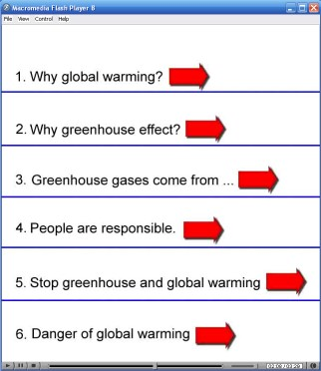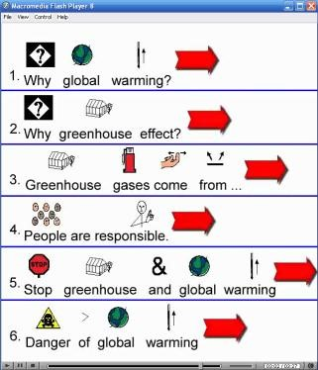
Figure 5. Example of a video searching screen after both captioning conditions.

By clicking the red arrow hyperlink with a mouse, the participants were taken to the segment of the video that corresponded to the selected phrase and contained the answer to the target question. During this phase, the researcher mentioned the number of the question answered partially correctly, incorrectly, or no answered at all but did not prompt the participants to choose the correct link in any other way. Thus, it was possible to observe whether the participants with intellectual disabilities in this study were able and could benefit from more interactive computer-based video instruction. All adapted video clips were saved as separated files and stored on a CD-ROM drive. Multiple choice Level 2 questioning. In all research phases, participants were offered another opportunity to provide responses to any questions they answered partially correctly, incorrectly, or did not answered during oral Level 1 and oral Video Searching questioning levels. At that time, a student was offered two “A”-size pieces of papers with a question and possible answers in 28-size Times New Roman font. Answer sheet included four choices (one correct and three distractors) in a lettered vertical list. In both baseline phases as well as after V-HT and I-HT conditions, the question and multiple choice responses were displayed as text only. After V-P/W and I-P/W interventions, text for both the question and multiple choice responses were supplemented with picture symbols (see Appendix L).
Procedures
The procedures described below include the sequence of activities proposed for before, during, and after the research study. Prior to each session in any of the phases, the operation of the computer and videos was checked to ensure that everything functioned properly. Only one session, during which the participants experienced technical computer problems, was terminated.
Independent Observer’s Training
Prior to the reliability checking the researcher met with the other doctoral student serving as the independent observer and introduced her to the descriptions of dependent and independent variables. The researcher verbally explained the use of the data collection sheet (Appendix E). Training with the observation and data collection procedures was conducted using videotapes of pilot testing members performing the targeted tasks. During the videotaped reviews, the researcher and independent observer practiced collecting the data simultaneously, and then discussed all questions the observer had regarding the forms.
Participants’ Training
Prior to the beginning of the study, the researcher introduced the research study participants to the equipment and available video adaptations. The 15-20 minute small group trainings (2-3 participants at a time) took place in the proposed research setting in September 2007. During the training, the researcher introduced students to the project and demonstrated the different kinds of videos. The participants learned about how to navigate through the video by clicking the mouse. The researcher demonstrated the questioning frame and explained that the participants would hear the comprehension questions based on the video content. The participants practiced answering the questions orally. The researcher demonstrated searching the video procedure and the participants had a chance to practice individually until they felt comfortable with the process. The researcher then modeled the multiple choice Level 2 questioning. Other procedures were discussed. Each participant received two days of training, during which the researcher followed the pre-established training script that can be found in Appendix D.
Due to the fact that some video adaptations included picture symbols, the participants were introduced to the format. Several LIFE students were familiar with picture symbols as they were integrated into some literacy activities in their classes. Picture symbols used in the WWS 2000 program are clear, line drawings that represent a word. The picture symbols are considered to be easily understood, especially as they are accompanied by a written word (Slater, 2002). However, in order to enhance participants‟ experiences with picture symbols, LIFE instructors utilized picture-supported materials in all of their classes for at least one month prior to the beginning of this research study.
Random Assignment of Participants
Participants were subject to randomized assignment at three levels: a) Experiment 1 or 2; b) order of beginning of treatment in Experiment 1 or 2; and c) order of alternating treatments. Prior to the beginning of data collection, study participants were randomly assigned to the order in which they received various captioning treatments. Thus, the participants randomly assigned to the Experiment 1 had a chance to trial highlighted text captioning in the primary study (Phase II) and picture/word-based captions in the counterbalancing study (Phase IV), while those in the Experiment 2 started with picture/word-based captions in the first study (Phase II) and counterbalanced with highlighted text captioning (Phase IV). The random assignment of students to two experiments was conducted as follows. The researcher put students‟ names on cards and placed each card in a separate envelope. Randomly selected half of the envelopes included names of students for the Experiment 1 (Students V, N, G, C, and K), while the second half participated in the Experiment 2 (Students J, L, A, R, T, and E).
Furthermore, the random assignment of participants to the multiple baseline conditions and the order in which they started intervention was conducted. Participants were randomly assigned to a number from 1 to 5 within Experiment 1 and to a number from 1 to 6 within Experiment 2. The number determined in which order the participants received intervention in the staggered multiple baseline design. Predetermined five points between the first and the second participants, and then three points for each subsequent participant separated each individual‟s entry into the first treatment phase in the primary study (Phase II). Starting in Session 25, the treatments were withdrawn and all participants returned to the second baseline (Phase III). The reversed treatments in the counterbalancing study (Phase IV) were subsequently introduced to the participants in the same order. Three points between the first, second, and the third participants, and then two points for each subsequent participant separated individual entries into the second treatment phase in the counterbalancing study (Phase IV).
The envelops with the participants‟ names were used one more time within each experiment to determine the random assignment of alternating treatments to observation times or the order, in which participants will alternate between two intervention formats (e.g., motion video versus static images). Within each experiment, half of the envelopes were used to determine students‟, who would start rotating between interventions with motion videos enhanced with the adaptation corresponding to the experiment and the study (highlighted text captioning or picture/word-based captioning). Logically, the second half of students was first introduced to the static pictures with the appropriate adaptation. Using randomization procedures made the randomization tests valid. Various random assignments are summarized in Appendix M.
Phase I: Initial Baseline Procedures
Prior to the beginning of the study, the individual schedule of participation for each student was established. The overall Data Collection Schedule can be found in Appendix N. The researcher conducted interventions on a daily basis for 10-15 minutes with each individual student. The participants had a choice to engage in the intervention before their classes (Students K, C, L, R, and J) or during lunch (Students T, V, E, G, A, and N) based on students‟ schedule (e.g., arriving on campus 1 hour before classes start), availability, and personal preference. The research project did not interfere with students‟ classes or other study related activities. The participants‟ reactions to viewing the videos
were systematically analyze to ensure that they were not influenced by the session timing.
Watching videos. During the initial baseline in both experiments, participants arrived to the research setting according to the schedule. The sessions were conducted in a 1:1 format to reduce the threat of observational learning by other participants. The participants were individually positioned in front of the laptop computer. The height of the computer monitor was adjusted to the participant‟s eye level and to avoid computer screen glare. If participants arrived earlier, they waited for their turn in the hallway to reduce distraction, maintain confidentiality and independence between subjects. The participants sat directly in front of the computer and the researcher sat to the students‟ right with a data collection sheet. The location of the researcher remained consistent throughout the study. At the beginning, each participant was given a verbal instruction to view the video (e.g., “Let‟s view the video”). The researcher helped prompting attention to the screen if needed (e.g., “Pay attention to the screen”; see Appendix D).
Oral Level 1 questioning. Following the video, the researcher provided instructions to prepare a participant for answering comprehension questions based on the video content (e.g., “It is time to answer questions!”). The researcher asked three factual and three inferential questions. Participants were encouraged to respond orally during
Level 1 questioning (e.g., “Please, say your answer out loud, so I can hear you”). The researcher and the reliability observer (when applicable) recorded the number of questions answered correctly, partially correctly, incorrectly, and not answered. If a participant did not make an attempt to initiate a response within 30 seconds of the question, the next question was presented.
Multiple choice Level 2 questioning. If a participant answered all the questions correctly, the researcher ended the session. In cases when a participant answered some questions partially correctly, incorrectly, or did not answer at all, the researcher announced the multiple choice Level 2 questioning (e.g., “Let‟s go back and answer some questions one more time, but this time you will be able to chose an answer from some options.”). First an appropriate printed question was placed in front of a student (see Appendix L for examples). The question was read out loud by the researcher. Then, a participant received another paper with four lettered choices (e.g., a, b, c, and d). Without reading out loud any of the choices, the researcher asked a participant to choose the correct answer and announce the letter of the correct answer out loud. If a student chose the correct response, he/she was asked to read it to control for „guessing‟ (“e.g., “What does it say?”). When all the questions answered partially correctly, incorrectly, or not answered at all during oral Level 1 questioning were revisited, the researcher ended the data collection.
Prior Knowledge. After the session, a participant was inquired whether he/she was familiar with the topic prior to watching the video. Students were asked to share everything they had known about the topic before (e.g., “Today we watched the video about X. Did you know anything about this topic before we started watching the video? If yes, could you share with me what you had known?”) The researcher completed a Prior
Knowledge Rubric based on students‟ responses (see Appendix F). The researcher then provided nonspecific verbal praise for attending and attempting to answer the questions.
No other instructional procedures were applied outside of the video intervention.
Phase II: First Treatment Procedures
A series of repeated measures of participants‟ performance under the intervention conditions were initiated after the pre-established baselines were achieved. Following Alberto and Troutman (2006), at least 5 data points were collected and plotted before the intervention was introduced to the first participant in each experiment. The rest of the participants remained in baseline. Subsequent introduction of the randomly ordered adaptations was staggered at least three sessions apart across all the participants in each experiment. Due to the use of randomization testing, the next participant needed to start the intervention even without an obvious trend in the treatment phase of the previous participant.
Watching video. The same procedures were used for all treatment conditions
except for the difference in the featured adaptations (motion videos and/or static images with highlighted text captioning and/or picture/word based captioning). As described earlier, the order in which the video adaptations were presented was randomized in both experiments (see p. 173). During treatment phases of the primary study all participants arrived to the research setting and were asked to view adapted videos individually. The computer was placed in a location where it could be easily seen and operated by both the participant and the researcher. A participant was oriented toward the computer screen as the researcher announced, “Let‟s watch the video.” During treatment phases the researcher also directed a participant to attend to various types of captions at the top of the video screen (e.g., “Today while watching the video, you will see highlighted or picture/word captions at the top of your screen. I want you to pay special attention to them!”). The researcher then started the video clip.
Oral Level 1 questioning. When the video clip ended, the researcher announced the beginning of the questioning session and asked questions out loud (e.g., “It is time to answer questions!”). At this point, a participant was given 30 seconds to orally answer each question similarly to the initial baseline phase. After a participant attempted to answer all the questions orally, he/she was taken to the „video searching‟ still frame described in the Materials section above (p. 170). At this time, if a student answers all the questions correctly, the researcher delivered nonspecific verbal praise and announced the end of the session (e.g., “You are done! Excellent job today!”).
Video Searching level questioning. If a student answers any questions partially correctly, incorrectly, or did not answer them at all during oral Level 1 questioning, he/she was able to search the video for correct answers using the red arrow hyperlinks. A still frame with phrases corresponding to the questions was provided. The researcher announced which question needed to be corrected and offered an opportunity to search the video for answers (e.g., “Let‟s go back in the video and check some answers. Let‟s check question #X”). No additional prompting was delivered. It was a participant‟s responsibility to choose the correct hyperlink from the numbered list and activate it with a mouse click. If a student selected a wrong link, the answer to that question was recorded as incorrect.
Upon successful hyperlink activation, a questioning screen appeared (see p. 164).
The researcher re-asked the question and activated the invisible button under the word
„Questions‟ on the screen (e.g., “The question #X was … Let‟s check.”). A participant viewed a segment of the video featuring the correct answer. Following the video segment, the researcher repeated the question just one more time (e.g., “So, what/when/who/why …”) and allowed a participant to orally answer it again.
In case of student‟s mindless repetition of the sentence from the segment, the researcher asked a participant to elaborate on his/her response. The response was coded as correct only if a student was able to provide more information. If he/she was unable to expand, the response was coded as partially correct and underwent validation of partially correct responses process by the expert panel described above on p. 156.
Multiple choice Level 2 questioning. If there were still some questions that a participant answered partially correctly, incorrectly, or did not answer after both oral
Level 1 and oral Video Searching levels, the researcher moved on to the multiple choice Level 2 questioning format. A participant received a notification of the additional questioning time (e.g., “You are doing a great job for me. Let‟s go back in the video and check some questions just one more time. But this time you will be able to choose an answer from some options.”). The researcher announced the number of a question needed to be checked; waited for a student to activate the hyperlink for appropriate question; put the printed question in front of a student when a questioning screen appeared; read the question out loud; and activated an invisible button on a questioning screen. In treatment phases, a student was provided with a text-based printed question and multiple choice responses after working with highlighted text captions and with a picture symbol-based question and answers after experiencing picture/word-based captioning. After a participant viewed the video segment containing the correct answer, the researcher repeated the question and put the multiple choice sheet in front of a student allowing him/her to pronounce the letter corresponding to the correct answer (e.g., Please choose and name the letter for the correct response: a, b, c, or d.”). Just like in the baseline condition, a participant was asked to read his/her choice after selecting the correct one.
After all questions were revisited once, the researcher concluded data collection.
Prior Knowledge. Once again at the end of each session, the researcher solicited the level of participants‟ prior knowledge on the video topic. Based on students‟ selfreports, prior knowledge was coded by the researcher as extensive, medium, none, and not relevant on the Prior Knowledge Rubric (Appendix F).
Finally, the researcher provided a nonspecific verbal praise for attending, interacting with the video, and attempting to answer the comprehension questions. The treatment phases continued until all the participants were introduced to the consequent adaptations. In order to determine the effectiveness of specific adaptations, interventions were replicated with each subsequent participant accordingly. Relatively large numbers of observation sessions were used to control for the novelty of treatment (Clark, 1983).
Phase III: Second Baseline Procedures
All the participants across both experiments started the second baseline in the counterbalancing study simultaneously in Session 25. The participants followed the same order and time schedule as in the primary study. The procedures for viewing regular, nonadapted videos in the second baseline (Phase III) were identical to the research procedures described in Phase I: Initial Baseline Procedures (pp. 175-177). Students progressed through oral Level 1 questions and multiple choice Level 2 questioning providing oral and multiple choice format responses to three factual and three inferential comprehension questions asked by the researcher and shared their prior knowledge on the video topic, just like in the initial baseline of the primary study (Phase I).
Phase IV: Second Treatment Procedures
The research procedures in the second treatment phase in the counterbalancing study (Phase IV) mirrored the process described in Phase II: First Treatment Procedures on pages 177-181. The participants went through all the levels of questioning (oral Level 1 questions, oral Video Searching level, and multiple choice Level 2 questions) as described above, differing only in the type of captioning adaptations they received according to the random assignment (p. 173). The only difference was the amount of time participants remained in the baseline. In the second baseline phase of the counterbalancing study (Phase III), three data points were collected and plotted before the intervention was introduced to the first participant in each experiment. The rest of the participants remained in baseline. The second participant entered the treatment phase after three more sessions. Subsequent introduction of the randomly ordered adaptations was staggered at least two sessions apart across all the participants in each experiment.
Phase V: Maintenance Procedures
In order to measure the performance of participants beyond acquisition level, the maintenance competence needed to be determined (Alberto & Troutman, 2006). Maintenance probes utilizing video adaptations shown to be the most effective and/or preferred by the participants were conducted after the end of the counterbalancing research study (see Table 5). Three data probes were collected for each participant 5 days after the last day of interventions. Maintenance data were collected in the same setting and participants followed the same predetermined treatment procedures described above.
The retention of learned information by the participants in this study was not formally assessed. The topics covered in the study were only introduced by the short video clips according to the research design and were not reinforced in LIFE classes or other educational activities. We believe that in order for students to retain knowledge featured in the videos, more substantial instructional activities needed to be designed and implemented. Thus, this study attempted to solely investigate if students with intellectual disabilities were able comprehend the information from non-fiction academic video clips enhanced with various adaptations, so that teachers could potentially integrate them in more complex and complete academic instruction to students with intellectual disabilities.
Table 5
Video Adaptations Used by the Participants in the Maintenance Phase V
Participants | Video Adaptations for Maintenance Phase
Student V  Student N  Student G  Student C  Student K  Student J  Student L  Student A  Student R  Student T  Student E | I-P/W  V-HT  V-P/W  V-HT  I-HT  I-HT  V-HT  I-P/W  V-P/W  V-HT  V-P/W
Note: V-HT = motion videos with highlighted text captions; I-HT = static images with highlighted text captions; V-P/W = motion videos with picture/word-based captions;
P/W = static images with picture/word-based captions.

Social Validity
At the end of the study, participants were interviewed to determine their satisfaction with various adaptations. Interviews took place during the last day of the primary data collection as well as at the end of the maintenance phase. Interviews took place in the research setting and lasted 15-20 minutes. Interviews were audio-recorded using an Olympus Digital Recorder. Participants were asked to share their perceptions of video adaptations and their opinions about the usefulness of adaptations in comprehension of video content. In particular, the interviews included questions on participants‟ likes and dislikes of each adaptation. The students were asked to point to a screenshot representing their favorite video adaptation. They were asked if they would like to continue watching videos with the adaptations and whether they would recommend the adapted videos to other persons with intellectual disabilities. The interview protocol can be found in Appendix H. While knowledge retention was not formally assessed, the participants were asked if they remember any information from the videos during the interviews.
Data Analysis
In order to examine the functional relations and answer research questions addressed by this study, a comparative analysis of various video adaptations on factual and inferential video comprehension by students with intellectual disabilities was conducted (Kennedy, 2005). The efficacy of different video adaptations was determined through a visual analysis of data, percent of non-overlapping data (PND) scores, and randomization tests. In addition, the consumer satisfaction was examined through qualitative analysis of the semi-structured social validity interviews.
Visual Analysis
The total number of comprehension questions answered correctly by the participants after viewing the videos was summarized and charted in a graphic form. The number of correctly answered factual and inferential comprehension questions were collected and graphed separately for each participant. The graph‟s abscissa demonstrated how frequently data were collected and the ordinate labeled the number of comprehension questions answered correctly out of maximum three.
Upon the end of the study, the researcher visually inspected the repeated measures of video comprehension before, during, and after the introduction of various video adaptations. The lines of progress were drawn using the mean levels of data between the phases and interventions determining the magnitude of change in students‟ performance with and without different video adaptations. The rapidity of change was also inspected to determine how long the participants needed to be engaged with the specific adaptation before a change in performance occurred (Alberto & Troutman, 2006). Thus, the immediate changes were noted when the first data point in the treatment phases did not overlap with the last point in the corresponding baseline phase. The within and acrossphases variability of data were examined to compare the range of correct responses by the participants after using various adaptations and to control for internal validity threats. Due to high variability of data described in Chapter 4, the inconclusive analysis of trend and slope of data was not employed in this research study. The multiple baseline design provided the means for observing the systematic replication of possible functional relations across the participants in both experiments for enhancing external validity. The researcher conducted an on-going systematic visual inspection of data to facilitate datadriven decision making in terms of any unusual patterns that could be of further interest (Alberto & Troutman). Thus, the decisions for supplementary analysis described below were made.
Percent of Non-overlapping Data (PND)
The visual inspection of data points in both experiments incorporated a primary indicator of intervention effectiveness, the PND (Scruggs, Mastropieri, & Regan, 2006).
PND scores are represented by “the proportion of overlapping data displayed between treatment and baseline” (Scruggs, Mastropieri, & Casto, 1987, p. 27). The percent of data points that did not overlap with the highest data point was determined to calculate the PND scores. By determining the PND between each baseline and corresponding treatment phase in both experiments, it was established whether the adapted videos were effective. Thus, it was possible to conclude whether videos enhanced with highlighted text captioning and/or picture/word-based captioning facilitated an increased comprehension of video content by each participating student with intellectual disabilities.
Randomization Tests
The visual analysis of single subject research data can be cumbersome due to the variability of data (Park, Marascuilo, & Gaylord-Ross, 2002). Indeed, the data in this research data was characterized by high variability within and across the phases for each of the participants. Thus, the visual inspection of data in this study was supplemented by objective randomization tests. The test statistic was obtained to determine the probability of having a difference between a baseline and each of the adaptations within and across the participants by chance. However, the conclusion of significance of results on all randomization tests was made only with the joint agreement between the visual and statistical data analyses.
Randomization tests were conducted with the help of software intended for single-subject designs (Todman & Dugard, 2001) and other software designed for statistical analysis (e.g., SPSS for Windows 15.0; Scruggs, et al., 2006). Two randomization tests were run for each experiment. The first multiple baseline randomization test (Design 3 – AB Multiple Baseline) was conducted across participants in each experiment (separately for Experiment 1 and Experiment 2) between:
- The initial baseline (Phase I) and combined interventions in the first treatment phase (Phase II) after oral Level 1 questions;
- The initial baseline (Phase I) and combined interventions in the first treatment phase (Phase II) after oral Video Searching level questions;
- The second baseline (Phase III) and combined interventions in the second treatment phase (Phase IV) after oral Level 1 questions;
- The second baseline (Phase III) and combined interventions in the second treatment phase (Phase IV) after oral Video Searching level questions. In this research study the participants were randomly assigned to the order in which they started the intervention. However, instead of assigning the starting point for each participant from the universe of possible numbers as suggested by Todman and Dugard (2001), it was predetermined systematicaly (e.g., two subsequent participants were separated by a certain pre-established number of data sessions). Thus, the requirements for this randomization test were approximated enabling an appropriate estimation of a true randomization analysis (Levin, Marascuilo, & Hubert, 1978). The changes were made to the SPSS macros provided by Todman and Dugard to reflect the specific limits to the treatment duration for each of the participants and to represent a more accurate probability estimate for the current study (see Appendix O for details).
Other randomization procedures applied in this study allowed using the results of this approximated multiple baseline randomization test for explanatory purposes only. Thus, the visual analysis of efficacy of overall adapted video clips without specification of adaptation format (e.g., motion videos or static images) was supplemented by this multiple baseline randomization test. The significance of a difference between the baseline and treatment phases across participants was established. Statistics were computed for the combined treatment data points and for 2000 randomly selected arrangements of intervention points across participants separately for each experiment. A significant result did not infer that any specific participant was affected by the intervention. However, it was possible to determine whether the adapted videos were effective for at least one participant in each experiment. Furthermore, visual inspection provided an additional indication of how many participants showed increased comprehension of video content with the help of video adaptations (Todman & Dugard).
A second randomization test for the alternating treatments research design was pursued in order to determine which video format (motion videos with captions or static images with captions) was more effective for each individual participant in both experiments (Design 5a - Single Case – 2 Randomized Treatments). Participants in the present study were randomly assigned to two experiments and multiple treatments were randomly assigned to measurement sessions in order to increase the power of this randomization test (Ferron & Onghena, 1996; Todman & Dugard, 2001). Design 5a test was chosen because it allowed unequal number of sessions for each of the two adaptations. Due to the staggered nature of the multiple baseline design, the number of observations for each adaptation was different (e.g., 4 data points in V-HT condition and 5 data points in I-HT condition). The statistic was computed for the actual alternated data points and then for 2000 randomly chosen arrangements of the data separately for each individual participants in both experiments. The directional prediction of one-tailed randomization test assumed that the mean for Condition 2 (e.g., I-HT) was greater than for Condition 1 (e.g., V-HT). Thus, it was possible to determine whether motion videos with captions were more effective than static images with captions for each individual participant.
Design 5a - Single Case – 2 Randomized Treatments was used one more time to determine the relative effectiveness of two different captioning conditions for each of the participants in each individual treatment phase. Observations with highlighted text captions and picture/word-based captions were randomly assigned to treatment periods (Phases II and IV in Experiment 1 and 2). The test statistic was represented by the difference between condition means (Condition 2 – Condition1). Thus, the captioning condition with higher expected mean (as observed via mean lines on the graphical displays) was coded as Condition 2 for each participant. Once again, the statistic was computed for actual data as well as for 2000 random arrangements of data. The proportion of data arrangements that were at least as large as the static for actual data determined the p-value, and thus the statistical value of each captioning adaptation for each of the participants.
Qualitative Analysis
The interviews with the participants were conducted at the end of the study in order to establish the social validity of video adaptations. The qualitative analysis of that data was conducted using elements of the constant comparative analysis (CCA) method
(Merriam, 1998). The descriptive nature of the participants‟ perceptions about each specific video adaptation and the research project in general was determined through open coding. After transcribing the interviews, the researcher read through them multiple times to note if tentative categories and themes emerged from the data. The transcripts were organized in Microsoft Word and meaningful chunks were open coded to allow themes to emerge from the data (Glesne, 2006). The tentative emerging themes were documented in the margins. The recurring patterns across all interviews and anecdotal notes provided valuable information on the social acceptance of video adaptations by the participants with intellectual disabilities.
4. Results

This chapter presents the results of the single-subject research study determining the effectiveness of alternative narration, alternative captioning adaptations, and interactive video features on the factual and inferential comprehension of non-fiction content by students with intellectual disabilities. As described in Chapter 3, two singlesubject experiments were conducted simultaneously. Allowing for rigorous yet compact multiple baseline studies, five study participants were randomly assigned to Experiment 1, while six other participants were assigned to Experiment 2. Both experiments followed the same five phases: Phase I – the initial baseline in the primary study; Phase II – the treatment phase in the primary study, where the adapted videos were introduced; Phase III – the return to the baseline in the counterbalancing study; Phase IV – the treatment phase in the counterbalancing study, where the reversed video adaptations were examined; and Phase V – maintenance, where the participants viewed videos with those adaptations that were the most effective and/or were preferred by the participants.
Experiment 1 and Experiment 2 differed in the order of captioning adaptations used in Phases II and IV. While participants in Experiment 1 trialed videos with highlighted text captions in Phase II and videos with picture/word-based captions in Phase IV; Experiment 2 participants followed the reverse order, testing videos with picture/wordbased captions in Phase II and videos with highlighted text captions in Phase IV (see Figure 1 on p. 144 for details).
The single-subject and qualitative results are discussed in the subsections following the order of the main research questions. The additional results are comprised of the descriptive statistical analyses of latency of students‟ oral and multiple choice responses, as well as visual inspection of possible relationship between students‟ factual and inferential comprehension accuracy and the level of their prior knowledge on the video topic.
Explanation of Graphic Representation of Data
Following the research study procedures described in detail in Chapter 3, the factual and inferential comprehension of video content in each of the treatment and maintenance phases (Phase II, IV, and V) were measured on several levels. After a participant provided oral responses (Level 1 questions), he/she was offered an opportunity to search the video for answers using interactive hyperlinks for any question that a student answered partially correctly, incorrectly, or did not answer during oral
Level 1 questions and re-answer once again orally (oral Video Searching level questions). Furthermore, those questions that a student still answered partially correctly, incorrectly, or did not answer during oral Video Searching level were then re-asked in a multiple choice format (multiple choice Level 2 questions). Consequently, the data across all questioning levels for each participant would be graphically represented as in Figure 6.
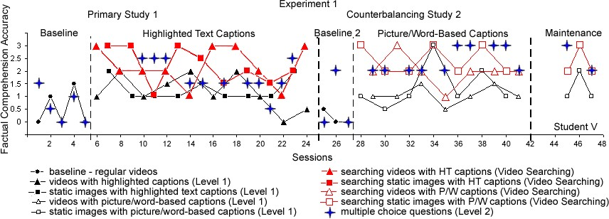
Figure 6. Example of graphic representation of data across all questioning levels for one study participant.

For purposes of presentation clarity, the data for student‟s original oral responses (Level 1) and oral responses after searching the videos for answers (oral Video Searching level) were separated into two separate graphs (Figure 7a and 7b). As a result, both graphs shared the same baseline data but included only oral Level 1 responses (see Figure 7a) or only oral Video Searching responses (see Figure 7b) in treatment phases. The visual inspection of the results always followed the order from the initial baseline Phase I to the first treatment Phase II with oral Level 1 responses as in Figure 7a, and then to the first treatment Phase II with oral Video Searching responses as in Figure 7b. Thus, the results in the primary study were established for the original videos to captioned videos, and then to interactive captioned videos. Furthermore, the results of the counterbalancing study were reported as a progression from the second baseline Phase III to the second treatment Phase IV with oral Level 1 responses as in Figure 7a, and then to the second treatment Phase IV with oral Videos Searching responses as in Figure 7b.
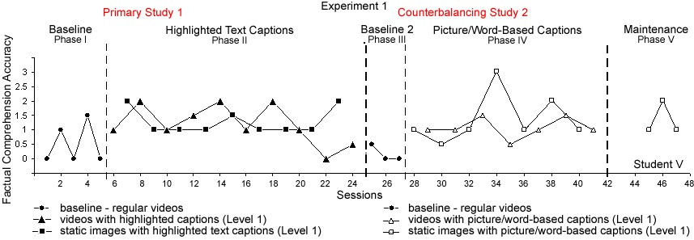
Figure 7a. Example of graphic representation of data for oral Level 1 responses for one study participant with the same baseline data as in Figure 7b.

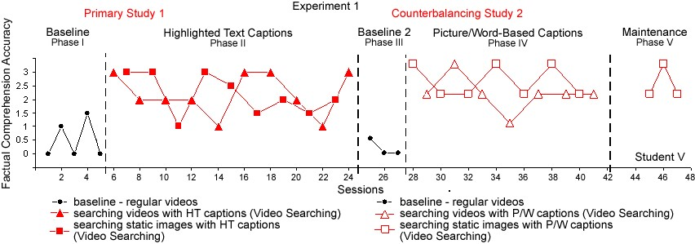
Figure 7b. Example of graphic representation of data for oral Video Searching responses for one study participant with the same baseline data as in Figure 7a.

Separate graphs are similarly presented for all study participants in both Experiment 1 and Experiment 2 throughout the chapter to avoid the confusion of data as presented in Figure 6. Furthermore, later in the chapter when the results are discussed based on the participants‟ responses in a multiple choice format (Level 2 questions); the multiple choice data is added to the oral Video Searching graph and is displayed as in Figure 8.

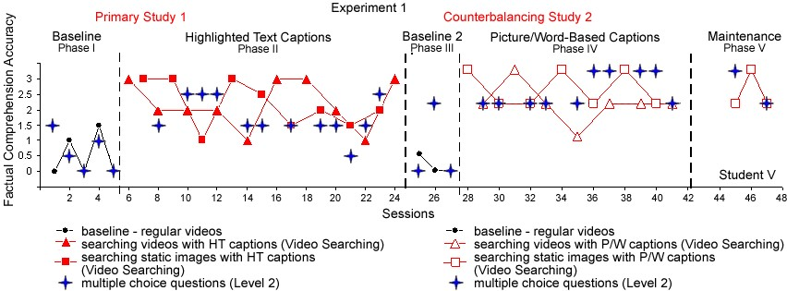
Figure 8. Example of graphic representation of data for multiple choice Level 2 responses for one study participant.

Adapted and Interactive Videos and Content Comprehension This section combines the results for the research questions 1 and 2: “Do alternative narration and captioning adaptations impact video content comprehension by students with intellectual disabilities?” and “Do students with intellectual disabilities further improve video content comprehension after prompted interactive video searching for answers?” respectively. In order to determine the overall effectiveness of adapted and interactive videos, the accuracy of students‟ oral responses to 3 factual and 3 inferential comprehension questions were analyzed in two treatment phases (Phases II and IV) directly after viewing the video enhanced with captioning adaptations (oral Level 1 questions) and after interactive searching of that adapted video for answers (oral Video Searching level) as compared to the oral responses in two corresponding baselines. All participants displayed relative increase in the number of correct responses after videos were enhanced with alternative narration and various captions. Both factual and inferential comprehension further improved after the participants had an opportunity to search the video for answers in response to the researcher‟s prompting. The results in this section are discussed separately for factual and inferential comprehension measures, as well as separately for 5 participants randomly assigned to Experiment 1 (Students V, N,
G, C, and K) and 6 participants in Experiment 2 (Students J, L, A, R, T, and E).
Factual Comprehension: Experiment 1
Despite the variability in the individual responses to intervention, discussed in detail below, all participants in Experiment 1 demonstrated an improved factual comprehension of video content based on their oral responses (Level 1 questions) when videos were adapted with alterative narration and various captions.
Primary study: oral Level 1 responses. There was a detectable increase through visual inspection in the mean lines from the initial baseline (Phase I) to the first treatment (Phase II) for all 5 participants (Figure 9a), as they viewed videos adapted with alternative narration and highlighted text captioning. The level increase for Student K was more than by 1 point on a 3-point scale, while Students V, N, G, and C improved by at least 0.5 point on average (see Table 7 on p. 203). However, due to elevated data points during several of baseline sessions, the first treatment data point for all 5 participants always overlapped with the baseline points indicating the lack of the immediacy of effect. The high variability of data also determined the low percent of nonoverlapping data (PND = 36.6%) between the initial baseline (Phase I) and the first treatment (Phase II), based on students‟ oral Level 1 responses averaged for all the participants in Experiment 1 (Figure 9a).
Primary study: oral Video Searching responses. A more significant increase in the mean lines was observed when students‟ responses in the baseline were compared to their oral responses after searching the video for answers (Video Searching level; Figure 9b). In addition to the visually obvious increase in the mean lines for all participants, Students V, N, C, and K demonstrated an immediate change when the first data point in the treatment Phase II did not overlap with the initial baseline (Phase I). While Student G did not demonstrate an immediate change, he was able to answer correctly on average
1.66 factual questions more after video searching as compared to his baseline responses. The significance of interactive video searching effectiveness was reflected in 86% PND score between Phase I and Phase II in Figure 9b averaged for all the participants in Experiment 1.
Counterbalancing study: oral Level 1 responses. Continuing, the level of accuracy of students‟ responses decreased to the initial baseline level when the intervention was withdrawn in the counterbalancing baseline, Phase III. This established a clear functional relation in the treatment design. In fact, more stability was noted in the second baseline and the averaged number of correct responses was 66%, 100%, and 43%, lower than in the initial baseline for Students V, N, and G respectively (Phase III; Figure
9a).
The positive outcomes of adapted videos on the participants‟ factual comprehension (oral Level 1 question) were reinstated during the counterbalancing treatment, where alternative narration and picture/word-based captioning were introduced (Phase III in Figure 9a). The analysis of data between the second baseline (Phase III) and the second treatment (Phase IV) confirmed the obvious immediacy of treatment effect for
Students V, N, G, and K along with the significant level change for all 5 participants. However, due to the apparent variability of data, the 54% PND score suggested questionable effectiveness of picture/word-based captioning on the participants‟ oral Level 1 responses in Experiment 1 (see Figure 9a). These results were contravened by the randomization testing results described below, providing valuable information about the true impact of this video adaptation.
Counterbalancing study: oral Video Searching responses. More substantial and visually significant changes in the number of correct responses were achieved by each student in the second treatment (Phase IV; Figure 9b) as compared to the second baseline (Phase III) after they searched the video for answers (oral Video Searching level) with 89% PND across the participants (see Figure 9b). The effectiveness of video searching intervention in this phase is also supported by the randomization tests described below.
The increased mean levels were sustained on both questioning levels (oral Level 1 and oral Video Searching level), as participants entered the maintenance phase. Figures
9a and 9b illustrate the changes in factual comprehension performance for participants in Experiment 1 based on their oral Level 1 responses (9a) and oral Video Searching responses (9b) across both baselines, both treatments, and maintenance phases.

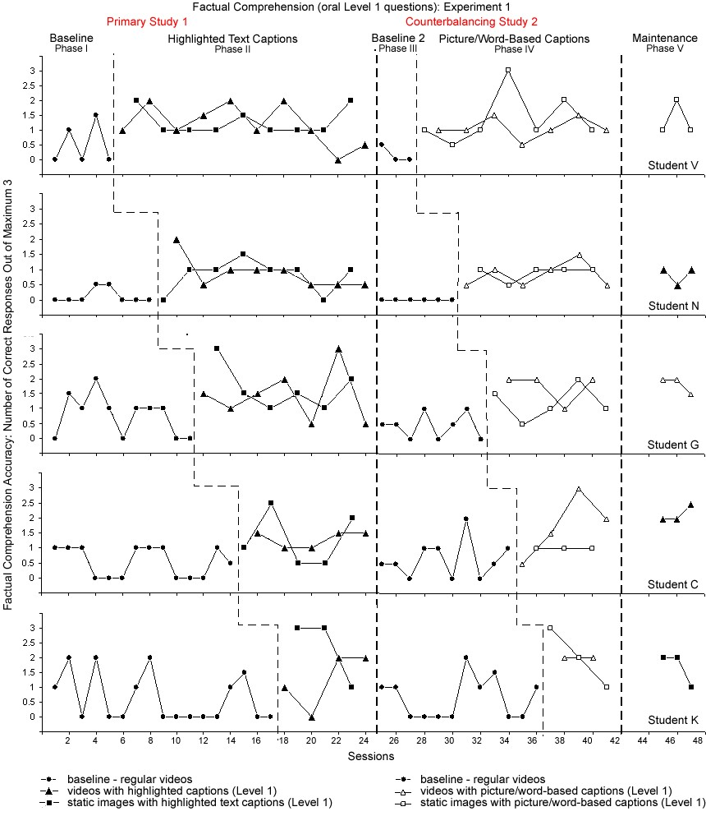

Figure 9a. Accuracy of oral Level 1 responses to factual comprehension questions by students in Experiment 1 across the research phases.
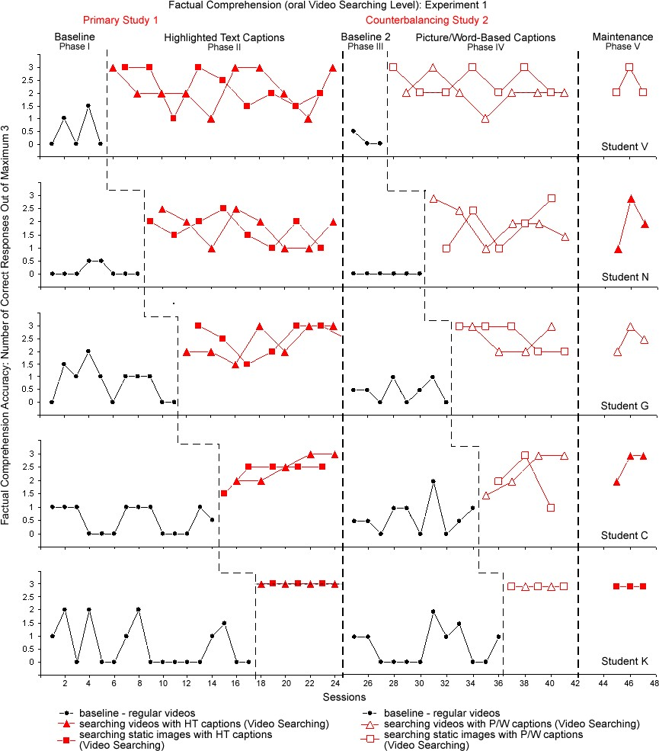

Figure 9b. Accuracy of oral Video Searching responses to factual comprehension questions by students in Experiment 1 across the research phases.

Approximated multiple baseline randomizations test, used in this study for the comparative purposes only, confirm and further clarify the visual analysis results.
According to the Todman and Dugard‟s (2001) Design 3 (AB Multiple Baseline) test, the prediction that factual comprehension of video content as measured by oral Level 1 responses across all students in Experiment 1 would increase after viewing captioned videos (Phase II) as compared to regular videos (Phase I), the proportion of 2000 randomly sampled data divisions giving the accuracy difference in the predicted direction at least as large as the experimentally obtained difference was 0.0005. Therefore, the obtained difference between factual comprehension accuracy after viewing regular videos and videos adapted with alternative narration and highlighted text captions (oral Level 1) was statistically significant (p < 0.05; one-tailed).
Similarly, the obtained differences in the accuracy of participants‟ oral responses to factual comprehension questions in Experiment 1 between various phases were all statistically significant (p < 0.05; one-tailed) as summarized in Table 6.
Thus, all adaptive video features, including alternative narration with highlighted text captions and picture/word-based captions, as well as interactive video searching were statistically significant for improving factual comprehension of video content for at least one of the participants in Experiment 1 as measured by the accuracy of students‟ oral responses (oral Level 1 and oral Videos Searching level). Overall, despite low PND scores for some participants in Figure 9a, visual inspection of data mean levels (Table 7) supported by the results of the randomization tests suggests that both captioning and video searching interventions were effective for all of the participants in Experiment 1.
Table 6
Summary of Randomization Tests for Factual Comprehension Accuracy in Experiment 1
Factual Comprehension Accuracy Between: Proportion of 2000 One-tailed data divisions probability
Regular videos and videos with HT captions  (Oral Level 1 questions: Phases I-II in Figure 9a) | 0.0005 | p < 0.05
Regular videos and videos with HT captions  (Oral Video Searching: Phases I-II in Figure 9b) | 0.0005 | p < 0.05
Regular videos and videos with P/W captions (Oral Level 1: Phases III-IV in Figure 9a) | 0.0005 | p < 0.05
Regular videos and videos with P/W captions  (Oral Video Searching: Phases III-IV in Figure 9b) | 0.0005 | p < 0.05

Individual factual comprehension results for participants in Experiment 1. The nature of Design 3 (AB Multiple Baseline) randomization test does not allow any inference about the improved performance of any specific student that was affected by the treatment. Thus, it is imperative to conduct visual and statistical analysis of data for each individual student (Todman & Dugard, 2001). The data on factual comprehension across all study phases for individual students in Experiment 1 is summarized in Table 7. The mean, standard deviation, and PND values are combined and averaged for different video formats (motion videos and static images) in each of the treatment phase in order to determine the effectiveness of adapted videos in general, without the specification of the alternating treatment.
Table 7

Means, Standard Deviations, and PND Scores for Factual Comprehension Accuracy Measured by 3 Oral Factual Questions in Experiment 1
Participant |  | Primary Study |  | Counterbalancing Study
 | Baseline  Phase I | HT  Captions  Phase II | Video  Searching Phase II | Baseline  Phase III | P/W  Captions  Phase IV | Video  Searching  Phase IV
Student V  M_{c}(SD_{c})  PND_{c}  Student N  M_{c}(SD_{c})  PND_{c}  Student G  M_{c}(SD_{c})  PND_{c}  Student C  M_{c}(SD_{c})  PND_{c}  Student K  M_{c}(SD_{c})  PND_{c} | 0.5 (0.7)  0.13 (0.2)  0.77 (0.7)  0.54 (0.5)  0.62 (0.8) | 1.24 (0.6)  26%  0.84 (0.5)  63%  1.54 (0.8)  15%  1.3 (0.6)  50%  1.71 (1.1)  29% | 2.18 (0.8)  74%  1.72 (0.6)  100%  2.43 (0.6)  54%  2.4 (0.5)  100%  3 (0)  100% | 0.17 (0.3)  - (0)  0.44 (0.4)  0.65 (0.6)  0.63 (0.7) | 1.21 (0.6)  86%  0.86 (0.3)  100%  1.44 (0.5)  56%  1.43 (0.8)  14%  2 (0.7)  20% | 2.21 (0.6)  100%  1.95 (0.8)  100%  2.56 (0.5)  100%  2.21 (0.8)  43%  3 (0)  100%
Note: M_{c} (SD_{c}) = Means and standard deviations combined for all data points in each phase; PND_{c} = Percents of non-overlapping data combined for all data points in each phase.

Student V. Over the initial baseline (Phase I), Student V was able to answer on average 0.5 (SD = 0.71) of 3 factual questions correctly. Following the introduction of videos adapted with alternative narration and highlighted text captioning in Phase II, Student‟s V averaged number of correct oral Level 1 responses approximately doubled to more than 1 (M = 1.24, SD = 0.56), exhibiting a considerable change from 17% to 41% of accuracy between Phases I and II (Figure 9a). The addition of interactive video searching features resulted in further gradual improvement enabling Student V to answer on average more than 2 (M = 2.18, SD = 0.75) out of 3 questions correctly (Video Searching level), and thus increasing from 17% to 73% of correct responses (Phase II in Figure 9b) as compared to the initial baseline in Phase I.
In the counterbalancing study, the accuracy of Student‟s V Level 1 responses systematically increased from the baseline measure of 0.17 (SD = 0.29) out of 3 correct responses in Phase III to more than 1 (M = 1.21, SD = 0.64) in Phase IV, following the introduction of videos with alternative narration and picture/word-based captioning. After having an opportunity to search the adapted videos for answers, Student‟s V performance on factual comprehension accelerated to the average of more than 2 (M = 2.21, SD =
0.58) of 3 correct responses. Thus, Student V went from 6% to 40% (oral Level 1; Phase IV in Figure 9a) and to 74% (oral Video Searching level; Phase IV in Figure 9b) of accuracy in the counterbalancing study. Overall, Student V performed slightly better with the picture/word-based captions in Phase IV but only due to the lower accuracy measures in the baseline Phase III.
The maintenance was implemented 5 days after the completion of the second treatment phase (Phase IV) for all the participants. Student V viewed videos adapted with alternative narration and picture/word-based captions in the maintenance phase. As a result, Student V maintained factual comprehension of video content averaged at more than 1 of 3 correct oral Level 1 responses (M = 1.33, SD = 0.58) and subsequently increased to more than 2 of 3 correct oral responses (M = 2.33, SD = 0.58) after interactive searching the video for answers.
Despite the increased mean levels in treatments and maintenance phases, the data for Student V demonstrated high variability. The PND scores for the accuracy of oral responses to factual comprehension questions for Student V were as follows: 26% between the initial baseline (Phase I) and highlighted text captions in Phase II (see Figure 9a); 74% between the initial baseline (Phase I) and searching the adapted videos in Phase II (see Figure 9b); 86% between the second baseline (Phase III) and picture/word-based captions in Phase IV (see Figure 9a); and 100% between the second baseline (Phase III) and interactive video searching in Phase IV (see Figure 9b). Similar data for other participants as displayed in Figures 9a and 9b are summarized in the following format.
Student N. Student N increased from the averaged 0.1 (M = 0.13, SD = 0.23) correct oral responses in the initial baseline Phase I to almost 1 of 3 correct oral response
(M = 0.84, SD = 0.51; PND = 63%) after viewing videos with highlighted text captions in
Phase II (oral Level 1 questions), and then to almost 2 of 3 correct oral responses (M =
1.72, SD = 0.58; PND = 100%) after searching the video for answers (oral Video
Searching level). Thus, Student‟s N accuracy rose from 4% to 28% (Level 1) and then to 57% (Video Searching level). In the counterbalancing study, Student N progressed from no correct responses (M = 0, SD = 0) in the second baseline (Phase III) to almost 1 of 3 correct oral Level 1 response on average (M = 0.86, SD = 0.32; PND = 100%), when videos were enhanced with picture/word-based captions (Phase IV). After active video searching, Student N was able to orally answer almost 2 of 3 factual comprehension questions correctly (M = 1.95, SD = 0.76; PND = 100%). Thus, the increase in Student‟s N accuracy in the counterbalancing study went from 0% to 29% (Level 1) and then to 65% (Video Searching level). Overall, Student N performed only slightly better with picture/word-based captions. During maintenance Phase V, Student N viewed videos with highlighted text captions answering correctly on average almost 1 (M = 0.83, SD = 0.29) of 3 oral Level 1 factual question and 2 of 3 (SD = 1) oral questions after interactive video searching, thus maintaining consistent gains.
Student G. Student G increased from almost 1 (M = 0.77, SD = 0.68) of 3 correct oral response on average in the initial baseline Phase I to more than 1.5 correct oral responses (M = 1.54, SD = 0.80; PND = 15%) after viewing videos with highlighted text captions in Phase II (oral Level 1 questions), and then to almost 2.5 of 3 correct oral responses (M = 2.43, SD = 0.58; PND = 54%) after searching the video for answers (oral
Video Searching level). Thus, Student‟s G accuracy increased from 26% to 51% (Level 1) and then to 81% (Video Searching level). In the counterbalancing study, Student G progressed from less than 0.5 correct responses (M = 0.44, SD = 0.42) in the second baseline (Phase III) to almost 1.5 of 3 correct oral Level 1 responses on average (M = 1.44, SD = 0.54; PND = 56%), when videos were enhanced with picture/word-based captions (Phase IV). After active video searching, Student G was able to orally answer more than 2.5 of 3 factual comprehension questions correctly (M = 2.56, SD = 0.53; PND
= 100%). Thus, Student‟s G accuracy in the counterbalancing study rose from 15% to
48% (Level 1) and to 85% (Video Searching level). Overall, Student G performed only slightly better with picture/word-based captions. During maintenance Phase V, Student G viewed videos with picture/word-based captions answering correctly on average almost 2 (M = 1.83, SD = 0.29) of 3 oral Level 1 factual question and 2.5 (SD = 0.5) of 3 oral questions after interactive video searching, thus maintaining consistent gains.
Student C. Student C increased from the averaged more than 0.5 (M = 0.54, SD = 0.63) of 3 correct oral responses in the initial baseline Phase I to almost 1.5 of 3 correct oral response (M = 1.3, SD = 0.63; PND = 50%) after viewing videos with highlighted text captions in Phase II (oral Level 1 questions), and then to almost 2.5 correct oral responses (M = 2.4, SD = 0.46; PND = 100%) after searching the video for answers (oral
Video Searching level). Thus, Student‟s C accuracy accelerated from 18% to 43% (Level 1) and then to 80% (Video Searching level). In the counterbalancing study, Student C changed from more than 0.5 correct responses (M = 0.65, SD = 0.63) in the second baseline (Phase III) to almost 1.5 of 3 correct oral Level 1 responses on average (M = 1.43, SD = 0.84; PND = 14%), when videos were enhanced with picture/word-based captions (Phase IV). After active video searching, Student C was able to answer more than 2 of 3 oral factual comprehension questions correctly (M = 2.21, SD = 0.81; PND =
43%). Thus, Student‟s C accuracy in the counterbalancing study went from 22% to 48% (Level 1) and to 74% (Video Searching level). Overall, Student C performed slightly better with highlighted text captions. During maintenance Phase V, Student C viewed videos with highlighted text captions answering correctly on average more than 2 (M = 2.17, SD = 0.29) of 3 oral Level 1 factual question and more than 2.5 (M = 2.67, SD =
0.58) of 3 oral questions after interactive video searching, thus indicating greater gains as compared to the study.
Student K. Student K improved from the averaged 0.62 (SD = 0.82) correct oral responses in the initial baseline Phase I to almost 2 of 3 correct oral responses (M = 1.71, SD = 1.11; PND = 29%) after viewing videos with highlighted text captions in Phase II
(oral Level 1 questions), and then to the maximum average of 3 correct oral responses
(SD = 0; PND = 100%) after searching the video for answers (oral Video Searching level).
Thus, Student‟s K accuracy increased from 21% to 57% (Level 1) and then to 100% (Video Searching level). In the counterbalancing study, Student K went from similar more than 0.5 correct responses (M = 0.63, SD = 0.71) in the second baseline (Phase III) to almost 2 of 3 correct oral Level 1 responses on average (M = 1.67, SD = 0.58; PND = 20%), when videos were enhanced with picture/word-based captions (Phase IV). After active video searching, Student K was once again able to orally answer the maximum 3 factual comprehension questions correctly (SD = 0; PND = 100%). Thus, the increase in
Student‟s K accuracy in the counterbalancing study rose from 21% to 67% (Level 1) and to 100% (Video Searching level). Overall, Student K performed equally well with both highlighted text and picture/word-based captions. During maintenance Phase V, Student K chose to view videos with highlighted text captions answering correctly on average almost 2 (M = 1.67, SD = 0.58) of 3 oral Level 1 factual question and the maximum criterion of 3 (SD = 0) oral questions after interactive video searching, thus sustaining consistent gains.
Factual Comprehension: Experiment 2
Like participants in Experiment 1, students in Experiment 2 participated in the initial baseline (Phase I), the first captioning treatment (Phase II), the second baseline (Phase III), and the reversed captioning treatment (Phase IV), followed by the maintenance (Phase V). The only difference was that participants in Experiment 2 were introduced to videos with alternative narration and picture/word-based captioning in the first treatment (Phase II), while videos adapted with highlighted text captions were viewed in the second counterbalancing treatment in Phase IV.
Primary study: oral Level 1 responses. Based on the visual inspection, participants in Experiment 2 showed a relative increase in factual comprehension of video contend based on their oral Level 1 responses (Phase II; Figure 10a), although gains were not as obvious as in Experiment 1. Students J, L, and A increased by less than 0.5 point on a 3-point scale, while Students T and E progressed by more than 1 point with the adapted videos in Phase II (oral Level 1). Overall, participants in Experiment 2 exhibited high variability of data with the mean PND of 14% that complicated the visual analysis (see Figure 10a).
Primary study: oral Video Searching responses. However, just like in Experiment 1, both significant changes in mean lines and immediacy of effect were evident from the visual inspection of data between the initial baseline (Phase I) and the oral Video Searching responses in Phase II (see Figure 10b). In fact, interactive searching of videos adapted with picture/word-based captioning was found to be very effective for Students J and R (PND = 95% and 90% respectively) and effective for Students L, T, and E (PND = 75%, 71%, and 75% respectively). PND score for Student A (46%) was suppressed by one elevated baseline data point (Session 3; Figure 10b).
Counterbalancing study: oral Level 1 responses. The deceleration of accuracy means in the counterbalancing baseline (Phase III) in Experiment 2 was less dramatic than in Experiment 1. However, the mean level in Phase III returned to the initial baseline level or was lower than in Phase I for all participants, except Students A and R, who demonstrated slight increase in the second baseline (Phase III). The accuracy mean lines increased significantly based on the oral Level 1 responses when the reversed treatments, videos with highlighted text captions, were introduced in Phase IV (Figure 10a). Obvious level change was corroborated by the immediacy of effect for Students J, L, T, and E, who also showed 90-100% PND between Phases III and IV (oral Level 1). The overall PND score was hindered by the performances of Student A and R, who demonstrated 0% and 14% PND respectively due to a few elevated data points in Phase III (see Figure 10a).
Counterbalancing study: oral Video Searching responses. The factual comprehension further improved when students had an opportunity to search the video for answers in Phase IV (Figure 10b). Students J, L, T, and E demonstrated 100% PND after searching videos with highlighted text captions. Moreover, Students T and E reached the maximum of 3 (SD = 0) points eliciting all correct oral responses in the Video Searching level (see Figure 10b).
The increased mean levels were sustained as the participants entered the maintenance phase. Figures 10a and 10b illustrate the changes in the factual comprehension performance for participants in Experiment 2 based on Level 1 responses (10a) and Video Searching responses (10b) across both baselines, both treatments, and maintenance phases.
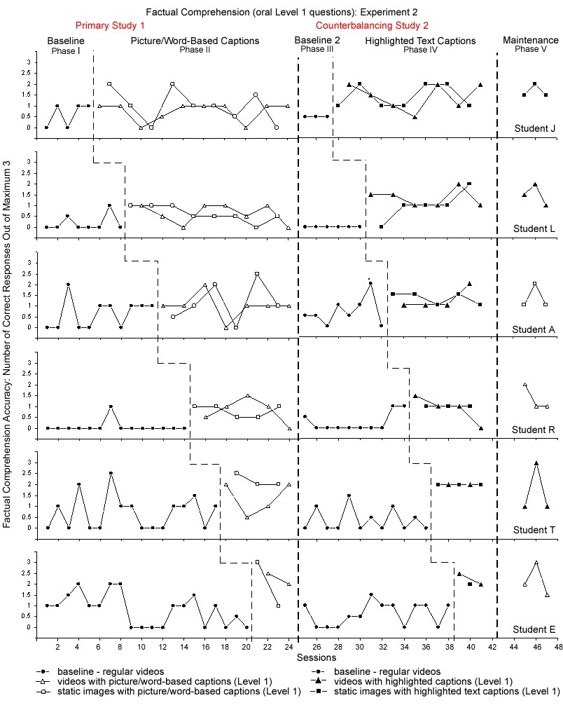
Figure 10a. Accuracy of oral Level 1 responses to factual comprehension questions by students in Experiment 2 across the research phases.
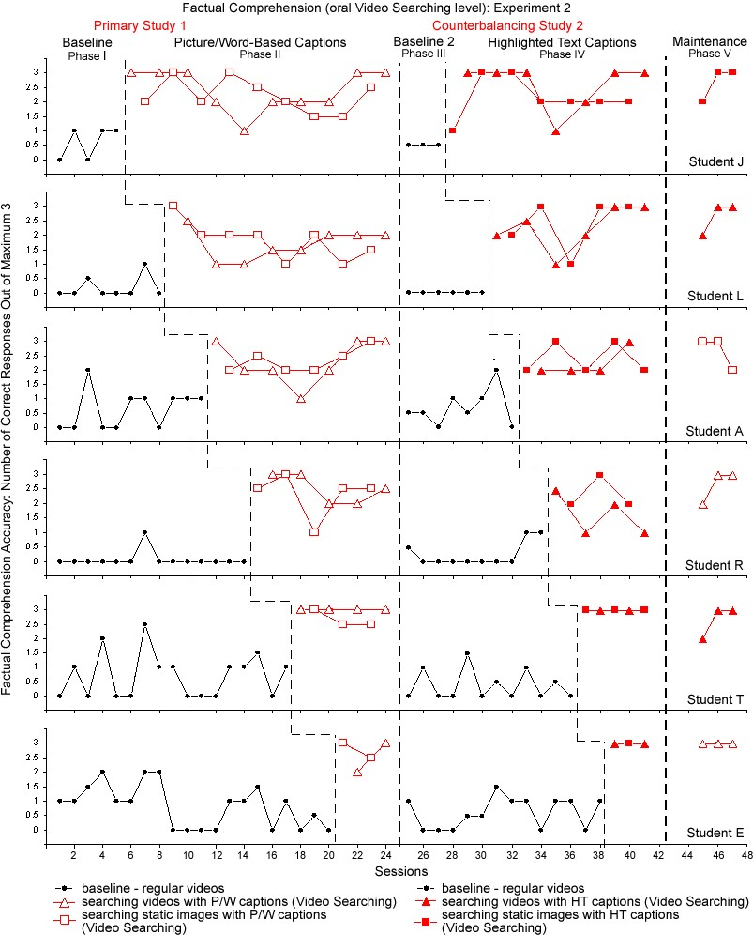
Figure 10b. Accuracy of oral Video Searching responses to factual comprehension questions by students in Experiment 2 across the research phases.
In a randomization test of the prediction that the summed accuracy of factual comprehension of video content by all Experiment 2 participants would increase after being exposed to (a) videos with picture/word-based captions (oral Level 1 questions in Phase II; Figure 10a); (b) interactive searching of videos with picture/word-based captions (oral Video Searching level in Phase II; Figure 10b); (c) videos with highlighted text captions (oral Level 1 questions in Phase IV; Figure 10a); and (d) interactive searching of videos with highlighted text captions (oral Video Searching level in Phase IV; Figure 10b), the proportion of 2000 randomly sampled data divisions giving combined accuracy differences in the predicted direction at least as large as the experimentally obtained difference was 0.0005 in each of four aforementioned conditions. Therefore, the obtained difference (a) between regular videos in the initial baseline and videos adapted with picture/word-based captions; (b) between regular videos in the initial baseline and adapted videos allowing searching for answers; (c) between regular videos in the second baseline and counterbalancing videos with highlighted captions; and (d) between regular videos in the second baseline and adapted counterbalancing videos allowing searching for answers were all statistically significant (p < 0.01; one-tailed). Thus, despite inconclusive visual analysis, all adaptive and interactive video treatments significantly improved factual comprehension of video content based on students‟ oral responses for at least one of the participants in Experiment 2. The individual data on factual comprehension across all study phases for students in Experiment 2 is presented in Table 8.

Table 8
Means, Standard Deviations, and PND scores for Factual Comprehension Accuracy
Measured by 3 Oral Factual Questions in Experiment 2
Participant |  | Primary Study |  | Counterbalancing Study
 | Baseline  Phase I | P/W  Captions  Phase II | Video  Searching Phase II | Baseline  Phase III | HT  Captions  Phase IV | Video  Searching  Phase IV
Student J  M_{c}(SD_{c})  PND_{c}  Student L  M_{c}(SD_{c})  PND_{c}  Student A  M_{c}(SD_{c})  PND_{c}  Student R  M_{c}(SD_{c})  PND_{c}  Student T M_{c}(SD_{c}) PNDc  Student E  M_{c}(SD_{c}) PND_{c} | 0.6 (0.6)  0.19 (0.4)  0.64 (0.7)  0.07 (0.3)  0.71 (0.8)  0.83 (0.7) | 0.87 (0.6)  16%  0.62 (0.4)  0%  1.08 (0.7)  8%  0.8 (0.4)  10%  1.71 (0.7)  0%  2.13 (0.9)  50% | 2.32 (0.6)  95%  1.75 (0.6)  75%  2.31 (0.6)  46%  2.4 (0.6)  90%  2.86 (0.2)  71%  2.62 (0.5)  75% | 0.5 (0)  - (0)  0.69 (0.7)  0.25 (0.4)  0.38 (0.5)  0.61 (0.5) | 1.43 (0.6)  93%  1.18 (0.6)  91%  1.28 (1.4)  0%  0.93 (0.5)  14%  - (0)  100%  2.17 (0.3)  100% | 2.36 (0.7)  100%  2.32 (0.8)  100%  2.33 (0.5)  33%  1.93 (0.7)  71%  3 (0)  100%  3 (0)  100%
Note: M_{c} (SD_{c}) = Means and standard deviations combined for all data points in each phase; PND_{c} = Percents of non-overlapping data combined for all data points in each phase.

Thus, based on approximation of randomization tests and visual inspection of data
means, captioned videos were relatively effective for at least 4 out of 6 participants in the primary study (except Student J and A; Figure 10a) and for at least 4 out of 6 participants in the counterbalancing study (except Student A and R). The low PND scores can be explained by sporadic elevated points in participants‟ baselines. Again, despite low PND scores for some participants in Figure 10b, visual inspection of mean values suggests that video searching intervention was in fact effective for all of the participants.
Individual factual comprehension results for participants in Experiment 2. The visual inspection and statistical analysis of improved factual comprehension as measured by oral responses for each of the participants in Experiment 2 is as follows.
Student J. Student J exhibited an increase from the averaged 0.6 (SD = 0.55) correct oral responses in the initial baseline Phase I to almost 1 of 3 correct oral response (M = 0.87, SD = 0.60; PND = 16%) after viewing videos with picture/word-based captions in Phase II (oral Level 1), and then to almost 2.5 of 3 correct oral responses (M = 2.32, SD = 0.63; PND = 95%) after searching videos for answers (oral Video Searching level). Thus, Student J improved from 20% to 29% (Level 1; Phase II in Figure 10a) and then to 77% (Video Searching level; Phase II in Figure 10b) on factual comprehension accuracy. In the counterbalancing study, Student J went from 0.5 correct oral responses (SD = 0) in the second baseline (Phase III) to almost 1.5 of 3 correct oral Level 1 responses on average (M = 1.43, SD = 0.55; PND = 93%), when videos were enhanced with highlighted text captions (Phase IV). After active video searching, Student J was able to answer almost 2.5 of 3 factual comprehension questions correctly (M = 2.36, SD =
0.74; PND = 100%). Thus, accuracy gains from 17% to 48% (Level 1; Phase IV in Figure 10a) and to 79% (Video Searching level; Phase IV in Figure 10b) were noted for Student J in the counterbalancing study. Overall, Student J performed better with highlighted text captions. During maintenance Phase V, Student J viewed videos with highlighted text captions providing correct answers to almost 2 (M = 1.67, SD = 0.29) of 3 questions on average (oral Level 1) and accelerating to almost 3 (M = 2.67, SD = 0.58) correct oral responses after interactive video searching, thus maintaining level increases.
Student L. Student L demonstrated an increase from the averaged 0.2 (M = 0.19, SD = 0.55) correct oral responses in the initial baseline Phase I to more than 0.5 correct oral responses (M = 0.62, SD = 0.39; PND = 0%) after viewing videos with picture/wordbased captions in Phase II (oral Level 1), and then to almost 2 of 3 correct oral responses (M = 1.75, SD = 0.58; PND = 75%) after searching the video for answers (oral Video
Searching level). Thus, Student L improved from 6% to 21% (Level 1) and then to 58% (Video Searching level) on factual comprehension accuracy. In the counterbalancing study, Student L went from no correct responses (M = 0, SD = 0) in the second baseline (Phase III) to more than 1 of 3 correct oral Level 1 responses on average (M = 1.18, SD =
0.56; PND = 91%), when videos were enhanced with highlighted text captions (Phase IV). After active video searching, Student L was able to answer almost 2.5 of 3 factual comprehension questions correctly (M = 2.32, SD = 0.78; PND = 100%). Thus, accuracy gains for Student L in the counterbalancing study rose from 0% to 39% (Level 1) and to 77% (Video Searching level) were noted for Student L. Overall, Student L exhibited most substantial gains with highlighted text captions. During maintenance Phase V, Student L viewed videos with highlighted text captions providing correct answers to averaged 1.5 (SD = 0.5) of 3 oral questions (Level 1) and accelerating to almost 3 (M = 2.67, SD = 0.58) correct oral responses after interactive video searching, thus maintaining gains in counterbalancing study.
Student A. Student A accelerated from the averaged more than 0.5 (M = 0.64, SD = 0.67) correct oral responses in the initial baseline Phase I to more than 1 of 3 correct oral response (M = 1.08, SD = 0.73; PND = 8%) after viewing videos with picture/wordbased captions in Phase II (oral Level 1), and then to almost 2.5 of 3 correct oral responses (M = 2.31, SD = 0.60; PND = 46%) after searching the video for answers (Video Searching level). Thus, Student A improved from 21% to 36% (Level 1) and then to 77% (Video Searching level) on factual comprehension accuracy. In the counterbalancing study, Student A increased from more than 0.5 correct responses (M =
0.69; SD = 0.65) in the second baseline (Phase III) to more than 1 of 3 correct oral Level 1 responses on average (M = 1.28, SD = 1.36; PND = 0%), when videos were enhanced with highlighted text captions (Phase IV). After active video searching, Student A was able to answer almost 2.5 of 3 factual comprehension questions correctly (M = 2.33, SD =
0.5; PND = 33%). Thus, accuracy gains from 23% to 43% (Level 1) and to 78% (Video Searching level) were noted for Student A in the counterbalancing study. Overall,
Student‟s A showed the highest variability hindering the conclusions about the most effective type of captioning. During maintenance Phase V, Student A viewed videos with picture/word-based captions providing correct oral answers to almost 1.5 (M = 1.33, SD = 0.58) of 3 oral questions on average (Level 1) and accelerating to almost 3 (M = 2.67, SD
= 0.58) correct oral responses after interactive video searching, sustaining accuracy gains.
Student R. Student R exhibited an increase from the averaged less than 0.1 (M = 0.07, SD = 0.27) correct oral responses in the initial baseline Phase I to almost 1 of 3 correct oral response (M = 0.8, SD = 0.42; PND = 10%) after viewing videos with picture/word-based captions in Phase II (oral Level 1), and then to almost 2.5 of 3 correct oral responses (M = 2.4, SD = 0.61; PND = 90%) after searching the video for answers (Video Searching level). Thus, Student R went from 2% to 27% (Level 1) and then to 80% (Video Searching level) on factual comprehension accuracy. In the counterbalancing study, Student R accelerated from 0.25 correct responses (SD = 0.42) in the second baseline (Phase III) to almost 1 of 3 correct oral Level 1 response on average (M = 0.93, SD = 0.71; PND = 14%), when videos were enhanced with highlighted text captions (Phase IV). After active video searching, Student R was able to answer almost 2 of 3 oral factual comprehension questions correctly (M = 1.93, SD = 0.71; PND = 71%). Thus,
Student‟s R accuracy in the counterbalancing study rose from 8% to 31% (Level 1) and to 64% (Video Searching level). Overall, Student R demonstrated more substantial gains with picture/word-based captions. During maintenance Phase V, Student R viewed videos with picture/word-based captions providing correct answers to almost 1.5 (M = 1.33, SD
= 0.58) of 3 oral questions on average (Level 1) and accelerating to almost 2.5 (M = 2.33, SD = 0.58) of 3 correct oral responses after interactive video searching, further improving factual accuracy.
Student T. Student T increased from the averaged almost 1 (M = 0.71, SD = 0.55) correct oral responses in the initial baseline Phase I to almost 2 of 3 correct oral responses (M = 1.71, SD = 0.70; PND = 0%) after viewing videos with picture/word-based captions in Phase II (oral Level 1), and then to almost 3 correct oral responses (M = 2.86, SD =
0.24; PND = 71%) after searching the video for answers (Video Searching level). Thus, Student T improved from 24% to 57% (Level 1) and then to 95% (Video Searching level) on factual comprehension accuracy. In the counterbalancing study, Student T went from less than 0.5 correct responses (M = 0.38, SD = 0.53) in the second baseline (Phase III) to averaged 2 of 3 correct oral Level 1 responses (SD = 0; PND = 100%), when videos were enhanced with highlighted text captions (Phase IV). After active video searching, Student T was able to answer on average 3 factual comprehension questions correctly (SD = 0;
PND = 100%), reaching the criterion ceiling. Thus, accuracy gains from 13% to 67% (Level 1) and then to 100% (Video Searching level) were noted for Student T in the counterbalancing study. Overall, Student T performed substantially better with highlighted text captions. During maintenance Phase V, Student T viewed videos with highlighted text captions providing correct answers to almost 2 (M = 1.67, SD = 1.15) of 3 questions on average (oral Level 1) and rising to almost 3 (M = 2.67, SD = 0.58) oral correct responses after interactive video searching, sustaining the improved performance.
Student E. Student E improved from almost 1 (M = 0.83, SD = 0.73) correct oral response on average in the initial baseline Phase I to more than 2 of 3 correct oral responses (M = 2.13, SD = 0.85; PND = 50%) after viewing videos with picture/wordbased captions in Phase II (oral Level 1), and then to more than 2.5 of 3 correct oral responses (M = 2.62, SD = 0.48; PND = 75%) after searching the video for answers (Video Searching level). Thus, Student E increased from 28% to 71% (Level 1) and then to 87% (Video Searching level) on factual comprehension accuracy. In the counterbalancing study, Student E rose from approximately 0.5 correct responses (M =
0.61, SD = 0.53) in the second baseline (Phase III) to more than 2 of 3 correct oral Level 1 responses on average (M = 2.17, SD = 0.29; PND = 100%), when videos were enhanced with highlighted text captions (Phase IV). After active video searching, Student E was able to answer the maximum 3 oral factual comprehension questions correctly (SD
= 0; PND = 100%). Thus, Student‟s E accuracy increased from 20% to 72% (Level 1) and to 100% (Video Searching level) in the counterbalancing study. Overall, Student E performed slightly better with highlighted text captions. During maintenance Phase V, Student E viewed videos with picture/word-based captions providing correct answers to more than 2 (M = 1.67, SD = 0.29) of 3 questions on average (oral Level 1) and reaching the maximum of 3 (SD = 0) correct oral responses after interactive video searching, maintaining level increases.
Factual Comprehension Based on Multiple Choice Responses
In order to provide more opportunities for demonstrating factual comprehension of video content, each question that a participant answered partially correctly, incorrectly, or did not answer during oral Level 1 and oral Video Searching questioning levels was re-asked in a multiple choice format (Level 2 questions). To display how multiple choice responses enhanced overall students‟ performance on factual comprehension, additional data points were plotted on the graphs previously used in this chapter (Figures 9b and 10b). The analysis of multiple choice Level 2 responses was rooted in the visual analysis and descriptive statistics. The video adaptations were considered to be effective when participants reached the maximum of possible correct responses before entering multiple choice questioning level. Thus, the research phases with lower percentage of multiple choice Level 2 responses represented better participants‟ performance. Furthermore, the percentage of multiple choice Level 2 responses that increased students‟ factual comprehension accuracy to the maximum 3 points also suggested the positive impact of adapted and interactive video features.
Experiment1. Figure 11 illustrates the accuracy of factual comprehension by students in Experiment 1 based on both oral (Video Searching level) and multiple choice (Level 2) responses across all research phases. Based on the visual inspection and descriptive statistics, participants in Experiment 1 were required to answer multiple choice (Level 2) questions in 100% of sessions across two baselines (Phases I and III). That means that none of the students reached the maximum of 3 correct oral factual responses after viewing regular videos. Consequently, only two students (Students G and K) increased the accuracy of their responses to reach the maximum with the help of questions in a multiple choice format (during multiple choice Level 2 questions) in 11% of overall baseline sessions across all the participants in Experiment 1.
When the adapted videos with captioning and interactive searching features were introduced in two treatment phases (Phases II and IV) as well as in maintenance (Phase V), students in Experiment 1 reached the ceiling accuracy with oral Level 1 and Video Searching responses in 49 out of total 126 sessions. Therefore, they were subjected to multiple choice questioning level only in 61% of sessions after viewing adapted videos. Furthermore, in 40% of those sessions they reached the maximum accuracy with the help of multiple choice (Level 2) questions, thus demonstrating the advantage of adapted videos over the regular clips.

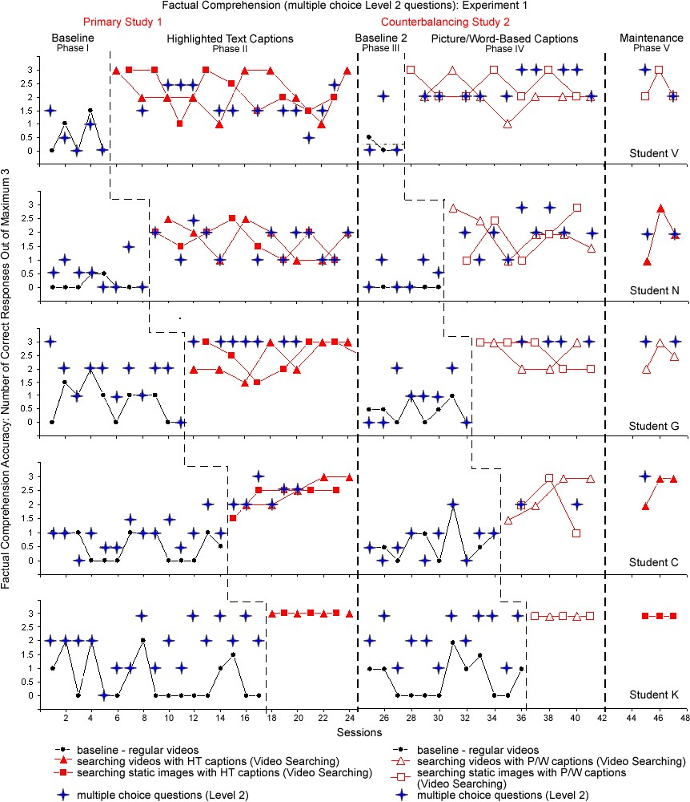
Figure 11. Accuracy of multiple choice Level 2 responses to factual comprehension questions by students in Experiment 1 across the research phases.
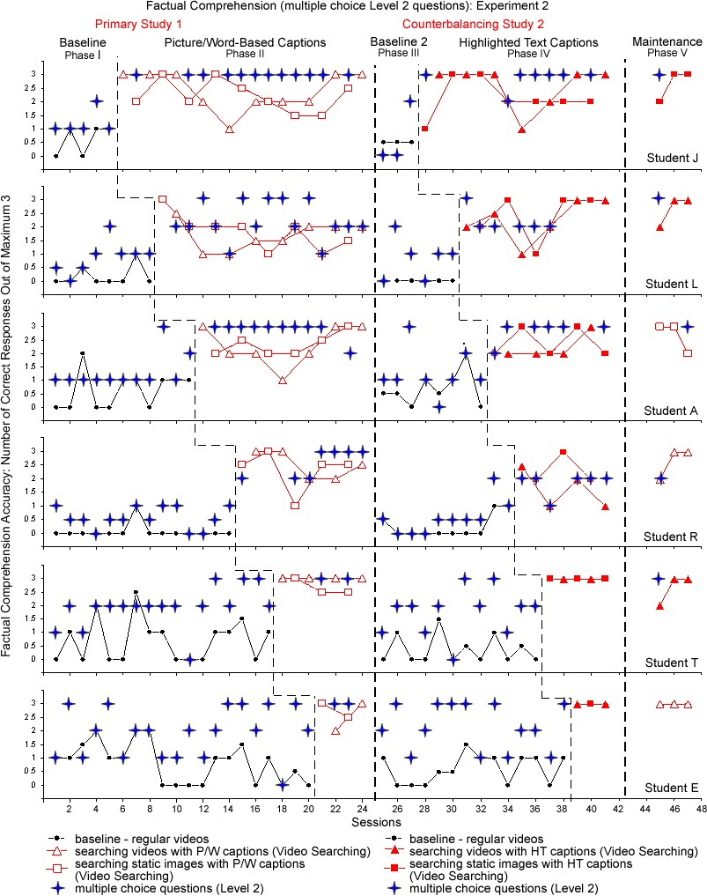
Figure 12. Accuracy of multiple choice Level 2 responses to factual comprehension questions by students in Experiment 2 across the research phases.
Experiment 2. Similar analysis of factual comprehension based on the multiple choice (Level 2) responses for the participants in Experiment 2 was conducted through the visual inspection and descriptive statistics of data presented in Figure 12. As can be seen in Figure 12, participants in Experiment 2 were subjected to proceed to the multiple choice (Level 2) questioning level in 100% of baseline sessions (Phases I and III). As a result, three students (Student A, T, and E) improved their responses to the maximum of 3 points with the help of multiple choice questions in 15% of total baseline sessions.
Consequently, adapted videos across two treatments and maintenance phases (Phases, II, IV, and V) enabled participants to provide all correct oral responses before even entering multiple choice (Level 2) questioning level in 58 out of total 136 sessions. Thus, they were to advance to the multiple choice questions only in 57% of all treatments and maintenance sessions combined. In turn, multiple choice questions enabled all students reach the maximum of 3 correct responses in 68% of those sessions.
Overall, Student K in the Experiment 1, reached the maximum accuracy with adapted videos even before entering multiple choice (Level 2) questioning level in all sessions of treatment (Phases II and IV) and maintenance phases (Figure 11). Students T and E from the Experiment 2 also reached the maximum accuracy of oral responses before entering multiple choice (Level 2) questioning in treatment sessions of the counterbalancing study (Phase IV; Figure 12).
Inferential Comprehension: Experiment 1
The accuracy of students‟ responses to three inferential comprehension questions based on the video content was calculated across various research design phases. The averaged accuracy for each individual student in Experiment 1 is provided in Table 9.

Table 9
Means, Standard Deviations, and PND Scores for Inferential Comprehension Accuracy
Measured by 3 Oral Inferential Questions in Experiment 1
Participant |  | Primary Study |  | Counterbalancing Study
 | Baseline  Phase I | HT  Captions  Phase II | Video  Searching Phase II | Baseline  Phase III | P/W  Captions  Phase IV | Video  Searching  Phase IV
Student V  M_{c}(SD_{c})  PND_{c}  Student N  M_{c}(SD_{c})  PND_{c}  Student G  M_{c}(SD_{c})  PND_{c}  Student C  M_{c}(SD_{c})  PND_{c}  Student K  M_{c}(SD_{c})  PND_{c} | 0.3 (0.3)  0.19 (0.3)  0.41 (0.6)  0.5 (0.7)  0.59 (0.6) | 1.18 (1.0)  68%  0.53 (0.6)  44%  0.92 (0.7)  8%  0.6 (0.7)  0%  1.64 (0.1)  29% | 1.66 (1.0)  89%  1.13 (0.5)  88%  1.92 (0.7)  23%  1.15 (0.6)  0%  2.57 (0.6)  71% | 0.17 (0.3)  0.17 (0.4)  0.38 (0.6)  0.4 (0.5)  0.33 (0.5) | 0.82 (0.5)  64%  0.64 (0.5)  0%  0.94 (0.7)  22%  1.14 (0.6)  43%  2.2 (0.8)  80% | 1.86 (0.7)  100%  1.18 (0.9)  36%  2.28 (0.7)  89%  1.86 (0.7)  71%  2.8 (0.5)  100%
Note: M_{c} (SD_{c}) = Means and standard deviations combined for all data points in each phase; PND_{c} = Percents of non-overlapping data combined for all data points in each phase.

The actual point-by-point data for accuracy of inferential oral Level 1 responses and oral Video Searching responses is Experiment 1 is visually illustrated in Figures 13a and 13b.

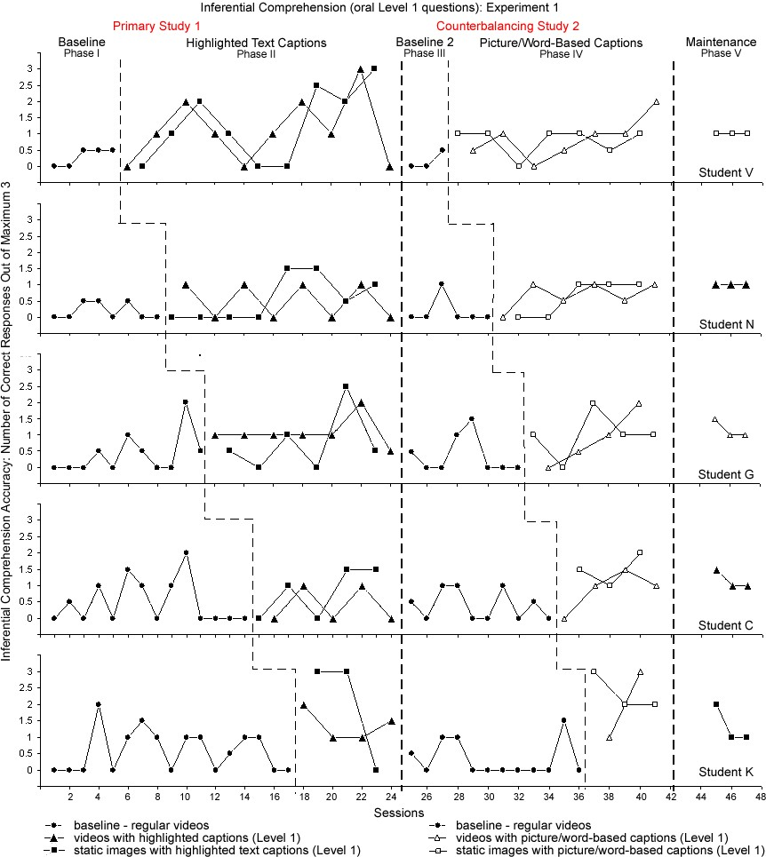
Figure 13a. Accuracy of oral Level 1 responses to inferential comprehension questions by students in Experiment 1 across the research phases.
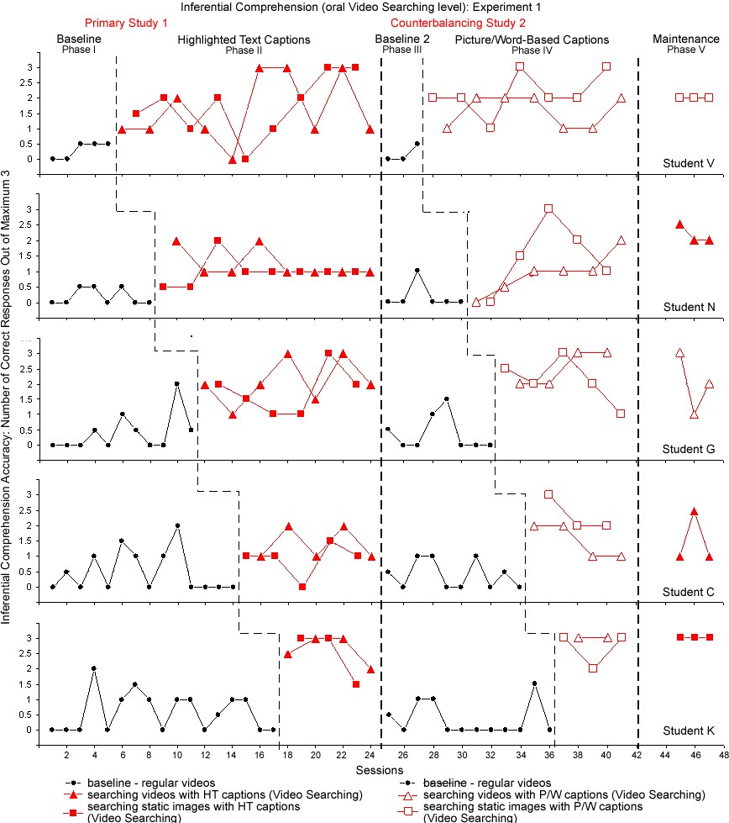
Figure 13b. Accuracy of oral Video Searching responses to inferential comprehension questions by students in Experiment 1 across the research phases.

The visual analysis of the results confirmed that all students in Experiment 1
exhibited a slight increase in the mean number of inferential oral Level 1 questions answered correctly after the introduction of videos with alternative narration and highlighted text captions in the first treatment (Phase II; Figure 13a) and videos with picture/word captioning in the second treatment (Phase IV; Figure 13a). Like in factual comprehension performance, the greatest gains in participants‟ inferential comprehension, as measured by the number of correct oral Video Searching responses, were noted when students had an opportunity to search the video for answers (Figures 13b).
Primary study: oral Level 1 responses. As can be seen in Figure 13a, all the participants demonstrated very low levels of inferential comprehension accuracy during the initial baseline (Phase I). In fact, the averaged baseline level for inferential questions was 38% lower than the averaged factual comprehension performance in the initial baseline Phase I by the same participants (see Figure 9a). During the first treatment (Phase II), the visual inspection indicated a relative change in level by more than 1 correct response on a 3-point scale for Students V and K (M = 1.18, SD = 1.04 and M = 1.64, SD = 0.11 respectively), when they viewed videos with highlighted text captions (oral Level 1; Figure 13a). However, only minimum changes (by 0.5 or less correct responses) were noted for all the remaining students in Experiment 1, especially Student C who improved only by 0.1 point (Figure 13a).
The apparent variability of data within and across participants and phases was relatively high resulting in great overlap between the initial baseline (Phase I) and oral Level 1 responses in the first treatment (Phase II). This was reflected in the averaged 44% of PND. The individual PND scores for the participants in Experiment 1 were: Student V = 68%, Student N = 44%, Student G = 8%, Student C = 0% and Student K = 29% (see Figure 13a).
Primary study: oral Video Searching responses. According to Figure 13b, the addition of interactive video searching features in the primary study (Phase II; Figure
13b) resulted in increased level of correct oral inferential responses for all students in Experiment 1. However, the level acceleration was considerably lower than during the factual oral Video Searching condition (Table 9). Thus, after searching the video Students N and C were able to answer on average more than 1 of 3 oral inferential questions (M = 1.13, SD = 0.47 and M = 1.15, SD = 0.58 respectively); Students V and G improved to almost 2 of 3 correct oral responses (M = 1.66, SD = 1.00 and M = 1.92, SD = 0.73 respectively); and only Student K provided on average more than 2.5 of 3 correct oral responses (M = 2.57, SD = 0.61). The difference between students‟ outcomes on factual and inferential comprehension could also be observed when comparing the accuracy gains for each individual participant. Thus, the percentage of correct oral inferential responses for Student V went from 10% to 39% (oral Level 1; Phase II in Figure 13a) and to 55% (oral Video Searching level; Phase II in Figure 13b); for Student N – from 6% to 18% and to 38%; for Student G – from 14% to 31% and to 64%; for Student C – from 17% to 20% and to 38%; for Student K – from 20% to 55% and to 86%. Supporting the visual analysis, interactive searching of videos adapted with highlighted captions in Phase II was found to be questionably effective according to the 54% averaged PND score. In fact, PND scores for Students G and C suggested ineffectiveness of video searching adaptations (23% and 0% respectively), while relative effectiveness of intervention was noted for Students V, N, and K (PND = 89% , 88%, and 71% respectively).
Counterbalancing study: oral Level 1 responses. The withdrawal of treatment during the second baseline (Phase III) resulted in a steady decrease in the number of oral inferential questions answered correctly. As documented in Table 9, all students in Experiment 1 were able to answer only less than 0.5 of 3 oral questions correctly in the second baseline Phase III. Following the introduction of reversed treatment (Phase IV; Figure 13a), videos with picture/word-based captioning, Students V, N, G, and C accelerated to approximately 1 of 3 correct oral inferential response (Level 1) on average (M_{V} = 0.82, SD_{V} = 0.50; M_{N} = 0.64, SD_{N} = 0.45; M_{G} = 0.94, SD_{G} = 0.73; M_{C} = 1.14, SD_{C}
= 0.63 respectively), while Student K rose to approximately 2 of 3 correct responses (M = 2.2, SD = 0.84). Despite the consistent level of change over the baseline (Phase III), high variability and data overlap in Phase IV (oral Level 1 questions) was still evident for all participants in Experiment 2. As displayed in Figure 13a, the following PND scores were noted for the participants: Student V = 64%, Student N = 0%; Student G = 22%, Student C = 43%, and Student K = 80% (Figure 13a).
Counterbalancing study: oral Video Searching responses. Finally, the number of correct inferential responses approximately doubled from the oral Level 1 responses when the video searching features were added (Figure 13b) in the counterbalancing treatment phase. When comparing students‟ performance after searching the video for answers in Phase IV with the counterbalancing baseline (Phase III), the effectiveness of interactive features became evident. Besides the immediate change in the level with regard to inferential accuracy by approximately 1.5 correct responses, Students V, G, C, and K displayed 100%, 89%, 71%, and 100% PND scores respectively (Figure 13b). The overlapping data for Student N was hindered by one elevated baseline point (Session 27). Therefore, in the counterbalancing study Student V went from 6% to 27% (oral Level 1; Phase IV in Figure 13a) and to 62% (oral Video Searching level; Phase IV in Figure 13b) correct responses; Student N – from 6% to 21%, and to 39%; Student G – from 13% to 31% and to 76%; Student C – from 13% to 38% and to 62%; Student K – from 11% to 73%, and to 93% correct responses. Overall, all participants in Experiment 1 performed slightly better with picture/word-based captions used in the counterbalancing study, while Student N exhibited similar performance with both captioning adaptations. The level changes corresponding to oral Level 1 and oral Video Searching conditions continued during the maintenance phase (Phase V) of the study across all the participants in
Experiment 1 (see Figures 13a and 13b).
Supplementing the visual analysis of highly variable data in all phases across the participants in Experiment 1, randomization tests allowed determining whether the increases in inferential comprehension as measured by oral Level 1 and oral Video Searching responses in all study conditions were statistically significant for at least one of the students. Based on the results demonstrated by an approximated randomization test of the prediction that the number of inferential questions answered correctly by students in Experiment 1 would increase after the introduction of various adaptive and interactive video features, the following conclusions can be made (Table 10). The obtained differences in inferential accuracy between two baseline phases (Phase I and Phase III) and viewing videos adapted with highlighted text captions (Phase II) and picture/wordbased captions (Phase IV) for students in Experiment 1 were not statistically significant. In turn, searching videos adapted with highlighted text and picture/word-based captions were found to be statistically significant for improving inferential comprehension of video content by at least one of the participants in Experiment 1.

Table 10
Summary of Randomization Tests for Inferential Accuracy in Experiment 1
Inferential Comprehension Accuracy Between: | Proportion of 2000 data divisions | One-tailed probability
Regular videos and videos with HT captions  (oral Level 1 questions: Phases I-II in Figure 12a) | 0.3 | p > 0.05
Regular videos and videos with HT captions (oral Video Searching: Phases I-II in Figure 12b) | 0.0005 | p < 0.05
Regular videos and videos with P/W captions  (oral Level 1 questions: Phases III-IV in Figure 12a | 0.067 | p > 0.05
Regular videos and videos with P/W captions  (oral Video Searching: Phases III-IV in Figure 12b) | 0.0005 | p < 0.05

To summarize, according to approximated randomization tests, neither highlighted text nor picture/word-based captions were effective in increasing students‟ inferential comprehension. However, based on the visual analysis of data, Students V and K exhibited modest gains with HT captions in the primary study (Phase II; Figure 13a). Despite 0 PND for Student N, P/W captions seemed to be slightly effective for improving inferential comprehension for at least 3 out of 5 participants in the counterbalancing study (except Student C and G; Phase IV in Figure 13a). In turn, based on the increased means in Table 9 and statistical significance, interactive video searching was effective for all the participants in the primary and counterbalancing studies.
Inferential Comprehension: Experiment 2
The results for the participants in Experiment 2 are as follows.
Primary study: oral Level 1 responses. Like in Experiment 1, a slight increase in accuracy was observed among the participants in Experiment 2 as measured by their oral Level 1 responses to inferential questions from the initial baseline (Phase I) to the first intervention (Phase II; Figure 14a). The immediate change was hindered by the high variability of data and a great percentage of overlapping data between the two phases. PND score averaged at the lowest 8.3%. In fact, the performance of Student A did not show any improvement in the first captioning treatment (Phase II; Figure 14a), when videos with picture/word-based captions were offered as compared to original videos in the initial baseline (Phase I). Student R reached the average of only 0.2 of 3 correct oral responses in Phase II but showed minor improvement as compared to less than 0.1 correct responses in the baseline (Phase I). While Students T and E showed 0% and 25% PND respectively, they went from less than 1 of 3 correct oral response in the baseline to almost 2 of 3 correct oral responses in the first treatment (Student T rose from M (SD) =
0.44 (0.63) to M (SD) = 1.71 (0.39); Student E went from M (SD) = 0.73 (0.77) to M(SD) = 1.75 (0.65); see Table 12). Students J and L improved from baseline to the intervention by about 0.5 points on a 3-point scale, demonstrating 11% and 6% PND respectively (Phase II; Figure 14a). Inferential accuracy in Experiment 2 measured by oral Level 1 (Figure 14a) and oral Video Searching (Figure 14b) responses is illustrated below.
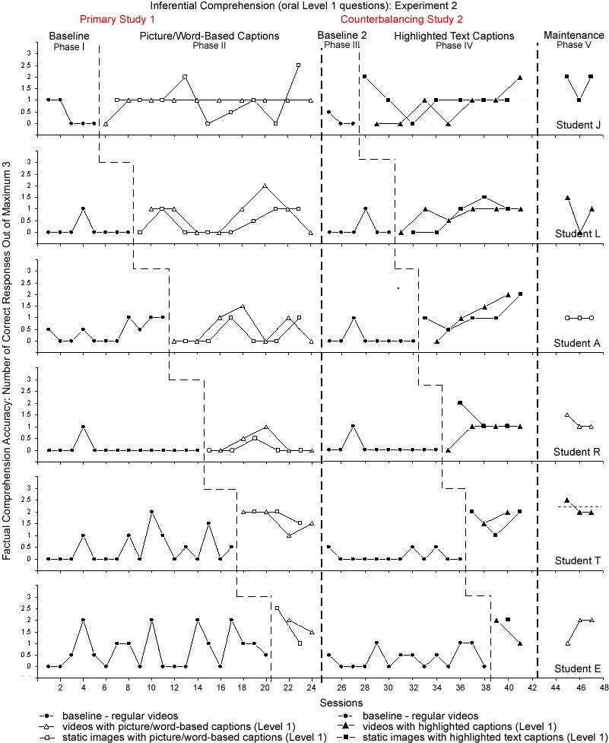

Figure 14a. Accuracy of oral Level 1 responses to inferential comprehension questions by students in Experiment 2 across the research phases.
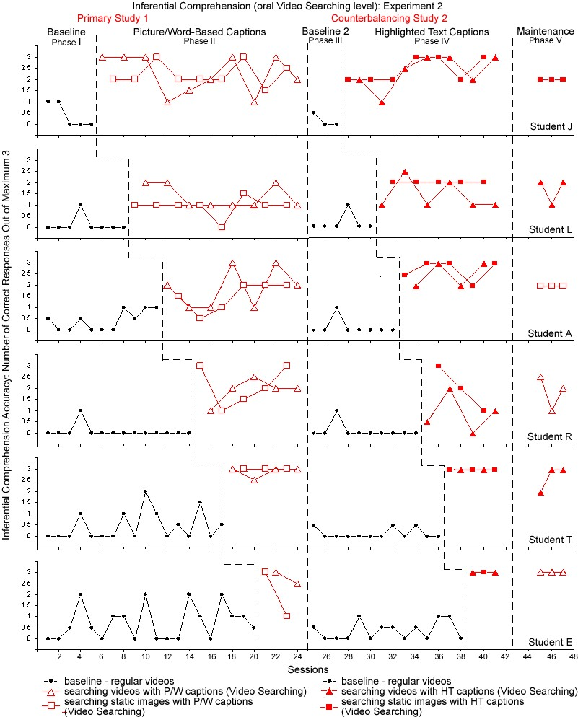
Figure14b. Accuracy of oral Video Searching responses to inferential comprehension questions by students in Experiment 2 across the research phases.
Primary study: oral Video Searching responses. All six students in Experiment 2 demonstrated significant gains in inferential comprehension after they had an opportunity to search the video for answers in Phase II (see Figure 14b). Students L and A progressed to more than 1 of 3 correct oral responses as compared to less than 0.5 points in the baseline (Phase I). Students J and R demonstrated gains from less than 0.5 points to more than 2 of 3 correct responses after video searching in Phase II (Figure 14b), while
Students T and E accelerated from less than 1 to more than 2 (M = 2.37, SD = 0.95 for Student E) and even to almost 3 (M = 2.93, SD = 0.19 for Student T) correct oral inferential responses. Mirroring these changes, PNDs for Student J (89%), Student R (80%), Student T (100%), and Student E (75%) indicated the effectiveness of interactive searching of videos adapted with picture/word-based captions. Few elevated points in the baseline decreased PND scores for Students L and A to 25% and 62% respectively
(Figure 14b). When the scores were combined and compared, the students in Experiment 2 demonstrated the following gains in the percentage of correct oral responses: Student J increased from 13% to 32% (oral Level 1; Phase II in Figure 14a) and to 75% (oral Video
Searching level; Phase II in Figure 14b); Student L – from 4% to 20% and to 39%; Student A – from 14% to 14% and to 56%; Student R – from 2% to 7% and to 67%;
Student T – 15% to 57% and 98%; Student E – 24% to 58% and to 79% (see Table 12).
Counterbalancing study: oral Level 1 responses. The decrease to the initial baseline levels in Phase III for all participants in Experiment 2 and reinstatement of inferential accuracy mean lines in Phase IV clearly indicated the positive impact of videos with highlighted text captions on students‟ inferential comprehension. The number of correct Level 1 responses (Phase IV; Figure 14a) increased significantly for all participants demonstrating the range of increase from 4 to 13 times (Table 12). However, the variability of data once again did not allow for high PND scores. Students J, T, and E exhibited a change between the last data point in baseline and the first data point following treatment in Phase IV (Figure 14a). The data overlap was apparent over the sessions for both Student J (71%) and E (67%), but not for Student T (100%). While Students L, A, and R demonstrated a relative change in the number correct inferential oral responses between the second baseline (Phase III) and the second treatment, their PND scores were minimal (9%, 33%, and 14% respectively; Phase IV in Figure 14a).
Counterbalancing study: oral Video Searching responses. The addition of interactive video searching in Phase IV (Figure 14b) resulted in dramatic improvement in the number of correct inferential responses (oral Video Searching level) for all students. Thus, Students J, A, T, and E accelerated immediately demonstrating 100% PND across the second baseline (Phase III) and video searching in Phase IV (Figure 14b). Student L exhibited 33% PND and Student R had only 14 % PND due to one data point in baseline Phase III (Session 27). The overall level change in the counterbalancing study for students in Experiment 2 went as follows: Student J went from less than 0.2 (6%) to almost 1 of 3 (29%) in oral Level 1 questions (Phase IV; Figure 14a) and then to almost
2.5 of 3 (80%) in oral Video Searching correct responses (Phase IV; Figure 14b); Student L – from less than 0.2 (6%) to almost 1 (24%) and then to almost 2 (56%); Student A – from 0.1 (4%) to more than 1 (37%) and then to more than 2.5 (87%); Student R – from
0.1 (3%) to 1 (33%) and then to almost 1.5 (45%); Student T – from 0.1 (4%) to almost 2 (57%) and then to the maximum of 3 (100%); Student E – from less than 0.5 (12%) to almost 2 (56%) and then to 3 (100%) points (details can be found in Table 12). Like in Experiment 1, all the participants in Experiment 2 performed better with the counterbalancing treatment employing videos with HT captions, except for Student R who exhibited more substantial gains with picture/word-based captions.
In an approximated randomization test rooted on 2000 randomly sampled data permutations, the prediction that the number of correct oral inferential responses by students in Experiment 2 would not have a significant increase after the introduction of picture/word-based or highlighted text captions. In turn, the statistically significant impact of interactive video searching on inferential comprehension of students in
Experiment 2 was established. The results are provided in Table 11.

Table 11
Summary of Randomization Tests for Inferential Accuracy in Experiment 2
Inferential Comprehension Accuracy Between: | Proportion of 2000 data divisions | One-tailed probability
Regular videos and videos with P/W captions  (oral Level 1 questions: Phases I-II in Figure 13a) | 0.67 | p > 0.05
Regular videos and videos with P/W captions (oral Video Searching: Phases I-II in Figure 13b) | 0.0005 | p < 0.05
Regular videos and videos with HT captions  (oral Level 1 questions: Phases III-IV in Figure 13a | 0.16 | p > 0.05
Regular videos and videos with HT captions  (oral Video Searching: Phases III-IV in Figure 13b) | 0.0005 | p < 0.05

Table 12 displays the summary of individual means, standard deviations, and PND scores for Experiment 2 necessary for final conclusions on the effectiveness of video adaptations.

Table 12
Means, Standard Deviations, and PND Scores for Inferential Comprehension Accuracy
Measured by 3 Oral Inferential Questions in Experiment 2
Participant |  | Primary Study |  | Counterbalancing Study
 | Baseline  Phase I | P/W  Captions  Phase II | Video  Searching Phase II | Baseline  Phase III | HT  Captions  Phase IV | Video  Searching  Phase IV
Student J  M_{c}(SD_{c})  PND_{c}  Student L  M_{c}(SD_{c})  PND_{c}  Student A  M_{c}(SD_{c})  PND_{c}  Student R  M_{c}(SD_{c})  PND_{c}  Student T M_{c}(SD_{c}) PNDc  Student E  M_{c}(SD_{c}) PND_{c} | 0.4 (0.6)  0.13 (0.4)  0.41 (0.4)  0.07 (0.3)  0.44 (0.6)  0.73 (0.8) | 0.95 (0.6)  11%  0.59 (0.6)  6%  0.42 (0.6)  8%  0.2 (0.3)  0%  1.71 (0.4)  0%  1.75 (0.7)  25% | 2.24 (0.7)  89%  1.16 (0.5)  25%  1.69 (0.8)  62%  - (0.7)  80%  2.93 (0.2)  100%  2.37 (1.0)  75% | 0.17 (0.3)  0.17 (0.4)  0.13 (0.4)  0.1 (0.3)  0.13 (0.2)  0.36 (0.4) | 0.86 (0.7)  71%  0.73 (0.5)  9%  1.11 (0.7)  33%  - (0.6)  14%  1.7 (0.5)  100%  1.67 (0.6)  67% | 2.39 (0.7)  100%  1.68 (0.8)  33%  2.61 (0.5)  100%  1.36 (0.7)  14%  3 (0)  100%  3 (0)  100%
Note: M_{c} (SD_{c}) = Means and standard deviations combined for all data points in each phase; PND_{c} = Percents of non-overlapping data combined for all data in each phase.
Overall, despite a lack of the statistical significance of picture/word-based captions or highlighted text captions, Students L, T, and E in the primary study and all students in the counterbalancing study showed modest gains in the mean values. The improvements in inferential comprehension after interactive video searching for all students were visually evident and supported by the significant statistical results for both the primary and the counterbalancing studies. The low PND scores can be explained by only a few elevated baseline data points across all participants in Experiment 2.
Inferential Comprehension Based on the Multiple Choice Responses
The visual analysis of students‟ performance on the inferential comprehension questions in a multiple choice format provides additional information. Figures 15 and 16 illustrate the accuracy of inferential comprehension by students in Experiment 1 (Figure
15) and by students in Experiment 2 (Figure 16) as measured by both oral (Video
Searching Level) and multiple choice (Level 2) responses across all research phases.
As displayed in Figures 15 and 16, none of the participants in Experiment 1 or in Experiment 2 were able to orally answer the maximum possible (3) inferential questions correctly after viewing regular videos in two baselines (Phases I and III). Thus, all 11 students were asked multiple choice Level 2 questions in 100% of baseline sessions. The multiple choice format of Level 2 questions enabled students to reach the maximum of 3 correct responses in 15% of overall baseline sessions across participants in Experiment 1 (Figure 15) and in 12% of overall baseline sessions across participants in Experiment 2
(Figure 16).
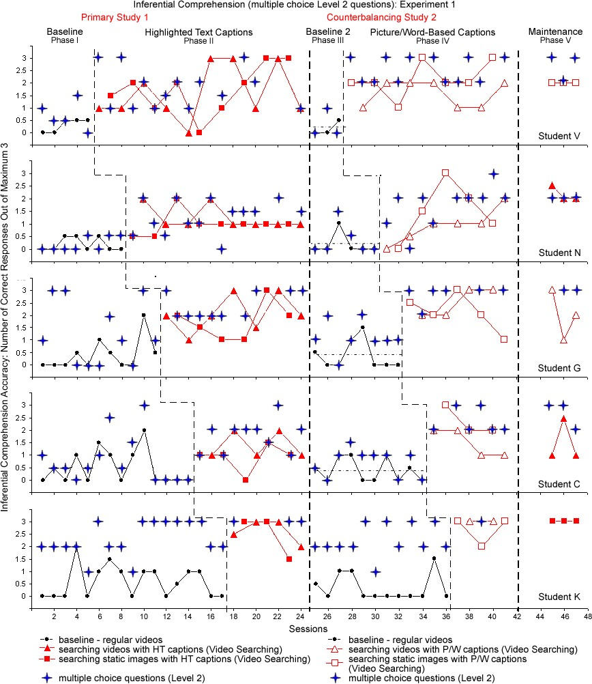

Figure 15. Accuracy of multiple choice Level 2 responses to inferential comprehension questions by students in Experiment 1 across the research phases.

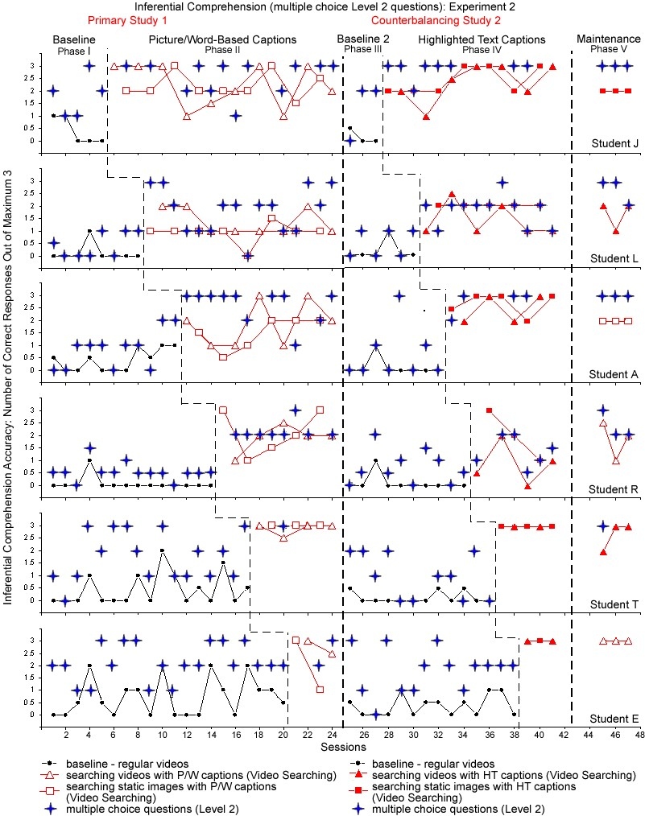
Figure 16. Accuracy of multiple choice Level 2 responses to inferential comprehension questions by students in Experiment 2 across the research phases.
The effectiveness of adapted and interactive videos was demonstrated repeatedly when students in Experiment 1 met the criterion of 3 correct oral inferential responses in 29 of 126 treatment and maintenance sessions (Figure 15) and students in Experiment 2 reached that maximum in 45 of 136 sessions across all treatment and maintenance phases (Figure 16) before even entering multiple choice questioning level. Thus, as can be seen in Figure 15, students in Experiments 1 were required to proceed to the multiple choice questions in 77% of all sessions when they used adapted videos. Furthermore, in 27% of those sessions, they reached the maximum of 3 correct inferential responses with the multiple choice questioning format. In turn, participants in Experiment 2 were asked the multiple choice Level 2 questions in 67% of all intervention sessions. In 32% of those sessions, they were able to accelerate to the maximum accuracy (Figure 16).
Highlighted Text versus Picture/Word-Based Captions
In response to the research question 3, “Do two different captioning adaptations produce differential effects on video content comprehension by students with intellectual disabilities?”, each participant had an opportunity to view videos adapted with alternative narration and both captioning types: highlighted text and picture/word-based captions across the primary and the counterbalancing multiple baseline single-subject studies. While participants in Experiment 1 were initially introduced to the highlighted text captions succeeded by the latter, participants in Experiment 2 followed a reverse schedule starting with picture/word-based captions. For more evident visual analysis, the mean levels for participants‟ comprehension of the video content after viewing clips enhanced with both captioning adaptations in various study phases were plotted and compared in the bar graphs (Figures 17, 18, 19, and 20). The results from such graphic representation were corroborated by the randomization tests which permitted to conclude that individual students in some study phases exhibited a statistically significant difference in accuracy outcomes after viewing videos with highlighted text and/or picture/word-based captions
(statistically significant cases are marked by red stars on the graphs).

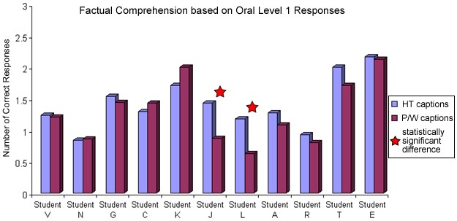
Figure 17. Comparison of highlighted text and picture/word-based captions for students‟ factual comprehension based on the averaged oral Level 1 responses.
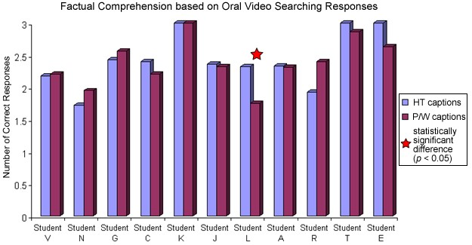
Figure 18. Comparison of highlighted text and picture/word-based captions for students‟ factual comprehension based on the averaged oral Video Searching responses.

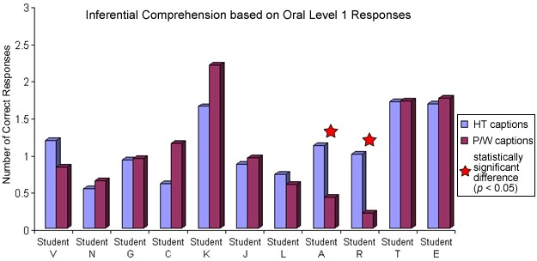
Figure 19. Comparison of highlighted text and picture/word-based captions for students‟ inferential comprehension based on the averaged oral Level 1 responses.
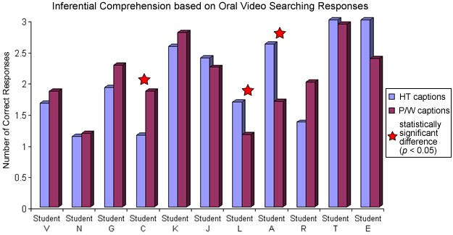
Figure 20. Comparison of highlighted text and picture/word-based captions for students‟ inferential comprehension based on the averaged oral Video Searching responses.

According to the visual inspection of all of the above figures, most of the students did not demonstrate a significant difference in factual and/or inferential comprehension of the video content enhanced with different types of captions. However, a few students (Students C, L, J, L, A, and R) appeared to perform better with a certain type of captioning. According to the Todman and Dugard‟s (2001) Design 5a (Single Case – Two Randomized Treatments), randomization testing of the prediction that one type of captioning (e.g., highlighted text captioning) would ensure greater factual and/or inferential comprehension of video content whether directly after viewing adapted videos or after additional interactive video searching was based on the proportion of 2000 randomly sampled data divisions giving a captioning adaptation difference in the predicted direction at least as large as the experimentally obtained difference. After testing each participant individually across all the conditions, the following statistically significant differences were obtained:
- Student J – 0.007 probability in factual comprehension measured by the oral Level 1 responses (see Figure 17) demonstrates statistically significant difference between two captioning adaptations (p < 0.05; one-tailed). Therefore, Student J performed better with highlighted text captions on the factual comprehension oral Level 1 measures.
- Student L – 0.004 probability in factual comprehension measured by oral Level 1 responses (see Figure 17) demonstrates statistically significant difference between captioning adaptations (p < 0.05; one-tailed). Therefore, Student L also performed better with highlighted text captions on the factual comprehension oral Level 1 measures.
- Student L – 0.03 probability in factual comprehension after interactive searching the video (see Figure 18) indicates statistically significant difference between two captioning adaptations (p < 0.05; one-tailed). Therefore, Student L performed relatively better with highlighted text captions as measured by oral Video Searching factual responses.
- Student A – 0.02 probability in inferential comprehension measured by oral Level 1 responses (see Figure 19) indicates statistically significant difference between two captioning adaptations (p < 0.05; one-tailed). Therefore, Student A demonstrated significant gains with highlighted text captions on the inferential comprehension oral Level 1 measures.
- Student R – 0.005 probability in inferential comprehension measured by oral Level 1 responses (see Figure 19) demonstrates statistically significant difference between two captioning adaptations (p < 0.05; one-tailed). Therefore, Student R also performed substantially better with highlighted text captions on the inferential comprehension oral Level 1 measures.
- Student C – 0.03 probability in inferential comprehension after interactive searching the video (see Figure 20) indicates statistically significant difference between two captioning adaptations (p < 0.05; one-tailed). Student C performed relatively better with picture/word-based captions as measured by oral Video Searching inferential responses.
- Student L – 0.01 probability in inferential comprehension after interactive searching the video (see Figure 20) shows statistically significant difference between two captioning adaptations (p < 0.05; one-tailed). Therefore, Student L exhibited significantly larger number of correct inferential Video Searching level responses with highlighted text captions.
- Student A – 0.004 probability in inferential comprehension after interactive searching the video (see Figure 20) indicates statistically significant difference between two captioning adaptations (p < 0.05; one-tailed). Student A performed significantly better with highlighted text captions as measured by oral Video Searching inferential responses.
Motion Videos versus Static Images
The research question 4, “What effects do motion videos versus static images taken from the clip have on video content comprehension by students with intellectual disabilities?” was investigated as follows. During all treatment conditions (Phases II and IV), study participants alternated between adapted motion videos and adapted static images taken from the videos. These two conditions were tested to determine the impact of captioning video adaptations on the abilities of students with intellectual disabilities to process information incoming through multiple channels (e.g., visual, auditory). The intent was to explore possible solutions for reducing cognitive overload by limiting the motion on the screen. Figures 21, 22, 23, 24 discussed later in the chapter (pp. 258-261), displayed separate mean lines for motion videos and static images adapted with various captioning and interactive features. Through the visual analysis of those graphs, the results indicated that most of the students did not demonstrate any substantial differences in the accuracy performance when viewing adapted videos or static images. In fact, the mean levels were identical in 14 out of total 88 treatment phases across all study participants, questioning levels, and conditions. Tables 13 and 14 provide means and standard deviations for the number of factual (Table 13) and inferential (Table 14) comprehension questions students orally answered correctly after they viewed and searched adapted motion videos and/or static images.
Table 13
Means and Standard Deviations of Students’ Factual Comprehension of Adapted Motion
Videos and Adapted Static Images across Research Phases
St. | Captions 1 |  | Video Searching1 |  | Captions 2 |  | Video Searching2
 | Video M(SD) | Images M(SD) | Video M(SD) | Images M(SD) | Video M(SD) | Images M(SD) | Video M(SD) | Images M(SD)
St. V  St. N  St. G  St. C  St. K  St. J  St. L  St. A  St. R  St. T  St. E | 1.2(0.7)  - 9(0.5)  - 4(0.9)  1.3(0.3)  1.3(0.1)  0.8(0.4)  0.6(0.4)  1(0.6)  - 8(0.6)  - 4(0.8)  - 3(0.4) | 1.3(0.4)  - 8(0.5)  - 7(0.8)  - 3(0.9)  - 3(1.2)  1(0.8)  - 6(0.4)  - 2(0.9)  0.8(0.3)  2.2(0.3)  2(1.4) | 2.2(0.8)  - 8(0.7)  - 4(0.6)  2.5(0.5)  3(0)  2.4(0.7)  - 7(0.5)  - 3(0.8)  2.5(0.5)  3(0)  2.5(0.7) | 2.2(0.8)  - 7(0.5)  - 5(0.6)  2.3(0.4)  3(0)  2.2(0.6)  - 8(0.7)  - 3(0.4)  2.3(0.8)  2.7(0.3)  2.8(0.4) | 1.1(0.3)  - 8(0.4)  - 8(0.5)  1.8(1.0)  2(0)  1.4(0.6)  1.3(0.4)  1.3(0.5)  0.9(0.6)  2(0)  2.3(0.4) | 1.4(0.9)  - 9(0.2)  - 2(0.6)  1(0)  2(1)  1.4(0.5)  1(0.7)  1.3(0.3)  1(0)  2(0)  2(N/A) | 2(0.6)  2(0.7)  2.5(0.6)  2.4(0.7)  3(0)  2.6(0.8)  2.3(0.8)  2.3(0.5)  1.6(0.8)  3(0)  3(0) | 2.4(0.5)  - 9(0.9)  - 6(0.5)  2(1)  3(0)  2.1(0.7)  2.4(0.9)  2.4(0.5)  2.3(0.6) 3(0)  3 (N/A)
Note. St. = Student; M = Mean; SD = Standard Deviation; N/A = standard deviation could not be computed due to the limited number of data points.

Table 14
Means and Standard Deviations of Students’ Inferential Comprehension of Adapted
Motion Videos and Adapted Static Images across Research Phases
St. | Captions 1 |  | Video Searching1 |  | Captions 2 |  | Video Searching2
 | Video M(SD) | Images M(SD) | Video M(SD) | Images M(SD) | Video M(SD) | Images M(SD) | Video M(SD) | Images M(SD)
St. V  St. N  St. G  St. C  St. K  St. J  St. L  St. A  St. R  St. T  St. E | 1.1(0.1)  - 5(0.5)  - 1(0.4)  - 4(0.5)  - 4(0.5)  0.9(0.3)  0.8(0.7)  0.5(0.6)  - 3(0.4)  - 6(0.5)  1.8(0.4) | 1.3(1.1)  0.6(0.7)  0.8(0.9)  0.8(0.8)  2(1.7)  1(0.8)  0.4(0.5)  0.3(0.5)  - 1(0.2)  - 8(0.3)  1.8(1.1) | 1.6(1.1)  - 2(0.5)  - 1(0.7)  - 3(0.5)  - 6(0.5)  2.3(0.9)  1.4(0.5)  1.9(0.9)  - 9(0.5)  - 9(0.3)  2.8(0.4) | 1.7(0.1)  1(0.5)  1.8(0.8)  0.9(0.5)  2.5(0.9)  2.2(0.5)  - 9(0.4)  - 5(0.6)  - 1(0.9)  3(0)  2(1.4) | 0.9(0.6)  0.7(0.4)  0.9(0.9)  0.9(0.6)  2(1.4)  0.7(0.8)  - 8(0.4)  - 1(0.9)  - 8(0.5)  - 8(0.4)  1.5(0.7) | 0.8(0.4)  - 6(0.5) 1(0.7)  - 5(0.5)  - 3(0.6)  1(0.6)  - 7(0.7)  - 1(0.5)  1.3(0.6)  1.7(0.6)  2(N/A) | 1.6(0.5)  0.9(0.6)  2.5(0.6)  - 5(0.6)  3(0)  - 4(0.7)  - 4(0.7)  - 5(0.6)  0.9(0.9)  3(0)  3(0) | 2.1(0.7)  - 5(1.1)  - 1(0.8)  2.3(0.6)  2.7(0.6)  2.4(0.5)  2(0)  2.7(0.4)  2(10)  3(0)  3(N/A)
Note. St. = Student; M = Mean; SD = Standard Deviation; N/A = standard deviation could not be computed due to the limited number of data points.

As can be seen from Tables 13 and 14, the majority of students exhibited relatively equal performance, regardless whether they worked with adapted motion videos or static images. The only two students who showed a difference of at least 1 correct response on a 3-point scale were Students K and R. From Table 13, Student‟s K factual comprehension in Phase II (oral Level 1 questions; Figure 9a) was better with still images adapted with highlighted text captions. As can be seen in Table 14, Student R demonstrated a greater performance on oral inferential questions after searching the static images enhanced with highlighted text word captioning as compared to motion videos (oral Video Searching questions; Phase IV in Figure 14b). However, as described below those differences were not found to be statistically significant.
To support the visual analysis, the differences between motion videos and static images take from the video were tested for each individual student in each of the research phases using randomization tests (Design 5a: Single Case – Two Randomized
Treatments). In effort to determine which condition is more beneficial for students‟ factual and inferential comprehension of the video content based on the 2000 random sampled data permutations, no statistically significant differences were found for any of the participants. Thus, motion videos and static images adapted with various captioning and interactive features had similar impact on the performance of students with intellectual disabilities as measured by the factual and inferential comprehension questions across the research phases.
Social Validity Results
In order to establish the social validity of the study goals, procedures, and outcomes, all of the research participants were interviewed at the end of the study. The interviews provided important information about students‟ opinions and preferences in regard to various video adaptations in response to the research question 5, “What are students‟ perceptions of various video adaptations?” Results of the interviews indicated that all the participants had positive feelings about the research project. They all liked viewing different videos and enjoyed learning “new stuff” enhanced by the fact that videos “helped memory”. While 100% of students thought it would be great to watch video clips in the classrooms, five participants expressed preference to learn from the teacher. This was explained by the notion that students could ask a teacher questions
“afterwards” and interact about the content.
Five out of 11 study participants (Students V, G, L, A, and E) preferred picture/word-based captions because picture symbols “helped understand what video was about.” The other 5 students (Students N, C, K, J, and T) favored highlighted text captions because “yellow highlight moved” from word to word and that type of captions did not have pictures, suggesting that picture symbols could have been distracting for some students. The remaining 1 participant (Student R) could not make a decision and stated that he liked both types of captions the same. All students reported that they looked both at the video content and at the words and/or picture symbols on the top of the screen during video viewing. However, none of the students had any preference on the motion video and/or static images.
The feature that made it easier to answer questions according to the opinions of all study participants was the video searching via hyperlinks. This interactive feature was
“fun” and “very helpful” to go back if a student forgot what the clip was about. While all students expressed excitement about watching small video segments before answering questions, 4 out of 11 participants exhibited reservations about doing it on their own without the researcher‟s prompting. Overall, 100% of students noted that they would like to watch adapted videos in the future and would “definitely” recommend them to others.
Supplementary Analysis
A few supplementary results provided additional information as follows.
Response Latency
In order to analyze patterns of students‟ responsiveness to both factual and inferential questions, the time between the prompt and the onset of students‟ answer was examined. The measurements included the latency for oral responses (Level 1 and Video Searching) as well as multiple choice (Level 2) responses across all research phases (Phases I – IV). According to the research procedures, students were forced to provide an answer within 30-second period. Out of total 2,904 questions asked across all phases and participants, the students reached the time limit in only 26 cases (less than 1% by
Students V, K, R, and T). Those answers were coded as „no response‟. The averaged latencies for combined oral factual and inferential responses across all participants were:
- 5 seconds (SD = 4) during the initial baseline (Phase I);
- 5 seconds (SD = 3) during the first captioning treatment for oral Level 1 responses (Phase II);
- 3 seconds (SD = 2) after searching the adapted videos for answers in Phase II;
- 6 seconds (SD = 3) during the second baseline (Phase III);
- 5 seconds (SD = 3) during the counterbalancing captioning treatment in Phase
IV while at oral Level 1 questioning level; and
- 3 seconds (SD = 2) after searching the videos in Phase IV (see Table 15).
In response to questions in a multiple choice format, the averaged time students spent selecting the correct response was 7 seconds (SD = 3–6) in each of the study phases (see Table 16).

Table 15
Latency of Students’ Oral Responses to Combined Factual and Inferential
Comprehension in Seconds
Participant | Baseline1  M(SD) | Captions1  M(SD) | Video  Search 1  M(SD) | Baseline 2  M(SD) | Captions2  M(SD) | Video  Search 2  M(SD)
Student V  Student N  Student G  Student C  Student K  Student J  Student L  Student A  Student R  Student T  Student E  Total | 1 (2)  6 (4)  3 (2)  7 (4)  4 (4)  4 (3)  7 (5)  5 (5)  12 (6)  8 (6)  2 (2)  5 (4) | 5 (4)  4 (2)  - (3)  - (4)  5 (4)  5 (3)  9 (2)  6 (4)  10 (5)  4 (3)  2 (2)  5 (3) | - (2)  - (2)  - (1)  - (2)  - (1)  - (2)  6 (3)  4 (4)  4 (2)  2 (2)  - (2)  - (2) | 5 (3)  5 (2)  - (1)  - (2)  4 (2)  6 (2)  8 (2)  6 (4)  12 (4)  8 (4)  2 (1)  6 (3) | 6 (3)  5 (4)  4 (2)  - (2)  - (2)  - (3)  8 (3)  5 (3)  13 (6)  4 (2)  2 (1)  5 (3) | 3 (2)  3 (1)  - (1)  - (1)  - (1)  - (2)  - (2)  3 (2)  7 (5)  - (1)  - (2)  - (2)
Note. St. = Student; M = Mean; SD = Standard Deviation
Table 16
Latency of Students’ Multiple Choice Responses to Combined Factual and Inferential
Comprehension in Seconds
Participant | Baseline 1  Multiple Choice M(SD) | Intervention 1  Multiple Choice M(SD) | Baseline 2  Multiple Choice M(SD) | Intervention 2  Multiple Choice M(SD)
Student V  Student N  Student G  Student C  Student K  Student J  Student L  Student A  Student R  Student T  Student E  Total | - (2)  - (3)  8 (3)  7 (3)  10 (4)  9 (4)  7 (3)  6 (3)  9 (4)  7 (3)  9 (5)  7 (4) | 5 (4)  3 (2)  - (4)  - (4)  9 (11)  11 (7)  10 (4)  3 (1)  11 (7)  3 (4)  5 (1)  7 (6) | 7 (4)  5 (2)  8 (2)  7 (4)  12 (3)  - (2)  - (2)  4 (1)  9 (2)  8 (2)  10 (3)  7 (3) | 12 (12)  9 (4)  12 (4)  6 (3)  4 (N/A)  10 (8)  6 (2)  5 (3)  8 (3)  N/A  N/A  7 (6)
Note. St. = Student; M = Mean; SD = Standard Deviation; N/A = descriptive statistics could not be computed due to the limited number of data points.

Prior Knowledge
In effort to establish possible relationships between participants‟ comprehension accuracy as measured by oral Level 1 responses and the level of their prior knowledge on the video topic, the following visual inspection of data was conducted. Students‟ selfreported familiarity with concepts portrayed in the clip coded by the researcher at the end of each data collection session as „extensive‟, „medium‟, „none‟, and „not relevant‟ was collapsed into two categories renamed as „prior knowledge‟ and „no knowledge‟
(„extensive‟ and „medium‟ categories constituted „prior knowledge‟ group; while „none‟ and „not relevant‟ data merged into „no knowledge‟ category). Across all 11 participants, prior knowledge was reported in 137 sessions (28% out of 484 total sessions) and no knowledge was reported in 347 sessions (72%). Sessions when „prior knowledge‟ was indicated were marked by circles on the graphs previously used in this chapter (Figures 9a, 10a, 13a, and 14a). Thus, Figures 21, 22, 23, and 24 display how prior knowledge on the video topic related to the number of correct factual (Figures 21 and 22) and inferential (Figures 23 and 24) oral Level 1 responses by each of the participants. Overall, prior knowledge seemed to enhance students‟ factual and inferential oral Level 1 responses. Factual comprehension and prior knowledge. As can be seen in Figures 21 and 22, among 137 sessions when prior knowledge was reported, the performance was noted as above average in 102 of those sessions (74%) across all 11 participants. However, participants exhibited an above average performance in only 26% of sessions when no prior knowledge was indicated (in 91 out of 347 sessions).
Inferential comprehension and prior knowledge. The above average number of correct oral Level 1 inferential responses was observed in 61% of sessions with prior knowledge (83 out of 137 sessions) and in 30% of sessions without any prior knowledge (in 103 out of 347 sessions; Figures 23 and 24).

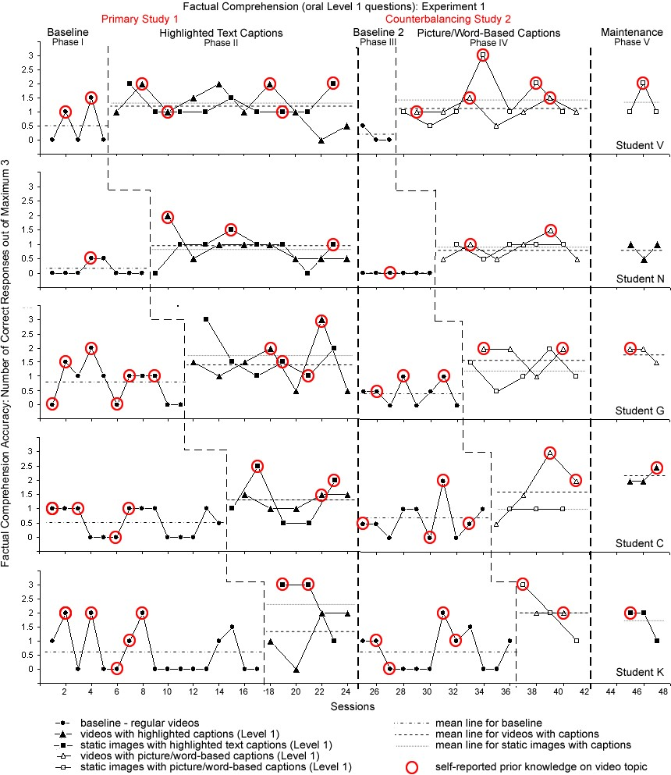
Figure 21. Incidences among factual oral Level 1 responses by students in Experiment 1 when prior knowledge on the video topic was reported.
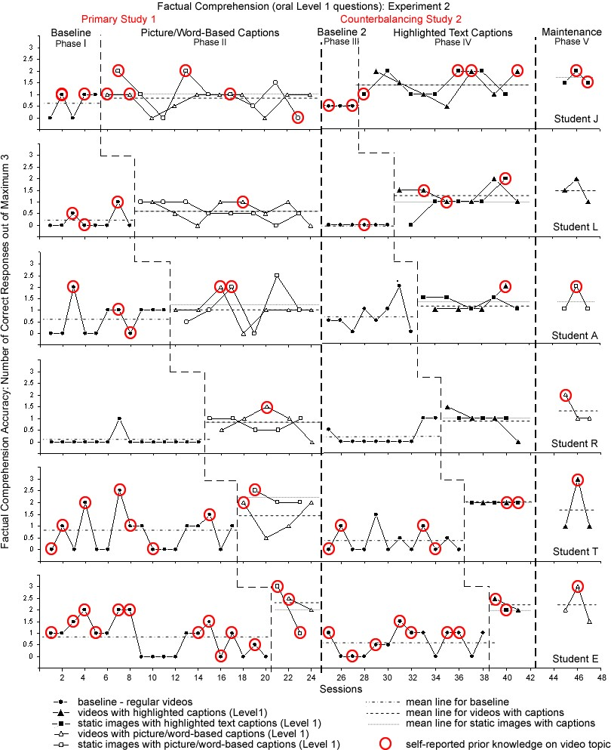
Figure 22. Incidences among factual oral Level 1 responses by students in Experiment 2 when prior knowledge on the video topic was reported.
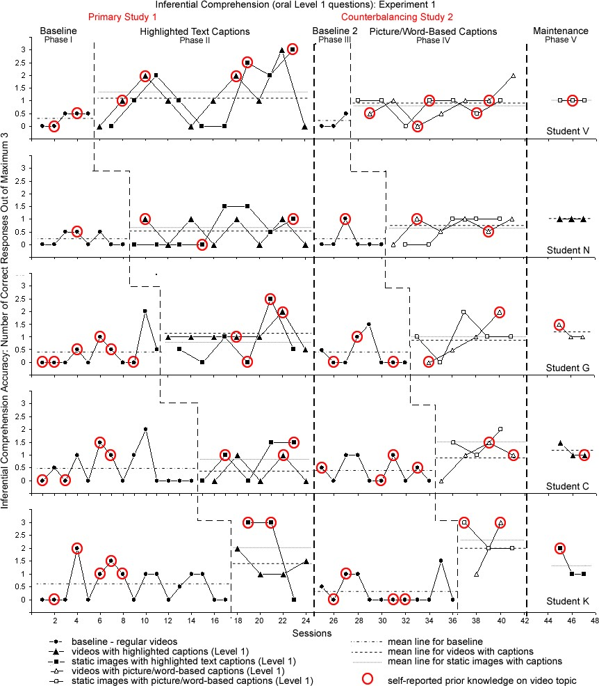

Figure 23. Incidences among inferential oral Level 1 responses by students in
Experiment 1 when prior knowledge on the video topic was reported.
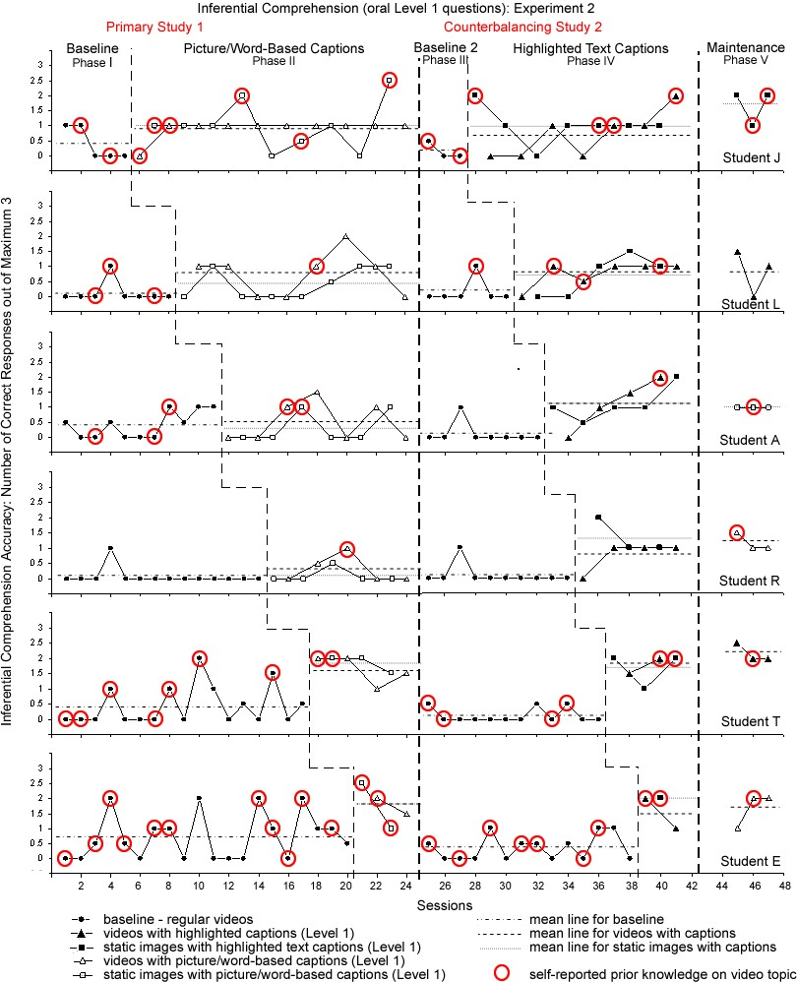
Figure 24. Incidences among inferential oral Level 1 responses by students in
Experiment 2 when prior knowledge on the video topic was reported.
5. Discussion

Due to increased availability and familiarity, television and video technologies are widely used to replace and supplement instruction in general and special educational classrooms for students with various abilities and needs (Schreibman, Whalen, & Stahmer, 2000; Wetzel, Radtke, & Stern, 1994). In an effort to raise expectations and learning outcomes, educators are searching for new evidence-based, effective educational strategies to include their students with intellectual disabilities into meaningful academic instruction (Agran, Cavin, Wehmeyer, & Palmer, 2006; Browder, Wakeman, Flowers, Rickelman, Pugalee, & Karvonen, 2007; Wehmeyer, 2006). This chapter presents the discussion of major findings and their implications for both researchers and practitioners that surfaced from the single-subject research study on adapted content videos with 11 postsecondary students with intellectual disabilities. Students‟ responses to factual and inferential questions were examined to determine the effectiveness of alternative narration, various types of captioning (e.g., highlighted text and picture/word-based), and an interactive features (prompted video searching via hyperlinks) for improving comprehension of non-fiction video content as compared to regular, not-adapted video clips. Visual analysis and randomization tests of the multiple baseline and alternating treatments single-subject research data provided answers to the main research questions and enabled the following conclusions:
- All 11 participants significantly improved their factual comprehension of nonfiction video content after viewing videos modified with alternative narration and various captioning adaptations;
- Despite less obvious gains and non-significant results of randomization tests, 8 out of 11 students with intellectual disabilities demonstrated a modest increase in their inferential comprehension of video content with adapted clips;
- Both factual and inferential comprehension across all 11 participants significantly improved further after students had an opportunity to search the video for answers and adjust their original oral responses;
- Adapted and interactive videos enabled students to provide the correct oral responses more frequently than with non-adapted videos, eliminating the need for a more concrete multiple-choice questioning format;
- The majority of participants performed equally well regardless of the type of the captions, although in just a few phases, four students performed significantly better with highlighted text captions, and one student with picture/word-based captions;
- There was no significant difference in comprehension measures between motion videos and static images taken from the video for any of the participants;
- Cognitive processing in preparation for oral Level 1 responses (measured by latency) averaged at 5.3 seconds after watching both regular and captioned videos and 3 seconds after interactive video searching. Participants spent on average only 7 seconds choosing multiple choice Level 2 responses regardless of the study phase or video adaptation, suggesting the possibility of careless responding;
- According to the visual analysis of data, the accuracy measures in oral Level 1 responses depended on students‟ prior knowledge and familiarity with the video topic and/or content;
- All 11 participants demonstrated relatively more stable performance and greater gains in the counterbalancing study, suggesting their adjustment to the novelty of treatment; and
- Randomization tests substantiated cumbersome and occasionally inconclusive visual analysis of highly variable data, where the effects of treatment were less obvious.
Adapted and Interactive Videos and Content Comprehension
Results from both visual and statistical analyses in this research study revealed that students with intellectual disabilities benefited from viewing videos adapted with alternative/simplified narration, various captions, and especially opportunities for active interaction with the video content. The benefits were demonstrated by the increased number of factual and inferential questions participants were able to answer correctly with adapted versus non-adapted videos. Building on existing practices of integrating video in teaching various subjects for general education students at all grade levels (Boster et al., 2006; Harwood & McMahon, 1997; Jackson, 1997; Lalley, 1998; Linebarger, Kosanic, Greenwood, & Doku, 2004; Strauss & Kinzie, 1994), this research study expanded long-established applications of video instruction for students with intellectual disabilities from functional skill development to presenting academic content. Such undertaking was supported by positive findings from numerous previous studies employing various video formats for teaching concrete social, behavioral, and dailyliving skills to students with intellectual disabilities (e.g., Hitchcock, Prater, & Dowrick, 2004; Kroeger, Schultz, & Newsom, 2007; Kyhl, Alper, & Sinclair, 1999; Mechling, Gast, & Cronin, 2006; Sigafoos et al., 2005; Simpson, Langone, & Ayres, 2004; Van Laarhoven & Van Laarhoven-Myers, 2006).
The value of video media as a rich source of information allowing students to easily create mental models, thus improving comprehension, has been identified by many researchers (Boone, Higgins, & Williams, 1997; Bransford, Sherwood, Hasselbring,
Kinzer, & Williams, 1990; CTGV, 1993c; Kroeger, Schultz, & Newsom, 2007; Moore, Rieth, & Ebeling, 1993; Reagon, Higbee, & Endicott, 2006). Video instruction can be effective for students who are visual learners and are motivated by watching television (Graetz, Mastropieri, & Scruggs, 2006; King, 2002; Tardif-Williams et al., 2007; Sherer et al., 2001). This notion may have accounted for the performances of participants in the present study across baseline conditions. Thus, students reached 15% (range from 0% to 28%) factual accuracy and 10% (2% - 24% range) inferential accuracy across two baseline phases (Phase I and III). Such baseline performances showing some factual and inferential comprehension after watching non-adapted videos may be attributed to the familiarity and common usage of video format with the participants. This may also suggest that visual presentation of the material can be an intervention in itself. In turn, several innovative adaptations used in the present study, including alternative narration, captioning adaptations, and interactive video searching features enabled the successful combination of effective video medium and general curriculum content making the latter more comprehendible, and thus more accessible for students with disabilities.
Alternative Narration and Captioning Adaptations
Relative improvements in content comprehension were observed for the majority of students as soon as they were introduced to video clips adapted with alternative narration and various types of captioning. It is not rare that educators modify materials by simplifying or shortening them, especially in content-heavy areas such as science and social studies (Mastropieri & Scruggs, 1992). The positive findings in this study suggest that adapted non-fiction video clips with alternative narration have a great potential to enable active participation of students with intellectual disabilities in general curriculum academic activities by addressing their abilities and needs (Copeland, Hughes, Agran, Wehmeyer, & Fowler, 2002; Snell, 1997). At the same time, video narrations were altered so that they would not change the curriculum (Wehmeyer, Lance, & Bashinski, 2002; Wehmeyer, Lattin, & Agran, 2001). Thus, while some words and sentence structures were simplified, adapted videos were compatible with the original content as was determined by an expert panel.
While script alterations prevent conclusions about the unique contribution of closed captioning to comprehension gains, captions have been known to improve content recall and listening comprehension for second graders, foreign language learners, at-risk and students with learning disabilities (Guillory, 1998; Huang & Eskey, 1999; Linebarger, 2001; Kirkland, 1995; Koskinen, Wilson, Gambrell, & Jensema, 1986; Markham, 1999; Markham, Peter, & McCarthy, 2001; Meyer & Lee, 1995; Shea, 2000). However, only 16 percent of special educators have considered captioning strategies for students with mental retardation (Bowe & Kaufman, 2001). The present study was the first attempt to demonstrate the effectiveness of captioning adaptations in teaching these students. Current findings provide empirical evidence to support integration of captioning with this population of students.
The possible benefits of alternative narration and various captioning adaptations emerging from this study were validated through direct replication of positive findings across 11 participants. Regardless of the extent of increased accuracy within and across participants, the functional relations between the dependent and independent variables were established (Alberto & Troutman, 2006; Kennedy, 2005) when students returned to the baseline level of performance as soon as the adapted videos were withdrawn and improved yet again when they were reinstated. However, participants demonstrated better performance and more substantial gains when responding to factual rather than higherorder, inferential questions.
Factual comprehension. Rooted in a combination of visual analysis and randomization testing, alternative narration and various adapted captions appeared to be significantly effective for improving factual comprehension of video content for at least 10 out of the 11 participants. Even for that one student, where high data variability hindered the clear impact of adapted captioned videos on his factual comprehension; relative gains were seen in the mean levels of response accuracy. Overall, the straight forward nature of literal comprehension questions was reflected in the evidently greater students‟ performances across all conditions as compared to their inferential measures. This finding is not surprising in light that factual comprehension questions explicitly stated in the video represent a lower level in the cognitive taxonomy (Bloom, Engelhart, Furst, & Krathwohl, 1956). Thus, more accurate responses for literal rather than inferential questions would be expected.
In addition to effective visual learning, the use of alternative narration and captioning adaptations further enhanced the performance of participants with intellectual disabilities. On average, students improved from 17 percent correct responses (range from 2% to 28%) to 42 percent (range from 21% to 71%) in the first treatment phase and from 13 percent (range from 0% to 23%) to 48 percent of correct responses (range from 29% to 72%) in the counterbalancing study. One possible explanation for the factual comprehension gains may be that captions support visual learners who may have auditory processing difficulties (Bowe & Kaufman, 2001). Difficulties with auditory comprehension were explicitly reported for 7 out of 11 participants in this study. Thus, a majority of the participants exhibited an improved understanding of factual non-fiction information presented in the videos via multiple modalities (e.g., text, video, and audio). This finding is consistent with previous investigations (Guillory, 1998; Shea, 2000; Smith
& Shen, 1992; Weasenforth, 1994).
Inferential comprehension. Measuring the inferential comprehension of nonfiction video content, students were expected to interpret the implicit ideas by combining their background knowledge and information provided in the video. While students‟ performance across two baseline phases measured at 10% accuracy (2% - 24% range) somewhat similar to factual comprehension, it then accelerated to only 35% accuracy across the two treatment phases (7% - 73% range). It is not surprising that approximated randomization tests did not demonstrate any statistically significant improvement after videos adapted with alternative narration and various captions were instroduced. It is interesting however, that while some students exhibited little or no improvement in inferential accuracy (e.g., Student A and C), others showed more pronounced changes in inferential comprehension than in factual (e.g., Student J).
Overall, generally lower performance of students on inferential measures is consistent with the notion that these skills represent higher level of cognition on the hierarchy and are harder to answer, especially for students with disabilities who may lack prior knowledge of the video topic (Burns, Roe, & Ross, 1998; Fisher, Schumaker, & Deshler, 2002; Fritschmann, Deshler, & Schumaker, 2007). Although, educators might assume that students with significant cognitive disabilities can only achieve the most basic cognitive level (i.e., recall), professionals urge the development of research on achievements of students with intellectual disabilities in higher-order thinking skills (Browder et al., 2007; Flowers, Browder, & Ahlgrim-Delzell, 2006). The present research study supports the potential for achieving higher levels.
Prior knowledge. Dependence of students‟ comprehension performance upon
prior knowledge on the video topic was anticipated. However, the fact that prior knowledge resulted in slightly better factual measures (74%) than inferential (61%) suggests that while students might have had prior knowledge, they struggled with applying it and making sense of the video content. Regardless of students‟ achievement on basic reading skills, higher-order skills require instruction (Abadiano & Turner, 2002;
Carr & Thompson, 1996; Rapp, van den Broek, McMaster, Kendeou, & Espin, 2007). Several studies have demonstrated that training on various strategies (e.g., repeated reading, summarization, questioning, and inferential strategies) result in significant improvements in inferential comprehension performance by students with reading difficulties (e.g., Abadiano & Turner; Fritschman, Deshler, & Schumaker, 2007; Therrien, Wickstrom, & Jones, 2006). A possible explanation of the lower inferential accuracy for all participants in the current study may be attributed to their inability to connect prior knowledge and information in the videos as no explicit training in inferential strategies was provided.
Another interesting finding emerged in that participants performed above average without any prior knowledge in 26% of factual measures and in 30% inferential measures. This supports existing research demonstrating that video anchors enable learners to easily create mental models and contribute to the establishment of common grounds for learners who may not have similar background knowledge (CTGV, 1992a; Snow, 2002; Xin & Rieth, 2001; Young, 1993). However, it is important to consider here that prior knowledge was assessed based on the participants‟ self-reports after watching the video. Timing was selected based on the existing research indicating that activation of prior knowledge before intervention increases comprehension (Carr & Thompson, 1996).
However, the anecdotal data in the present study suggest that students at times simply repeated information provided in the video, thus questioning the validity of their selfreports (Wise & Kong, 2005).
In light of the complexity of the higher order skills required in the study, the gains that 8 out of 11 students, although not statistically significant, demonstrated on the number of correct inferential responses seem promising. While positive findings of improved inferential comprehension of video content with the help of alternative narration and captioning adaptations were not as pronounced, participants demonstrated better understanding of the overall video concepts. For example, on several occasions
Student N and L could summarize the video essence after captioned videos and seemed „lost‟ after watching regular, non-adapted clips. Similarly, all participants were able to recall at least some general information that they had learned from the videos during the social validity interviews. For example, Student V stated that “hurricanes have an eye” and Student G remembered that “you can listen to lectures on the iPod.” Other students were able to appropriately use such sophisticated words as “electors” and/or “al Qaeda” demonstrating their general understanding of video topics. Such level of understanding was recognized as preferable compared to a rote response (Browder et al., 2007).
Up until now, the majority of research on closed captioning focused on improving more concrete academic skills such as word recognition (Koskinen, Knable, Markham, Jensema, & Kane, 1996; Markham, 1999), sight word instruction (Bean & Wilson, 1989), and other vocabulary learning activities (Goldman & Goldman, 1988; Neuman & Koskien, 1991, 1992). This research study extended existing research on closed captioning by applying this adaptation to higher-order comprehension skills. It is an important undertaking since even alternate assessments in high stakes testing contain items at various depths of knowledge (Flowers, Browder, & Ahlgrim-Delzell, 2006; Roach, Elliott, & Webb, 2005). In addition, a high priority for inferential questions was noted in the Virginia Standards of Learning. Thus, adapted video instruction may potentially serve as an innovative approach for targeting the development of higher-order cognitive skills by students with intellectual disabilities.
Overall, alternative narration and captioning adaptations appeared to be effective for focusing students‟ attention on relevant cues and anchoring their comprehension and retention (Dowrick, 1991; Charlop-Christy, Le, & Freeman, 2000; Maione & Mirenda, 2006; Shipley-Benamou, Lutzker, & Traubman, 2002). However, combined visual and auditory representation of information was effective even during some baseline, noncaptioning sessions. For example, while watching one of the regular, non-adapted videos, the answer to one question was displayed on the screen as text. Almost all students were able to provide the correct response to that question. For some students, that correct response confounded the visual inspection of data across the phases in the current study.
A somewhat similar Reagon, Higbee, and Edicott‟s study (2007) achieved unclear results which did not suggest a reinforcing value of textual prompts embedded in videos. This may be explained by the young age of their participants (preschoolers with autism), i.e., the children were non-readers and text prompts may or may not have been appropriate. The postsecondary students with intellectual disabilities in the current study seemed to benefit from textual prompts whether in the form of captions or embedded text.
Additional Interactive Features
While students demonstrated relatively increased comprehension of video content after the videos were enhanced with alternative narration and various captioning adaptations, their performance accelerated even more with the introduction of an interactive video searching option. Students‟ gains were more evident after they had an opportunity to go back in the video and view short segments containing correct answers in response to the researcher‟s prompting. The gains in the number of correct factual and inferential comprehension questions were visually detectable for all 11 participants and supported by statistically significant results of randomization tests. In fact, the PND scores averaged across all students and treatment phases indicated the effectiveness of interactive video searching as an intervention for improving both factual (M PND = 83%) and inferential (M PND = 73%) comprehension accuracy.
These findings are corroborated by the extensive research on the concepts of active learning and anchored instruction (AI). Active learning has been promoted for many years to enhance traditional instruction for students of different abilities and needs (e.g., Feldman & Denti, 2004; Johnson, Griffin-Shirley, & Koening, 2000; McCarthy, 2005). AI design incorporates active learning principles in searching video for problems and solutions. With embedded data, learners are motivated to search video anchors for the resolutions (Bottge et al., 2007; CTGV, 1992a; Young, 1993).
Several studies reported the positive impact of AI on developing skills to solve complex authentic problems by students with and without learning difficulties (Bottge et al., 2007; CTGV, 1992c; Kinzer, Gabella, & Rieth, 1994; Rieth et al., 2003; Van
Haneghan, Barron, Young, Williams, Vye, & Bransford, 1992; Xin & Rieth, 2001). In fact, findings in the current study are also consistent with the notion that AI-based interactive videos are superior to regular linear clips for the mastery of science concepts as reported by Goldman et al. (1996). In the present study, linear videos, even those adapted and captioned, were still less effective than adapted videos allowing interactive searching.
Up until now interactive video programs were effectively used by students with cognitive difficulties only for teaching functional, behavioral, and daily-living skills (Ayres & Langone, 2002; Ayres et al., 2006; Mechling, 2004, Mechling, Gast, & Langone, 2002; Mechling & Gast, 2003; Mechling, Pridgen, & Cronin, 2005). From one of the earliest studies utilizing interactive video-based simulation of purchasing in a convenience store (Wissick, Lloyd, & Kinzie, 1992) to one of the most recent studies incorporating interactive video program for practicing job tasks (Mechling & OrtegaHurndon, 2007), all researchers agree that a higher degree of interactivity enables more substantial gains in the performance. Greater mastery was achieved by students with intellectual disabilities locating items in a store after practicing with video-based programs requiring screen touching than when passively viewing the videos (Mechling, 2004; Mechling & Gast, 2003). It is not surprising that interactive searching allowed students in the present study to further master factual and inferential comprehension of the video content. In fact, all students reported that „searching screen‟ and „red arrow hyperlinks‟ were their favorite part of the process, thus motivating all the participants to attend more to video content.
Other research trends also support the conclusions about the positive impact of interactive video searching for teaching academic content to students with intellectual disabilities. For example, video prompting is often used in conjunction with video modeling when subjects are shown the entire task prior to being shown each individual step of the task analysis at a time (Norman, Collins, & Schuster, 2001). Video prompting clips usually include still frames that allow enough time for a subject to complete a given step before moving on to the next one. Participants in the present study watched the whole video in order to get the general concept before selecting the hyperlink, viewing one segment, and responding to one question at a time.
It is not surprising that video prompting is typically used for effective teaching of more complex tasks such as multi-step cooking, purchasing, daily living and self-help skills (Alberto, Cihak, & Gama, 2005; Grave, Collins, & Schuster, 2005; Norman, Collins, & Schuster, 2001; Sigafoos et al., 2005), as well as learning to operate technology (LeGrice & Blampied, 1994). While no research exists on the use of video prompting in teaching academic content, this format appears to be appropriate for learning complex academic skills. Indeed, the current research study supported the positive impact of using one prompt at a time allowing students to focus on a shorter video segment and/or information chunk, thus reducing the cognitive demand (Wehmeyer, Lance, & Bashinski, 2002). The participants appeared to exhibit substantially greater accuracy with shorter video segments after activating the searching feature. Providing longer searching segments seemed to confuse students and hinder their ability to answer the questions correctly. Some students (e.g., Student J) verbally expressed that they could remember “only one fact.”
Despite all obvious benefits, it is unknown how students will perform when making independent decisions to search the video for answers without the researcher‟s prompting. As a matter of fact, four participants were unsure about how much they would use this feature on their own as expressed in their interviews. Unfortunately, this may hinder the effectiveness of interactive video searching features during independent learning activities. Thus, more research is needed to determine the efficiency of video searching interactive feature in uncontrolled, unprompted conditions.
Adapted and Interactive Videos and Content Comprehension Summary
In conclusion, the various levels of support provided by the presented video adaptations had apparent but different impact on the participants. Alternative narration and captioning adaptations seemed sufficient for improving comprehension for some students (e.g., Students K, E, and T). Those were the students who also reached the maximum of three correct responses after viewing and searching adapted videos, thus avoiding the need to go into multiple choice questioning. For other students, alternative narration and captions were not enough and they improved only when the interactive video searching features were introduced (e.g., Students V, G, J, and A). Still others appeared to need even more support, since even video prompting and searching did not promote them to consistent performance at the oral accuracy mastery criteria (e.g., N, C, L, and R). However, these students did demonstrate improved performance with the multiple choice questioning format.
Highlighted Text versus Picture/Word-Based Captions
The visual analysis of single-subject data indicates the relative similarity between highlighted text (HT) and picture/word-based (P/W) captioning adaptations. A few students (Students J, L, A, and R) demonstrated some statistically significant differences favoring HT captioning in a few phases, but not consistent throughout the study. Other participants also demonstrated slightly better performance with HT captions although it was not found to be statistically significant (Students T and N). While not substantial, some advantage of HT captions can be explained by students‟ familiarity with this form of content presentation, which is used in the majority of the assistive technology reading programs utilized by all LIFE students in various classes. Indeed, highlighted text tends to help especially those readers who exhibit poor comprehension (Elkind, 1998; Elkind, Cohen, & Murray 1993; Hecker et al., 2002; Higgins & Raskind, 1997; Montali & Lewandowski, 1996). This was consistent with the observations in the present study where all participants demonstrated low comprehension abilities. The value of visual presentation of auditory input by highlighting text, fostering students‟ attention and blocking distractions, as discussed by Hecker et al., was corroborated by improvements in comprehension accuracy; especially for students diagnosed with ADD (e.g., Student J and T). Visual presentation was also one of the comments in the participants‟ interviews that the “yellow highlight” helped them follow and read the captions.
Only one participant (Student C) demonstrated significantly better inferential accuracy after interactive searching of videos with picture/word-based captions. However, several other students scored better, although not statistically significant (through individual randomization tests), in many experiments with this type of captioning adaptation (e.g., Student V, G, K, E, and R). An important factor that may have skewed
the effectiveness of picture/word-based captions on comprehension accuracy was that none of the participants in this study had extensive experience with Mayer-Johnson picture symbols. While used in some of their classes, most students were quite novice with the use of picture symbols. For example, when the picture symbol for the word „hurt‟ was used in the captions portraying an arm with a bloody wound, both Students A and R based their responses on “You can hurt/cut yourself.” Such observation has both negative and positive connotations. First, it demonstrates that some students were not familiar with various symbol/words still associated with them. In a positive way, such statements proved that participants were paying attention to the captions in general and picture symbols in particular. The benefits of P/W captions were also apparent during the multiple choice questioning level, when students seemed to be more effective and time efficient in choosing the correct answer by matching the picture symbols displayed in the captioning line. Thus, there is a promise that those students with disabilities who use picture symbols on a regular basis will demonstrate even greater gains and will benefit more from this type of captioning adaptation.
In addition, all conclusions about the relative effectiveness of the type of captioning must be made with caution due to the fact that the majority of participants (except Students C and R) demonstrated slightly better performance with the captioning type used in the counterbalancing study (a picture/word-based captioning for Experiment 1 and highlighted text captioning for Experiment 2). Thus, the influence of the novelty effect may have accounted for the differences between highlighted text and picture/wordbased captions (Clark, 1983). However, despite the need for more research, both highlighted text and picture/word-based captions worked to improve comprehension and appeared to be effective strategies that practitioners could use for students with different abilities and needs based on their characteristics and/or prior experiences. The purpose and the questioning level may also influence the decision to choose which type of captioning adaptation to use.
Motion Videos versus Static Images
According to the dual coding theory (Chandler & Sweller, 1992) and the theory of cognitive overload (Mayer & Moreno, 2003), learners may experience difficulties with information processing when the instructional materials are presented though the same channel (e.g., visual or verbal). Based on that, adapted videos used in this study would produce a split-attention effect since the information is presented through video (visual channel), narration (verbal channel), and captions (visual channel again). However, any comparisons are hindered because all existing research examines the use of either two visual inputs (e.g., animation and on-screen text) or two visual inputs (e.g., narration and background music; Mayer, et al., 1999; Mayer & Moreno, 1998; Moreno & Mayer, 1999, 2000, 2002; Moreno, Mayer, Spires, & Lester, 2001). None of the studies explore cognitive overload with motion pictures enhanced with synchronized narration and the verbatim captions (visual + verbal + visual).
However, based on the cognitive overload theory, it was decided in the current study to alternate between motion videos adapted using captions and narrated static images taken from the video also adapted with captions. This was an attempt to explore possible cognitive processing overload caused by captioning added to motion videos and to provide a solution in the form of static images.
The results of the study did not show any substantial differences between the motion and static video formats used. Both adapted motion videos and narrated static images taken from the video had an equally positive impact on factual and inferential comprehension by students with intellectual disabilities. The randomization tests also did not find any differences that were statistically significant for any of the participants. None of the participants expressed strong preferences in terms of watching motion videos and/or static images during the social validity interviews. These findings are supported by limited research indicating that static images and motion videos had equal efficiency and effectiveness for students with intellectual disabilities (Alberto, Cihak, & Gama, 2005; Cuvo & Klatt, 1992; Cihak et al., 2006). Practically though, it may be more efficacious to just use the motion video as it is, rather than edit it to get static images. However, more empirical research is needed to examine the possible focusing and motivating value of motion video format (as for Students N, L, and T) along with its distracting nature to students with ADD (as for Student J).
Interestingly, according to aforementioned research on cognitive overload, it is imperative to synchronize corresponding words and pictures as precisely as possible. The current study supports such a recommendation. Through field observations and interviews with participants, the importance of a close match between text in captions and the video images appearing on the screen became apparent. For example, Student N answered one question incorrectly referring to „smog‟ after viewing a video segment.
Indeed, a picture of smog was on the screen during the segment while captions provided different information containing the correct answer. Students N and L often based their answers on what they saw on the screen, rather than what was in the caption window. Therefore, it was important to match captions with images. This recommendation needs to be taken into consideration when utilizing adapted videos in instruction for students with disabilities.
Additional Findings Related to Previous Research
In addition to the conclusions related to the main findings in this study, several additional results were observed. They provided important supplementary information.
Latency
Quick response time has been considered as a characteristic of unmotivated learners not putting the necessary amount of effort into low-stakes assessments. Wise and Kong (2005) introduced an important measure identified as response time effort (RTE) in order to control for the effort an examinee devotes to reading and seriously considering the assessment options, especially in situations not resulting in sanctions for low performance and/or incentives for high attempts. Based on the performance of 472 freshmen during computer-based achievement tests, the researchers determined that a
RTE score was a valid measure of the participant‟s test-taking effort.
Interestingly, the average time the participants in the current study spent between the onset of the questions and their answers was very similar regardless of the video adaptations (e.g., various captions or interactive features), study phase (e.g., baseline with regular or treatment with adapted videos), or response modality (e.g., oral or multiple choice responses). Participants spent 5.3 seconds on average responding orally to questions after both adapted and not-adapted videos and only 7 seconds when they were asked to choose the answer from a list of multiple choices; again regardless of the video condition. In fact, close examination of individual latency data across baseline conditions indicated that students with lower reading abilities (Students N, C, and R) exhibited equal or shorter response time for Level 2 multiple choice questions as compared to Level 1 oral questions (see Tables 15 and 16). While Students L, A, and T were identified as higher level readers, their response time was also almost identical across the questioning levels in all phases. Therefore, it could be possible that all aforementioned students did not devote a full effort to multiple choice Level 2 questions and demonstrated “guessing the correct answer” behaviors. In turn, Students V, G, K, J, and E skilled at an average 4th grade reading level, spent more time choosing the correct response using the multiple choice format (Level 2) than providing the response orally (Level 1). However, it could be that an average of 7 seconds was not enough to read and fully consider choices often provided in complete sentences, thus also suggesting that they may have been guessing.
However, as can be seen in Figures 11, 12, 15, and 16 on pages 222, 223, 241, 242, several students reached the maximum of 3 correct responses with the help of multiple choice questioning format in all treatment phases. Thus, it may be possible that students were able to select the correct responses from the list because they saw similar words and/or picture symbols within the captions. In turn, students spent 3 seconds on average providing a response after they viewed a segment in the video searching condition. It is possible that they took at least some time to process the information and that those responses were actually considered, not just echoed from the video segment (Charlop-Christy, Le, & Freeman, 2000).
Novelty of Treatment
All 11 study participants demonstrated relatively more stable performance and greater gains in the counterbalancing study, suggesting their adjustment to the novelty of treatment. There is research that suggests that studies with technology may be biased by the novelty effect associated with the technology medium integration. Clark (1983) noticed an increased level of effort and focus in research subjects as they were introduced to novel media. This increased attention seemed to diminish as they became more familiar with the technology medium. Thus, Pianfetti (1999) observed the novelty effect of Internet-based digital videos on student‟s math performance as they shifted focus from math to the technical aspect of technology. While the research procedures and adapted video materials were most definitely novel to the participants in the current research study, a video format in general had been used previously in LIFE classes. Thus, the stability by the end of the study could have been attributed to the participants adjusting within research routines. They seemed to pay more attention to captions and video searching segments as they became more aware of the expectations. However, even though there may have been a novelty effect between the primary and the counterbalancing studies, all participants improved relatively in each study. Therefore, more research is needed to investigate the novelty effect of academic video instruction received by students with intellectual disabilities.
Following the criteria suggested for effective video-modeling formats, sufficient video exemplars were provided to increase students‟ performance (Strokes & Baer, 1977; Apple, Billingsley, & Schwartz, 2005; Gena, Couloura, & Kymissis, 2005; Maione & Mirenda, 2006). Thus, the use of multiple videos allowed a sufficient amount of research sessions, possibly contributing to participants getting used to the research procedures and expectations, and thus exhibiting more stable data in the counterbalancing study. More importantly, the usage of multiple exemplars allowed the researcher to establish true learning benefits of adapted videos since they were compared to the same media (regular videos). Based on Clark‟s (1983) claims, the medium of instruction delivery does not influence the learning outcomes, only the method or content that is introduced. Once again, multiple videos in this study belonged to one topic category allowing comparison between the formats as each topic was represented in both baseline and treatment phases, and all videos were developed by the researcher (Liao, 2004).
Randomization Tests
The use of randomization tests, if only approximated at times, in this study provided important confirmation. Due to a high variability of data, the visual analyses of data were at times inconclusive. In addition, the low PND scores in several cases suggested questionable effectiveness of the intervention. However, in a majority of cases, the PND scores were influenced by few elevated data points in the baseline conditions. Those elevated points could have been associated with extraneous factors such as the participant‟s extensive prior knowledge of the video topic. For example, Student A demonstrated an extraordinary knowledge and retention of any dates presented in the video. He was able to answer any question dealing with an event date (e.g., Sessions 3 and 31). Other students demonstrated anecdotal preference of certain video topics. In some cases, video topics were conceptually harder than others (e.g., Electoral College versus Hurricane Katrina), although they were approved by the expert panel and were on the same readability level. So, the great variability in students‟ performance is not surprising and should be considered and controlled in future research. In addition, the limited number of opportunities students had to answer (the ceiling of 3 factual and inferential questions) might have explained a small difference between the accuracy counts across the baseline and treatment conditions for all participants.
All of the aforementioned factors obstruct conclusions about the true value of video adaptations based only on the visual inspection of data. In this case, randomization tests were able to adjust for outliers and analyze the performance that did not depend on them. However, it is critical to make conclusions about the statistically significant value of the treatment only if it is supported by visual analysis. In a study like this, with a large number of participants, it is relatively easy to reach the statistically significant measures. Great effort was devoted to link the decision on functional relation to the various analytical criteria in combination (Park, Marascuilo, & Gaylord-Ross, 1990; Parsonson & Baer, 1986; Todman & Dugard, 2001).
Finally, the current study presents a classic example where adapted randomization procedures allow more flexibility and control over research procedures. As can be seen in Figures 9a, 9b, 10a, 10b, 13a, 13b, 14a, 14b (pp. 199, 200, 211, 212, 226, 227, 234, 235 respectively), baseline conditions for a majority of the participants were marked by a high variability of data. Based on the criteria for multiple baseline designs, the intervention can be introduced only after a subject reached the stability in his/her baseline data. Thus, this study would have been impossible and/or time inefficient since the stability of baseline for these participants was unlikely. The randomization procedures allow entering treatment condition during a certain session randomly assigned prior to the study (Edgington & Onghena, 2007; McReynold & Kearns, 1983; Kazdin, 1982b; Scruggs,
Mastropieri, & Regan, 2006; Todman & Dugard, 2001).
Social Validity
Overall, research participants enjoyed both the research procedures and materials in this study. According to the qualitative findings presented in Chapter 4, a majority of the participants would continue to further use adapted videos and recommend them to other students. On several occasions they expressed how much new information they were able to learn with adapted videos and how “easy” it was to answer questions. Thus, adapted video instruction was shown to be both enjoyable and relatively effective for improving factual and inferential comprehension of non-fiction video content by students with intellectual disabilities. Participants‟ positive perceptions should be taken into consideration by researchers and practitioners working with this population.
Social validation of the intervention format was also established with the help of existing research. As mentioned before, video format has been extensively found to be effective for teaching students with intellectual disabilities, although in non-academic skills (Bellini & Akullian, 2007; Dowrick, 1999; Hitchcock, Dowrick, & Prater, 2003; Schreibman, Whalen, & Stahmer, 2000). All adaptations used in the present study were based on empirical evidence of their effectiveness for other populations. Thus, the interactive video searching features incorporated elements of anchored instruction widely used to marry technology-based instruction with grade and subject-based content (Bottge et al., 2007; CTGV, 1992c; Kinzer, Gabella, & Rieth, 1994; Rieth et al., 2003; Van Haneghan et al., 1992; Xin & Rieth, 2001). More importantly, the design and development of adapted videos was guided by the necessity of inclusion of students with disabilities in the general education curriculum (Browder et al., 2004; Dymond & Orelove, 2001).
However, the social validity of instructional materials is also imperative, especially in educational settings. Despite obvious effectiveness of interactive videos in teaching students with disabilities, the existing research of this video format is quite limited. As can be seen in Table 1 (pp. 33-45), only 13 studies employed the materials enabling participants to be physically involved in the program via touching the appropriate buttons, photographs, and hyperlinks on the computer screen (e.g., Ayres & Langone, 2002; Mechling & Ortega-Hurndon, 2007). Even among other video formats researchers emphasize the more time efficient ones. Thus, video modeling was deemed to be slightly more efficient than video self-modeling because it required less editing and production time (Sherer et al., 2001).
Indeed, 44 video titles were used in this research study. Five versions of each title were developed (regular; V-HT; I-HT; V-P/W; I-P/W) resulting in 220 (1.5-2 minute) video clips. Each adapted video clip (except the regular one) took approximately 10 hours to create, proving to be a time intensive task. Educators seek practical strategies that are not too complex and time consuming to prepare and implement. Despite the positive findings in this research study, the widespread use of videos adapted with various captioning adaptations and interactive features would not be possible without providing educators with a time efficient, easy-to-use tool for creating such videos. Its development would be guided by the learning research described in this work (Cobb, 1997). Such tool would incorporate the capability to add standard, highlighted text, and/or picture/wordbased captions, tag them to the narration of the video for synchronized presentation, as well as substitute motion videos with static images. While this research study did not demonstrate a difference between motion videos and static images taken from the video, this option should be available for students with whom this could benefit (e.g., Student K).
Educational Implications and Recommendations
Several other educational implications for practitioners can be discussed.
Universal Design for Learning (UDL)
Each new educational strategy is more accepted if it finds applications for broader group of students. One of the most important implications merged from this research study must be the fact that universally designed adapted videos can provide teachers with solutions for content-based instruction to students of different abilities and needs. The following principles of UDL are essential in ensuring success of students with intellectual disabilities in the general curriculum: equitable use, flexible use, simple and intuitive use, perceptible information, tolerance for error, and low physical and cognitive effort (Bowe, 2000). Almost all of these principles can be addressed with video adaptations. Such video enhancements as alternative narration, highlighted text, picture/word-based captions, and interactive searching features are able to provide instruction to students with a diverse array of abilities, needs, and learning preferences. In this research study, higher-level readers enjoyed videos and defined the positive impact of adapted videos by reaching the maximum possible with oral responses, never needing the multiple choice Level 2 questioning. Moreover, adapted videos provided access to instructional material at myriad levels of complexity. Given that teachers create and use enhanced videos, students will have access to manageable, easy-to-use materials that present „chunked‟ information available for repeated use (Wehmeyer, Lance, & Bashinski, 2002). This was evident in the study when just after two training sessions, students of many cognitive and physical abilities, needs, as well as background experiences with technology were able to easily use interactive hyperlinks to go back in the video and view segments containing correct answers. Thus, videos can be adapted so that they appear as similar to materials typically used by students without disabilities as possible (Browder et al., 2007; Flowers, Browder, & Ahlgrim-Delzell, 2006; Wehmeyer, 2006).
In their study, Collins et al. (1999) concluded that students with disabilities can learn from strategies commonly employed in general education classrooms. At the same time, Wehmeyer, Lance, and Bashinski (2002) urge consideration of the benefits of materials designed with special needs in mind for all students. In fact, since video formats, alternative texts, highlighted text, closed captioning, and video searching in anchored instruction have shown to be effective for students with mild or no disabilities, adapted videos can find a place in general education classrooms (Boster et al., 2006; Bottge et al., 2007; Hecker et al., 2002; Linebarger, 2001; Mastropieri & Scruggs, 1992; Xin & Rieth,
2001). Thus, adapted video instruction can be beneficial not only for teaching students

such as those with intellectual disabilities but for all students (Browder et al., 2007).
Academic Instruction
While for typical students adapted videos may be a valuable supplement, usage of enhanced clips is one of only few solutions available to students with significant disabilities for meeting alternative standards of learning in all subject areas. To ensure not just access but also adequate progress in the general curriculum, materials such as adapted videos should be closely aligned with grade-level state standards, thus providing true and not just “cosmetic change” in curriculum requirements for students with disabilities (Browder et al., 2004; Dymond & Orelove, 2001; Wehmeyer, Lance, & Bashinski, 2002). This research study demonstrates how easy it is to align available videos with the standards of learning.
Another compelling feature of adapted videos integration is that even if the content complexity is reduced, videos enable educators to focus on purposeful, understandable, and age and grade appropriate materials for students with intellectual disabilities (Browder et al., 2007). This may not be possible through other available technological materials such as software programs geared more towards elementary school children (Wehmeyer, 1998; Wehmeyer, Smith, & Davies, 2005). Driven by legal mandates and practical implications of providing access to the general curriculum, researchers and practitioners aspire to develop new strategies for academic content instruction for students with disabilities.
However, only limited resources exist to illustrate how to teach content to students with intellectual disabilities (Browder & Spooner, 2006; Downing, 1996;
29 0
Ryndak & Alper, 2003). New curriculums and programs are just being developed to ensure quality education for these students. Early Literacy Skill Builder (ELSB) curriculum is one example that addresses the problems of prevalence of teaching functional sight word acquisition to students with intellectual disabilities (Browder, Gibbs, Ahlgrim-Delzell, Courtade, & Lee, 2007). It offers literacy instruction for students with significant developmental disabilities in K-5 grades by adapting strategies shown to be effective for children who are typically developing. The preliminary results of the first year study indicate effectiveness of ELSB as compared to the traditional sight word instruction (Browder, Ahlgrim-Delzell, Courtade, Gibbs, & Flowers, in press).
Similarly, current video interventions represent the adapted curriculum materials and/or tools that can be used for students with disabilities of any age in order to make instruction available in various subject areas. This is an innovative approach towards enhancing students‟ performance in general education activities which adds to the existing, quite limited choices of evidence-based academic interventions for students with intellectual disabilities.
Students with Intellectual Disabilities and Their Abilities
Another important educational implication of the current research study is the proof of incredible abilities of students with intellectual difficulties. Specifically, this study supplemented the existing research on reading comprehension (Byrne, MacDonald,
& Buckley, 2002; Fletcher & Buckley, 2002; Law, Boyle, Harris, Harkness, & Nye, 2000,
Turner & Alborz, 2003; Verucci, Meghini, & Vicari, 2006; van den Bos, Nakken,
Nicolay, & van Houter, 2007) by examining auditory and visual comprehension of video content by students with intellectual disabilities demonstrating their substantial gains. Unfortunately, only a few studies had earlier demonstrated the ability of students with cognitive disabilities to attend to and comprehend academic content in math, science, and social studies (Browder et al., 2006; Browder, Spooner, Ahlgrim-Delzell, Flowers,
Algozzine, & Karvonen, 2003; Collins, Hall, Brandon, & Holder, 1999; McDonnell et al., 2002). The comprehension gains in video instruction containing science and social studies information in this study provide evidence that students with intellectual disabilities are capable of comprehending content-based information from non-fiction video clips. In addition, all the videos were aligned with the Virginia Standards of Learning in science, history, social studies, computer/technology, and health demonstrating the students‟ capacity for improved performance in all those areas. Thus, educators can employ adapted video instruction in any subject as long as they have access to the video portraying a topic.
Recommendations for Classroom Implementation
All of the aforementioned findings suggest a few practical recommendations for teachers to effectively implement adapted videos in the classroom. The research from this study illustrates potential applications in every day teaching in any subject area and for any grade level. The use of various video adaptations may be extended into the classrooms to enhance educational activities, especially in heavy-content subjects such as science and social studies for students with intellectual disabilities. Specific suggestions for teachers are as follows.
Widespread use of videos adapted with various captioning adaptations and
interactive features used in this research study may be problematic for many practitioners due to the skills and knowledge of various technologies, as well as the production time required of busy teachers. The development of an innovative, easy-to-use software-based tool would provide teachers with effective and time efficient video enhancements. Created as an overlay mechanism, the tool would allow uploading and modifying existing video clips with any or all adaptive features without breeching the copyright laws and altering the original videos. All teachers would need is access to a video, particularly one correlated with appropriate curriculum and/or learning standards. Several existing video services such as unitedstreaming, CNN Student News offer clips already aligned with generic and state-linked standards. In fact a service like unitedstreaming allows teachers searching existing video database by subject, grade level, or curriculum standards. The appropriate video clips would then be enhanced with necessary features appropriate for specific students and their characteristics. For example, teachers may add highlighted text captioning for students who are able to read but have comprehension difficulties; picture/word-based captions for non-readers who are familiar with picture symbols; static images for students with attention deficits; interactive searching features for all students, especially those who need additional supports in understanding and retaining the video content. Such adapted videos would be ready to use and incorporated during group and/or individual instruction.
Even without the proposed tool, educators can incorporate the principles of adapted videos shown to be effective in this research study. Regular closed captioning would be the easiest to find and use. Numerous video clips available from unitedstreaming services, CNN Student News, Public Broadcasting Service (PBS), and many local broadcasting stations enable teachers to easily turn on and/or off available closed captioning. In addition, captions can be activated on any TV set. While more research is necessary before recommending regular captioning to students with intellectual disabilities, the effectiveness of textual prompts embedded into the video (as captions or as text on the screen) was apparent in this study. Teachers should search for captioned videos and be encouraged to use them with students with intellectual disabilities.
Another easy to implement adaptation would include video “chunking.” The presentation of content in smaller chunks in this research study was corroborated by existing research and the results from two pilot studies, including the intervention validation pilot study and the qualitative pilot study with teachers of students with intellectual disabilities. Smaller segments allow these students to better focus on the video content and do not seem to overload the cognitive comprehension and retention processes. So, teachers can either search for smaller videos or segment longer videos into shorter clips with widely available and relatively intuitive programs such as MovieMaker (PC platform) and iMovie (Macintosh platform). Even within the smaller chunks, teachers could stop the video from time to time to allow for dynamic discussions of factual information and/or for modeling the inferential skills by making connections with students‟ past experiences. In addition, while the process of altering narration may be too complex for many educators requiring special materials and equipment, the teachers can turn off the sound during some of the video chunks and verbally narrate, thus adjusting it to students‟ ability levels.
For more technologically sophisticated teachers, available tools for video editing are relatively easy to use. With such programs as Camtasia or Adobe Premiere, teachers can create hyperlinks embedded in the video to segments that correspond to their factual and inferential comprehension questions. Those hyperlinks would allow students to benefit from interactive video searching for answers which was shown in this study to be very effective for students of different abilities and needs. Moreover, programs built in any Macintosh or PC desktop or portable computer (MovieMaker and iMovie) enable teachers to easily develop timelines by placing clips or segments in sequence as well as create various menus and transitions within the storyboard simulating the interactive video searching used in the project.
Moreover, for those teachers who would like to invest more time and skill, creating adapted and interactive videos for their students with intellectual disabilities is possible with such programs as Microsoft PowerPoint. After embedding the video chunks into the PowerPoint, teachers could easily enhance them with regular, edited or picture/word-based captions. Additional features such as associating a picture symbol with a video chunk to focus and anchor students‟ comprehension and retention could easily be inserted into the slides. Furthermore, teachers could easily create searching opportunities for students in PowerPoint instead of using more complex video editing programs by linking individual slides with video segments to a slide with questions in either written text or picture symbol format. Finally, it is important to remember the value of supplementary activities to the video instruction. While not examined in this research study, sentence strips with or without picture symbols could be used to simulate picture/word-based captions. They could also be incorporated in questioning procedures such as a multiple choice format which was also found to be effective in the current study.
Limitations
The aforementioned findings should be interpreted with caution taking into consideration the following limitations. Participants in this study represented a diverse group of students of different ages, reading and other educational abilities, as well as disability categories. While the researched video adaptations were found to be relatively effective for all the participants through randomization tests, the visual analysis of the multiple baseline data across the students was complicated. The diversity across the participants and their characteristics may have contributed to a high variability of data skewing the PND scores. Grouping students by their ability levels could possibly have helped to present clearer results.
The second major limitation to the study involved the use of picture symbols.
While all LIFE students were immersed in reading materials adapted with MayerJohnson picture symbols in all classes for at least one month prior to the beginning of the research study, none of the study participants reported a history of consistent picture symbol use for an extensive period of time. Since, the participants were not tested on the knowledge of each individual symbol; it is unclear how the students‟ performance with the videos adapted with picture/word-based captions was affected by that. Selecting participants from the regular Mayer-Johnson picture symbols users may have increased the effectiveness of picture/word-based captions.
Single-subject research methodology suggests several threats to the internal validity of the study (Alberto & Troutman, 2006; Kennedy, 2005). Several confounding variables may or may not have affected the results of this study. First, adaptations to the videos included both alternative narration and captioning enhancements. Thus, it is impossible to determine how individual components contributed to the improvements in factual and inferential comprehension.
The research materials in this study also involved videos on current events in society, thus covering many different subject areas and topics. Reviewing many topics that are actively discussed around and/or with the participants of the study may have accounted for the high variability of data. Moreover, some topics were and/or may have been more interesting for certain participants, thus skewing the comprehension results (e.g., Student A was fascinated with hurricanes and could answer any question about them). In an attempt to control for this confounding variable, students were asked to report their prior knowledge on the video topic. However, these were self-reports, and it was difficult to conclude how accurate and/or truthful participants were when sharing their familiarity with the video topic.
The significant improvements in the number of both factual and inferential questions all the participants were able to answer orally might have been influenced by the fact that in the Video Searching condition, the researcher announced the question before the students searched and viewed the video segment containing the correct answer. Thus, it is impossible to say whether the comprehension gains were explained by active interaction with the computer screen (e.g., activating a red arrow hyperlink), by
prompting the correct response (e.g., by watching a short segment representing only necessary information), or by focusing students on a question (e.g., asking a question before watching the segment as compared to questioning after the video, as in oral Level 1 condition). Further research is needed to determine the effectiveness of each of these components on academic performance by students with intellectual disabilities.
Recommendations for Future Research
Further research on all new and existing strategies in content-based instruction for students with disabilities is needed (Agran, Alper, & Wehmeyer, 2002). In addition, further research on adapted video instruction could benefit from replicating this study with school-aged students who have intellectual disabilities to ensure social validity of video integration into existing general curriculum activities (Browder et al., 2007;
Flowers, Browder, & Ahlgrim-Delzell, 2006; Wehmeyer, 2006; Browder et al., 2007). The effectiveness of various captioning adaptations (especially highlighted text captions) and interactive video searching features should be examined with other student populations as well, including students with autism, learning disabilities, etc. The present study included one student with autism (Student A) and one student with specific learning disabilities (Student K), but larger samples with similar characteristics are needed for componential analysis of adapted video effectiveness.
The findings in this research study indicated relatively equal students‟ comprehension of video content with both highlighted text and picture/word-based captions. However, it is very important to replicate this study with students who use
Mayer-Johnson symbols and/or any other picture symbols on a regular basis in order to determine the true value of this type of video adaptation. While picture symbols used in this study were characterized in the literature as easy-to-understand and intuitive, knowledge and experience with symbol systems is necessary for better results
(Detheridge & Detheridge, 2002; Slater, 2002).
In order to further promote the integration of adapted videos for all students including in general education settings, it is important to research the effectiveness of captioning adaptations (whether highlighted text, picture/word-based, or standard) in clips with the original narration. The not-altered narration will probably require more complex captions and a higher presentation rate, thus such conditions need to be examined before further recommendations are provided. In addition, the use of original narration will simplify the video design and development process, making these materials more appealing to teachers.
Captions used in this study were represented verbatim. However, they could have been considered edited due to the fact that the video narration was altered and simplified. Thus, different types of captioning presentation should be further explored. Those may include but are not limited to full captions (with the original narration) and/or main idea captions representing only the essential information to students. Some research exists indicating the surprising advancement of verbatim captions. Thus, full-text captions outscored edited captions in two studies with English language learners, students with learning disabilities and students who were deaf or hard of hearing (Guillory, 1998; Kirkland, 1995; Ward, Wang, Paul, & Loeterman, 2007; respectively). However, despite these preliminary results, more research is needed, especially with students with intellectual disabilities. Interestingly, several participants in the current research study appeared to pay attention to the generic picture symbols (e.g., “you”, “is”, etc.) rather than to the picture symbols carrying the critical information. Students would point to the word or mimic the picture symbol. Thus, it is important to examine whether captions presenting only main ideas rather than the complete sentences would limit distractions and increase students comprehension and retention of the video content. Several studies explored the use of video instruction in conjunction with supplementary interventions (e.g., Alcantara, 1994; Apple, Billingsley, & Schwartz, 2005; Embregts, 2000), especially for mastering more complex tasks or skills. Exploration of various activities to further support the use of adapted videos is needed, especially to enhance students‟ performances in inferential comprehension (LeBlanc et al., 2003). Thus, explicit instruction in inferential skills along with adapted videos may be beneficial (Fritschmann, Deshler, & Schumaker, 2007; Therrien, Wickstrom, & Jones, 2006). The anecdotal data in this study supports previous conclusions that students with disabilities tend to focus on irrelevant stimuli missing the important information (Cannella-Malone, et al., 2006; Matson & Smiroldo, 1999). Incorporation of more descriptive video elements into video narration may cue students with intellectual disabilities on the important video segments represented in comprehension questions (Rabbitt & Carmichael, 1993). Overall, the present study demonstrated a wide-spread efficacy of alternative narration, various captions, and interactive video searching features. The large-scale empirical investigation will contribute to the generalizability of the positive findings emerged from the present study.

Summary and Conclusions
The evolution of educational perspectives for students with disabilities continues (Browder et al., 2004). It seems a logical step to extend the mainstreaming principles to include students with intellectual disabilities into the same general curriculum as their peers who are non-disabled (Browder et al., 2007). With that in mind, the present study pursued the main purpose to determine whether adapted video instruction can be effectively used for teaching non-fiction academic content to students with intellectual disabilities and which adaptive features should be included in such videos. As summarized in Figure 25, the research findings indicate the progression from regular videos, to captioned videos, and then to interactive captioned videos in improving comprehension of the subject matter content. Moreover, highlighted text and picture/word-based captions were equally effective, and motion videos and static images taken from the video equally impacted students‟ factual and inferential performance.

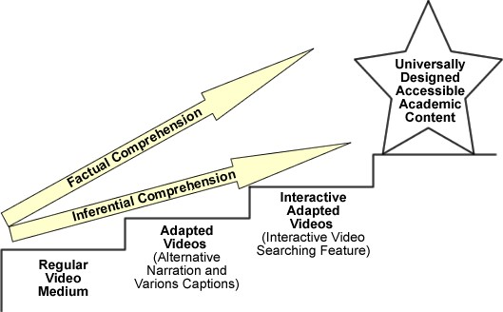
Figure 25. Effects of adapted videos on factual and inferential video comprehension by students with intellectual disabilities.
Adapted videos provide educators with much needed means to meet the legal requirements of the No Child Left Behind (2001) Act and the Individuals with
Disabilities Education Improvement Act (2004) and ensure students‟ active participation in grade and subject-linked academic activities (Agran, Cavin, Wehmeyer, & Palmer,
2006; Browder et al., 2007; Dymond & Orelove, 2001; Wehmeyer, Lance, & Bashinski, 2002). Alternative video narration, highlighted text and picture/word-based captions, and interactive video searching features offer innovative, universally designed solutions for students of all abilities to attempt and achieve high academic standards.
APPENDIX A
INFORMED ASSENT AND CONSENT FORMS FOR RESEARCH STUDY AND PILOT TESTING
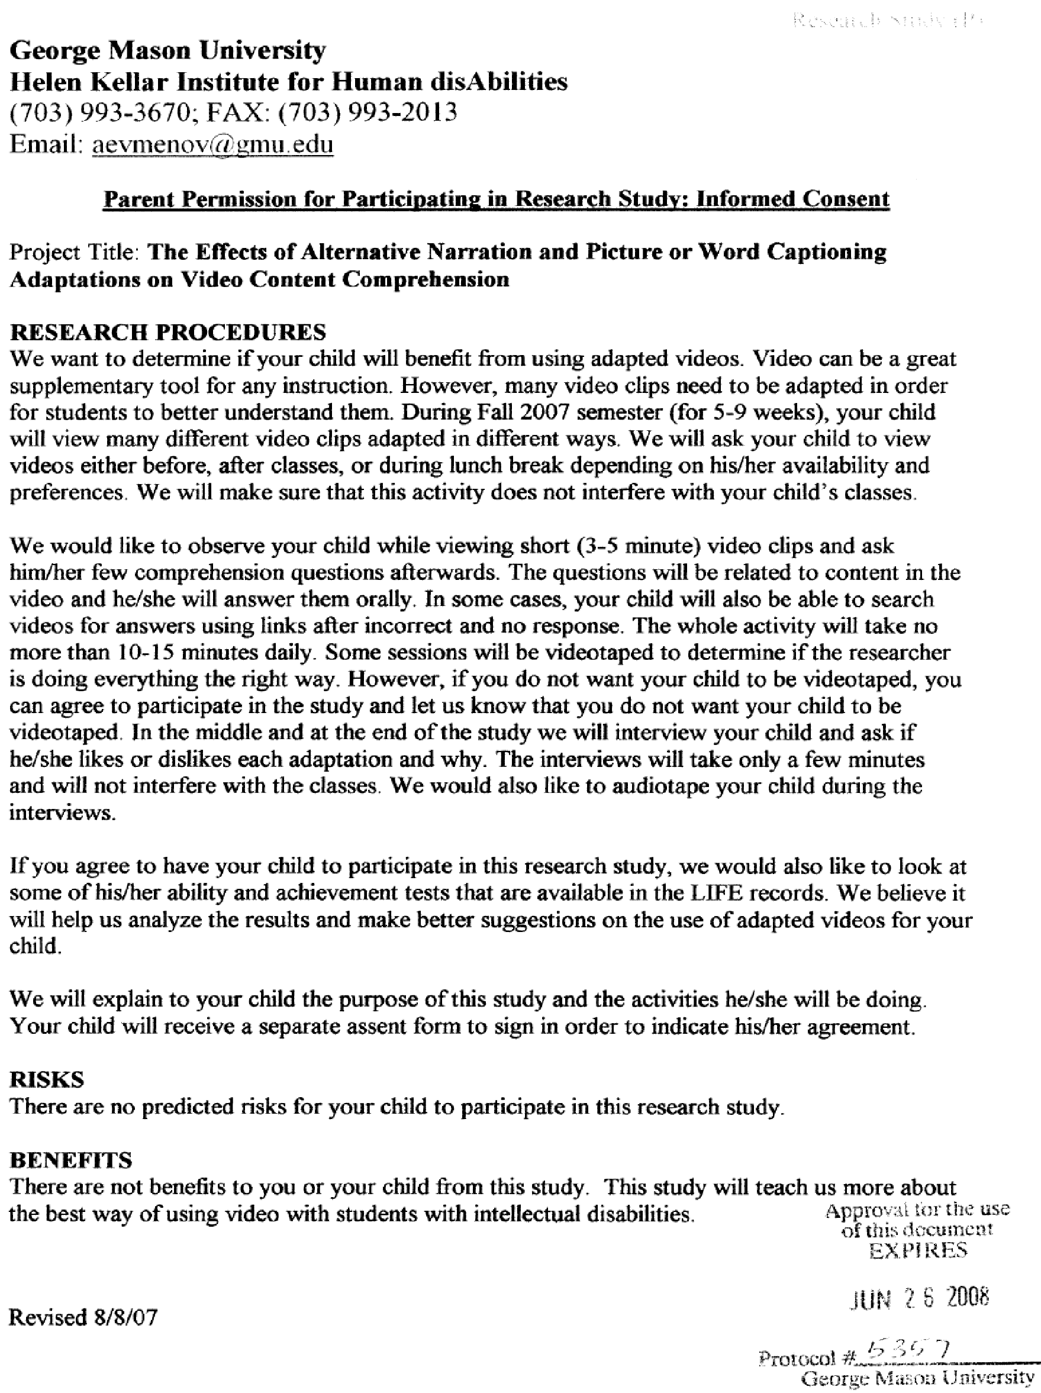
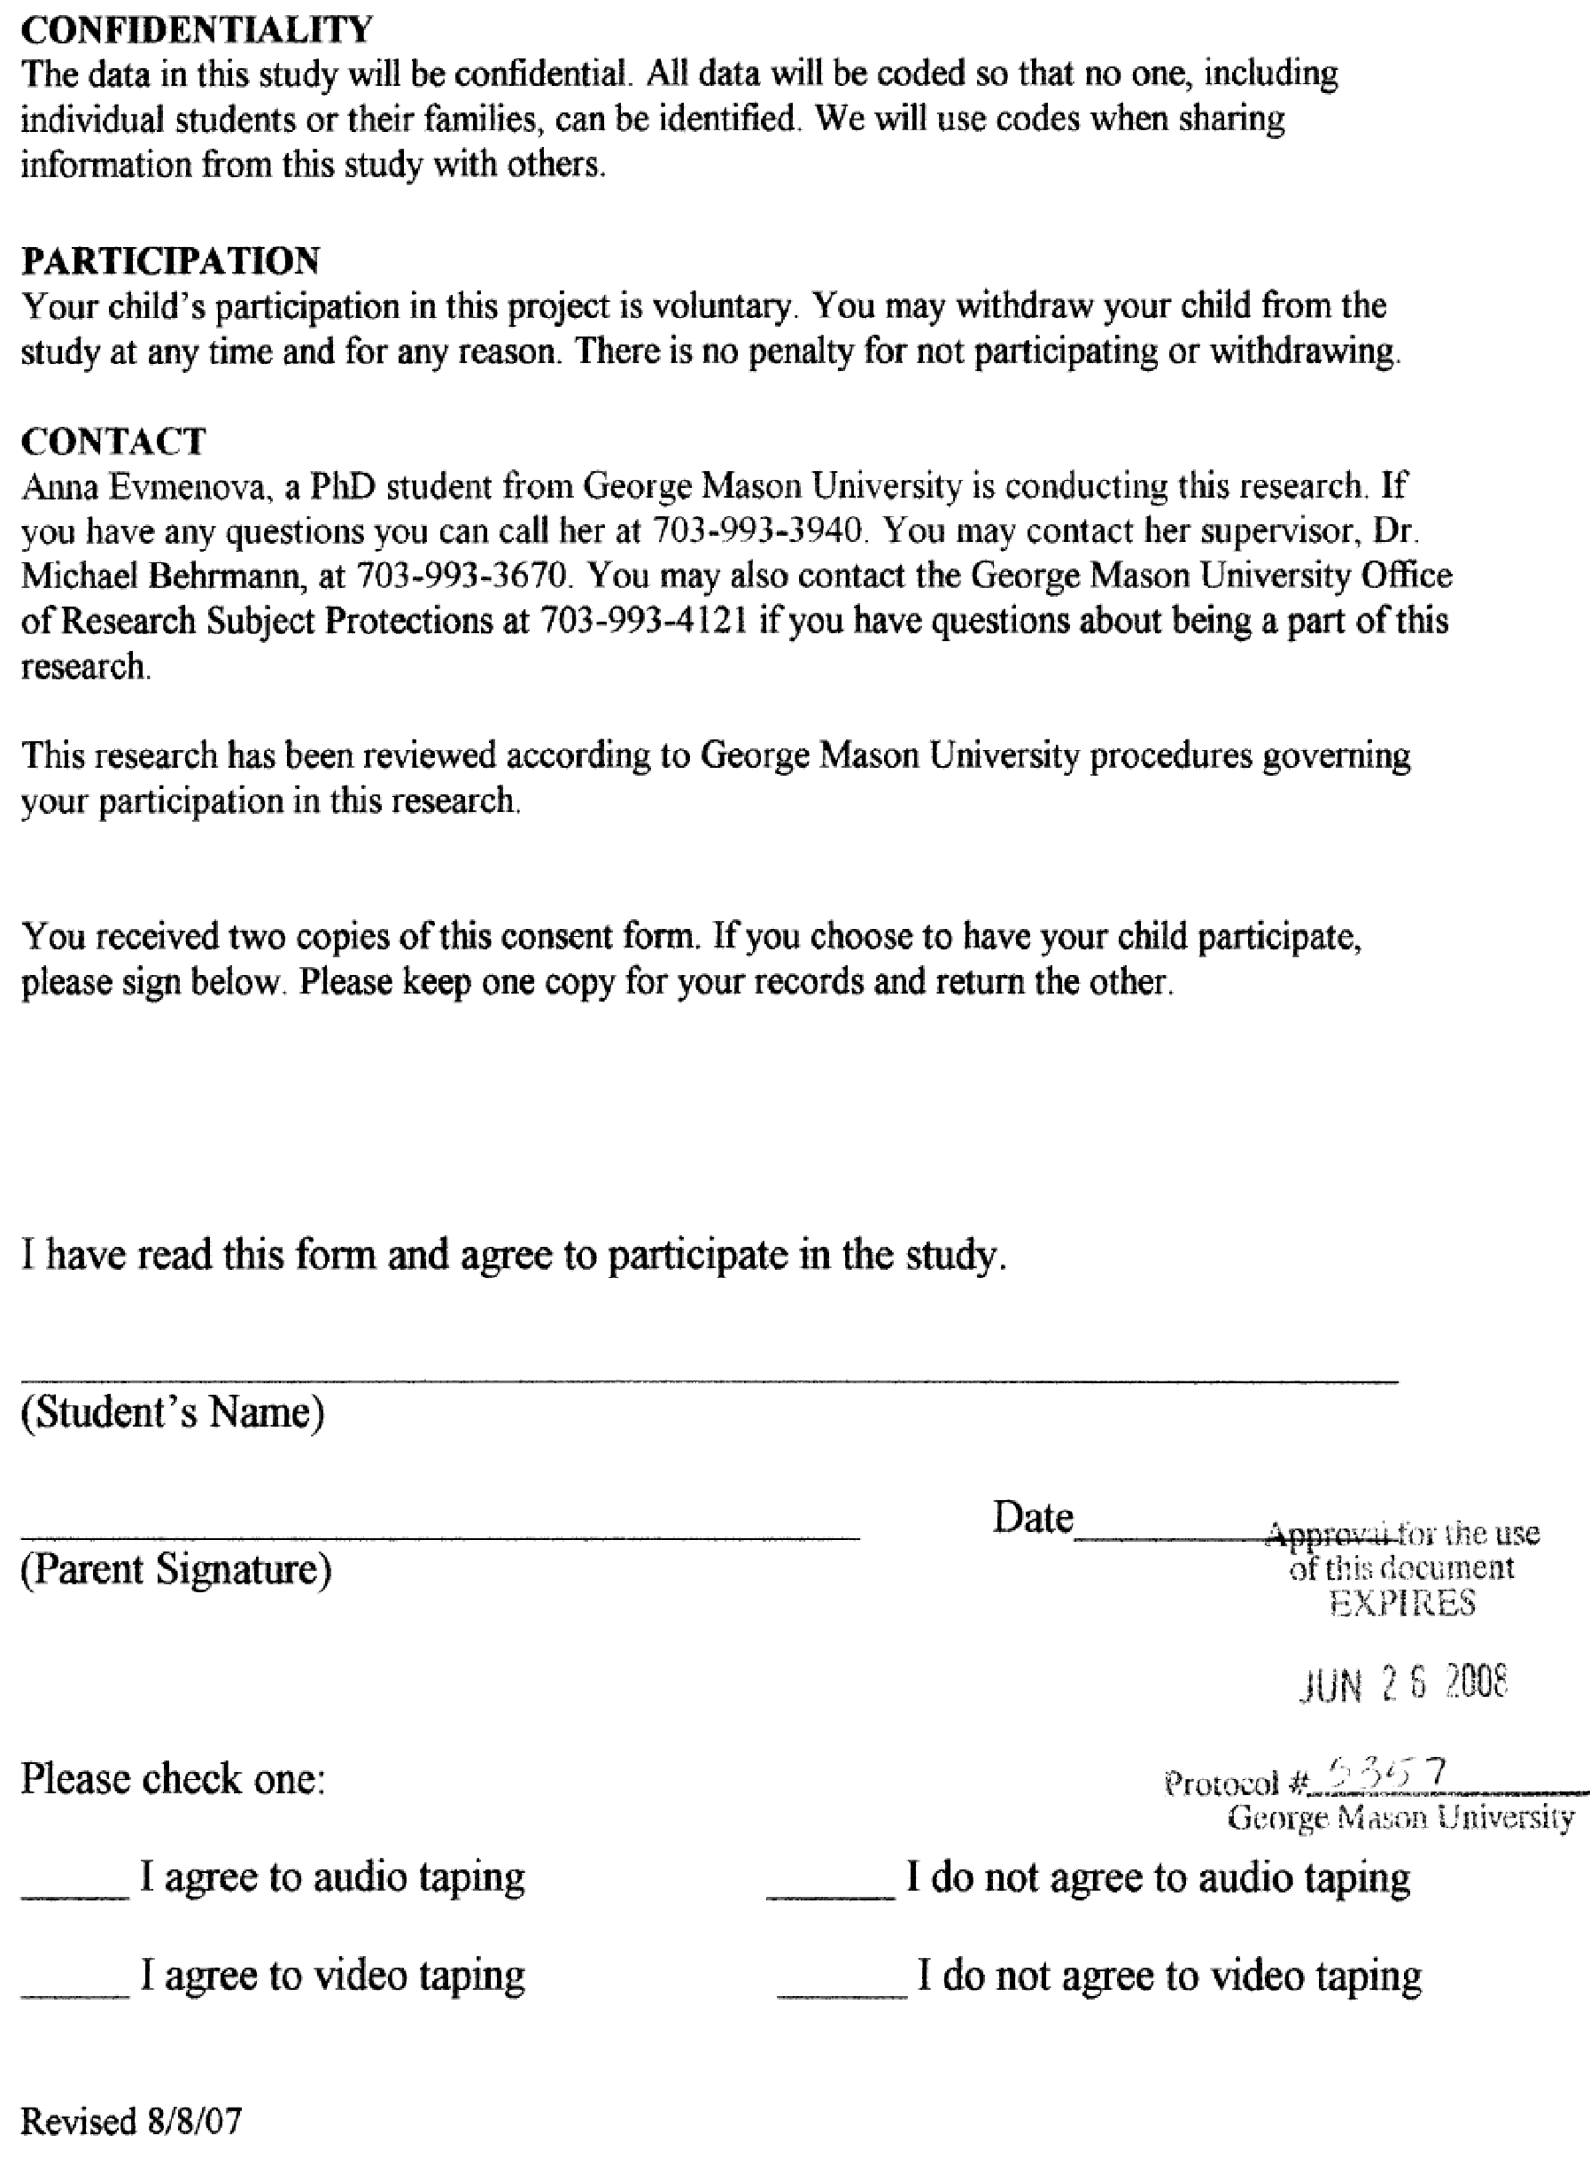
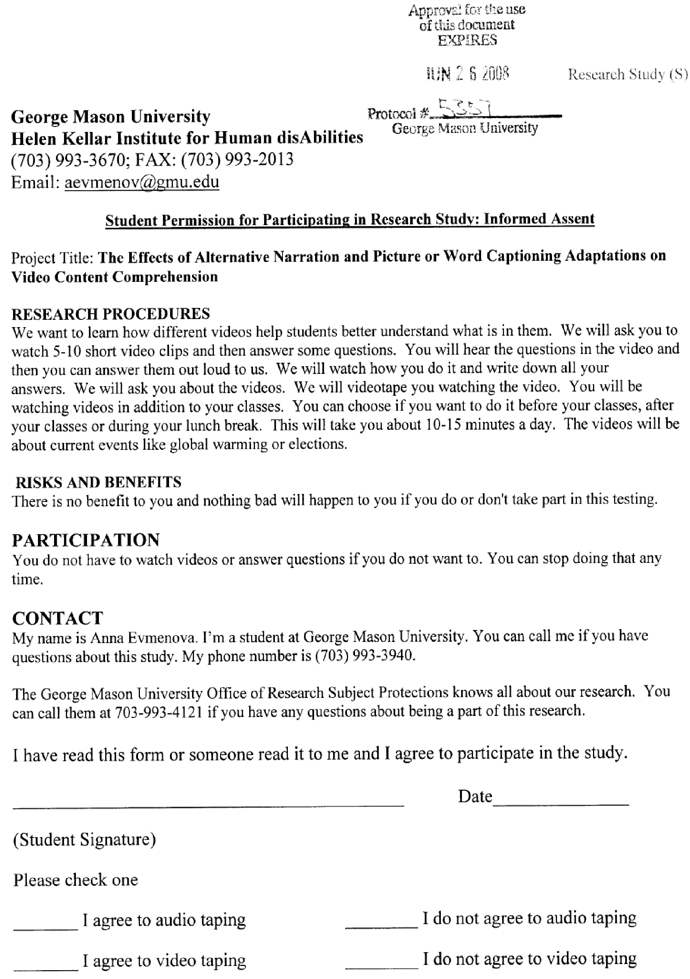
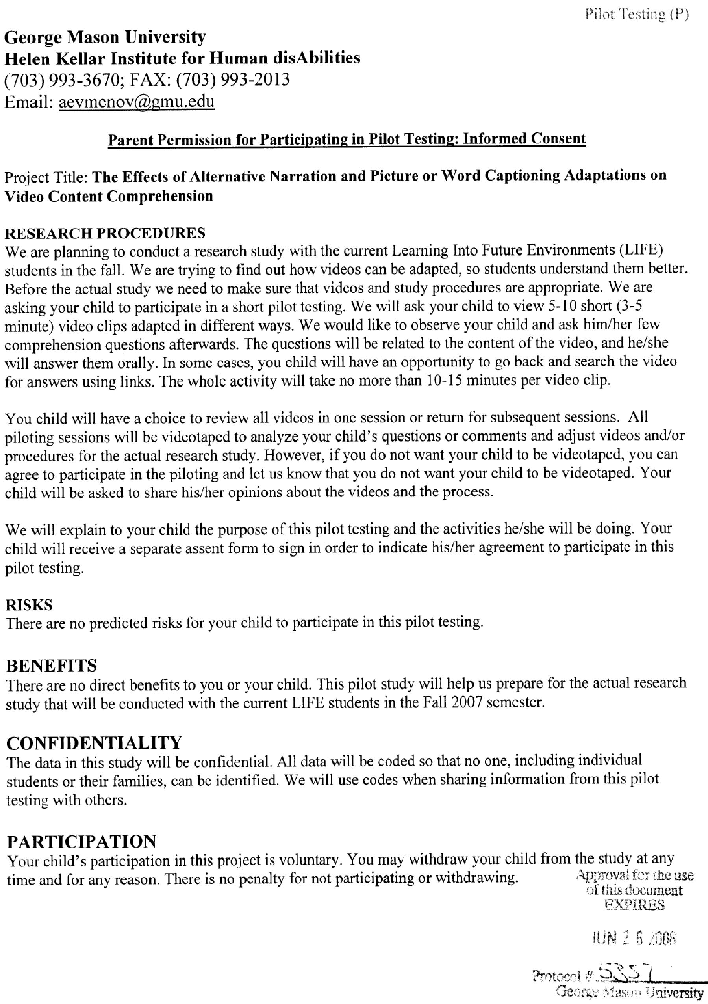
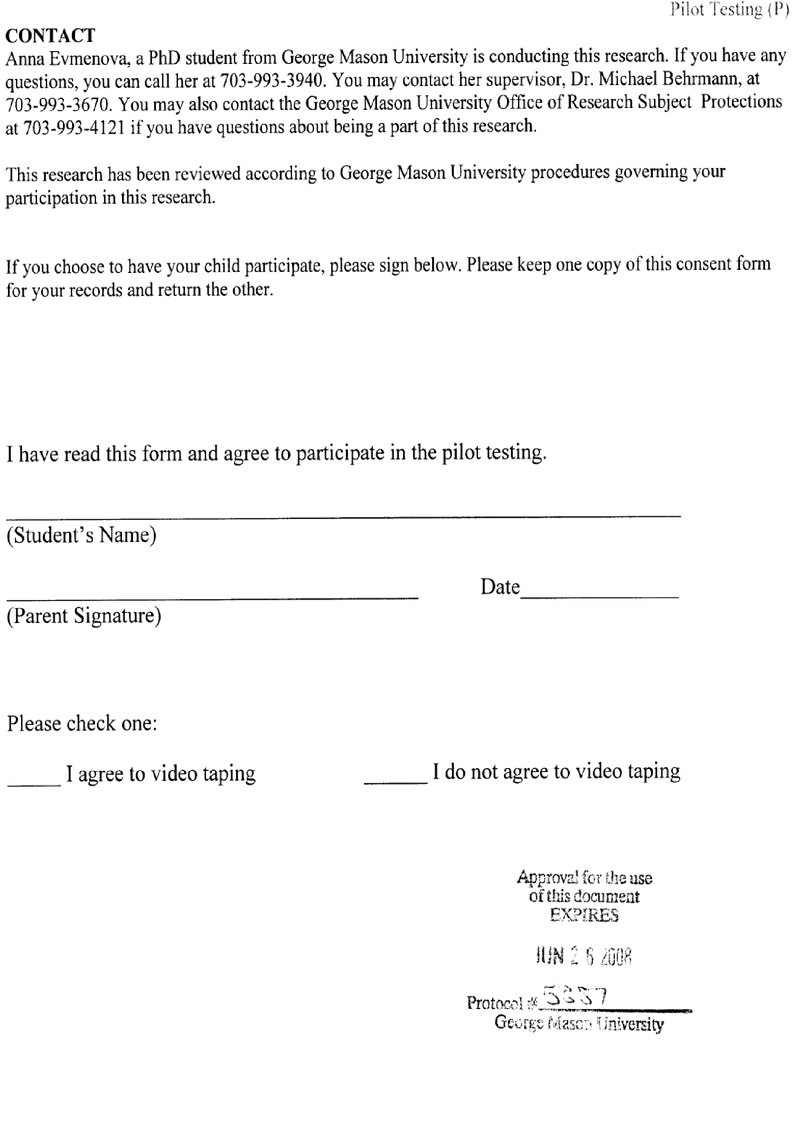
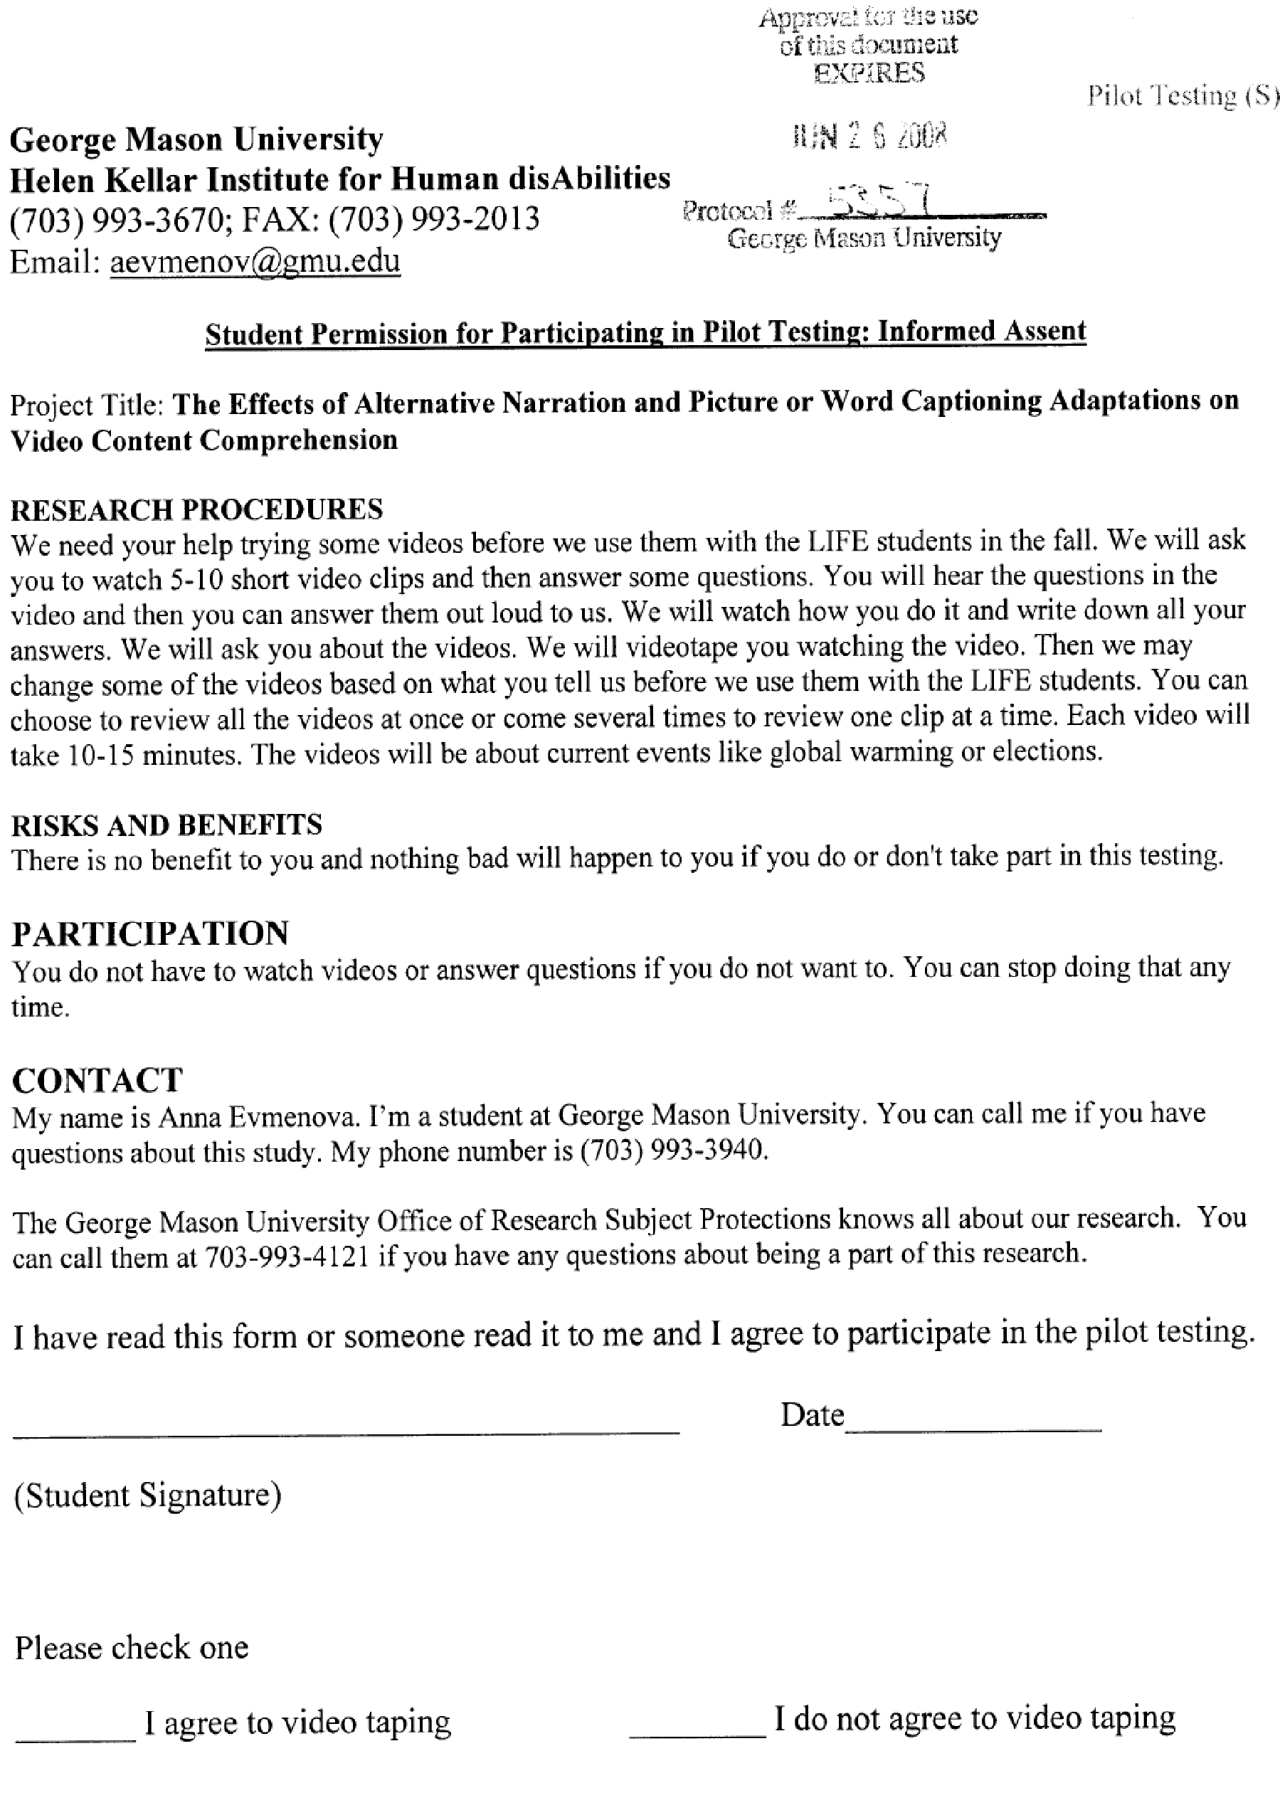
APPENDIX B
SAMPLE VIDEO SCRIPTS AND QUESTIONS

“Global Warming: Greenhouse Effect” Original Script (9.2 reading level)

So far we have seen how changes in the atmosphere‟s composition are harming the environment. But as bad as the problems that we‟ve seen so far are, there is another change going on that may prove even more deadly. Simply put, may experts warn tat the earth is getting a fever. That our climate is warming faster than normal. Known as the greenhouse effect, many think that this global warming is caused mostly by the build up of carbon dioxide and other gases in the atmosphere that our widespread use of fossil fuels, such as coal, oil, gasoline, and natural gas has produced since the industrial age began in 1850s.
Whenever these or anything else is burnt, carbon dioxide is released. This and other greenhouse gases form a blanket that traps some of the sun‟s energy. Thus, many scientists fear causing the earth climate to warm faster than normal. Just how fast this global warming is taking place and how far it would go is uncertain.
However, scientists are now beginning to get at least some idea of what to expect. Rising sea levels caused by the melting of the world‟s ice caps and the flooding that would accompany it, is one widely predicted result. Our agriculture could also suffer if abnormal warming made it impossible to grow crops, where they once were. Our forests could also be damaged if global warming killed off those trees that could not adapt fast enough to a warmer environment.

“Global Warming: Greenhouse Effect” Altered Script (4.6 reading level)

Our atmosphere is changing.
The earth is getting warmer.
The climate is getting warmer very fast.
Global warming happens because of the greenhouse effect.
Greenhouse effect happens because gases build up in the air.
Carbon dioxide and other gases are called greenhouse gasses.
The gases build up because we burn fossil fuels.
We burn coal, oil, gasoline, and natural gas. We began burning fossil fuels in 1850s, when the industry began.
When we burn fossils, gases go out in the air.
These greenhouse gases make a blanket around the earth.
That blanket traps the sun‟s energy. The heat is trapped inside.
That heat makes climate get warmer.
Global warming will make ice caps melt.
The sea levels will rise and many places will be flooded. If it gets warmer, the fruit and vegetables will not grow, where they usually grow.
Global warming will kill trees in forests, if they cannot adjust to a warmer weather. “Global Warming: Greenhouse Effect”
Comprehension Questions

Factual Recall
- Why does global warming happen?
  - Bad weather
  - The greenhouse effect *
  - The sun and the rain
  - Global warming does not exist.
- Why does greenhouse effect happen?
  - People paint houses green.
  - Greenhouse effect does not happen.
  - Because people use blankets.
  - Because gases build up in the air. * 3. Where do greenhouse gases come from?
  - Burning fossil fuels *
  - Space
  - Air
  - The ocean

Inferential Comprehension
4. Why do they say that people are responsible for global warming?
- People don‟t care about the Earth.
- People are not responsible at all.
- People like when it gets warmer.
- We burn fuels and global warming started when the industry began. * 5. What can we do to stop greenhouse effect and global warming?
- Spend more time in the sun
- Stop burning fossil fuels *
- There is nothing we can do to stop greenhouse effect.
- Get ready for warm weather
6. Why is global warming dangerous to things that grow?
- They will get hurt by all the snow.
- Global warming is not dangerous to things that grow.
- It‟s getting too cold for things that grow.
- Fruit, vegetables, trees will not grow the same way and die if it gets warmer. *

* Note: Options marked with an asterisk represent answers that will be counted as correct. The answers will be counted as partially correct if they are partially accurate, similar to the correct answer but not clearly stated, or entails an accurate idea but does not match a predetermined correct answer to a comprehension question. Other answers will be offered as multiple choice distractors.
APPENDIX C EXPERT PANEL CHECKLIST Name:
Script Title:
Directions: Please review video scripts and comprehension questions and mark the appropriate box for each of the items below.

1. The readability level of the altered, simplified script is below 6th | Yes | No
grade level according to Microsoft Word readability statistics.*

- 3 factual and 3 inferential comprehension questions are provided.

- Comprehension questions‟ format, style, and vocabulary match materials commonly used by the LIFE students.

Yes Some No
- The altered, simplified script conveys essential information from the original script.

- Factual questions are based on the information explicitly presented in both the original and simplified scripts.

- Answers to inferential questions can be implied from both the original and simplified scripts.

- Language and vocabulary are at the appropriate level for the LIFE students.

If you checked “Some” or “No”, please list the words that you would change and/or eliminate:

If you marked “Some” or “No” for any of the above statements, please suggest possible changes that could improve the scripts and questions. Use additional pages if needed.

- Note: To obtain readability statistics in Microsoft Word, select Options from the Tools menu. Select Spelling and Grammar tab. Check “Show readability statistics” and click OK. Highlight the simplified script and click Spelling and Grammar from the Tools menu.
APPENDIX D
INTERVENTION SCRIPT

Training:
(conducted prior to the beginning of the study in a research setting. All manipulations with the video were conducted on the laptop computer used in the study. The participants received training in small groups [2-3 study participants] according to their schedule).

DAY 1 TRAINIG:

Levels | Actions | Script
Introduction | 1. Introduce yourself
 | 2. Describe the project. | e.g., “Let me briefly describe the project that you agreed to participate in. With this project we are trying to figure out the best way to use video. You will watch short video clips each day.”
 | 3. Demonstrate a short segment of a regular video (e.g., about polar bears)
Oral  Level 1  Questions | 4. Demonstrate the questions | e.g., “After watching the video, you will see a black screen with a word „Questions‟ on it. Just like this one.” Show the questioning screen. “You will hear me say „it is time to answer questions‟. I will ask you 6 questions and you will answer them out loud, so I can hear you. You will have 30 seconds to answer. Let‟s practice”
 | 5. Practice answering questions. Ask an easy question (e.g., Question # 1) and ask a student(s) to answer it out loud. | e.g., “Question # 1 is „What is this video about?‟ Please, say your answer out loud, so I can hear it.”
 | 6. Do NOT provide any verbal prompting or feedback. | e.g., you can node, say “OK” or “uhh”

 | 7. Describe various treatments (video adaptations). | e.g., “Sometimes you will watch videos with some words at the top of the screen. You will see either highlighted words or words with pictures. Those words are called captions. Captions will help you understand and remember the  video.”
 | 8. Demonstrate a short segment of the video with highlighted text captions. | e.g., “Did you see highlighted words at the top of the screen? You can read and hear the text at the same time. After the video is over I will ask  you questions just like last time.”
 | 9. Practice answering questions. Read Question # 2 and ask a student to answer it out loud. | e.g., “Question # 2 is „Where do polar bears live?‟ Please, say your answer out loud, so I can hear it.” Wait for the student to answer. “So you will tell me your answer. If you do not know the answer, you can just say „I do not know.‟ But I want you to try your best to answer all of the questions.”
 | 10. Demonstrate a short segment of the video with picture-based captions. | “Let‟s watch a little bit more.” Show a segment of the video with picturebased captions. “This time, did you see the picture symbols with words at the top of the screen? Once again you can read and hear the text at the same time. And once again after the video is over I will ask you questions  and you will answer them out loud.”
 | 11. Practice answering questions. Ask a question (e.g., Question # 3). | e.g., “Question # 3 is “Where do polar bears spend time?‟ Just like that I will ask you to answer 6 questions about each video.”

Multiple  Choice  Level 2  Questions | 12. Describe the multiple choice questions level. | e.g., “After you answer all 6 questions for the first time, I may ask you the same questions for the second time. You will hear me say „Let‟s go back and answer some questions just one more time.‟ This time I will ask the question and give you a paper with that question printed on it, so you can hear and see the question at the same time.”
 | 13. Show an example of the printed question. Read the question out loud. | e.g., “Let‟s go back and answer the question 2.” Put the printed question in front of a student “Question 2 was „Where do polar bears live?”
 | 14. Describe multiple choices. | e.g., This time I will ask you to choose the correct answer from a list of multiple choices. I will ask you to please say the letter of the correct answer. It does NOT mean that your answers in the first round were wrong. This is just for us to see which way it is more convenient to answer questions. Let‟s practice”
 | 15. Repeat the question. Put the answer sheet with multiple choices in front of a student and ask to name the letter corresponding with the correct response. | e.g., “So where do polar bears live?” Provide the answer sheet. “Please choose the correct answer and say the letter of the correct answer out loud.”
 | 16. Do NOT provide any specific verbal prompting or feedback. | e.g., you can node, say “OK” or “uhh”
Conclusion | 18. Review Day 1 training. | e.g., “This is it for now. Today I showed you a regular video, a video with highlighted words, and a video with picture symbols. We practiced answering questions. Tomorrow I will show you some more interesting things about these videos.”
 | 19. At the end, praise for attending and answering questions. | e.g., “You are done! You did great today! You can leave now.”

DAY 2 TRAINING:

Levels | Actions | Script
Introduction | 1. Greetings
 | 2. Review the procedures | e.g., “I showed you yesterday different kinds of videos – regular ones, with highlighted words, and picture symbols on the top of the screen. We have also practiced answering questions. Let‟s practice some more”
 | 3. Play a short segment of adapted video
Oral  Level 1  Questions | 4. Announce questioning time, when the black screen with the word „Questions‟ appears. | e.g., “It is time to answer questions! Please say your answer out loud, so  I can hear it.”
 | 5. Practice asking questions. | e.g., “Question # 4 is „Where do polar bears give birth?”  Question # 5: “Why do polar bears have very thick fur?”  Question #6: “What do polar bears  like”  Just like that I will always ask you 6 questions about each video.”
 | 6. Do NOT provide any specific verbal prompting or feedback. | e.g., you can node, say “OK” or  “uhh”

Oral  Video  Searching Level  Questions | 7. Introduce searching the video level | e.g., “Sometime after you answer all 6 questions for the first time, I will ask you to go back and check your answers. It will not be for a grade but I want you to always try your best when answering questions.”
 | 8. Demonstrate the searching screen | e.g., “This screen is here to help you search the video for answers.” Point to the video screen. “It has short phrases about each of the questions you already answered with numbers by them.”
 | 9. Demonstrate and practice using the links corresponding to the number of the question in response to the prompt. | e.g., “When you hear me say, „Let‟s go back and check question #X‟, you will find the number I said and click on this red arrow with a mouse. Let‟s practice.  If I say „Let‟s go back and check question #X‟, show me which arrow you would click.” Repeat several times until students feel comfortable.
 | 10. Explain clicking on the arrow. | e.g., “When you click on the red arrow, you will see the questioning screen. At this time I will repeat the question for you. After you hear the question, the link will take you back in the video. You will see a tiny segment of the video that has the answer. So you need to watch carefully! Let‟s try. „Let‟s go back  and check Question # 4.‟
 | 11. Allow students to choose and click the link corresponding to question # 4. Review choosing the links process if needed.

 | 12. Ask the question when the questioning screen appears. Click on the invisible link under the word „Questions‟ to proceed to the video segment. | e.g., “Question #4 was – Where do polar bears give birth? Click on the invisible link under the word „Questions‟.
 | 13. Allow students to watch video segment. Repeat question when the searching screen reappears. | e.g., “So where do polar bears give birth. Please say your answer out loud so I can hear it.”  “Did you see how when you clicked the arrow, it showed you a tiny segment with the answer?”
 | 14. Review the ways questions can be asked | Sometimes I will ask you to say your answer out loud and sometimes I will ask you to pick the right answer just like last time. Let‟s try.”
 | 15. Announce searching the video | e.g., “Let‟s go back in the video and check some questions.”
 | 16. Announce the number of the question, wait for students to choose and click the link and read the question itself out loud when the questioning screen appears. Click the invisible link under the word „Questions‟ to proceed to the video segment. | e.g., “Let‟s check question # 5.” Wait for students to choose and click the link. “The question was – Why do polar bears have very thick fur? Let‟s check.” Click the invisible link under the word „Questions‟.
 | 17. Repeat the question after the video segment. | e.g., “So why do polar bears have very thick fur?” Please say your answer out loud, so I can hear it.  Repeat with Question #6
 | 18. Do NOT provide any specific verbal prompting or feedback. | e.g., you can node, say “OK” or  “uhh”

Multiple  Choice  Level 2  Questions | 19. Announce additional searching video time. | e.g., “You are doing a great job for me. Let‟s go back in the video and check some questions just one more time. But this time you will be able to choose an answer from some options.”
 | 20. Announce the number of the question. Wait for students to click the link. Put printed question in front of the student. Read the question out loud. Click the invisible link under the word „Questions‟ to proceed to the segment. | e.g., “Let‟s check the question # 5.” Wait for students to click the link.  Provide the paper. “Question #5 was – Why do polar bears have very thick fur? Let‟s check” Click invisible link under the word  „Questions‟
 | 21. Put a multiple choice answer sheet in front of a student. Ask to point and name the letter corresponding to the correct answer. | e.g., Provide an answer sheet “So why do polar bears have very thick fur?” Please choose the correct answer and name the letter (a, b, c, d)
 | 22. Do NOT provide any specific verbal prompting or feedback. | e.g., you can node, say “OK” or  “uhh”
Conclusion | 23. Review Day 2 training. | e.g., “This is it. Today I showed you how sometimes we are going to search the video for answers. Once again, sometimes you will say the correct answer or pick the correct answer. We will start watching videos on Monday.”
 | 24. At the end, praise for attending and answering questions. | e.g., “You are done! You did excellent today! You can leave now.”
INTERVENTION SCRIPT

BASELINE:

Levels | Actions | Script
Introduction | 1. Greetings | e.g., “Hello”
 | 2. Provide directions to start. | e.g., “Let‟s view the video. I want you to pay attention to the screen.”
3. Play the video *.
IMPORTANT: make video full screen (View-Full Screen).
Oral  Level 1  Questions | 4. Announce questioning time, when the black screen with the word „Questions‟ appears. | e.g., “It is time to answer questions! Say your answer out loud, so I can hear it.”
 | 5. Ask questions. | e.g., “Question #X is …”
 | 6. After asking each question, start a stopwatch. Record latency (time between a question and when a student answers). If a student does not respond within 30 seconds, move to the next question.
 | 7. Do NOT provide any specific verbal prompting or feedback. | e.g., you can nod, say “OK” or “uhh”
 | 8. Ask and allow students to answer all 6 questions before moving to the next level.
 | 9. If a student answers all of the questions correctly, move into the Conclusion section of the script.

 | 10. If a student does not answer any of the questions, or answers any of them incorrectly and/or partially correct, move into Multiple Choice Level 2 section of the script and re-ask those questions that were missed.
Multiple  Choice  Level 2  Questions  (if there is any  question that a  student  answered partially  correctly,  incorrectly,  or did not answer  during oral  Level 1 questions) | 11. Announce additional questioning time. | e.g., “Let‟s go back and answer some questions just one more time. But this time you will be able to choose an answer from some options.”
 | 12. Go back to each question a student did not answer, answered incorrectly or partially correct. Repeat one question at a time.
 | 13. Put the printed question in front of the student. Read the question out loud. | e.g., “Let‟s go back to question #X.” Provide the printed question.  “Question #X was …”
 | 14. Put the answer sheet with multiple choices in front of a student and ask to name the letter corresponding with the correct response. | e.g., Provide the answer sheet.  “Please choose the correct answer and say the letter of the correct answer out loud (a, b, c, or d).”
 | 15. After asking a student to name the letter of the correct answer, start a stopwatch. Record latency. If a student does not respond within 30 seconds, move to the next question.
 | 16. Do NOT provide any specific verbal prompting or feedback. | e.g., you can nod, say “OK” or  “uhh”
 | 17. Revisit all the questions that a student did not answer, answered incorrectly or partially correct during oral Level 1 questioning.
Conclusion | 18. Review video topic and assess students‟ background knowledge.  REMEMBER: to record students‟ answers. | e.g., “Today we watched the video about X. Did you know anything about this topic before we started watching the video? If yes, could you share with me what you knew?”
 | 19. At the end, praise for attending and answering questions | e.g., “You are done! You did well today! You can leave now.”

- From the CD open the file with following name: Name_controller.swf (e.g., Global Warming and Islands_controller.swf)
INTERVENTION SCRIPT

TREATMENTS:

Levels | Actions | Script
Introduction | 1. Greetings | e.g., “Hello”
 | 2. Provide attentional cues to a specific adaptation | e.g., “Today while watching the video, you will see highlighted words/pictures with words captions at the top of your screen. I want you to pay special attention to them.”
 | 3. Provide directions to start | e.g., “Let‟s view the video. I want you to pay attention to the screen.”
 | 4. Play the video
Oral  Level 1  Questions | 5. Announce questioning time, when the black screen with the word „Questions‟ appears. | e.g., “It is time to answer questions! Say your answer out loud, so I can hear it.”
 | 6. After asking each question, start a stopwatch. Record latency (time between a question and when a student answers). If a student does not respond within 30 seconds, move to the next question.
 | 7. Do NOT provide any specific verbal prompting or feedback. | e.g., you can nod, say “OK” or “uhh”
 | 8. Ask and allow students to answer all 6 questions before moving to the next level.
 | 9. If a student answers all the questions correctly, move into the Conclusion section of the

 | script.
 | 10. If a student does not answer any of the questions, or answers any of them incorrectly and/or partially correct, move into Video Searching section of the script and re-ask those questions that were missed.
Oral  Video  Searching Level  Questions  (if there is any question that a  student  answered partially  correctly,  incorrectly,  or did not answer  during oral  Level 1 questions) | 11. Announce searching the video when the searching screen appears. | e.g., “You did a good job today. Let‟s go back in the video and check some answers.”
 | 12. Go back to each question a student did not answer, answered incorrectly or partially correct. Repeat one question at a time.
 | 13. Announce the number of the question to search. Search one question at a time. | e.g., “Let check question # X.
 | 14. Allow a student to click the corresponding link on the searching screen.
 | 15. Do NOT provide any specific verbal prompting or feedback even if the student selected the wrong link (if a student selected the wrong link, the answer will be recorded as incorrect). | e.g., you can nod, say “OK” or  “uhh”
 | 16. Ask the question when the questioning screen appears. Click the invisible link under the word „Questions‟ to proceed to video segment. | e.g., “The question #X was … Let‟s check.” Click the invisible  link under the word „Questions‟

 | 17. Allow a student to watch the video segment corresponding to the question. Repeat the question when the searching screen re-appears. | e.g., “So what/when/how …”
 | 18. After asking each question for the second time (after watching video segment), start a stopwatch. Record latency. If a student does not respond within 30 seconds, move to the next question that needs to be searched for.
 | 19. Do NOT provide any specific verbal prompting or feedback. | e.g., you can nod, say “OK” or  “uhh”
 | 20. Allow searching for each question a student missed in oral Level 1 questioning.
 | 21. If a student answers all the revisited questions correctly, move into the Conclusion section of the script.
 | 22. If a student still missed any of the questions, move into Multiple Choice Level 2 section of the script and re-ask those questions that were missed during the Video Searching phase.
Multiple  Choice  Level 2  Questions**  (if there is any | 23. Announce additional questioning time. | e.g., “You are doing a great job for me. Let‟s go back in the video and check some questions just one more time. But this time you will be able to choose an answer from some options.”

questions that a  student  answered partially  correctly  incorrectly, ,  or did not answer  during oral Video  Searching  questions)  ** In the treatment phase, multiple choice Level 2 questions will also include Video Searching  elements | 24. Go back to each question a student did not answer, answered incorrectly or partially correct during oral Video Searching questions.  Repeat one question at a time.
 | 25. Announce the number of the question. | e.g., “Let‟s check the question #X.”
 | 26. Allow a student to click the corresponding link on the searching screen.
 | 27. Do NOT provide any specific verbal prompting or feedback even if a student selected the wrong link (if a student selected the wrong link, the answer will be recorded as incorrect). | e.g., you can nod, say “OK” or  “uhh”
 | 28. Put printed question in front of a student when the questioning screen appears. Read the question out loud. Click the invisible link under the word „Questions‟ to proceed to the video segment. | e.g., Provide the printed question.  “Question #X was … Let‟s check.” Click the invisible link under the word „Questions‟.
 | 29. Allow a student to watch the video segment corresponding to the question.
 | 30. Repeat the question when the searching screen re-appears. Put a multiple choice answer sheet in front of a student and ask to name the letter corresponding with the correct response. | e.g., “So what/when/how …”  Provide an answer sheet. Please choose and name the letter for the correct response (a, b, c, or d).”
 | 31. After asking a student to point to the answer, start a stopwatch. Record latency. If a student does not respond within 30 seconds, move to the next question.
 | 32. Do NOT provide any specific verbal prompting or feedback. | e.g., you can nod, say “OK” or  “uhh”
 | 33. Allow searching each question a student missed in oral Video Searching level questioning.
 | 34. Even if there are still questions that a student did not answer, answered incorrectly or partially correct after all the above levels/phases, move into the Conclusion section of the script
Conclusion | 35. Review topic and check background knowledge. REMEMBER: to record students‟ answers. | e.g., “Today we watched the video about X. Did you know anything about this topic before we started watching the video? If yes, could you share with me what you knew?”
 | 36. At the end, praise for attending and answering questions. | e.g., “You are done! You did excellent today! You can leave now.”

- From the CD open the file with following name: Name_controller.swf (e.g., Global Warming and Islands_controller.swf)

APPENDIX E
DATA COLLECTION SHEET
Student: _____________________________
Observer: ____________________________
Adaptation: __________________________
Date: ___________________________________________
Beginning Time: __________________________________
Ending Time: ____________________________________
Length of the Video: _______________________________
328

 | Response* | Latency | Respons  searching t | e* after  he video | Latency after searching the video | Respons multiple | e * after  choice | Latency after multiple choice
Factual Question #1
Factual Question #2
Factual Question #3
Inferential Question #4
Inferential Question #5
Inferential Question #6

Oral Level 1 Questions Oral Video Searching Questions Multiple Choice Level 2 Questions **

*Behavior Code: correct response (+); partially correct response (1/2); incorrect response (–); no response (0)
** Multiple choice Level 2 questions phase entails difference in baseline and treatment. Refer to Intervention Script for details. 328

Data Summary:

Total number of correctly answered factual questions: __________________
Total number of correctly answered inferential questions: _______________
Average latency for the factual questions: ____________________________
Average latency for inferential questions: ____________________________

Total number of correctly answered factual questions after searching the video: _____________
Total number of correctly answered inferential questions after searching the video: __________
Average latency for the factual questions after searching the video: _______________________ Average latency for inferential questions after searching the video: _______________________
329

Total number of correctly answered factual questions after multiple choice: _____________
Total number of correctly answered inferential questions after multiple choice: __________
Average latency for the factual questions after multiple choice: _______________________ Average latency for inferential questions after multiple choice: _______________________

Anecdotal Notes:
______________________________________________________________________________________________________
______________________________________________________________________________________________________ ______________________________________________________________________________________________________
329

APPENDIX F
PRIOR KNOWLEDGE RUBRIC

Date: __________________________________________

Student: ________________________________________

Video Name: ____________________________________

 | Criteria
1  . Extensive | A student demonstrates extensive and relevant knowledge on the topic portrayed in the video. A student shares only a few facts from previous knowledge but they cover the main concept/ideas of the video. Prior knowledge is sufficient to answer comprehension question(s).
2  . Medium | A student shares 1-3 facts on the topic. A student knows something about the topic but the prior knowledge does not cover all the ideas represented in the video and is not sufficient to answer comprehension question(s).
3  . None | A student does not have any prior knowledge on the topic portrayed in the video.
4  . Not Relevant | A student shares some previous knowledge on the topic portrayed in the video but it is not relevant to the ideas/concepts covered in the video and/or comprehension questions.

Comments: ______________________________________________________________
________________________________________________________________________
________________________________________________________________________ APPENDIX G
FIDELITY OF TREATMENT CHECKLIST: BASELINE

Observer: __________________________ Condition: __________________________
Student: ___________________________ Date: ______________________________
Note: Mark each step completed or not completed by the researcher. The fidelity of treatment will be calculated by dividing the number of steps completed by the number of steps planned.

Baseline Yes  1. Ensures that computer is on and a regular video clip is provided | No
according to the schedule.

- Provides task directions according to the intervention script.

- Ensures a student has an opportunity to watch video from the beginning to the end.

- Announces questioning time according to the intervention script.

- Ensures that a student has 30 seconds in order to answer a question before moving to the subsequent question during all levels/phases.

- Provides an opportunity to answer all 6 questions before moving to the next level.

- Records the answers according to the data collection sheet.

- If a student answers all the questions correctly in oral Level 1 questions, concludes the session according to the intervention script.

- If a student answers any of the questions incorrectly, partially correct, or does no answer at all, moves into Level 2 Questions and re-asks all questions that were missed in Level 1 Questions.

- Provides a printed question and a multiple choice answer sheet for each question that a student missed in oral Level 1 questions.
.
- Inquires about students‟ background knowledge on the topic.

- Researcher uses vocabulary at students‟ age/ability level.
FIDELITY OF TREATMENT CHECKLIST: TREATMENT

Observer: __________________________ Condition: __________________________
Student: ___________________________ Date: ______________________________

Note: Mark each step completed or not completed by the researcher. The fidelity of treatment will be calculated by dividing the number of steps completed by the number of steps planned.

Treatment  1. Ensures that computer is on and an adapted video clip is provided | Yes | No
according to the schedule.

- Provides treatment condition according to the randomly assigned schedule.

- Provides task directions according to the intervention script.

- Provides attention cues to a specific adaptation according to the intervention script.

- Ensures a student has an opportunity to watch video from the beginning to the end.

- Announces question time according to the intervention script.

- Ensures that a student has 30 seconds in order to answer a question before moving to the subsequent question in all levels/phases.

- Provides an opportunity to answer all 6 questions before moving to the next level.

- Records the answers according to the data collection sheet.

- If a student answers all the questions correctly in oral Level 1 questions, concludes the session according to the intervention script.

- If a student answers any of the questions incorrectly, partially correct, or does not answer at all, moves into oral Searching Video.

- Provides prompts to search the video for all questions that a student
missed in oral Level 1 questioning.
13. Announces the number of the question that needs to be searched
one at a time and allows a student to select the corresponding link without any additional prompts.

14. Allows a student to hear and respond to all missed questions after
repeated video viewing.

- Records the answers according to the data collection sheet.

- If a student answers all the questions correctly in oral Video
Searching, concludes the session according to the intervention script.

- If a student answers any of the questions incorrectly, partially correct, or does no answer at all, moves into Level 2 Questions and re-asks all questions that were missed in oral Video Searching.

- Provides prompts to search the video for all questions that a student
missed in oral Video Searching level questioning.

- Announces the number of the question that needs to be searched one at a time and allows a student to select the corresponding link without any additional prompts.

- Provides a printed question and a multiple choice answer sheet for each question that a student missed in oral Video Searching.

- Records the answers according to the data collection sheet.

- Inquires about students‟ background knowledge on the topic.

- Researcher uses vocabulary at students‟ age/ability level.

Notes:
________________________________________________________________________
________________________________________________________________________
________________________________________________________________________ APPENDIX H INTERVIEW QUESTIONS
- Do you like videos in general?
- Did you like coming here and watching all these videos?
- Would it be great if your teachers always used video clips in the classroom?
- Do you learn and remember things better when a teacher tells you or when you watch a video?
- There were many different types of videos that you watched this semester. Which one was your favorite? Point to your favorite one.
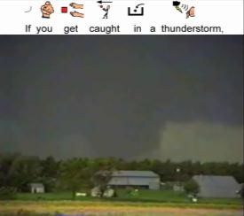
(Note: The larger pictures were actually shown to students.)
- What did you like/dislike about text captioning?
- What did you like/dislike about picture symbol-based captioning?
- Were you looking at the words/pictures on the top of the screen or were you looking only at the video?
- Which videos made it easy to answer questions?
- Did you like it better when you watched real videos or pictures that didn‟t move?
- What did you think about searching the video for answers using the links?
- Did red arrows help you answer questions?
- Was it fun to go back and see a tiny segment of the video that had the answer?
- What did you like about watching the video the most and why?
- Would you like to watch videos like that again in the future?
- What kind of things have we learned with all these videos? Give me examples.
APPENDIX I
REFERENCE LIST OF UNITEDSTREAMING VIDEOS
Al Qaeda after 9/11. Discovery Channel School (n.d.). Retrieved February 1, 2008, from unitedstreaming: http://streaming.discoveryeducation.com/
Commander in Chief: Bill Clinton. Discovery Channel School (2001). Retrieved February 1, 2008, from unitedstreaming: http://streaming.discoveryeducation.com/
Coral Reef Biomes: Essential and Endangered. Rainbow Educational Media (1999).
Retrieved February 1, 2008, from unitedstreaming:
http://streaming.discoveryeducation.com/
Dropout Prevention: Nowhere to Go. United Learning (1991). Retrieved February 1, 2008, from unitedstreaming: http://streaming.discoveryeducation.com/
Exploring Weather: Severe Weather. United Learning (1993). Retrieved January 31,
2008, from unitedstreaming: http://streaming.discoveryeducation.com/
Food Into Fuel: Our Digestive System. Rainbow Educational Media (1992). Retrieved February 1, 2008, from unitedstreaming: http://streaming.discoveryeducation.com/
Hooked: The Addiction Trap - Part 1: What is Addiction?. United Learning (1999).
Retrieved February 1, 2008, from unitedstreaming:
http://streaming.discoveryeducation.com/
Hooked: The Addiction Trap - Part 2: The Consequences of Addiction. United Learning (1999). Retrieved February 1, 2008, from unitedstreaming:
http://streaming.discoveryeducation.com/
Hooked: The Addiction Trap - Part 3: Alternatives to Addiction. United Learning (1999).
Retrieved February 1, 2008, from unitedstreaming:
http://streaming.discoveryeducation.com/
Hurricanes, Tornadoes, and Thunderstorms. Rainbow Educational Media. (1997).
Retrieved January 31, 2008, from unitedstreaming:
http://streaming.discoveryeducation.com/
Life Science: Viruses. Discovery Channel School (2002). Retrieved January 31, 2008, from unitedstreaming: http://streaming.discoveryeducation.com/
Live Right, Grow Right: It's the Only Body You've Got. Rainbow Educational Media (1997). Retrieved February 1, 2008, from unitedstreaming:
http://streaming.discoveryeducation.com/
Marijuana Update. United Learning (1997). Retrieved February 1, 2008, from unitedstreaming: http://streaming.discoveryeducation.com/
Marijuana: Why and How to Say No. United Learning (1996). Retrieved February 1,
2008, from unitedstreaming: http://streaming.discoveryeducation.com/
Natural Disasters. Discovery Education (2007). Retrieved January 31, 2008, from unitedstreaming: http://streaming.discoveryeducation.com/
Our Federal Government: Electing A President: The Process. Rainbow Educational Media (2004). Retrieved January 31, 2008, from unitedstreaming:
http://streaming.discoveryeducation.com/
Our Federal Government: Electing A President: The Process. Rainbow Educational Media (2004). Retrieved February 1, 2008, from unitedstreaming:
http://streaming.discoveryeducation.com/
Our Federal Government: The Legislative Branch. Rainbow Educational Media (2004).
Retrieved January 31, 2008, from unitedstreaming:
http://streaming.discoveryeducation.com/
Our Federal Government: The Legislative Branch. Rainbow Educational Media (2004).
Retrieved February 1, 2008, from unitedstreaming:
http://streaming.discoveryeducation.com/
Our Federal Government: The Presidency. Rainbow Educational Media (2004).
Retrieved February 1, 2008, from unitedstreaming:
http://streaming.discoveryeducation.com/
Power Up: Energy in Our Environment. Rainbow Educational Media (1992). Retrieved January 31, 2008, from unitedstreaming: http://streaming.discoveryeducation.com/
Reality Matters: Drugs: Deadly Highs. Discovery Channel School (2001). Retrieved February 1, 2008, from unitedstreaming: http://streaming.discoveryeducation.com/
Understanding: Viruses. Discovery Channel School (1997). Retrieved February 1, 2008, from unitedstreaming: http://streaming.discoveryeducation.com/
Water: Friend and Foe. Discovery Channel School (2004). Retrieved January 31, 2008, from unitedstreaming: http://streaming.discoveryeducation.com/
Wonders of Weather. Discovery Channel School (1996). Retrieved January 31, 2008, from unitedstreaming: http://streaming.discoveryeducation.com/
APPENDIX J
DESCRIPTION OF CAMTASIA STUDIO SCREEN RECORDER SOFTWARE

Description: Camtasia Studio Screen Recorder Software by TechSmith
Corporation is a program designed to record, edit, and publish video-based materials and presentations. Camtasia Studio incorporates a myriad of various features that can be used for producing multimedia products. From recording full motion narrated videos of anything on the computer screen to enhancing the video with zooming and captions, this program allows for easy development of video-based activities. Some of the other video enhancement features include: editing video and audio; creating title pages; using callouts and other interactive options; designing interactive quizzes and tests. Due to the unique nature of captions proposed for this study, the existing captioning feature was not utilized. However, for other projects, Camtasia Studio can be used to easily make any video/audio recording accessible via adding text captioning as an overlay or below the video screen. In this project, the program was used to slice and join video and audio tracks for existing video clips. Highlighted text and picture/word-based sentence strips were added to the video screen and synchronized with the narration. Still frames (e.g., questioning and searching screens) were created using text, clip art, and picture symbols. The callouts in the form of red arrows were added and linked to the appropriate time marks corresponding to the video segments containing correct answers. The final version of the adapted video was published using Camtasia Studio Flash Movie video file format to ensure its compatibility with the computer.

TechSmith Corporation
2405 Woodlake Drive
Okemos, MI 48864-5910 USA
Tel.: (800) 517-3001 (517) 381-2300 http://www.techsmith.com
Price: $299
APPENDIX K
DESCRIPTION OF WRITING WITH SYMBOLS 2000 SOFTWARE

Description: Writing with Symbols (WWS) 2000 is software developed and distributed by Mayer-Johnson LLC, a renowned provider of various augmentative and alternative communication hardware and software products. It is a picture-based word processing program that incorporates features of a standard word processing program enhanced by line drawings assigned to each word (if needed). WWS 2000 has a large library of picture symbols, including black, write, and color Mayer-Johnson Picture Communication Symbols (PCS) and Rebus symbols (black and white) that are displayed as each word is typed. The program allows the user to adjust font size, style, text, and background color as well as to alter graphics appearance and location against the text. In most cases, WWS 2000 offers a choice of images appropriate for one word. Furthermore, extra symbols and photos can be imported. WWS 2000 includes many additional features that students with disabilities can benefit from while working with the program, including a pictorial spell checker, text-to-speech, and grids for overlays. WWS 2000 can be used for creating literacy support materials such as picture stories, directions, schedules, etc. Teachers can use it to create instructional materials, while students with printed related difficulties can use it to write by selecting the symbols. For the purposes of this study, WWS 2000 program was used to create caption sentence strips with a picture symbol appearing on the top of each word. The example can be seen in Figure 4 on page 169.

Mayer-Johnson LLC
PO Box 1579
Solana Beach, CA 92075-7579
Tel: (800) 588-4548 (858) 500-0084
http://www.mayer-johnson.com
Price: $199-219

Picture Communication Symbols © 1981-2007 by Mayer-Johnson LLC. All Rights Reserved Worldwide. Used with permission.
APPENDIX L SAMPLE LEVEL 2 MULTIPLE CHOICE MATERIALS
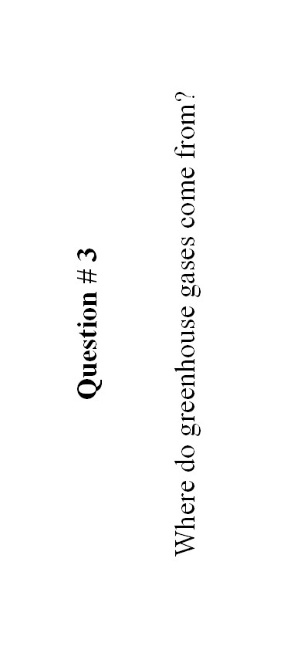

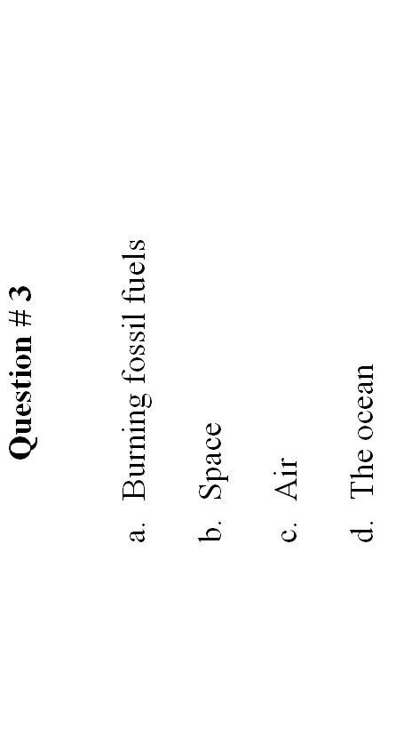
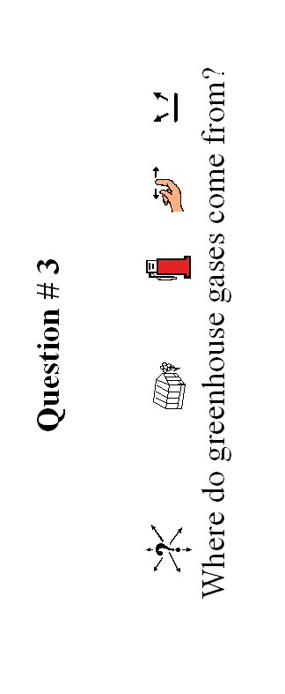

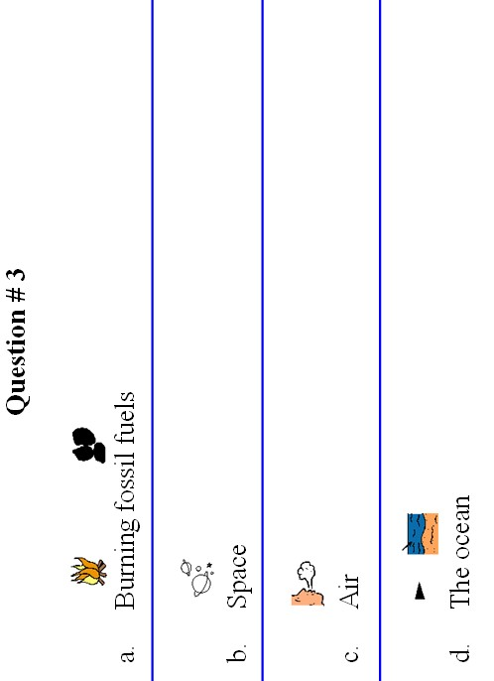

APPENDIX M
RANDOM ASSIGNMENT OF STUDENTS TO INTERVENTION CONDITIONS IN THE PRIMARY STUDY
344

Participants | 9  24  / | 9  25  / | 9  26  / | 9  27  / | 9  28  / | 10  1  / | 10  2  / | 10  3  / | 10  4  / | 10  5  / | 10  8  / | 10  9  / | 10  10  / | 10  11  / | 10  12  / | 10  15  / | 10  16  / | 10  17  / | 10  18  / | 10  19  / | 10  12  / | 10  23  / | 10  24  / | 10  25  / | 10  26  /
Experiment 1  Student V  Student N  Student G  Student C  Student K | 1  1  1  1  1 | 1  1  1  1  1 | 1  1  1  1  1 | 1  1  1  1  1 | 1  1  1  1  1 | 2  1  1  1  1 | 3  1  1  1  1 | 2  1  1  1  1 | 3  3  1  1  1 | 2  2  1  1  1 | C  O  L  U  M | 3  3  1  1  1 | 2  2  2  1  1 | 3  3  3  1  1 | 2  2  2  1  1 | 3  3  3  3  1 | 2  2  2  2  1 | 3  3  3  3  1 | 2  2  2  2  2 | 3  3  3  3  3 | 2  2  2  2  2 | 3  3  3  3  3 | 2  2  2  2  2 | 3  3  3  3  3 | 2  2  2  2  2
Experiment 2  Student J  Student L  Student A | 1  1  1 | 1  1  1 | 1  1  1 | 1  1  1 | 1  1  1 | 4  1  1 | 5  1  1 | 4  1  1 | 5  5  1 | 4  4  1 | B  U  S  D  A  Y | 5  5  1 | 4  4  4 | 5  5  5 | 4  4  4 | 5  5  5 | 4  4  4 | 5  5  5 | 4  4  4 | 5  5  5 | 4  4  4 | 5  5  5 | 4  4  4 | 5  5  5 | 4  4  4
Student R | 1 | 1 | 1 | 1 | 1 | 1 | 1 | 1 | 1 | 1 |  | 1 | 1 | 1 | 1 | 5 | 4 | 5 | 4 | 5 | 4 | 5 | 4 | 5 | 4
Student T | 1 | 1 | 1 | 1 | 1 | 1 | 1 | 1 | 1 | 1 |  | 1 | 1 | 1 | 1 | 1 | 1 | 1 | 4 | 5 | 4 | 5 | 4 | 5 | 4
Student E | 1 | 1 | 1 | 1 | 1 | 1 | 1 | 1 | 1 | 1 |  | 1 | 1 | 1 | 1 | 1 | 1 | 1 | 1 | 1 | 1 | 5 | 4 | 5 | 4
Note: 1 = regular video; 2 = V-HT; 3 = I-HT; 4 = V-P/W; 5 = I-P/W.
344

RANDOM ASSIGNMENT OF STUDENTS TO INTERVENTION CONDITIONS IN THE COUTERBALANCING STUDY
AND MAINTENANCE
345

Participants | 10  29  / | 10  30  / | 10  31  / | 11  1  / | 11  2  / | 1  1  5  / | 11  6  / | 11  7  / | 11  8  / | 11  9  / | 11  12  / | 11  13  / | 11  14  / | 11  15  / | 11  16  / | 11  19  / | 11  20  / | 11  21  / | 11  22  / | 11  23  / | 11  26  / | 11  27  / | 11  28  /
Experiment 1  Student V  Student N  Student G  Student C  Student K | 1  1  1  1  1 | 1  1  1  1  1 | 1  1  1  1  1 | 5  1  1  1  1 | 4  1  1  1  1 | 5  1  1  1  1 | 4  4  1  1  1 | 5  5  1  1  1 | 4  4  5  1  1 | 5  5  4  1  1 | 4  4  5  4  1 | 5  5  4  5  1 | 4  4  5  4  5 | 5  5  4  5  4 | 4  4  5  4  5 | 5  5  4  5  4 | 4  4  5  4  5 | T  H  A  N  K | S  G  I  V  I  N  G | B  R  E  A  K | 5  2  4  2  3 | 5  2  4  2  3 | 5  2  4  2  3
Experiment 2  Student J  Student L  Student A  Student R | 1  1  1  1 | 1  1  1  1 | 1  1  1  1 | 3  1  1  1 | 2  1  1  1 | 3  1  1  1 | 2  2  1  1 | 3  3  1  1 | 2  2  3  1 | 3  3  2  1 | 2  2  3  2 | 3  3  2  3 | 2  2  3  2 | 3  3  2  3 | 2  2  3  2 | 3  3  2  3 | 2  2  3  2 |  |  |  | 3  2  5  4 | 3  2  5  4 | 3  2  5  4
Student T | 1 | 1 | 1 | 1 | 1 | 1 | 1 | 1 | 1 | 1 | 1 | 1 | 3 | 2 | 3 | 2 | 3 |  |  |  | 2 | 2 | 2
Student E | 1 | 1 | 1 | 1 | 1 | 1 | 1 | 1 | 1 | 1 | 1 | 1 | 1 | 1 | 2 | 3 | 2 |  |  |  | 4 | 4 | 4
Note: 1 = regular video; 2 = V-HT; 3 = I-HT; 4 = V-P/W; 5 = I-P/W. 345

APPENDIX N DATA COLLECTION SCHEDULE
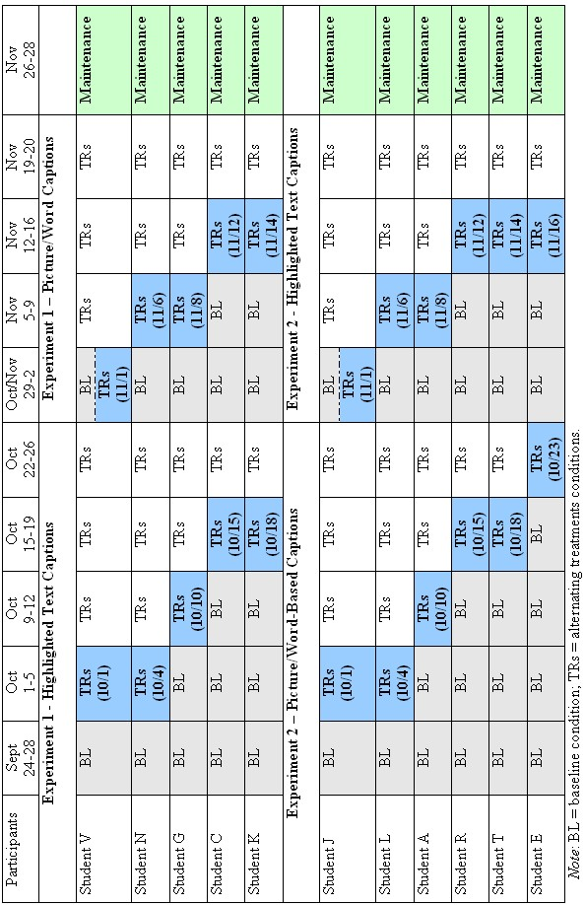

APPENDIX O
ADJUSTMENTS TO DESIGN 3 RANDOMIZATION TEST
Due to the predetermined rather than random assignment of interventionm Todman and Dugard‟s (2001) macro for Multiple Baseline (Design 3) randomization test were modified to address the specific limits to the treatment duration for each of the participants. Thus, the number of possible probability was limited representing more accurate probability estimate for the current study.

Changes made to DESIGN3.SAV Data and DESIGN3.SPS Syntax Files to reflect experimental settings.

In DESIGN3.SAV in column “limits” starting in the row 5 increments of baseline observations for each student were added, i.e. if baseline observations were 5, 8, 11, 14, 17 for 5 students, the limits staring in row 5 in column 1 would be 0, 3, 3, 3, 3 (reflecting minimum 5 baseline points for the first participant; minimum 5 + 3 = 8 baseline points for the second participant, etc.) Thus, it was specified that the treatment started not in any possible randomly selected session but in pre-determined sessions (6, 9, 12, 15, 18, etc.)

Changes in the syntax file were:

1. Line in DESIGN3.SPS (page 166; Todman & Dugard, 2001):
compute temp1=limits(2)-limits(3)-limits(4)+1.

was changed to the code (new variable) that sums up those increments in the new parameter “d” to reflect the starting point of intervention for each student. Then it computes the duration of intervention based on the starting point for that student and uses that duration number in parameter “temp1”. So, the above line became:

compute d=limits(5). loop l=5 to 5+k-1.
compute d=d+limits(l). end loop.
compute temp1=limits(2)-(limits(3)+d)-limits(4)+1.

2. Line in DESIGN3.SPS (next line at the bottom page 166): compute interven=trunc(temp1*rand(k))+limits(3)+1.

was also changed to reflect the choice of starting position of intervention computed above in parameter “d” and became:

compute interven=trunc(temp1*rand(k))+limits(3)+d+1.
References

References

Aaron, B. C. (1998). Effects of autocorrelation and model specification on parametric and randomization significance tests for single-subject data. Dissertation Abstracts International, 59(07-A), 2463. (UMI No. 9842138)

Abadiano, H. R., & Turner, J. (2002). Reading expository test: The challenges of students with learning disabilities. The NERA Journal, 38(2), 49-55.

Abell, M., & Lewis, P. (2005). Universal design for learning: A statewide improvement model for academic success. Information Technology and Disabilities, 11, 1-15.

Acrey, C., Johnstone, C., & Milligan, C. (2005). Using universal design to unlock the potential for academic achievement of at-risk learners. Teaching Exceptional Children, 38(2), 22-31.

Agran, M., Alper, S., & Wehmeyer, M. (2002). Access to the general curriculum for students with significant disabilities: What it means to teachers. Education and Training in Mental Retardation and Developmental Disabilities, 37, 123-133.

Agran, M., Cavin, M., Wehmeyer, M., & Palmer, S. (2006). Participation of students with moderate to severe disabilities in the general curriculum: The effects of the Self-Determined Learning Model of Instruction. Research & Practice for Persons with Severe Disabilities, 31, 230-241.

Agran, M., & Wehmeyer, M. (1999). Teaching problem solving to students with mental retardation. Washington, DC: American Association on Mental Retardation.

Alberto, P. A., & Troutman, C. A. (2006). Applied behavior analysis for teachers (7th ed.). Upper Saddle River, NJ: Pearson Prentice Hall.

Alberto, P. A., Cihak, D. F., & Gama, R. I. (2005). Using of static picture prompts versus video modeling during simulation instruction. Research in Developmental Disabilities: A Multidisciplinary Journal, 26, 327-339.

Alcantara, P. R. (1994). Effects of videotape instructional packaging on purchasing skills of children with autism. Exceptional Children, 61, 40-56.

Apple, A. L., Billingsley, F., & Schwarts, I. S. (2005). Effects of video modeling along and with self-management on compliment giving behaviors of children with highfunctioning ASD. Journal of Positive Behavior Interventions, 7, 33-46.

Armstrong, K. J., Ehrhardt, K. E., Cool, R. T., & Poling, A. (1997). Social validity and treatment integrity data: Reporting in articles published in the Journal of Developmental and Physical Disabilities, 1991-1995. Journal of Developmental and Physical Disabilities, 9, 359-367.

Arnone, M. P., & Grabowski, B. L. (1992). Effects on children‟s achievement and curiosity of variations in learner control over an interactive video lesson. Educational Technology, Research and Development, 40(1), 15-27.

Ayres, K. M., & Langone, J. (2002). Acquisition and generalization of purchasing skills using a video enhanced computer-based instructional program. Journal of Special Education Technology, 17(4), 15-28.

Ayres, K. M., & Langone, J. (2005). Intervention and instruction with video for students with autism: A review of literature. Education and Training in Developmental Disabilities, 40, 183-196.

Ayres, K. M., Langone, J., Boone, R. T., & Norman, A. (2006). Computer-based instruction for purchasing skills. Education and Training in Developmental Disabilities, 41, 253-263.

Baddeley, A. D. (1986). Working memory. Oxford, England: Oxford University Press.

Baer, D. M. (1977). Perhaps it would be better not to know everything. Journal of Applied Behavior Analysis, 10, 167-172.

Baer, D., Wolf, M., & Risley, R. (1968). Some current dimensions of applied behavior analysis. Journal of Applied Behavior Analysis, 1, 91-97.

Bandura, A. (1986). Social Foundations of Thought and Action: A Social Cognitive Theory. Englewood Cliffs, NJ: Prentice Hall.

Barlow, D. H., & Hayes, S. C. (1979). Alternating treatments design: One strategy for comparing the effects of two treatments in a single subject. Journal of Applied Behavior Analysis, 12, 199-210.

Barlow, D. H., & Hersen, M. (1984). Single case experimental designs: Strategies for studying behavior change (2nd ed.). New York: Pergamon Press.

Bean, R. M., & Wilson, R. M. (1989). Using closed captioned television to teach reading to adults. Reading Research and Instruction, 28, 27-37.

Behrmann, M., & Jerome, M. K. (2002). Assistive technology for students with mild disabilities: Update 2002. ERIC Digest E623. (ERIC Document Reproduction Service ED 463 595)

Bellini, S., & Akullian, J. (2007). A meta-analysis of video modeling and video selfmodeling interventions for children and adolescents with autism spectrum disorders. Exceptional Children, 73, 261-284.

Bernad-Ripoll, S. (2007). Using a self-as-model video combined with social stories to help a child with Asperger syndrome understand emotions. Focus on Autism and Other Developmental Disabilities, 22, 100-106.

Biemiller, A., & Siegel, L. S. (1997). A longitudinal study of the effects of the Bridge reading program for children at risk for reading failure. Learning Disability Quarterly, 20, 83-92.

Bird, S. A., & Williams, J. N. (2002). The effect of bimodal input on implicit and explicit memory: An investigation into the benefits of within-language subtitling. Applied Psycholinguistics, 23, 59-533.

Bishop, K., Rankin, J., & Mirenda, P. (1994). Impact of graphic symbol use on reading acquisition. AAC: Augmentative and Alternative Communication, 10, 113-125.

Blamires, M. (1999). Universal design for learning: Re-establishing differentiation as part of the inclusion agenda? Support for Learning, 14, 158-163.

Blanton, S., Robin, B. R., & Kinzie, M. B. (1991). Repurposing a feature film for interactive multimedia. Educational Technology, 31, 37-41.

Bloom B. S., Engelhart, M. B., Furst, E. J., & Krathwohl, D. R. (1956). Taxonomy of education objectives: The classification of educational goals. Handbook 1: Cognitive domain. New York: Longmans Green.

Bondy, A., & Frost, L. (1994). The picture exchange communication system. Focus on Autistic Behavior, 9, 1–19.

Bondy, A., & Frost, L. (1998). The picture exchange communication system. Seminars in Speech and Language, 19, 373-389.

Bondy, A., & Frost, L. (2001). The picture exchange communication system. Behavior Modification, 25, 725-744.

Boone, R., Higgins, K., & Williams, D. (1997). Supporting content area instruction with videodiscs and multimedia technologies. Intervention in School and Clinic, 32, 302-311.

Borras, I., & Lafayette, R. (1994). Effects of multimedia courseware subtitling on the speaking performance of college students of French. The Modern Language Journal, 78, 61-75.

Boster, F. J., Meyer, G. S., Roberto, A. J., Linsey, L., Smith, R., Inge, C., et al. (2006). The impact of video streaming on mathematics performance. Communication Education, 56, 134-144.

Bottge, B. A. (1999). Effects of contextualized math instruction on problem solving of average and below-average achieving students. The Journal of Special Education, 33, 81-92.

Bottge, B. A. (2001). Reconceptualizing math problem solving for low-achieving students. Remedial and Special Education, 22, 102-112.

Bottge, B., & Hasselbring, T. (1993). Comparison of two approaches for teaching complex, authentic mathematics problems to adolescents in remedial math classes. Exceptional Children, 59, 556-566.

Bottge, B. A., Heinrichs, M., Chan, S. Y., & Serlin, R. C. (2001). Anchoring adolescents‟ understanding of math concepts in rich problem-solving environments. Remedial and Special Education, 22, 299-314.

Bottge, B. A., Heinrichs, M., Mehta, Z. D., & Hung, Y. H. (2002). Weighing the benefits of anchored math instruction for students with disabilities in general education classes. The Journal of Special Education, 35, 186-200.

Bottge, B. A., Heinrichs, M., Chan, S. Y., Mehta, Z. D., & Watson, E. (2003). Effects of video-based and applied problems on the procedural math skills of average- and low- achievement adolescents. Journal of Special Educational Technology, 18(2), 5-22.

Bottge, B. A., Rueda, E., Serlin, R. C., Hung, Y. H., & Kwon, J. M. (2007). Shrinking achievement differences with anchored math problems: Challenges and possibilities. The Journal of Special Education, 41, 31-49.

Bowe, F. G. (2000). Universal design in education: teaching non-traditional students. Westport, CT: Bergen & Garvey.

Bowe, F. G., & Kaufman, A. (2001). Captioned media: Teacher perceptions of potential value for students with no hearing impairments: A national survey of special educators. Retrieved February 15, 2008, from http://www.dcmp.org/caai/nadh51.pdf.

Brady, N. C., & McLean, L. K. (1996). Arbitrary symbol learning by adults with severe mental retardation: Comparison of lexigrams and printed words. American Journal on Mental Retardation, 100, 423-427.

Branham, R. S., Collins, B. C., Schuster, J. W., & Kleinert, H. (1999). Teaching community skills to students with moderate disabilities: Comparing combined techniques of classroom simulation, videotape modeling, and community-based instruction. Education and Training in Mental Retardation and Developmental Disabilities, 34, 170-181.

Bransford, J. D., Sherwood, R. D., Hasselbring, T. S., Kinzer, C. K., & Williams, S. M.
(1990). Anchored instruction: Why we need it and how technology can help. In D. Nix & R. Spiro (Eds.), Cognition, education, and multimedia: Exploring ideas in high technology (pp. 115-142). Hillsdale, NJ: Lawrence Erlbaum Associates.

Braverman, B. B., & Hertzog, M. (1980). The effects of caption rate and language level on comprehension of a captioned video presentation. American Annals of the Deaf, 125, 943–948.

Bray, M. A., & Kehle, T. J. (1996). Self-modeling as an intervention for stuttering. School Psychology Review, 25, 358-369.

Bray, M. A., & Kehle, T. J. (1998). Self-modeling as an intervention for stuttering. School Psychology Review, 27, 587-598.

Bremer, C. D., Clapper, A. T., Hitchcock, C., Hall, T., & Kachgal, M. (2002). Universal design: A strategy to support students‟ access to the general education curriculum. Information Brief, 1(3), 3-8.

Browder, D. M., Ahlgrim-Delzell, L., Courtade, G., Gibbs, S. L., & Flowers, C. (in press). Evaluation of the effectiveness of an early literacy program for students with significant developmental disabilities using group randomized trial research. Exceptional Children.

Browder, D. M., Flowers, C., Ahlgrim-Delzell, L., Karvonen, M., Spooner, F., & Algozzine, R. (2004). The alignment of alternate assessment content to academic and functional curricula. The Journal of Special Education, 37, 211-223.

Browder, D. M., Gibbs, S. L., Ahlgrim-Delzell, L., Courtade, G., & Lee, A. (2007). Early Literacy Skills Builder. Madison, WI: Attainment Company.
Browder, D. M., & Spooner, F. H. (2006). Teaching reading, math, and science to students with significant cognitive disabilities. Baltimore: Brookes.

Browder, D. M., Spooner, F., Ahlgrim-Delzell, L., Flowers, C., Algozzine, R., & Karvonen, M. (2003). A content analysis of the curricular philosophies reflected in states' alternate assessments performance indicators. Research and Practice for Persons with Severe Disabilities, 28, 165-181.

Browder, D. M., Wakeman, S. Y., Flowers, C., Rickelman, R. J., Pugalee, D., & Karvonen, M. (2007). Creating access to the general curriculum with links to grade-level content for students with significant cognitive disabilities: An explication of the concept. The Journal of Special Education, 41, 2-16.

Browder, D. M., Wakeman, S. Y., Shawnee, Y., & Flowers, C. (2006). Assessment of progress in the general curriculum for students with disabilities. Theory into Practice, 45, 249-259.

Browder, M. D., Wakeman, Y. S., Spooner, F., Ahlgrim-Delzell, L., & Algozzine, B. (2006). Research in reading instruction for individuals with significant cognitive disabilities. Exceptional Children, 72, 392-408.

Brown, G., & Middleton, H. (1998). Use of self-as-a-model to promote generalization and maintenance of the reduction of self-stimulation in a child with mental retardation. Education and Training in Mental Retardation and Developmental Disabilities, 33, 76-80.

Brown, J. S., Collins, A., & Duguid, P. (1989). Situated cognition and the culture of learning. Educational Researcher, 18(1), 32-42.

Browning, R. M., & Stover, D. O. (1971). Behavior modification in child treatment: An experimental and clinical approach. Chicago, IL: Aldine.
Brungardt, J. B., & Zollman, D. (1995). Influence of interactive videodisc instruction using simultaneous-time analysis on kinematics graphing skills of high school physics students. Journal of Research in Science Teaching, 32, 855-869.
Bruner, J. (1966). Toward a theory of instruction. Cambridge, MA: Harvard University Press.

Buggey, T. (1995). An examination of the effectiveness of videotaped self-modeling in teaching specific linguistic structures to preschoolers. Topics in Early Childhood Special Education, 15, 434-425.

Buggey, T. (2005). Video self-modeling applications with students with autism spectrum disorder in a small private school setting. Focus on Autism and Other Developmental Disabilities, 20, 52-63.

Buggey, T., Toombs, K., Gardner, P., & Cervetti, M. (1999). Training responding behaviors in students with autism: Using videotaped self-modeling. Journal of Positive Behavior Interventions, 1, 205-214.

Burns, P. C., Roe, B. D., & Ross, E. P. (1998). Teaching reading in today’s elementary schools (7th ed.). Boston, MA: Houghton Mifflin Company.

Byrne, A., MacDonald, J., & Buckley, S. (2002). Reading, language and memory skills: a comparative longitudinal study of children with Down syndrome and their mainstream peers. British Journal of Educational Psychology, 72, 513-529.

Campbell, J. M. (2004). Statistical comparison of four effect sizes for single-subject designs. Behavior Modification, 28, 234-246.

Cannella-Malone, H., Sigafoos, J., O‟Reilly, M., de la Cruz, B., Edrisinha, C., & Lancioni, G. E. (2006). Comparing video prompting to video modeling for teaching daily living skills to six adults with developmental disabilities. Education and Training in Developmental Disabilities, 41, 344-356.

Captioned Media Program (2006). Captioning key: Guidelines and preferred techniques. Retrieved February 12, 2008 from http://www.cfv.org/caai/nadh7.pdf.

Carr, J. E., Austin, J. L., Britton, L. N, Kellum, K. K., & Bailey, J. S. (1999). An assessment of social validity trends in applied behavior analysis. Behavioral Interventions, 14, 223-231.

Carr, D., & Felce, J. (2007a). Brief report: Increase in production of spoken words in some children with autism after PECS teaching to Phase III. Journal of Autism and Developmental Disorders, 37, 780-787.

Carr, D., & Felce, J. (2007b). The effects of PECS teaching to Phase III on the communicative interactions between children with autism and their teachers. Journal of Autism and Developmental Disorders, 37, 724-737.

Carr, S. C., & Thompson, B. (2006). The effects of prior knowledge and schema activation strategies on the inferential reading comprehension of children with and without learning disabilities. Learning Disability Quarterly, 19, 48-61.

Chambers, B., Cheung, A., Madden, N.A., Slavin, R.E., & Gifford, R. (2006). Achievement effects of embedded multimedia in a Success for All reading program. Journal of Educational Psychology, 98, 232-237.
Chambers, B., Slavin, R. E., Madden, N. A., Cheung, A., & Gifford, R. (2004). Effects of Success for All with embedded video on the beginning reading achievement of Hispanic children. Baltimore: Johns Hopkins University, Center for Research on the Education of Students Placed at Risk.

Chandler, P., & Sweller, J. (1992). The split-attention affect as a factor of instruction. Cognition and Instruction, 8, 233-246.

Charlop-Christy, M., Carpenter, M. L., LeBlanc, L. A., & Kellet, K. (2002). Using the picture exchange communication system (PECS) with children with autism: Assessment of PECS acquisition, speech, social-communicative behavior, and problem behavior. Journal of Applied Behavior Analysis, 3, 213-232.

Charlop-Christy, M. H., Le, L., & Freeman, K. A. (2000). A comparison of video modeling for teaching children with autism. Journal of Autism and Developmental Disorders, 30, 537-555.

Charlop, M. H., & Milstein, J. P. (1989). Teaching autistic children conversational speech using video modeling. Journal of Applied Behavior Analysis, 22, 275-285.

Chong, R. (2006). The teaching of functional language skills in a second language to a child with autism. K@ta, 8, 89-101.

Christensen, C., & Gerber, M. (1990). Effectiveness of computerized drill and practice games in teaching basic math facts. Exceptionality, 1, 149-165.

Cihak, D., Alberto, P. A., Taber-Doughty, T., & Gama, R. I. (2006). A comparison of static picture prompting and video prompting simulation strategies using group instructional procedures. Focus on Autism and Other Developmental Disabilities, 21, 89-99.

Clare, S. K., Jenson, W. R., Kehle, T. J., & Bray, M. A. (2000). Self-modeling as a treatment for increasing on-task behavior. Psychology in the Schools, 37, 517-522.

Clark, R. E. (1983). Reconsidering research on learning from media. Review of Educational Research, 53, 445-459.

Cobb, T. (1997). Cognitive efficiency: Toward a revised theory of media. Educational Technology, Research and Development, 45(4), 21-35.

Cognition and Technology Group at Vanderbilt (1990). Anchored instruction and its relationship to situated cognition. Educational Researcher, 19(6), 2-10.

Cognition and Technology Group at Vanderbilt (1992a). An anchored instruction
approach to cognitive skills acquisition and intelligent tutoring. In J. W. Regian & V. J. Shute (Eds.), Cognitive approaches to automated instruction (pp.135-170). Hillsdale, NJ: Lawrence Erlbaum Associates.

Cognition and Technology Group at Vanderbilt (1992b). The Jasper Series as an example of anchored instruction: Theory, program, description, and assessment data. Educational Psychologist, 27, 291-315.

Cognition and Technology Group at Vanderbilt (1992c). The Jasper experiment: An exploration of issues in learning and instructional design. Educational Technology, Research and Development, 40(1), 65-80.

Cognition and Technology Group at Vanderbilt (1993a). Toward integrated curricular: Possibilities from anchored instruction. In M. Rabinowitz (Ed.), Cognitive science foundation of instruction (pp. 33-56). Hillsdale, NJ: Lawrence Erlbaum Associates.

Cognition and Technology Group at Vanderbilt (1993b). The Jasper Series: Theoretical foundations and data on problem solving and transfer. In L. A. Penner, G. M. Batsche, H. M. Knoff & D. L. Nelson (Eds.), The challenge in mathematics and science education: Psychology’s response (pp. 113-152). Washington D.C.: American Psychological Association.

Cognition and Technology Group at Vanderbilt (1993c). Anchored instruction and situated cognition revisited. Educational Technology, 33, 52-70.

Cognition and Technology Group at Vanderbilt (1996). Multimedia environments for enhancing learning in mathematics. In S. Vosniadou, E. DeCorte, R. Glaser, & H. Mandl (Eds.), International perspectives on the design of technology-supported learning environments (pp. 285-306). Hillsdale, NJ: Lawrence Erlbaum Associates.

Collins, B. C., Hall, M., Branson, T. A., & Holder, M. (1999). Acquisition of related and unrelated factual information delivered by a teacher within an inclusive setting. Journal of Behavioral Education, 9, 223-237.

Cooper, J. O., Heron, T. E., & Heward, W. L. (1987). Applied behavior analysis. Columbus, OH: Merrill.

Copeland, S. R., Hughes, C., Agran, M., Wehmeyer, M. L., & Fowler, S. E. (2002). An intervention package to support high school students with mental retardation in general education classrooms. American Journal on Mental Retardation, 107, 3245.

Creer, T. L., & Miklich, D. R. (1970). The application of self-modeling procedure to modify inappropriate behavior: A preliminary report. Behavior Research and Therapy, 8, 91-92.

Creswell, J. W. (2005). Educational Research: Planning, Conducting, and Evaluating Quantitative and Qualitative Research, (2nd ed.). Upper Saddle River, NJ: Prentice Hall.

Cronin, M. W., & Cronin, K. A. (1992). Recent empirical studies of the pedagogical effects of interactive video instruction in “soft skill” areas. Journal of Computing in Higher Education, 3(2), 53-85.

Curry, C., Cohen, L. G., & Lightbody, N. (2006, March). Universal design in science learning. The Science Teacher, 73(3), 32–37.

Cushing, L. S., Clark, N. M., Carter, E. W., & Kennedy, C. H. (2005). Access to general education curriculum for students with significant cognitive disabilities. Teaching Exceptional Children, 38(2), 6-13.

Cuvo, A. J., & Klatt, K. P. (1992). Effects of community-based, videotape, and flash card instruction of community-referenced sight words on students with mental retardation. Journal of Applied Behavior Analysis, 25, 499-512.

D‟Ateno, P., Mangiapanello, K., & Taylor, B. (2003). Using video modeling to teach complex play sequences to preschooler with autism. Journal of Positive Behavior Interventions, 5, 5-11.

d‟Ydewalle, G., & Pavakanun, U. (1995). Acquisition of a second/foreign language by viewing a television program. In P. Winterhoff-Spurk (Ed.), Psychology of media in Europe: The state of the art – perspectives for the future (pp. 51-64). Opladen, Germany: Westdeutcher Verlag GmbH.

d‟Ydewalle, G., & Pavakanun, U. (1997). Could enjoying a movie lead to language acquisition? In P. Winterhoff-Spurk & T. Van der Voort (Eds.), New horizons in media psychology (pp. 145-155). Opladen, Germany: Westdeutcher Verlag GmbH.

Danan, M. (1992). Reversed subtitling and dial coding theory: New directions for foreign language instruction. Language Learning, 42, 497-527.

Denenberg, V. H. (1982). Comparative psychology and single-subject research. In D. W. Fiske, A. E. Kazdin, & A. H. Tuma (Eds.), New directions for methodology of social and behavioral sciences: Single-case research designs (Vol. 13, pp. 9-31).
San Francisco: Jossey-Bass.
Deshler, D., Schumaker, J., Bulgren, J., Lenz, K., Jantzen, J., Adams, G., et al. (2001). Making learning easier: Connecting new knowledge to things students already know. Teaching Exceptional Children, 33(4), 82-85.

Detheridge, T., & Detheridge, M. (2002). Literacy through symbols: Improving access for children and adults (2nd ed.). London: David Fulton.

Dewey, S. (1933). How we think: Restatement of the relation of reflective thinking to the educative process. Boston: Heath.

Didden, R., de Graaff, S., Nelemans, M., Vooren, M., & Lancioni, G. (2006). Teaching sight words to children with moderate to mild mental retardation: Comparison between instructional procedures. American Journal on Mental Retardation, 111, 357-365.

Didden, R., Prinsen, H., & Sigafoos, J. (2000). The blocking effect of pictorial prompts on sight-word reading. Journal of Applied Behavior Analysis, 33, 317-320.

Dore, R., Dion, E., Wagner, S., & Brunet, J. P. (2002) High school inclusion of adolescents with mental retardation: A multiple case study. Education and Training in Mental Retardation and Developmental Disabilities, 37, 253-261.

Downing, J. E. (1996). Including students with severe and multiple disabilities in typical classrooms. Baltimore: Brookes.

Dowrick, P. W. (1986). Social survival for children: A trainer’s resource book. New York: Brunner & Mazel.

Dowrick, P. W. (1991). Practical guide to using video in the behavioral sciences. New York: John Wiley & Sons.

Dowrick, P. W. (1999). A review of self modeling and related interventions. Applied and Preventative Psychology, 8, 23-39.

Dowrick, P. W., & Dove, C. (1980). The use of self-modeling to improve the swimming skills of spina-bifida children. Journal of Applied Behavior Analysis, 13, 51-56.

Dymond, K. S., & Orelove, P. F. (2001). What constitutes effective curricula for students with severe disabilities? Exceptionality, 9, 109-122.

Dymond, S. K., Renzaglia, A., Rosenstein, A., Chung, E. J., Banks, R. A., Neswander, V., et al. (2006). Using a participatory action research approach to create a universally designed inclusive high school science course: A case study. Research & Practice for Persons with Severe Disabilities, 31, 293-308.
Edgington, E. S. (1987). Randomized single-subject experiments and statistical tests. Journal of Counseling Psychology, 34, 437-442.

Edgington, E. S. (1992). Nonparametric tests for single-case experiments. In T. R.
Kratochwill & J. R. Levin (Eds.), Single-case research design and analysis (pp. 113-158). Hillsdale, N J: Lawrence Erlbaum Associates.

Edgington, E. S. (1995). Randomization tests (3rd ed.). New York: Dekker.

Edgington E., & Onghena, P. (2007). Randomization tests (4th ed.). Boca Raton, FL: Chapman & Hall/CRC Press.

Edyburn, D. L. (2002, April/May). Cognitive rescaling strategies: Interventions that alter the cognitive accessibility of text. Closing the Gap, 1, 10-11, 21.

Elkind, J. (1998). Computer reading machines for poor readers. Perspectives, 24(2), 9-13

Elkind, J., Cohen, K., & Murray, C. (1993). Using computer-based readers to improve reading comprehension of students with dyslexia. Annals of Dyslexia, 43, 238-259.

Ely, R., Emerson, R. W., Maggiore, T., Rothberg, M., O‟Connel, T., & Hudson, L. (2006). Increased content knowledge of students with visual impairments as a result of extended descriptions. Journal of Special Education Technology, 21(3), 31-43.

Embregts, P. J. (2000). Effects of video feedback on self-evaluation and videotape feedback on inappropriate social behavior of young with mild mental retardation. Research in Developmental Disabilities, 21, 409-423.

Embregts, P. J. (2002). Effects of video feedback on social behavior of young people with mild intellectual disability and staff responses. International Journal of Disability, Development, and Education, 49, 105-116.

Embregts, P. J. (2003). Using self-management, video feedback, and graphic feedback to improve social behavior of youth with mild mental retardation. Education and Training in Developmental Disabilities, 38, 283-295.

Engleman, M. D. (2006). Online courses in higher education: What about accessibility? Journal of Interactive Instruction Development, 17(4), 22-34.

Erickson, K., & Koppenhaver, D. (1995). Developing a literacy program for children with severe disabilities. The Reading Teacher, 48, 676-684.

Faith, M. S., Allison, D. B., & Gorman, B. S. (1996). Meta-analysis of single-case research. In R. D. Franklin, D. B., Allison, & B. S. Gorman (Eds.), Design and analysis of single-case research (pp. 245-278). Mahwah, NJ: Lawrence Erlbaum Associates.
Fawcett, S. B. (1991). Some values guiding community research and action. Journal of Applied Behavior Analysis, 24, 621-636.

Feldman, K., & Denti, L. (2004). High-access instruction: Practical strategies to increase active learning in diverse classrooms. Focus on Exceptional Children, 36(7), 1-12.

Fels, D. L., Udo, J. P., Diamond, J. E., & Diamond, J. I. (2006). A comparison of alternative narrative approaches to video description for animated comedy. Journal of Visual Impairment & Blindness, 100, 295-305.

Fels, D. I., Udo, J. P., Ting, P., Diamond, J., & Diamond, J. (2006). Odd Job Jack described: A first person narrative approach to described video. Journal of Universal Access in the Information Society, 5, 73-81.

Ferron, J., & Onghena, P. (1996). The power of randomization tests for single-case phase designs. Journal of Experimental Education, 64, 231–239.

Ferron, J., & Ware, W. B. (1995). Analyzing single-case data: the power of randomization tests. Journal of Experimental Education, 63, 167-178.

Finney, J. W. (1991). On further development of the concept of social validity. Journal of Applied Behavior Analysis, 24, 245-249.

Fisher, J. B., Schumaker, J. B., & Deshler, D. D. (2002). Improving the reading comprehension of at-risk adolescents. In C. C. Block & M. Pressley (Eds.), Comprehension instruction: Research-based best practices (pp. 351-364), New York: Guilford.

Fletcher, H., & Buckley, S. (2002). Phonological awareness in children with Down syndrome. Down Syndrome Research and Practice, 8, 11–18.

Flowers, C., Browder, D. M., & Ahlgrim-Delzell, L. (2006). An analysis of three states‟ alignment between language arts and mathematics standards and alternate assessments. Exceptional Children, 72, 201-215.

Franklin, R. D., Allison, D. B., & Gorman, B. S. (1996). Design and analysis of singlecase research. Mahwah, NJ: Lawrence Erlbaum Associates.

Franklin, R. D., Gorman, B. S., Beasley, T. M., & Allison, D. B. (1996). Graphic display and visual analysis. In R. D. Franklin, D. B. Allison, & B. S. Gorman (Eds.),
Design and analysis of single-case research. Mahwah, NJ: Lawrence Erlbaum Associates.

Frazier, G., & Coutinho-Johnson, I. (1995). The effectiveness of audio description n in providing access to educational AV media for blind and visually impaired students in high school. San Francisco: AudioVision.

Freeman, S. F. N., & Alkin, M. C. (2000). Academic and social attainments of children with mental retardation I general education and special education settings. Remedial and Special Education, 21, 3-18.

Fritschmann, N. S., Deshler, D. D., & Schumaker, J. B. (2007). The effects of instruction in an inference strategy on the reading comprehension skills of adolescents with disabilities. Learning Disabilities Quarterly, 30, 245-262.

Fuller, D. R., & Lloyd, L. L. (1992). Effects of configuration on the paired-associate learning of Blissymbols by preschool children with normal cognitive abilities. Journal of Speech and Hearing Research, 35, 1376-1383.

Fuller, D. R., & Stratton, M. M. (1991). Representativeness versus translucency:
Different theoretical backgrounds, but are they really different concepts? AAC: Augmentative and Alternative Communication, 7, 51-58.

Gable, R. A., & Warren, S. F. (1993). Strategies for teaching students with mild to severe mental retardation. Baltimore, MD: Paul H. Brookes.

Ganz, J. B., & Simpson, R. L. (2004). Effects on communicative requesting and speech development of the picture exchange communication system in children with characteristics of autism. Journal of Autism and Developmental Disorders, 34, 395-409.

Garmezy, N. (1982). The case for the single case in research. In D. W. Fiske, A. E. Kazdin, & A. H. Tuma (Eds.), New directions for methodology of social and behavioral sciences: Single-case research designs (Vol. 13, pp. 5-17). San Francisco: Jossey-Bass.

Garza, T. J. (1991). Evaluating the use of captioned video materials in advanced foreign language learning. Foreign Language Annals, 24, 293-258.

Gena, A., Couloura, S., & Kymissis, E. (2005). Modifying the affective behavior of preschoolers with autism using in-vivo or video modeling and reinforcement contingencies. Journal of Autism and Developmental Disorders, 35, 545-556.

Giangreco, M. F., & Doyle., M. B. (2000). Curricular and instructional considerations for teaching students with disabilities in general education classrooms. In. S. Wade (Ed.), Inclusive education: A case book of readings for prospective and practicing teachers (Vol. 1, pp. 51-69). Hillsdale, NJ: Lawrence Erlbaum Associates.
Glass, G. V., Willson, V. L., & Gottman, J. M. (1975). Design and analysis of time-series experiments. Boulder, Colo.: Colorado Associated University Press.

Glesne, C. (2006). Becoming qualitative researchers: An introduction (3rd ed.). New York: Allyn & Bacon/Longman.

Goforth, D. (1992). Visualization and computer assisted learning: The role of videodiscs. British Journal of Educational Technology, 23, 21-27.

Goldman, M. E., & Goldman, S. (1988). Reading with close-captioned TV. Journal of Reading, 31, 458-461.

Goldman, S. R., Petrosino, A. J., Sherwood, R. D., Garrison, S., Hickey, D., Bransford, J. D., et al. (1996). Anchoring science instruction in multimedia learning environments. In S. Vosniadou, E. DeCorte, R. Glaser, & H. Mandl (Eds.), International perspectives on the design of technology-supported learning environments (pp. 257-284). Hillsdale, NJ: Lawrence Erlbaum Associates.

Goossens, C. A. (1984). The relative iconicity and learnability of verb referents differentially represented as manual signs, Blissymbolics, and Rebus symbols: An investigation with moderately retarded individuals. Dissertation Abstracts International, 45(03-A), 809. (UMI No. 8407541).

Gorman, B. S., & Allison, D. B. (1996). Statistical alternatives for single-case designs. In R. D. Franklin, D. B., Allison, & B. S. Gorman (Eds.), Design and analysis of single-case research (pp. 159-214). Mahwah, NJ: Lawrence Erlbaum Associates.

Gottman, J. M., & Glass, G. V. (1978). Analysis of interrupted time-series experiments. In T. R. Kratochwill (Ed.), Single subject research: Strategies for evaluating change. New York: Academic Press.

Graetz, J. E., Mastropieri, M. A., & Scruggs, T. E. (2006). Using video self-modeling to decrease inappropriate behavior. Teaching Exceptional Children, 38(5), 43-48.

Gragg, C. I. (1940). Teachers also must learn. Harvard Educational Review, 10, 30-47.

Graves T. B., Collins, B. C., & Schuster, J. W. (2005). Using video prompting to teach cooking skills to secondary students with moderate disabilities. Education and Training in Developmental Disabilities, 40, 34-46.

Greenberg, D., Buggey, T., & Bond, C. L. (2002). Video self-modeling as a tool for improving oral reading fluency and self-confidence. (ERIC Document Reproduction Service No. ED471091).

Griffin, R., & Dumestre, J. (1993). An initial evaluation of the use of captioned television to improve the vocabulary and reading comprehension of navy sailors. Educational Technology, 22, 193-196.

Guillory, H. G. (1998). The effects of keyword captions to authentic French video on learner comprehension. Calico Journal, 15(1-3), 89-108.

Guldager, L. (1972). Using video tape in education of deaf-blind children. New Outlook for the Blind, 66, 178-182.

Hansen, E.G., Lee, M. J., & Forer, D. C. (2002). A “self-voicing” test for individuals with visual impairments. Journal of Visual Impairment & Blindness, 96, 273-275.

Harp, S. F., & Mayer, R. E. (1998). How seductive details do their damage: A theory of cognitive interest in science learning. Journal of Educational Psychology, 90, 414-434.

Harwood, W. S., & McMahon, M. M. (1997). Effects of integrated video media on student achievement and attitudes in high-school chemistry. Journal of Research in Science Teaching, 34, 617-631.

Hasselbring, T. S., & Glaser, C. H. (2000). Use of computer technology to help students with special needs. Future of Children, 10, 102-22.

Hayles, L. W., & Shaw, I. S. (1995, April). The effect of videos on student thinking about the Holocaust in World War II. Paper presented at the annual meeting of the American Educational Research Association, San Francisco, CA.

Hecker, L., Burns, L., & Elkind, J., Elkind, K., & Katz, L. (2002). Benefits of assistive reading software for students with attention disorders. Annals of Dyslexia, 52, 243-272.

Hepting, N. H., & Goldstein, H. (1996). Requesting by preschoolers with developmental disabilities: Videotaped self-modeling and learning of new linguistic structures. Topics in Early Childhood Special Education, 16, 407-421.

Hersen, M., & Barlow, D. H. (1976). Single-case experimental designs: Strategies for studying behavior change. New York: Pergamon.

Hester, P. P., Baltodano, H. M., Gable, R. A., Tonelson, S. W., & Hendrickson, J. M. (2003). Early intervention with children at risk of emotional/behavioral disorders: A critical examination of research methodology and practices. Education and Treatment of Children, 26, 362–381.
Higgins, E., & Raskind, M. (1997). The compensatory effectiveness of optical character recognition/speech synthesis on reading comprehension of post secondary students with learning disabilities. Learning Disabilities: A Multidisciplinary Journal, 8, 75-87.

Hine, J. F., & Wolery, M. (2006). Using point-of-view video modeling to teach play to preschoolers with autism. Topics in Early Childhood Special Education, 26, 8393.

Hitchcock, C. (2001). Balanced instructional support and challenge in universally designed learning environments. Journal of Special Education Technology, 16(4). Retrieved February 15, 2008, from http://jset.unlv.edu/16.4/hitchcock/first.html

Hitchcock, C. H., Dowrick, P. W., & Prater, M. A. (2003). Video self-modeling intervention in school-based settings. Remedial and Special Education, 24, 36-45.

Hitchcock, C., Meyer, A., Rose, D., & Jackson, R. (2002). Providing new access to the general curriculum: Universal design for learning. Teaching Exceptional Children, 35(2), 8-17.

Hitchcock, C. H., Prater, M. A., & Dowrick, P. W. (2004). Reading comprehension and fluency: Examining the effects of tutoring and video self-modeling on first-grade students with reading difficulties. Learning Disability Quarterly, 27, 89-103.

Hitchcock, C., & Stahl, S. (2003). Assistive technology, universal design, universal design for learning: Improved learning opportunities. Journal of Special Education Technology, 18(4), 45-52.

Hoffer, T., Radke, J., & Lord, R. (1992). Qualitative/quantitative study of the effectiveness of computer-assisted interactive video instruction: The hyperiodic table of elements. Journal of Computers in Mathematics and Science Teaching, 11, 3-12.

Horner, R. D., & Baer, D. M. (1978). Multiple probe technique: A variation on the multiple baseline. Journal of Applied Behavior Analysis, 11, 189-196.

Horner, R., Carr, E., Halle, J., McGee, G., Odom, S., & Wolery, M. (2005). The use of single subject research to identify evidence-based practice in special education. Exceptional Children, 71, 165-179.

Huang, H. C., & Eskey, D. E. (1999). The effects of closed-captioned television on the listening comprehension of intermediate English as a second language (ESL) students. Journal of Educational Technology Systems, 28, 75-96.

Hurlbut, B. I., Iwata, B. A., & Green, J. D. (1982). Nonvocal language acquisition in adolescents with severe physical disabilities: Blissymbols versus iconic stimulus formats. Journal of Applied Behavior Analysis, 15, 241-258.

Individuals with Disabilities Education Improvement Act, Amendments of 2004, Public Law No. 108-446, § 614, U.S.C. 1414. Retrieved February 15, 2008, from http://www.ed.gov/policy/speced/leg/idea/idea.pdf.

Jackson, D. E. (1997). Case studies of microcomputer and interactive video simulations in middle school earth science teaching. Journal of Science Education and Technology, 6, 127-141.

Jensema, C. (1998). Viewer reaction to different television captioning speeds. American Annals of the Deaf, 143, 318-324.

Jensema, C. J., Danturthi, S., & Burch, R. (2000). Time spent viewing captions on television programs. American Annals of the Deaf, 145, 464-468.

Jensema, C. J., Sharkawy, S. E., Danturthi, R. S., Burch, R., & Hsu, D. (2000). Eye movement patterns of captioned television viewers. American Annals of the Deaf, 145, 275-285.

Jensema, C., McCann, R., & Ramsey, S. (1996). Closed-captioned television presentation speed and vocabulary. American Annals of the Deaf, 141, 284-292.

Jerome, M. K., Neuber, K., Stegall, B., Evmenova, A., & Behrmann, M. (2007).
Technology for integration of students with disabilities in higher education. In S. Helal, M. Mokhtari, & B. Abdulravak (Eds.), Technology for aging, disability, and independence: Computer and engineering for design and applications. Indianapolis, IN: John Wiley & Sons.

Johnson, K., Griffin-Shirley, N., & Koening, A. J. (2000). Active learning for children with visual impairments and additional disabilities. Journal of Visual Impairment & Blindness, 94, 584-594.

Jones, F. W., Long, K., & Finlay, W. M. L. (2007). Symbols can improve the reading comprehension of adults with learning disabilities. Journal of Intellectual Disability Research, 51, 545-550.

Katz, A., & Turcotte, J. (1993). Measurement of comprehension changes in television viewing of visually impaired persons using descriptive video study: Research report. Boston: New England College of Optometry.

Kazdin, A. E. (1977). Artifact, bias, and complexity of assessment: The ABCs of reliability. Journal of Applied Behavior Analysis, 10, 141-150.

Kazdin, A. E. (1982a). Single-case experimental designs in clinical research and practice. In A. E. Kazdin & A. H. Tuma (Eds.), Single-case research designs: New directions for methodology of social and behavioral science (pp. 33-49). San Francisco, CA: Jossey-Bass.

Kazdin, A. E. (1982b). Single-case research designs: Methods for clinical and applied settings. New York: Oxford University Press.

Kazdin, A. E. (1984). Statistical analysis for single-case experimental designs. In D. H. Barlow & M. Hersen (Eds.), Single case experimental designs: strategies for studying behavior change (2nd ed., pp. 285-324). New York: Pergamon Press.

Kazdin, A. E. (1998). Research design in clinical psychology (3rd ed.). Needham Heights, MA: Allyn and Bacon.

Kazdin, A. E., & Hartmann, D. P. (1978). The simultaneous treatment design. Behavior Therapy, 9, 912-922.

Kennedy, C. H. (2002). The maintenance of behavior change as an indicator of social validity. Behavior Modifications, 26, 594-604.

Kennedy, C. H. (2005). Single-case designs for education research. Boston, MA: Allyn and Bacon.

King, J. (2002). Using DVD feature films in the EFL classroom. Computer Assisted Language Learning, 15, 509-523.

Kinney, E. M., Vedora, J., & Stromer, R. (2003). Computer-presented video models to teach generative spelling to a child with an autism spectrum disorder. Journal of Positive Behavior Interventions, 5, 22-29.

Kinzie, M. B. (1991). Design of an interactive informational program: Formative evaluation and experimental research. Educational Technology Research and Development, 39(4), 17-26.

Kinzer, C. K., Gabella, M. S., & Rieth, H. J. (1994). An argument for using multimedia and anchored instruction to facilitate mildly disabled students learning of literacy and social-studies. Technology and Disability, 3, 117-128.
Kinzie, M. B., Strauss, R., & Foss, J. (1993). The effects of an interactive dissection simulation on the performance and achievement of high school biology students. Journal of Research in Science Teaching, 30, 989-1000.

Kirkland, C. E. (1995, April). The effectiveness of television captioning on comprehension and preference. Paper presented at the annual meeting of the American Educational Research Association, San Francisco, CA.

Kirkland, C. E. (1999). Evaluation of captioning features to inform development of digital television captioning capabilities. American Annals of the Deaf, 144, 250260.

Kleinert, H. L., Kennedy, S., & Kearns, J. (1999). The impact of alternative assessments: A statewide teacher survey. The Journal of Special Education, 33, 93-102.

Koolstra, C. M., & Beentjes, J. W. (1999). Children‟s vocabulary acquisition in a foreign language watching subtitled television programs at home. Educational Technology Research and Development, 47(1), 51-60.

Koolstra, C. M., van der Voort, T. H. A., & van der Kamp, L. J. T. (1997). Television‟s impact on children‟s reading comprehension and decoding skills: A 3-year panel study. Reading Research Quarterly, 32, 128-152.

Kortering, L., McClannon, T., & Braziel, P. (2005). What algebra and biology students have to say about universal design for learning? Information Brief, 4(2), 1-5.

Koskinen, P. S., Knable, J., Markham, P., Jensema, C., & Kane, K. (1996). Captioned television and the vocabulary acquisition of adult second language correctional facility residents. Journal of Educational Technology Systems, 24, 359-373.

Koskinen, P. S., Wilson, R. M., Gambrell, L. B., & Jensema, C. (1986). Using closed captioned television to enhance reading skills of learning disabled students. National Reading Conference Yearbook, 35, 61–65.

Koskinen, P. S., Wilson, R. M., Gambrell, L. B., & Jensema, C. J. (1987, February). Using the technology of closed-captioned television for teaching reading to handicapped students. Performance Report. Falls Church, VA: National Captioning Institute.

Koskinen, P. S., Wilson, R. M., Gambrell, L. B. & Neuman, S. B. (1993). Captioned video and vocabulary learning: An innovative practice in literacy instruction. The Reading Teacher, 47, 36-43.

Kothari, B., Takeda, J., & Ashok, J. (2002). Same language subtitling: a butterfly for literacy? International Journal of Lifelong Education, 21, 55-66.

Kravits, T. R., Kamps, D. M., Kemmerer, K., & Potucek, J. (2002). Brief report: Increasing communication skills for an elementary-aged student with autism using the Picture Exchange Communication System. Journal of Autism and Developmental Disorders, 21, 225-230.

Kroeger, K. A., Schultz, J. R., & Newsom, C. (2007). A comparison of two groupdelivered social skills programs for young children with autism. Journal of Autism and Developmental Disorders, 37, 808-817.

Kyhl, R., Alper, S., & Sinclair, T. J. (1999). Acquisition and generalization of functional words in community grocery stores using videotaped instruction. Career Development for Exceptional Individuals, 22, 55-67.

Lalley, J. P. (1998). Comparison of text and video as forms of feedback during computer assisted learning. Journal of Educational Computing Research, 18, 323-338.

Langone, J., Shade, J., Clees, T. J., & Day, T. (1999). Effects of multimedia instruction on teaching functional discrimination skills to students with moderate/severe intellectual disabilities. International Journal of Disability, Development and Education, 46, 493-513.

Lasater, M. W., & Brady, M. P. (1995). Effects of video self-modeling and feedback on task fluency: A home-based intervention. Education and Treatment of Children, 18, 389-407.

Law, J., Boyle, J., Harris, F., Harkness, A., & Nye, C. (2000). Prevalence and natural history of primary speech and language delay: Findings from a systematic review of the literature. International Journal of Language & Communication Disorders, 5, 165-188.

LeBlanc, L. A., Coates, A. M., Daneshvar, S., Charlop-Christy, M. H., Morris, C., & Lancaster, B. M. (2003). Using video modeling and reinforcement to teach perspective-taking skills to children with autism. Journal of Applied Behavior Analysis, 36, 253-257.

Lee, Y., & Vail, C. O. (2005). Computer-based reading instruction for young children with disabilities. Journal of Special Education Technology, 20(1), 5-18.

LeeSing, A. C., & Miles, C. A. (1999). The relative effectiveness of audio, video, and static visual computer-mediated presentations. Canadian Journal of Education, 24, 212-221.

LeGrice, B., & Blampied, N. M. (1994). Training pupils with intellectual disability to operate educational technology using video prompting. Education and Training in Mental Retardation and Developmental Disabilities, 29, 321-220.

Lehman, J. D., & Brickner, D. (1996). Teacher‟s use and perceptions of interactive videodisc in the science classroom. The Journal of Computer in Mathematics and Science Teaching, 15, 85-102.

Leonard, W. H. (1992). A comparison of student performance following instruction by interactive videodisc versus conventional laboratory. Journal of Research in Science Teaching, 29, 93-102.

LePage, P., & Mills, J. (1990). The effect of a picture symbol prereading program on preschool children‟s attitudes toward reading. Child Study Journal, 20, 55-65.

Levin, S. R. (1991). The effects of interactive video enhanced earthquake lessons on achievement of seventh grade earth science students. Journal of Computer-Based Instruction, 18, 125-129.

Levin, J. R., Marascuilo, L.A., & Hubert, L. J. (1978). N=nonparametric randomization tests. In T. R. Kratochwill (Ed.), Single subject research: Strategies for evaluating change (pp. 167-197). New York, NY: Academic Press.

Liao, Y. C. (2004). Effects of computer-assisted instruction of students‟ achievement in Taiwan, A meta-analysis. Computers & Education, 48, 216-233.

Linebarger, D. L. (2001). Learning to read from television: The effects of using captions and narration. Journal of Educational Psychology, 93, 288-298.

Linebarger D. L., Kosanic, A. Z., Gereenwood, C. R., & Doku, N. S. (2004). Effects of viewing the television program Between the Lions on the emergent literacy skills of young children. Journal of Educational Psychology, 96, 197-308.

Logan, K. R., & Malone, D. M. (1998). Instructional context for students with moderate, severe, and profound intellectual disabilities in general education elementary classrooms. Education and Training in Mental Retardation, 33, 62-75.

Lovaas, O. I., Koegel, R. L., & Schreibman, L. (1979). Stimulus overselectivity in autism: A review of research. Psychological Bulletin, 86, 1236-1254.

Maccini, P., Gagnon, J. C., & Hughes, C. A. (2002). Technology-based interventions for secondary students with learning disabilities. Learning Disability Quarterly, 25, 247-262.

MacDonald, R., Clark, M., Garrigan, E., & Vangala, M. (2005). Using video modeling to teach pretend play to children with autism. Behavior Interventions, 20, 225-238.

Maione, L., & Mirenda, P. (2006). Effects of video modeling and video feedback on peer-directed social language skills of a child with autism. Journal of Positive Behavior Interventions, 8, 106-118.

Manly, B. F. J. (1997). Randomization and Monte Carlo methods in biology (2nd ed.). New York: Chapman and Hall.

Mastropieri, M. A., & Scruggs, T. E. (1992). Science for students with disabilities. Review of Educational Research, 62, 377-411.

Markham, P. L. (1989). The effects of captioned television videotapes on the listening comprehension of beginning, intermediate, and advanced ESL students. Educational Technology, 29, 38-41.

Markham, P. L. (1999). Captioned videotapes and second-language listening word recognition. Foreign Language Annals, 32, 321-328.

Markham, P. L., & Peter, L. A. (2003). The influence of English language and Spanish language captions on foreign language listening/reading comprehension. Journal of Educational Technology Systems, 31, 331-341.

Markham, P. L., Peter, L. A., & McCarthy, T. J. (2001). The effects of native language vs.
target language captions on foreign language students‟ DVD video comprehension. Foreign Language Annals, 34, 439-445.

Matson, J. L., & Smiroldo, B. B. (1999). Intellectual disorders. In W. K. Silverman & T. H. Ollendick (Eds.), Developmental issues in the clinical treatment of children (pp.261-279). Boston, MA: Allyn and Bacon.

Mayer, R. E. (1997). Multimedia learning: Are we asking the right questions? Educational Psychologist, 32, 1-19.

Mayer, R. E. (1999). The promise of educational psychology: Learning in the content areas. Upper Saddle River, NJ: Prentice Hall.

Mayer, R. E. (2000). The challenge of multimedia literacy. In A. W. Pailliotet & P. B.
Mosenthal, (Eds.), Reconceptualizing literacy in the media age (pp. 363-376). Stamford, Connecticut: JAI Press.

Mayer, R. E., Heiser, J., & Lonn, S. (2001). Cognitive constraints on multimedia learning: When presenting more material results in less understanding. Journal of Educational Psychology, 93, 187-198.

Mayer, R. E., & Moreno, R. (1998). A split-attention effect in multimedia learning:
evidence for dual processing systems in working memory. Journal of Educational Psychology, 90, 312-320.

Mayer, R. E., & Moreno, R. (2003). Nine ways to reduce cognitive load in multimedia learning. Educational Psychologist, 38, 43-52.

Mayer, R. E., Moreno, R., & Boire, M. (1999). Maximizing constructivist learning from multimedia communications by minimizing cognitive load. Journal of Educational Psychology, 91, 638-643.

Mayer, R. E., Moreno, R., Boire, M., & Vagge, S. (1999). Maximizing constructivist learning from multimedia communications by minimizing cognitive load. Journal of Educational Psychology, 91, 638-643.

Mayer, R. E., Steinhoff, K., Bower, G. & Mars, R. (1995). A generative theory of textbook design: Using annotated illustrations to foster meaningful learning of science text. Educational Technology Research and Development, 43, 31-43.

McCarthy, C. B. (2005). Effects of thematic-based, hands-on science teaching versus a textbook approach for students with disabilities. Journal of Research in Science Teaching, 42, 245-263.

McCormic, S. (1992). Disabled readers‟ erroneous responses to inferential comprehension questions: Description and analysis. Reading Research Quarterly, 27, 54-77.

McCoy, K., & Hermansen, E. (2007). Video modeling for individuals with autism: A review of model types and effects. Education and Treatment of Children, 30, 183213.

McDonnell, J., Johnson, J. W., Polychronis, S., & Risen, T. (2002). Effects of embedded instruction on students with moderate disabilities enrolled in general education classes. Education and Training in Mental Retardation and Developmental Disabilities, 37, 363-377.

McGregor, E., Whiten, A., & Blackburn, P. (1998). Transfer of the picture-in-the-head analogy to natural contexts to aid false belief understanding in autism. Autism, 2, 367-387.

McLaughlin, M. J., & Thurlow, M. (2003). Educational accountability and students with disabilities: Issues and challenges. Educational Policy, 17, 431–451.
McNeil, B. J., & Nelson, K. R. (1991). Meta-analysis of interactive video instruction: A 10 year review of achievement effects. Journal of Computer-Based Instruction, 18, 1-6.

McReynolds, L. V., & Kearns, K. P. (1983). Single-subject experimental designs in communicative disorders. Baltimore, MD: University Part Press.

Mechling, L. C. (2004). Effects of multimedia computer-based instruction on grocery shopping fluency. Journal of Special Education Technology, 19(1), 23-34.

Mechling, L. C. (2005). The effect of instructor-created video programs to teach students with disabilities: A literature review. Journal of Special Education Technology, 20(2), 25-36.

Mechling, L. C., & Gast. D. L. (2003). Multi-media instruction to teach grocery word associations and store location: A study of generalization. Education and Training in Developmental Disabilities, 38, 62-76.

Mechling, L. C., Gast, D. L., & Cronin, B. A. (2006). The effects of presenting highpreference items, paired with choice, via computer-based video programming on
task completion of students with autism. Focus on Autism and Other Developmental Disabilities, 21, 7-13.

Mechling, L. C., Gast, D. L., & Langone, J. (2002). Computer-based video instruction to teach persons with moderate intellectual disabilities to read grocery aisle signs and locate items. The Journal of Special Education, 35, 224-240.

Mechling, L. C., & Langone, J. (2000). The effects of a computer-based instructional program with video anchors on the use of photographs for prompting augmentative communication. Education and Training in Mental Retardation and Developmental Disabilities, 35, 90-105.

Mechling, L. C., & Ortega-Hurndon, F. (2007). Computer-based video instruction to teach young adults with moderate intellectual disabilities to perform multiple step job tasks in a generalized setting. Education and Training in Developmental Disabilities, 4, 24-37.

Mechling, L. C., Pridgen, L. S., & Cronin, B. A. (2005). Computer-based video instruction to teach students with intellectual disabilities to verbally respond to questions to make purchases in fast food restaurants. Education and Training in Developmental Disabilities, 40, 47-59.

Merriam, S. B. (1998). Qualitative research and case study applications in education.
San Francisco: Jossey-Bass.
Meyer, M., & Lee, Y. B. (1995). Closed-captioned prompt rates: Their influence on reading outcomes. (ERIC Document Reproduction Service ED383324).

Michael, J. L. (1993). Concepts and principles of behavior analysis. Kalamazoo, Michigan: Society for the Advancement of Behavior Analysis.

Milone, M. N. (1993). Closed-caption TV: A new toll for reading and ESOL. Technology & Learning, 14, 22-23.

Mirenda, P. (2003). Toward functional augmentative and alternative communication for students with autism: Manual signs, graphic symbols, and voice output communication aids. Language, Speech, and Hearing Services in Schools, 34, 203-216.

Mirenda, P., Eicher, D., Beukelman, D. R. (1989). Synthetic and natural speech preferences of male and female listeners in four age groups. Journal of Speech and Hearing Research, 32, 175-183.

Mirenda, P., & Locke, P. A. (1989). A comparison of symbol transparency in persons with intellectual disabilities. Journal of Speech and Hearing Disorders, 54, 131140.

Mizuko, M. (1987). Transparency and ease of learning of symbols represented by Blissymbolics, PCS, and Picsyms. AAC: Augmentative and Alternative Communication, 3, 129-136.

Mizuko, M., & Reichle, J. (1989). Transparency and recall of symbols among intellectually handicapped adults. Journal of Speech and Hearing Disorders, 54, 627-633.

Montali, J., & Lewandowski, L. (1996). Bimodal reading: Benefits of a talking computer for average and less skilled readers. Journal of Learning Disabilities, 29, 271-279.

Moore, P., Rieth, H., & Ebeling, M. (1993). Considerations in teaching higher order thinking skills to students with mild disabilities. Focus on Exceptional Children, 25(7), 1-12.

Moreno, R., & Mayer, R. E. (1999). Cognitive principles of multimedia learning: The role of modality and contiguity. Journal of Educational Psychology, 91, 358-368.

Moreno, R., & Mayer, R. E. (2000). A coherence effect in multimedia learning: the case for minimizing irrelevant sounds in the design of multimedia instructional messages. Journal of Educational Psychology, 92, 117-125.
Moreno, R., & Mayer, R. E. (2002). Verbal redundancy in multimedia learning: when reading helps listening. Journal of Educational Psychology, 94, 156-163.

Moreno, R., Mayer, R. E., Spires, H. A., & Lester, J. C. (2001). The case for social agency in computer-based teaching: Do students learn more deeply when they interact with animated pedagogical agents? Cognition and Instruction, 19, 177214.

Moreno, R., & Valdez, A. (2005). Cognitive load and learning effects of having students organize pictures and words in multimedia environments: The role of student interactivity and feedback. Educational Technology Research and Development, 53(3), 35-45.

Mousavi, S. Y., Low, R., & Sweller, J. (1995). Reducing cognitive load by mixing auditory and visual presentation modes. Journal of Educational Psychology, 87, 319-334.

Nagle, K., Yunker, C., & Malmgren, K. W. (2006). Students with disabilities and accountability reform. Journal of Disability Policy Studies, 17, 28-39.

National Captioning Institute. (2007). A brief history of captioned television. Retrieved February 15, 2008 from http://www.ncicap.org/caphist.asp.

Neisworth, J. T., & Wert, B. Y. (2002). Videotaped self-modeling as a technique for training preschoolers with autism in social-communicative functioning. (ERIC Document Reproduction Services No. ED469547)

Neuman, D. B., & McCormick, S. (1995). Single-subject experimental research:
Applications for literacy. Newark, NJ: International Reading Association.

Neuman, S., & Koskinen, P. S. (1991). Captioned television as comprehensible input:
Effects of incidental word learning from context for language minority students. (ERIC Document Reproduction Service ED332538).

Neuman, S., & Koskinen, P. S. (1992). Captioned television as comprehensive input:
Effect of incidental word learning from context for language minority students. Reading Research Quarterly, 27, 95-106.

Nietupski, J., Hamre-Nietupski, S., Clancy, P., & Veerhusen, K. (1986). Guidelines for making simulation an effective adjunct to in vivo community instruction. Journal of the Association for Persons with Severe Handicaps, 11, 12-18.

Nietupski, J., Hamre-Nietupski, S., Curtin, S., & Shrikanth, K. (1997). Review of curricula research in severe disabilities from 1976 to 1995 in sex selected journals.
The Journal of Special Education, 31, 36-55.

Nikopoulos, C. K., & Keenah, M. (2004). Effects of video modeling on social initiations by children with autism. Journal of Applied Behavior Analysis, 37, 93-96.

Nikopoulos, C. K., & Keenah, M. (2007). Using video modeling to teach complex social sequences to children with autism. Journal of Autism and Developmental Disorders, 37, 678-693.

No Child Left Behind Act of 2001, Public Law No. 107-10. Retrieved February 15, 2008, from http://www.ed.gov/nclb/landing.jhtml.

Norman, J. M., Collins, B. C., & Schuster, J. W. (2001). Using an instructional package including video technology to teach self-help skills to elementary students with mental retardation. Journal of Special Education Technology, 16(3), 5-18.

Nugent, G. C. (1983). Deaf students‟ learning from captioned instruction: The relationship between the visual and caption display. The Journal of Special Education, 17, 227-234.

Orkwis, R. (1999). Curriculum access and universal design for learning. (ERIC Document Reproduction Service ED437767).

Paivio, A. (1986). Mental representations: A dual-coding approach. New York: Oxford University Press.

Park, H., Marascuilo, L., & Gaylord-Ross, R. (1990). Visual inspection and statistical analysis in single case designs. Journal of Experimental Education, 58, 311–320.

Parsonson, B. S., & Baer, D. M. (1986). The graphic analysis of data. In A. Poling & W. R. Fuqua (Eds.), Research methods in applied behavior analysis: Issues and advances (pp. 157-186). New York: Plenum Press.

Pavakanun, U., & d‟Ydewalle, G. (1992). Watching foreign television programs and language learning. In F. L. Engel, D. G., Bouwhuis, T. Bosser, & G. d‟Ydewalle (Eds.), Cognitive modeling and interactive environments in language learning (pp. 193-198). Berlin: Springer.

Peli, E., Fine, E. M., & Labianca, A. T. (1996). Evaluating visual information provided by audio description. Journal of Visual Impairment & Blindness, 90, 378-385.

Penney, C. G. (1989) Modality effects and the structure of short-term memory. Memory and Cognition, 17, 398–442.
Pettitt, B., Sharpe, K., & Cooper, S. (1996). AUDETL: Enhancing television for visually impaired people. British Journal of Visual Impairment, 14, 48-52.

Pianfetti, E. S. (1999). Digital video and mathematics: Helping high school students understand and interpret abstract concepts. Dissertation Abstracts International, 59(11-A), 4058. (UMI No. 3163734).

Piety, P. J. (2004). The language system of audio description: An investigation as a discursive process. Journal of Visual Impairments & Blindness, 98, 453-469.

Pisha, B., & Coyne, P. (2001). Jumping off the page: Content area curriculum for the Internet age. Reading Online, 5. Retrieved February 8, 2008 from http://www.readingonline.org/articles/pisha/.

Plass, J. L., Chun, D. M., Mayer, R. E., & Leutner, D. (1998). Supporting visual and verbal learning preferences in a second language multimedia learning environment. Journal of Educational Psychology, 90, 25-36.

Poling, A., & LeSage, M. (1995). Evaluating psychotropic drugs in people with mental retardation: Where are the social validity data? American Journal of Mental Retardation, 100, 193-200.

Poling, A., Methot, L. L., & LeSage, M. G. (1995). Fundamentals of behavior analytic research. New York: Plenum Press.

Preis, J. (2006). The effect of Picture Communication Symbols on the verbal comprehension of commands by young children with autism. Focus on Autism and Other Developmental Disabilities, 21, 193-210.

Presno, C. (1997). Bruner‟s three forms of representation revisited: Action, pictures, and words for effective computer instruction. Journal of Instructional Psychology, 24, 112-118.

Price, K. (1984, Fall). Closed-captioned TV: An untapped resource. MATSOL Newsletter, 12, 4-5.

Rabbitt, P. M. A., & Carmichael, A. (1994). Designing communications and informationhandling systems for elderly and disabled users. In J. Snel & R. Cremet (Eds.), Word and aging: A European perspective (pp. 173-196). London: Taylor & Francis.

Raghavendra, P., & Fristoe, M. (1995). “No shoes; they walked away?”: Effects of enhancements on learning and using Blissymbols by normal 3-year-old children.
Journal of Speech and Hearing Research, 38, 174-186.
Rapp, D. N., van den Broek, P., McMaster, K. L., Kendeou, P., & Espin, C. A. (2007). Higher-order comprehension processes in struggling readers: A perspective for research and intervention. Scientific Studies of Reading, 11, 289-312.

Reagon, K. A., Higbee, T. S., & Endicott, K. (2006). Teaching pretend play skills to a student with autism using video modeling with a sibling as model and play partner. Education and Treatment of Children, 29, 517-528.

Reagon, K. A., Higbee, T. S., & Endicott, K. (2007). Using video instruction procedures with and without embedded text to teach object labeling to preschoolers with autism: A preliminary investigation. Journal of Special Education Technology, 22(1), 13-21.

Regan, K. (2005). Prompting Expressive Writing among students with emotional and behavioral disturbance via the dialogue journal. Dissertation Abstracts International, 66(02-A), 551. (UMI No. 3163734).

Rehfeldt, R. A., Latimore, D., & Stromer, R. (2003). Observational learning and the formation of classes of reading skills by individuals with autism and other developmental disabilities. Research in Developmental Disabilities, 24, 333-358.

Reynolds, M.E., Isaac-Duvall, C., & Haddox, M. L. (2002). A comparison of learning curves in natural and synthesized speech comprehension. Journal of Speech, Language, and Hearing Research, 45, 802-810.

Richards, S., Taylor, R. L., Ramasamy, R., & Richards, R. Y. (1999). Single subject research: Applications in educational and clinical settings. San Diego, CA: Singular Publishing Group.

Rickelman, R. J., Henk, W. A., & Layton, K. (1991). Closed-captioned television: A viable technology for the reading teacher. The Reading Teacher, 44, 598-599.

Rieth, H. J., Bryant, D. P., Kinzer, C. K., Colburn, L. K., Hur, S. J., Hartman, P., et al. (2003). An analysis of the impact of anchored instruction on teaching and learning activities in two ninth-grade language arts classes. Remedial and Special Education, 24, 173-184.

Roach, A. T., Elliott, S. N., & Webb, N. L. (2005). Alignment of an alternate assessment with state academic standards: Evidence for the content validity of the Wisconsin alternate assessment. The Journal of Special Education, 38, 218-231.

Rose, D. (2001). Universal design for learning: Deriving guiding principles from networks that learn. Journal of Special Education Technology, 16(2), 66-67.
Rose, T. L., & Furr, P. M. (1984). Negative effects of illustrations as word cues. Journal of Learning Disabilities, 17, 334-337.

Rose, D. H., & Meyer, A. (2000). Universal Design for Learning. Journal of Special Education Technology, 15(1), 67-70.

Rose, D. H., & Meyer, A. (2002). Teaching every student in the digital age: Universal design for learning. Alexandria, VA: The Association for Supervision and Curriculum Development.

Rose, D. H., Meyer, A., & Hitchcock, C. (2005). The universally designed classroom: Accessible curriculum and digital technologies. Cambridge, MA: Harvard Education Press.

Rotholz, D. A., & Berkowitz, S. F., & Burberry, J. (1989). Functionality of two modes of communication in the community by students with developmental disabilities: A comparison of signing and communication books. Journal of the Association for Persons with Severe Handicaps, 14, 227-233.

Ryndak, D. L., & Alper, S. (2003). Curriculum and instruction for students with significant disabilities in inclusive settings (2nd ed.). Boston: Allyn and Bacon.

Scattone, D. (2008). Enhancing the conversational skills of a boy with Asperger‟s disorder through social stories and video modeling. Journal of Autism and Developmental Disorders, 38, 395-400.

Schlosser, R. W., & Lloyd, L. L. (1993). Effects of initial element teaching in a storytelling context on Blissymbol acquisition and generalization. Journal of Speech and Hearing Research, 36, 979-995.

Schmeidler, E., & Kirchner, C. (2001). Adding audio description: Does it make a difference? Journal of Visual Impairment & Blindness, 95, 197-221.

Schreibman, L., Whalen, C., & Stahmer, A. C. (2000). The use of video priming to reduce disruptive transition behavior in children with autism. Journal of Positive Behavior Interventions, 1, 3-11.

Schwab, J. J. (1962). What do scientists do? Behavioral Science, 5, 1-27.

Schwartz, I. S., & Baer, D. M. (1991). Social validity assessments: Is current practice state of the art? Journal of Applied Behavior Analysis, 24, 189-204.

Schwartz, I. S., Garfinkle, A. N., & Bauer, J. (1998). The Picture Exchange
Communication System: Communicative outcomes for young children with
disabilities. Topics in Early Childhood Special Education, 18, 144-159.

Scott, S. S., McGuire, J. M., & Shaw, S. F. (2003). Universal design for instruction: A new paradigm for adult instruction in postsecondary education. Remedial and Special Education, 24, 369-379.

Scruggs, T. E. (1992). Single subject research methodology in the study of learning and behavioral disorders: Design, analysis, and synthesis. In T. E. Scruggs & M. A.
Mastropieri (Eds.), Advances in learning and behavioral disabilities (Vol. 7, pp. 223-248). Greenwich, CT: JAI Press.

Scruggs, T. E., & Mastropieri, M. A. (1996). Teacher perceptions of mainstreaming/inclusion 1958-1995: A research synthesis. Exceptional Children, 63, 59-74.

Scruggs, T. E., Mastropieri, M. A., & Casto, G. (1987). The quantitative synthesis of single-subject research: Methodology and validation. Remedial and Special Education, 8, 24-33.

Scruggs, T. E., Mastropieri, M. A., & Regan, K. (2006). Statistical analysis for single subject research designs. In T. E. Scruggs & M. A. Mastropieri (Eds.), Applications of research methodology: Advances in learning and behavioral disabilities (pp.33-55). Oxford, UK: Elsevier.

Serafino, K., & Cicchelli, T. (2003). Cognitive theories, prior knowledge, and anchored instruction on mathematical problem solving and transfer. Education and Urban Society, 36, 79-93.

Seung, H. K., & Chapman, R. (2004). Sentence memory of individuals with Down‟s syndrome and typically developing children. Journal of Intellectual Disability Research, 48, 160-171.

Shea, P. (2000). Leveling the playing field: A study of captioned interactive video for second language learning. Journal of Educational Computing Research, 22, 243263.

Sheehy, K. (2002). The effective use of symbols in teaching word recognition to children with severe learning difficulties: A comparison of word alone, integrated picture cueing, and the handle technique. International Journal of Disability, Development and Education, 49, 47-59.

Sheehy, K. (2005). Morphing images: A potential tool for teaching word recognition to children with severe learning difficulties. British Journal of Educational Technology, 36, 293-201.
Sheehy, K., & Howe, M. J. A. (2001). Teaching non-readers with severe learning difficulties to recognize words: The effective use of symbols in a new technique. Westminster Studies in Education, 24, 63-71.

Sherer, M., Pierce, K. L., Paredes, S., Kisacky, K. L., Ingersoll, B., & Schreibman, L. (2001). Enhancing conversational skills in children with autism via video technology: Which is better, “self” or “other” as a model? Behavior Modification, 25, 140-158.

Sherwood, R. D., Kinzer, C. K., Bransford, J. D., & Franks, J. J. (1987). Some benefits of creating macro-contexts for science instruction: Initial findings. Journal of Research in Science Teaching, 24, 417-435.

Shih, Y. F., Shyu, H. Y,. & Chen, R. S. (1997). Effects of knowledge abstraction with anchored instruction on learning transfer. (ERIC Document Reproduction Service ED409877).

Shipley-Benamou, R., Lutzker, J., & Taubman, M. (2002). Teaching daily living skills to children with autism through instructional video modeling. Journal of Positive Behavior Interventions, 4, 165-175.

Shyu, H. Y. (1999). Effects of media attributes in anchored instruction. Journal of Educational Computing Research, 21, 119-139.

Shyu, H. Y. (2000). Using video-based anchored instruction to enhance learning:
Taiwan‟s experience. British Journal of Educational Technology, 31, 57-69.

Sidman, M. (1960). Tactics o scientific research: Evaluating experimental data in psychology. New York: Basic Books.

Sigafoos, J., O‟Reilly, M., Cannella, H., Upadhyaya, M., Edrisinha, C., Lancioni, G., et al. (2005). Computer-presented video prompting for teaching microwave oven use to three adults with developmental disabilities. Journal of Behavior Education, 14, 189-201.

Simpson, A., Langone, J., & Ayres, K. M. (2004). Embedded video and computer based instruction to improve social skills for students with autism. Education and Training in Developmental Disabilities, 39, 240-252.

Simsek, A., & Hooper, S. (1992). The effects of cooperative versus individual videodisc learning on student performance and attitudes. International Journal of Instructional Media, 19, 209-218.

Sindelar, P. T., Rosenberg, M. S., & Wilson, R. J. (1985). An adapted alternating
treatment design for instructional research. Education & Treatment of Children, 8, 67-76.

Singh, N. N., & Solman, R. T. (1990). A stimulus control analysis of the picture-word problem: The blocking effect. Journal of Applied Behavior Analysis, 23, 525-532.

Skinner, B. F. (1938). The behavior of organisms. New York: Appleton-Century-Crofts.

Slater, J. M. (2002). A pictorial approach for improving literacy skills in students with disabilities: An exploratory research study. Journal of Special Education Technology, 17(3), 58-62.

Smith, J. J., (1990). Closed-caption television and adult students of English as a second language. (ERIC Document Reproduction Service ED339250).

Smith, E. E., & Shen, C. (1992). The effects of knowledge of results feedback of captioning on listening comprehension of English as a Second Language in interactive videodisc systems. (ERIC Document Reproduction Services ED348026).

Snell, M. E. (1998). Characteristics of elementary school classrooms where children with moderate and severe disabilities are included: A compilation of findings. In S. J. Vitello & D. E. Mithaug (Eds.), Inclusive Schooling: National and International Perspectives (pp.76-96). Laurence Erlbaum Associates: Mahwah, NJ.

Snow, C. E. (2002). Reading for understanding: Toward a research and development program in reading comprehension. Santa Monica, CA: Rand.

Solman, R. T, & Singh, N. N. (1992). Pictures block the learning of sight words. Educational Psychology, 12, 143-154.

Solman, R. T., & Wu, H. M. (1995). Pictures as feedback in single word learning. Educational Psychology, 15, 227-244.

Spanos, G., & Smith, J. J. (1990). Closed captioned television for adult LEP literacy learners. (ERIC Document Reproduction Services ED321623).

Spath, S. L. (1990). A study of closed-captioned television and word recognition for third- and fourth-grade below average readers. Dissertation Abstracts International, 50(07-A), 1929A. (UMI No. 8924271).

Spooner, F., Baker, J. N., Harris, A. A., Ahlgrim-Delzell, L., & Browder, D. M. (2007).
Effects of training in universal design for learning on lesson plan development.
Remedial and Special Education, 28, 108-116.
Spooner, F., Dymond, S. K., Smith, A., & Kennedy, C. (2006). What we know and need to know about accessing the general curriculum for students with significant cognitive disabilities. Research and Practice for Persons with Severe Disabilities, 31, 277-283.

Stewart, M. A., & Pertusa, I. (2004). Gains to foreign language while viewing target language closed-caption films. Foreign Language Annals, 37, 438-443.

Strauss, R. T., & Kinzie, M. B. (1994). Student achievement and attitudes in a pilot study comparing simulation to conventional teaching. The American Biology Teacher, 56, 398-402.

Strokes, T. E., & Baer, D. M. (1977). An implicit technology of generalization. Journal of Applied Behavior Analysis, 10, 349-367.

Sweller, J. (1988). Cognitive load during problem solving: Effects on learning. Cognitive Science, 12, 257-285.

Sweller, J. (1989). Cognitive technology: Some procedures for facilitating learning and problem solving in mathematics and science. Journal of Educational Psychology, 81, 457-466.

Tardif-Williams, C. Y., Owen, F., Feldman, M., Tarulli, D., Griffiths, D., Sales, C., et al. (2007). Comparison of interactive computer-based and classroom training on human rights awareness in persons with intellectual disabilities. Education and Training in Developmental Disabilities, 42, 48-58.

Tawney, J. W., & Gast, D. L. (1984). Single-subject research in special education. Columbus, OH: Charles, E. Merrill.

Taylor, B. A., Levin, L., & Jasper, S. (1999). Increasing play-related statements in children with autism toward their siblings: Effects of video modeling. Journal of Developmental and Physical Disabilities, 11, 253- 264.

Therrien, W. J., Wickstrom, K., & Jones, K. (2006). Effects of a combined repeated reading and question generation intervention on reading achievement. Learning Disabilities Research & Practice, 21, 89-97.

Thiemann, K. S., & Goldstein, H. (2001). Social stories, written text cues, and video feedback: Effects on social communication of children with autism. Journal of Applied Behavior Analysis, 3, 425-446.

Todman, J., & Dugard, P. (2001). Single-case and small-n experimental designs: A practical guide to randomization tests. Mahwah, NJ: Lawrence Erlbaum Associates.

Turner, S., & Alborz, A. (2003). Academic attainments of children with Down‟s syndrome: A longitudinal study. The British Journal of Educational Psychology, 73, 563-583.

Ulman, J. D., & Sulzer-Azaroff, B. (1975). Multi-element baseline design in educational research. In E. Ramp & G. Semb (Eds.), Behavior analysis (pp. 377-392). Englewood Cliffs, NJ: Prentice Hall.

van den Bos, K. P., Nakken, H., Nicolay, P. G., & van Houten, E. J. (2007). Adults with mild intellectual disabilities: Can their reading comprehension ability be improved. Journal of Intellectual Disability Research, 50, 1-15.

Van Haneghan, J. P., Barron, L., Young, M. F., Williams, S. M., Vye, N. J., & Bransford, J. D. (1992). The Jasper Series: An experiment with new ways to enhance mathematical thinking. In D. F. Halpern (Ed.), Enhancing thinking skills in the sciences and mathematics (pp. 15-38). Hillsdale, NJ: Erlbaum

Van Horn, R. (2001). Streaming video and rich media. Phi Delta Kappa, 82, 561-562.

Van Houten R. (1979). Social validation: the evolution of standards of competency for target behaviors. Journal of Applied Behavior Analysis, 12, 581–591.

Van Laarhoven, T., & Van Laarhoven-Myers, T. (2006). Comparison of three videobased instructional procedures for teaching daily living skills for persons with developmental disabilities. Education and Training in Developmental Disabilities, 41, 365-381.

Van Lommel, S., Laenen, A., & d‟Ydewalle, G. (2006). Foreign-grammar acquisition while watching subtitled television programmes. British Journal of Educational Psychology, 76, 243-258.

Vanderplank, R. N. (1988). The value of teletext subtitles in language learning. ELT Journal, 43, 272-281.

Verucci, L., Menghini, D., & Vicari, S. (2006). Reading skills and phonological awareness acquisition in Down syndrome. Journal of Intellectual Disability Research, 50, 477-491.

Walker, L., Munro, J., & Richards, F. W. (1998). Teaching inferential reading strategies through pictures. The Volta Review, 100, 105-120.

Ward, P., Wang, Y., Paul, P., & Loeterman, M. (2007). Near-verbatim captioning versus edited captioning for students who are deaf or hard of hearing: A preliminary investigations of effects on comprehension. American Annals of the Deaf, 152, 20-28.

Watkins, L. T., Sprafkin, J. N., & Krolikowski, D. M. (1990). Effects of video-based training on spoken and sign language acquisition by students with mental retardation. Research in Developmental Disabilities, 11, 273-288.

Watkins, L. T., Sprafkin, J. N., & Krolikowski, D. M. (1993). Using videotaped lessons to facilitate the development of manual sign skills in students with mental retardation. AAC: Augmentative and Alternative Communication, 9, 177-183.

Weasenforth, D. L. (1994). Closed captioning: Students’ responses. (ERIC Document Reproduction Service ED370434).

Wehmeyer, M. L. (1998). National survey of the use of assistive technology by adults with mental retardation. Mental Retardation, 36, 44-51.

Wehmeyer, M. L. (1999). Assistive technology and students with mental retardation:
Utilization and barriers. Journal of Special Education Technology, 14(1), 50-60.

Wehmeyer, M. L. (2006). Universal design for learning, access to the general education curriculum and students with mild mental retardation. Exceptionality, 12, 225-235.

Wehmeyer, M. L. & Agran, M. (2006). Promoting access to the general curriculum for students with significant cognitive disabilities. In D. Browder & F. Spooner (Eds.), Teaching language arts, math, and science to students with significant cognitive disabilities (pp. 15-37). Baltimore: Paul H. Brookes.

Wehmeyer, M. L., Lance, G. D., & Bashinski, S. (2002). Providing access to the general curriculum for students with mental retardation: A multi level model. Education and Training in Mental Retardation and Developmental Disabilities, 37, 223-234.

Wehmeyer, M. L., Lattin, D., & Agran, M. (2001). Achieving access to the general curriculum for students with mental retardation: A curriculum decision-making model. Education and Training in Mental Retardation and Developmental Disabilities, 36, 327-342.

Wehmeyer, M. L., Smith, S. J., & Davies, D. K. (2005). Technology use and students with intellectual disability: Universal design for all students. In D. L. Edyburn, K. Higgins, & R. Boone (Eds.), Handbook of special education technology research and practice (pp. 309-324). Whitefish Bay, WI: Knowledge by Design.

Weller, H. G. (1996). Assessing the impact of computer-based learning in science.
Journal of Research in Education, 28, 461-485.

Wert, B. Y., & Neisworth, J. T. (2003). Effects of video self-modeling on spontaneous requesting in children with autism. Journal of Positive Behavior Interventions, 5, 30-34.

Wetzel, C. D., Radtke, P. H., & Stern, H. W. (1994). Instructional effectiveness of video media. Hillsdale, NJ: Lawrence Erlbaum Associates.

Whitehead, A. N. (1929). The aims of education. New York: Macmillan.

Whitlow, C. K., & Buggey, T. (2003). Video self-modeling: An effective intervention for a preschooler with language delays. Journal of Research in Special Education Needs, 3, 1-8.

Willis, L. H., Koul, R. K., & Paschall, D. D. (2000). Discourse comprehension of synthetic speech by individuals with mental retardation. Education and Training in Mental Retardation and Developmental Disabilities, 35, 106-114.

Wise, M., & Groom, F. M. (1996). The effects of enriching classroom learning with the systematic employment of multimedia. Education, 117, 61-69.

Wise, S. L., & Kong, X. (2005). Response time effort: A new measure of examinee motivation in computer-based tests. Applied Measurement in Education, 18, 163183.

Wissick, C. A., Gardner, E., & Langone, J. (1999). Video-based simulations: Considerations for teaching students with developmental disabilities. Career Development for Exceptional Individuals, 22, 233-249.

Wissick, C. A., Lloyd, J. W., & Kinzie, M. B. (1992). The effects of community training using a videodisc-based simulation. Journal of Special Education Technology, 11(4), 207-222.

Wittrock, M. C. (1989). Generative processes of education. Educational Psychologist, 24, 345–376.

Wolery, M., Antony, L., Snyder, E. D., Werts, M.G., & Katzenmeyer, J. (1997) Training elementary teachers to embed instruction during classroom activities. Education and Treatment of Children, 20, 40-58.

Wolf, M. M. (1978). Social validity: The case for subjective measurement or how applied behavior analysis is finding its heart. Journal of Applied Behavior Analysis, 11, 203-214.
Woodward J., & Gerstenm, R. (1992). Innovative technology for secondary students with learning disabilities. Exceptional Children, 58, 407-421.

Wu, H. M., & Solman, R. T. (1993). Effective use of pictures as extra stimulus prompts. British Journal of Educational Psychology, 63, 144-160.

Xin, J., & Rieth, H. (2001). Video-assisted vocabulary instruction for elementary school students with learning disabilities. Information Technology in Childhood Education Annual, 12, 87-103.

Young, M. F. (1993). Instructional design for situated learning. Educational Technology Research and Development, 41, 43-58.

Young, M. F., & Kulikowich, J. M. (1992). Anchored instruction and anchored assessment: An ecological approach to measuring situated learning. (ERIC Reproduction Document Service ED 354269).
CURRICULUM VITAE

Anna Evmenova is originally from Saratov, Russia. She earned both B.S. and M.S. in Foreign Language and Literature (English/German) from Saratov State University in 2001. She also received a M.A.Ed in learning disabilities and an assistive technology graduate certificate from East Carolina University in 2003. She is certified and has teaching experience in public schools both in Russia (ESL teacher) and in U.S. (learning disabilities teacher in resource and inclusive settings). In addition, she has university teaching experience at master‟s level, including several courses in assistive technology and research in special education. From 2005-2008, Anna Evmenova was a full-time student in the PhD in Education program at George Mason Univeristy. She also worked as a graduate research assistant at the Kellar Institute for Human disAbilities. She presented at numerous national and international conferences. Her current research interests include assistive and instructional technology for students with disabilities, alternative formats for textbooks and other instructional materials, as well as teacher training and preparation programs.

