Academic Instruction through
Captioned and Interactive
Videos: Usability Testing of

ACTIV 1.0
Anya Evmenova, Heidi Graff, Michael Behrmann
George Mason University

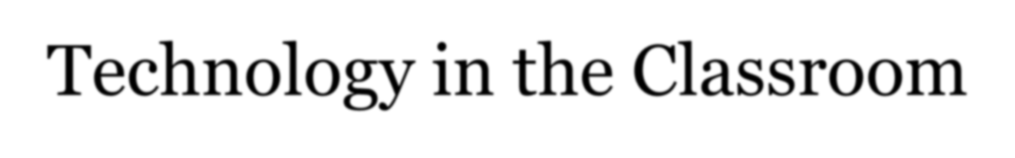

Technology in the Classroom
Increase in video use in general ed. Evidence-based

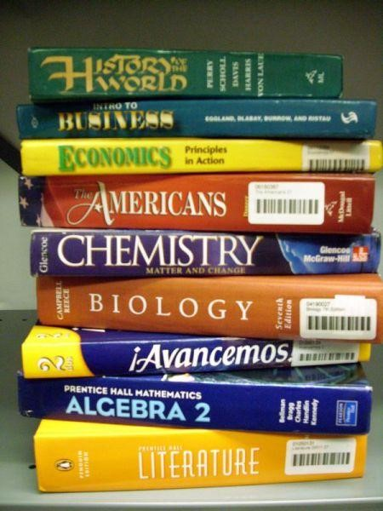
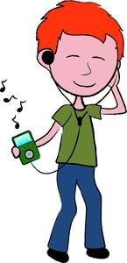
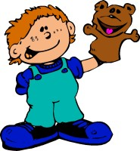
strategies for academic
education for students with disabilities Age appropriate technology

Literature: Video Meta-Analysis
- Videos effectively present academic content to ALL students

- Teaching functional, social, and behavioral skills to students with intellectual disabilities;

- May have to be adapted for cognitive needs
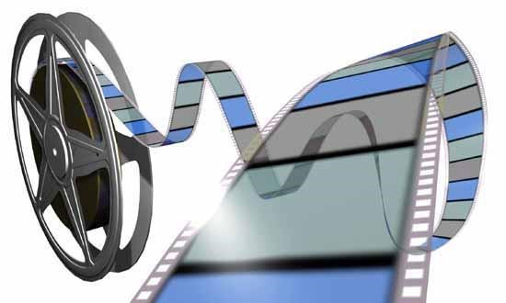
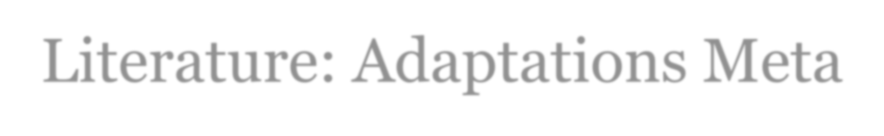

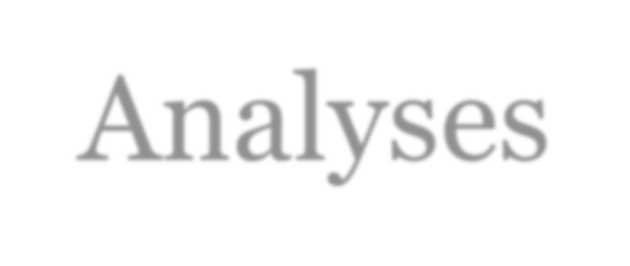
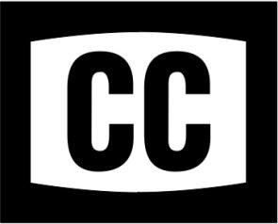
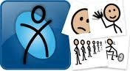
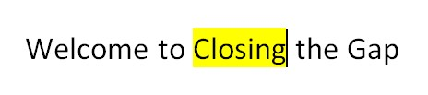
•
Literature: Adaptations Meta
-
Analyses

Closed captioning

Highlighted text

Picture symbols

•
•

- Interaction 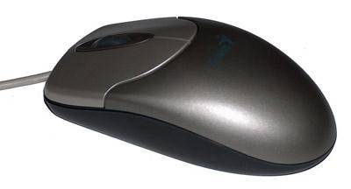

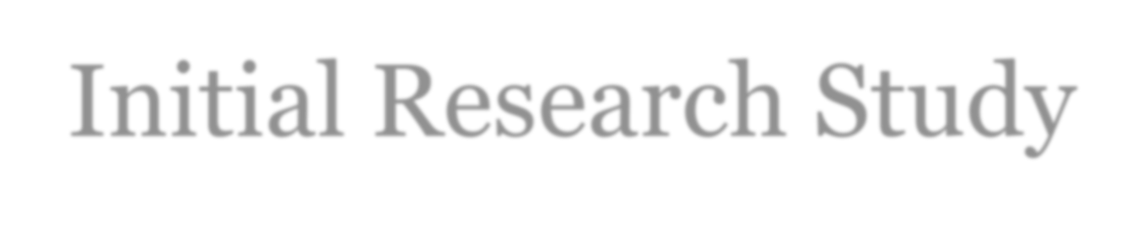
Initial Research Study
- 11 students with intellectual disabilities from the
Mason LIFE program at GMU

- Repeatedly watched regular and adapted videos
(1,5-2 minutes long)

- Answered 3 factual and 3 inferential questions about the video

Video Materials
- Editable videos from Unitedstreaming aligned with VA SOLs
- Comprehension questions asked by the researcher

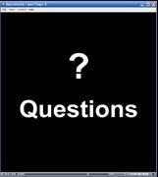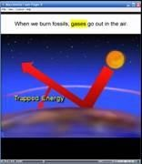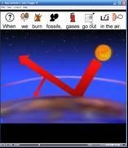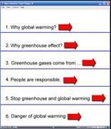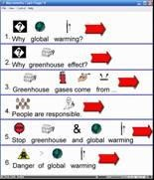

- Altered narration via natural synthesized voice
- Video with highlighted text captions
- Video with picture/word-based captions
- Prompted interactive video searching for answers

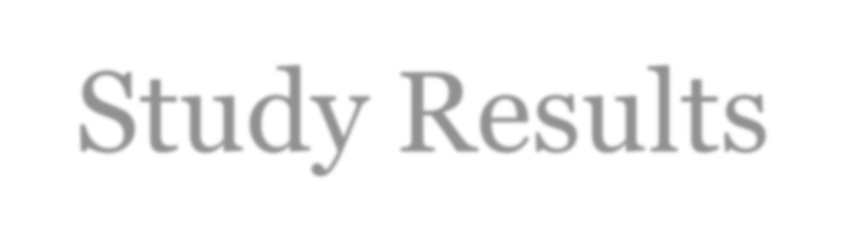
Study Results
- Significantly improved factual comprehension

- Significant improvements in both factual and inferential comprehension after searching the video for answers

- No difference between highlighted text captions and picturesymbol based captions;

- Students LOVED adapted videos!

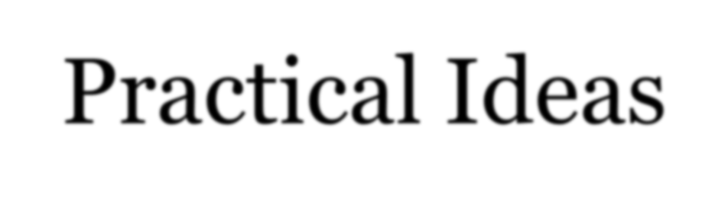
Practical Ideas
- Access to videos aligned with curriculum standards (e.g., Unitedstreaming)
- Videos with regular closed captioning (e.g., CNN)
- Video „chunking‟/stopping for discussion or narrating;
- Hyperlinks to segments corresponding to comprehension questions with MovieMaker
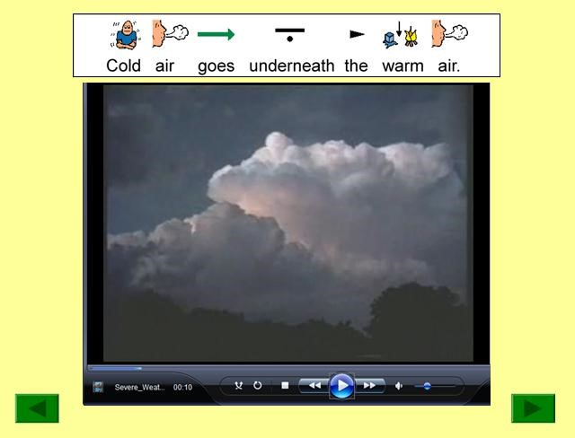
- Video chunks with picture symbol-based captions embedded into PowerPoint

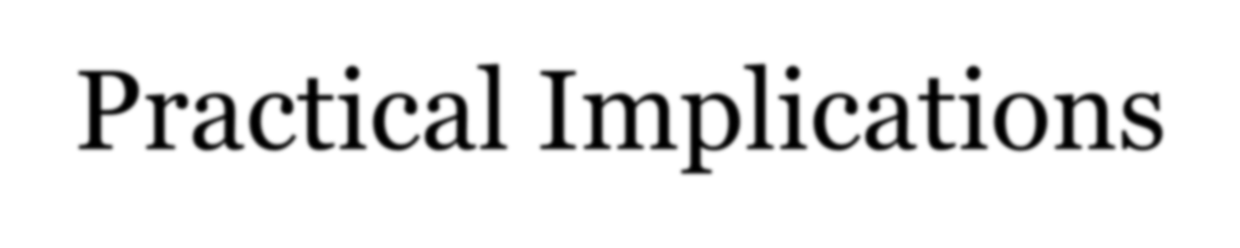
Practical Implications
- Too time consuming and labor intensive to adapt existing videos with various adaptations
- VIDEO ENHANCEMENT PROGRAM IS NEEDED!

2008-2010 Steppingstones of Technology Innovation for Children with Disabilities grant:

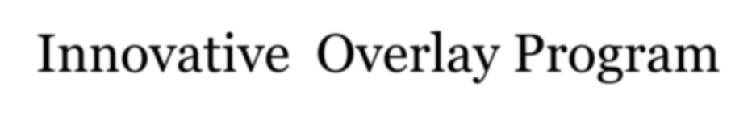
Adapted Captions through Interactive Video (ACTIV)
Innovative Overlay Program

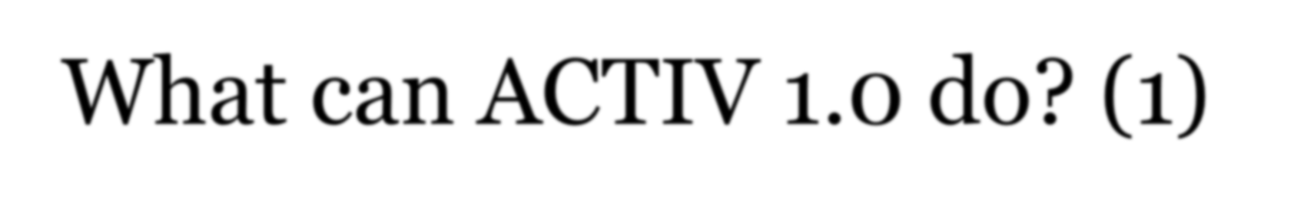
What can ACTIV 1.0 do? (1)
- Upload any existing video (.wmv; .avi) in the user or
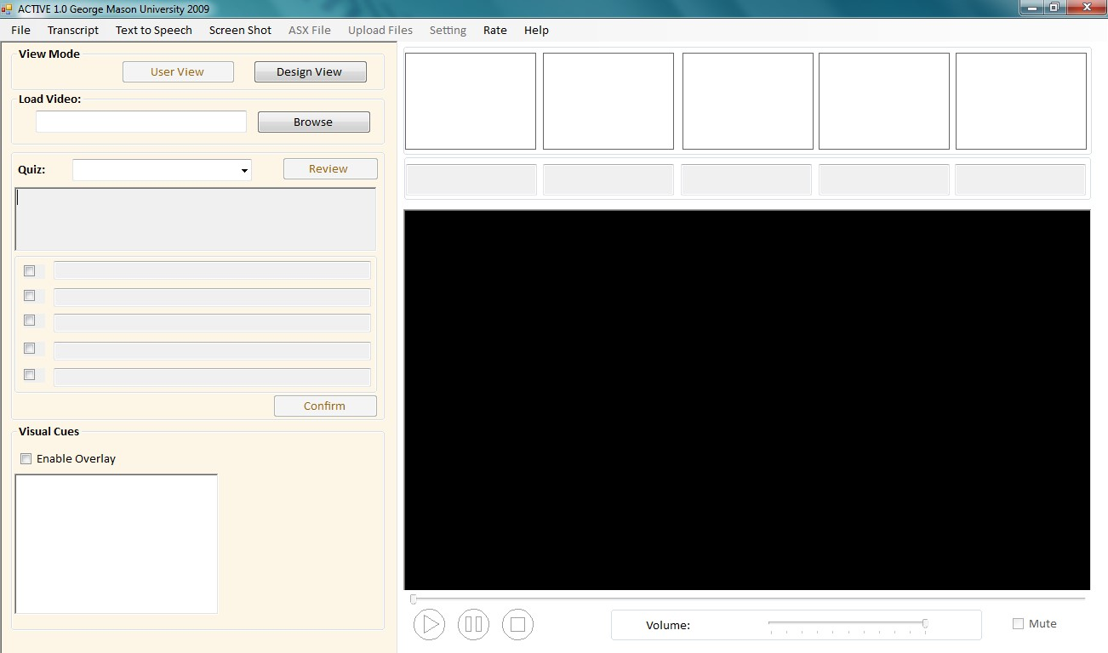
design view

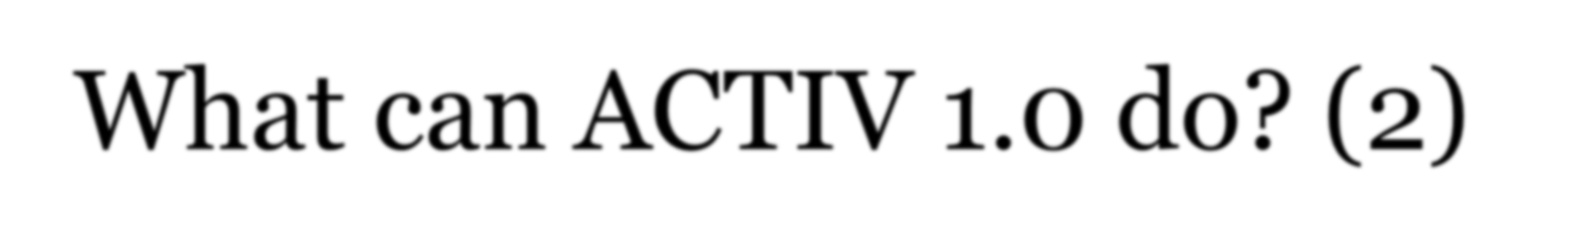
What can ACTIV 1.0 do? (2)
- Automatically create video transcript by converting speech to text and adding time stamps to each word in the video (providing regular captions)
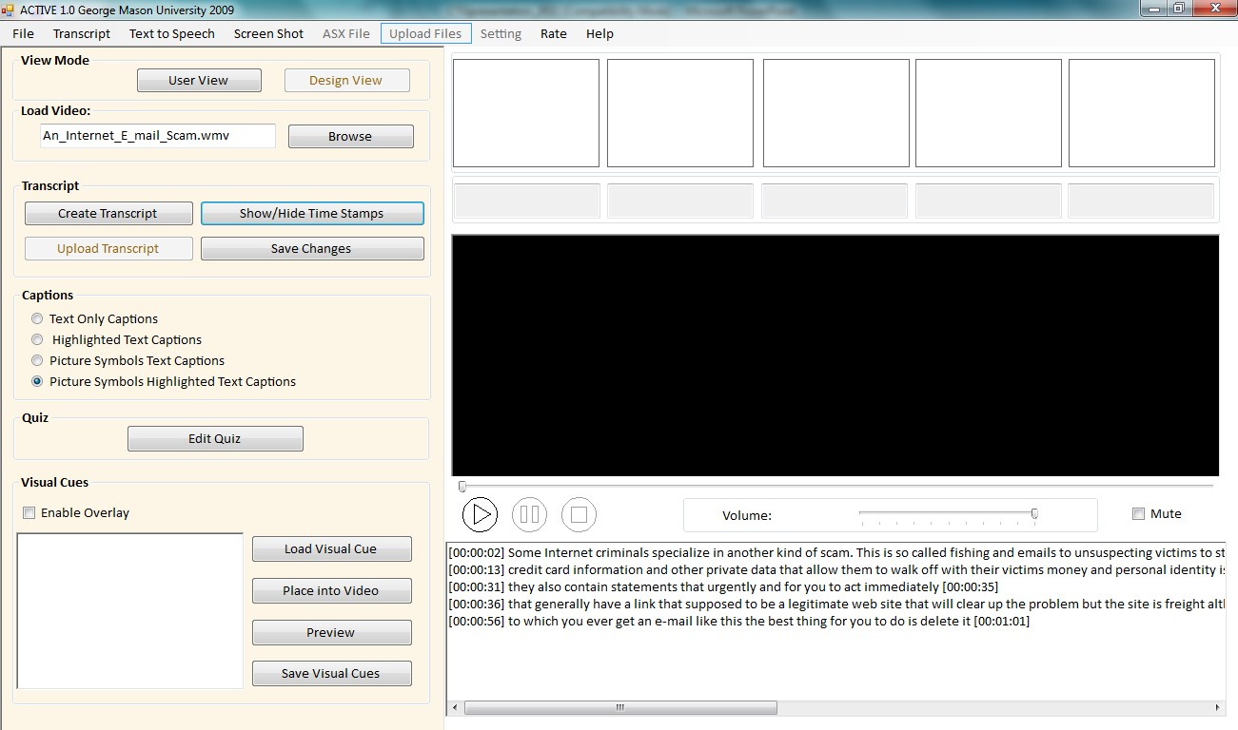

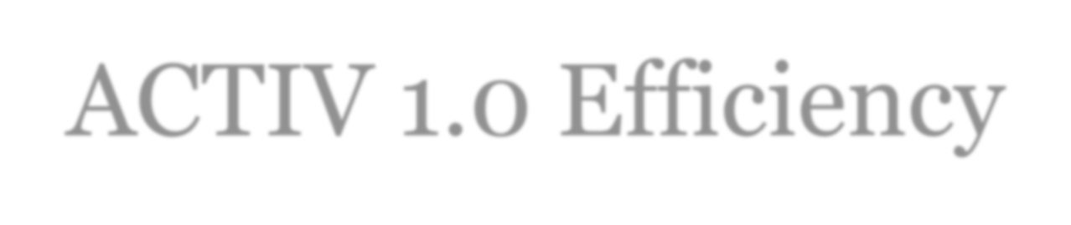
ACTIV 1.0 Efficiency
- It does not take long to create a transcript from the video.
Video Length (min.)
y = 0.2777x + 0.4754
R
2
= 0.9733
0
10
20
30
40
50
0
20
40
60
80
100
120
140
160
Video Length (min.)
Transcript Load (min.)
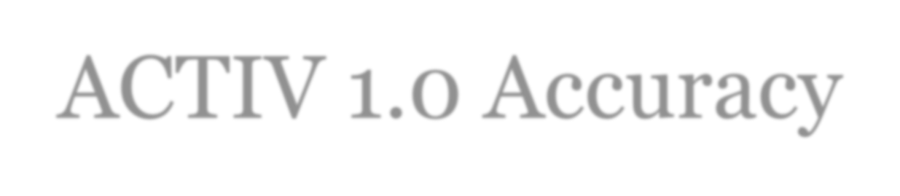
ACTIV 1.0 Accuracy
- ACTIV speech-to-text accuracy keep increasing.
0
10
20
30
40
50
60
70
80
1
2
3
4
5
6
7
8
9
10
11
12
13
14
15
16
17
18
19
20
Accuracy % - ACTIVE Application
Accuracy % - Docsoft

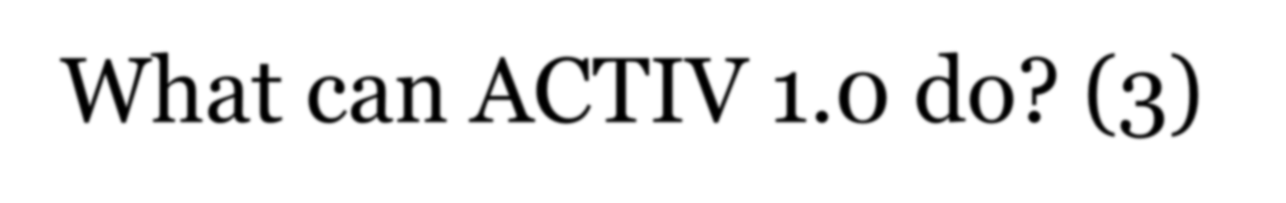
What can ACTIV 1.0 do? (3)
- Text in the transcript (right in the transcript or through the advanced screen) can be edited while maintaining time stamps (improving accuracy and creating key word captions)
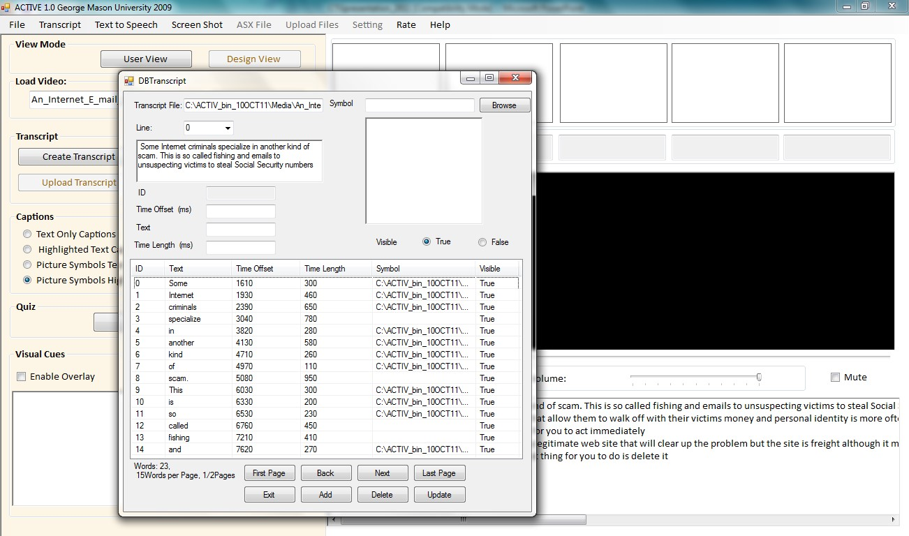
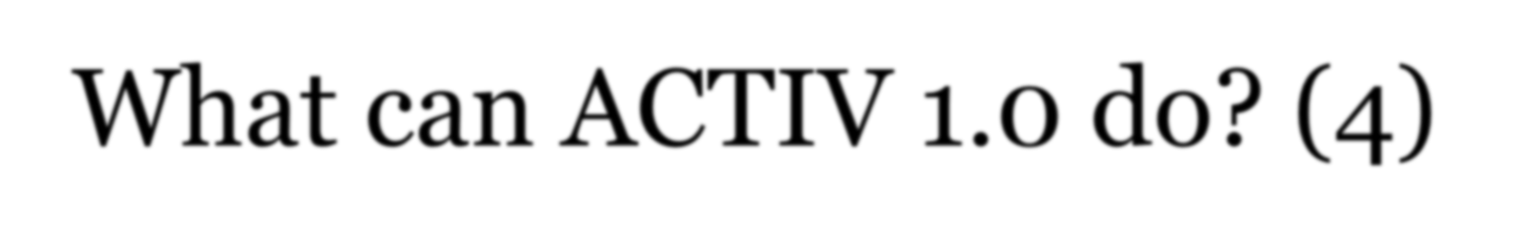
What can ACTIV 1.0 do? (4)
- Each word in the text-based captions is automatically highlighted as it is spoken out (can turn this feature off).
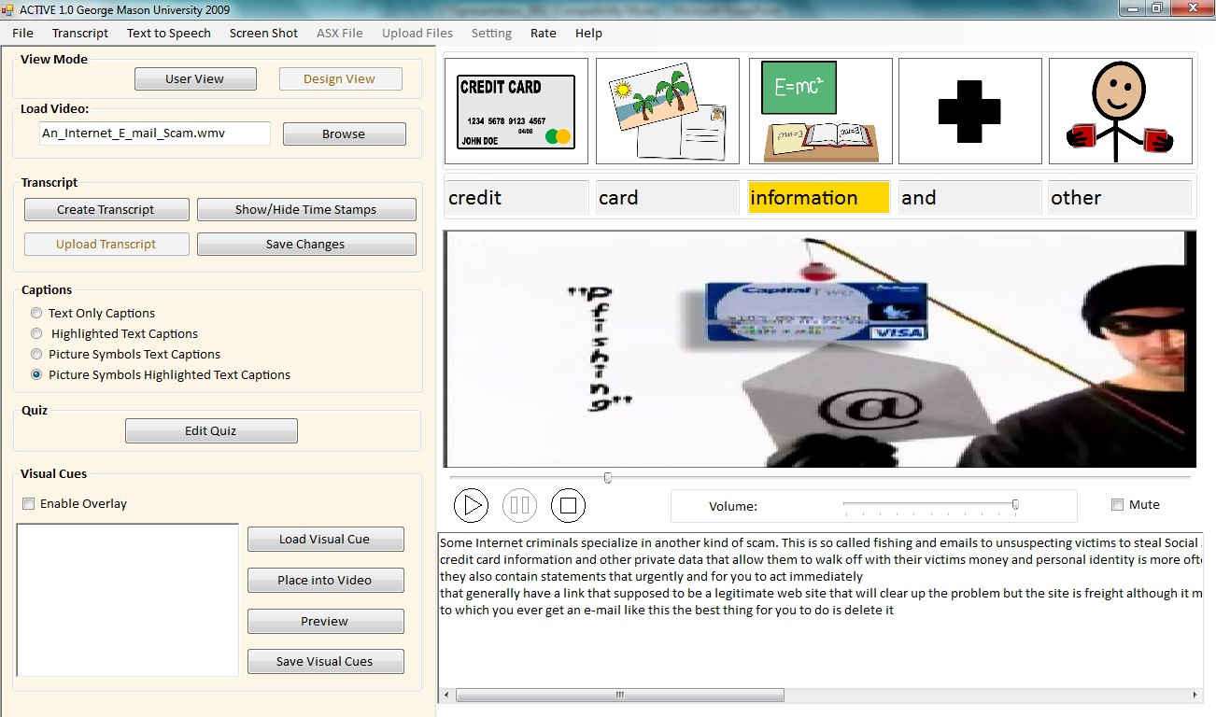

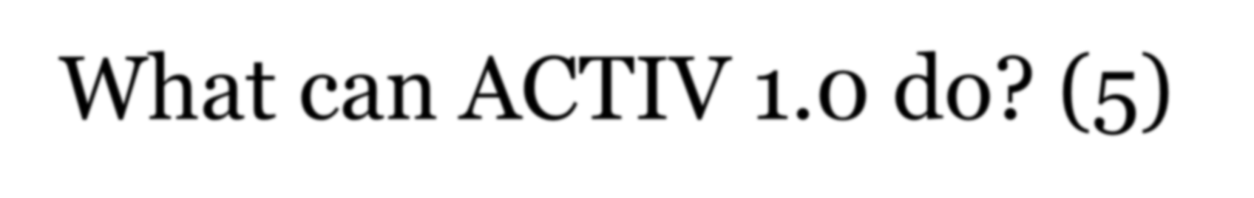
What can ACTIV 1.0 do? (5)
- Picture symbols from Symbolstix are automatically added to each word in the captions (can turn this feature off)

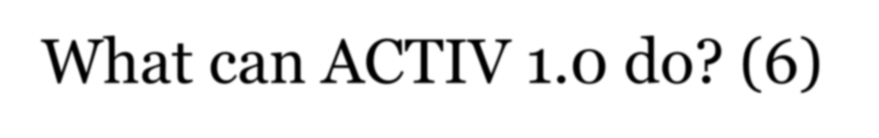
What can ACTIV 1.0 do? (6)
- Graphics can be added to the video (as the overlay) to focus user‟s attention on important stimuli.
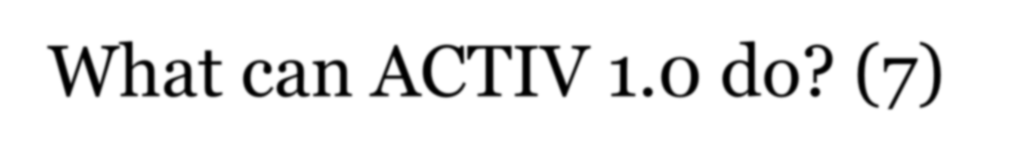
What can ACTIV 1.0 do? (7)
- Teachers can mute the video, narrate, or use text-tospeech feature.
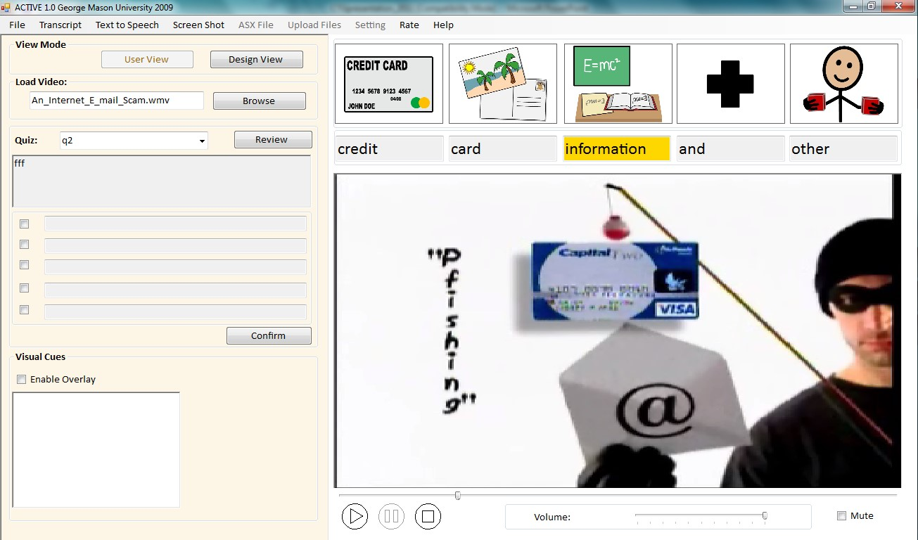
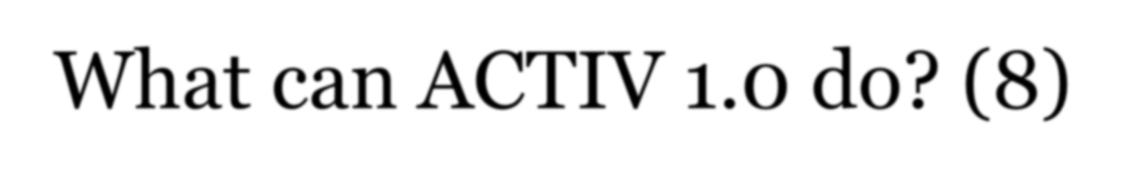
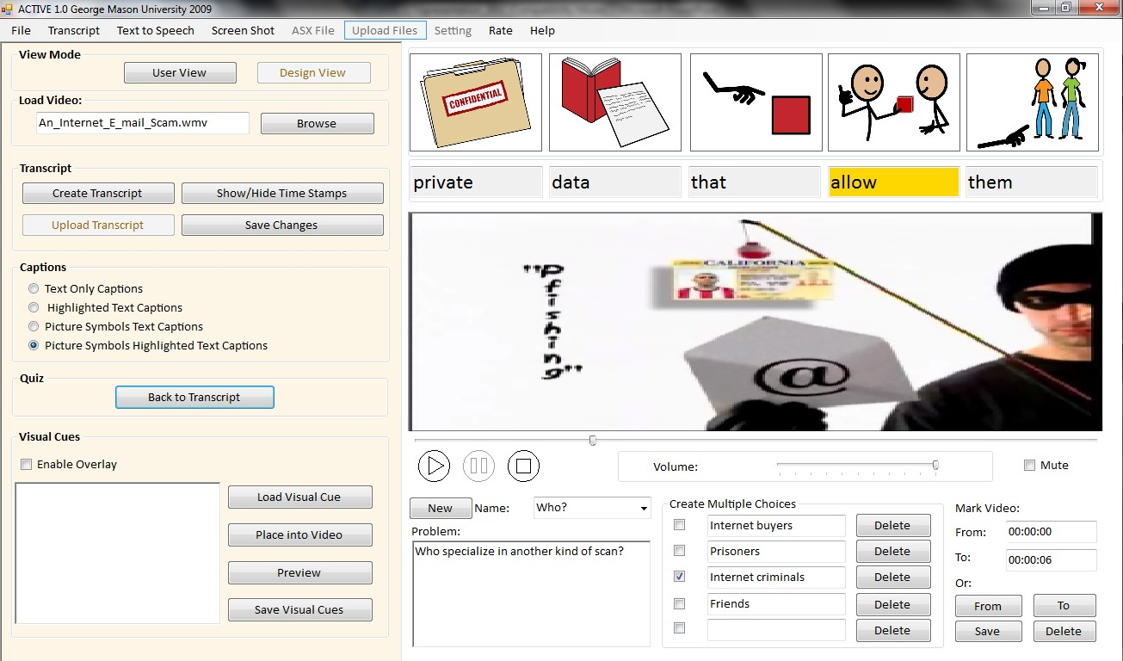
What can ACTIV 1.0 do? (8)
- Multiple-choice quizzes can be easily created to test user‟s comprehension of the video content.

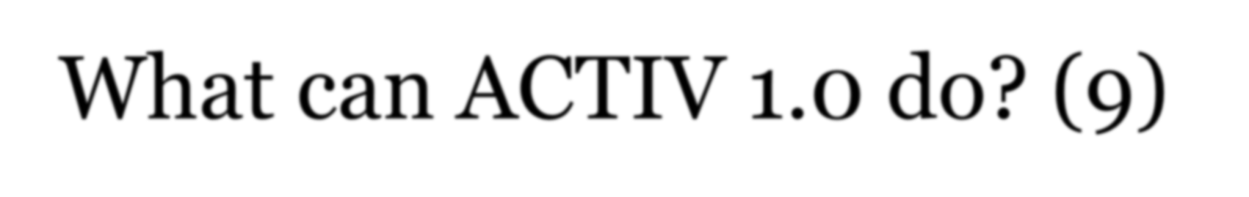
What can ACTIV 1.0 do? (9)
- Each question can be tagged in the video, so that the user can preview/watch a segment containing the correct answer before or after answering each question.
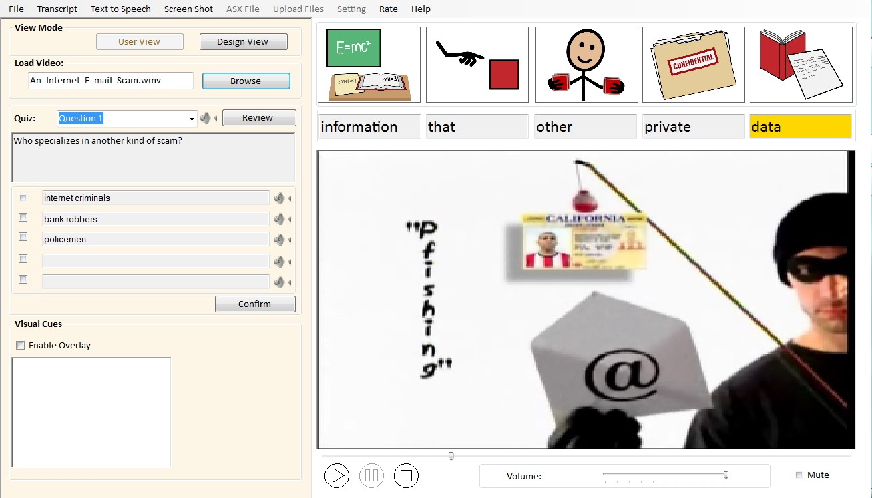
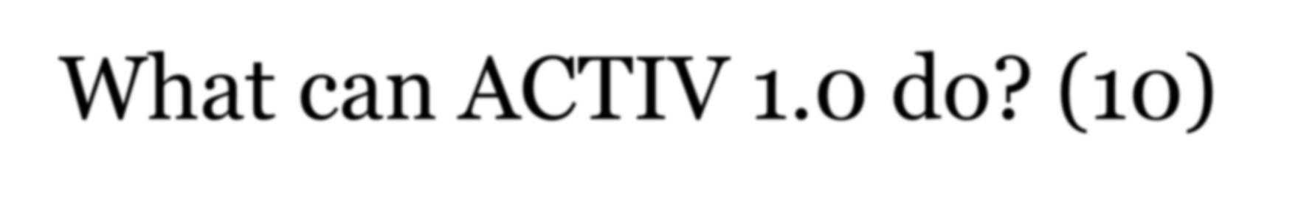
What can ACTIV 1.0 do? (10)
- Each question and answer choice can be read out loud to
the student

- ACTIV 1.0 collects mouse clicks data
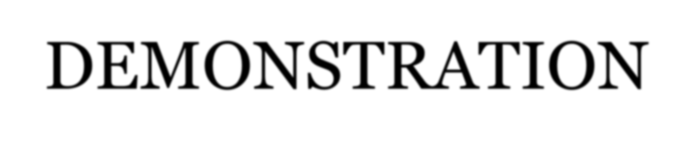
DEMONSTRATION

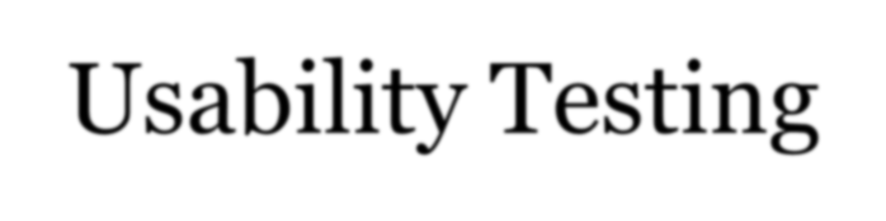
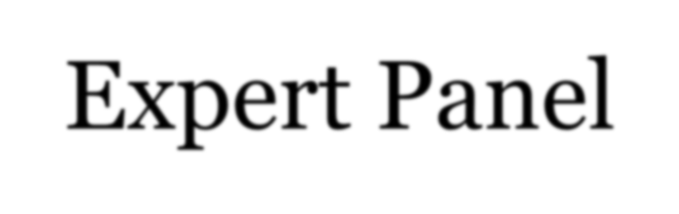
Usability Testing Expert Panel
Questionnaires, observations, and interviews with 6 experts in
- teaching students with intellectual disabilities
- instructional design/assistive technology
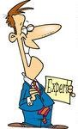
- content instruction for students with disabilities

- Functional changes
  - E.g., Be able to edit text within transcript window

- Interface changes
  - E.g., Increase captioning font and decrease words per line

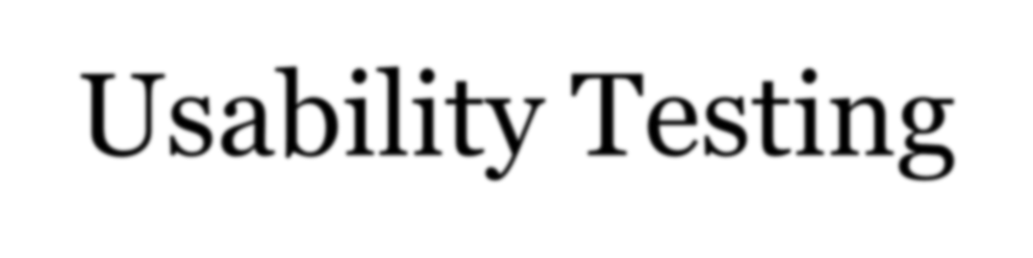
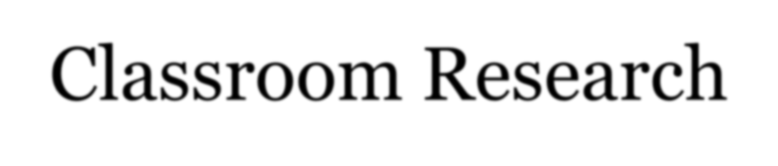
Usability Testing Classroom Research
- Three single-subject research studies in:

  - Middle school science classroom
  - Middle school history classroom
  - High school transition classroom

- 4 students with intellectual disabilities in each classroom

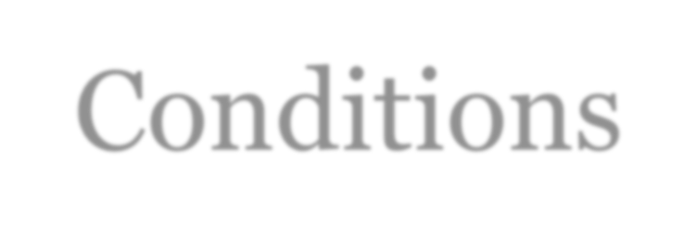
Conditions
Baseline Treatment

Regular videos Alternate between highlighted verbatim
captions vs. highlighted key idea captions

Regular videos Alternate between picture-symbol
verbatim vs. picture-symbol key idea
captions

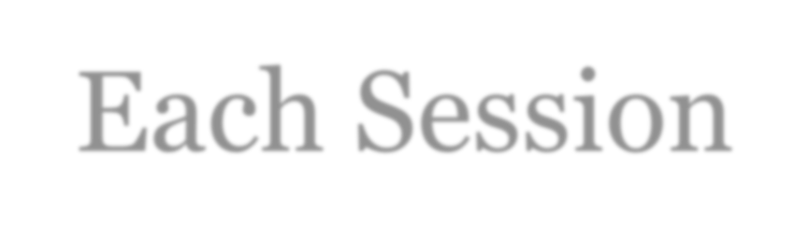
Each Session
- Students watched 3-5 minutes videos (regular or adapted) from Unitedstreaming

- Students answered 6 factual questions embedded in the video

- In treatment condition, students could review the video for answers to adjust their original responses
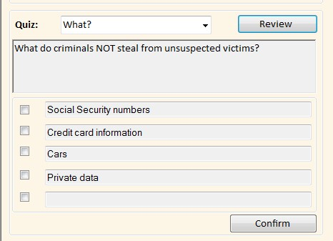

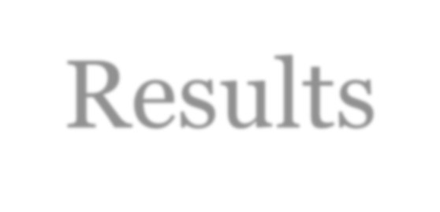
Results
- No functional relation between watching videos adapted with captions and factual comprehension

- Similar performance with verbatim and key word captions

- Significantly increased factual comprehension of the video content after reviewing/searching captioned clips for answers

- Students loved the videos but did not look at the captions because “they were small and moving too fast”
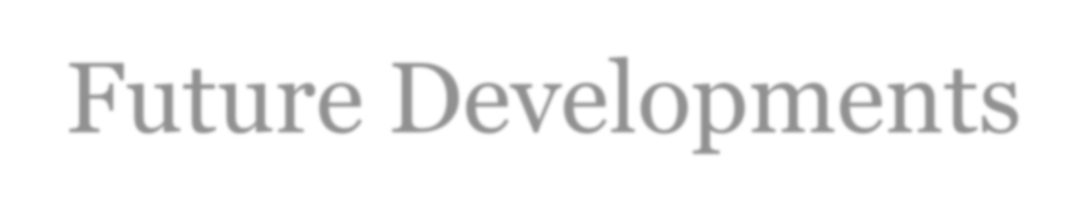
Future Developments
- Improving transcript accuracy

- Creating multiple text options for each picture symbol

- Synchronizing text-to-speech option to slow down the narration speed

- Exploring ways to automatically adjust transcript‟s readability levels

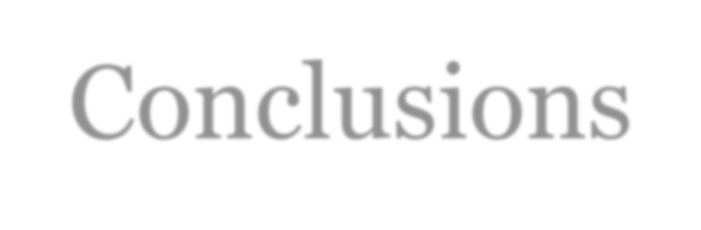
Conclusions
Adapted and interactive videos offer innovative, universally designed solutions that can be used effectively for teaching academic content to students of all abilities, including those with disabilities.


