U.S. Department of Education OMB No. 1894-0003 Grant Performance Report (ED 524B) Project Final Report
PR/Award # (11 characters): H327A080013

SECTION A - Performance Objectives Information and Related Performance Measures Data (See Instructions. Use as many pages as necessary.)

1. Project Objective [ ] Check if this is a status update for the previous budget period.

Initial and refined design to create an Alpha prototype tool to be used with adapted video interventions for middle and high school students with intellectual disabilities in the content areas of language arts, science, and social studies.

1. Performance Measures | Measure Type |  |  | Quantitative Data
1.1 Define user profiles  1.2 Construct storyboard of the features and how the user interacts with each element  1.3 Develop flow chart of the Alpha prototype  1.4 Design interface of the Alpha prototype  1.5 Create software program | Project |  | Target |  | Actual Performance Data
 |  | Raw Number | Ratio | % | Raw Number | Ratio | %
 |  |  | 5/5 | 100 |  | 5/5 | 100

Explanation of Progress (Include Qualitative Data and Data Collection Information)


All 5 objectives within Goal 1 were met reaching 100% on the actual performance data as compared to the anticipated targets. As a result of Goal 1, the Alpha prototype of Adapted Captions through Interactive Videos (ACTIV) program was developed. Three user profiles: teachers, parents, and students with intellectual disabilities that emerged from the initial review guided the conceptualization of the imperative program features. The storyboard was then developed to exhibit the screens and their layouts offered to the user. All screens incorporated into the program matched the descriptions in the grant application (pp.17-21). Interactive flowchart was created to display the interactions between the screens from the storyboard (both storyboard and flowchart available at http://kihd.gmu.edu/research/activ/). Visual C# application framework was chosen as a platform for creating the prototype based on its ability to incorporate all the required features. User profiles, storyboard, and flowchart of the innovative tool were reflected in the Alpha prototype of ACTIV. The following features were incorporated into the prototype: verbatim captions (regular, highlighted, or picture/word-based); key word captions (regular or picture/word-based); visual placement cuing; comprehension quiz; opportunity to review the video for correct answers; and data collection capability.

2. Project Objective

Expert panel review of Alpha prototype. The expert panel will consist of content-instruction experts, school setting consultant and research team, teachers and parents of students with intellectual disabilities.

2. Performance Measure | Measure Type |  |  | Quantitative Data
2.1 Conduct expert panel review  2.2 Compile a list of revisions based on feedback and recommendations | Project |  | Target |  | Actual Performance Data
 |  | Raw Number | Ratio | % | Raw Number | Ratio | %
 |  |  | 2/2 | 100 |  | 4/2 | 200

Explanation of Progress (Include Qualitative Data and Data Collection Information)

Both objectives within Goal 2 were met. In addition to anticipated outcomes, two (instead of one) expert panel reviews of the Alpha prototype of ACTIV were conducted. Preliminary expert panel review was conducted in 2010 with the research team consisting of the content-based instruction expert, a teacher and a parent of students with intellectual disabilities. Initial revisions including changes to interface appearances, adaptation placement, and additional features were incorporated into the prototype. The complete list of changes can be found below in the executive summary.

The more rigorous, second round of review was conducted in 2011. The panel consisted of six members including technology specialists, schoolbased special educators for students with intellectual disabilities, as well as experts in the area of content-based instruction and instructional design. The expert panel members were observed using the Alpha prototype of ACTIV. Expert behaviors were recorded. In addition, the experts completed Likert-scale questionnaires and interviews providing ideas for prototype development. The qualitative data from the second round of expert panel review were also analyzed in order to compile a list of revisions and adaptations for the Alpha prototype of ACTIV. The list of revisions is included in the executive summary below. Adaptations were divided into functional changes and changes to the program interface.

3. Project Objective

Revisions to create a Beta prototype tool and material development of adapted and interactive videos to be used during the usability testing with middle and high school students school students with intellectual disabilities in content areas.

3. Performance Measure | Measure Type |  |  | Quantitative Data
3.1 Re-develop flow chart for the Beta prototype  3.2 Re-design interface for the Beta prototype  3.3 Revise software program for the Beta prototype  3.4 Create materials for usability testing, which includes versions of the adapted and interactive videos | Project |  | Target |  | Actual Performance Data
 |  | Raw Number | Ratio | % | Raw Number | Ratio | %
 |  |  | 4/4 | 100 |  | 4/4 | 100

Explanation of Progress (Include Qualitative Data and Data Collection Information)

All 4 objectives within Goal 3 were met reaching 100% on the actual performance data as compared to the anticipated targets. Following the expert panel reviews a flowchart was redeveloped for the Beta prototype of ACTIV 1.0 (an updated flowchart is available at http://kihd.gmu.edu/research/activ/) and the interface was redesigned. The most important revisions suggested by the expert panel were incorporated into the tool in order to start the next phase (usability testing with students with intellectual disabilities). The materials for the usability testing were created. The plan was to include 9 versions of videos: baseline, regular videos; videos with regular verbatim captions; videos with regular key word captions; videos with highlighted text verbatim captions; videos with highlighted text key word captions; videos with picture-symbols verbatim captions; videos with picture-symbols key word captions; videos with verbal cuing; and videos with verbal cuing. However, the decision was made not to include some of the above conditions due to requests from participating teachers. Thus, the materials for the usability testing were created to incorporate 7 versions of videos meeting objecting 3.4.

4. Project Objective

Usability testing of the adapted and interactive videos created with the help of the Beta prototype of the tool with both a high school class and middle school class of students with intellectual disabilities.

4. Performance Measure | Measure Type |  |  | Quantitative Data
4.1 Studies set up  4.2 Implementation for each group  4.3 Collecting and graphing data  4.4 Establishment of fidelity of intervention and implementation | Project |  | Target |  | Actual Performance Data
 |  | Raw Number | Ratio | % | Raw Number | Ratio | %
 |  |  | 4/4 | 100 |  | 4/4 | 100
Explanation of Progress (Include Qualitative Data and Data Collection Information)

All 4 objectives within Goal 4 were met reaching 100% on the actual performance data as compared to the anticipated targets. The usability testing of adapted and interactive videos designed with the Beta prototype of ACTIV 1.0 was set up in three classrooms for students with intellectual disabilities. Those classrooms included: (1) high school transition classroom; (2) middle school social studies classroom; and (3) middle school science classroom. The study procedures and materials were discussed and selected in collaboration with the participating teachers. Overall, 4 students in each classroom met the inclusion criteria specified in the proposal narrative (p. 25) and agreed to participate in the usability testing. In all conditions students watched 3-5 minutes videos (regular or adapted) from Unitedstreaming video database. All classrooms watched regular videos in their baseline conditions. Students started treatment in a staggered fashion. In treatment, students in both middle school classrooms used highlighted text verbatim and key word captions for science and social studies, while the students in high school transition classroom used picture-symbol verbatim and key word captions. After watching the videos, students answered 6 factual questions. In treatment conditions, students would review the video for answered to adjust their original responses. The data were graphed as they were collected. Fidelity of intervention and implementation was collected regularly across classrooms, individual students, and different conditions.

5. Project Objective

Final innovative technology product with recommendations for future efficacy studies in areas that showed positive outcomes during usability testing, data dissemination, and evaluation of the project

5. Performance Measure | Measure Type |  |  | Quantitative Data
5.1 Analyzing single-subject and qualitative data  5.2 Revisions for final innovative technology product  5.3 Recommendations and reports for future studies  5.4 Write articles for publication  5.5 Make conference presentations  5.6 Conduct project evaluation | Project |  | Target |  | Actual Performance Data
 |  | Raw Number | Ratio | % | Raw Number | Ratio | %
 |  |  | 6/6 | 100 |  | 6/6 | 100

Explanation of Progress (Include Qualitative Data and Data Collection Information)

All 6 objectives within Goal 5 were met reaching 100% on the actual performance data as compared to the anticipated targets. The data from the usability testing were analyzed. Graphs can be found in the executive summary below. Based on the results, there was no functional relation between watching videos adapted with captions and increases in factual comprehension. Students demonstrated similar performance with verbatim and key word captions. However, students' factual comprehension significantly increased after reviewing captioned clips for answers. Based on interviews with students, they enjoyed watching the videos but did not look at the captions because "they were small and moving too fast." The list of final revisions to the innovative technology product; recommendations for future studies; and project evaluation were compiled and presented in the executive summary below. In addition, manuscripts on the expert panel review of the Alpha prototype of ACTIV 1.0, usability testing data, as well as the iterative process of innovative technology design and development were prepared. To-date the research team presented ACTIV 1.0 at 6 conferences. Furthermore, ACTIV 1.0 presentations have been accepted and scheduled for 3 more conferences for Spring 2012. References for manuscripts and conference presentations are available in the executive summary.

I. Program Performance Measure #1 | Measure Type |  |  | Quantitative Data
The percentage of technology and media projects judged to be of high relevance of improving outcomes of infants, toddlers, children and youth with disabilities. | Program |  | Target |  | Actual Performance Data
 |  | Raw Number | Ratio | % | Raw Number | Ratio | %
 |  | 1 |  |  | 1

II. Program Performance Measure #2 | Measure Type |  |  | Quantitative Data
The percentage of technology and media projects judged to be of high quality. | Program |  | Target |  | Actual Performance Data
 |  | Raw Number | Ratio | % | Raw Number | Ratio | %
 |  | 1 |  |  | 1

III. Program Performance Measure #3 | Measure Type |  |  | Quantitative Data
The percentage of technology and media projects that produce findings, products and/or other services that contribute to improving results for infants, toddlers, children and youth with disabilities. | Program |  | Target |  | Actual Performance Data
 |  | Raw Number | Ratio | % | Raw Number | Ratio | %
 |  | 1 |  |  | 1

IV. Program Performance Measure #4 | Measure Type |  |  | Quantitative Data
The federal cost per unit of technology and media services program. | Program |  | Target |  | Actual Performance Data
 |  | Raw Number | Ratio | % | Raw Number | Ratio | %
 |  | 999 |  |  | 999

Explanation of Progress (Include Qualitative Data and Data Collection Information)

Program Performance Measure #1: The development of the video interventions is of high relevance to improving outcomes of children and youth with disabilities. While a majority of students with intellectual disabilities are reported to use a computer, most existing technology-based products for content instruction appear to be too complex or age inappropriate for older students. Thus, there exists a need for a new universally-designed approach to increase students’ performance through strategies and tools like the adapted and interactive video program (ACTIV) that is being developed.

Program Performance Measure #2: The high quality of this development project is secured by having an iterative design and research process that is kept in balance with project meetings and annual performance reviews. As of now, the project follows the quality management plan as specified on pages 36-42 of the approved grant application. Currently we are meeting the project goals and benchmarks within milestones as predicted with the adjusted timeline. Key personnel consistently meet their responsibilities as dictated by the load chart on page 41.

Program Performance Measure #3: The final product anticipated as a result of this development project will contribute to improving academic performance of children and youth with disabilities. Specifically, the adapted and interactive videos will support academic instruction in the major subject areas (e.g., language arts, science, and social studies) for middle and high school students with intellectual disabilities. During the iterative development process only features that would enhance learning for this population of students are considered for the final application.

Program Performance Measure #4: The federal cost per unit of technology and media service program will be considered upon completion of the final product, which is anticipated to be a technology-based software program for video enhancement as described in detail on pages 17-21 of the approved grant application. Thus, the final prototype software will have commercial viability and will be available to users for purchase. The research team is currently in the process of licensing through the George Mason Technology Transfer department. The negotiations are also happening with the software vendor company interested in disseminating ACTIV 1.0.


U.S. Department of Education

Grant Performance Report (ED 524B)

Project Status Chart

PR/Award # (11 charact
ers):
H327A080013

SECTION B
-

Budget Information (
See Instructions. Use as many pages as necessary.)

SECTION C
–

Additional Information (
See Instructions. Use as many pages as necessary.)

OMB No. 1894
-
0003


U.S. Department of Educ
ation

Grant Performance Report (ED 524B)

Executive Summary

PR/Number # (11 characters):

H327A080013

OMB No. 1894
-
0003

(See Instructions)

The Steppingstones (84.327A) grant award entitled Development and Usability Testing of Adapted and Interactive Videos Intervention for Students with Intellectual Disabilities began on September 1, 2008. To-date, all Phases (I, II, III, IV, and V corresponding Goals 1, 2, 3, 4, and 5) have been completed. The iterative developmental procedures were enhanced with regular Key Personnel meetings and formative evaluation of completed goals. During that time, Co-Project Directors, Heidi J. Graff and Anna Evmenova, in collaboration with the Programmer, Shuangbao Wang, and Senior Researcher, Michael Behrmann, accomplished the following iterative milestones:

- Development of the Alpha prototype: The Adapted Captions through Interactive Video (ACTIV) program, which included various video adaptations was researched and developed through the iterative process. This goal focused on the review and demonstration of existing software programs that included features essential for ACTIV (e.g., picture symbol programs, text-to-speech programs, etc.). The majority of features were developed by the project programmer except for the picture symbol library. The research team contacted and collaborated with the News-2-You Company to acquire the Symbolsix online database of nearly 13,000 picture symbols. The storyboard and flowchart were created and included 10 screens symbolizing 10 steps necessary for adapting an existing video clip as well as interactions between the screens and the program features. As a result, the alpha prototype of ACTIV was developed on the Visual C# application framework. To-date the program allows users to:

    - Upload any existing video clip (.wmv; .avi) in the user or design view;
    - Automatically create video transcript by converting speech to text and adding time stamps to each word in the video (providing regular captions);
    - Have each word in the captions automatically highlighted as it is spoken aloud (can turn this feature off);
    - Have picture symbols from Symbolstix automatically added to each word in the captions (can turn this feature off);
    - Edit text in the transcript (right in the transcript window or through the advanced screen) while maintaining time stamps (to improve accuracy and creating key word captions);
    - Add visual cues to the video (as overlay graphics) to focus user’s attention on important stimuli;
    - Mute the video and use text-to-speech feature;
    - Create built-in multiple-choice or true/false quizzes to test user's comprehension of the video content;
    - Tag each question in the video, so that the user can review/watch a segment containing the correct answer before or after answering each question;
    - Collect button clicks data and generate reports.

The detailed description of ACTIV is available from the Reference Manual attached at the end of the executive summary. This is an updated version of the manual that incorporates all the changes that have occurred throughout all 5 Phases of the project and that are described in details below.

The ACTIV website was also developed (http://kihd.gmu.edu/research/activ/) to include all the relative information as mandated by the priority requirements of the current RFP.

- Planned and conducted two expert panel reviews: The preliminary review was completed with the research team consisting of a content-based instruction expert, a teacher, and a parent of students with intellectual disabilities. The following changes have been incorporated into the Alpha prototype of ACTIV 1.0 based on the expert recommendations:

  - Consider the placement of the picture symbols right above each word in the captioning line;
  - Change the color of highlighted text to yellow in the highlighted text captions;
  - Incorporate screen shot feature for better visual cuing;
  - Add picture symbols on the side of the screen and connecting arrows for visual cuing; • Explore and program text-to-speech engine for alternative narration; • Add data collection capability.

The more rigorous second round of expert panel review was conducted to explore additional recommendations. The panel consisted of six members including technology specialists, school-based special educators for students with intellectual disabilities, as well as experts in the area of content-based instruction and instructional design. The expert panel members were observed using the Alpha prototype of ACTIV 1.0. The experts also completed Likert-scale questionnaires and interviews providing ideas for prototype revisions and adaptations. The qualitative data from the second round expert panel review were analyzed to compile a list of additional changes to ACTIV 1.0. Adaptations were divided into functional changes and changes to the program interface. The following is the list of proposed adaptations:

  - Think of a way to create a separate picture symbols database for the usability testing studies; • Incorporate Question name into the data collection Button Clicks report;
  - Maker User View as default;
  - Make it work on 64-bit computers;
  - Create the database of multiple text options for each picture symbol;
  - Be able to change the location of the captioning window (above or below the video) based on the student's needs;
  - Make the captioning font larger (at least 18pt.) and have 5 text boxes per line;
  - Be able to change the transcript in the transcript window rather than in the advanced edit window;
  - Be able to choose picture symbols, upload photos (story specific images) in the advanced window;
  - Be able to increase the font size in the transcript window; make sure the text is wrapped around in the transcript window;
  - Have built-in 'library' of visual cues to include: arrow, line, picture symbol; as well as being able to highlight/mask important information, have screenshot, draw, import an image and add text (e.g., sight words);
  - Being able to rewind and forward the video one/two frames back and forth to precisely place the visual cue;
  - In the Advanced Edit window, true/false changes should be more than on at a time;
  - Incorporate video name and question (or which one was the correct answer) into the data collection; • Increase font size in the quiz;
  - Have spell checker when creating the quiz;
  - When answering the question incorrectly on the quiz, the pop-up window should say, 'Review the video' to guide students to the Preview button;
  - Change the scary word "overwrite" in the pop-up window when answering the question on the quiz after reviewing the video;
  - See Interface Changes screenshot for more.

- Based on the qualitative data that emerged from Phase II, the most critical changes for the usability testing with middle and high school students with intellectual disabilities had to be incorporated into ACTIV. Following the expert panel reviews a flowchart was redeveloped for the Beta prototype (an updated flowchart is available at http://kihd.gmu.edu/research/activ/) and the interface was redesigned. The most important revisions suggested by the expert panel that were implemented in time for Phase III:

  - Create a separate picture symbols database for the usability testing studies;
  - Incorporate Question name into the data collection Button Clicks report;
  - Maker User View as default;
  - Be able to change the transcript in the transcript window rather than in the advanced edit window;
  - Have built-in 'library' of visual cues to include: arrow, line, picture symbol; as well as being able to highlight/mask important information, have screenshot, draw, import an image and add text (e.g., sight words).

Some of the adaptations were not mandated for creating usability testing materials and were incorporated into ACTIV prototype later in the project. The list of final changes to the tool is presented below in the executive summary (in Phase V/Goal 5).

In addition, the ACTIV 1.0 interface has been redesigned based on the expert panel feedback to ensure ease of use and better presentation of the program features. Those changes included the following:
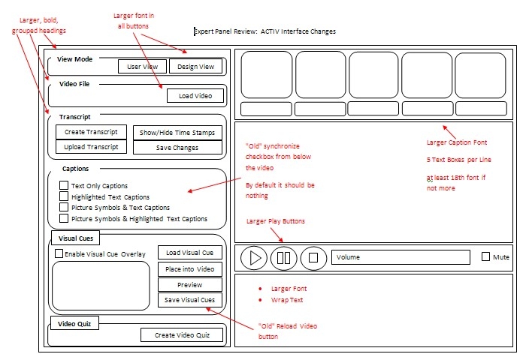

The updated Beta prototype of ACTIV 1.0 was used to create video materials for the usability testing with students with intellectual disabilities. Based on students’ needs and participating teachers’ requests, the following versions of videos have been created:

  - 15 video segments including (version 1) baseline, regular videos; (version 2) videos with picture-symbols verbatim captions; and (version 3) videos with picture-symbols key word captions.
  - 18 video segments including (version 1) baseline, regular videos; (version 4) videos with highlighted text verbatim captions in social studies; and (version 5) videos with highlighted text key word captions in social studies;
  - 18 video segments including (version 1) baseline, regular videos; (version 6) videos with highlighted text verbatim captions in science; and (version 7) videos with highlighted text key word captions in science.

The aforementioned adaptations were chosen by participating teachers based on students' abilities and needs. Thus, regular captions, verbal and visual cuing were not included into this usability testing due to the participants' specific characteristics.

- The usability testing of adapted and interactive videos designed with the Beta prototype of ACTIV 1.0 were set up in three classrooms for students with intellectual disabilities. Those classrooms included: high school transition classroom (4 students); middle school social studies classroom (4 students); and middle school science classroom (4 students). Participating students met the inclusion criteria stated on p. 25 of the grant proposal and provided informed assent, as well as parents/guardians' informed consent. Short (3-5 minutes) regular and adapted videos compiled from Unitedstreaming database were introduced to each group of students in each classroom. Teachers and students were trained on how to use those videos. Students were then randomly assigned to the order in which they started the intervention within each classroom. Fifteen video titles were used in the high school transition classroom that focused on transportation and the community. Eighteen videos on Civil War were presented in middles school social studies classroom, and 18 videos on reptiles and extreme weather were part of the middle school science classroom. In the baseline condition all students watched regular, non-adapted videos. Then the first participant started using adapted videos while the rest of the students remained in baseline. Thus, students in each classroom were introduced to the intervention in a staggered fashion. After watching videos across conditions, students were asked to answer 6 factual comprehension questions about the content in the video. In the treatment sessions students were allowed to review the video segments containing the correct answers that were tagged to each comprehension question. Data were collected by ACTIV 1.0 built-in Button Click report. The studies lasted 15 and 18 sessions in high school transition and both middle school classrooms respectively. Randomly selected sessions were observed to ensure fidelity of treatment and implementation. In addition, built-in reports were analyzed by an independent observer to ensure interobserver agreement. At the end of the study social validity interviews were conducted with all students and participating teachers to determine their perceptions of the video instruction, adapted videos, and ACTIV 1.0 tool for creating adapted videos.

- The data from 3 usability testing studies were plotted on the graph and analyzed. Visual inspection of the data focused on data patterns across different conditions for each student, specifically change in level, trend, variability of data, data overlap, immediacy of effect, and consistency of data patterns. Based on the visual analysis, there was no functional relation between captioned videos and changes in students' factual comprehension (see Figures 1, 2, and 3). Based on observations and interviews with participating students, the video narration was so fast that the students did not have an opportunity to following the adapted captions. However, the comprehension of video content significantly improved as soon as students had a chance to review small segments of captioned videos and adjust their original responses (see Figures 4, 5, and 6). In addition, there was no obvious difference between verbatim and key word captions. In fact, in several sessions, students actually did slightly better with the verbatim captions. Based on the usability testing with middle and high school students with intellectual disabilities including interviews with the participants and the teachers at the end of the research study, the following suggestions were discussed:

  - Incorporate picture symbols into questions;
  - Increase font size in the quiz (considerably);
  - If possible to have text-to-speech feature in the quiz (to read out loud questions and choices);
  - Have a pop-up window indicating the end of the quiz;
  - If possible, to have spell check when the teacher creates the quiz.

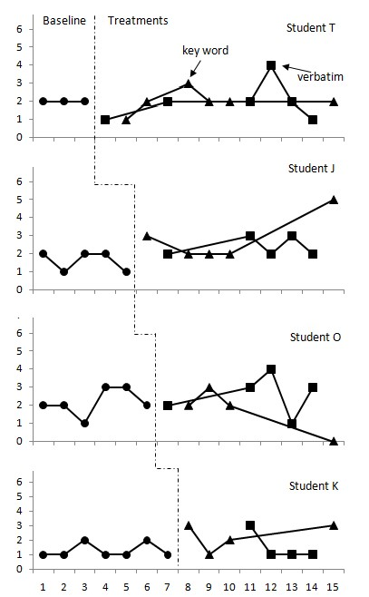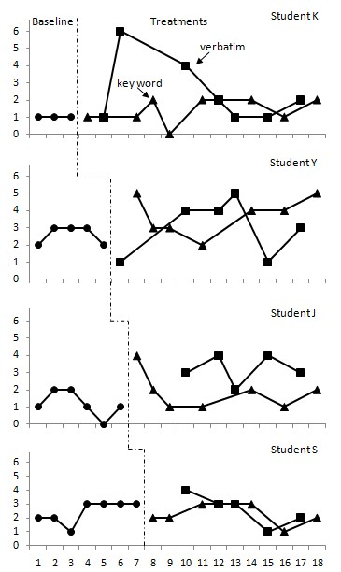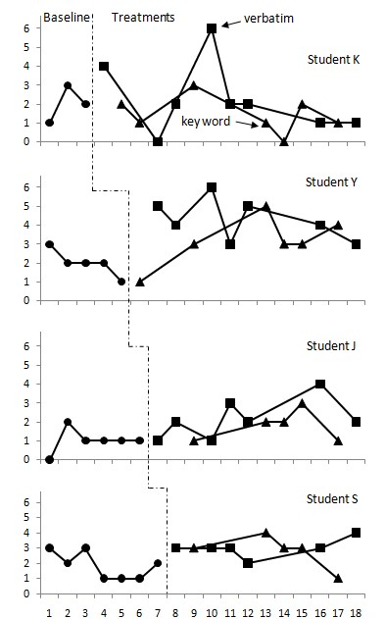

Figure 2
.
Highlighted text

ca
p
tions in mid
dle school
s
o
cial studies classroom
before

revi
ewing

videos for a
n
swers
.

Figure 1
. Picture symbol
-
based

captions in
high

school
transition

classroom
before

r
e
viewing

videos for answers
.

Figure 3
.
Highlighted text

captions in middle school
sc
i-
ence

classroom
before

r
e-
viewing

videos for answers
.

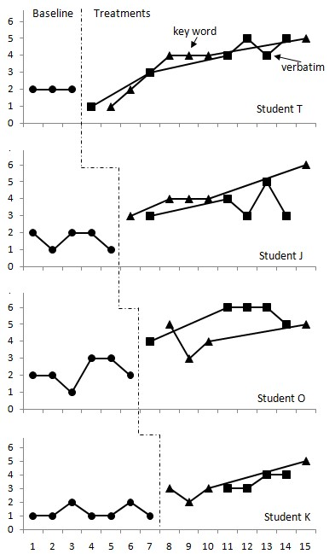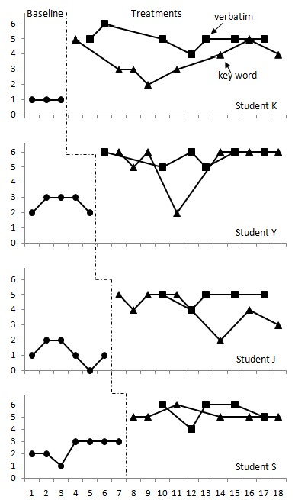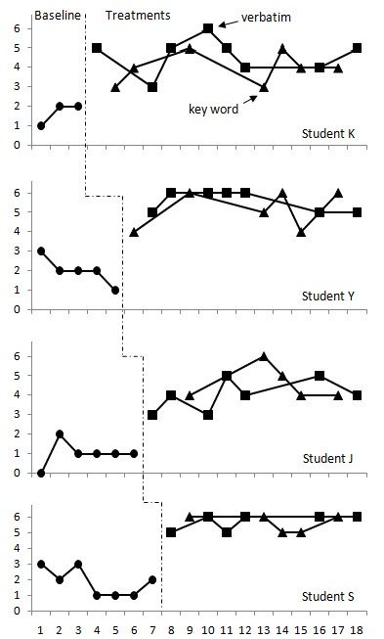

Figure 6
.
Highlighted text

captions in middle school
sc
i-
ence

classroom
after

r
e-
viewing

videos for a
n
swers
.

Figure 5
.
Highlighted text
captions in mid
dle school
s
o
cial studies classroom
after

reviewing

videos for a
n
swers
.

Fi
gure 4
. Picture symbol
-
based

captions in
high

school
transition

classroom
after

r
e
viewing

videos for answers
.

Final revisions to the innovative technology product were compiled. In addition to the revisions previously incorporated in Phase III, the following changes were encompassed into the final prototype of the ACTIV 1.0:

  - Make it work on 64-bit computers;
  - Create the database of multiple text options for each picture symbol;
  - Be able to increase the font size in the transcript window; make sure the text is wrapped around in the transcript window;
  - Have built-in 'library' of visual cues to include: arrow, line, picture symbol; as well as being able to highlight/mask important information, have screenshot, draw, import an image and add text (e.g., sight words);
  - Be able to pause the video at any point to add the visual cue to a very specific moment in the video;
  - Be able to rewind and forward the video one/two frames back and forth to precisely place the visual cue;
  - In the Advanced Edit window, make true/false changes for more than one word at a time;
  - In the Advanced Edit window, allow making changes in the sentences and phrase window (not only in the table); • Incorporate video name and question (or which one was the correct answer) into the data collection;
  - Increase font size in the quiz;
  - When waiting for the transcript to load, add clarification to the pop-up window (e.g., "The transcript will appear in the window below the video. It will take approximately N minutes to create the transcript depending on the size of the video");
  - When answering the question incorrectly on the quiz, add the reference to the Review button in the pop-up window (e.g., "Review the video");
  - Eliminate the need to close the application for Button Clicks report to be generated (if multiple students are using the same computer); • Edit words in the captions' text boxes; • Improve punctuation in the transcript;
  - Be able to choose between various captioning adaptations: (1) Text Only Captions; (2) Highlighted Text Captions; (3) Picture Symbols Text Captions; (4) Picture Symbols Highlighted Text Captions.

In addition, the work continues beyond this grant project in the following three directions:
  - Populate the database of multiple text options for each picture symbol (having 5-6 synonym word options for each picture symbol); • Incorporate text-to-speech feature into the quiz (reading the question and all answer choices out loud); and
  - Incorporate picture symbols into the quiz (inserting picture symbols for answer choices on the quiz).

Furthermore, the results of the usability testing studies guided the team towards recommendations for future development and research studies. Thus, the decision has been made that it will be essential to conduct similar usability testing studies incorporating eye-tracking technology. This would assist in determining whether participants look at the captions while watching the video. Some plans for further development include:

  - Incorporating intelligent profiles and noise filters to improve transcript accuracy;
  - Creating multiple text options for each picture symbol to increase the number of symbols choices in the captions;
  - Synchronizing text-to-speech option with the video image to allow for slower narration speed;
  - Explore ways to automatically adjust transcript's readability levels.

Project formative was conducted throughout the iterative development process, while summative evaluation was part of the finalization of the ACTIV 1.0 tool. The research team reviewed all the data, suggested and incorporated revisions, and feedback from users to influence the final innovative technology product. Throughout the funding period, a collaborative relationship was established with the George Mason University marketing sources promoting and facilitating the use of innovations by the business community. The Office of Technology Transfer (OTT) and the George Mason Intellectual Properties, Inc. (GMIP) are responsible for contacting companies who are interested in evaluating and licensing university intellectual property for commercialization, collaborating on research, or teaming on federal grants. As part of this process, an agreement was reached with the News-2-You Company regarding the use of the Symbolstix picture library within ACTIV 1.0. Furthermore, one of the major vendors in the area of assistive technology, Don Johnston Inc., expressed interest in continuous development of the ACTIV 1.0 prototype as well as future licensing possibilities. This collaboration encouraged the entrepreneurship of the innovative technology development.

Guided by the project evaluation, the research team has been actively involved in distributing the information about the development of ACTIV 1.0 innovative technology tool through multiple publications and presentation. The references for the manuscripts are as follows:

  - Evmenova, A. S., & Graff, H. J. (2011). Usability testing: Making functional and interface changes based on data. Manuscript in preparation.
  - Evmenova, A. S., Graff, H. J., Behrmann, M. M., & Wang, S. (2011). Design research: Developing an innovative technology tool through an iterative process. Manuscript in preparation.
  - Evmenova, A. S., Graff, H. J., & Behrmann, M. M. (2011). Accessing academic content through interactive video viewing. Manuscript in preparation.

The references for the presentations made by the research team at the national conferences include:

- Indexing and Automatic Transcript Creation - Paper Presentation, International Conference on Education Research, New Orleans, LA,
09.26-09.28.10
- ACTIV 2.0: Adapted Captioning Though Interactive Video for Students with Disabilities - Paper Presentation, Access, Employment, & Learning Conference, George Mason University, Fairfax, VA, 10.12-10.13.2010
- Development of ACTIV 2.0: Adapted Captioning Through Interactive Video Program for students with Disabilities - Poster Presentation,
2010 Technology Innovators Conference, National Center for Technology Innovation, Washington D.C., 11.15-11.16.2010
- Adapted and Interactive Video Interventions for Students with Intellectual Disabilities: ACTIV 1.0 Innovative Technology Tool - Poster Presentation, OSEP Project Directors' Conference, Washington, D.C., 07.18-07.20-2011
- Learning Academic Content through Adapted and Interactive Videos – Paper Presentation, Closing The Gap (CTG) Conference, Minneapolis, Minnesota, 10.12-14.2011
- Academic Instruction for Students with Disabilities: ACTIV Innovative Technology Tool – Paper Presentation, Assistive Technology Industry Association (ATIA) Conference, Schaumburg/Chicago, Illinois, 11.03-11.05.11

In addition, 3 more presentations have been accepted and scheduled for future conferences (that will take place in the Spring 2012)

  - Adapting Academic Videos for Students with Disabilities with ACTIV Tool - Paper Presentation accepted for Assistive Technology Industry Association (ATIA) Conference in January 2012
  - Academic Instruction Through Captioned and Interactive Videos: Usability Testing of ACTIV 1.0 - Paper Presentation accepted for Council for Exceptional Children (CEC) Conference in April 2012
  - Development of ACTIV 1.0 through Design Research: Innovative Form of Learning for Students with Various Abilities and Needs - Poster Presentation accepted for American Educational Research Association (AERA) Conference in April 2012

This developmental project has made contributions to the knowledge and practice of currently available technologies to support video instruction for students with intellectual disabilities. Once the ACTIV tool is ready for commercialization and distribution, the project will further contribute to the research and practice of improving academic outcomes of students with intellectual disabilities in the general education curriculum environment.

Reference Manual
ACTIV 1.0

Adapted Captions through Interactive Video (ACTIV) system is designed to easily enhance existing video clips with adaptive features such as highlighted text captions, picture symbols, visual cues, interactive quizzes, etc. It serves as a productivity tool for teachers as well as a learning tool for students with and without disabilities.

Operating System: Windows 7

Note: ACTIV 1.0 is currently NOT supported on 64-bit systems

Media Formats: The following formats are tested - .wmv, .avi

1. Launch the Application

Click the program: ACTIV_APPLICATION.EXE
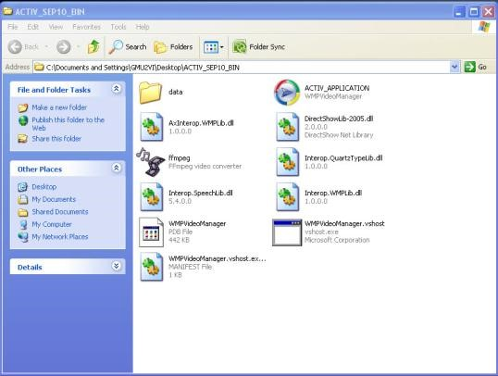

2. Open Media Files

Click “Browse” button on top of the control panel under Load Video heading. Choose the media file to open (e.g., An_Interven_E-mail_Scam.wmv). Please double check the file address in the text box on the left “Browse” button to make sure the address (or path) has no space in it.

3. Create Transcript

Once the media file is successfully loaded, click “Create Transcript” button under Transcript heading. Wait for the transcript loading information box to pop up. Created transcript will appear in the window below the media player.

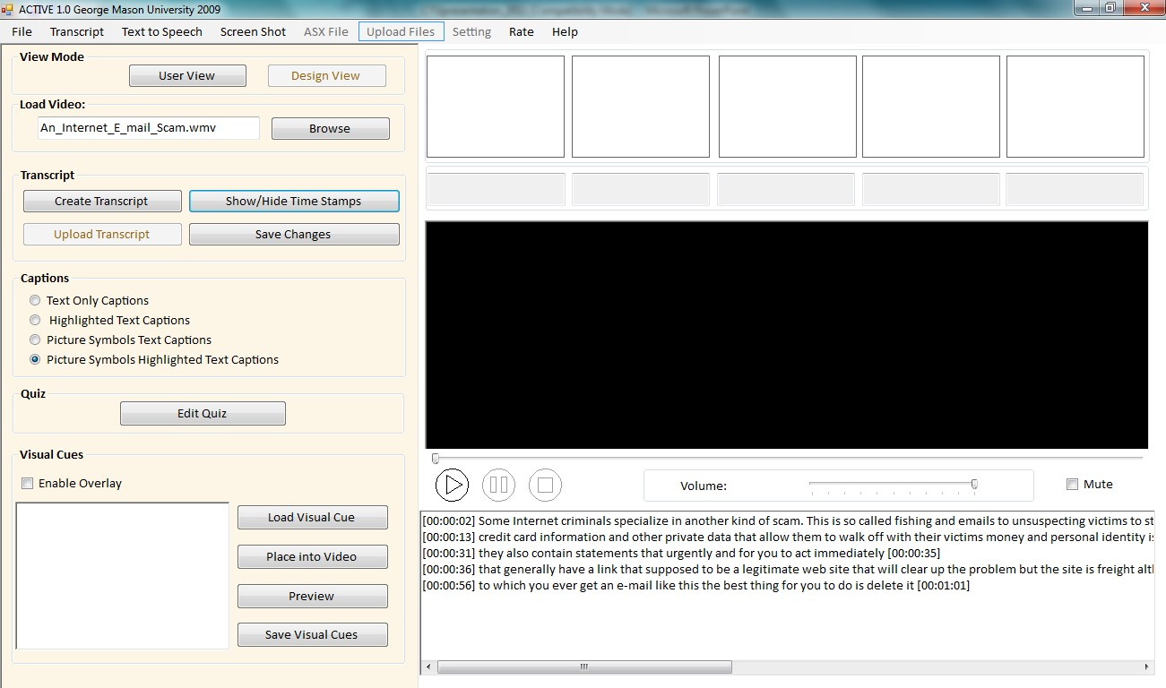

4. Adapted Captions
Choose one of four captioning choices: (1) Text Only Captions; (2) Highlighted Text Captions; (3) Picture Symbols Text Captions; and (4) Picture Symbols Highlighted Text Captions under Captions heading. As you start playing the video, captions will automatically appear on top of the screen.
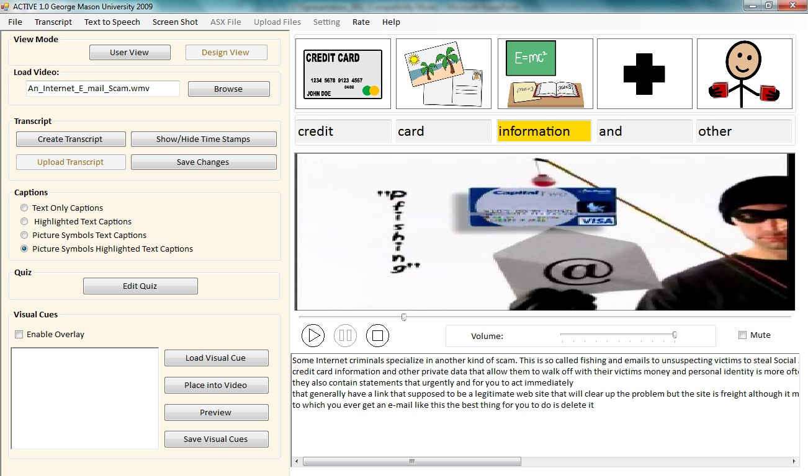

5. Transcript Changes via Advanced Edit
“Advanced Edit” allows users to make necessary changes to every attribute of each word (e.g., text, spelling, symbol, etc.) To open “Advanced Edit” panel, click “Transcript” tab on the menu strip at the top of the application. Find “Advanced Edit” button in the drop down menu and click on it.

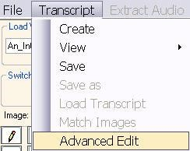

First, choose a sentence in the “Line” combo box so that all the words from that sentence are displayed in the table below. Click on the word in the table you would like to modify. Change the word/spelling in the “Text” box. NOTE: Each word in the transcript has a time stamp. The user should NOT try to modify the time information for each word at this point. Make the word invisible (e.g., hide unnecessary words, create key word captions, etc.) by checking “False” option under “Visible” for that word. NOTE: Each word that has a Visible-False setting will not appear in the captioning window. Click “Update” at the bottom of the window to save the changes you made.

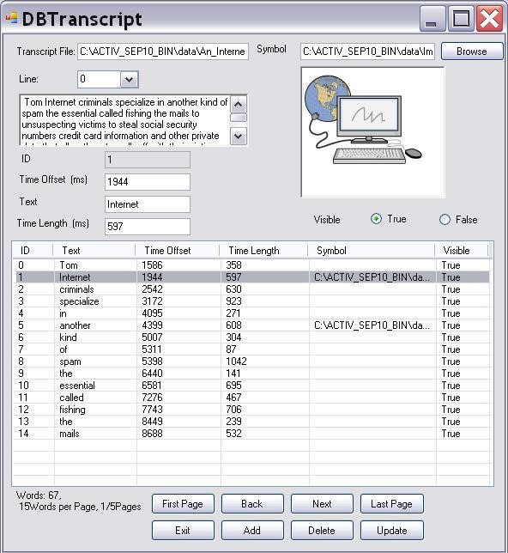

6. Caption Line Split

If necessary, the number of words appearing in each caption line can be limited. Thus, the user may choose to split a transcript into short (e.g., 3-words) phrases. In order to do that, go to the “Transcript Window” below the media player, put the cursor where you want to make the split, and click “Enter” at the end of the phrase to separate it from the next phrase. Click “Save” button under the Transcript heading after each change.

7. Time Stamps

Each word in the transcript is automatically time stamped. Click “Show/Hide Time Stamps” button under the Transcript heading to view the time stamps for each caption line.

8. Text-to-Speech

The user may choose to mute the original narration in the video and use text-to-speech function to listen to the modified transcript (e.g., lower readability level). Check “Mute” box below the media player to mute the original narration. Click “Text to Speech” tab on the menu strip at the top of the application. Choose “Speech Synthesize” drop down option.

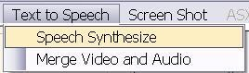

This function converts text from the “Transcript Window” below the media player into synthesized speech.
IMPORTANT: Make sure that you do NOT have time stamps displayed in the “Transcript Window”!

The user may change rate, volume, and voice settings under “Speech Synthesize”. Click “Speak” to hear text-to-speech.

NOTE: Synchronization of text-to-speech and video is currently under development and is NOT available at this time.
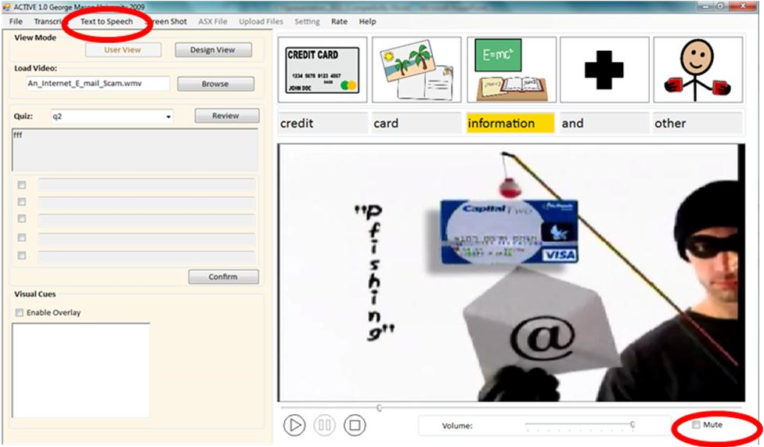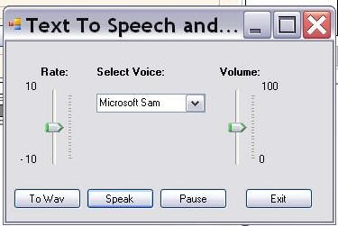

9. Visual Cues
The user may want to add visual cues to the screen to focus attention on important stimuli in the video. The visual cue will be added to the video screen as an overlay. So first make sure to check “Enable Overlay” box. Click “Load Visual Cue” button to upload any picture (e.g., arrow) to the “Image” window. Click “Place into the Video” button and the visual cue will appear on the media player screen. While the video is playing, left click on the visual cue and drag it across the screen to put it in the desired location.

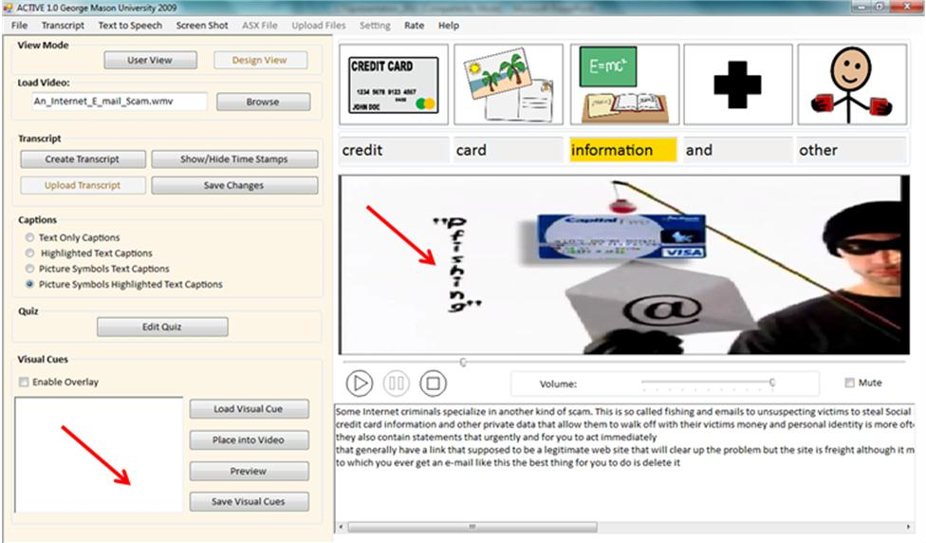

At this point the visual cue is overlaid from the beginning to the end of the video. It is necessary to specify the segment in the video where the visual cue will appear. First, click “Pause” the video at the point where you want to start showing the visual cue. Right click on the picture. Click “Start Time”. Then, click “Pause” the video at the point where you want to stop showing the visual cue. Right click on the picture. Click “End Time”. To save the changes click “Reload Video”. Play the video from the beginning to ensure that the visual cue appears in the correct place and at the correct time.

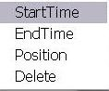

10. Interactive Quizzes
In order to create a quiz after the video, click “Edit Quiz” button under Quiz heading to load the edit quiz panel. Here you can add as many questions as you like. Name the question in the “Name” text box. Type-in the quiz question in the “Problem” text box. Type-in multiple choice answers in the “Create Multiple Choices” group box. Check the box for the correct answer.

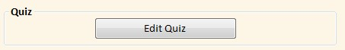

In order to Tag the segment in the video containing the correct answer to the question, click “Pause” the video at the beginning of the desired segment. Click “From” button at the bottom of the application. The beginning of the reference segment is marked. Then, click “Pause” the video at the end of the desired segment. Click “To” button at the bottom of the application. The end of the reference segment is marked. Click “Save”.

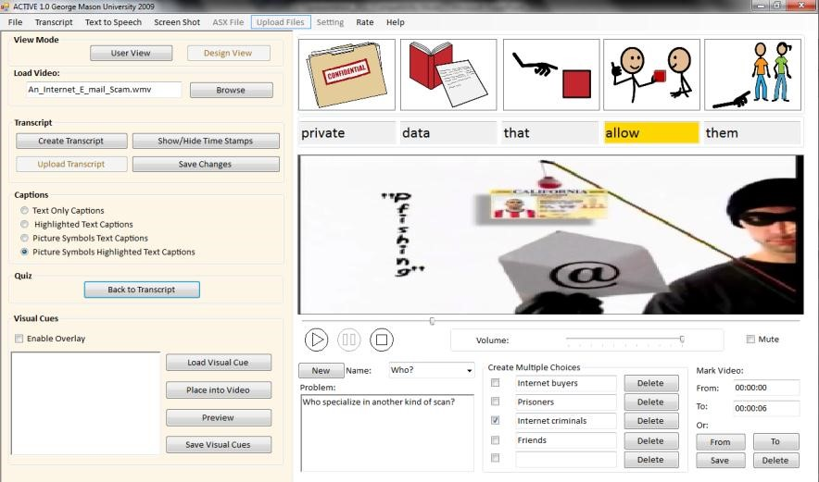

11. Take the Quiz

In order to take the quiz, click “User View” button at the top of the application.

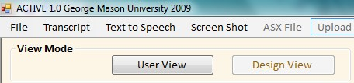

Check the box for the answer that seems to be correct. Click “Confirm” button at the bottom. Feedback window will pop up. In order to preview the video segment containing the correct answer, click “Review” button.
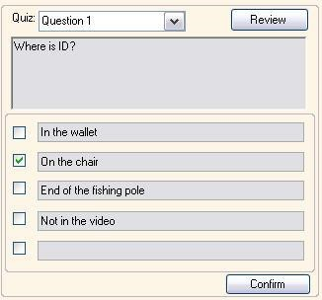

Organize the File Folder
- Media file address (path) format
ACTIV 1.0 system requires the path to the media files to have no space in it. For example, if a media file is stored at:
C:\Program Files: \media.wav, this media file will not be recognized by the system because a space exists in the address. To solve the problem, you can create a folder C:\ACTIV10 and put the media files in the folder.
NOTE: Be careful when choosing media files, make sure the address of the media file has no space in it.
- Image Library
When processing the media file, ACTIV 1.0 system will automatically generate a file folder name “Image Library” in the same root of the media file. User should store all the image files in this folder to enable the image matching function.

