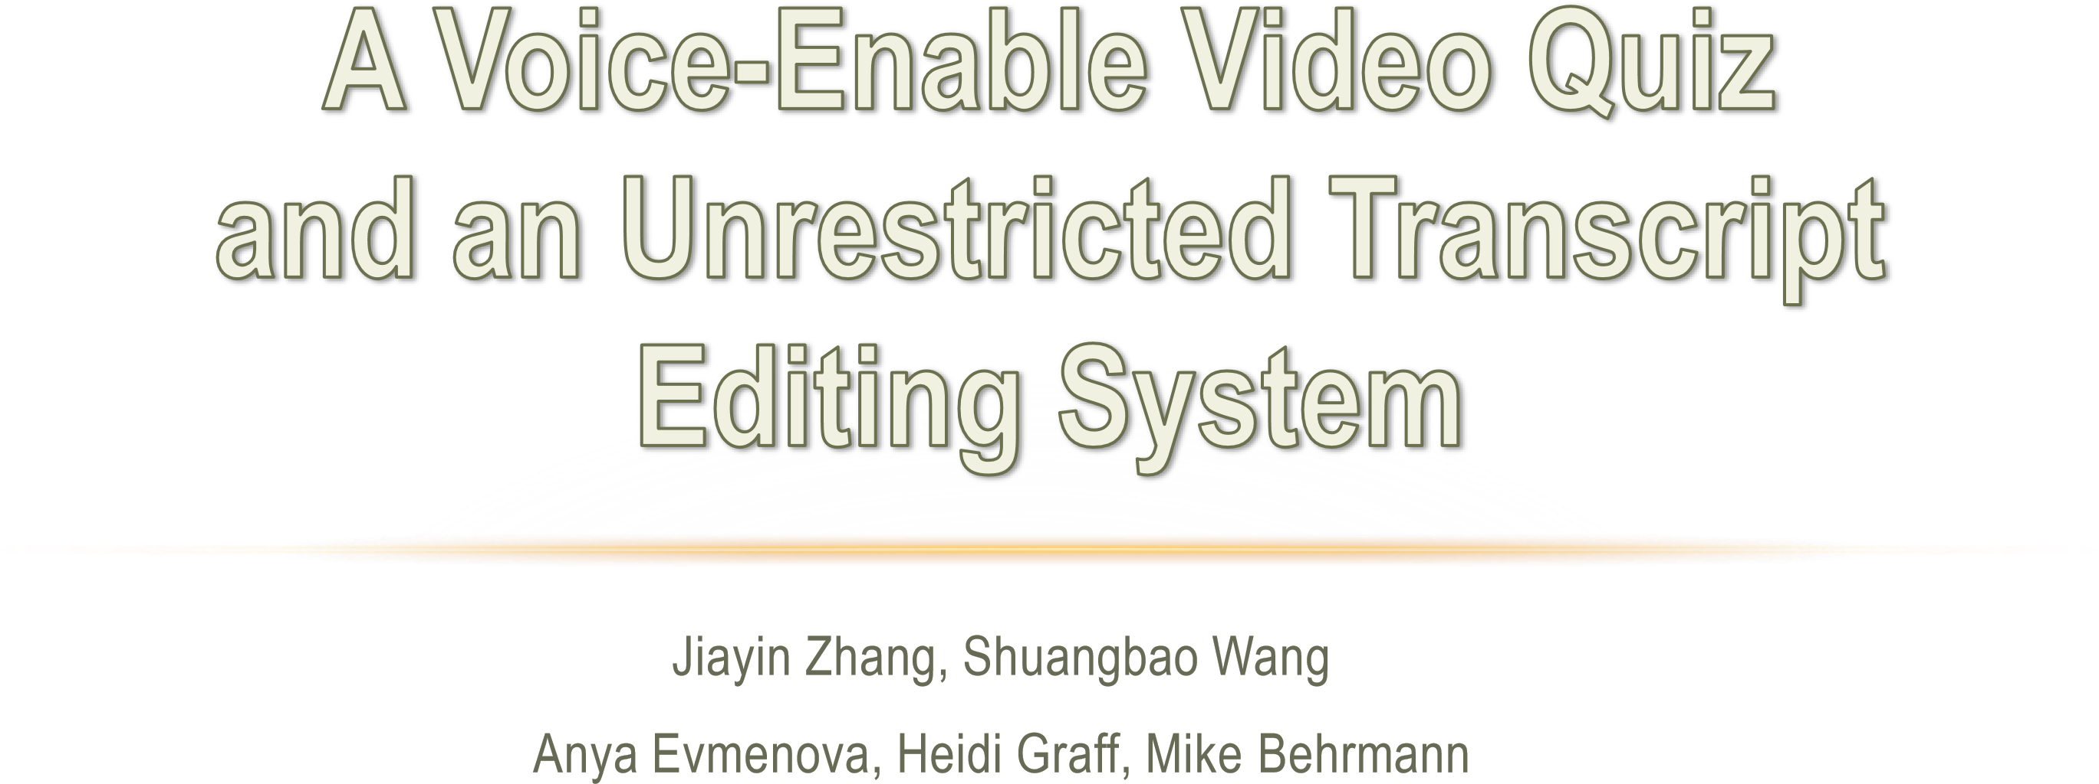
- What is the video quiz and the video quiz system?
- The video quiz is a type of quiz designed for students to study while watching the video learning material. questions and answers for each quiz are related to the content of a specific scene in the video.


- The video quiz system is an integrated environment for video quiz designing and displaying. Separated views with different functions are implemented to fulfill the different needs of teachers and students.
- Main features
- Duel-view
- Caption system
- Text-to-speech



Designer
view

•
Editing quiz

•
Multiple choice supported

•
Setting the related video
segment

User view

•
Taking quiz

•
Playing corresponding video
segment

•
Displaying caption

•
Reading question and
answers

•
Recording user choice

MODULE

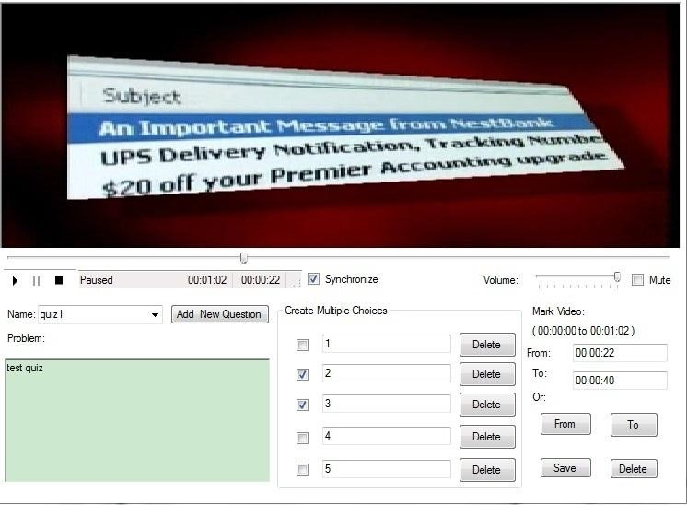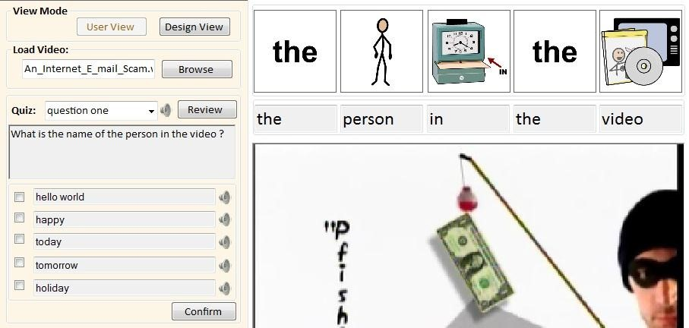
Designer View

User view


•
Quizzes will be saved in XML format:

QUIZ Name="quiz1"
<
To_Position
=
"40"
From_Position
>
=
"22"

>
Content>test quiz</Content
<

<
MultipleChoices
>

>
<
Choices Checked="False" Text="1"/

<
>
Choices Checked="True" Text="2"/

>
Choices Checked="True" Text="3"/
<

>
Choices Checked="False" Text="4"/
<

<
>
Choices Checked="False" Text="5"/

/
<
MultipleChoices
>

<
>
/QUIZ

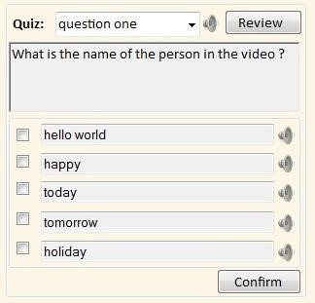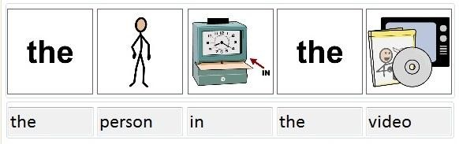
•
Caption

system

•
Automatically
searching

from
Database

•
Symbol
db

•
Text
-
to
-
speech

q/a
read out

•
Microsoft TTS
engine



- What is The unrestricted transcript editor?
The free transcript editor is a convenient tool for teachers to correct and edit the transcript automatically generated by the speech recognition engine.

- What is the difference between our editor and the normal text editor?
The difference between the transcript editing and the normal text editing is that a transcript has timestamps which must be kept, so that the transcript can be played synchronously to the video. Since each editing method, e.g. add, change or delete, may influent timestamps afterward, the editor should be able to distinguish different operations such as insertion, deletion, merge or change.

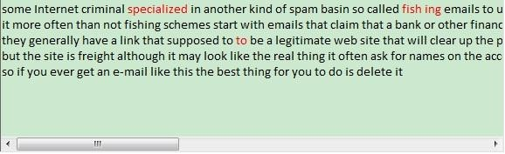
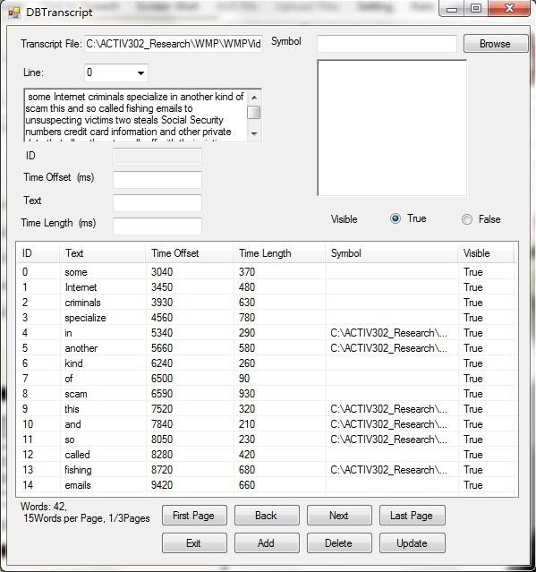
•
Key Words:

Simple, easy to use

New View

Old View

Operations:

insert, delete, replace, change lines.


Key words:

Color is the key

•
Add : Original < Changed

•
Delete: Original > Changed

•
Replace: Original = Changed


- The transcript is saved in XML format:
<LINE>
<CAPTION CNT="1" VISIBILITY="TRUE"
LENGTH="370" SYNC="1520"
CAPTIONTEXT="some" ID="0"/>
<CAPTION CNT="1" VISIBILITY="TRUE"
LENGTH="444" SYNC="1890"
CAPTIONTEXT="Internet" ID="1"/>
<CAPTION CNT="1" VISIBILITY="TRUE"
LENGTH=“444" SYNC="2334"
CAPTIONTEXT="criminal" ID="2"/>
</LINE>
- Our goal is to minimize the influence to the original time stamps.
- Keep as many original SYNC tags as possible.


- Reduce the influence of the
length of each word.


- Preliminary results show that our quiz system can easily create and take video quizzes, and the new caption and TTS features can help students with disabilities to understand the video content easily.
- The results also show that our transcript editor can help teachers to edit the transcript freely without any restrictions, which can save them a lot of time in transcript editing.



