
Kellar Instructional Handheld data (KIHd) System
A Real Time Mobile Collaborative
Data Collection and Analysis Tool
Autism’s Impact on Society
- Affects more children than cancer, diabetes, and AIDS combined
- Fastest growing developmental disability
- 1 in 150 Americans diagnosed
- 1.5 million Americans affected
- $35 billon in cost in the U.S. annually
Autism Society of America. (n.d.). Improving the lives of all affected by autism .
Retrieved May, 2007, from http://www.autism-society.org/site/PageServer
A Real Time Mobile Collaborative Data Collection and Analysis Tool

KIHd System
- Real Time Observable Data Collection
  - How many?
  - How Long?
  - How Accurate? – How Fluent?
- Easy Data Entry and Analysis
- Browser Based Multi-Platform
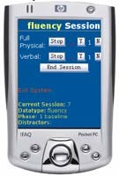
- Simultaneous Use
- Immediate Feedback

Replaces
- Clipboards (Paper Processes)
- Non Standard Data Collection
- Manual Data Manipulation
- Manual Data Transposition
- Incomplete Data Analysis and Reporting
- Delayed (or no) Feedback

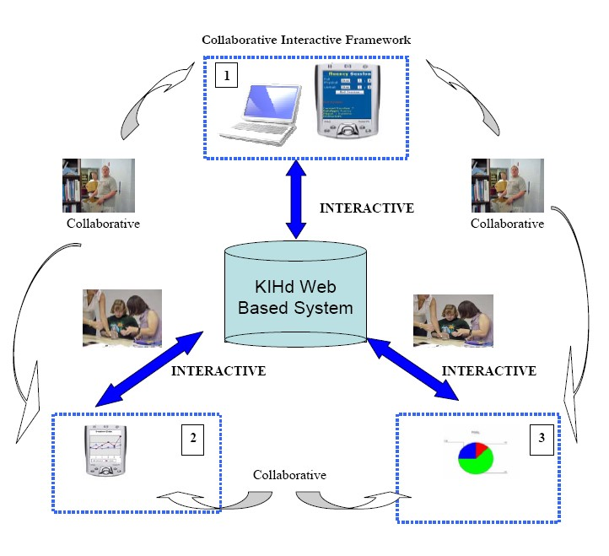
Collaborative Interactive Framework

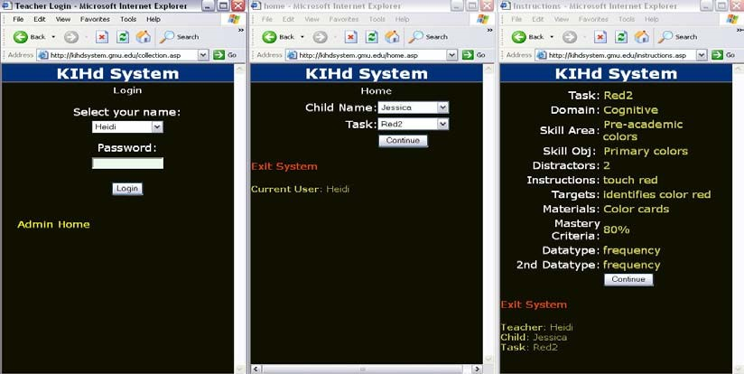
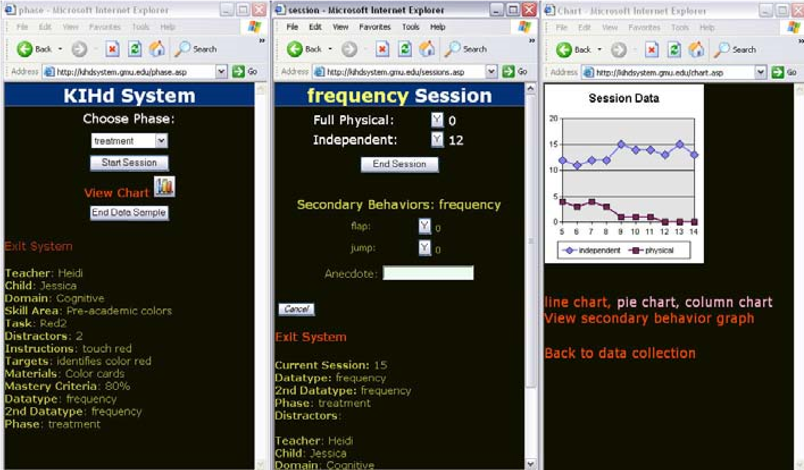
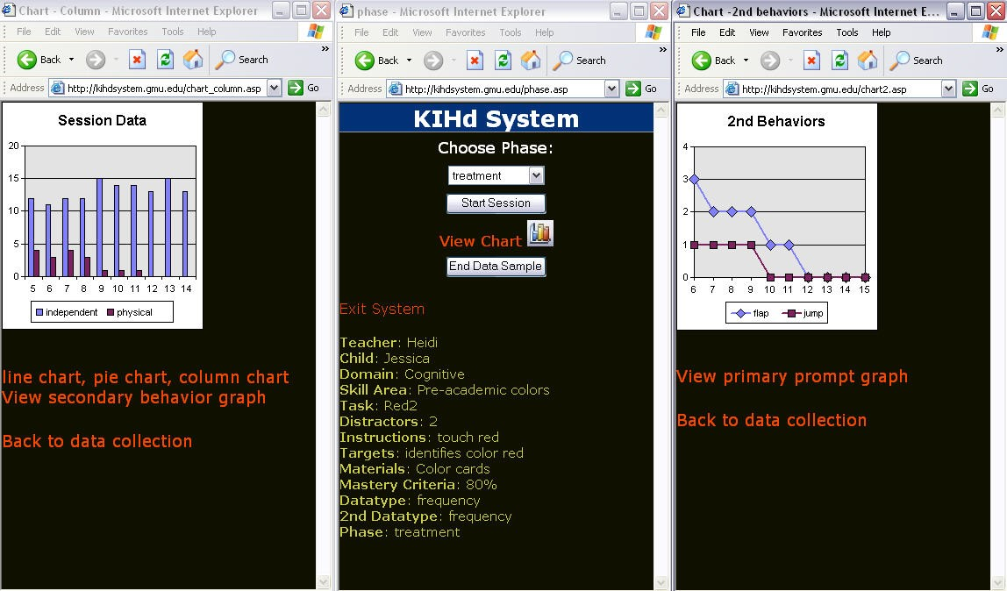
Handheld Data Collection
Screen Shots of KIHd System Admin Pages
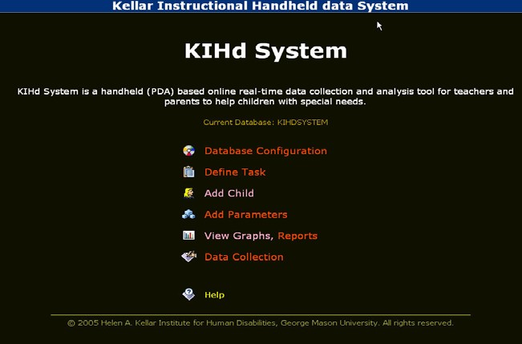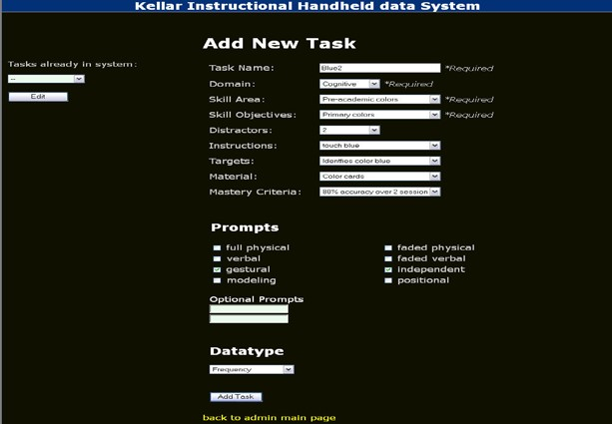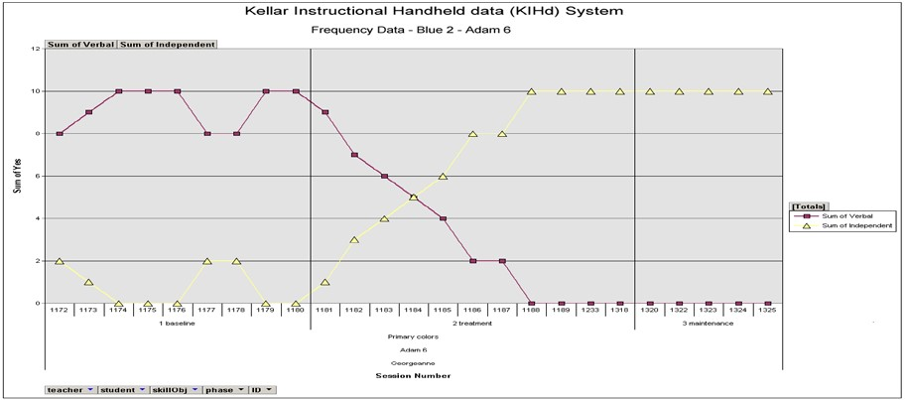
Current State of Technology
• $600K U.S. Department of Education Steppingstones of Technology Grant • System (Patent Pending) • Proprietary Software (Copyright) • Four Years of Development and Testing Completed • Classroom Tested

MILESTONES
Years (2003-2006)
- Developed concept and test technology feasibility and grant application
- Prototype Design and Usability testing followed by grant application
  - Mason IDD Immersion team
  - Beta Testing with teachers
- Field testing followed by successful grant application
  - Refinement and testing with Mason LIFE Instructors
- Autism Focused Implementation Research
    - 2 Year U.S. Department of Education, Steppingstones of Technology
Grant (CFDA 84.327A, Innovations for Students with Disabilties/H327A060031)
    - Increase in traffic as expected (more teacher participants)
    - Time on site increased from 20 seconds to 6 minutes
    - Pages viewed per visitor increased from 8 pages to 18 pages
    - Completion of the requested version of the print graph
    - Completion of the stand alone synching system • 2007-2008
      - Home program continuing since summer 2007
      - Adding more student participants
      - Increase number of classrooms
      - Market development
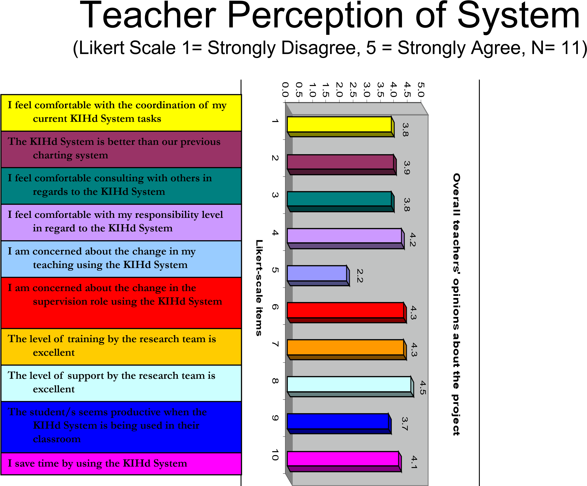
Competitive Landscape
- mTrial
  - Palm System Only
  - Only Measures Frequency
  - Not Real-time
- Observer
  - Uses a Preprogrammed Curriculum
  - Not User Adaptable
  - Not Multi-platform
  - Highly Complex
- DT Trainer
  - Only for Students 2-9 years old
  - Uses a Preprogrammed Curriculum
  - Curriculum Not Changable
Product Models and Market Segments
Education Regulatory Mandates



(No Child Left Behind) 
KIHd Enterprise
For all Users
Data Stored on Local Server
License to # Servers and #Users
KIHd Web Based
3
users/10 students
15
users/75 students
100
users/500 students
KIHd Stand Alone
+
Web Based
Mobile Device
Synchronize with Web
Database
User Licenses
3
, 15 and 100
New Markets
General Education
Health Sciences
Animal Studies
Worker Productivity
Quality Control (e.g. assembly line)
Homeland Security
Etc……..
Helen A. Kellar Institute for Human disAbilities (703) 993-3670 (voice/TTY)

Michael M. Behrmann, EdD, mbehrman@gmu.edu
Heidi J. Graff, PhD, hgraff@gmu.edu
Shuangbao Wang, PhD
Yoosun Chung, PhD
Research Assistants: YouRi Shim, Kavita Mittapalli KIHd System http://kihdsystem.gmu.edu
Version 1.0 Available January 2008
User Licenses
•Web Based for Home or Classroom
•Stand Alone + Web Synchronization
Server Licenses
•Enterprise Edition

