

B
USINESS
C
ASE

FOR

P
RISM

Automated Tool for
Recording, Tracking and Analyzing
Autistic Behaviors Using Applied Behavioral Analysis

Veronica Cuello

Bret Dennis
Charles Hoover
Roger Lindquist
Table of Contents
1. Executive Summary 4
2. Background 6
2.1. The Pearson Advantage 6
3. Problem Statement 7
4. High-level Product Description 8
5. Situational Analysis 9
5.1. What is Autism? 9
5.2. Educational Drivers 10
6. Market Analysis 14
6.1. Market Segmentation 14
6.2. Market, Demand Estimation, Industry Trends 15
7. Marketing Strategy 18
7.1. Product Positioning 18
7.2. Product Description 18
7.3. Prism Models & Customer Profiles 23
7.4. Primary and Secondary Research 26
7.5. Price 26
7.6. Distribution 28
7.7. Promotion 29
8. Competitive Analysis 33
8.1. Primary Competitors 33
8.2. Secondary and Indirect Competitors 34
8.3. The Prism Advantage 35
8.4. Competition Product Comparison 35
9. Intellectual Property Acquisition 37
9.1. Intellectual Property Alternatives Impact 38
10. Financials 39
10.1. Financial Executive Summary 40
11. Scenario Analysis 41
11.1. Demand Scenario 41
11.2. Cost Scenario 41
11.3. Price Scenario 42
12. Worst Case Scenario and Exit Strategy 43
13. Conclusion 45
Appendix A: Prism Development Project Plan 46
Appendix B: Autism Description 47
Appendix C: Project Strengths, Weaknesses, Opportunities, Threats 48
Strengths 48
Weaknesses 48
Opportunities 48
Threats 48
Appendix D: Financial Model Details 49
Summary Detail 49
Revenue 50
5 Year Sales Forecast 51
Demand Support Data 52
5 Year Incremental Cost 53
Fixed Cost & Taxes 55
Prices 56
Appendix E: Internal Project Risk 57
Risk Identification and Assessment 57
Risk Transfer 58
Risk Prioritization and Mitigation 59
Appendix F: Product Development 60
Software Architecture 60
Software Development 62
Information Assurance 63
Appendix G: ASP Hosted Architecture Diagram 65
Appendix H: Survey Questions and Results 66
Appendix I: Primary and Secondary Research 69
Primary Research 69
Secondary Research 70
Appendix J: Product Trials 71
Phase 1: Alpha Testing 71
Phase 1: Beta Testing 71
Phase 2: Prism Pilot 72
Appendix K: Applied Behavioral Analysis Paper Forms 73
ABA General Acquisition Data Sheet 73
Frequency of Reinforcement Per School Day 74
Probe Data Sheet 75
Multi-Purpose Data Sheet 76
Acknowledgements 77

Tables and Figures

Table 1: Summary Financial Highlights ........................................................................ 4
Figure 1: High Level Prism Development Schedule ..................................................... 5
Figure 2: Pearson Organization ..................................................................................... 6
Table 2: Per Pupil Average Expenditure ..................................................................... 12 Table 3: Prism Model Summary .................................................................................. 14
Table 4: Total Estimated U.S. Spending on Special Education.................................. 15
Table 5: Estimated Special Education Expenditures on Technology ........................ 15
Table 6: Autism Growth 1987 – 2002 ............................................................................ 16
Table 7: Number of Autistic Students in Select Districts ............................................ 17
Table 8: Prism Model Summary .................................................................................. 23
Figure 3: Prism Personal Model .................................................................................. 24
Figure 4: Prism Enterprise Model ............................................................................... 25
Figure 5: Prism ASP Model .......................................................................................... 25
Table 9: Sample Cost Estimates .................................................................................. 26
Table 10: Promotion Methods, Frequencies and Budget ............................................ 29
Table 11: Print Advertising & Direct Mail ................................................................... 30
Table 12: Predicted Sales Cycle .................................................................................... 32 Table 13: mTrial vs. Prism ........................................................................................... 34
Table 14: Competitor Product Comparison ................................................................. 36
Table 15: IP Acquisition: Acquisition vs. Licensing/Royalty ..................................... 38
Table 16: IP Acquisition Summary .............................................................................. 38
Table 17: Demand Scenario Summary ......................................................................... 41
Table 18: Cost Scenario Summary ................................................................................ 42
Table 19: Price Scenario Summary ............................................................................... 42
Table 20: Probability of Worst Case Scenario .............................................................. 43
Table 21: Worst Case Scenario ..................................................................................... 43
Appendix E: Qualitative Risk Assessment Table ........................................................ 58
Appendix E: Risk Prioritization and Mitigation ......................................................... 59 Appendix F: Prism Software Architecture ................................................................... 61
Appendix F: Waterfall Software Development Model ................................................. 62
Appendix F: Prism Information Assurance ................................................................. 64

1. EXECUTIVE SUMMARY
Today’s manual behavioral data collection processes for teachers in special education classrooms impedes instruction and learning. This business plan articulates how the Prism product line addresses the challenges teachers of autistic children have collecting, reporting, and analyzing behavioral data. Valuable instructional time and effort is being expended on manual, paper-based processes, multiple data entry sessions, and complex reporting and analysis procedures.
Teachers, parents, and classroom staff will use this product as an effective means of collecting, analyzing, and reporting behavior patterns in autistic children. The product will provide the benefits that technology offers through real-time data collection and analysis, a variety of reporting options, and reducing manual and paper-based processes in the classroom.

Prism integrates World Wide Web and database technologies to provide an easy-to-use and powerful solution to address the complexities of using data to make instructional and remediation decisions for autistic students. Applied Behavior Analysis is a commonly practiced method of treating autistic children. The method calls for collection and analysis of behavior patterns and is commonly used in instructional programs for autistic students. Prism takes this process “off the books” and puts it “online.” With ubiquitous access and instantaneous analysis and reporting capabilities, Prism will change the way teachers and parents responsible for children with autism approach the instructional process.

Autism is experiencing an aggressive rate of rate. It is estimated that 1/166 births is a child with an autism spectrum disorder. Growth rates for this disorder are estimated at over 10% year-over-year. Public school districts, private schools, and parents in the home will all benefit from incorporating Prism into the educational process. These three customer groups are the target markets for the product. The product development team has created three tiers of service that will address the specific needs of these groups in the form of Prism Personal: a standalone solution, Prism ASP: an Internet accessible model, and Prism Enterprise: a software licensing model. Given the growth of autism, the product is expected to perform well in a market with few competitors. Table 1 shows estimated financial highlights.

 | Financing Request | Payback Period | NPV | MIRR
Estimated 5-year Figures | $1,493,338 | 2.25 years | $1,555,284 | 29.26%
Table 1: Summary Financial Highlights

The Pearson Education product portfolio includes educational technology that assists schools, teachers, and specialists with managing data and ultimately supporting growing trends in datadriven decision making in educational institutions. New accountability measures mandated by legislation and public funding sources are driving school districts and educational institutions to invest in technology. This is partly due to efforts being made to reduce the time and effort dedicated to reporting and analysis of data in order to save resources and time for classroom instruction.
Pearson Education is dedicated to bring innovative technology solutions to education for just that purpose; so teachers can spend time on instruction and less time on administrative tasks.
Prism has been developed in cooperation with expert assistance of George Mason University’s Kellar Institute for Human Disabilities. Pearson Education has reserved the option to acquire ownership of a patent that covers the basic functionality for Prism. In a survey of teachers engaged in behavioral analysis, 83.4% claimed automating their data management processes would be of value. Prism is poised to be the sole product on the market available to a range of markets from individual parents to the largest of public school districts.
The mission of the Prism product line is consistent with that of Pearson Education bringing technology to education in such a way the impacts the bottom line of the company’s core market: effective classroom instruction and maximizing every student’s learning potential. The objectives of Prism are to provide technologically driven benefits to schools at affordable prices, contribute to Pearson Education’s profitability and value-added product offerings, and continue the trend of setting the standard for instructional technology product quality, ease-of-use, and innovation.
Product development is scheduled to begin in late May of this year and will complete in time for the beginning of the 2008/2009 school year. Figure 1 shows a high-level schedule and the major events within that schedule. A more detailed timeline can be found in Appendix A.

5/21/2007
3/21/2008
1/2007
6
/
1/2007
7
/
/
1/2007
8
9
1/2007
/
1/2007
/
10
1/2007
/
11
1/2007
/
12
1/2008
/
1
1/2008
2
/
/
3
1/2008
4/2007
/21/2007 - 6/
5
Project Initialization
11/16/2007
/10/2007 -
9
Software Design
12
/7/2007 -
3/21/2008
IV&V
11
/16/2007 -
1/25/2008
Post-Development Testing
3/21/2008
/15/2007 -
8
Software Development
6
/5/2007 -
7/20/2007
Reverse Engineering & Gap Analysis
5
/21/2007 -
8/14/2007
Analysis

Figure 1: High Level Prism Development Schedule

“Teachers need an electronic way of collecting behavioral
observations and immediately
graphing and analyzing data.”
- Laurie Heilman, President,
Matthews Center for Visual Learning
The benefits of Prism are centered around streamlining classroom processes that enable teachers, specialists, and parents to focus on instruction and learning for students. Real-time reporting and analysis allow instant decisionsupport using the data for determining and applying appropriate interventions and remediation on an individualized student basis.

2. BACKGROUND
The Prism product development team has partnered with George Mason University’s Kellar Institute for Human Disabilities for developing, prototyping and field testing of the software. The Institute’s personnel provided expert assistance and guidance in the areas of autism research, Applied Behavior Analysis, and functional requirements for the product. The George Mason University Technology Transfer Office also provided assistance with intellectual property concerns as well as facilitating the relationship between the product development team and the Kellar Institute.

Seed funding was provided to the Kellar Institute for research, development, and testing. In return, Pearson Education has the authorization to commercialize the resulting output and go to market with a product. Due to the efforts of the Kellar Institute’s staff, the software is currently in an active prototype status and exists under the working name of “KIHd System” or more simply, “KIHd.” This stands for Kellar Instructional Handheld Data System. Supporting documentation, software screenshots, and appendices may refer to the software by any combination of these names. The go-to-market naming convention will fall under the Prism family of products.

2.1. The Pearson Advantage
Pearson’s global publishing interests focus on education, business information, and consumer publishing markets. According to Pearson product management, Pearson has substantial presence in the United States with an estimated presence in 65% of public school districts. In 2005 Pearson had overall sales of $7 billion with an adjusted operating profit of $875 million. However, the launch of Prism will fall under the Pearson Education division and can be positioned as part of the learning and assessment tools and services. Prism aligns with Pearson Education’s core business of educational publishing, learning tools, school administration tools, and testing programs. Pearson Education Organizational Overview
Pearson Education has holdings, intellectual property capital, and interests in all levels of educational and administrative products and services. The organization is divided into subbusiness units that address specific educational vertical markets.
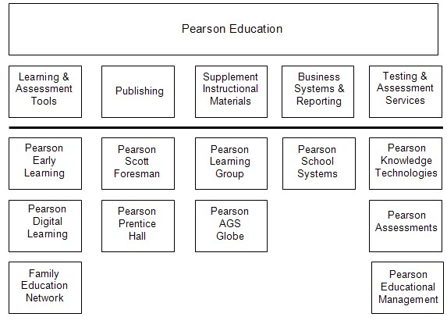
Figure 2: Pearson Organization

3. PROBLEM STATEMENT
Complying with individual student accountability and performance mandated in today’s educational landscape requires the use of data. This includes data down to the individual student level, classroom level, and school level. More appropriate to individual student performance, data is also used to track progress and make remediation decisions to enhance the effectiveness of instructional time. Teachers need to have tools available to make the process of managing and using data that do not obstruct instructional time and provide value to the learning process. Valuable instructional time and effort is being expended on manual, paper-based processes, multiple data entry sessions, and complex reporting and analysis procedures. Appendix K provides examples of the paperwork required in today’s data collection and analysis processes. The result of the current processes is large, unwieldy binders of paperwork that proves difficult to manage in terms of historical tracking, longitudinal analysis over time, and creating crossclassroom, student, and school reports. In summary:
- Teachers engaged in behavioral analysis need to automate data management processes
- Existing paper-based processes cost time, effort, and resources
- Reporting and accountability demands are higher than ever; technology can help meet the demand

4. HIGH-LEVEL PRODUCT DESCRIPTION
Prism enables the efficient collection and analysis of behaviors when using Applied
Behavioral Analysis (ABA) practices. Parents and professionals record behavioral data using Prism software via a simple user interface on a handheld device, workstation, laptop computer, or any other device that can connect to the Internet. This data is stored in a database which is accessed to retrieve data or to produce graphs and charts that can be analyzed to determine the effectiveness of autism intervention techniques. The Prism product is available in three models: Prism Personal, Prism Enterprise and Prism ASP. These models are designed to meet two target market segments, parents/families and educational institutions; the table below provides a description of these models.




Prism Personal is a software package targeted for the parents and families of autistic children; it allows behavioral analysis to continue after school. It is purchased and downloaded from Prism’s website or on compact disk at conferences and trade shows. Volume discounts are not offered for this model.

Prism Enterprise allows school systems and private schools with in-house IT capabilities to deploy their own Prism solution. This model provides robust storage and data manipulation capabilities and is intended for medium to large size deployments. Volume pricing is available.
Prism ASP is targeted at public and private schools that do not have in-house capabilities or do not otherwise wish to manage a Prism infrastructure. With this outsourced model, licenses include the full management of the infrastructure in an
externally hosted environment. Volume pricing is available.

5. SITUATIONAL ANALYSIS

5.1. What is Autism?
There are many misconceptions and myths about autism that may impact teachers, parents and other officials in their decision making process regarding autistic children and education. Movies such as “Rain Man” and opinions expressed by casual observers have often mislabeled autistic people as unable to form human bonds or cope with environments such as our public education system. One of the missions of organizations such as “Autism Speaks” and the “Autism Society of America” is to spread awareness about this disorder and to promote better understanding of autism worldwide in the hopes that better understanding will promote more opportunities and a better life for people living with autism and their families.

Autism is a neurological disorder that is a “spectrum disorder” because the symptoms and their severity vary widely from person to person. Even identical twins, both diagnosed with autism, manifest symptoms and respond to treatments in different ways. It is important to understand that each person with autism is an individual and thus their treatment and education must be tailored to suit their individual strengths and weaknesses.

The cause of autism is still undetermined and is a controversial subject. However, brain scans have shown differences in the shape and structure of the brains of autistic children compared to non-autistic children. The three main areas that may be impacted are socialization, communication, and behavior. For example, individuals with autism may exhibit some of the following traits:
- Insistence on sameness; resistance to change
- Difficulty in expressing needs, using gestures, or pointing instead of words
- Repeating words or phrases in place of normal, responsive language
- Laughing (and/or crying) for no apparent reason or showing distress for reasons not apparent to others
- Preference to being alone; aloof manner
- Tantrums
- Difficulty in mixing with others
- Not wanting to cuddle or be cuddled
- Little or no eye contact
- Unresponsive to normal teaching methods
- Sustained odd play
- Spinning objects
- Obsessive attachment to objects
- Apparent over-sensitivity or under-sensitivity to pain
- No real fears of danger
- Noticeable physical over-activity or extreme under-activity
- Uneven gross/fine motor skills
- Non responsive to verbal cues; acts as if deaf, although hearing tests in normal range.

These characteristics, as well as the communication-related developmental disabilities which are common to nearly all autistic individuals, present a challenges to the public school system which is required to provide a “free and appropriate” education to all students with disabilities per the Individuals with Disabilities Education Act (IDEA). Most professionals agree that educational planning for children with autism should be structured, specialized (customized and tailored to each individual), and measurable. Additionally, instructional activates should include social skill development, communication, behavior, and sensory integration. As with the larger treatment program for individuals with autism, education plans must also be flexible as the first approach chosen may not be the most successful. Prism provides a flexible method for supporting individualized education plans for autistic children and a system for performance measurement supported by automated data collection.

5.2. Educational Drivers
The instructional landscape in K-12 education is marked by the increasing use of data, metrics, and performance indicators to improve instructional practices and ultimately the performance of individual students in order to meet adequate yearly progress goals. The efficient and effective collection, storage, reporting, and analysis of data are crucial to its ultimate use in realizing benefits to student achievement. Technology tools aid in the processing of data from collection to analysis. All investments in technology for educational purposes must show benefits in terms of student performance, costs savings, or operational efficiencies in schools.
5.2.1. Federal and State Mandates for Reporting, Progress, School Annual Yearly Progress
In 2001, President George W. Bush announced the public education reform program called No Child Left Behind (NCLB). The measure’s intent was to increase schools’ accountability for every student’s achievement and every school’s overall performance. The program included the means for parents to remove their children from failing schools and place them in higher performing schools. The cost for providing students alternative schools to attend falls on the school districts.
Schools receive financial assistance funding through the Title I Program. Funding sources include State Educational Agencies (SEAs) and Local Educational Agencies (LEAs). Title I funds are targeted for children who are failing or at the most risk of failing. The NCLB act mandates that Title I funds can be used to make alternatives available to children who must be transported to other locations when the child’s “home” school fails to meet NCLB standards.
The NCLB Act has created increased accountability for schools regarding the performance and advancement of every student. Special Education students are not exempt from these achievement guidelines. Performance and achievement progress for all students must be accounted for and schools need tools that will assist in maximizing every student’s potential. Prism directly addresses specific obstacles faced by those responsible for autistic students and using data and information effectively in the instructional process.

"Five years ago, we rose above partisan differences to pass the No Child Left Behind Act, preserving local control, raising standards, and holding those schools accountable for results.... Now the task is to build on the success, without watering down standards, without taking control from local communities, and without backsliding and calling it reform."
—President Bush

Most of today’s industry trends in education are fueled by legislation initiatives such as the
NCLB. NCLB stresses stronger accountability, more local freedom, proven methods and choices for parents.

With 56 billion dollars in appropriated for the Department
of Education, the American people demand accountability for their tax dollars. In order to measure and report these results, the Department of Education defines goals in its | FY 2008 Budget Breakdown (In  Billions)
Special  Education | Other
strategic plan, and issues an annual Performance and 15 Accountability report where specific pre-defined performance metrics results are documented. Poor performance puts appropriations for the following year at 41 risk. Makes certain students with disabilities are all being properly assessed and fully included in adequate yearly progress (AYP) determinations.

"In the past, we underestimated what students with disabilities could learn.... We now know that the vast majority of these children can achieve grade-level standards."

— U.S. Secretary of Education Margaret Spellings
As evidenced by the large appropriation for students with disabilities totaling nearly 15 billion dollars for 2007, NCLB objectives also apply to students with disabilities. Special education grants to states programs have increased 66% since 2001.⁷ This funding helps districts improve the academic achievement of these students under the highest possible standards. In the spirit of flexibility, states are also allowed to tailor assessments to small groups of students with disabilities and modified or alternate achievement standards as long as they are of high technical quality and promote challenging instruction.
5.2.2. General Educational Industry Trends
- More local freedom – Allowing states and districts to determine how they will meet achievement goals; give them the “what” not the “how”.
- Flexibility - States are increasingly able to prioritize their school improvement activities based on the specific needs and successes of the school (i.e. 100 percent of specified federal funds may be moved among programs).
- Proven methods and accountability – This trend requires the disaggregation of achievement results so that students in critical subgroups remain the focus of attention. Schools are then held accountable for improving the performance of these students.
- Choices for parents - Increased spending in school districts and required per-child on extra tutoring for students with disabilities above what is already available under the supplemental educational services (SES) provision of NCLB.
5.2.3. Reducing School Cost through Increased Use of Generalized Education Programs
General education programs, where students are part of the general student population, are approximately 55% less costly per student than if that student was in a special education program. The cost for providing special education is approximately $20,000 to $30,000 more per student. Thus, it should be the goal of all schools to discover methods that allow special needs students to be integrated into general education programs to the extent this is possible. In order to support this, early identification and intervention of special needs is critical, not only for the development of the child, but also for schools because it increases the likelihood of integrating special needs to students into lower cost general education programs. The graph below shows the relative higher costs of special education programs on a per pupil basis across elementary, secondary, and special school programs as compared to the baseline general education per pupil with no special needs. Many studies have shown that autistic children who benefit from early and effective intervention measures have a higher probability of significant improvement; making it more likely that they can be integrated into general education programs earlier in primary and secondary school settings.
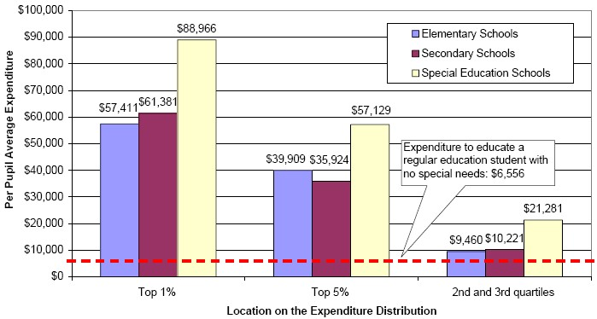
Table 2: Per Pupil Average Expenditure

It is expected that Prism will be an effective classroom tool when used in the early educational years of autistic students. Instructional technology tools that enable teachers to make decisions that maximize each individual student’s learning potential.
5.2.4. Data Driven Decision Making for Individual Student Needs
Trends in primary and secondary education show movement towards individualized educational practices based on specific instructional needs of each student. This trend began with special education students with the advent of Individualized Education Programs (IEPs). Individualized instruction requires specific performance and advancement tracking for each student. Formative instructional activities are implemented to gauge student’s progress towards achieving learning objectives, knowledge, and skill areas. Summative activities and assessments measure the actual levels of achievement that have been gained.
Throughout the formative process, teachers, assistants, and administrators must be able to track student progress and make instructional adjustments as needed on an individual basis. Performance data can be analyzed to pinpoint specific areas of need and intervention and remedial responses can be undertaken based on those needs. In order for this process to be efficient and most effective for students, electronic collection, analysis, and reporting of data for individual students is necessary. The K-12 education industry is gradually migrating away from paper-bound and manual processes. Student information systems, formative assessment engines, and online teacher resources and curriculum tools are leading the charge for technologysupported instructional practices.
5.2.5. Improving Educational Processes (Time, Effort, Resource Perspectives)
Technology products are services are slowly supplementing and sometimes replacing traditional paper-based processes in educational institution administration and the instructional process itself. Successful integration of technology in schools is often judged by the impact on the bottom line of student achievement and performance. With accountability requirements and ever-increasing responsibilities of the classroom teacher, technology is often sought as the solution to time and efficiency savings.
5.2.6. Integrating School-based and Home-based Data Collection, Recording, Analysis
Fully engaging parents in the instructional process is a challenge for public education systems. The more parents are directly involved in their children’s education, the more likely the child is to succeed. In the case of instructional technology tools, parents are far more likely to have an impact if the tools used in the classroom are available at home. The parent teacher partnership is vital to maintaining consistent application of activities for special needs children. Similarly, if the collection and analysis of performance and progress data that takes place in the home can be combined with what takes place in the classroom, more accurate intervention decisions can be made for each child’s individual needs.
5.2.7. Applied Behavior Analysis
Applied behavior analysis (ABA) is defined as the application of behavioral principles to shape behaviors and teach new skills. Behaviors are observed and analyzed to determine their function. The antecedents and consequences (events preceding and subsequent to the behavior) are analyzed and manipulated in an effort to shape or change behavior. Skills are broken down into small, discrete steps and taught systematically.
According to the Cambridge Center for Behavioral Studies, Applied Behavior Analysis is the most comprehensive and most effective approach to improving the lives of persons with autism and their families.
Prism is integral with the use of ABA due to its reliance on data collection and analysis for measuring student progress. Additionally, because performance is measured down to the individual student level, teachers and schools require efficient processes and tools to gauge the effectiveness of each student’s learning plan. Prism provides this benefit.

6. MARKET ANALYSIS

6.1. Market Segmentation
This product will be marketed to three distinct market segments. This segmentation strategy leverages the use of base software across the target segments with service options designed to scale with regard to infrastructure required for each segment.
6.1.1. Public School Districts
U.S.-based public school districts as well as individual schools in districts that do not elect to adopt the product across the enterprise are key targets for this product. This segment is forecasted to make up approximately 80% of total sales. It is expected that districts’ preferences between ASP and Enterprise service models will vary based on their level of technical expertise, existing infrastructure, and ability to implement and support the system on an ongoing basis.
6.1.2. Private Schools
Private schools are a secondary segment to public school districts for the product and will most likely be interested in the ASP model. These account for approximately 9% of predicted sales.
6.1.3. Parents of Autistic Children
Parents and families of autistic children are becoming more integrated into the instruction and remediation process. The local product model enables parents to observe and record behavior in the home and provide that data as part of the overall analysis of instructional needs for students. The local model can be used in a standalone mode or can be synchronized with data being collected by teachers and specialists when the student is in instructional settings. It is expected to account for approximately 11% of total sales.
Prism Model | Market Segment | User Profile
Prism Personal | Home Use  Single Classroom Use Mobile Device | Parent  Teacher
Prism Enterprise | Medium - Large School Districts  (More than 500 Students) | Teacher  Instructional Assistant  Classroom Staff
Prism ASP | Scales to Any Sized District or  Number of Schools | Teacher  Instructional Assistant Classroom Staff
Table 3: Prism Model Summary

6.2. Market, Demand Estimation, Industry Trends
6.2.1. Market Size
In total, states will spend an estimated $1.48 trillion; with approximately 33% of state spending in support of education. State IT spending in fiscal 2007 will total $23.7 billion. In addition, local IT spending, which is growing at a higher rate than state spending, is estimated to be a $27.2 billion market (with approximately 60 percent going towards education.). Finally, this market in general is growing at an accelerated rate and expected to ultimately reach $10 billion by fiscal year 2010.
Specifically, total US spending on special education is estimated to be close to $52 billion with $600 to $700 million going towards instructional software and software supporting IEPs.
Targeted special education spending | $50 billion
Targeted “regular education” spending | $28 billion
Spending on other special ed programs | $2 billion
Total | $80 billion
Table 4: Total Estimated U.S. Spending on Special Education

Instructional software & assistive technology | $300 million
Instructional hardware | $400-$500 million
Administrative software; Individualized Education Plans | $300-$400 million
Technology-related staff development | $80-$100 million
Table 5: Estimated Special Education Expenditures on Technology

The total market size for the Prism product line consists of the sum of potential consumers in the public school, private school and home markets. The following describes the total size of these markets (before accounting for autism statistics):
- Public - There are close to 49 million students (K-12) in approximately 95,000 public schools divided into approximately 14,000 school districts.
- Private - There are approximately 27,000 private schools in the US, comprising of
6.2 million students.
- Home - Approximately 67% of the 114 million households in the US include school age children; this amounts to nearly 78 million households.
As previously stated, autism statistics vary by source, but it is estimated that a child with an autism spectrum disorder is born one out of every 166 births; this accounts for approximately 1.5 million Americans.
“I see value in a tool that streamlines the process and
reduces the complexity of collecting and analyzing data.”

- Cheryl Temple, Ph.D., Coordinator, Assistive Technology,
Fairfax County Public Schools

6.2.2. Demand Estimation
Between 1987 and 2002, there was over 600% in growth in reported cases of autism. The growth continues to be approximately 10% annually and trend upwards after 2002. It is not well understood if this growth is due to better diagnosis, actual increased occurrence of the disorder, or both. The growth rate used for the demand estimate in Years 1 through 5 (financial model) is the sum of the increase in actual autistic students, and the increase in sales to organizations and parents. This projected rate of 10 – 12% (depending on the product model) is conservative because it includes increased sales as well as an increase in the overall market.
Age Group | 0 - 4 | 5 - 9 | 10 14 | 15 19 | 20-  24 | 25-  29 | 30-  34 | 35-  39 | 40-  44 | 45-  49 | 50 + | Total
1987 | 125 | 460 | 399 | 453 | 543 | 407 | 226 | 100 | 43 | 10 | 12 | 2,778
2002 | 2421 | 7518 | 4282 | 1887 | 1108 | 729 | 641 | 658 | 536 | 329 | 268 | 20,377
Table 6: Autism Growth 1987 – 2002
In order to determine the initial public school markets in the demand estimate, the team identified thirteen large school districts that have higher concentrations of IEPs. The number of IEPs correlates to the numbers of disabled students, of which autism is a subset. The school districts identified in Table 7 are examples of the demand in these highconcentration school districts. All of these school districts, while not specifically identified by name, are represented within the 5 year demand, for either the Prism Enterprise or ASP model. Thus, from the total number of students in these larger districts, the number of autistic students was calculated using the statistical approximation of .6% (derived from 1/166 estimate described in Market Size).
The private school demand estimate was derived using conservative estimates of obtaining a total of 56 private school installations at the end of five years; which accounts for .2% of the total number of private schools. The majority of these installations are expected to be specialty private schools for disabled children. The local model demand estimate was calculated as a percentage of the Enterprise and ASP models, assuming that some parents will purchase local versions to continue monitoring and measuring behavior at home after school. The growth rate for local starts at 5% and increases to 13% at the end of Year 5 as deployment of Prism Enterprise and ASP expand.
Large District Targets | Autistic Students
NYC  LA  Chicago  Miami  Ft. Lauderdale  Tampa  Houston  Palm Beach Orlando  Jacksonville  Dallas  Largo  San Diego | 7,146
 | 4,833
 | 2,916
 | 2,470
 | 1,683
 | 1,101
 | 1,397
 | 1,031
 | 1,010
 | 843
 | 1,082
 | 757
 | 950
 | 27,218

Table 7: Number of Autistic Students in Select Districts

7. MARKETING STRATEGY

7.1. Product Positioning
Prism will empower teachers, school administrators, and parents with the ability to provide high quality instruction and remediation for children with autism. This solution will enable the collection, analysis, and reporting of behavioral data and synthesize it into useable information to help autistic children reach their maximum potential.
This solution is uniquely positioned in the market to address the needs of an individual to a large school district with thousands of students. There are no products on the market in this space that can provide the breadth of features to the numbers of users that school districts need.
The philosophy behind Prism is integrating technology with a proven and standardized process for managing behavioral data and making instructional decisions based on collected and analyzed data. What teachers are doing today is manual, paper-based, and has no efficient means of collating and using data collected across periods of time. Technology alone cannot solve the problems faced by today’s educators. However, technology can be appropriately applied in ways that ease the burdens of manual and administrative tasks and enable teachers to focus on the students and the instructional process.

7.2. Product Description
The three product models designed to address specific market segments are based on technical capability, user base characteristics, and existing infrastructure. Each version is built with the same analysis algorithm module that provides a commonality across each model. The significant difference comes with the ability to expand from a single user to an Enterprise solution.
Generally, the product requires the use of:
- Data Collection Device - A device for data collection such as a cell phone, PDA, tablet PC, Laptop PC, or Desktop PC. The emphasis on this product as a learning tool is on providing mobility and efficiency in collecting data. The integration of handheld devices in the data collection process frees the observer and recorder from pen/paper or being bound to a desktop, stationary computer.

- Data Analysis Software - The Prism application is installed and accessible via the Internet, WAN, LAN (Intranet), or via direct sync. The heart of the system is the analysis tool that enables easy to use manipulation and presentation of collected data. The interface also provides the means for teachers, administrators, and parents to control the database, manage accounts, initiate the data collection process, and create and view reports.

- Database – The database will be created using a commonly used database application called MySQL. The architecture of the product is such that the data and presentation are separate. Prism is the presentation software that is fed by the database. Data from a single child’s record can be shared and/or fed via different data collection devices.
- Web Enabled user Interface – An HTTP user interface will be created using Apache 2.2 toolset. This will allow for connectivity in a stand-alone scenario and still allow users to connect to Pearson’s Prism ASP provider.
7.2.1. Prism Functionality
The user interface has been designed to maximize ease of use in the classroom. The following section outlines the basic steps for users to collect data and generate a graphic representation of the results. This automated process will replace the current manual collection, analysis and graphing of data which consist of recording behaviors on worksheets as presented in Appendix K. The interface is designed to comply with ABA data collection and analysis practices so that sampling methods and reports are consistent with ABA standards. For example, Prism is able to collect four types of data common with ABA: behavior frequency, duration, accuracy, and fluency. The analysis tool within Prism enables teachers to evaluate performance of students by skill objectives or across skill objectives of specific types. Also, performance can be evaluated and compared across groups of students or groups of teachers for comparative purposes. The reporting and analysis is in real-time providing instructors immediate feedback.
Step 1: Logon - This screen enables users to log on to the system with a username and password.
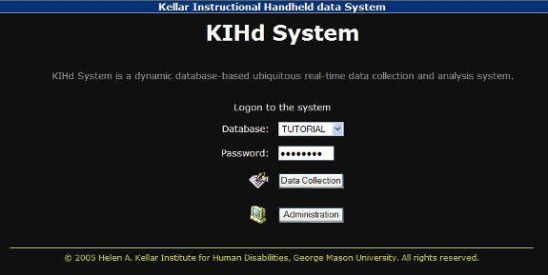
Step 2: Administrative Screen - From this screen a user will enter a student into the system.
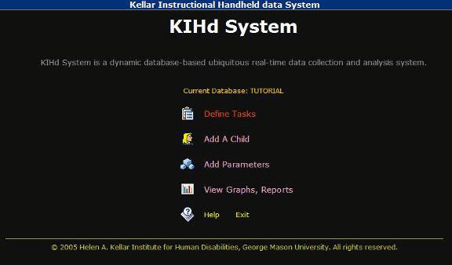

Step 3: Student Information - This screen defines the name of the student and the behavioral analysis to be conducted with that student.
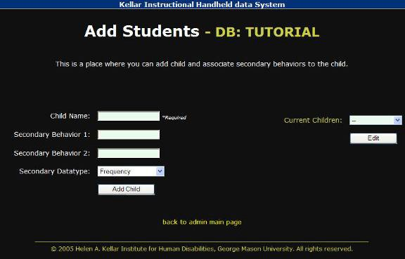

Step 4: Define Task - This screen defines the detail of the tasks and objectives of the task.
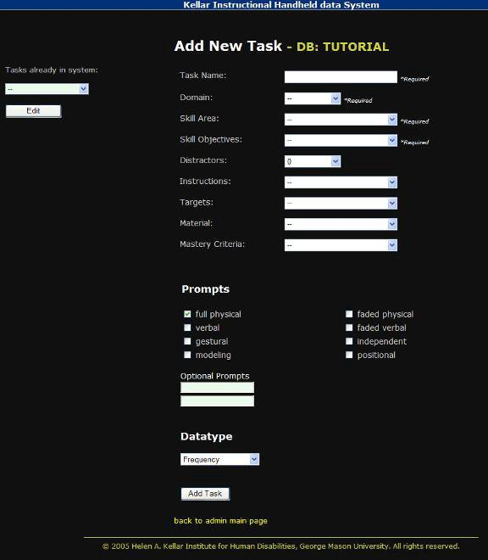

Step 5: Start Behavior Data Collection Session - This step initiates the data collection session.
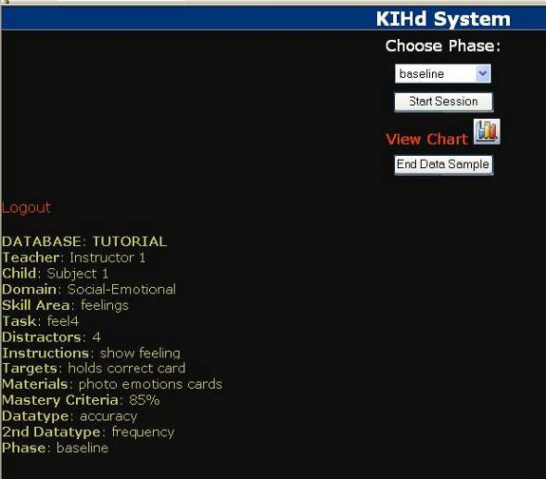

Step 6: Collect Data Based on Observation and End Session - In this step, users record behavioral occurrences in real time.
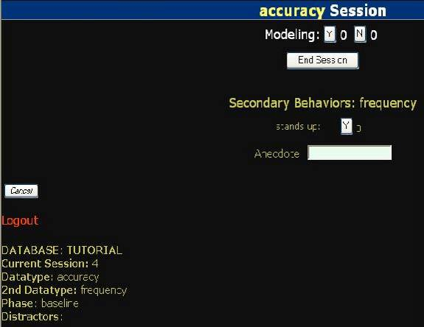

Step 7: Data Graph – This graph is an example of the data that Prism compiles which can be used for analysis. Pie charts, line, bar and log graphs can also be generated.
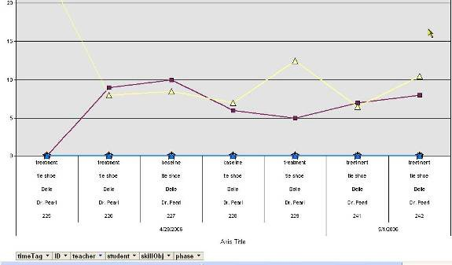

Additional Capabilities: Reporting Features – This is an example of a report that can be generated which compiles baseline data from multiple students
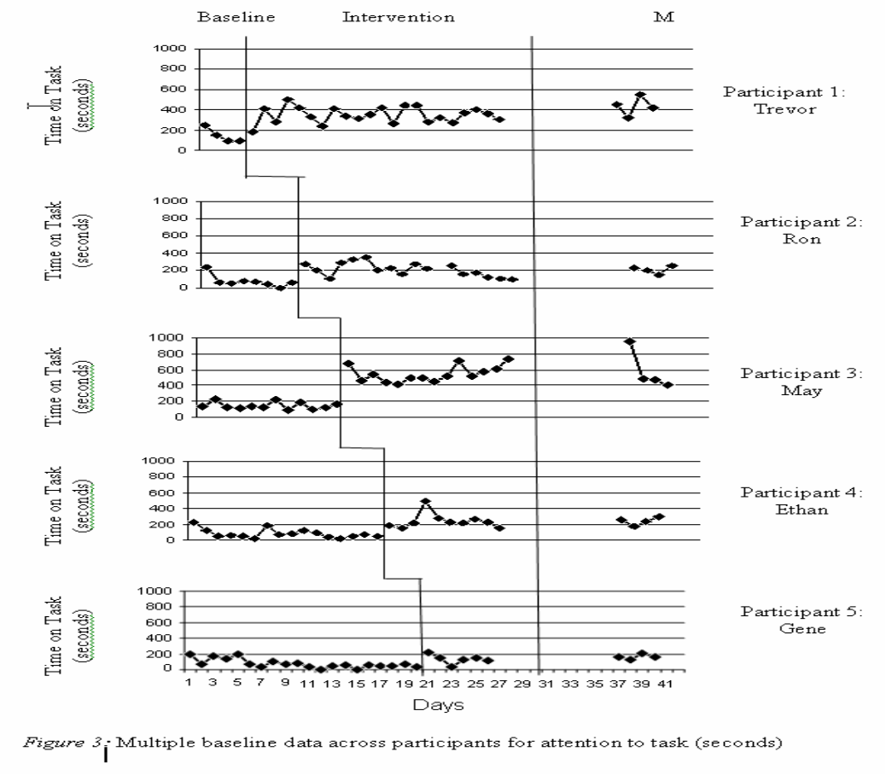

7.3. Prism Models & Customer Profiles

Prism Model | Market Segment | Supported Devices | Software | Platform | Connectivity
Prism Personal | Home Use  Single Classroom  Use  Mobile Device | Desktop  Computer Laptop  Handheld Tablet | Microsoft  Windows  XP (All Editions)  Vista (All Editions)  Macintosh OS 10 | Intel Family  PowerPC  32-bit  PowerPC  64-bit  Intel Family | None  Required (Internet possible)
Prism Enterprise | Medium  Network  Large Network Multiple  Classroom Use  Campus  Network | Desktop Server | Microsoft  Windows XP,  Vista, or Server 2003  Macintosh OS 10 | Intel Family  PowerPC, 32-bit;  PowerPC, 64-bit, Intel Family | Internet
 |  |  | Linux | Intel Family
Prism ASP | Medium  Network  Large Network Multiple  Classroom Use  Campus  Network | Desktop  Computer Laptop  Handheld Tablet | Red Hat Enterprise Linux 4 | Intel Family | Internet
Table 8: Prism Model Summary
7.3.1. Prism Personal (Standalone Model)
- Market Segment – home use, single classroom use, mobile device.
- Hardware – Handheld device for mobile data collection. A PC configured for use as a server. The PC can be used as the data collection device if no handheld units are available.
- Software - Native database, data analysis software, and any commonly used database included in common software suites (such as Microsoft Access).
- Connectivity – Direct synchronization between the data collection device and the data analysis software and database. No Internet, WAN, or LAN access is required in this model.
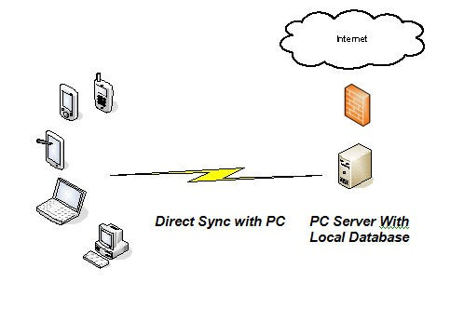
Figure 3: Prism Personal Model
7.3.2. Prism Enterprise
- Market Segment – Large school districts with wide area networks in place and the capability to host in-house.
- Hardware – Handheld device for mobile data collection. A PC can be used as the data collection device if no handheld units are available. Database and application servers are required for this model. Depending on the scalability and volume requirements, a single server device may be used as a combination database and application appliance.
- Software - Data analysis software and a Java front-end user interface. The database platform will be MySQL which will by dynamically linked via the Java interface. The reporting system will be created using the Business Intelligence and Reporting Tools (BIRT) toolset.
- Connectivity – Wide Area Network, or Intranet, access from data collection devices to the application server. In this instance, Internet connectivity is not required for school –based data collection devices. However, if external devices are to be granted access a secure means such as Virtual Private Network (VPN) accessibility should be provided.
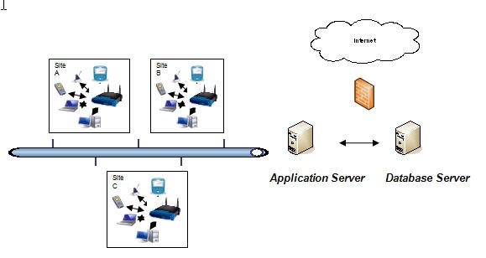
Figure 4: Prism Enterprise Model

7.3.3. Prism ASP
- Hardware – Handheld devices for mobile data collection. A PC can be used as the data collection device if no handheld units are available. Database and application servers are not required for this model as they will be hosted and maintained at the provider’s facilities.
- Software – Access to the application only requires a web-browser resident on data collection devices described above with the ASP model. Data analysis and database applications are resident in the hosted facility.
- Connectivity – Internet access is required to access the application. Secure access to each customer’s instance will be provided through authentication processes included with the service.

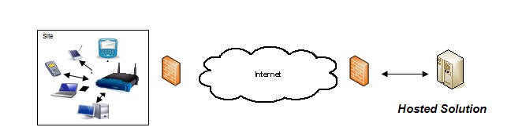
Figure 5: Prism ASP Model

7.4. Primary and Secondary Research
The Prism team will conduct primary and secondary research in Year 0 and Year 3 in order to better understand the needs and utility of the product such as:
- The benefit derived from using Prism as compared with existing paper-based processes
- The perceived differentiators of Prism as compared to competitors
- Which features were most important to potential Prism users (educators and parents)
- The overall ease-of-use of the Prism including:
  - Prism interface
  - The presentation of information to end users (e.g. terminology)
- Evaluate the changing marketing needs of the Prism product models
- Other comments provided by respondents

Preliminary research was conducted with the cooperation of education professionals and parents in several different schools (public and private), school districts and states. Appendix H and I articulate the survey questions and results, as well as primary and secondary research conducted that supports the overall need for the functionality that Prism provides.

7.5. Price
The pricing strategy for the Prism product models reflects Prism’s premium positioning in the market. List pricing reflects a basis of “per-seat” costs for schools. This is an industry standard practice of pricing instructional software products and services in the education market.

 | Personal | Enterprise | ASP
Single Seat | $99 | $75 | $20
100 Seats | - | $7,500 | $2,000
250 Seats | - | $18,750 | $4,500
500 Seats | - | $35,000 | $7,500
1000 Seats | - | $65,000 | $13,000
2000 Seats | - | $130,000 | $26,000
2500 Seats | - | $150,000 | $32,500
Table 9: Sample Cost Estimates

Table 9 shows a comparison of base prices for each model and specific seat counts. Prism Personal and Prism Enterprise are one-time prices for the software license. The ASP prices are annual rates for subscription to Prism. These do not include upgrades, maintenance, installation, or training fees.
Prism Personal – The one-time license fee for Prism Personal and mTrial, Prism’s primary competitor, is $99. Although Prism is positioned as a premium product, the Prism team decided not to raise the price above $99 because:
- Analysis of features and capabilities revealed that mTrial is overpriced based on the functionality that users demand
- A price of $100 or more may deter consumers in the Prism Personal target market segment (psychological impact of two digit vs. three digit pricing)

Prism Enterprise – School districts, especially larger and more technically inclined districts, often request pricing for district-wide solutions in the form of a subscription model or license purchase model. The Enterprise model is priced based on a per seat model with Prism Personal as the baseline and taking into account seat volume required by larger school districts. The per seat price of Prism Enterprise is significantly higher than the per seat price of Prism ASP because the seat purchase transfers ownership of the license.
Prism ASP – Pricing is determined by seat and charged annually. The pricing is comparable to that of Work Sampling Online. Work Sampling Online is a Pearson Education product that is offered as a subscription service through an ASP model. The prices range from $11 - $20 per user per year depending on volume. The Prism ASP per seat price is significantly lower than the Prism Enterprise per seat cost because it is an annual service subscription (must be renewed annually).
Enterprise and ASP tiers of service have upgrade and maintenance contract provisions that are charged at 20% of the license fees. Additionally, an overall average price increase is expected to occur in Year 4 based on enhancements and value-added options that will become available at that time.
Tiered Pricing Strategy – Volume pricing is based on a tiered structure with reduced per seat prices at higher volumes. It is expected that negotiation and price accommodations will have to be made for larger school districts. This may be especially so in the event of responding to competitive procurement situations and Request for Proposals issued by districts searching for solutions in Prism’s space.
Finally, a school district at or near a volume discount threshold in the ASP or Enterprise models may be provided the lower price point in exchange for either multi-year contracts or agreeing to serve as a subject for case study, white paper, or reference for Prism.
Bundling Strategy – As a new product to the Pearson Education family, lower prices may be negotiated if other Pearson products are deployed or are existing at the client’s site. Due to the level of penetration of other Pearson products and services in the K-12 market, Prism may be presented as an add-on product to the existing customer base.
Product managers will be involved in large scale enterprise and ASP sales where bundling with other Person products or multi-year commitments are being negotiated. This is to ensure profitability minimums are adhered to and acceptable contract terms are provided for in the negotiations.

7.6. Distribution
7.6.1. Product Distribution Strategy
Pearson Education has local, regional, and national sales and sales support organizations that will be leveraged to sell this product. Additionally, the sales force and marketing structure in place supports new business generation, new and existing account development, and generating interest in new products with existing schools and school districts through an account management organization.
Pearson Education has approximately 65% penetration into U.S. school districts. It has accomplished this market share through acquisition and organic growth of educational product and service lines. This installed customer base provides opportunities for Pearson to market and directly sell this product as well as integrate the product into existing locations. This product is uniquely designed to provide specific features and functionality among the various Pearson product lines. As such, it can be positioned independently to special education staff and departments or accompanied by a suite of Pearson products providing benefits across various departments in schools. The features and functionality of Prism place it at a premium position in the market and is priced accordingly.
Prism will have a dedicated product managers, project managers, and business analysts to oversee the development, launch, and ongoing management of the product. This team will report up through the Pearson Education chain of command as part of the new product development and management team. The existing Pearson Help Desk will be expanded to provide customer service and support for Prism. The cost associated with providing additional customer support representatives is included in the cost model available in Appendix D.
Prism Personal software will be distributed through direct sales via Pearson’s web page. The procurement process provides a secure connection to credit card integrity during financial transactions. Prism personal software can be downloaded from the product’s website or a CD can be requested to be mailed to an address supplied. The software will also be available via CD media and distributed through third-party resellers and replicators such as www.campustech.com and www.journeyeducationmarketing.com. These organizations typically charge $7.95 - $12.95 per order for CD replication, order processing, and shipping & handling to end users. These costs are passed through to the end customer resulting in no additional costs to Pearson. Price controls will be in place among resellers to prevent channel conflict and to preserve Prism’s premium positioning. The product should be available through multiple outlets because school districts often have relationships with resellers and may prefer to procure products and services from specific outlets.
Prism Enterprise will require a technical installation team to travel to each site and provide installation and/or integration into the organization’s enterprise architecture. Each site installation will be customized to interface with the school/school district’s existing enterprise architecture. The technicians will be responsible for providing guidance and installation directions to site system administrators for the Prism software. Any existing software and hardware will be the responsibility of the customer. Pearson’s system administrators will provide technical specifications and troubleshooting guidelines while full product training will be provided by the dedicated onsite team during the “train the trainer” sessions for school staff. Prism Enterprise will be sold through direct sales teams, account managers, and field staff through existing contacts and relationships with schools.
Prism ASP will require a sales force that will promote the qualities and convenience of an ASP model to the end user. The ASP model will require on site training for the software utilization or a comprehensive Computer Based Training (CBT) CD that will guide users through the various features. Each ASP site will be provided with an account manager that will help them initially setup the instructors and student personal information. This will be provided for 30 days after the initial installation. Further help will be available through Pearson’s highly dedicated help desk.

7.7. Promotion
Promotion of the Prism product line will be focused on addressing the needs of Prism users, who are teachers, parents, and classroom staff. Additionally, Prism Enterprise and Prism ASP central staff, such as curriculum specialists, program administrators, and staff members of special education departments and offices are key target audiences and decision makers. Central staff is typically engaged in analysis and assessment of new instructional technologies for the classroom. Teachers and classroom staff are often influencers, but in the case of ASP and Enterprise models, central staff members have final decision authority.
For the Personal model, parents typically learn of these technologies through working with teachers and administrators. However, visibility in autism related periodicals and websites that are frequented by parents and instructional personnel alike will be key to the overall strategy and gaining visibility and mindshare of all target audiences. It is expected that Prism Personal will have appeal to teachers and instructional assistants who work in schools with a very limited number of students.
Table 10 shows the promotional activities with 5-year budgeted marketing costs.
Media | Budget | Frequency | Outlet | Target
Print Advertising & Direct Mail | $837,357 | Monthly, Quarterly | eSchool News, School  Administrator, Special  Education, Behavior  Therapy, Targeted School Districts | Teachers, Program  Administrators,  Parents, Program  Administrators,  Curriculum Specialists
Web Advertising | $436,794 | Ongoing | eSchool News, Autism  Speaks, Autism Society | Teachers, Program  Administrators,  Curriculum Specialists
Primary and  Secondary  Research | $200,000 | Year 0 and  Year 3 | Surveys, Wiki, Blogs,  Community User Groups | Teachers, Program  Administrators,  Parents, Program  Administrators,  Curriculum Specialists
Conferences | $1,757,689 | Up to 20 Per Year | NECC, NETC, State  Conferences in Target Markets | Teachers, Program  Administrators,  Curriculum Specialists
Table 10: Promotion Methods, Frequencies and Budget
7.7.1. Print Advertising & Direct Mail
Prism will purchase 1/4 page advertisements in special education and general educational publications including eSchool News, T.H.E. Journal: Technological Horizons in Education, Journal of Applied Behavior Analysis, Journal of Autism and Developmental Disorders, Journal of Special Education Technology, Teacher Education and Special Education. Table 11 below illustrates the frequency of 1/4 page advertisements. These periodicals serve as informational and reference material for school-based personnel and parents alike and are desirable targets for maintaining visibility to these audiences. Many, if not all, of these titles have accompanying websites with resources and information that will be part of the web and banner advertising strategy.
A targeted quarterly direct mail campaign is planned for all 5 years. The campaign includes 250,000 4”x 5” post cards at $0.065 per card. Direct mailers will be sent Pearson’s existing and prospective customers. The timing of the campaigns will be coordinated with industry events and conferences to entice attendance and booth visits. In subsequent years, direct mail will keep the school community up to date on enhancements and information about the product.
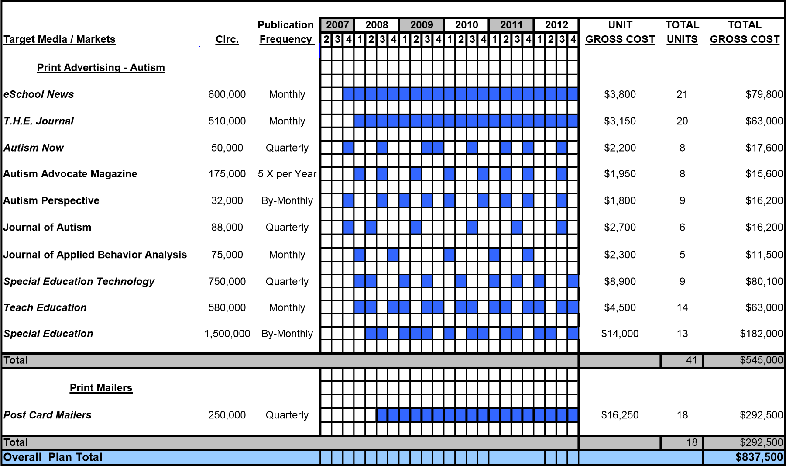
Table 11: Print Advertising & Direct Mail
7.7.2. Web/Banner Advertising
Most of the print publications have accompanying websites with banner advertising and sponsored event opportunities. Those that focus on technology integration such as eSchool News and special education publications are preferable.
Websites that will be targeted for web/banner advertising are the periodicals that also maintain websites, as well as websites specifically designed to address autism such as www.autismspeaks.com and www.autism-society.org. Similar to print periodicals, these websites are used by parents and school-based staff for information, resources, communication, and learning about new technologies related to assisting with the instructional process for autistic children.
The cost budgeted for web/banner advertising is based on Cost per Thousand Impressions (CTI) as defined by the Interactive Advertising Bureau. Standard rates for a center banner are $70 per thousand; allowing Prism up to 1 million clicks for the budgeted amount.
7.7.3. Trade Shows and Conferences
Educators often learn about new technologies and instructional technology integration practices at trade shows, seminars, and conferences. Pearson Education already participates in many of these events such as:
- ISTE - International Society of Technology in Education
- NECC - National Education Computing Conference
- NETC - National Educational Technology Standards
- Association for Behavior Analysis Conference
- Regional and State Conferences such as the Virginia Department of Education’s Educational Technology Leadership Conference

The Prism team will have exhibit space and participate in approximately 15 to 20 conferences per year. The budget allows for approximately $20,000 per conference, which is adequate for educational conferences which do not require extensive technology, displays, personnel and floor space. Pearson often sponsors learning sessions, workshops and tutorials regarding instructional technology as well as social events for networking with prospective customers. Teachers, program administrators, and curriculum specialists attending these events will be provided 30-day trial software to try Prism and get a feel for its ease of use and functionality. Contact information will be collected for follow-up. Live demonstrations of the software will also be conducted. These conferences and events are an effective means of collecting first hand feedback from instructional personnel that can be used for product enhancements and planning.
7.7.4. Public Relations
In addition to other marketing activities, a public relations strategy which includes press releases, media interviews, pilot programs and press events will be incorporated to assist in gaining mindshare and media exposure for Prism. Also, key customers will be used as case studies for generating white papers and references for future sales opportunities.
7.7.5. Sales Cycle
The Prism product line will be ready for release by late March 2008 which will give the Prism team six months to install products at customer sites prior to the 2008/2009 school year. The sales force will start promoting the software as early as June 2007 to generate interest during client visits, sales calls, and conferences. The web page will be operational with all of the pertinent information and promotional information by early July 2007.
It is expected that the sales cycle for this type of product will vary with the model. Each sales person will promote the Prism Personal model by discussing the family of products and through product deployment. The ASP and Enterprise solutions will be the emphasis of sales professionals. Table 12 provides Pearson’s standard sales cycle for similar product deployments.
Model | Sales Cycle | Visits | Projected Success
Prism Personal | 7 Days | Web/Conferences | 60%
Prism ASP | 1-4 Months | 1-3 Visits | 22%
Prism Enterprise | 3-6 Months | 2-5 Visits | 8%
Table 12: Predicted Sales Cycle
7.7.6. Sales Commission
There is no direct sales commission for Prism Personal since the product is sold online and through second party vendors. Relationships with channel partners are handled by existing Pearson account managers who are compensated based on total channel sales. The ASP and Enterprise models will be prorated at 4.5% of the total revenue for one calendar year and paid as a commission.

8. COMPETITIVE ANALYSIS
Pearson is a recognized global media provider of educational, business information and consumer publishing products. Pearson has worldwide penetration in over 60 countries with over 29,000 employees. Pearson has a substantial educational division providing diversified products to over 100 million school age children. Pearson Education has a presence in 65% of overall U.S. K-12 market. The development of Prism products will provide educational institutions with a variety of tools that will meet varied enterprise needs. The key to Prism commonality of functions is that each child can be assessed at a standard level that is repeatable across the enterprise.

8.1. Primary Competitors
8.1.1. The Observer
The Observer was developed by Noldus Information Technology, a one-man software development company in the Netherlands. Noldus Information Technology was founded in 1989 and has grown to 85 employees worldwide. The company develops, markets, and supports innovative software, hardware and integrated solutions for research on human and animal behavior. The Observer is the professional software package for the collection, analysis and presentation of observational data.

Providing a wide range of feature for data collection and analysis, The Observer can be applied to study observable behavior such as activities, postures, gestures, facial expressions, movements, and social or human-system interactions. Trials can be instantly analyzed and the results can be exported to SPSS.
8.1.2. mTrial
Mobile Thinking Inc. is a small independent company established in 2003. In 2004, Mobile Thinking applied for a patent for mTrial software. mTrial is a software program that agencies, clinics, consultants, and parents can use to record discrete trial, cold probe, and verbal behavior data. mTrial allows users to create and maintain programs, behaviors, student accounts, and tutor accounts on a PC, which are shared with a Palm handheld. Trial behaviors are recorded on a Palm handheld, which is then saved to the PC.

mTrial supports graph, chart, and other report generation on a PC and allows users to have complete control over the programs that are defined, and which programs are assigned to which students. Table 13 below compares mTrial and Prism features.

 | mTrial |  | Prism
•  • | Only collects data on a Palm  Only show graph on PC | •  •  • | Collects data on variety of PDA’s and PC  Shows last ten data points on PDA  Has ability to show line, bar, semi-log, and pie on PDA
• | Only shows line graph | •  • | Has interactive dynamic graph on PC  Can show progress with one student over many teachers or one teacher with many students
 |  | • | Have prompt levels-up to 12 with three
•  • | Only uses correct, incorrect or prompt  Only collect accuracy data | •  •  • | Create your own  Collects accuracy, frequency, duration, and fluency data  Uses cookies to let instructor know response, materials, etc….
 |  | • | Room for anecdotal notes during data collection
• | Only synch system | •  • | Real time data collection  Only need internet connection
• | Has OAR funding and CARD for testing | •  • | Stepping Stones Grant  Mason and site for testing
Table 13: mTrial vs. Prism

8.2. Secondary and Indirect Competitors
8.2.1. Learner Profile
Sunburst Technology is a subsidiary of Houghton Mifflin Company. Sunburst develops, produces and distributes educational software and videos and distributes supplemental curriculum materials for educational institutions. Founded in 1972, Sunburst emerged as market leader in 1983 by releasing the popular “Voyage of the Mimi” educational television program. Sunburst supported this series with interdisciplinary, multimedia products and instructional software. This began to build Sunburst’s presence in the educational technology market with a philosophy of creating stable and reliable programs for schools. Sunburst Technology is a leader in developing and publishing award-winning, multimedia educational software, videos and printed supplements for use in schools. It publishes school products for grades K to 12 under the teachers' favorite Sunburst brand. Focusing its business on math and instructional keyboarding programs, Sunburst is best known for the Type to Learn® series and award-winning business simulation programs such as “Hot Dog Stand: The Works and Ice Cream Truck”.
Learner Profile by Sunburst is an assessment management tool to track Adequate Yearly
Progress. Learner Profile gives teachers the ability to record student's grades, track assignments, organize student information, and develop reports. Teachers can use Learner Profile on their computer, and Learner Profile to Go on their Palm or Palm-compatible PDA.
8.2.2. HanDBase
DDH Software, Inc. is a privately owned corporation based in Wellington, FL. Their mission is to provide high quality, affordable productivity solutions for mobile handheld and smartphone users.

HanDBase is a cross-platform, small footprint, flexible and complete solution for databases on handheld devices (PalmOS and PocketPC and Symbian Series 60 platforms) and desktops (primarily MS-Windows and MacOS). HanDBase was not designed as an autistic or behavior tracking device, but has a powerful customizable database that can be developed by individual or groups to customize autistic data collection.

8.3. The Prism Advantage
Pearson is an established global producer of educational software with a vast distribution system and partnerships with numerous school systems throughout the United States. Pearson’s installed base will be leveraged for Enterprise and ASP solutions, and discounts will be offered to existing customers. Pearson’s primary and secondary competitors do not have broad penetration into school systems. Pearson’s competitors are primarily small operations that have a single product offering or a product with broadly-defined functionality. Finally, Prism is capable of being used as a stand-alone system (no Internet) and/or on any web-enabled device and accommodates all size deployments with the Prism Personal, Prism Enterprise, and Prism ASP models.

8.4. Competition Product Comparison
The following points of comparison are shown in terms of most to least important. Success factors for automated tools for recording and analyzing trials using ABA:
- Reporting Capability – Based on primary research conducted during product trials, it was determined that the ability to produce reports such as graphs and charts is considered a key product feature.
- Ease of Use – User acceptance is a critical determinant in the success of automated tools; products must be easily used and understood.
- Platform Adaptability – Offering functionality on multiple platforms and versions will allow users to install and use the software on workstations, tablets and handheld devices.
- Multiple Model Support - Especially for organizations considering broader deployment (e.g. schools and school districts), the availability of enterprise or hosted services is a key decision factor.
- Price – Since this market is not flooded with competition, price is a not the most important factor, but still plays a role in consumer decision making.
- Analysis Capability – Analysis capability, especially enhanced functionality that can suggest mediation techniques is an important value-add.

Table 14 below provides a side-by-side comparison of these key features:
 | Prism | mTrial | The Observer | Learner Profile | HanDBase
Reporting | ✓ | ✓ | ✓ | ✓ | ✓
Ease of Use | ✓ |  | ✓ | ✓
Platform | ✓ |  |  |  | ✓
Multiple Model | ✓ |  |  |  | ✓
Price | ✓ | ✓ |  | ✓ | ✓
Analysis | ✓ | ✓ | ✓
Table 14: Competitor Product Comparison

Some competitor products include functionality (not shown in Table 13) that is not currently supported by Prism:
- The HanDBase product has the capability to be fully customized to meet a variety of different conditions that improves its efficiency. This is demonstrated with the use of HanDBase tool for human behavioral analysis, animal analysis, business solutions, and technicians. Prism is not currently considering developing this functionality because this capability is better suited for a broader set of trials, and Prism is currently targeting behavioral analysis for autistic children.
- Learner Profile software includes student performance tracking capabilities that are a desired future enhancement for Prism (includes integration with Pearson’s student information systems).

9. INTELLECTUAL PROPERTY ACQUISITION
Through the course of research and design of the Prism product, it was discovered that a patent had recently been awarded based upon similar attributes as Prism. United States Patent #6,905,883 was issued on June 14, 2005 to Mobile Thinking and the mTrial product. The Prism product would infringe on the basic claims made in the existing patent therefore creating the need to acquire legal use of the intellectual property through acquisition or a licensing arrangement in order to sell Prism commercially.
The property owner, Mobile Thinking, LLC., is a sole proprietorship listed under the Standardized Industry Code “Computer Programming Services.” The firm had estimated revenues of $85,000 in 2003. The product currently on the market, mTrial, related to this intellectual property consists of a single user configuration similar to Prism Personal. Based on the firm’s website, mTrial has not been productized to provide large scale implementation as with Prism Enterprise and Prism ASP. It does not appear that the property owner has the funding or plans to deploy a fully developed solution for school districts other than custom-built instances.
There are three alternatives for proceeding with obtaining legal use of the intellectual property. These alternatives include direct acquisition, licensing, and cross-licensing arrangements.
- Outright Acquisition – this is a direct purchase of the intellectual property from the current owner resulting in transfer to Pearson, PLC.
- Licensing and Royalty Agreement – this arrangement results in Pearson, PLC. Paying licensing and royalty fees to the owner so long as a contractual relationship exists with applicable terms and conditions for use of the intellectual property.
- Cross-Licensing Agreement – the ultimate plan for this product is to enhance the current capabilities with specialized reporting and analysis engines to be included as part of the Prism product. Through obtaining patents on these enhancements, Pearson, PLC would enter into a cross-licensing agreement with Mobile Thinking resulting legal use of both entities’ intellectual property.

Outright Acquisition and the Licensing and Royalty Agreement alternatives will be evaluated in the following section as the most viable to the Prism business plan. The Cross-Licensing Agreement alternative would be explored in future years as the Prism product line is enhanced and possibly awarded patents of its own. This would only be necessary if the event of a licensing agreement for the foundational intellectual property.

Table 15 shows a comparison between the alternatives of Outright Acquisition and a Licensing and Royalty Agreement. The model shows net present value (NPV) of the alternatives for Mobile Thinking.
 |  |  |  | Outright Acquisition
mTrial Forecast Acquisition Offer  PV mTrial Forecast  PV Acquisition Offer | Year 0  $ -  $ 80,000  $246,440  $287,135 | Year 1  $ 87,125  $ 80,000 | Year 2  $ 88,868  $ 80,000 | Year 3  $ 90,645  $ 80,000 | Year 4  $ 92,458  $ 80,000 | Year 5  $ 94,307  $ 80,000 | Sum  $ 453,402  $ 480,000
 |  |  |  | Licensing and Royalty Agreement
Royalty Rate  Extended Revenue Forecast  Royalty Payments  PV 5 years  PV 10 Years | 2.00%  Year 0  $ 85,000  $271,654  $489,387 | Year 1  $ 1,799,400  $ 35,988 | Year 2  $ 3,113,234  $ 62,265 | Year 3 Year 4 Year 5 | $ 3,955,985 $ 4,933,823 $ 5,977,944 | $ 79,120 $ 98,676 $ 119,559 | Year 6  $ 7,009,380  $ 140,188 | Year 7 Year 8 Year 9 Year 10  $ 8,027,148 $ 9,044,916 $ 10,062,683 $ 11,080,451  $ 160,543 $ 180,898 $ 201,254 $ 221,609
Table 15: IP Acquisition: Acquisition vs. Licensing/Royalty

Alternatives Assumptions –
- A forecast for mTrial was generated using $85,000 as a baseline. A growth rate of 2.5% was applied to the next five years. The growth rate is based on the benchmark of autism growth and adjusted for the lack of substantial growth of mTrial so far.
- The acquisition offer is $480,000 amortized over 6 years. The first payment of $80,000 is scheduled upon approval of this Business Plan. The $480,000 offer is based on the PV of mTrial’s projected growth over five years.
- A 2% royalty rate is shown for the Licensing and Royalty Agreement based on consultation with the Pearson Mergers and Acquisitions legal team. According to a patent attorney consulted for this project, 2% is a common benchmark for intellectual property royalty payments. This is based on total revenue for all Prism product models. In order to show long term benefits, regression analysis was used to extend the base 5-year forecast out to 10 years.

9.1. Intellectual Property Alternatives Impact
Table 16 shows the impact of the alternatives on the Prism business plan in terms of overall project NPV, MIRR, and Payback Period.
Project Metrics | Outright Acquisition | Licensing and Royalty Agreement
NPV | $1,555,284 | $1,620,421
MIRR | 29.26% | 29.84%
Payback Years | 2.25 | 2.22
Table 16: IP Acquisition Summary

While the Licensing and Royalty Agreement alternative is slightly better in the 5-year timeframe, the acquisition strategy is a lower cost of ownership in the long-term, as well as decreasing the risk of licensing from Mobile Thinking (e.g. Mobile Thinking licenses to competitors, or discontinues the licensing rights).

10. FINANCIALS
The Prism team is asking for $1.5M first year funding for the commercialization and launch of the
Prism product line. It is not expected that Pearson will need to seek out additional debt. The Prism team is requesting that this project be funded from existing Pearson new product development and marketing funds. Additionally, taking on debt on a project with a payback period on slightly more than 2 years is not recommended.

The tax rate was estimated as a stand alone project and not as part of Pearson’s total income. The Prism team feels that this is the worst case. The tax rate of 34% was derived from the typical business tax rate for revenues consistent with the projected revenues of Prism and that of Pearson.

The Modified Internal Rate of Return (MIRR) was derived from the expected demand for Prism. This prediction is based on the growth of the diagnosis of autism over the last 10 years. It is further predicted that with Pearson’s dominance in the education industry and the steps that are being taken to protect Prism through intellectual property rights acquisition, Prism will be viewed as the premium product in this sector.

The Net Present Value (NPV) is driven by the high demand for Prism. The NPV is also due to the economies of scale that the Prism product will achieve with the installed Pearson product development base. Lastly, the NPV number is driven by the substantially lower costs due to the use of open source software.

Prism development and maintenance costs were proportionately allocated across each product line using the revenue generated by that individual product line. This philosophy allows for a more accurate comparison of each product line against another. The percentage breakdown is located on the Fixed Cost and Taxes tab of Appendix D. The percentages flow back across the 5 year incremental cost tab, allowing the numbers to have the same basis, making the predictions in the financial model that much more realistic.

Several costs have been lumped together and accounted for in the financials as 5 work years of effort. This additional work will be required from the existing work force but do not require additional people to be hired just for Prism. Examples of this additional work would be in the marketing, finance, or engineering departments.

One area that will be directly affected by the launch of Prism will be the need for additional help desk staff. Help desk personnel calculations were calculated by the number of installations times the average number of calls to a help desk per user at an installation. The help desk function will be outsourced.

Appendix D has further details of the entire financial model.

10.1. Financial Executive Summary
Pearson Education Learning - Prism Executive Summary
This Executive Summary is the very top-level information from the cost, revenues, and income models in the Prism Financial model.
Individual Summaries are provided, but have been rolled up, further detail of these numbers are provided in Appendix D. Additionally, a breakeven chart is provided for quick reference.

11. SCENARIO ANALYSIS
In recognition of the potential inaccuracies of the forecasted data included in the financial analysis for the Prism products, scenarios were developed to illustrate the impact of unexpected outcomes for the following variables:
- Demand
- Cost
- Price

Note that the worst case scenario analysis, which combines a bad outcome of multiple variables at once, is presented in the section entitles “Worst Case Scenario and Exit Strategy”.

11.1. Demand Scenario
The base case financial model uses growth rates based on the demand estimations discussed in the section entitled Market Size, Demand Estimated and Industry Trends. Enterprise and ASP use fixed growth rates, while the local model uses a variable rate of 100% (Year 1), 25% (Year 2), 20% (Year 3) and 20% (Year 4).
 | Better | Base | Worse
Demand Variable | Increased  Demand by 20% | Variable% Local  12% Enterprise  10% ASP | Reduced Demand by 20%
Profit | $7,136,152 | $5,483,299 | $3,830,446
NPV | $3,469,973 | $1,555,284 | ($359,405)
MIRR | 42.10 % | 29.26 % | 13.78 %
Table 17: Demand Scenario Summary

11.2. Cost Scenario
One variable that is sometimes difficult to predict is cost. The Prism team has conducted extensive research on the costs and the financial cost estimates are derived from that research. Factors such as the quantity purchased and the timing of the buy, will affect the cost of the Prism business line. The scenario that was chosen was that costs would increase or decrease by 20%. While no one would expect all costs to increase or decrease at the full 20%, these are the best and worst case scenarios for cost. All fixed and ASP model infrastructure costs are the basis for the calculations.

 | Better | Base | Worse
Variable | Decrease all costs by 20% | Existing fixed costs | Increase all costs by 20%
Profit | $6,870,484 | $5,483,299 | $4,506,891
NPV | $4,111,712 | $1,555,284 | ($511,766)
MIRR | 50.78.% | 29.26 % | 13.16 %
Table 18: Cost Scenario Summary

11.3. Price Scenario
The pricing of Prism Personal was established from a direct competitor’s price that has a like capability; mTrial is priced at $99.00. Prism Enterprise does not have any direct competition in this market at this time; this price was derived by the Prism team from experience of other Pearson Education products. Prism ASP pricing was established from a like Pearson product, Mobile Thinking Online.
The following table depicts if Pearson, as the industry leader, were to increase prices due to being a premium product. The table also shows what the results would be if due to market entrants, prices were to be reduced by 10 %.

 | Better | Base | Worse
Variable | Increase price by 10%  (all products) | Existing Price | Decrease price by 10%  (all products)
Profit | $6,316,114 | $5,483,299 | $4,650,484
NPV | $2,520,091 | $1,555,284 | $590,477
MIRR | 36.11 % | 29.26 % | 21.91 %
Table 19: Price Scenario Summary

12. WORST CASE SCENARIO AND EXIT STRATEGY
The Prism team has defined a worst case scenario in order to determine the potential impact on key financial measures. The worst case scenario includes increased cost, decreased demand and decreased price (could occur through a large amount of promotional discounts). The likelihood of the collision of all of these occurrences is less than 1% (see Table 20), however, the impact is catastrophic for the project, resulting in significantly less profit, a negative NPV, and a negative MIRR (see Table 21). If this scenario (or a similar scenario) occurs, the Prism team has developed an exit strategy.
Condition | Probability of Occurrence
Significant Increased Cost | 20%
Lower that Projected Demand | 30%
Decreased Price | 15%
Probability of all 3 occurring simultaneously | .2*.3*.15=.009
Table 20: Probability of Worst Case Scenario

 | Base | Worst
Variables | None (Base) | Raised cost by 20%  Decreased demand by 20% Lowered Price by 20%
Profit | $5,483,299 | $2,334,331
NPV | $1,555,284 | ($3,310,332)
MIRR | 29.26 % | -10.73 %
Table 21: Worst Case Scenario

Prism’s exit strategy is based on profitability of the individual product and its value as an asset to the overall Pearson product family. Prism may not be directly profitable but enhance sales of existing Pearson Educational product lines.

If Prism meets the conditions stated in Table 20 Pearson will execute the exit strategy.
Prism will contact customers and discuss alternate solutions to provide their current needs. This will include providing them with alternative vendor products. Prism feels that the goodwill of this act will soften the negative business aspect towards the other business units.
Prism will strive to accomplish the following:
- Prism will negotiate with the ASP provider to terminate service on a predetermined date.
- All software users will be notified at our earliest opportunity providing at least 90 day notice that service will not be available via the ASP.
- All Prism Enterprise and Personal users will be notified that the software will no longer be supported.
- Enterprise customers can choose to pay the service fees directly to MySQL and continue using Prism.

It is Prism’s hope that even with the failure of a profitable business venture that the software will live on and expand. With that in mind, in the event of product failure, Pearson will donate the software to a non-profit organization such as AutismSpeaks.org with the hope that members will support the software and provide continued benefits for the children and families affected by autism spectrum disorders.

13. CONCLUSION
Prism provides Pearson with a new product division in a virtually untapped market with significant potential growth. Pearson has the opportunity to be on the leading edge of capturing an emergent market for autism.

The Prism software has the diversity to be expanded to other business areas that will benefit Pearson financially. With the success of Prism for Autistic children, Pearson can choose to expand into a larger behavioral market. The product can be used for other special needs disorders, animal behavior tracking, market research and lab data collection.

In addition, with the deployment of Prism, Pearson will improve the lives of autistic children and their families. Prism is a valuable asset that is needed to endow parents and teachers with an effective tool to fight back against autism. This provides a significant social benefit to this product, and will help foster goodwill towards the Pearson brand name.

Prism Product team feels that the potential profits outweigh the risk of moving forward. In order to mitigate any risk of product launch failure due to budget cuts the product team is requesting to be fully funded for $1.5 Million for a start date of May 21, 2007 to meet the 2008/2009 school year deadlines.

APPENDIX A: PRISM DEVELOPMENT PROJECT PLAN
The associated cost of the Prism Product line is captured within the project plan. The cost of for the product manager, marketing, Quality assurance, logistics, 24X7 operations support, training, and installation are captured in the overall cost model. The Prism development team believes that it is a key factor to include all cost for the entire life-cycle to allow for a successful project to be launched. The direct cost associated for just the development of the Prism product line is detailed below:
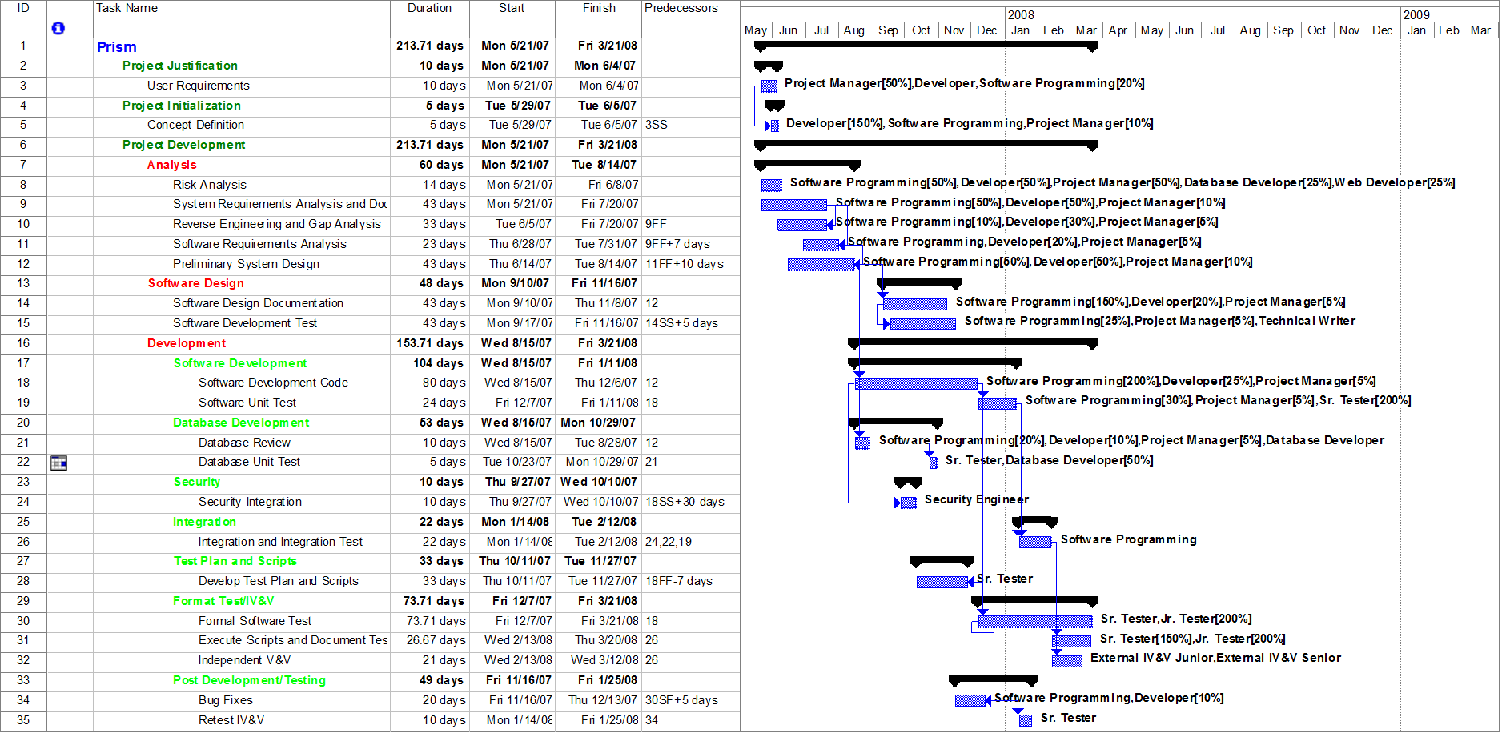
Page 46 of 77

APPENDIX B: AUTISM DESCRIPTION
The following is from Diagnostic and Statistical Manual of Mental Disorders (DSM IV):

- A total of six (or more) items from (A), (B), and (C), with at least two from (A), and one each from (B) and (C) (A) qualitative impairment in social interaction, as manifested by at least two of the following:
1. marked impairments in the use of multiple nonverbal behaviors such as eye-to-eye gaze, facial expression, body posture, and gestures to regulate social interaction 2. failure to develop peer relationships appropriate to developmental level
3. a lack of spontaneous seeking to share enjoyment, interests, or achievements with other people,
(e.g., by a lack of showing, bringing, or pointing out objects of interest to other people)
4. lack of social or emotional reciprocity ( note: in the description, it gives the following as examples:
not actively participating in simple social play or games, preferring solitary activities, or involving others in activities only as tools or "mechanical" aids )
  - qualitative impairments in communication as manifested by at least one of the following:
    - delay in, or total lack of, the development of spoken language (not accompanied by an attempt to compensate through alternative modes of communication such as gesture or mime)
    - in individuals with adequate speech, marked impairment in the ability to initiate or sustain a conversation with others
    - stereotyped and repetitive use of language or idiosyncratic language
    - lack of varied, spontaneous make-believe play or social imitative play appropriate to developmental level
  - restricted repetitive and stereotyped patterns of behavior, interests and activities, as manifested by at least two of the following:
    - encompassing preoccupation with one or more stereotyped and restricted patterns of interest that is abnormal either in intensity or focus
    - apparently inflexible adherence to specific, nonfunctional routines or rituals
    - stereotyped and repetitive motor mannerisms (e.g. hand or finger flapping or twisting, or complex whole-body movements)
    - persistent preoccupation with parts of objects
- Delays or abnormal functioning in at least one of the following areas, with onset prior to age 3 years:
  - social interaction
  - language as used in social communication
  - symbolic or imaginative play
- The disturbance is not better accounted for by Rett's Disorder or Childhood Disintegrative Disorder

APPENDIX C: PROJECT STRENGTHS, WEAKNESSES, OPPORTUNITIES, THREATS

Strengths
- Pearson is a market leader in the educational products and services industry.
- Pearson is the market leader with a 65% market share in student information systems and other services in U.S. school districts.
- Pearson’s experience brings extensive institutional and industry knowledge regarding bringing educational technology products to market.
- Prism will integrate with other Pearson product lines.
- Prism is the only product of its kind that offers Enterprise and ASP models.

Weaknesses
- Pearson does not currently have an installed base of customers for which this product is a direct upgrade.
- Some Prism Personal trial respondents cited navigation concerns and inconsistencies in the terms used to describe behaviors.

Opportunities
- There is not currently a competing product on the market for use district-wide.
- Federal legislation and accountability mandates are driving school districts to digitize data collection and reporting processes.
- Number of diagnosed autistic individuals is growing.
- IDEA requires IEPs for all special needs students; Prism supports IEPs by providing individual performance assessments.
- Current process is labor-intensive requiring double entry of data.

Threats
- Budget cuts that impact state grants and Federal funding can significantly impact a school systems ability to invest in IT solutions.
- Large installations are more difficult to obtain but are more profitable because they require less resources.
- Educational institutions often do not view technology implementations as priorities.

APPENDIX D: FINANCIAL MODEL DETAILS

Summary Detail

The Summary Detail tab of the financials shows the breakdown of each Prism Model for cost, revenue, NPV, MIRR, and Payback. The total of these 3 models is reflected in the final figures in the Executive Summary.

Revenue
Type | Year 0 | Year 1 | Year 2 | Year 3 | Year 4 | Year 5
Personal |  | $ 198,000.00 | $ 401,940.00 | $ 700,686.93 | $ 621,132.95 | $ 756,539.94
Personal License | $ - | $ 198,000.00 | $ 401,940.00 | $ 509,961.38 | $ 621,132.95 | $ 756,539.94
Maintenance/ Upgrade | $ - | $ - | $ - | $ 190,725.55 | $ - | $ -
Enterprise |  | $ 904,200.00 | $ 1,541,884.00 | $ 1,432,978.08 | $ 1,815,745.49 | $ 2,187,990.94
Enterprise 1-500 | $ - | $ 187,500.00 | $ 210,000.00 | $ 235,200.00 | $ 284,497.92 | $ 318,637.67
Maintenance/ Upgrade | $ - | $ 37,500.00 | $ 79,500.00 | $ 126,540.00 | $ 193,562.78 | $ 257,290.32
Training Teacher/Admin | $ - | $ 90,000.00 | $ 105,000.00 | $ 120,000.00 | $ 150,000.00 | $ 195,000.00
On-Site Integration | $ - | $ 60,000.00 | $ 100,000.00 | $ 140,000.00 | $ 160,000.00 | $ 200,000.00
Enterprise 501-1500 | $ - | $ 336,000.00 | $ 376,320.00 | $ 421,478.40 | $ 509,820.27 | $ 570,998.71
Maintenance/ Upgrade | $ - | $ 67,200.00 | $ 142,464.00 | $ 226,759.68 | $ 346,864.51 | $ 461,064.25
Training Teacher/Admin | $ - | $ 60,000.00 | $ 75,000.00 | $ 75,000.00 | $ 105,000.00 | $ 75,000.00
On-Site Integration | $ - | $ 66,000.00 | $ 66,000.00 | $ 88,000.00 | $ 66,000.00 | $ 110,000.00
Enterprise 1501-2400 | $ - | $ - | $ 273,000.00 | $ - | $ - | $ -
Maintenance/ Upgrade | $ - | $ - | $ 54,600.00 | $ - | $ - | $ -
Training Teacher/Admin | $ - | $ - | $ 30,000.00 | $ - | $ - | $ -
On-Site Integration | $ - | $ - | $ 30,000.00 | $ - | $ - | $ -
Enterprise 2400+ | $ - | $ - | $ - | $ - | $ - | $ -
Maintenance/ Upgrade | $ - | $ - | $ - | $ - | $ - | $ -
Training Teacher/Admin | $ - | $ - | $ - | $ - | $ - | $ -
On-Site Integration | $ - | $ - | $ - | $ - | $ - | $ -
ASP |  | $ 697,200.00 | $ 1,169,410.00 | $ 1,822,320.00 | $ 2,496,944.40 | $ 3,033,463.20
ASP 1-100 | $ - | $ 88,000.00 | $ 186,400.00 | $ 282,800.00 | $ 407,376.00 | $ 511,488.00
Installation | $ - | $ - | $ - | $ - | $ - | $ -
ASP 101-250 | $ - | $ 56,700.00 | $ 118,260.00 | $ 182,520.00 | $ 264,578.40 | $ 341,755.20
Installation | $ - | $ - | $ - | $ - | $ - | $ -
Training Teacher/Admin | $ - | $ 210,000.00 | $ 285,000.00 | $ 480,000.00 | $ 705,000.00 | $ 825,000.00
ASP 251-500 | $ - | $ 82,500.00 | $ 173,250.00 | $ 264,000.00 | $ 383,130.00 | $ 481,140.00
Installation | $ - | $ - | $ - | $ - | $ - | $ -
Training Teacher/Admin | $ - | $ 150,000.00 | $ 225,000.00 | $ 285,000.00 | $ 330,000.00 | $ 375,000.00
ASP 501+ | $ - | $ 65,000.00 | $ 136,500.00 | $ 208,000.00 | $ 301,860.00 | $ 379,080.00
Installation | $ - | $ - | $ - | $ - | $ - | $ -
Training Teacher/Admin | $ - | $ 45,000.00 | $ 45,000.00 | $ 120,000.00 | $ 105,000.00 | $ 120,000.00

The Revenue tab shows where the revenues are being generated from within each Prism model in each year.

5 Year Sales Forecast
Type | Year 0 | Year 1 | Year 2 | Year 3 | Year 4 | Year 5 | TOTALS
Personal
Personal License |  | 2,000 | 4,000 | 5,000 | 6,000 | 7,200 | 24,200
Maintenance/ Upgrade |  | 0 | 0 | 9,350 | 0 | 0
Enterprise
Enterprise Up to 500 |  | 2,500 | 2,800 | 3,136 | 3,512 | 3,934 | 15,882
Maintenance/ Upgrade |  | 2,500 | 5,300 | 8,436 | 11,948 | 15,882
Installation |  | 6 | 7 | 8 | 10 | 13
Training Teacher/Admin |  | 6 | 7 | 8 | 10 | 13
On-Site Integration |  | 3 | 5 | 7 | 8 | 10
Enterprise Up to 1500 |  | 4,800 | 5,376 | 6,021 | 6,744 | 7,553 | 30,494
Maintenance/ Upgrade |  | 4,800 | 10,176 | 16,197 | 22,941 | 30,494
Installation |  | 4 | 5 | 5 | 7 | 5
Training Teacher/Admin |  | 4 | 5 | 5 | 7 | 5
On-Site Integration |  | 3 | 3 | 4 | 3 | 5
Enterprise Up to 2400 |  | 0 | 4,200 | 0 | 0 | 0 | 8,400
Maintenance/ Upgrade |  | 0 | 4,200 | 0 | 0 | 0
Installation |  | 0 | 2 | 0 | 0 | 0
Training Teacher/Admin |  | 0 | 2 | 0 | 0 | 0
On-Site Integration |  | 0 | 2 | 0 | 0 | 0
Enterprise 2400+ |  | 0 | 0 | 0 | 0 | 0 | 0
Maintenance/ Upgrade |  | 0 | 0 | 0 | 0 | 0
Installation |  | 0 | 0 | 0 | 0 | 0
Training Teacher/Admin |  | 0 | 0 | 0 | 0 | 0
On-Site Integration |  | 0 | 0 | 0 | 0 | 0
ASP
ASP 1-100 |  | 4,400 | 9,320 | 14,140 | 18,860 | 23,680 | 23,680
Installation |  | 53 | 80 | 97 | 112 | 136 | 136
ASP 101-250 |  | 3,150 | 6,570 | 10,140 | 13,610 | 17,580 | 17,580
Installation |  | 21 | 27 | 42 | 56 | 66 | 66
Training Teacher/Admin |  | 14 | 19 | 32 | 47 | 55 | 55
ASP 251-500 |  | 5,500 | 11,550 | 17,600 | 23,650 | 29,700 | 29,700
Installation |  | 15 | 19 | 22 | 28 | 33 | 33
Training Teacher/Admin |  | 10 | 15 | 19 | 22 | 25 | 25
ASP 501+ |  | 5,000 | 10,500 | 16,000 | 21,500 | 27,000 | 27,000
Installation |  | 5 | 5 | 10 | 8 | 9
Training Teacher/Admin |  | 3 | 3 | 8 | 7 | 8
The 5 Year Sales Forecast is a summary table of all the sales that the Prism team predicts. Prices for Enterprise and ASP vary depending on the number purchased. ASP 1 – 100 indicates the number of licenses sold for installations that contain up to 100 users. The same descriptions are provided for Prism Enterprise. Note that Prism ASP sales are cumulative totals because it is a subscription service. Thus for ASP 1 – 100, (23,680) reflects total license sales across 5 years, Years 1 – 5 must be totaled for Enterprise to determine the total number of Prism licenses sold (15,822). The Prism team anticipates a new release of software in year three, that accounts for the 9300+ maintenance/upgrades in the Personal product line.

Demand Support Data

This tab shows the anticipated annual demand, and feeds the 5 Year Sales Forecast tab. The salient point from this tab is that the Prism team believes that the private schools and families of autistic children will grow at a faster rate then that of the public school sector. The main reason for this is that the public school sector has more requirements on how and what they procure. Private schools typically have more buying freedom and thus the demand will be greater. Parents of autistic children are typically very active in their child’s education and that is why the Prism team believes that the demand will grow at the rate that is predicted.
Page 52 of 77

5 Year Incremental Cost
Summary of Incremental Costs Year 0 Year 1 Year 2 Year 3 Year 4 Year 5
Total ASP Model Costs $ 597,049.84 $ 636,302.68 $ 806,386.58 $ 1,114,005.83 $ 1,058,002.78 $ 1,145,332.43

The Incremental Cost tab shows how the Prism Family of products costs will be allocated to each product. This allocation is calculated as a percentage of the revenue that each Prism model generates. The Prism Personal model will be sold over the web so there will not be any sales commissions generated. The distribution costs will be media generation for third party sales as well as demonstration software for sales and for conferences and trade shows. The software development cost is to take what is existing today and productizing Prism for more than it is designed for today, that of making it Enterprise and ASP capable.

The Help Desk costs are anticipated to be outsourced to cheaper labor markets thus enabling a reduced cost to Prism and Pearson. The predicted growth of Prism will have the Help Desk growing from two years of effort in Year 1 up to 4 years of effort my Year 5.

The 5 work-years of effort in support of Prism anticipated coming from existing staff. The Prism team believes that there will be effort needed from all departments of Pearson Education but that there is adequate staff available to accommodate the additional work.

The Intellectual Property Acquisition has been explained previously and is allocated as a percent of revenue across the Prism models.

The Prism ASP model will require hardware for the hosting and storage of the Prism software as will as the data from the schools. This cost is being minimized by leasing the equipment and storage.

Fixed Cost & Taxes

The Fixed Costs and Taxes tab shows again a rolled up total for all three-product lines as well as the taxes that each product line will incur from the revenue that it has generated.

The evenue per Model portion of this tab is how all the different costs have been allocated throughout the entire financial model.
Page 55 of 77

Prices

The Prices tab is a break down of the price to the customer of each of our services. Two things of note on this tab is the price of each product line and that at year four there will an increase in the price of Prism Enterprise and ASP.

The prices of the product line have been previously stated but for further clarity, Prism Personal is priced to undercut a direct competitor by 10%. Prism Enterprise has no competitor in this market so the price is based on other Pearson Enterprise applications. Lastly, Prism ASP is competitively priced using a like software application that Pearson already produces, that of Work Sampling Online.

In year three, Prism expects to upgrade the Prism Operating System. Since it will be easier to incorporate these changes in Prism Personal they will get the changes first, thus the earlier upgrade charge.

APPENDIX E: INTERNAL PROJECT RISK
Pearson has a strong program for identifying and mitigating risk during the entire project life cycle. Prior to project start up, a Prism Risk Assessment Team will be established and include a project manager, Senior Software developer, Database lead, Hardware lead and a Senior Tester. This team will be responsible for determining potential risk, impact and detection difficulty within their areas of responsibility. Pearson management will clearly layout responsibilities of each team member. This will reduce the risk of missing a vital component during development. A Work Breakdown Structure will identify all functional and technical requirements, and assign a lead and an alternate for each work package. The Prism team will provide regular reports and briefs to Pearson during the entire project lifecycle.

These risks will be stored in a centralized database and re-assessed periodically during the Prism project. The Prism Risk Assessment Team will also validate these findings with relevant experts within the Pearson organization. This independent verification will assure that common risk events have not been overlooked and that relevant risk have been considered. Pearson senior management will be responsible for notifying the Prism team of potential risks to the program occurring as a result of events within the Pearson organization.

Risk Identification and Assessment
The risk analysis for the Prism project includes management, operational and technical risks to project outcomes and variables. In order to identify the risks that are associated with the Prism project, the Prism Risk Assessment Team compiled historical data from similar projects. The table below is a collection of initial risks, the Prism Risk Assessment Team will conduct thorough risk identification and validation prior to the start of the project.

For this initial risk assessment, a qualitative methodology was employed as follows:

- Impact – Each potential risk is assigned an impact value from 1 to 5. A score of 1 indicates the impact of the risk occurring will cause little to no harm in terms of schedule, cost, revenue or profit. A score of 5 indicates severe impact on the project. • Probability - Each potential risk is assigned an probability value from 1 to 5. A score of 1 indicates the probability of the risk occurring is low, a score of 5 indicates the risk is almost certain to occur.
- Detection - Each potential risk is assigned an detection value from 1 to 5. A score of 1 indicates the risk will be highly detectable (prior to causing impact), a score of 5 indicates the risk will almost certainly be undetectable, or will be detectable only after causing a negative impact.
- Risk Value – The final risk value takes impact, probability and detection into consideration. The overall risk value was determined as follows:
Impact X Probability X Detection = Risk Value

Appendix E: Qualitative Risk Assessment Table

Risk Transfer
The Prism team is reducing overall project risk by transferring risk to an outsourced service provider (who will provide the infrastructure for Prism ASP). Prism will execute Service Level Agreements with the outsource provider to ensure contractual obligations are in place in order to protect Pearson’s interests. Prism ASP hardware and underlying network infrastructure will be provided by the outsource provider, thus all of the inherit risk associated with internet attacks, virus, data integrity, bandwidth, and backup is the responsibility of the provider. This arrangement also allows Prism to focus on the core business instead of the latest Internet attacks, hardware upgrades, and software patches.

Risk Prioritization and Mitigation
The table below prioritizes the risk based on the total risk score and provides a mitigation strategy. This list will be expanded as risks expand, and communicated with Pearson Senior Management and other stakeholders as appropriate.

Appendix E: Risk Prioritization and Mitigation

APPENDIX F: PRODUCT DEVELOPMENT

Software Architecture
The Prism Software is made up of a collection of shareware programs to maintain a lower cost of production that is passed on to the end user. School systems across the country cannot afford the large licensing fees that are required for similar product types. This by far does not degrade the capabilities of the software. The available products currently accessible with open license are more than adequate to handle the product volume and complexity. The Prism software application will be built using Java as the primary source code. This web browser application framework interfaces with the other applications. Java will make queries to the database and the report generator as needed. This means that the current prototype software application will be converted and enhance to breach all three product models. Each of the applications was chosen carefully due to their expandability, breadth of scope and relative low costs. This will require that the Prism architecture migrate all data and applications to a set of new tools.

The software support application build is based on the following toolsets:
- MySQL Enterprise Server 5.0 software is an open source database that is currently being used in over 10 Million applications. It has grown in popularity due to its fast performance and reliability.
- Apache 2.2 is HTTP server software that provides a commercial quality application that is capable of hosting the Prism ASP product line and Web interface. Apache product line is tightly regulated by the Apache HTTP Project Management Committee. It is Apache desire to provide software that is free for use by everyone.
- Apache Tomcat 6.0.10 application is an open source product that is the servlet container that is used in the official Reference Implementation for the Java serlet and Java Server pages technologies.
- Java Platform, Enterprise Edition version 5.0 is the current standard used in commercial environment to develop server Java applications. Java Enterprise Edition is the industry standard for developing transferable and secure Java applications for web services, component model, management, and communications that can allows us to grow.
- Business Intelligence and Reporting Tools (BIRT) is a robust reporting tool is adaptive to the Java Enterprise Edition. BIRT creates detailed integrated reports from the MySQL database. It is user friendly and can be utilized by the end consumer.

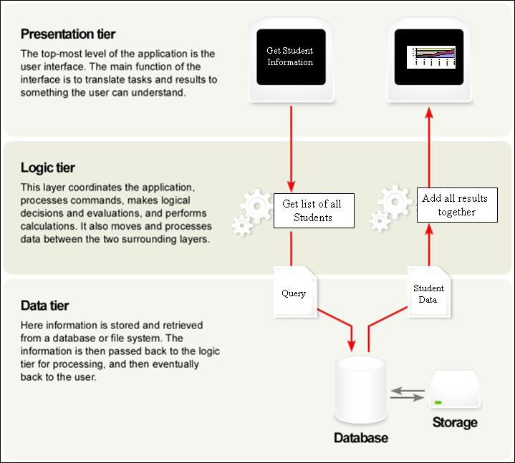

Appendix F: Prism Software Architecture

Software Development
The development of the software will be tightly controlled through the Pearson IT processes that have been the established guidelines. Pearson has collected invaluable real environment experience with the beta testing of the trial version. Researchers collected countless data and recommended refinement to the final software requirements. This has given the Prism team the confidence to be assured that the requirements gathering process is at a greater level than ordinary software developments.

The Prism project will use the waterfall approach to the development of the Prism product line. The Prism Software will be subjected to individual unit testing and control gates that will verify that the project remains in scope.

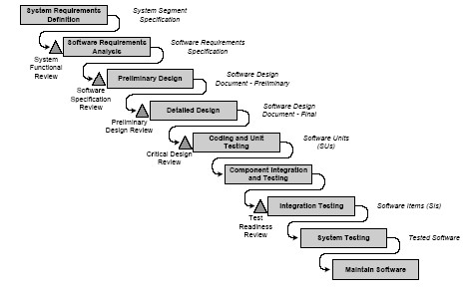

Appendix F: Waterfall Software Development Model

A detailed software development schedule was created to provide a comprehensive step-bystep process that will be required to build the Prism product line (Appendix A). Each area of development is covered from the development of user requirements and carried through to the project implementation. The estimated duration of the overall project is 214 man days and will be completed on 3/21/08. The projected start date is May 21, 2007 subsequent to Pearson board acceptance. The schedule is flexible and significant lag time has been incorporated. This will still provide adequate time to deliver prior to the fall 2008 school year.

Every effort has been made to calculate all known and unknown risks within the schedule.
It is the team’s intention to deliver the Prism product line ahead of schedule and under budget. The team will leverage lessons learned from Pearson’s experiences with similar software development projects and deployment as a base model. The team expanded beyond the model with Prism’s prototype version which has been tested in an environment similar to the target market.

Information Assurance
The Prism team recognizes the potential sensitivity of the type of data that Prism products collect and store. Due to the potential nationwide deployment of Prism, the Prism team will follow Federal guidance regarding information assurance regulations and guidance, including the National Institute of Technology (NIST) Special Publications (800 series). These publications are published on NIST’s website at http://csrc.nist.gov/publications/nistpubs/. This robust information assurance program is outlined in The table below, and will be required for all outsource partners (ASP model) via contractual arrangement.
Appendix F: Prism Information Assurance

APPENDIX G: ASP HOSTED ARCHITECTURE DIAGRAM
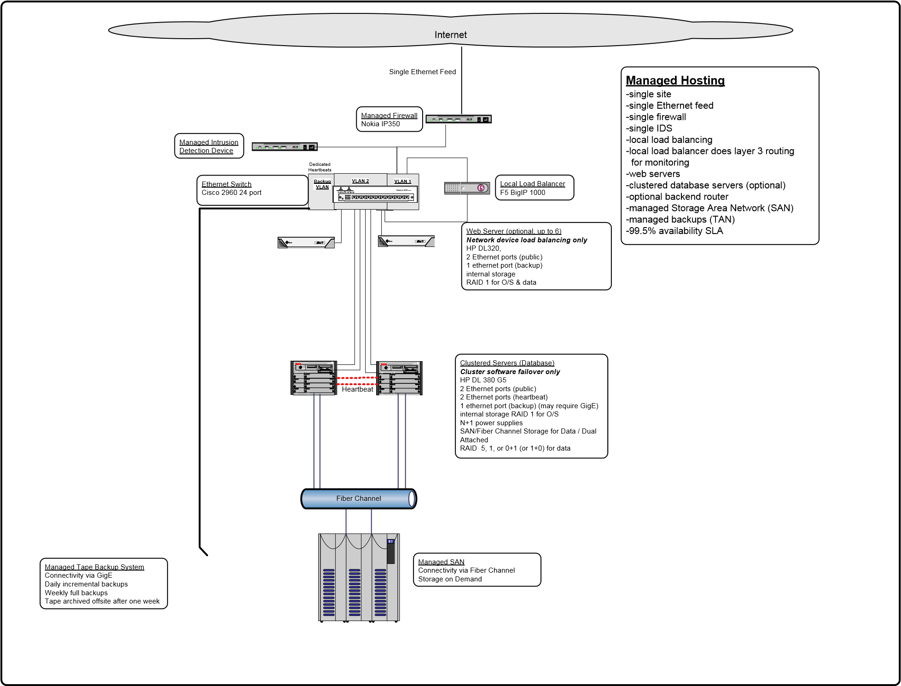

APPENDIX H: SURVEY QUESTIONS AND RESULTS

- How many special needs students are you responsible for per year?

1 Student | 21.40%
2-3 Students | 14.30%
4-7 Students | 50.00%
8-12 Students | 7.10%
13-16 Students
17-24 Students
25+ Students

- How many discrete behaviors do you collect per student (average)?

1 Behavior
2-5 Behaviors | 7.10%
6-10 Behaviors
11-15 Behaviors | 21.40%
16-20 Behaviors | 14.30%
21-25 Behaviors | 28.60%
26-30 Behaviors | 14.30%
30+ Behaviors | 7.10%

- How long does it take to record a behavior per student per day (average)?

1-5 Seconds | 50.00%
6-10 Seconds | 14.30%
11-15 Seconds | 7.10%
16-20 Seconds
21+ Seconds | 7.10%

- Do you compile, graph or otherwise analyze the data you collect?

Yes | 78.60%
No | 7.10%

- What time savings would you consider beneficial in the collection, analysis, and display of data?

  - Any
  - Possibly having a program to graph on the computer rather than by hand
  - Database to input data and automatically graph
  - Not having to use a pencil and paper
  - Any time savings
  - Saving time graphing would be beneficial
  - Having a computerized graphing program would greatly speed up things. Also, it would allow me to do more with the data when analyzing it
  - I would find it beneficial if there was a more systematic way to analyze data that is user friendly, and that anyone can use regardless of their experience
  - Any simple way to transfer data into the computer to receive percentages and to view increases/decreases
  - Behavior Analysis (adding up each student’s daily totals per behavior per day) Discrete Trial Analysis (averaging daily trial percentages)
  - Real time data would be helpful

- I am currently able to graphically represent and compare student behavioral data.

Strongly Agree | 46.20%
Agree | 23.10%
Somewhat Agree
Neutral
Somewhat Disagree | 15.40%
Disagree | 7.70%

- Automation of the collection, compilation and analysis of this data would be helpful to me.

Strongly Agree | 50.00%
Agree | 16.70%
Somewhat Agree | 16.70%
Neutral | 16.70%
Somewhat Disagree
Disagree
Strongly Disagree

- What features would be helpful in an electronic device for the collection, analysis and display of Discrete Trial or Probe data?

  - Ease of graphing
  - Graphing on the computer but collection is easiest on paper for me
  - Include prompt level choices, latency periods
  - Something to enter data into, once collected that will graph it on the computer
  - Being able to input the questions asked and type of answer (i.e. is it open ended / yes or no / etc) automatic graphing, while being able to adjust the graph or add in footnotes being able to see data over at least 6 months
  - Small, portable, and it can be customized for each child's programs. Then compatible to Macs and PC for transfer of data and graphing templates built in to ease the process
  - I feel that it is essential that it is user-friendly
  - Time efficient way to transfer data, there’s no point if it takes more time to transfer the data into the system than doing what we are doing now
  - Graphing of discrete trial sessions, averages of specified sessions/trials • Real time data collection

- Would you be willing to participate in an interview or focus group pertaining to this topic? If so, please include a means for us to contact you.

87.5% of the respondents indicated that they would be willing.

APPENDIX I: PRIMARY AND SECONDARY RESEARCH

Primary Research
Primary research was conducted by the Prism team via surveys and interviews with education professionals. Surveys were conducted independently of interviews (different sample groups) so as not to influence results. The following institutions were contacted and indicated a desire to participate and are believed to be the major suppliers of survey information:

- The New England Center for Children, Southborough, Massachusetts
- The Matthews Center, Manassas, Virginia
- The Virginia Institute of Autism, Charlottesville, Virginia
- Marana Unified School District, Marana, Arizona

The full set of survey questions and the aggregate responses are available in Appendix H. The survey results indicate that the majority of professionals are responsible for 4 to 7 students, collect approximately 21 to 30 discrete behaviors are collected per student, and spend between 1 and 5 seconds recording these behaviors. 78% of the respondents also graph these behaviors, and approximately 84% of respondents agreed that the automation of this process would be helpful. The overall analysis of the results indicates that respondents view time savings in the graphing of trial behaviors as Prism’s greatest potential benefit. For example, a teacher with 6 students collecting 25 behaviors could have a time savings of as much as 99.96% per day using Prism. In summary, more than three-quarters of the teacher’s could benefit from increased productivity thus allowing them to spend more time working on mediation techniques with their students.

Interviews conducted with teachers indicated that improved efficiency in data collection and analysis would provide additional time that could be used to prepare more effective IEP’s for their students. Other desired features and benefits mentioned during interviews included:

- Technology reduces recording and graphing errors that can occur with manual processes,
- Archiving of data, and;
- Analysis of multiple trial sessions.

All these requests are attainable with Prism. The common thread during the interviews was that teachers need to have timely and accurate information on each student; Prism delivers just that.

Secondary Research
The Prism team analyzed a report by the Texas Youth Autism Project. The report stated that a significant amount of behavior therapists time is required to collect and analyze data, thus reducing time available for therapy. New technologies and software, like Prism, will allow for data collection using PDA’s and data analysis reports through personal computers. The study examined actual time required for each method, PDA vs. pen and paper, for children with autism enrolled in a center-based discrete trial behavioral intervention program.

The results of this study showed that in addition to the analysis and graphing being more efficient; therapist increased the gathering of data by 36%. Some of the other findings include:
- Creating progress reports was also found to require less time using PDA data then pen and paper recording
- Implications for this research are that behavioral therapists would be able to spend less time recording data, and more time engaging with their client, and
- Results confirm the hypothesis that the learning curve for PDA data collection was steeper, however, over time therapists become very efficient in data collection

These two factors combined show a true time reduction for the gathering, analyzing, and displaying of data. Prism is the tool that makes this possible.

APPENDIX J: PRODUCT TRIALS
Prism Personal is in existence and has begun trials as documented in “Kellar Institute Handheld Data System” attached as Appendix L. As previously mentioned, this proposal was developed in partnership with George Mason University and the Keller Institute. To date two phases of product trials have been conducted, and are summarized below.

Phase 1: Alpha Testing
The study encompassed four steps: training video, discrete trial session, questionnaire, and interview. Eight individuals were tested, four parents of children with special needs and four teachers of children with special needs. All individuals had experience and prior exposure to one-on-one discrete trial work and a variety of types of data collection.

The results showed that seventy-five percent of the participants felt the system was very easy for making educational decisions. Seventy-five percent also felt the system was easy to navigate.

Comments ranged from “…to have the information instantaneously is very helpful” to “…it was just right there and was very clear.” While the overall tone of the results was positive, some testers had concerns about navigation term clarification.

Phase 1: Beta Testing
It is important to note that all interventions used during this study were part of the curriculum for Growing: Ready and Emerging Abilities for Tomorrow (GREAT) program. Instead of paper/pencil results, the use of the Prism Personal prototype led to more effective collection of data and analysis of student performance.

Two groups of participants were included in this phase. The first group encompassed seventeen GREAT students. The GREAT Program is designed for young adults with intellectual disabilities such as significant learning disabilities, cognitive disabilities including mental retardation and developmental disabilities such as Autism (students’ intellectual disabilities might also be accompanied by physical/sensory disabilities). The second group consisted of eight GREAT instructors.

Data were collected on each student participant across each data type. Baseline data was collected for one session before intervention. Interventions include a variety of teaching strategies ranging from direct teaching to modeling. The treatment phase ranged from one to ten sessions depending on the student’s mastery level of the task and maintenance phase data were collected thereafter until the two-week data collection period was completed. The researcher was available at all sessions to maintain consistency and fidelity of the data collection.

The study encompassed six steps:
- Training session for instructors on usage of the Prism Personal prototype,
- A goal development session for each instructor to decide on what skill, intervention and data type to be collected,
- A brief introduction to the students,
- Data collection sessions using the Prism Personal prototype for a period of 2 weeks, 5. A Likert scale questionnaire for both students and instructors and
6. A five to ten minute video-taped interview for all participants.

Results improved over the Alpha Testing with 85% of the participants reporting the system was very easy for making educational decisions; and 95% stating that the system was easy to navigate. Most of the interview responses referred to “ease of use” and “graphing”.
The comments ranged from “…it was easy to collect data.” to “…to have the information graph is very beneficial.” While the majority of participants were positive about the system, the areas of revision were similar to the Alpha testing and identified as navigation concerns and term clarification.

Phase 2: Prism Pilot
This phase is integrating the No Child Left Behind Act provisions of implementing and documenting student improvement on IEP goals through data collection and analysis. The performance data that Prism generates will serve as a type of performance metric and thus contribute to documenting student improvement.

The Green School of MD, was chosen in part because of their rigorous, on-going data collection procedures to provide an environment where employees are already skilled data collectors; thus eliminating that variable from the trial. The Green School serves students ages 4-21 with specific learning disabilities, mental retardation, speech/language impairment, other health impairments, multiple disabilities, and Autism in the greater Washington metropolitan area. It receives public and private funding and uses a consultative model to provide an individual education program for each student.

The Green School Autism Program serves 43 students in 6-7 classrooms at a 1:1 or 1:2 teacher to student ratio. Individualized education programs with a focus on functional life skills are developed following ABA methodology. Teachers collect and chart data daily.

All participants are parents, teachers, and students from Green. Twenty participants will be students between the ages of 7 and 19 with a diagnosis of Autism. The parents of four students will be solicited to participate in order to test Prism Personal in home environments. Since home environments vary, the parents will not necessarily be parents of those students participating in the school-based portion of the study. Ten teachers will collect data on students using Prism Personal.

APPENDIX K: APPLIED BEHAVIORAL ANALYSIS PAPER FORMS

ABA General Acquisition Data Sheet
Instructions: In the spaces under the programs, write the specific target items. Beside the target item under the specific date write either a (+) sign for an independent correct response or a (-) sign for an incorrect or no response. See example below.

Frequency of Reinforcement Per School Day

Student’s Name _______________________ School _________________________

Observer’s Name _____________________ Date __________________________

*Record a tally every time reinforcement is given to student across the school day

Probe Data Sheet

Student: _____________________________ Objective/Goal:
________________________________

Skill Area: ___________________________ Mastery Criteria:
_______________________________

Page 75 of 77

Multi-Purpose Data Sheet
Can be used for FFC, multiple exemplars of properties/actions/relations, and generalization.

Student: ____________________ Objective/Goal:
_______________________
Skill Area: _______________________ Mastery Criteria:
___________________________

Page 76 of 77

ACKNOWLEDGEMENTS
The Prism team would like to acknowledge the following individuals for their expertise, consultation, guidance and real world experience.
Cheryl Temple | Fairfax County Public Schools
Christine Pak | Fairfax County Public Schools
David Grossman | Technology Transfer Office, George Mason University
Heidi Graff | Kellar Institute of Human Disabilities, George Mason University
J. P. Auffret | George Mason University
Jeff Matsuura | Alliance Law Group
Jennifer Albert | Hunton Williams
Jennifer Murphy | Technology Transfer Office, George Mason University
Karen Hallows | George Mason University
Laurie Heilman | Matthews Center for Visual Learning
Lucas Samaras | Booz Allen Hamilton
Marybeth Fraser | Fraser Consulting
Michael Behrman | Kellar Institute of Human Disabilities, George Mason University
Michael McKee | Virginia Institute of Autism
Scott Knapp | Qwest Communications
Shawn Firth | Robbins Gioia
Shuangbao Wang | Kellar Institute of Human Disabilities, George Mason University

Page 77 of 77

Based on prevalence statistics from the National Institutes of Health (2004) and the Centers for Disease Control and Prevention (2001).
http://www.dds.ca.gov/autism/pdf/AutismReport2003.pdf
http://www.pearson.com/index.cfm?pageid=11
Appendix B contains the diagnostic criteria for Autism.
http://www.autism-society.org/site/PageServer?pagename=about_whatis_characteristics
http://www.ed.gov/nclb/overview/intro/reauth/index.html ⁷ http://www.ed.gov/about/overview/budget/budget08/factsheet.html?
http://www.aeiou.org.au/autism-early-intervention
Fairfax County Public Schools: http://www.fcps.edu/ss/ABA/FAQs.htm
Cambridge Center for Behavioral Studies: http://www.behavior.org/autism/
http://www.fcw.com/article95178-07-10-06-Print
Ibid.
Ibid.
http://www.input.com/corp/press/detail.cfm?news=1066
http://nces.ed.gov/programs/digest/d05/tables/dt05_084.asp
http://www.capenet.org/facts.html
http://pubdb3.census.gov/macro/032006/hhinc/toc.htm
Based on prevalence statistics from the National Institutes of Health (2004) and the Centers for Disease Control and Prevention (2001).
Based on the autism prevalence rate of 2 to 6 per 1,000 (Centers for Disease Control and Prevention, 2001) and 2000 U.S. Census figure of 280 million Americans.
http://www.dds.ca.gov/autism/pdf/AutismReport2003.pdf
http://www.taap.info/epidemic.asp
www.worksamplingonline.com
http://www.postcardmania.com/postcards_standard.asp
www.iab.net
http://www.noldus.com/site/doc200401012
http://www.mobilethinking.com/dtm/
http://store.sunburst.com/Company.aspx
http://www.learnerprofile.com/
http://www.manta.com/comsite5/bin/pddnb_company.pl?pdlanding=1&referid=4490&id=gms4rh
http://tomcat.apache.org/
http://www.stsc.hill.af.mil/resources/tech_docs/gsam4/chap2.pdf
A reduction from 750 seconds (6 students X 5 seconds per behavior X 25 behaviors) to .5 seconds with Prism.
Electronic versus Traditional Data Collection Procedures in a Behavioral Program for Children with Autism http://www.mobilethinking.com/dtm/downloads/Texas_Young_Autism_Project.pdf

