Technology Adoption and Usage of a Data Collection Tool in a School Setting Servicing Students with Autism: A Qualitative Look at the Process and Perspectives
A dissertation submitted in partial fulfillment of the requirements for the degree of Doctor of Philosophy at George Mason University

By

Heidi J. Graff Bachelor of Science
State University of New York, College at Cortland, 1986 Masters of Library Science
Long Island University, Palmer School of Library and Information Science, 1987

Director: Michael M. Behrmann, Ed.D. Kellar Professor of Special Education Graduate School of Education

Spring Semester 2007 George Mason University Fairfax, VA

UMI Number: 3255791

Copyright 2007 by Graff, Heidi J.

All rights reserved.

INFORMATION TO USERS

The quality of this reproduction is dependent upon the quality of the copy submitted. Broken or indistinct print, colored or poor quality illustrations and photographs, print bleed-through, substandard margins, and improper alignment can adversely affect reproduction.
In the unlikely event that the author did not send a complete manuscript and there are missing pages, these will be noted. Also, if unauthorized copyright material had to be removed, a note will indicate the deletion.

UMI
®

UMI Microform 3255791
Copyright 2007 by ProQuest Information and Learning Company. All rights reserved. This microform edition is protected against unauthorized copying under Title 17, United States Code.

ProQuest Information and Learning Company 300 North Zeeb Road
P.O. Box 1346
Ann Arbor, Ml 48106-1346

11

Copyright 2007 Heidi J. Graff All Rights Reserved

TECHNOLOGY ADOPTION AND USAGE OF A DATA COLLECTION TOOL IN A SCHOOL SETTING SERVICING STUDENTS WITH AUTISM: A QUALITATIVE LOOK AT THE PROCESS AND PERSPECTIVES

by

Heidi J. Graff A Dissertation Submitted to the Graduate Faculty
of
George Mason University in Partial Fulfillment of
the Requirements for the Degree of
Doctor of Philosophy in Education


Committee:
/

Chair

Program Director

�L�--
Dean, College of Education and Human Development


Date: Spring Semester 2007
George Mason University Fairfax, VA

DEDICATION

This is dedicated to my loving partner, Sarah, my wonderful children JB and Jessica, our dog Brandy, our bunny Cyrus, and a twinkle in our hearts. In loving memory of Grandma Belle who was so happy to know the process had begun and for her joy of learning. In loving memory of Abby and Clancy, may their noses still wiggle and their feet still hop in heaven.

ACKNOWLEDGEMENTS

I would like to thank my dissertation committee for their strong leadership and guidance during this journey. Dr. Margo Mastropieri, your cheerleading and assurance that I can work a 25 hour day almost made it possible. Dr. Judith Fontana thank you for letting me walk in your shoes and showing me that there is light at the end of the tunnel.
Dr. Michael Behrmann from my first confusion at Immersion to a parking lesson in Maine, you have remained steadfast in your belief that student learning comes first. I will always be grateful for your "big picture" thinking as you have provided me with diverse, rich, experiences. I will never forget doc student meetings where I got a first hand look at the true higher education perspective. I feel greatly blessed and enriched by knowing each of you.

A huge thanks goes to the KIHd System Steppingstones research team, especially
Dr. Yoosun Chung and Dr. Shuangbao Wang who feels that I can do anything because he knows it is "easy." I would graciously also like to thank all the wonderful people who work at the Kellar Institute for Human disAbilities. I would like to acknowledge my friend, Sheri Berkeley for her excellent APA editorship, and her belief that we would make it through together. A special thanks to Janey Templeton for somehow always finding appointment times even when the calendar was full. A warm thanks goes out to the site, their administrators, teachers, technical staff, and their students. Their willingness to participate and ability to "persevere" with happy smiles made my job a lot easier.

I would be remiss if I also did not acknowledge my family. Sarah without your love and constant support, I long ago would have lost faith. For JB because all things that begin in love are possible. For Jessica who continues to show me the true joy of learning. To a twinkle in our hearts for reminding me to always look to the sky in hope. And to my faithful sleepy dog Brandy who kept me company while I typed away in the study. I need to hug and thank my Mom and Dad who made sure I went in the right direction by always placing an emphasis on education. To my sister, Mindi and her family, and for my brother, Howard and his loving partner Michael, thank you for teaching me to keep trying. I would like to thank my Tanta Barbara for showing me the path. Not to be forgotten and for being so wonderful and caring throughout this process are Ramsey and Nathaniel. To Jim and Carolyn, thank you for your unwavering confidence that I would finish and your kind words of encouragement.

TABLE OF CONTENTS
Page Abstract. ix
- Introduction 1
Statement of Problem 1
Background of Problem 2
Purpose of the Study 7
Research Questions 8
Definition of Terms 9
- Literature Review 11
Introduction to Autism 12
Perspectives 14
Autism Interventions 16
Behavioral Interventions 21
Data collection 29
Innovation Adoption 33
Technology Usage 35
KIHd System 36
Pilot Study 41
Current Study 54
- Methodology 56
Design 57
Method 58
Procedures 81
Data Analysis 82
Validity 84
Limitations 88
- Research Findings 89
Data Analysis 89
Training 98
Technology Usage 106
Data Collection 114
School Culture 124
Summary 133
- Conclusions 136
Overview 137
An Evolving Experiential Research Base for the KIHd System 140
Summary of Results 144

Discussion of Findings 153
Comparison of Findings 161
Implications and Future Research 163
Limitations 164
Conclusions 165
List of References 167
Appendix A 192
Appendix B 194
Appendix C 195
Appendix D 196
Appendix E 197
Appendix F 199
Appendix G 200
Appendix H 202
Appendix I 203
Curriculum Vitae 204

LIST OF TABLES

Table Page
- Intervention Approaches 18
- Research Team Demographics 63
- Timeline 79
- Mini-Interview and Training Topics 81
- Researcher Memo Examples 84
- Note Categories 90
- NVivo Codes 92
- Researcher Memo Highlights 93
- Participant Demographics 97
- Discrete Trial Training with the KIHd System 118

LIST OF FIGURES

Figures Page
- Pilot Concept Map 47
- Likert Scale Questionnaire 65
- Teacher Feedback Form 66
- Demographic Questions 67
- Fidelity Sheet 69
- Administrative Page 71
- Parameter Page 72
- Task Page 73
- Graph Page for Computer 74
- PDA Data Collection Screens 1-3 75
- PDA Data Collection Screens 4-6 76
- Data Collection Screens 7-9 78
- Triangulation of Data Sources 87
- Current Study Concept Map 94
- Participant Organizational Map 96
- Findings Teacher Feedback Form 98
- Findings Likert Scale Questionnaire 107
- Map of room 360 116
- PDA Graph for Session 119
- Administration Personas 125
- Teacher Personas 126
- Technical Support Staff 131
- Influence of innovation Venn diagram 134 & 138

ABSTRACT

TECHNOLOGY ADOPTION AND USAGE OF A DATA COLLECTION TOOL IN A SCHOOL SETTING SERVICING STUDENTS WITH AUTISM: A QUALITATIVE LOOK AT THE PROCESS AND PERSPECTIVES

Heidi J. Graff, PhD

George Mason University, 2007

Dissertation Director: Dr. Michael M. Behrmann

This study was part of a Phase II, U.S. Department of Education, Steppingstones of Technology Grant (CFDA 84.327A, Steppingstones of Technology, Innovations for Students with Disabilties/H327A060031). Using a qualitative research methodology, teacher perspectives were examined for a twenty week period within an educational setting during the adoption process of the KIHd System, a data collection and analysis technology tool. Through the process of technology adoption the perceptions of the participants in the areas of training, technology usage, data collection, and school culture were discovered via the data sources of interviews, questionnaires, meeting notes, e-mails, and observations. In addition, thoughts about how the new technology fit into the classroom for daily data collection on students with Autism were explored. The research questions emphasized major areas: training, technology, data collection, and school culture. Under the heading of training, the research questions were: (1) What are the attitudes of the teachers about the training received on the KIHd System technology?; and
(2) What types of training and support do teachers need to use KIHd System technology in the classroom? With the area of technology, the research questions were: (1) What are

teacher perceptions of the KIHd System technology in regard to the beginning adoption process of this innovation?; and (2) What are the characteristics of a teacher who uses KIHd System technology? Under the section of data collection, the research questions were: (1) How does the KIHd System technology fit into a classroom servicing students with Autism?; and (2) How are discrete trial training sessions described using the KIHd System technology? With the heading of school culture, the research questions were: (1) What are the perspectives of administrators and technical support staff in regard to the beginning adoption process of this innovation?; (2) What are the dynamic roles of administrators, technical support staff, and teachers in the process of technology adoption? The results provided new ways to think about the amount and type of training support needed to sustain technology adoption and usage; data collection with student with Autism; and the dynamic relationships between teacher, administers, and technical staff.

- Introduction

Motivation for technology adoption and usage comes from an understanding or belief that a product will ultimately be worth the time and energy expended to be beneficial. When looking at the factors that influence the process of innovation adoption within an educational setting, teacher's perceptions become of paramount importance.
This study explored those perceptions during the implementation of an innovative data collection tool for students with Autism. Specifically, by focusing on the procedures and support needed for the adoption of the Kellar Instructional Handheld data (KIHd) System.
Statement of the Problem

For many students, including those with the disability of Autism, teachers need to keep careful records of students' daily progress in order to provide adequate instruction. Therefore, data collection and the subsequent visual analysis of that data are paramount for teachers who provide intervention to students with Autism. Some schools collect the data, yet do not chart the information. This often happens because the current practice of using graph paper and a pencil is very cumbersome and time consuming. Other schools demand their teacher complete this rigorous task of hand charting daily resulting in less time for other classroom preparation. Even when graphing is completed, often it doesn't happen until the end of the week, or month, and this seriously impedes an educator's ability to make evidence-based decisions on a lesson. New technology now allows the

1

data to be entered and charted simultaneously. However, with this new break through, there are new areas of concern that need to be scrutinized. This current study investigated teacher perspectives within an educational setting during the adoption process of a data collection technology tool, the training needed for implementation, and how the tool fits into the classroom for daily data collection on their students with Autism.
Background of the Problem

According to the Diagnostic and Statistical Manual of Mental Disorders (American Psychiatric Association, 1994), Autism is one of several Pervasive Developmental Disorders (PDDs) that are caused by a dysfunction of the central nervous system leading to disordered development. All children with PDD are characterized by qualitative impairments in social interaction, imaginative activity, and both verbal and nonverbal communication skills (American Psychiatric Association, 1994). Historically, 50-75% of individuals with Autism also have some degree of mental retardation (Freeman, 1997; Rapin, 1997).
The reported prevalence of Autism has increased dramatically over the past 20 to 30 years. In the 1970s, the reported prevalence was considered to be approximately 1 in 2,500 births. Recent studies found that the prevalence of Autism may range between 1 in 1000 births (Fombonne, 2003) or, as much as, 1 in 150 (Centers for Disease Control and Prevention, 2007). According to the Autism Society of America (n.d.), Autism is the
fastest-growing developmental disability with 10-17% annual growth. In some states, the

number of identified Autism cases has increased at an astounding rate. For example, in the state of Virginia, the number of school children with Autism has increased from 571 in 1991 to 3,533 in 2003 and the state of Maryland reported the increase of the number of

school children with Autism from 28 in 1991 to 3,536 in 2003 (FightingAutism, 2004). An increase in the prevalence of Autism necessitated research of effective instructional strategies, which resulted in the implementation of a variety of teaching methods for students with Autism including Applied Behavioral Analysis (ABA) services. ABA is the systematic application of behavioral principles to significantly change behavior and a research tool to enable users to verify the functional relationship between a behavior and an intervention (Alberto & Troutman, 2006).
According to Peterson (2000), the educational system fails to meet the needs of children with Autism due to the insufficient number of schools offering ABA services because of the difficulty of data collection and analysis. Powers (1992) described the importance of carefully planned, individualized, systematic instruction based on the principles of ABA. It is important to make data-based decisions regarding teaching programs to permit responsive modifications of instructional strategies based upon the data (Kabot, Masi, & Segal, 2003).
ABA is grounded in data-based decision making. Assessment driven instruction promotes accountability at federal, state, and local levels. It is supported by the No Child Left Behind Act (NCLB, 2001), the Individuals with Disabilities Education Improvement Act (IDEIA, 2004), and the Council for Exceptional Children (Stanford & Reeves, 2005). In addition to legal requirements, assessment strengthens educational decision making by: (a) promoting objective decisions, (b) revealing incremental improvements and/or stagnated progress (Janney & Snell, 2000), and (c) predicting future progress (McLean, Wolery, & Bailey, 2004; Odom & Wolery, 2003). Effective use of assessment data involves summaries, graphs, and rule-based decisions (McLean et al., 2004). Graphic

representations assist with this process (Snell & Brown, 2006) and their visual format promotes communication between parents, teachers, and other school personnel (Deno, 2003). Data collection systems need to be simple, efficient, and user-friendly (Meyer & Janney, 1989); in addition, they need to be socially appropriate (Test & Spooner, 1996). Research has shown that on-going monitoring of student progress generates more appropriate decisions regarding instruction (Deno, 2003; Farlow & Snell, 1989; Fuchs, Fuchs, & Hamlett, 1993), and consequently, greater outcomes for students with disabilities (Todman & Dugard, 2001), such as increased employment and enhanced quality of life for individuals with disabilities.
Despite the demonstrated importance of data collection and analysis, they are not always used appropriately to guide instruction. Farlow and Snell (1989) found teachers were more likely to analyze raw data. Another study found teachers tended to place less emphasis on the data they graphed when making instructional decisions, focusing more on training data than probe data (Grigg, Snell, & Lloyd 1989). In addition, teachers report that it is difficult to manage data collection (Farlow & Snell, 1994). With the emphasis on inclusion and increased student caseloads, time constraints have become more pronounced (Deno, 2003). Teachers struggle to find a balance between teaching and data collection (McLean et al., 2004). Consequently, special education teachers are relying more on paraprofessionals who have little or no training in data collection (Causton-Theoharis & Malmgren, 2005; Broer, Doyle, & Giangreco, 2005; Moshoyannis, Pickett, & Granick, 1999). Furthermore, special education positions are often staffed with personnel holding alternative and emergency certificates, who may lack training in data collection and analysis (Katsiyannis, Zhang, & Conroy, 2003; Miller, Brownell, & Smith,

1999). The barriers to data collection and analysis are concentrated around issues of management, time, and skill (Sandall, Schwartz, & Lacroix, 2004). Consequently, there is a need for technology based data collection alternatives to promote efficient and effective data collection and instructional decisions (Fuchs, 2004).
Advancement of Knowledge and Theory

Wireless technology as discussed at the American Society for Engineering Education Conference of 2003 (Choudhury, Ramrattan, & Butt, 2003), has the potential to improve analysis and feedback due to the capacity to transfer data in real time. The use of a PDA and "live" data allows for an interactive process that can have immediate consequences for analysis. As seen in practice at nationally known aircraft industry, Locke Manufacturing Company, technology infused data collection improved analysis with better control and faster access to data (Taylor, 1993). A similar cost efficient result was observed at Law Engineering Incorporated (Woods & Krasno, 1994). In the field of medicine, technology and data feedback have become an invaluable source of patient information leading to better patient care (Dorr, Wilcox, Donnelly, Bums, & Clayton, 2005; Hart, Hawkey, & Whyte, 2002; Meadows, 2003; Merbitz, et al., 1992; Young et al., 2005). Following in the footsteps of this empirically-based, medical model, education has turned to the use of technology to improve student learning, particularly in the area of special education.
The ability to statically demonstrate effectiveness of interventions using the
advancement of current technology tools makes this an exciting era in research. It is the foundation of efforts at early intervening services such as the Regular Education Initiative (REI) which are designed to keep children learning in the general curriculum

(Kleinhammer-Tramill, 2003). More than ever before, legislative mandates make the responsibility of showing progress a necessity. The NCLB (2001) demand for accountability and maximum access to the general education curriculum embodied in the IDEIA (2004) is leading to higher expectations and greater accountability for schools and students with disabilities. Simultaneously, there has been an increase in the number of students receiving special education services (U.S. Department of Education, 2005).
Consequently, there has been an increased expectation of teachers to provide evidence, supported by data, of student learning (Yell, Drasgow, & Lowrey, 2005). There exists a pressing need for an uncomplicated system of one-touch data collection. The KIHd System was developed to meet this need. The use of the KIHd System, a universally accessible internet (browser based) Personal Digital Assistant (PDA) and Personal Computer (PC) data collection system, is appropriate for use with children with disabilities enabling wireless discrete trial data collection using Microsoft Access, a commonly available database, for data analysis.
Kellar Instructional Handheld data System

The KIHd System provides new technology to support the innovative practice of one-touch data collection whereby the data is collected and inputted at the same time.
Maximizing data with effective analysis is critical (McIntire, 2005). The KIHd System is potentially useful for teachers of student with Autism to utilize a single subject design methodology. Besides being an individually appropriate form of assessment for students, single subject designs can further education research and practices. The design can be used to identify and establish additional evidence based practices (Homer, Carr, Strain, Todd, & Reed, 2002). Single subject design research provides an experimental approach

to address causal questions, which the National Research Council reported as a critical type of question in educational research (Shavelson & Towne, 2002). Therefore, due to new developments in wireless, handheld, and database interfaces, technology is leading to broader access of information for both teachers and researchers. Teachers may find the technology an efficient tool to use in determining student progress in learning activities.
Researchers may use the technology developments to assist in the assessment of effective intervention strategies.
The KIHd System is unique in its class and is designed to be an easy-to-use teacher-friendly tool. Users need not enter an entire curriculum along with data collection parameters at the start. Instead, the KIHd System allows educators and other data collectors to immediately begin collecting chosen individual student performance data.
Later, they can organize the curricular content, including linking it to the general education curriculum. The KIHd System is primarily designed for collecting discrete performance data on children with disabilities. As a tool, the KIHd System is designed so that data collectors, teachers, parents, paraprofessionals, and volunteers can collect individual performance data on a handheld device.
Purpose of the Study

As part of year one of a Phase II, U.S. Department of Education, Steppingstones of Technology Grant (CFDA 84.327A, Steppingstones of Technology, Innovations for Students with Disabilties/H327A060031), the purpose of this study was to explore the influences of technology adoption and usage of the KIHd System, a data collection tool, in a metropolitan school where discrete trail teaching (DTT) was employed with students on the Autism spectrum. A qualitative methodology was implemented for a twenty week

period to ascertain perceptions of teachers during the adoption process in four main areas: data collection, technology usage, training, and the dynamic culture of a school environment.
Research Questions
The research questions for this study focus on teacher perspectives during the adoption process of the KIHd System including: training, technology usage, data collection, and school culture.
Training

What are the attitudes of the teachers about the training received on the KIHd System technology?
What types of training and support do teachers need to use KIHd System technology in the classroom?
Technology Usage

What are teacher perceptions of the KIHd System technology in regard to the beginning adoption process of this innovation?
What are the characteristics of a teacher who uses KIHd System technology?

Data Collection

How does the KIHd System technology fit into a classroom servicing students with Autism?
How does the use of the KIHd System technology change how teachers describe and
implement discrete trial training sessions?

School Culture

What are the perspectives of administrators and technical support staff in regard to the beginning adoption process of this innovation?
What are the dynamic roles of administrators, technical support staff, and teachers in the process of technology adoption?
Definition of Terms

Applied Behavioral Analysis (ABA) is the systematic application of behavioral principles to significantly change behavior and a research tool to enable users to verify the functional relationship between a behavior and an intervention.
Autism is defined by the Autism Society of America as a developmental disability that is neurological based and affects an individual's ability in the areas of social interaction, communication, and behaviors. For the purposes of this study the terms Pervasive Developmental Disorders (PDD) and Autism Spectrum were used interchangeably and fall under the definition of Autism.
Data Types for the KIHd System include accuracy, duration, fluency and frequency. Accuracy is the number of correct responses over the total number of responses. Duration is the length of time of the response. Fluency is the percent of correct responses over the time. Frequency is the number of responses.
Discrete Trial Training (DTT) is a form of Applied Behavioral Analysis (ABA) and for the purposes of this study was classified as systematic teaching.
JAWS is a program that reads aloud the information found on a computer screen.

Microsoft Access is a database software application.

Parameter defines the specific learning unit.

Personal Digital Assistant (PDA) is an electronic device that duplicates similar functions to a computer. For the purposes of this study the handheld unit was used for data collection and viewing of the last ten data points.
Phase choices are baseline, treatment or maintenance. Interventions occur after baseline data has been collected.
Prompt Level constitutes various levels of assistance to achieve the correct response.

Task is the name of the leaning goal.

508 compliance refers to the section of the Rehabilitation Act that sets the standard of accessibility for websites.

- Literature Review

As a parent of a child with Autism and longtime advocate for children with Autism Spectrum Disorder (ASD), I often get contacted to guide families. Recently, a parent wrote an e-mail stating that "autism is a LIFE CHANGING disorder, with ramifications across the board, in every facet of the family's life" (personal communication, September, 2005). This is true but not a complete picture. Students with Autism and their families are having an impact on our schools as well.
The family-school connection was the focus on a recent qualitative study published in the Focus on Autism and Other Developmental Disabilities. With the complex interactions of parents and educators three major themes emerged: parent perceptions, common experiences, and parental roles. This study highlights the need for "open communication, effective intervention practices, and service delivery that meets the needs of the child" (Stoner, Bock, Thompson, Angell, Heyl, & Crowley, 2005, p. 49).
From the educator's perspective, there is a tremendous need as well. In fact, the results of the November/December 2005 Autism Needs Assessment Survey conducted by the Virginia Department of Education Autism Priority Project investigated the reported needs of 134 educators who work with students with Autism. Eighty-three percent of the
respondents concluded there is a need to develop, modify, and utilize instructional materials, and eighty-two percent of the respondents believed that there is a need to develop, modify, and utilize behavioral techniques to meet the needs of students with
11

Autism (Virginia Department of Education, 2005).

This literature review will examine the educational responses to the needs of educators, families and students with autism by looking at eight main sections: (1) introduction to Autism, (2) perspectives, (3) Autism interventions, (4) behavioral interventions, (5) data collection, (6) innovation adoption, (7) technology usage, and (8) KIHd System. This will be followed by descriptions of the pilot study and the current study. The introduction will briefly discuss the definition of Autism and provide some historical background. Perspectives will explore family thoughts about having a child with the Autism diagnosis as well as look at the dynamic relationship between home and school. Autism interventions will review current therapies and practices for students with Autism while behavioral interventions will focus on evidence-based practices which include: Applied Behavior Analysis (ABA), Discrete Trial Teaching (DTT), and Precision Teaching (PT). Data collection will cover the ramifications of single subject data collection, display and analysis. Single subject design is the primary study design for students with Autism. Innovation adoption will look at the adoption process; especially the Concerns Based Adoption Model and technology usage will review current perceptions of educators. The Kellar Instructional Handheld data (KIHd) System will review the two past phases of the project. The chapter will close with a thorough discussion of the pilot study and a brief summary of the current study.
Introduction to Autism

Autism affects 1 in 250 births and is the fastest-growing developmental disability with a rate of 10-17 % annual growth (Autism Society of America, 2006). According to a study published by the London School of Economics (Jarbrink & Knap, 2001), the cost of

lifelong care can be reduced by 2/3 with early diagnosis and intervention. The primary symptoms of Autism fall into three areas: qualitative impairment in social interaction, impairment in communication, and restrictive, repetitive, stereotypical behaviors, interests, and activities (American Psychiatric Association, 1994). The Diagnostic and Statistical Manual of Mental Disorders, Fourth Edition, Text Revision (American Psychiatric Association, 2000) placed Autism under the umbrella category of Pervasive Developmental Disorders (PDD). Also included under PDD are Asperger Syndrome, Rett Syndrome, Childhood Disintegrative Disorder, and Pervasive Developmental Disorder Not Otherwise Specified. According to the National Dissemination Center for Children with Disabilities, "the disorders share in common the following characteristics: impairments in social interaction, imaginative activity, verbal and nonverbal communication skills, and a limited number of interests and activities that tend to be repetitive" (National Dissemination Center for Children with Disabilities, 2006).
Historical Background

The works of Leo Kanner, Hans Asperger, and Michael Rutter create the constructs of the clinical syndrome of Autism (Bregman, 2005). Kanners original paper published in 1943 describes infantile autism as characterized by an inability to form relationships and tolerate minor changes (as cited in Bregman, 2005). In subsequent papers he described speech and language delays, repetitive behaviors and unusual sensitivities. In 1944, Hans Asperger published a paper about four children who had restricted interests and social impairment yet whose language skills were sophisticated (as cited in Bregman, 2005). His work became more widely known in the 1980's (Bregman, 2005). Rutter, in his work published in the Journal of Autism and Childhood

Schizophrenia, states " the consistent failure to find deviant factors in the environmental situation... " begins to question Kanner's original thought of the disorder begin related to parent causation (Rutter & Bartak, 1971, p. 30). Rutter's work in the mid to late seventies continued to focus on social relatedness impairment, ritualistic patterns, and atypical language (Bregman, 2005).
Perspectives

How can one talk about effective interventions without first discussing the perspective of those that deal with the disability on a daily basis? The paragraph below begins my short essay called "School Day" (Graff, 2006).
Pencils, notebooks, loose-leaf paper ... Crayons, markers, binders, and colored ink pens... back to school supplies. Bringing out our list means Labor Day... then the First Day of School. With that; all the anxiety, fear, worry, but especially hope comes to my heart as it does for so many other parents of children with special needs. Will my child be able to keep up with the work? Will he know where to go? Will he get teased? Who will be there to help? My parental cocoon of protection will be opened. I want the world to see my child as I do: a wonderful, loving, unique boy with the tendency to need his private time. I want school to care how to help him learn best, to see his abilities. As trepidation and nervousness fill my soul and cooler breezes indicating fall is here touch his face: the beginning of a new school year has arrived. (p. 49)
This section will overview the research related to the feelings and thoughts of parents and the documented need for collaboration between family and school. Teachers' perspective

in working with this population will not be included as there is a significant lack of research in this area (Johnson, 2004).
As a parent of a child on the spectrum, I believe that the home-school collaborative partnership is paramount to a child's over-all growth. Simpson (2004) from the University of Kansas agrees that effective intervention works best when "these methods were individually orchestrated in accordance with family needs, preferences, and resources." In a synthesis of literature for young children with Autism from 1975 to
2001, (Levy, Kim, & Olive, 2006) findings showed that interventions that included parent participation produced the most positive outcomes.
Two other studies support this conclusion. The first study (Stuart, Flis, & Rinaldi, 2006) was a survey of 24 families of preschool children with Autism. The families completed a Likert scale designed to rate the satisfaction of particular autism intervention strategies, and an open ended questionnaire to describe their likes and dislikes about the preschool program. Findings indicated that 87% of students received ABA therapy from home and school, 71% used visual strategies such as visual schedules, and 53% used social stories. The themes that emerged related to parent priorities, empowerment, importance of a support group, communication, school climate, and staff knowledge level. One parent expressed her thoughts about school climate: "A lot of schools have some political or even institutionalized attitude-which is always counterproductive. But from the top down, caring, compassion, and hopefulness was the feeling you got here" (Stuart, Flis, & Rinaldi, 2006, p. 46).
The second study (Stoner et al., 2005) was a qualitative study that investigated the dynamic relationship between teachers and parents of young children on the spectrum.

During this study eight parents, four families, of children with Autism from ages 6-8 were interviewed over a nine month period of time. The following three major themes emerged: the influences on parent's perceptions, common experiences to both the home and school environment, and parent roles during interactions with the teachers. This study revealed both positive and negative perceptions. One parent placed a high value on the positive education her son has received by stating:
I do appreciate so much the work that they are doing. And I am sitting down at the IEP and there are those teachers there. And I just feel very appreciate and thankful that they chose the profession they did to help my son. (p. 46)
However, the researchers Stoner et al., 2005) point out that negative experiences lead to distrust even when the student's situation had improved as noted by this mother:
So, and that was a wake up call for us, because I personally trusted the school system. And I had no clue about these kids. So I put my trust in the school system. That they know these kids, they know what is best for them, and unfortunately it didn't tum out very well. (p. 46)
As indicated by the above parent, not all interventions are perceived to be effective. The next section will review the various contemporary strategies for student with Autism.
Autism Interventions

The Autism Society of America (ASA, 2006) provides parent guidelines and questions to ask about therapies. Some key questions include: (1) Is this a controlled (scientific) investigation, and is there a reference list of publications?; (2) Will there be any physical or psychological harm that might come to my child?; (3) What are the costs

in terms of time and money?; (4) Are the practitioners trained and how is their competence assured?; (5) How will this theory/practice be evaluated for my child?; and
(6) Does this approach mesh with my child's total program and our family? These questions should be kept in mind while reviewing the description of the interventions.
Interventions range from medication to swimming with the dolphins (see Table 1). According to the ASA (2006), interventions fall into three main categories: (1) complementary approaches, (2) biomedical and dietary approaches, and (3) behavioral and communication approaches. Complementary approaches (e.g., music therapy and art therapy) are often used as supplemental therapy for students with Autism and are supported by anecdotal stories. Since the complementary approaches have little empirical evidence when evaluated by scientific standards they will not be discussed, except for sensory integration therapy as this is a technique commonly used in schools. This methodology (sensory integration) is often used in conjunction with behavior and communication approaches. Biomedical and dietary approaches are best left to conjecture within the medical community. These approaches are covered thoroughly in the book Autism Spectrums Disorders: identification, education, and treatment (2005) in a chapter by Tsai, a renowned medical doctor at the University of Michigan Medical School.
Behavioral interventions will be the focus of the next section so the discussion here will be confined to the broadly termed communication approaches which include: Treatment and Education of Autistic and Related Communication of Handicapped Children (TEACCH), Picture Exchange Communication Systems (PECS), Pivotal Response Treatment (PRT), Floor Time, and Social Stories. As noted, sensory integration therapy of the complementary approaches will also be discussed.

Table 1
Intervention Approaches

Complementary Biomedical & Dietary Behavioral & Communication

Music Therapy
(Berger & Williams, 2003)
Art Therapy
(Evans & Dubowski, 2001)
Animal Therapy (Crawford, Pomerinke, & Smith, 2003)
Sensory Integration Therapy (Kranowitz,1998)
Medications (Tsai, 2005)
Vitamins & Minerals (Tsai, 2005)
Dietary Interventions (Tsai, 2005)

Secretin (Tsai, 2005)
ABA*

TEACCH
(Schopler & Olley, 1982)
PECS
(Bondy & Frost, 2002)

PRT
(Koegel & Koegel , 2005)

Floor Time (Greenspan & Wieder, 2006)
Social Stories (Gray, 2000)

*will be discussed at length in the next section

(Adapted from the ASA website, 2006, and Stichter et al., 2006)

TEACCH was first developed at the School of Medicine at the University of North Carolina in the 1970s. TEACCH uses a structured teaching approach by adapting the environment. For example, a student who has trouble focusing may need to use a partition board or a work station to minimize distractions. There is no single methodology

for this program except a commitment to work with the student at their functioning level. The main goal ofTEACCH is to help students grow up to have the maximum independence each individual is capable of as an adult (Schopler & Olley, 1982).
PECS began in the Delaware Autistic Program by Andrew Bondy and focuses on the initiation of communication. PECS is a form of augmented communication that uses pictures to communicate wants and needs in students who are non-verbal. The goal of PECS is to facilitate verbal language (Bondy & Frost, 2002).
PRT is generally thought of as part of the communication paradigm, although could also be placed under behavioral interventions (Simpson, 2005). PRT uses a child directed, naturalistic setting with target intervention focusing on communication, social and behavioral areas. This model looks at a child's motivation, self-management, and a reinforcement system directly related to the requested task as major factors in a student's skill development (Koegel & Koegel, 2005).
Child psychiatrist Stanley Greenspan developed the Floor Time approach which is based upon the play therapy interaction model. The goal is to open and close circles of communication and interaction between the child and adult in a developmentally based sequence. Greenspan uses the following six stages of a child emotional development: (1) self-regulation and interest in the world, (2) forming relationships, attachment, and intimacy, (3) intentional two way communication, (4) complex communication, (5) emotional ideas, and (6) emotional thinking (Greenspan & Wieder, 2006).
Social Stories developed by Gray (2000), are a tool for teaching social skills by describing a situation. Each story provides the important social cues and relays, in detail, the events as well as reactions the individual with Autism might expect to occur in the

situation. The goal of the story is to increase the individual's understanding of the situation in question (Wallin, 2004). The benefit of Social Stories is that the vignettes can be written by parents, teachers and caregivers. No special skill is required. These stories address deficits in a child's social patterns. Typically the stories have a description of the situation and address a perspective of a character participant to provide insight into the thoughts and feelings of others. Additionally, many stories include phrases the child may say or actions the child may do in the future.
Sensory Integration recognizes that students with autism may experience difficulty with sensory regulation. Sensory Integration incorporates various activities to help with the child's level of alertness. There are three main systems: tactile (touch), proprioceptive Goint pressure), vestibular (moving) with four subsystems: auditory, visual, olfactory, and gustatory (Kranowitz, 1998).
While each of these approaches offers possible growth for students with Autism, it is important to note that each one has little empirical evidence to support their methodology. Actually, one of the difficulties in comparing interventions is the lack of standardization in each program. Recommendations to the Committee on Education Intervention for Children with Autism (as cited in Kasari, 2002), suggests that more research needs to be conducted with rigorous study designs. Furthermore, each study needs to collect a statistically significant number of data points to sufficiently address the trajectory of change as related to the intervention (Kasari, 2002).
In reality, there is no one proven effective methodology for all students with Autism. However, best practices (Simpson, 2004; Simpson, 2005) support the practice of properly matching teaching methods to the needs of the student (Lerman, Vomdran,

Addison, & Kuhn, 2004), by knowledgeable, trained professionals (Sarokoff & Sturmey, 2004). Similar to the ASA guidelines questions for parents, Simpson (2005, p. 143) suggests, based on the work of Heflin and Simpson (1998), that educators ask the following questions when selecting a program:
- What are the efficacy and anticipated outcomes?

- Are the outcomes in harmony with the child's needs?

- What are the risks?
- What evaluation procedure will be used?

Behavioral interventions are currently the only approach that adequately answers these questions through empirical evidence that support the claim of growth and learning in students with Autism. To further illustrate that behavioral interventions are "evidence-based practices," Simpson (2005) reviewed and divided 33 commonly used interventions studies into the following categories: scientifically based, promising practice, practice having limited supporting information, and not recommended. The criterion for scientifically based were those studies that had "significant and convincing empirical efficacy and support" (Simpson, 2005, p. 145). The interventions that met the criteria for the scientifically based category were ABA and DTT. Both are behavioral interventions.
Behavioral Interventions

The current encompassing term for all types of behavioral interventions is Positive Behavioral Supports (PBS). The six elements that help define PBS are: a comprehensive approach, a life-span perspective, an ecologically valid methodology, an emphasis on prevention, a flexible attitude, and the use of a multiple theory perspective

(Scott, 2004). PBS brings about long-term durable changes by using proactive methods (Carr et al., 1999). Among the proactive methods are ABA, DTT, and PT.
A number of different approaches have been used to treat Autism, some based on a particular theory of causation, others focusing on specific observable behaviors, and some appearing to be rather trendy and controversial (Carr & Carlson, 1993). The relatively effective strategies for teaching students with Autism are computer-assisted instruction (Moore, McGrath, & Thorpe, 2000), peer tutoring (Kamps, 1994), social stories (Agosta, Graetz, Mastropieri, & Scruggs, 2004), and direct instruction (Myles, 1996). One of the most widely known and sought-after types of intervention for students with Autism is ABA.
Applied Behavior Analysis

ABA is the systematic application of behavioral principles to significantly change behavior and a research tool to enable users to verify the functional relationship between a behavior and an intervention (Alberto & Troutman, 2006). Among strategies for educating children with Autism, those based on ABA form the foundation of many effective individualized programs (Anderson & Romanczyk, 1999; Rosenwasser & Axelrod, 2001; Schloss & Smith, 1998). "Thirty years of research demonstrated the efficacy of applied behavioral methods in reducing inappropriate behavior and in increasing communication, learning, and appropriate social behavior" (U.S. Department of Health and Human Services, 1999, p. 164). Behavior Modification (2002) published a special issue with studies supporting ABA as an empirical model. The introduction states that ABA has the best-documented outcome data and that this approach is more effective as compared with other methods (Rosenwasser & Axelrod, 2002).

The study by Eikeseth, Smith, Jahr, and Eldevik (2002) stands out as a representation of the type of quality research that is currently being conducted. This research examined children 4-7 years of age for a one year period. The children were assigned to either a behavioral treatment (n = 13; 8 boys) or an eclectic treatment (n =12; 11 boys). The two conditions received the same amount of treatment time with a mean of
28.52 hours per week. The treatments were provided at the children's school. After a one year period, the behavioral treatment group made significantly larger gains in the areas of IQ (17 points), language comprehension (13 points), expressive language (23 points), and adaptive behavior (11 points) (Eikeseth et al., 2002). This study provides continued evidence to substantiate gains that can be made with intensive behavioral intervention.
ABA has been implemented in various areas of learning, including language acquisition, self-help skills, social skills, and daily living skills (Grindle & Remington, 2002; Schoen, 2003). Research shows that ABA has positive outcomes in addressing communication impairments in Autism (Ogletree & Oren, 2001; Prizant, Wetherby, & Rydell, 2000); improves peer interaction skills of young children with Autism (Strain & Hoyson, 2000); shows significant overall increases in functional skills and cognitive performance and decreases in autistic symptoms (Harris & Handleman, 2000). ABA and DTT procedures are largely effective in teaching the behaviors of interest (Goldstein, 2002) and demonstrate distinctive relevance to academic instruction and especially the special education of students with Autism spectrum disorders (Dunlap & Kern, 1997; Iwata et al., 1999). Findings have reported that ABA even produces improved results on standardized tests for this population of students (Rosenwasser & Axelrod, 2002; Jacobson, 2000). Early, intensive treatment using the ABA methodology enables a

significant number of children to enter the educational mainstream and achieve normal intellectual functioning (Harris & Delmolino, 2002).
Early intervention was also a focus of a comparison study of intensive behavior, eclectic, non-intensive generic treatments. This study (Howard, Sparkman, Cohen, Green, & Stanislaw, 2005), placed 61 preschool students with autistic disorder or pervasive developmental disorder in three different treatment groups for 14 months. The first group (n = 29; 25 boys) was given intensive behavior treatments with 25-30 hours per week of 1:1 ratio intervention in the home, school and community. The second group (n = 16; 13
boys) was given an eclectic mix of treatments with 25-30 hours per week of 1:1 or 1:2

ratio intervention in a school setting. The third group (n = 16; 16 boys) was given a generic treatment for multiple disabilities with 15 hours per week of 1:6 ratio intervention in a school setting. The students who received the intensive behavior intervention out-performed comparable children who received the eclectic intervention on cognitive skills, non-verbal skills, receptive and expressive language, and adaptive skills. In this study, the children who received the intensive behavior intervention gained skills in most domains that matched or exceeded the normal rate of a year of development. The children who received eclectic and generic interventions produced a negative mean change in several skill areas (Howard et al., 2005).

Discrete Trial Training
DTT is based on the ABA procedure. Over the past 30 years, the application of the principles of ABA and DTT procedures to meet the needs of children with Autism has been subjected to hundreds of meticulous studies (e.g., Lovaas, 1987; McEachin, Smith, & Lovaas, 1993; Smith, 2001). Each of these investigations demonstrated the

power of ABA and DTT to alter the developmental trajectory of children with Autism and to have a significant impact on learning outcomes.
"DTT is teacher-directed. The teacher determines the pace of instruction, selects the teaching stimuli, and creates consequences that are easily manipulated and controlled" (Zager & Shamow, 2005, p. 307). The incidental teaching approach of McGee, Krantz, and McClannahan (1985) provided a pivotal study which set the foundation for using DTT in students with Autism. With that study, traditional teaching was compared to incidental teaching on three language delayed students with Autism 8, 6, and 11 years of age. The verbal acquisition of twelve prepositions was measured after daily teaching until maintenance was achieved with the criterion of 80%. The results demonstrated that incidental teaching produced greater generalizations across settings and more spontaneous speech.
According to Smith (2001) each discrete trial has five parts: cuing, prompt, response, consequence, and intertribal interval. In 2002, Grindle and Remington used comparison conditions in regard to cuing and response making. Cueing in this study refers to the condition where the audio-visual reinforcement was presented after each correct response and again with a primary reinforcer after a five second delay. In the response making condition, the audio-visual reinforcement is present with all responses (both those correct and incorrect). Three students with Autism ranging from 4 to 8 years participated in the treatments to determine their speed of acquisition of receptive speech skills. The analysis revealed an advantage for the cue valuing condition. The study exemplifies the importance of quick and consistent reinforcement.

DTT relies on accurate interpretation of the interaction between behavioral antecedents and consequences. Teachers use this information to systematically plan desired learning and behavior change programs (Alberto & Troutman, 1999; Sulzer-Azaroff & Mayer, 1977). The behavior analyst uses data review to develop hypotheses as to why a particular behavior occurs in a particular context without regard to etiology or "cause," and then develops interventions to alter the identified behavior (Jensen & Sinclair, 2002).
DTT is a method for individualizing and simplifying instruction to enhance children's learning. For children with Autism, DTT helps them acquire a variety of skills in important areas such as communication, social interaction, self-care, and academics. DTT can also be used to teach more advanced skills and to manage disruptive behavior (Smith, Groen, & Wynn, 2001). In addition, some investigators have reported that when it is applied as part of a comprehensive ABA treatment program, DTT yields major long-term benefits for many children with Autism (Smith, 1999). These benefits include increases in IQ and decreases in the need for professional services, such as more restrictive special education placements (McEachin et al., 1993). Moreover, professionals and family members can implement DTT (Newsom, 1998; Smith, 1993).
While many of the studies focus on child gains, it is also important to examine teacher training and growth. Three special education teachers of students with Autism had training that included written instruction, feedback, rehearsal, and modeling of DTT procedures. Before the training, the mean scores for correct implementation of DTT were 43%, 49%, and 43%. After training, the mean scores for correct implementation ofDTT were 97%, 98%, and 99%. This study adds to the body of literature that suggests the

importance of that effective implementation. A technique like DTT is only good if the teacher can implement the procedures correctly (Sarokoff & Sturmey, 2004).
Precision Teaching

While both PT and DTT have a prompt and reinforcement schedule format until a skill is established, PT allows students practice skills at their own pace (Zager & Shamow, 2005). Due to the nature of structured teaching and PT principles, comprehensive data collection on student performance has become a strong component of educational programming for children with Autism and other PDD. The Committee of Interventions for Children with Autism (Lord & McGee, 2001) recommended that "ongoing measurement of educational objectives must be documented in order to determine whether a child is benefiting from a particular program" (p. 5) and then objectives should be adjusted in response to the data.
PT is a set systemic procedure for measuring behavior and facilitates decision-making (Binder & Watkins, 1990; Lindsley, 1990; Maloney, 1989; West, Young, & Spooner, 1990; White, 1986). PT works best when combined with effective educational approaches like Direct Instruction (Lindsley, 1997). According to Howell, Kaplan, and O'Connell (1979), the characteristics of PT follow five guidelines: (1) asks data-based questions, (2) requires direct and continuous measurement, (3) considers growth for individual learners, (4) measures rate, and (5) measures learning. Almost 20 years later, the principle remains relatively constant with Cooper (2000) stating that PT follows four guidelines (1) a focus on observable behavior, (2) frequency as a data type, (3) graphing student performance, and (4) making decisions based upon student performance. It should be noted that the fifth tenet that Lindsley borrowed from Skinner, "the principal

that the learner knows best" (Lindsley, 1971), has been dropped in the more contemporary literature.
The KIHd System, which will be further discussed later in this chapter, was created with the PT model as a foundation. As such, the first four principles will be examined in relevance to the KIHd System. The target behavior must be obvious to all observers and should be operationally defined for clarity (Lindsley, 1992; White, 1986). With the KIHd System, each task must be defined with parameters so all target behaviors are clearly defined before data collection begins. The second guideline is to use what Skinner called the "universal measure of behavior" (as cited in White, 1986) or the average number of behaviors observed over time (White, 1986). The KIHd System gathers frequency data as well as fluency, duration and accuracy. Tenet number three is centered around the standard celeration or antilogarithmic chart which uses a ratio scale (White, 1986). While the KIHd System has the ability to display data on an antilogarithmic chart, the visual data can also be displayed via a simple line graph, a percentage pie chart, and bar graph. The four guidelines as White describes are not just "dropping dots on the chart" but rather an evaluation of student progress (White, 1986). There can be no guarantee of the teachers looking at the KIHd System charts for analysis, however since the data is automatically charted with no additional effort, the expectation is that evidence-based decisions will be made.
Logically, PT has come into favor in teaching students with autism (Carbone, 2000; McGreevy, 2000; Moor & Fabrizio, 2000). Kubina, Morrison and Lee (2002) offer this advice "As long as teachers maintain a vigilant eye on research-based programs and keep in mind 'children with Autism are children,' methods such as Precision Teaching

may soon help many students with Autism greatly accelerate their learning" (Kubina, Morrison, & Lee, 2002, p. 243). During the 1990's, PT was rarely practiced, but recently there has been a resurgence in this method. Most likely this renewed interest is due to the ability to use technology to aid in the charting practices needed for PT instructors.
Data Collection
Single subject research designs are commonly employed in special education settings, especially with students with Autism, for a variety of reasons. This design is often used for daily assessment to chart a child's progress on IEP goals. Single subject design research involves direct observation of measurable outcomes, similar to the preferred goals and objectives contained in IEPs for students with severe disabilities. The usefulness of single subject design is attributed to the heterogeneity of the population receiving special education services. Students with the same disability label receive very different services, which makes the usefulness of large scale assessments questionable.
Under IDEIA 2004, children are to receive individualized education plans; as such, their assessments may also need to be individualized. Suggestions have been made about the usefulness of single subject design evaluations as opposed to the traditional evaluation instruments (Barnett, Daly, Jones, & Lentz, 2004). Single subject designs involve gathering multiple data points across time and settings, creating a more thorough picture of students' ability than a one time measurement. Given adequate training and tools, these evaluations can be conducted by teachers with whom students are comfortable, rather than an unfamiliar specialist. Furthermore, general education teachers can attempt "pre-referral interventions" (Deno, 2003, p. 188), collecting data based on single subjects methods to minimize misidentification of students (Barnett, Daly, Jones, & Lentz, 2004).

Besides being an individually appropriate form of assessment for students, single subject designs can further educational research and practices (Homer et al., 2005; Odom et al., 2003; Odom & Strain, 2002). Single subject design research provides an experimental approach to address causal questions, which the National Research Council reported as a critical type of question in educational research (Shavelson & Towne, 2002). Past research investigating the power and use of statistical analysis with single case designs has found that well-designed studies are internally and externally valid (Barlow & Hersen, 1984; Ferron & Onghena, 1996; Park, Marascuilo, & Gaylord-Ross, 1990). The American Psychological Association has also provided guidelines acknowledging the strength of this research design (Task Force on Psychological Intervention Guidelines, American Psychiatric Association, 1995).
While single subject research currently holds promise for education research, theories have been proposed to extend the experimental nature of single subject research. The concept of applying random assignment to data samples from single subject designs has been theorized for nearly a quarter of a century, but little has been done to put these theories into practice because of complicated statistical calculations and lack of random assignment criteria (Ferron & Sentovich, 2002). Todman and Dugard (2001) took steps to advance this theory by developing data analysis procedures to meet the random assignment criteria with the aid of technology, which has progressed to the point that desktop manipulation of Excel spreadsheets or SPSS models can be quickly run on single
subject data. Todman and Dugard (2001) explained that if intervention points were randomly determined within a preset range for each participant, then the effect of the treatment could be evaluated with randomization tests.

Collection and Display

Barlow and Hersen (1984) discuss the advantages and disadvantages of various procedures for observational data collection including real-time observations, event recording, duration recording, scan sampling, and interval recording. Depending upon the parameters of each task, the KIHd System has the capacity to collect each type of observational data.
Generally with single subject design, visual inspection depends on two main areas: magnitude of change across phases and rate of change. The magnitude of change looks at differences in the mean and level. The rate of change looks at differences in trend and latency (Kazdin, 1982). More specifically with the KIHd System, visual displays use the forms: line graph, pie chart, bar chart, and semi-logarithmic graph. As in all single subject design, each visual display has points plotted under various conditions. The displays characterize the data paths with and across phases to examine student learning. The characteristics included are: (1) the mean of the data points; (2) the levels of performance; (3) the trend in performance; (4) the percentage of data; and (5) the rapidity of change (Alberto & Troutman, 2006; Kazdin, 1976).
Analysis

In summary, the visual analysis will involve an interpretation of the level, trend, and variability of design and data type collected during various study designs (Homer, Carr, Halle, McGee, Odom, & Wolery, 2005). With all these characteristics to examine, the procedure to interpret the graphs can get quite complex. In truth, if two or three researchers inspected the chart, different conclusions may be reached. To minimize this design flaw, several criteria have been proposed. The first suggests better training to

analyze the graphs and the second to minimize interrater variability (Kennedy, 2005). While further training may help with the visual display investigation, statistical tests may also assist single subject analysis. Further discussion of the non-parametric, randomization test will be later in this section. Fisher, Kelley, and Lomas (2003) found that with training, observers increased accuracy from 55% to 95%.
Reliability. By making definitions objective, clear and complete, interrater reliability disagreements can be minimized (Hawkins & Dobes, 1977). Additionally, these conditions can produce more reliable results: (1) time for the observer to acclimate to the setting; (2) reliability assessments that are on a random schedule; (3) regular retraining of observers to note and not miss operant behavior; (4) reliability assessments that are conducted throughout the study; and (5) end calculations that are comprised by the researcher (Hartmann, 1982). Furthermore, observer biases of reactivity, observer drift, complexity, and expectancy must be accounted for, especially in the training of observers (Alberto & Troutman, 2006; Kazdin, 1982).
Validity. Threats to internal validity with single subject design are similar to the experimental threats. These encompass history, maturation, testing, instrumentation, statistical regression, selection bias, attrition, and diffusion of treatment (Kazdin, 1982). With external validity, there is no question that the results are confined to the specific population, setting, and subject. However, given time and other replications of the study, there is great hope for generalization (Kazdin, 1982).
Randomization testing. Since the statistical calculations were difficult to deal with and time consuming, the field needed the proposed research method to include some form ofrandom assignment (Ferron, Foster-Johnson, & Kromrey, 2003; Ferron & Sentovich,

2002). The Wampold-Worsham, the Marascuilo-Busk, and the Koehler-Levin Method of Randomization have been previously used on the single subject multiple-baseline designs (Ferron & Sentovich, 2002). However, technology has now moved to the point that desktop manipulation of even Excel spreadsheets or SPSS analysis can be quickly run on single subject data. Recently a book by Todman and Dugard (2001), Single-case and Small-n Experimental Designs: A Practical Guide to Randomization Tests, made randomization tests for statistically analyzing single subject designs a unique contribution to a study's analysis. The book provides a CD that makes it easy to apply the rather complicated data analysis procedures to meet the random assignment criteria. If data points were randomly determined within a preset range for each participant, then the effect of the treatment could be evaluated with a randomization test (Todman & Dugard, 2001). Data collected through the KIHd System is transportable to SPSS or other statistical packages for random assignment testing. The greater the amount of data points in a phase, the better chance there is of obtaining a statistical significance (i.e., a = 0.05,
a= .001).

While data collection is part of the aspect of using technology, another important factor is the process of adopting that innovation. In the next section, the concept of innovation adoption will be described as the beginning process to technology usage.
Innovation Adoption
Everett Roger's theory of diffusion of innovations provides a basic framework on which to view the adoption of technology. The process can be viewed across four elements: innovation, communication channels, time, and social systems. Innovation is defined as an idea or practice that is perceived as new by the individual. Communication

is the process by which ideas are shared and the channels are the means by which those messages get transferred. Time refers to the phases of introduction to the innovation though the ultimate rejection or adoption of the innovation, and social systems consist of a support network (Rogers, 2003). This concept of a supportive network is similar to the work within the community of practice theory espoused by the book Communities of Practice: Learning as a Social System by Etienne Wenger, Pea, Brown, and Heath (2003).
Concerns Based Adoption Model

Another conceptual framework for adoption of technologies is the Concerns Based Adoption Model (CBAM). Originally one strand in the work of Frances Fuller's stage model of teacher development, CBAM has generated extensive empirical evidence in the last twenty-five years (Anderson & Romanczyk, 1999; Hall, 1979; Hall & George, 1979; Hall & Hord, 1987, 2001; Hall & Loucks, 1978; James & Hall, 1981). Further studies have been conducted on using this model for adoption of educational technology (Atkins & Vasu, 2000; Cicchelli & Baecher, 1989; Hall, Wallace, & Dosset, 1973; Newhouse & Rennie, 2001). The National Research Council, part of the National Academies, is run under a congressional charter. This private, nonprofit institution now promotes CBAM as an integral part of their education policy.
CBAM has seven stages of concern which can identify and assess implications in the change process or adoption of an innovation. The stages have three major implications: being ready, early support, and assessment. The first idea is to address teachers in their present state of "openness" to the new technology. Next, there is a focus on early implementation and providing appropriate assistance, especially beyond the

three year mark. Finally, it is important to have an evaluative component to ensure student learning. The strength of the concerns model is the attention to individuals and their various needs for information, assistance, and moral support (National Academy of Science, 2005).
In 2005, a case study (Kelly & Staver) of a school district's adoption of a science program focused on using CBAM. Data collected concentrated on the CBAM Stages of Concern Questionnaire (SOCQ) which comprises a 35-item questionnaire that includes a Likert scale and free response section. Interestingly enough, even after two years of implementation, the majority of the teacher concerns still focused on time to prepare, execute, and teach the enormous amount of vocabulary and content. The research also indicated that administrative support was not sufficient to facilitate full implementation of the program (Kelly & Staver, 2005). This confirms a comparable response (Malone, 1984) to a 1984 science implementations study conducted by Malone. Both results emphasize the importance of teacher attitudes, perceptions, and especially support when adopting new innovations.
Technology Usage

In addition to the study of the adoption of innovation, technology usage must be reviewed. "Before the outcomes of technology integration can be studied, there must be a clear understanding of how teachers and students are using the technology" (Bebell, Russell, & O'Dwyer, 2004, p. 45).
The use of technology in Santa Clara County, California was studied (Hernandez-Ramos, 2005) through a survey of 203 practicing teachers in Kindergarten-twelfth grade. The findings revealed the major factors that influenced technology usage in the school

setting: technical proficiency, personal and professional background, access to support (both technical and training), and an identified need (Hernandez-Ramos, 2005). Under the category of personal and professional background, the article reported that 70.4% of teachers had no exposure to technology in their teacher preparation program, and 53.7% rarely or never use technology on a daily basis. This research supports "the view that technology integration is not a process involving just an individual decision by each teacher" (Hernandez-Ramos, 2005, p. 52).
Similar factors in technology usage were investigated by (Wozney, Venkatesh, & Abrami, 2006) in a study of the teacher perceptions and practices of 764 elementary and secondary teachers from the province of Quebec, Canada. The findings indicated that 39% of teachers rarely used technology, but 39% of the teachers received some type of training. The amount of technology-related support was reflected in the use of the computer in the classroom. "Teachers in our study generally reported the need for in-service training and when asked what resources could make their implementation easier, teachers referred to applied training that goes beyond skill development" (p. 194).
Technology adoption and usage are noteworthy areas for review. Another significant section is the technology device itself. The next segment will give an overview of the KIHd System, including a description and the two phases of testing. This will be followed by a discussion of the pilot study.
KIHd System
Due to the mandates ofNCLB (2001), and the re-authorization of the IDEIA (2004), the need for accountability with special education students has vastly increased. Assessments for these students should produce reliable and valid information that leads to

student learning and improved instruction. Documentation of student improvement on IEP goals through data collection and analysis might serve as one type of performance evidence. Therefore, efficient data collection and analysis tools are necessary to support school programs in documenting progress and making instructional decisions for students with disabilities. To address this need, the KIHd System, which provides input and output data, has been developed for teachers to support their instructional strategies and to assist in the evaluation of student progress in learning activities. The ultimate mission of the KIHd project was to create a data collection system for teachers and parents of children with special-needs that facilitate data-driven, educational decisions that ultimately improve student outcomes. A detailed description of the technology tool can be found in Chapter 3.
Development

In order to develop and implement such a complex system, there was an iterative process for both the design and usability testing of the device. A simple user interface supported by complex XML based programming code was developed. The system supports the use of an Internet browser linked to commonly available software, Microsoft Access.
To this end, the KIHd project served as a practicum project for the 2004/2005 George Mason University Graduate Immersion Program for Instructional Design and Development. The KIHd System received a George Mason University Innovations 2005 award for Best Use of Technology in a Competition among 56 other projects of unique and original designs. The Immersion program is described at the George Mason University's Instructional Technology program site,

http://immersion.gmu.edu/immsite/program/program.htm. The Immersion students use project-based experiences like the KIHd project to develop their instructional design skills. In the fall of 2004, Immersion students working with the KIHd project conducted a performance analysis to determine the background of the problem. The Immersion team learned that teachers and parents are currently using the method of paper and pencil for collecting data. Furthermore, the KIHd Immersion team found this method to be so cumbersome that the data is often under analyzed or unanalyzed.
Phase 1- alpha testing. In the spring of 2005, usability testing was conducted on the KIHd System to determine the performance problems and identify areas in need of revision for the KIHd prototype. The study encompassed four steps: training video, discrete trial session (Appendix A), questionnaire (Appendix B), and interview (Appendix C). Eight individuals were tested, four parents of children with special needs and four teachers of children with special needs. All individuals had experience and prior exposure to one-on-one discrete trial work and a variety of types of data collection.
Individuals were introduced to the KIHd prototype with a 15 minute training video created in TechSmith Camtasia by the Immersion team. Data was collected using a Likert scale questionnaire and in-person interviews. The Likert scale questionnaire was analyzed using the statistical analysis program SPSS and the transcripts of the video interview were entered into NVIVO.
The results showed 75% of the participants felt the system was very easy for making educational decisions. Seventy-five percent also felt the system was easy to navigate. Most of the interview responses referred to the graphs and ease of use. The quotes " ... to have the information instantaneously is very helpful" and " .. .it was just

right there and was very clear." While the majority of participants were positive about the system, navigation concerns and term clarifications were identified as areas in need of revision. These modifications were completed in late spring 2005 so that Beta testing was ready for implementation.
Phase 2-beta testing. Beta Testing was concluded in the fall of 2005. In this phase, data was collected across subjects with student who had a variety of disabilities. The data types collected include: accuracy, duration, fluency, and frequency. Data was collected during a three week period consisting of baseline, treatment, and maintenance phases. It is important to note that all interventions used during this study were part of the curriculum for Growing: Ready and Emerging Abilities for Tomorrow (GREAT) program. (This name was created to protect confidentiality of participants.)
Two groups of participants were included in this phase. The first group encompassed twelve GREAT students. The GREAT Program is designed for young adults with intellectual disabilities such as significant learning disabilities, cognitive disabilities including mental retardation and developmental disabilities such as Autism (students' intellectual disabilities might also be accompanied by physical/sensory disabilities). The program provides instruction in functional literacy skills, technology, career exploration/employment, and independent living skills. The second group consisted of eight GREAT instructors.
The GREAT students had a variety of classes including the following: communication-technology, consumer or practical math skills, independent living, social dynamics, fitness, and graphic design. The researcher collaborated with each instructor to determine which lessons would collect which data type using the KIHd System. For example, Jerome was learning how to e-mail his friend in communication-technology class and the instructor wanted to monitor how

long (duration) it took for Jerome to complete each e-mail and how many e-mails (frequency) Jerome completed during a class. The instructor and researcher entered the task parameters into the KIHd System. The instructor utilized the PDA's "one-touch" approach to input student responses by touching "yes" for frequency and starting the clock to obtain a measurement of duration. Upon task completion, analysis of the student's performance was reviewed on the PDA. Another task required that Herbert learn how to estimate a grocery purchase in consumer math skills. Based upon the goals of the lesson, data was collected on how many problems Herbert answered correctly over the total number of problems (accuracy) or how quickly and correctly Herbert calculated the answers (fluency).
The researcher was available at all sessions to maintain consistency and fidelity of the data collection. Upon completing data collection with KIHd, all participants completed a Likert scale questionnaire. In addition, all study participants were interviewed in a short video-tape. The video-tapes were transcribed and shown to the interview participant to verify all statements as part of a member-checking procedure.
The study encompassed six steps: (1) a training session for instructors on usage of the KIHd System, (2) a goal development session for each instructor to decide on what skill, intervention and data type to be collected, (3) a brief introduction to the students,
(4) data collection sessions using the KIHd System for a period of three weeks, (5) a Likert scale questionnaire for both students (Appendix D)and instructors (Appendix E), and (6) a five to ten minute video-taped interview (Appendix F)for all participants. The findings showed that 80% of the instructors had no prior experience with data collection using technology. Furthermore, in looking at students' perception, 80% percent of the

students felt that it was still very easy to complete their class work and were not distracted by the data collection.
Analysis of the qualitative video interviews resulted in the following categories: technology-successes and glitches, positive feelings, student interests and areas for further investigation. In terms of positive feelings, this was a typical comment by the teachers:
I didn't think that students were nervous or anxious about being watched. They were curious about the technology at times, which was great. I think it's a good thing to expose them to other people, especially in our communications and technology class. So that was a nice element.
Representative quotes that indicated student interest were: "Well the PDA is a very nice small computer;" "What kinds of information did you collect?" and "Did you notice anything I needed help on?" While the majority of participants were positive about the system, the areas of revision were identified as technology glitches due to "hot spot" concerns and clarification of behaviors through operant definitions.
Pilot Study

Teacher perceptions and training are commonly reported in the literature as major obstacles for technology integration adoption (e.g., Hasselbring & Glaser, 2000; Judge, 2001). This was also found in a study by Behrmann and Graff (2006) which provided insight into teacher's views and usage of technology at the Green School (fictional name). This study investigated the reasons that some teachers use technology and others do not. My first question I wanted to answer with this study was "What were teacher
perceptions about technology?" Another question that piggybacks the first would be

"How was technology currently being used?" Lastly, "What were some perceived barriers to technology adoption?" The Green School was chosen because that is the site for the formal implementation (the current study) of the KIHd System in August of 2006. Experiential Knowledge
This project came at a perfect time and was an immense catalyst to open that dialog and forge ahead in gently letting my presence be know in a non-threatening manner at the Green School. With some of my analysis underway with the Beta testing, I began to believe that teacher perception of technology was a critical factor in the adoption of the KIHd System. What better way to continue to dabble with this theory, then to start to ask questions at the Green School? I contacted the Program coordinator, Anna, by e-mail. I knew from our previous dealings that her number one priority was to protect her staff from intrusions. I also knew that she completely loved technology and believed that eventually the use of data collection devices in her program would reduce the teachers' workload.
Given the precept that as administer of my former private practice I was an expert on Applied Behavior Analysis (ABA) and Discrete Trial Training (DTT), I definitely had preconceived notions on "best practices." My research at GMU reinforced those concepts and so I was apprehensive as to what my first observation at Green School would yield. The Green School Autism Program serves 43 students in 6-7 classrooms at a 1:1 and 1:2 teacher to student ratio. Individualized education programs with a focus on functional life skills were developed following ABA methodology. Teachers at the school collect and chart data daily. While I pushed the selection of this site based upon information presented from administrators at the school, I had not had the opportunity to view the

staff "in action." I was especially concerned that the school would not live up to its responsibility of developing a unique program for each child to optimize their learning. I recognized that I can be a harsh critic and I wondered where the lines between "best" and "good" practices fall. So my biggest disadvantage was going into this study with pre-conceived notions of what I wanted or expected to see.
On the reverse side, one of my greatest strengths was going to this site knowing about the population served by the Autism Program. In addition, my familiarities with ABA and behavioral reinforcement systems have been a huge benefit. As I have consulted with various programs as a private practitioner, I can go into a school setting and immediately know what to look for in this environment. Whereas a person with a different background might have wanted to know the answers to some basic questions: Why are the children separated? Who are all the adults in the room? Why does each child need their own schedule? Why do the teachers use reduced language? What are communication devices? By having a strong knowledge base about teaching techniques and strategies for this population, I was able to observe each classroom with a seasoned set of eyes.

Participants
Of the six Autism teachers, I interviewed three participants and observed a forth for this study. Anna, the program coordinator, chose which classes I would observe and who I would interview based upon her idea of those teachers who were technology users and those that were not. All teachers' names were changed for this report. In the first class I observed Emily was the teacher whom Anna felt would not be apt to want technology in her classroom. The second class observation (which was the same teacher,

Katie, as for my first interview) was someone she felt would welcome the change. She wanted me to visit what she perceived were at opposite ends of the spectrum. I can say without hesitation that the classes were a lot more similar than different in their current technology usage. My two other teacher interviews (Dawn and Allison) were arranged by whoever responded the quickest to the program coordinator's e-mail request for assistance on this project.
The classes were a relatively homogenous student population and functioning level. For example, one teacher said
It's a class of five students almost completely male, only one girl. We're one-to-one student staff ratio, so there's one head teacher, one senior teaching assistant (TA) and three TAs. We rotate our work sessions, mostly focusing on functional life skills. A lot of hygiene skills, a lot of communication skills, and also getting them ready for some career or vocational in the future."
That seemed typical for all the classrooms.

As a whole, each teacher I interviewed had four or more years at Green School. "I started off as a teaching assistant, and got promoted to a senior teaching assistant, which involves more paperwork and documentation type stuff. Then, I was a teacher." This led me to believe that there is an elevated staff satisfaction as the typical turn over rate in this field is extremely high. In regard to the area of data collection, I noted that on average it takes the teachers 1-1.5 hours a day to graph data. "I would say at least 45 minutes, but I don't think it would be over estimating to say that mostly takes over an hour." The teacher comments ranged from "We graph every day." to "So we tally our data and graphs at the end of each day." This charting is completed by hand using line graphs.

Data Collection

Prior to my meeting each teacher, Anna had briefed each participant on my role and the topic. With each observation and interview, I began with having the teacher read and sign the consent form. Both observations and interviews (Appendix G) went very smoothly. The students barely took notice and the teachers seemed very comfortable and informed about the study.
I want to mention what I identified as the growing negotiation ability within the relationship between myself and Anna. The trepidation and cautiousness with which I approached my site seemed natural because I had other research depending on their cooperation. I did not want GMU to be perceived as placing unreasonable demands upon Green School. Those were of course my perceptions, not necessarily shared by Anna and the site. As the study progressed, the overt pressure of my requirements seemed to fall away. She was able to convey just how important this research was to her and set appropriate boundaries not restrictions on her teachers' time. In turn, I was able to feel more comfortable making requests. Along with meeting, interviews, and observations, other data collection sources included fielded notes, e-mails, respondent checking, and member checking
Data Analysis

I first looked at the data with an open coding approach, not having set categories. I did want to keep in mind the layers of data. This was an idea I constructed based upon having typed my transcriptions. I began to see the teachers as talking in terms of organizational codes and substantive codes. I still had not labeled them but felt that there were at least two levels. I also wanted to keep in mind etic (my concepts) versus emic

(the participants ideas). As a researcher, I needed to be open to not just my thoughts but constructs that burst forth from the stories of the participants, sometimes using their own words.
I felt the best way to keep me on track while I coded using NVivo was to keep notes in a quasi-memo format so that as my codes developed I could change them. I began to date the changes as well as to note the set time that there was a shift in coding. Visual reprehension of the data led to a pyramid, with the student's needs and learning styles at the base. The tip, and surprisingly least important, was the teacher's needs at the top of the structure. As I continued to code, the pyramid changed to a concept map which will be discussed more in the Findings section of this report. I used the concept maps to illustrate connections that developed my substantive codes. All the codes can be seen in Appendix H.
Results

From my analysis, I have created the concept map (see Figure 1) to show the connections and developed the following emic categories: philosophy-makes job easier for student and makes job easier for teachers. Additional etic codes of technology-devices, decision makers including family involvement, cost, training and support, frustration, and time were also created. The main conclusions were based upon these connections of positive results from technology related to feelings of perceived teacher effectiveness and student learning, parent commitment to device adoption, and with training and support resulting in less frustration.

Concept Map

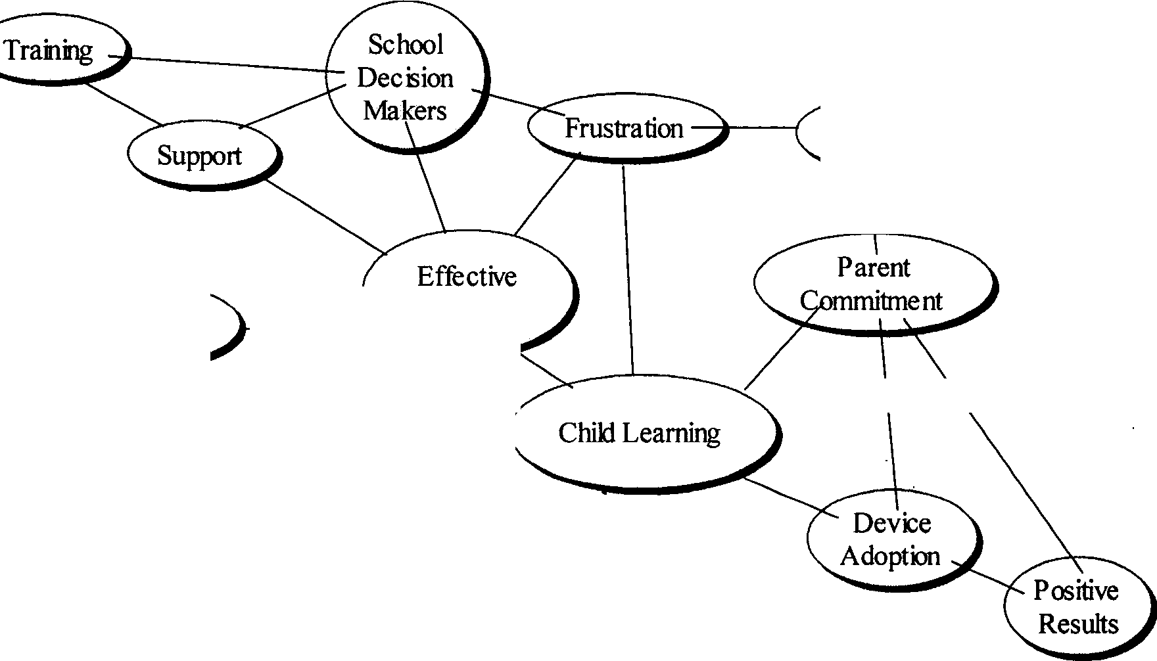
Cost
Time
Teaching

Figure 1. Concept map.

Positive results. The concept that perceived teacher effectiveness intertwined with child learning ran across interviews. An interesting notion was that the students led the determination of which device to use by their ability level. Looking at the following quotes made me realize that the adoption of each device was about the children's ability to use the technology. The devices discussed during the interviews included assistive communication (AT) devices, walkie talkies, computer programs to practice office work. Regardless of the device, the adoption and technology usage reflected in positive results. Dawn (Teacher), in discussion about the AT device, Say it Sam, stated:

Others were doing some trials with the one student to see if this would be good for them... I had another student in another classroom I was assigned to, who had the same device. And I saw the same positive results from it.
Dawn (Teacher) continued to talk about the child-centered nature of technology usage and the impact of not having that technology on both student and teacher.
Right now it [Say it Sam] is getting repaired. So we're seeing some of the same behaviors as before, but when she has the device and the device has word prediction too. Unlike PECS so if there's not an icon for it she's just not able to say it but with the word prediction software, and her being pretty familiar with it. If she doesn't know it and it is not able to be programmed in, then she is able to try and spell it out, which helps the instructor know what she wants knows what she needs. It takes out the well, what you want, and or the I don't understand, it takes away that frustration for her.
Katie (Teacher) concurred in her thoughts of AT devices which provided speech output for non-verbal students or students with severe articulation issues.
I loved them [voice output devices]. They were great - kind of nice to give these kids a voice. You can even program them to go in, press a button, and get a complete order at McDonalds without anything missing, and you are done. It's just has so many capabilities. It's amazing. It's helped an enormous amount for the kids we have introduced them for. To anticipate what these kids want to request. And there are new and exciting fun toys, and I want them to have access to it immediately, to request those things immediately. So ifwe discover something in

the middle of the day it would be great if someone could input it in right then and there, so the child could start and request it.
Allison (Teacher) agreed:

When he found it [iPod] and used it and we were so happy about that... I have a student, and his behaviors are treated through an enriched environment. When he is at school, he's constantly listening to music. And we decided to upgrade from a Walkman to an iPod.
Katie (Teacher) used words like "excited" and "I like playing with that kind of stuff' in her discussion of technology. Dawn summed up the teachers thoughts when she stated, "[Technology] I would think [is] something to assist the teachers and students with their school day."
Parent commitment. A connected thread was sewn between "cost" and parent commitment and the device adoption. Katie (Teacher) seemed the most vocal in discussing the cost, which can be very expensive depending upon the device.
I would say more comes from parents. Once we get the parent on board, they're usually pretty willing... Yeah for trial use. If we're considering a device, they have a couple they share in different classrooms, so kids can get a few hours practice with them. But Anna [program coordinator] has really taken over especially with some of these vendors to try and get some demos to see if they're effective for some of the kids... And there's funding, luckily some parents are willing to buy, but not all of them all are and then you have to fight the counties.
The funds to buy the devices were a concern. The family commitment was weighed in as a factor but it seemed that purchase of the device alone was not enough. Katie (Teacher),

for example, seemed interested in getting parents trained on inputting information into the device as well. She felt:
The devices I work with in my classroom and with parents at home. They go back and forth, but the student who's working with the word prediction. He keeps it here. He has one there, and one that he keeps here. The other kids, they just take them home in their backpacks... And I would like to see parents trained on it. I think a lot of times, even though it does go back and forth. It just sits on the counter and gets plugged in, and that's the end of it if there is something that they need programmed in.
Training and support. Along with parent commitment, the device adoption process is impacted by training and support. Katie (Teacher) commented on the occasional break down of the AT devices:
It depends upon the nature, if you're able to fix it quickly. It's not a big deal. It is frustrating at times. There seems to be runs where everything is breaking all the time, and then everything is working all the time. So that's what's frustrating, as long as there's a low-tech go to backup device. I'm fine with that. But there are just times when no one can figure it and it is completely frustrating. And it's breaking all the time. And what do you do, ship it out, and it's gone for a couple of months. So it seems that happens a lot, and it can get very frustrating and bothersome, but I've never been one to give up on a device. I'd always rather have it than not.

Even with the frustration of when the device broke down, Katie (Teacher) still wanted and used the technology. Frustration also resulted when there was not sufficient time for training. Allison (Teacher) was the most vocal in this area:
I think at that point [frustration about not being able to program the iPod]. It was a combination. There was a time constraint. It was given to the person [another teacher] because she had an iPod, and if I knew what to do it or maybe I had been given a longer time... I would've sat down with her and found out how to do it but because of the time constraints. I just passed the task over to her and she did it. I obviously took it out of the wrapping or the packaging that it was in and looked at the direction. Even with that. I feel I am a fairly intelligent person. However I had no idea what to do. It could have been Spanish. I had no idea.
All the teachers seemed very open to further training, even Dawn who seemed the most

comfortable with technology. Dawn (Teacher) mentioned in the interview a problem with her internet and how she wanted to receive assistance.
.. .with my computer at home, when I tried to install the DSL. I had problems. That was one thing I tried to troubleshoot on my own, but I did have to call for support. [When I called for support] I'm looking for someone to go step-by-step, telling me what needs to be done. I am pretty familiar with some things and I would probably be pretty frustrated at that point, and I would want someone to tell me exactly what I would need to do, because I probably would've already tried a variety of things.
In discussion of further training, Alison (Teacher) brought up:

The thing I would want to mention is, if I got a brand-new device. Not necessarily a chat, but something, if there was some super duper X 2000 device that came into my classroom that I would want more than just a manual. I would want something to go along with it, because as I mentioned, I am that hands-on learner.
Allison (Teacher) also seemed to sum up the notion that all the staff needed to be trained.

I think that training, especially for some of the new teachers that I mentioned, would be helpful. It would be really helpful, just the set up as simple as charging the devices. Turning them on and off properly. Things we take for granted, I've really had to focus with them. It would be helpful for me for some of the higher-level stuff. And I think it would be helpful for them for just some of the basics and that's something I took for granted too. I've got several new teachers this year, and I like automatically expect them to know. And one teacher finally said to me. I was never taught how to do this. How do you expect me to know when I've never been taught? It was an eye-opener for me, that these things are kind of intimidating. I shouldn't assume that everyone knows how to use them. I think everyone could use some training.
Validity Issues

To address reactivity, I disclosed to the participants all the study parameters at the very beginning of the study verbally and through written consent forms. I went into the project with the idea that this would be the start of my research relationship with these teachers and was very open about my role as a current researcher and as a future researcher.

While I was pleased with the generated NVivo reports, there was no doubt that coding and recoding took time. In fact, each time I looked at the data set new constructs seemed to appear. As a person new to qualitative research, I often had doubts about ifl was creating something new or if what I saw was based upon the evidence. Did that person say that or did they mean something else? My topic of exploring technology perceptions seemed straight forward during the interviews but as I manipulated the data, I got more concerned. I wanted to stay true to the original intent of the person I interviewed. In that light, I completed a respondent validation procedure, where the participants verified the raw transcripts and had the opportunity to add further input or clarification. I was also pleased that I was able to conduct two observations, so that my data appeared to triangulate with the interviews, field notes, and respondent validation. A member checking procedure was completed with researchers outside of this study to challenge all ideas that did not have sufficient evidence or support.
My personal bias must be looked at as well. Clearly, while this study did not directly work with the KIHd System, I can not overlook that it was the reason the study occurred. I am heavily vested in the project and this was phase three in that project. That being said, since it was looking at the broad arena of technology perspectives and it was a baseline study, there was not as much pressure to come up with pat answers or conclusions. Additionally, I was able to tape all interviews to minimize any other re-interpretation.
Reflections and Implications

The implications of this study at the Green School suggest there was various technology usage ranging from expensive, complex AT devices to less expensive, simple

slant boards. In general, the perceptions of technology were positive. Other research questions to examine would be "what would happen with the adoption and implementation of a innovation like the KIHd system?" and "Would the perception remain the same?"
Furthermore, the Green School Autism program results suggested the continued need for training and support though the device adoption process. On the flip side, the perceived barriers reflect frustration with the cost of the devices and the types of training and support. Future research could be done on comparing what types of training and support are most effective at this school. Additionally, the conclusions of this study were be used as baseline knowledge and guiding details in the creation of a technology manual and on-line tutorial on the KIHd System.
Current Study

This current study inspected the teacher perspectives within an educational setting during the adoption process of a data collection technology tool, the training needed for implementation, and how it fit into the classroom for daily data collection on their students with Autism. The research questions for this study focused on teacher perspectives during the adoption process of the KIHd System and include the headings: training, technology usage, data collection, and school culture.
Training

What are the attitudes of the teachers about the training received on the KIHd System

technology?

What types of training and support do teachers need to use KIHd System technology in the classroom?

Technology Usage

What are teacher perceptions of the KIHd System technology in regard to the beginning adoption process of this innovation?
What are the characteristics of a teacher who uses KIHd System technology?

Data Collection

How does the KIHd System technology fit into a classroom servicing students with Autism?
How does the use of the KIHd System technology change how teachers describe and

implement discrete trial training sessions?

School Culture

What are the perspectives of administrators and technical support staff in regard to the beginning adoption process of this innovation?
What are the dynamic roles of administrators, technical support staff, and teachers in the process of technology adoption?

- Methodology

A qualitative methods design was implemented for a twenty week period to understand the impact of the Kellar Instructional Handheld data (KIHd) System on teacher perceptions of data collections with their students with Autism in an educational setting on four main areas: training, technology usage, data collection, and school culture. The research questions for this study were the following:
Training

What are the attitudes of the teachers about the training received on the KIHd System technology?
What types of training and support do teachers need to use KIHd System technology in the classroom?
Technology Usage

What are teacher perceptions of the KIHd System technology in regard to the beginning adoption process of this innovation?
What are the characteristics of a teacher who uses KIHd System technology?

Data Collection

How does the KIHd System technology fit into a classroom servicing students with

Autism?

How does the use of the KIHd System technology change how teachers describe and implement discrete trial training sessions?
56

School Culture

What are the perspectives of administrators and technical support staff in regard to the beginning adoption process of this innovation?
What are the dynamic roles of administrators, technical support staff, and teachers in the process of technology adoption?
The major subheadings for this chapter include: design, methods, procedures, data analysis, validity, and limitations. The design subheading will provide a discussion of rationale for the study's qualitative nature. The methods subheading will provide a description of the participants, which includes the setting, teachers, and other school personnel, a review of the data collection sources, as well as a description of the KIHd System. The procedures subheading will map out the time frame for the study and discuss training. The data analysis subheading considers the process of evaluation of the data sources to include transcribing, rereading, using NVivo software and coding, creating concept maps, and researcher memos. The validity subheading will reflect on the concepts of researcher bias, member checking procedure, respondent validation, long-term involvement, and triangulation of data. Lastly the subheading of limitations will address the scope of this research.
Design

A systematic approach of exploring a phenomenon (Brantlinger, Jimenez, Klingner, Pugach, & Richardson, 2005) will provide a rich description of the process about the innovation adoption regarding the KIHd System. This study will implement a qualitative methodology based upon the understanding that Eisner (1998) describes:

Each person's history, and hence world, is unlike anyone else's. This means that the way in which we see and respond to a situation, and how we interpret what we see, will bear our own signature. This unique signature is not a liability but a way of providing individual insight into a situation. (p. 34)
Qualitative

According to Weiss (1994), reasons a topic is appropriate for a qualitative design include: developing detailed description, integrating multiple perspectives, describing a process, developing holistic descriptions, learning how events are interpreted, bridging intersubjectivities, identifying variables and framing hypothesis for quantitative research. The current study's research questions lent themselves to be answered in a detailed narrative from multiple perspectives that describe the process of technology adoption and usage. By using the evidence obtained through interviews of the teachers, administrators, and technical staff, various perspectives were used to develop holistic descriptions and learn how the process of technology adoption was interpreted.
Furthermore, other data sources were the foundation for forming patterns of student data collection, classroom sketches and characteristics which were identified variables. Based upon the six italicized factors, as noted by Weiss, and employed in this study, qualitative design was the method chosen for this research.
Method
As mentioned in chapter 1, this study was part of year one of a Phase II, U.S. Department of Education, Steppingstone of Technology Grant (CFDA 84.327A, Steppingstones of Technology, Innovations for Students with Disabilties/H327A060031). As such the researcher was an "observer as participant" (Glesne, 2006, p. 50), by having

participated in some activities such as reliability data collection, keeping track of targets and mastery criteria, yet maintained more distance with training, interviews and observations. More information will be provided in this chapter about the participants, which includes the setting, teachers, and other school personnel, a review of the data collection sources, as well as a description of the KIHd System.
Participants

Since the study was based at George Mason University I complied with all Human Subjects Review Board procedures. To ensure confidentiality of data collection in the KIHd System, all research activities of the proposed project's testing and evaluation incorporated the advised consent procedures approved by George Mason University's Human Subjects Review process. This study operated under George Mason University policies and guidelines in regard to all participants and provided for Human Subjects confidentiality.
Setting. The Green School was chosen in part because of their rigorous, on-going data collection procedures (primarily ABA style data) to help eliminate confounding variables (e.g., trained v. non-trained data collectors). Green School serves students ages 4 to 21 with specific learning disabilities, mental retardation, speech/language impairment, other health impairment, multiple disabilities, and Autism. It receives public and private funding and uses a consultative model to provide an individual education program for each student.
The specific program setting for this study is the Autism program. The Green School Autism Program serves 43 students in six to seven classrooms at a 1:1 and 1:2 teacher to student ratio. Individualized education programs with a focus on functional life

skills are developed following ABA methodology. Green School provides an 11 month program and extends their center based services to families by providing consultation through a generalization program, workshop program, and individualized home consultation. This is in addition to their quarterly parent educational clinics and annual IEP meetings. They conduct routine internal reviews of curriculum and student progress and an annual external professional review to ensure "state of the art" programming.
Class. The Green school Autism program has six classrooms. This study will
focus on the class in room 360. Room 360 is centrally located next to the administrators mentioned below and has seven students ranging in age from 8 to 11 years of age. Each student works on individualized programs based on the student's level of function. The curriculum consists of programs containing daily living skills and discrete trial training components.
Daily living skills are taught through a task analysis approach where each step of a program is systematically modeled and prompted until an independent level of functioning is reached. An example of a task analysis program would be teeth brushing. The student must perform each step from turning on the water, wetting the toothbrush, putting toothpaste on the brush, brushing each quadrant of the their mouth, rinsing their mouth, rinsing the brush, and turning off the water to complete the program. Data is collected on each step of the task analysis and on how many steps were independently completed.
The discrete trial training (DTT) programs have a cognitive or language component. An example of a DTT program would be learning the names and values of coins. DTT uses systematic teaching of finite learning targets by a stimulus and response

model. The teacher provides a stimulus in the form of a discriminative stimulus (SD) or command, such as "touch the penny." The student provides a response, such as touching the penny, touching the wrong item, or not giving any response. Teachers use assistance or prompting to encourage the student to make the correct response. Prompting, in this case, would be pointing to the penny. Data is collected on each response. Prompted responses are marked as incorrect since assistance was needed. For paper/pencil data collection, the teacher would circle a "c" for correct or an "i" for incorrect. The tally for percent correct is calculated and graphed later in the day after the students leave for the day.
Student. A nine year old boy with Autism, Campbell, was taught in room 360. His Childhood Autism Rating Score (CARS) score was 43.5 which placed him in the severely Autistic range. Although Campbell had early intervention services and was diagnosed with Autism by age 2, he still exhibited impairments in the social and communication domains. His monotone voice primarily used mands or requests for items such as, "I want TV please." Social commentary was not in his repertoire and greetings were still heavily prompted. His self stimulatory behavior consisted of picking at threads on his pants and vocalizing scenes from his favorite video, Wallis and Grommet. Gaining his attention before DTT could begin was a challenge. Often his responses were said in such a quiet voice that the answers were marked incorrect. Vocal tone and volume were active target behaviors marked for improvement.
Teachers. Teachers and assistants collect and chart all observable data, including

behavioral, academic and social on a daily basis. Both the Head Teacher (Katie) and Senior Assistant (Carmen) teach in room 360 and were included in this study. For the

purposes of the study Katie and Carmen will both be considered "teachers" since the scope of their responsibilities reflect data collection and analysis. Both Katie and Carmen are in their twenties with a Bachelor of Arts as their highest degree. They average five years of teaching experience and have been teaching at this site for over a year.
Administrators. The Green school has two administrators of the Autism program (Sasha and Anna). An additional administrator (Mary) helps support classroom 360. All three administrators (Sasha, Anna, and Mary) were included in this study. All are in their thirties with a Master's degree as their highest level of education. They average of 10 years of experience in the education field and have been at the site for over 9 years.
Technical staff The Green school has two Instructional Technology (IT) staff members (Evan and Ward). Both were participants in the study. They both are in their forties and have completed an undergraduate degree. On average, they each have some teaching experience and have been at the site about a year.
Research team. The research team consisted of two primary investigators (Pll and PI2), a senior researcher (SR), a project coordinator (PC), and two graduate assistants (GAi and GA2). The primary investigators and the senior researcher completed a doctoral degree as their highest level of education. While the senior researcher was a seasoned veteran with many years of experience, this was the first grant project for both primary investigators. Both primary investigators are research faculty, with one having expertise in programming and the other in assistive technology. The project coordinator and primary researcher of this study was conducting this research as her doctoral dissertation. One graduate assistant was in the master's program and the other was in the Ph.D. program. All researcher team demographic information is reflected in Table 2.

Table 2

Research Team Demographics

ID | Gender | Ethnicity | Age | Years on Project | Highest Degree Job Title
Pll | M | Chinese | 47 | 4 | Ph.D. Research Faculty
PI2 | F | Korean | 36 | .5 | Ph.D. Research Facuity
SR | M | w | 57 | 4 | Ed.D. Professor
PC | F | w | 42 | 3 | MLS Research Faculty
GAi | F | Indian | 33 | .5 | MS Doctoral Student
GA2 | F | Korean | 29 | .5 | BS Masters Student

Data Collection

As part of the Steppingstones grant project, the research team was involved with the site on a daily basis. The research team met every Wednesday morning for project meetings to discuss issues and concerns about the site. The principal data collection featured information from interviews; questionnaires which included Likert scales, teacher feedback form, and demographic questions; meetings and meeting notes; e-mails; observations which also encompassed field notes, fidelity sheets, and site visit notes from the primary researcher. Additional data collection of information such as project meetings and project meeting notes attended by the research team provided triangulation of the sources. Furthermore, some interviews, meetings, observations, and fidelity sheets involved more than one research team member. Through their added presence, the

research team positively impacted the study's validity. More will be addressed about validity and member checking procedures later in this chapter.
Interviews. Mini-interviews with the teachers were conducted throughout the study. The students have only a half day on Wednesdays and it provided the perfect opportunity to have a brief five to ten minute mini-interview with the teachers. Three of these sessions were audio-taped. These mini-interview sessions focused on the question, "Describe activities in relation to the KIHd System?" The final interviews or long interview, of all participants, lasting about 15 minutes were audio-taped and conducted toward the end of the study. The final interview focused on participant perception of the KIHd System and the process as a whole (see Appendix I). Open ended questions explored their thoughts of the implementations and how their perception concerning technology may have shifted.
Questionnaires. Three types of questionnaire were used to attain teacher thoughts: Likert scales, teacher feedback form, and demographic questions. Through the use of a variety of tools, the researcher's aim was to obtain accurate feedback without satiating the respondent. The Likert scales and the teacher feedback form were only completed by Katie and Carmen while the demographic questions were finished by all participants.
The Likert scales and the teacher feedback form were adapted from the CBAM Stages of Concern Questionnaire (SoCQ) which comprises a 35-item questionnaire using a Likert scale and free response section. Using the constructs of the SoCQ of CBAM (as noted in Chapter 2), the Likert scale questionnaire and the teacher feedback were created as simpler tools based on similar questions. The questions in the Likert scale (Figure 2)

centered around the areas of technology and the teacher feedback concentrated on the reactions in the area of training.

Likert scale questionnaire
Please rate the following statements by circling a number on the scale of 1 to 5.
1=strongly agree 2=agree 3=neither agree nor disagree 4=disagree 5=strongly disagree
I feel comfortable with the coordination of my current KIHd System tasks | 1 | 2 | 3 | 4 | 5
The KIHd System is better than our previous charting system | 1 | 2 | 3 | 4 | 5
I feel comfortable consulting with others in regard to the KIHd System | 1 | 2 | 3 | 4 | 5
I feel comfortable with my responsibility level in regard to the KIHd System | 1 | 2 | 3 | 4 | 5
I am concerned about the change in my teaching using the KIHd System. | 1 | 2 | 3 | 4 | 5
I am concerned about the change in my supervision role using the KIHd System. | 1 | 2 | 3 | 4 | 5
The level of training by the research team is excellent. | 1 | 2 | 3 | 4 | 5
The level of support by the research team is excellent. | 1 | 2 | 3 | 4 | 5
The student seems productive when the KIHd System is being used in the classroom. | 1 | 2 | 3 | 4 | 5
I save time by using the KIHd System. | 1 | 2 | 3 | 4 | 5

Figure 2. Likert scale questionnaire.

While it is not the same as the norm referenced test of the SoCQ, it still provided valuable information about the teacher's point of view during the implementation. This was completed by the teachers at the implementation and conclusion of the study. In addition, the teacher feedback form was a way to have Katie and Carmen rate the study experience to date (see Figure 3).

Teacher Feedback Form
On a scale of 1 to 10, how do you feel about the ongoing study at this point? (1 =worst, 10=best)
1 | I | 2 | I | 3 |  | I | 4 | I | 5 | I | 6 | I | 7 | I | 8 | I | 9 | I | 10
Based on a 5-point Likert scale, please check against each question.
1=strongly agree, 2=agree, 3=neither agree or disagree, 4=disagree and 5=strongly disagree
Question |  |  |  |  | Strongly agree |  |  |  | Agree |  | Neither agree or disagree |  |  | Disagree |  |  | Strongly disagree
The PDA is easy to use
The training I have received thus far is
useful to me
The frequency of
the training is adequate
The length of the training is adequate
The trainer is knowledgeable
I am able to better
collect data with the PDA
I am better able to collect data after the
training
I need additional training
How can the training be improved?
Figure 3. Teacher feedback form.

As Figure 4 shows, the demographic questions were completed as part of the long

interview process and provided a more comprehensive overview of each participant.

Demographic Questions.
Please fill out the form below.

- Name

- Year of birth

- Level of education ------
- Years ofteaching experience (total)
- Number of years at this school
- Your current position at this school _

- What are your current responsibilities? Please describe.
8. Please indicate your current comfort level in using educational
technology in your classroom.
Beginner Moderate
Proficient
10. Is this your first experience in using a hand-held PDA? Yes No

If yes, please specify when and for what purpose/shave you used it

before

12. Any comments about this research?
Figure 4. Demographic questions.

Meetings. Throughout the process, meeting with administrators and technical staff were both scheduled and held on an impromptu basis when needed. Weekly meetings

were planned and conducted with the teachers. These meetings provided a time for training and to work on any guidelines to minimize frustrations related to the technology. Meeting notes were taken at all meetings to assist this study and the larger Steppingstones grant project.
E-mails. E-mail contact was continuous and provided a great source of uninterrupted feedback. Often this was a medium used with participants and the researcher to voice concerns that would be covered the next meeting or a quick confirmation of information.
Observations. Observations were performed four times a week to ensure the

reliable operating of the KIHd System as well as to monitor classroom activities. For documentation purposes, as part of this research and the larger Steppingstones grant project, the composition and collection of field notes, fidelity sheets, and site visit notes were completed (see Figure 5). Some observational notes were marked right on the fidelity sheets using the commentary section and the margins. Information about targets and phases were written and technology issues were noted. Additional notes were marked in my project notebook. Since prior to my work on the KIHd System I consulted in a variety of settings for students with Autism, it was natural for me to use the same thought process to look at this environment in the same format. Therefore, I would comment in three areas, noting other ideas as necessary. The first was attendance (i.e., were my participants present?). The second was general activity level of the room (i.e., Were the work rotations being followed? Was data collection getting accomplished?). The third was looking at behavioral activity level in the room (i.e., Who was using inappropriate

behavior?). I usually reflected mentally on possible antecedents but did not note them unless my student participant was involved in the inappropriate behavior display.

Fidelity Sheet
Research's Name:

Room Number: Date: Instructor's name (s): Did you need to technically help? How many times? For how long?
Did you need to give assistance? How many times? For how long?

Did the instructors look at the PDA graphs? Which ones? For how long? Did they discuss the graph(s) among themselves?

Did you notice any secondary behaviors to track?

Did you, as the researcher, notice any other student who may be eligible for data collection?

Additional researcher comments:
Figure 5. Fidelity sheet.

Project meetings. Project meetings were distinguished from meetings based upon the location and the attendance of participants. Meetings were all conducted on site with any combinations of research team members, administrators, teachers and technical support staff; whereas project meetings were held at GMU and only attended by the research team. Project meetings provided a forum to discuss site concerns or issues.
Project team meeting notes were taken and posted on the project site,

http://kihdsystem.gmu.edu/stepstone/index.html.

The KIHd System

The technology tool used in this study was the KIHd System. This section will provide a brief overview. The training video and accompanying manual are accessible on
the KIHd System website, http://kihdsystem.gmu.edu. More information on the

Steppingstones grant project can be found at the website, http://kihdsystem.gmu.edu/

stepstone/index.html.

The KIHd System consists of two platforms: a PC which was used to mainly define and analyze the data collected, and a PDA used to primarily collect data. The data inputted to the PDA transmitted to the PC and stored into the database which can be accessed on the internet. That information (data) is stored making analysis possible using commonly available database software tool, Microsoft Access. Data collectors "touch" the data only one time. The numeric and graphic representation of the student performance is immediately available to them. The browser based system is designed to be 508 accessible, but many users with disabilities will need to use the computer based system in order to access the software (e.g., using JAWS or screen enlargement software

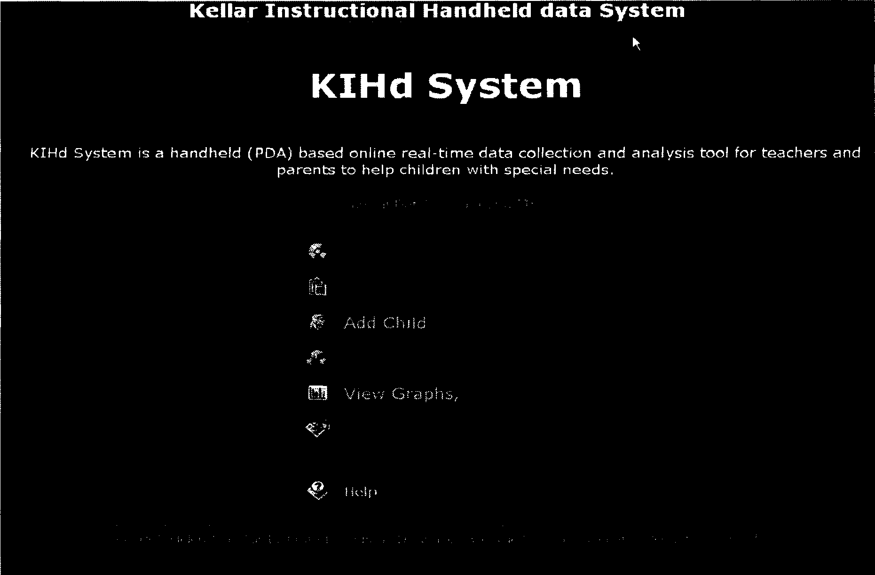
that is unavailable on PDAs). The administrative tool (see Figure 6) page is designed to provide a simple interface to the MS Access database on the server (online).
Figure 6. Administrative page.

From this page parents, teachers, and/or paraprofessionals can select their database configuration, define task, add or edit child information, add a parameter, view the graphs and reports or begin to collect data. While teachers, parents and/or paraprofessionals can use the system, for discussion purposes we will call our generic user a teacher. Although most data will be collected using the PDA, data collection can take place using the PC.
If the teacher wanted to add a new child, she would go to the child page. At this site children can have secondary behaviors associated with their name. For example,

Brianna has a flapping behavior. This association allows the teacher to collect secondary data on how long Brianna flaps during a period of time, perhaps circle time or work time. By collecting information on secondary behaviors, the behavior can be analyzed, and new socially appropriate behaviors may be introduced.
If the teacher chooses to add a new item to the curriculum, the parameter page (see Figure 7) will be selected. This page adds or edits a teacher and adds information into the KIHd System.

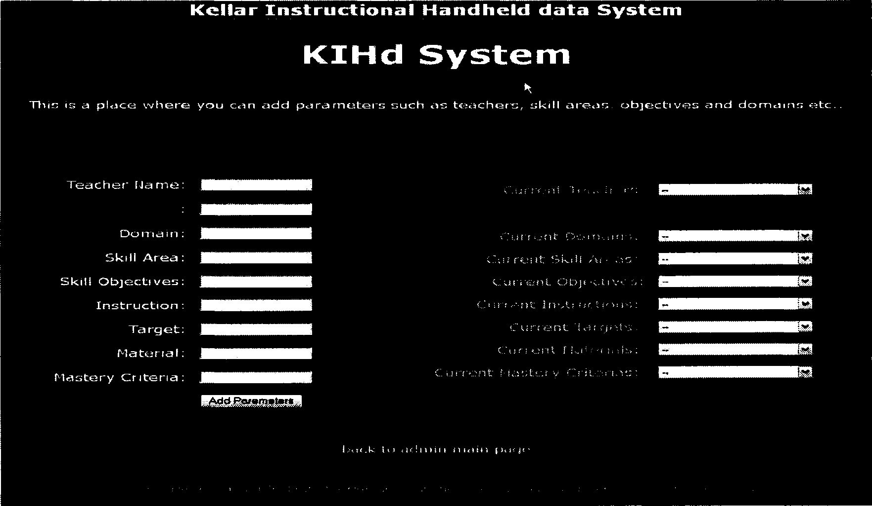
Figure 7. Parameter page.

The login password protects information entered into the system. The parameters for defining each item consist of the following information: domain name (physical, cognitive, etc.), skill areas (area of instruction), skill objective (item to be taught),

instructions (stimulus to be used), targets (what the child's response will be), material (items needed to implement the lesson), and mastery criteria (the percentage of correct responses needed for proficiency). For instance, a teacher may want to teach a lesson on colors. The domain in this case is "cognitive" with the skill area being "pre-academic colors." The skill object is to learn blue and the teacher instructions may be a verbal directive of "touch blue" with the target being the child touching the blue card. The materials would be color cards and the mastery criteria would be 90%. Once those parameters have been added, the teacher needs to define the specific task by going to the task page (see Figure 8).

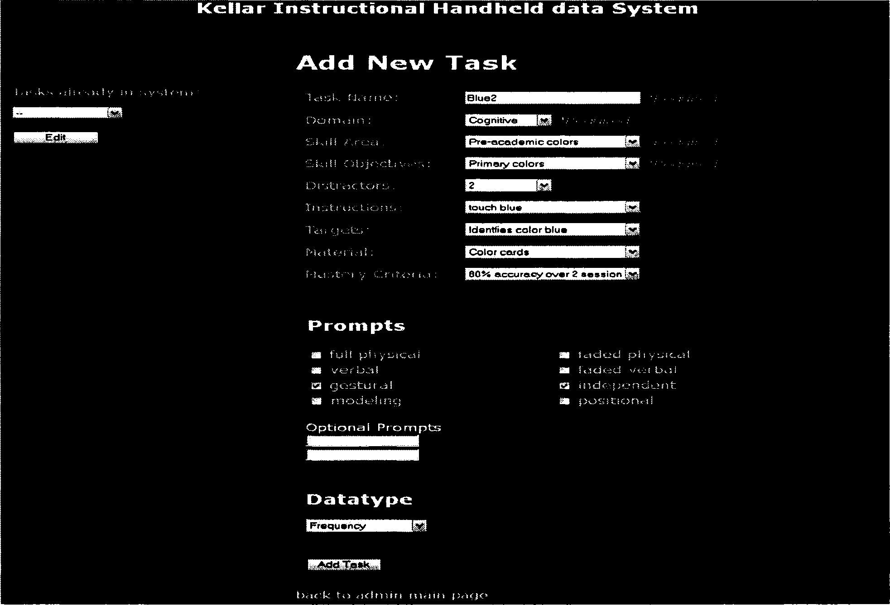
Figure 8. Task page.

The task page provides access to a simple interface to assist in the creation or editing of each learning component or "task." Here the information previously entered is narrowed down by providing a task name and associations, such as distractors (e.g., 2 with red and yellow), prompt level (e.g., gestural or independent prompting-how will you help the child), and data type (e.g., frequency-the type of data you will collect for this task). The KIHd System can collect four types of data: frequency (number of correct responses), duration (time to complete), accuracy (number correct over the total number), and fluency (number of correct responses over a time frame).

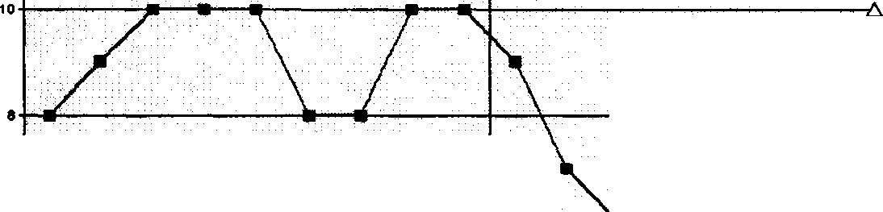

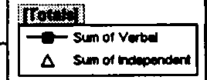
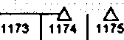
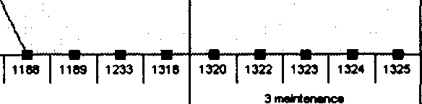
Kellar Instructional Handheld data (KIHd) System
Frequency Data - Blue 2 - Adam 6
AAAAAAA
�►s-----------�--��-�-------� ;
I
"'
I
A
1172
, ,�s ! 11n j 11ra I1�a !11ao 1101 1102 11eJ 1104 11es 11815 11e1
, ,.
2trMlm«t
Prlrnlry cCO'•

Ge«_.,.
Session Number

Figure 9. Graph page for computer.

The graph page provides access to the visual graphic displays of student performance, either individual students or groups of students (see Figure 9). All data will be able to be analyzed according to baseline, treatment or maintenance phases of instruction. The data will be able to be presented in traditional ABA type line graphs or understandable bar charts or pie graphs.
While the PC platform will primarily analyze the data, define and add information via the administrative tool pages, the PDA will mainly collect the data.

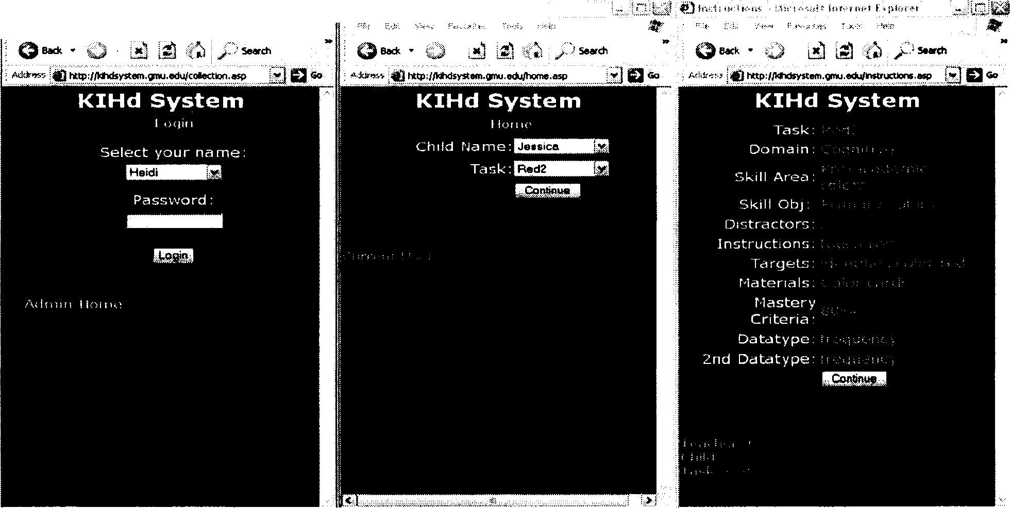
��lltt'iittili!ilii'fl!i,1Wii�• i).fo,,,,, P,, """' I"'"'""' '' ,,,,,.'
Fie Eclt View F...,ortes Tools Hlilp
�
Figure JO. PDA data collection screens 1-3.

As seen in Figure 10, the PDA based data collection tool will be designed to work in the

following way:

Screen 1: Teacher enters a "Login" screen to identify the person who will be collecting the data and enters a password. Selects "continue" to move to next screen.
Screen 2: Teacher identifies "student" and desired instruction task to be taught. Selects "continue" to move to next screen.
Screen 3: Teacher confirms domain, skill area, skill objective, distractors, instructions, targets, materials, mastery criteria, datatype, and secondary behavior datatype. Teacher selects "continue" to move to the next screen.

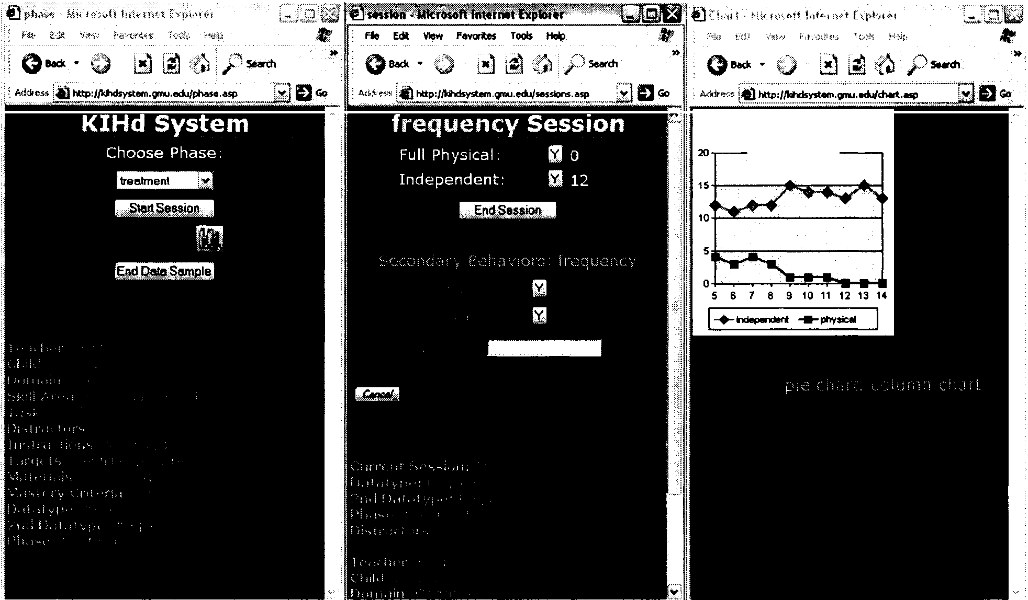
Session Data
Figure 11. PDA data collection screens 4-6.

As seen in Figure 11, the PDA continues in this manner:

Screen 4: PDA confirms selections from screens 1-3 in "breadcrumbs" on the left side of screen 4. At this point the teacher can view the graph to review the performance data for previous instruction on that particular skill objective with that particular student or begin collecting data by selecting "Start Session." The teacher also selects Phase (Baseline, Treatment or Maintenance).
Screen 5: Teacher collects data on individual student performance. The PDA confirms selections from screens 1-5 in scroll down menu. Actual data collected (e.g. frequency of correct and incorrect responses and prompt level used) for each trial during a session is seen on the PDA screen. Any number of trials makes up an individual session but 10 trials are recommended. During the data collection, secondary behaviors may be monitored and anecdotal information may be gathered. When the session is complete the teacher selects "End Session" and is automatically taken back to screen 5.
Screen 6: The session data can be viewed for immediate analysis. Here a line chart can be viewed with the blue line for independent and the red for physical prompting over 10 sessions.
Figure 12 depicts collection with these screens:

Screen 7: Session data can also be viewed in a bar format.

Screen 8: More sessions can be implemented or "End Data Sample" can be selected.
Screen 9: Secondary behavior data can also be viewed.

0-i9--lt-a- t-ll | -... | ..... | .... | ...9-
I


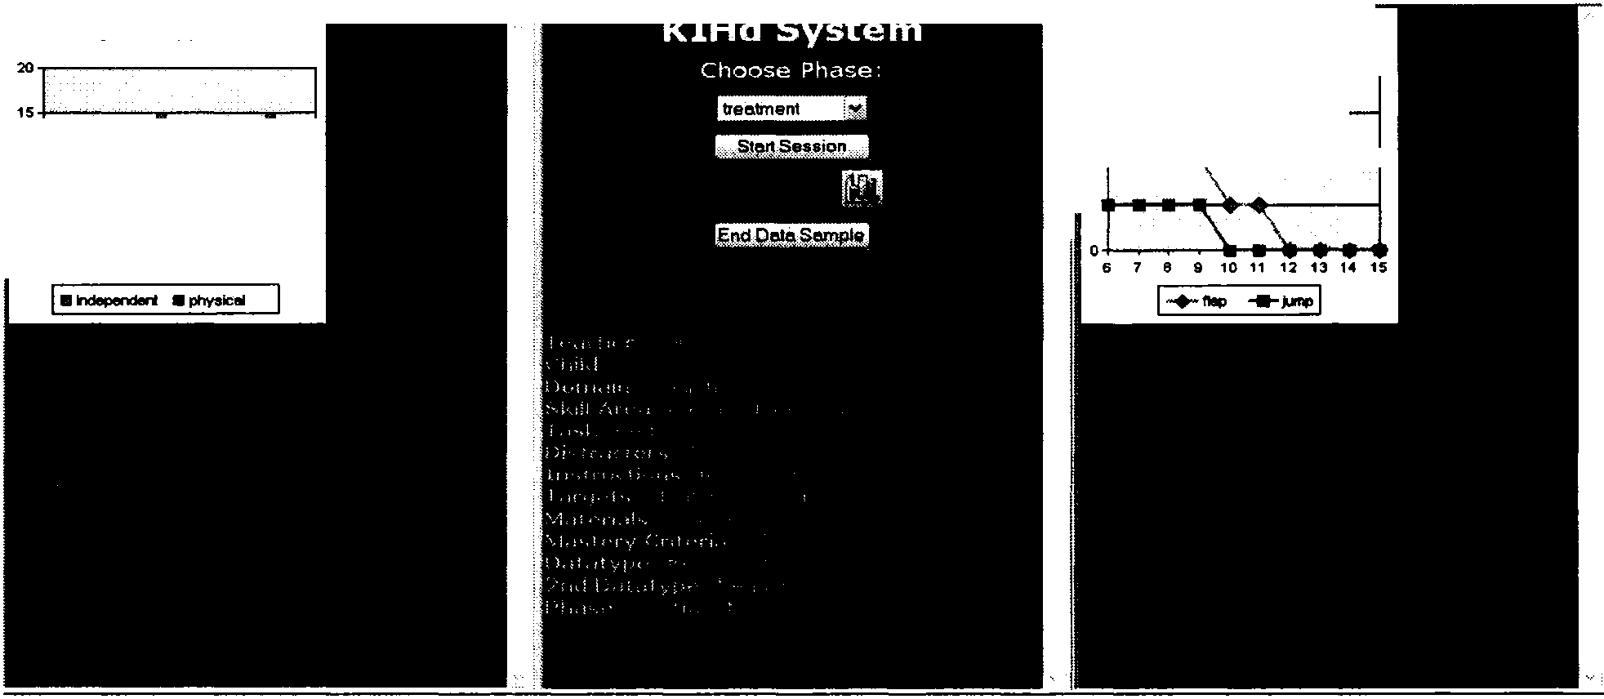
Figure 12. Data collection screens 7-9.
- : ,-::�T4t'r��tl���n;�...,
/ls--ch ·I o-. �� i-'5elrch
.,,
..
· Licl �Go
Se■■lon Data
I
l '"'"''•''!'.!"""'I�"."�:�:"°-"'�·- _.,..
J.illflGo
1:�-�
2nd Behaviors
1
i
I 2 t
I'
!
5 6 7 8 9 10 11 12 13 14

Anecdotal information is stored during data collection on screen 5 and can be retrieved in a chart format from the PC.
Procedures

This study began on August 30, 2006, and concluded on January 12, 2007 (see Table 3). This dissertation was conducted under the Steppingstones grant project and was implemented simultaneously. The timeline below reflects the events, scheduled meetings and time frame for dissertation data collection and it also show some dates of interest as denoted by the grant.

Table 3

Timeline

Date Events

Aug. 30
Sept. 6 Sept.11 Sept.13

Sept. 20
Sept. 26
Sept. 27
Sept. 28
Oct. 3
Oct. 4

Oct. 5
Oct. 10
Oct. 11

Oct. 12
Oct. 17
Oct. 18

Oct. 19

Oct. 24
Oct. 25
Oct. 26
Oct. 31

Nov. I Nov.2 Nov. 7
Nov. 8
Nov. 9
Nov. 15
Nov. 16

Nov. 21
Nov. 22-24
Nov. 28
Met with IT (Evan and Warren) department and Anna
Met with IT (Evan and Warren) department, Anna and Sasha Grant consent forms for students and parents were distributed Met with Sasha and Anna to finalize fall schedule
Autism staff meeting handed out consent forms and described study Wednesday check in interview performed
Observation and field notes collected Wednesday check in interview performed Observation and field notes collected Observation and field notes collected
Met with IT (Evan and Warren) department and Sasha Wednesday check in interview performed
Observation and field notes collected Observation and field notes collected
Wednesday check in interview and training completed Likert questionnaire completed for the first time Observation and field notes collected
Observation and field notes collected
Wednesday check in interview and training completed Met with Anna
Observation and field notes collected Met with Sasha, Anna, & Mary Observation and field notes collected
Wednesday check in interview and training completed Observation and field notes collected
Teacher data collection using the KIHd System began Observation and field notes collected
Wednesday check in interview (audio-taped) and training completed Observation and field notes collected
Election Day
Wednesday check in interview (audio-taped) and training completed Observation and field notes collected
Wednesday check in interview (audio-taped) and training completed Observation and field notes collected
Met with Anna
Observation and field notes collected Thanksgiving break
Observation and field notes collected

Nov. 29
Nov. 30 Dec.4
Dec. 5
Dec. 6
Dec. 7
Dec. 12
Dec. 13
Dec. 14
Dec. 19

Dec. 20
Dec. 21
Wednesday check in interview and training completed Observation and field notes collected
Observation and field notes collected Longer interviews with Evan and Ward Observation and field notes collected
Longer interviews with Mary, Katie, and Carmen Observation and field notes collected Observation and field notes collected
School holiday party-meeting cancelled Observation and field notes collected Observation and field notes collected Longer interview with Anna
School full day-meeting cancelled
Completion of Feedback form by Katie and Carmen Observation and field notes collected

Dec. 25-Jan. 1 Winter break

Jan. 2
Jan. 3
Jan. 4
Jan. 9
Jan. 10

Jan. 11
Jan. 12

Training
Observation and field notes collected
Wednesday check in interview and training completed Observation and field notes collected
Observation and field notes collected
Wednesday check in interview and training completed Likert questionnaire completed for the second time Observation and field notes collected
Longer interview with Sasha Data collection ended

Training was ensconced in the mini-interview process. The sessions were conducted in a 1:1 environment with training and participant thoughts of the KIHd System being the focus. While each session had a main topic as seen in Table 4, the sessions were really a 15 minute dialog of concerns or questions. Since there were only two participant users of the technology, this less formal approach helped the participants be more forthcoming with questions, concerns, and information.

Table 4

Mini-Interview and Training Topics

Date Topics

Sept. 20

Sept. 27

Oct. 4

Oct. 11

Oct. 18

Oct. 25

Nov. 1

Nov. 8

Nov. 15

Nov. 29 Jan.3 Jan 10
Described study Answered questions Collected consent forms
Training-Likert scales, gave manual, and video site Training-Simulated a data collection
Training-Discussed how to handle errors in collection PDA connectivity issues-reliability with research team PDA connectivity issues- reliability with research team Server issues
Server issues

Little graph before and after data collection Training-Likert scales

Since data collection was a process these participants were familiar with, the total training time for the KIHd System was under one hour and encompassed the three sessions in October. By October 31, the teachers were successfully using the system for data collection. Technology glitches with the PDA and server prevented making more progress in using the graph functions of the KIHd Systems. The first discussion of the

PDA's little graph was on January yct_ The study ended before more information could be collected about the teacher's graphing practices, patterns or perceptions.
Data Analysis

Data analysis involves organizing all your data collection sources into a cohesive system to "make sense of what you have learned" (Glesne, 2006, p. 147). The first step was to re-read all the transcriptions made from the interviews. Transcribing was completed by the researcher and the research team. Next was to review all the observational materials, meeting notes, e-mails, and questionnaires. Various tools from the computer software programs NVivo and Inspiration to writing researcher memos and color tagging notes formed the analysis toolkit for this research.
NVivo

While all the sources were evaluated by the researcher, the transcriptions were analyzed with the use of the software program NVivo 2.0 (Q.S.R.- Qualitative Solutions and Research, 2002). The program allows the user to code and organize data by the participant source or by the organizational code. Subcategories can also be created to support the organization code.
Notes

Researcher notes encompassed field notes from observations, fidelity sheets, meeting notes, and e-mails. The notes were coded using color post-it to note the dates and topics. Items were categorized by the content and sorted into groups. These groupings formed the basis for the initial concept maps.

Concept Maps

Although the NVivo software helped code the transcriptions, a great deal of the data collection came from variety of sources such as notes. Therefore, concept mapping became an important feature of the data analysis process. This analysis tool helped the development of the theory by giving a visual framework and helped identify contradictions (Maxwell, 2005). The concept maps were created with the software program Inspiration 6.0 (Inspiration Software, Inc., 1999). Initial concept maps were created using the color-tagged notes and then the NVivo codes from the transcriptions were added. Some of the categories changed to include bigger concepts while others were combined. Researcher memos helped keep track of the process.
Researcher Memos

Since the analysis tools included using two different software programs and a variety of data collection sources, writing researcher memos became imperative to help keep a comprehensive framework. The memos were written on an as needed basis to include idea changes and contractions. The memos were posted around the desk of the researcher to maximize clarity and keep track of the fluidity of the concept map iterations. Table 5 is a sample of highlighted issues within the researcher memos. The memos were notes to the researcher and were not done in complete sentences.

Table 5

Researcher Memo Examples

Date Topics

Jan. 12

Jan.20
With pilot has training and technology (AT) concerns
With new technology have added data collection and school culture since policies and who involved have not yet been set

Data Collection
Old-How is a typical classroom that uses KIHd System technology described?
Newer: How does the K!Hd System technology fit into a classroom servicing students with Autism?
New question: How does the KIHd System technology fit into an Autism classroom?
Old-How are teacher and student interactions described using K!Hd System technology?
New question: How are discrete trial training sessions described using the KIHd System technology?

Validity

This section will review the concept of validity. Through the use of discussion on

researcher bias, member checking procedure to include members of the research team, and an outside source, respondent validation with the participants, long-term involvement, and the triangulation of data, other plausible explanations or interpretations will be ruled (Maxwell, 2005).
Researcher Bias

When I found out that Katie would be a teacher participant, I was very pleased as she had been part of the sample for the pilot. I had observed in her classroom and found

her to be an excellent teacher. I worried that perhaps my expectations would color my observations. I didn't want to make suggestions that would unduly influence her natural teaching style or ability. To add a confounding variable, Campbell was the student selected to participate. As mentioned in Chapter 2, for almost a decade, I operated a private practice for families and children with Autism. Campbell was an early client who only left my program as he aged out of the service group. So on one hand, I was happy to be conducting research in Campbell's class, I was also concerned that my desire to see him make progress would affect the study outcomes.
Ultimately, the fact that this research was part of a bigger Steppingstones grant project provided a safety net in the form of other researchers. If I had a question about overstepping my boundaries, I would use their opinions as guidelines. As such, I was able to successfully navigate the role of "observer as participant." The impartial influences of my other researchers helped set up clear guidelines of professionalism.

Member Checking Procedure
Since the research team met every Wednesday morning for project meetings to discuss issues and concerns about the site and some interviews, meetings, observations, and fidelity sheets involved more than one research team member, it was natural that the research team became an important part of the member checking procedure. All findings were verified and defended to the research team. Research team members also acted as a sounding board for my researcher bias.
Similarly, an outside source, a teacher with three years of experience with the disability of Autism, concurred about the findings and felt the interpretations were plausible. This individual had been an assistant in a classroom for student with Autism

for three years prior to obtaining her teacher license. She was not on the research team or employed at the site. Her first hand knowledge of the head teacher and assistant roles provided validation for this study's conclusions.
Respondent Validation

The findings were also shown to all the participants to verify the interpretation and the data sources. Each accepted the accuracy of the concept map and saw the overlap in the Venn diagram as consistent. Each participant was also shown their personas (chapter 4) and asked to acknowledge their quote and personification object. The quotes were taken from the transcriptions of mini interviews, long interviews, or conversations held during observations. Personification objects visually represented an aspect of that individual's job as interpreted by the researcher.
Long-term Involvement

Including the pilot, research with this site has been on-going for almost a year.

Observational snapshots that were gathered with the pilot were confirmed with this specific study which occurred over a twenty week period. Site contact was five days a week with e-mail communication often over the weekend. The intensity and involvement with this school and the classroom lend credence to the findings and conclusion.
Triangulation of Data

Triangulation of the data sources is reflected in the visual design (see Figure 13).

Triangulatbn of data sources

Observations, meeting;, and project meetings




' "
Member Checking
Respondent Validation
I

E-mails, Likert questionnaires, teacher feedba:k, demographic questions, field notes, fidelity sheets, site visit notes, meeting notes, and project meeting notes
Interviews


Figure 13. Triangulation of data sources.

The data sources included interviews; questionnaires which included Likert scales, teacher feedback form, and demographic questions; meetings and meeting notes; e-mails; observations which also encompassed field notes, fidelity sheets, and site visit notes; and project meetings and project meeting notes. Member checking and validation respondent procedures were used to verify that the data findings were consistent and merged into logical conclusions.

Limitations

The limitations of this study include the sample size of just one school and the small number of participants. As a result, the conclusions can not be generalized.
However, the research did begin to explore teacher perceptions over the area of training, adoption of new technology, technology usage and frustrations, data collection, and school culture. By using a qualitative methodology, connections were explored in-depth and over a period of time.

- Research Findings

This chapter summarizes the findings based upon a complete analysis of all the data sources. The chapter was organized by the following headings: data analysis, the four major findings, and a summary. The data analysis section provides a detailed examination of the data by each source. The findings will reveal the exploration of the participant perspectives as related to the process of using the KIHd system in the areas: training, technology usage, data collection, and school culture. The summary concludes the chapter.
Data Analysis

Data from multiple sources was analyzed using the tools: color tagging notes, the computer software program of NVivo, researcher memos, and computer software program of Inspiration. The data sources used with color tagging included: meeting notes; e-mails; observations which also encompassed field notes, fidelity sheets, site visit notes, and project meeting notes. The data sources used with NVivo were the transcribed interviews. Research memos kept track of concepts as the construction of concepts maps developed into a visual that represented the findings.
Color Tagging Notes

Written products such as e-mails, meeting notes, observational field notes, fidelity sheets, site visit notes, and project meeting notes were tagged by date and by topic. Each artifact was then sorted into a category. A summary of the major topics for each note type
89

is reflected in Table 6. The percentage reflects the number of times that idea was discussed as compared to the total number of items.

Table 6

Note Categories
Type | Total | Major Topic | Percentage
E-mails | 35 | Questioning and information | 37%
Meeting notes | 9 | Procedures | 44%
Field notes | 27 | Data collection | 99%
Fidelity sheets | 33 | KIHd System | 43%
Site visit notes | 5 | Glitches | 60%
Project meeting notes | 17 | Glitches | 29%

E-mails. There were 35 total e-mails. The major topics presented were: questioning and answers (n == 13), reassurance (n == 10), and next steps (n == 6). Thee-mails that discussed roles were four and staff consisted of two.
Meeting notes. There were nine meetings and while the meeting notes reflect some overlap of discussion, the major topic was about procedures (n == 4). General training was the primary subject twice. School culture, specifically guidelines were a main subject three times.

Observational field notes. Of the 27 observational notes taken, two of them did not have the participants present due to illness. Data collection was mentioned 25 times as the work rotations consistently were accomplished. The energy level was extremely high but the student participant was only behaviorally mentioned 5 times for inappropriate vocalizations.
Fidelity sheets. There were 37 fidelity sheets in total. While 16 of them discussed the KIHd System and the successful data collection process, 15 fidelity sheets mention technology glitches. The last six discussed the fine tuning of data collection by noting targets and phase changes.
Site visit notes. Site visit notes were initially taken before implementation of the KIHd System was completed in the classroom. These were eventually faded out and replaced with observational field notes. Three of these visits surrounded the topic of glitches. Next steps and guidelines were the primary subjects of the other visits.
Project meeting notes. There was significant overlap of the categories at the project meetings. However, on five occasions, the main subject for the project meeting notes was technology glitches. The other topics of research to practice, the KIHd System, frustration, and roles were each a primary topic at least twice.
Interviews

Interviews were transcribed by the researcher and the research team and entered into the computer software program, NVivo. The four main categories emerged throughout the coding process: training, technology usage, data collection, and school culture. Under each category there bubbled up sub-categories as seen in the number of times a topic was mentioned as shown in Table 7.

Table 7

NVivo Codes
Category | Sub-category | Totals
Training | Questioning and information | 8
 | Reassurance | 12
 | Next steps | 18
 | Time | 6
Technology usage | Glitches | 4
 | Frustration | 11
 | Procedures | 21
 | Optimum | 10
Data collection | Fine tuning | 4
 | KIHd | 12
 | Research to practice | 10
School culture | Staff | 9
 | Roles | 23
 | Guidelines | 6

Researcher Memos

Writing researcher memos became imperative to help keep track and develop a comprehensive framework for the findings. The memos were written on an as needed basis to include idea changes and contradictions. The memos were posted around the desk of the researcher to maximize clarity and were the building blocks of the concept map iterations. Table 8 is a sample of highlighted issues within the researcher memos. The memos were notes to the researcher and were not done in complete sentences.

Table 8

Researcher Memo Highlights

Date Topics

Jan. 12

Jan. 13

Jan.14

Jan.16 Jan. 17

Jan. 19

Jan.20
With pilot has training and technology (AT) concerns
With new technology have added data collection and school culture since policies and who involved have not yet been set
Significant issue: Perspective with families, documented collaboration with families
No studies on perspectives of teachers with this population Perspective on teachers using new technology and pilot
No studies on teacher perspective of this population using new tech collect data
Substantive coding Trust
Merge questing and information into one code Time of interviews 11/1, 11/8
Substantive code under Training is support??? Not its own category??????
Support Trust

Missing research to practice area on the concept chart

Forming and clarification of questions. Perspectives and process only as policy and personnel are redundant.
Shift to more incidental and group teaching data collection just too hard on staff??

Data Collection
Old-How is a typical classroom that uses KIHd System technology described?
Newer: How does the KIHd System technology fit into a classroom servicing students with Autism?
New question: How does the KIHd System technology fit into an Autism classroom?
Old-How are teacher and student interactions described using K/Hd System technology?
New question: How are discrete trial training sessions described using the KIHd System technology?

Jan.21
Training
Old-What are the attitudes of teachers toward the KIHd System technology?
New questions: What are the attitudes of the teachers about the training received on the KIHd System technology?

Concept Map

The concept map was developed by organizing all the data from the notes and interviews into the main categories and sub-categories. Researcher memos aided in the organizational process. As the concepts maps were created, substantive codes, or the

Concept map
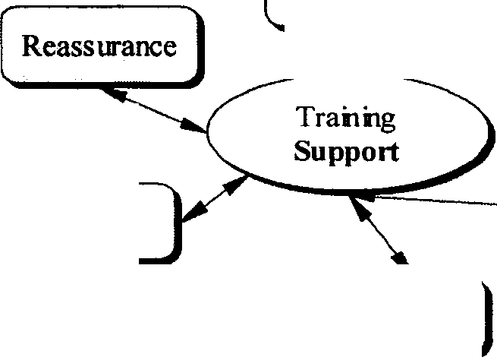
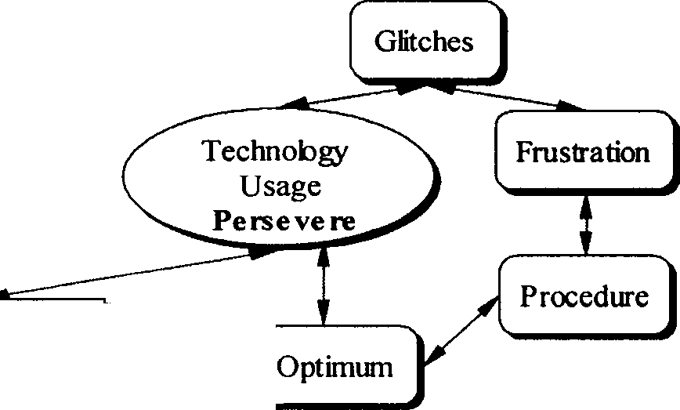
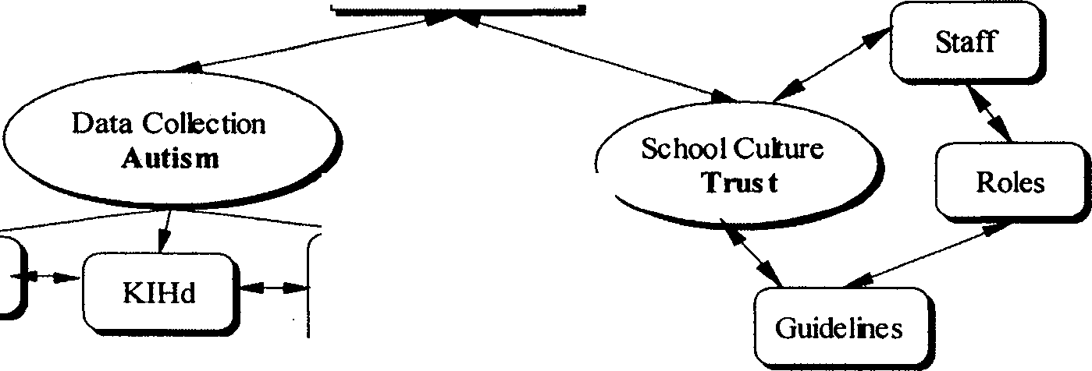
Next
steps
Tine
perspectives process
Fine Tuning
Research to Practi:e
Questioning and Information

Figure I 4. Current study concept map.

participant feelings, emerged. The substantive codes for each category were as follows: training = support, technology usage = persevere, data collection = Autism and school culture = trust. This was an iterative progression with the final concept map representing a visual image of the study's findings (see Figure 14).
Before a systematic evaluation of the findings is reviewed, an organizational map and demographic information will briefly introduce the participants. Significantly more participant discussion will follow in the school culture organization category under the area of personas. After discussion of the participant organizational map and demographic information, an examination of the findings will follow as reflected in the concept map in the sections of: training, technology, data collection, and school culture. A summary will conclude the chapter.
Participant Organizational Map

The participants in the study included administrators, teachers, and technical support staff. The focus of this study was teacher perceptions of a data collection system. However, a student participant was involved so the teachers had a student curriculum on which to collect data using the KIHd System. For the purposes of this study, Campbell was that student. Additionally, the research team, while mostly observers, provided other evidence which triangulated the data. Figure 15 depicts the hierarchy of the participants.

Sasha Director
Anna Assistant Director
l
Evan IT
Specialist
Mary
Program Suppor1 Specialist
Ward IT
Technician
Katie Head Teacher
Campbell 1
Student
Carmen Senior Assistant
[..
T_h_e_R_e_s_e_ar_c_h_T_e_am ]
Figure 15. Participant organizational map.

All participant demographic information is reflected in Table 9. Five out of the seven participants were female. Seventy-one percent were white (Caucasian). The mean age of the participants was 34 years. The mean length of years of employment at the site was five years. The least amount of time was only half a year with Ward (IT Technician) and the most amount of time was 12 years with Sasha (Autism Director). Fifty-seven percent of the participants held a Bachelor's degree and 43% held a Master's degree. The three participants that held the highest degrees were administrators.

Table 9

Participant Demographics

Name | Gender | Ethnicity | Age | Years at Site | Highest Degree | Job Title
Katie | F | w | 30 | 5 | BA | Head Teacher
Carmen | F | w | 23 | 1.5 | BA | Senior Assistant
Sasha | F | w | 37 | 12 | MA | Autism Director
Anna | F | w | 32 | 8 | MS | Assistant Director
Mary | F | w | 30 | 9 | MS | Program Support Specialist
Evan | M | B | 38 | 2 | BS | IT Specialist
Ward | M | B | 51 | .5 | BA | IT Technician

Research team. The research team consisted of two primary investigators, a senior researcher, a project coordinator, and two graduate assistants. The primary investigators and the senior researcher completed a doctoral degree as their highest level of education. While the senior researcher was a seasoned veteran with many years of experience, this was the first grant project for both primary investigators. Both primary investigators are research faculty, with one having expertise in programming and the other in assistive technology. The project coordinator and primary researcher of this study was conducting this research as her doctoral dissertation. One graduate assistant was in the master's program and the other was in the Ph.D. program. The research team met every Wednesday morning for project meetings which were held at GMU. Project meetings

provided a forum to discuss site concerns or issues. Project team meeting notes were

taken and posted on the project site, http://kihdsystem.gmu.edu/stepstone/index.html.

Training

The training organizational category held all the data pertaining to the concept of training and classified the subcategories: Questions and information, Reassurance, Next

Questions | Katie | Carmen | Average
The PDA is easy to use | 2 | 2 | 2= agree
The training I have received thus far is useful to  me | 2 | 1 | 1.5= agree
The frequency of the training is adequate | 2 | 1 | 1.5= agree
The length of the training is adequate | 2 | 1 | 1.5= agree
The trainer is knowledgeable | 1 | 1 | 1=strongly agree
I am able to better collect data with the PDA | 3 | 3 | 3=neither
I am better able to collect data after the training | 2 | 2 | 2=agree
I need additional training | 4 | 4 | 2=disagree

Figure 16. Findings teacher feedback form.

steps, and Time. Before looking at each specific subcategory, the teacher feedback fonn which focused on the training of the KIHd System was reviewed. Figure 16 above shows how both Katie and Carmen felt about the instruction they received. Both teachers were asked to use a 5-point Likert scale, 1 = strongly agree, 2 = agree, 3 = neither agree nor disagree, 4 = disagree and 5 = strongly disagree, to express their thoughts. Based on the numbers given in each question both were pleased about the length and frequency of

training and neither believed more was necessary. Katie and Carmen were also asked to score on a scale of 1 to 10, (1=worst, 10=best) how they felt about the ongoing study at that point? Katie gave the overall rating of an 8 and Carmen gave the number of 7.
The organizational code of training held the sub-categories of Questioning and Information, Reassurance, Next Steps, and Time. Quotes by the administration and teachers, meeting notes, project meeting notes, and field notes provided further evidence that the substantive, or "what does this mean," code of support was the feeling emitted. By looking at the information in each sub-category, the findings will be reviewed.
Questioning and Information

The questioning and information subcategory consisted of all the data that had to do with the "back and forth" reciprocal teaching process of training. Some of the training time was spent in reaching a consensus as data collectors as seen in this exchange between the researcher and Katie.
Researcher - So, what will be a prompt and a totally correct answer?

Katie (Head Teacher) - I would show the picture with me not saying anything, there are no prompts and I get a correct answer. That will be a correct.
Researcher - So, anything you say different from your SD is considered a prompt? Katie (Head Teacher) - Yes.
Researcher - Okay. Good. So, a great deal of your data falls in the prompt category.
Through the support received in the training, Katie was more confident there would be reliable data collection using the KIHd System. Other training sessions were spent

answering questions or providing specifics on the KIHd System. For example, this exchange discussed how to change an incorrect data entry.
Carmen (Senior Assistant) - If you were to say, mark something as correct without looking, how do you change it?
Researcher - A good question. This, you can go to the previous page and wipe it

out. If you collect something, but want to throw it out totally, just go ahead and cancel the session. If it's just one data point, then go back to the screen and wipe it out.
A further reflection of this type of questioning and providing information was seen during meeting notes on October 18th with Anna (Assistant Director). The topic of conversation was about data input. The researcher showed Anna how to enter the student's targets. Through the supported 1:1 training session, where Anna asked questions and was provided information, she successfully learned to enter the next items. Reassurance
Over time, a relationship forms between the researcher and the site. The

participants look to the researcher for reassurance. In my role as the "observer as participant" (mentioned in chapter 3), I found that a great deal of time was spent reassuring the participants, especially when there were training or technology issues related to the training. The following quotes are samples of researcher reassurance.
Researcher - The system is working. Anna has access and she can go in and

collect the graphs.

Researcher - So, we now know that we will be marking 'Y' is a correct and everything else is a No or an incorrect. At least from a reliability point of view, we will be more in sync. I will make the other options inactive.
Researcher - You are very good about that. You knew that you could go back to paper and pencil if it didn't work.
Researcher - Well, that's why we started slow in this. We have one student with one target. We added the new target. A researcher was able to add the target last week, and even though she put in frequency, I have changed it to accuracy. It was fine. Even if you put Campbell's target in wrong, I can go in and still change it really easily, so that can be done. That's not a big deal. Adding anything new is not an issue.
A large portion of our project meetings in the months of November, when GMU had technical difficulties, was spent talking about how to reassure our site. Project meeting notes on November 15th and field notes on November 6th and 10th by a project graduate assistant, reflect these issues. A large concern was for the site to continue to feel supported with the technology and be assured that all the problems would get solved. Next steps
While reassurance was primarily an area led by the researcher, Next Steps is a

joint harmonizing of vision of future participants and how fast the study will progress. Some training time discussion consisted of small next steps,
Carmen (Senior Assistant) - We are doing post-test now. We will be going into the next target.
Katie (Head Teacher) - Next target is in there?

Researcher - I don't know. I don't think we have it. But we can have it in there. But this is good; we can also talk about how to have it there. It's really simple. Katie (Head Teacher) - Maybe we can have Anna [Assistant Director] add a target in it.
Researcher - She can now, or next time we can do it on Friday
Other times, next steps consisted of looking toward the future implementation of the study with more student and teacher participants. Below Katie shares her thoughts,
Katie (Head Teacher) - One of the things that I would like to see is to have more programs in there even if there is just one target per kid. I know you said that there is a secondary behavior on which you can collect data, so it was great to see one of his internal targets as well to see how we do it. But the big thing is the transitioning from the paper graph to the computerized graph, so that's sort of the immediate next step for us right now.
Carmen discloses her thoughts,
Carmen (Senior Assistant) - I guess putting all the teaching phases and having it consistently working.
Researcher - What do you consider a timeframe for it to be considered consistently working? There are no right or wrong answers. Three weeks, a month?
Carmen (Senior Assistant) - Three weeks maybe. Just because, I think Campbell
has a real quick acquisition rate so I think we are taking more data on the paper. You will have to switch.

With Mary, the next steps look towards what was happening and what she would like to see in the future.
Researcher - Knowing that our next step is that we need to get the graph going, what other things do you anticipate other things happening?
Mary (Program Support Specialist) - With the classroom? Researcher - In terms of the PDA and the technology.
Mary (Program Support Specialist) - I would anticipate it to expand. So far I think, as we work all the bugs out, Carmen is loving it. It's really easy to collect the data. Campbell tried to take it as a toy a couple of times. I would think you would expand to more targets than more students.
Sasha expressed her thoughts on the subject to next steps in this manner:
Sasha (Director) - I believe you guys will systematically increase the number of programs per student and then get all the bugs out and then I think we will systematically increase the number of students. Once we get one classroom, you wanted to get a sample of another classroom and systematically build from there.
Part of thinking about the next steps for the project came from the feeling of support. Katie, Carmen, Mary, and Sasha believed that the study would continue to support their training needs, so the participants spoke about the next steps knowing that they would be supported in their requirements.
Time

Another sub-category was the issue of time. There was a concern before the study began by the administration and the teachers that the research project would take too much training time. This turned out not to be the case, as stated by Katie and Carmen:

Katie (Head Teacher) - I am fine. I feel good about it. We have two research projects happening and this is definitely less time consuming of the two so you guys win!
Carmen (Senior Assistant) - You guys are here like only... it does not taking away from my work time or anything.
Anna interjects that her worries were unfounded in the statement,
Anna (Assistant Director) - In the spring, you were doing interviews with the head teachers, I just helped organize that and schedule those and that went really well. Throughout the whole thing I was just worried about the time constraints, we do have so many demands and so many expectations for our instructors and head teachers, so I have been like a mother hen always trying to watch out for their time and trying to protect them. At times, I felt, I thought it's really going to take up a lot of time but it hasn't. I keep realizing that it hasn't taken up that much time. The end result is that it saves time.
Support

All conversations and evidence point to the substantive code and overall feeling of support. The general perspective during this research was that the research team provided ample support. The exchange below with Katie illustrated that while everything wasn't always smooth, the researcher was a solid source of comfort and guidance.
Researcher - So, how did you feel about the support provided by the university? Katie (Head Teacher) - You mean, you guys?
Researcher - Yes.

Katie (Head Teacher) - You guys have been great. You send us an email in the morning saying if it's going to be successful or not. Which is nice. I think we are on good communication terms. You and Anna communicate a lot so that's very good. It's great. It's nice that you come in once a day, even if you are not interacting, you are just there, you keep your distance, trouble shooting for us, which is great.
Researcher - That's good to know.

Anna expressed similar sentiments on two occasions.

Researcher - What we really want to talk about are some of your perspectives on how things have moved along from the very beginning.
Anna (Assistant Director) - Okay. In general, I think things are going really well. I really appreciated how flexible you guys have been and are willing to go at a slower pace. I think I have learned a lot along the way and it's the first project I have participated in- I mean a mutually collaborative research grant project that I have participated in. So, personally, I think I have learned a lot like different questions. I think it would have been great if I had asked those questions way back then. So, it's really been a nice learning experience for me. I think I was worried that it will go too fast and will take up too much time. But, I think it hasn't and it has been manageable you guys have been really flexible with all our different suggestions and little changes here and there. Actually, a lot of changes (laughs).
Anna (Assistant Director) - Okay. I think things have gone well in room 360. There have been a couple glitches. You have been very supportive, you have

always answered a lot of questions and you have definitely been available all the time. In the beginning, when you said somebody is going to be there every day, I was like, oh! My gosh! (laughs). That was something I didn't realize. Katie also mentioned several times that how respectful everyone is whey are in classroom and we really appreciate that and just being able to... they don't even notice that you are there. So, that's been really great.
Technology Usage
The technology usage organizational category held all the data pertaining to the concept of adoption and use of the KIHd System with the subcategories: Glitches, Frustration, Procedure, and Optimum. Before looking at each specific subcategory, the Likert scale questionnaire which focused on the technology aspect of the KIHd System will be examined. Figure 17 shows how both Katie and Carmen felt about the technology. Both teachers were asked to use a 5-point Likert scale, 1 = strongly agree, 2 = agree,
3 = neither agree nor disagree, 4 = disagree, 5 = strongly disagree, to express their

thoughts. The Likert scales were given at the implementation (Tl) and at the end of the study period (T2). As denoted by the Likert scales, there were slight improvements in the areas of coordination, responsibility level, concerns in teaching and supervision, support and student production. Since the study was only in progress for a twenty week period, any positive change in score helped support the idea that the teachers were comfortable with the technology.

Questions | Katie |  | Carmen |  | Average
Questions | Tl | T2 | Tl | T2 | Tl | T2
I feel comfortable with the coordination of my current KIHd System tasks | 2 | 2 | 2 | 1 | 2 | 1.5
The KIHd System is better than our previous charting system | 3 | 3 | 3 | 3 | 3 | 3
I feel comfortable consulting with others in regard to the KIHd System | 2 | 1 | 2 | 1 | 2 | 1
I feel comfortable with my responsibility level in regard to the KIHd System | 2 | 1 | 1 | 1 | 1.5 | 1
I am concerned about the change in my teaching using the KIHd System. | 3 | 4 | 4 | 4 | 3.5 | 4
I am concerned about the change in my supervision role using the KIHd System. | 4 | 5 | 4 | 4 | 4 | 4.5
The level of training by the research team is excellent. | 2 | 1 | 2 | 1 | 2 | 1
The level of support by the research team is excellent. | 1 | 1 | 2 | 1 | 1.5 | 1
The student seems productive when the KIHd System is being used in the classroom. | 3 | 2 | 2 | 2 | 2.5 | 2
I save time by using the KIHd System. | 3 | 3 | 3 | 3 | 3 | 3

Figure 17. Findings Likert scale questionnaire.

The organizational code of technology usage held the sub-categories of Glitches, Frustration, Procedure, and Optimum. Quotes by the administration, teachers, and technical support staff, meeting notes, project meeting notes, and field notes provided further evidence that the substantive, or "what does this mean," code of persevere was the feeling emitted. By looking at the information in each sub-category, the findings will be reviewed.

Glitches
Beginning glitches happen often as technology adoption gets underway. This study was no exception. In the conversation below Katie comments on the faulty equipment.
Katie (Head Teacher) - I haven't had that many opportunities to collect data. The system was down for a bit. But, I have enjoyed using it.
Researcher -We are working on system. One of the things that we are looking at is... I am not sure if it's the signal [wi fi] that is not strong enough, or is the device not working or do we need to move the router or is it something else that's going on here.
We have started color coding them now. The older ones- pink and purple ones are good- they always work.
Researcher - We are trying to narrow it down to see what doesn't work. The newest one [PDA's] we bought for your school, they don't work. We have three models set up here. We are going to send them back. I need to look at the connection. It's not the applications. The oldest model works.
Katie (Head Teacher) - Right. I don't run it every single day unless you guys are there. But, Carmen does run it every single day. She goes to the PDA first, if she has any hiccups at all, she puts it down, she goes to the paper-pencil.
These glitches and equipment problems were confirmed by field notes of the graduate
assistant for the steppingstones grant project on November 13th where she comments about the fact that "there are still technical problems." The project meeting notes from November 8th substantiate these issues by stating that we need to analyze technical

problems (1) PDA model problems (2) Connection problem, perhaps battery or access point (router) and (3) Firewall.
Frustration

Since glitches were common, it is important to discuss participant frustration with the technology. Katie and Anna seems more comfortable when everything doesn't go right but Carmen seems to get the most frustrated as the quotes below demonstrate.
Researcher - Are you frustrated with the technology? Katie (Head Teacher) - Problem solving can be an issue.
Carmen (Senior Assistant) - I am like, why does it happen to me?

Anna (Assistant Director) - We are having some problems, like getting on the system. So, we just wanted to make sure that you have gone through some problem solving. Then we have some other issues. They have been taking some paper data as well. Can we incorporate that as well as we haven't been able to really rely all the time on the device. Some data is in there but that is not in the system yet.
Carmen (Senior Assistant) - I think it's more so that, when it's not working, I have to have my student sit there while I am walking in the room hoping that the signal would come to the PDA. I give it a minute or so, and then I am going back to paper and pencil.
Procedure

Once glitches and then the feeling of frustrations occurred, the next step was to form a procedure of problem solving techniques to minimize the issue. This dialog illustrated devising a plan when the application was not working properly.

Researcher - We have to default back to the paper instead of the computer. Putting the data from the computer to the paper one will be the default one instead of the other way around. Until the device is reliable enough and is able to collect all of it. We are in the zone of still softening the glitches.
Katie (Head Teacher) - We have been graphing on paper pretty much. Researcher - You may have to do this until we have the device that it totally reliable. Certainly after Thanksgiving, I have a plan to have the phases on there and shift from the paper to the system. I do realize that's a problem.
During a meeting, concerns were expressed around the proper techniques to help the
devices run smoothly. As recorded in the meeting notes ofNovember 151\ the researcher demonstrated to the administrators and teachers how to shut down the PDA properly so upon starting up the device would connect quicker to the internet.
Additional discussion revolved around the procedures of getting started with the technology adoption and the technical support staff.
Researcher - From an access point of view, we ran into some issues. Could you talk a little bit about it?
Evan (IT Specialist) - The main issues were to obtain the IP address and everything for the actual access point and also securing the actual router. You guys kind of brought in the wrong tool. You guys got in a router instead of an actual access point so using a router like I guess a secure domain that we have and everything, you would need to know how our IP address works and that sort of thing and how we use our data, for that router but you don't need a router. You guys got a router, you guys actually need an access point. So we can get you the

VPN that access point and secure that IP address for you guys like the one that works now.
Researcher - Now, there were some discussions over servers. Could you address that?
Evan (IT Specialist) - The discussion we had over the server was that we weren't sure, at that time, you guys would need access to our network but you actually needed access to our servers. They are secure servers and we can't just open them up to an outside resource center. We didn't want to do this due to violations and privacy issues. We kind of got that cleared now.
Researcher - Absolutely. And the last thing that I want to address is that if from your perspective, you had someone approaching you and yes we wanted to do a new technology, what would be the process or channel of people or chains of command of approval?
Evan (IT Specialist) - Of course. It consists of a process that would be okay for any IT dept. You will need to tell us what type of access you will need. Not just any body is going to come up and open up the server or their IT network for outsiders and everything. You will need to tell us what exactly is your program, what is it about, how does it work, the hardware and software that you will need for the work. We will all need to sit down and take into consideration all these things in order to get approval for the next step. In general, we will basically need a detailed plan of action. This will help me decide if we can provide access points to the router. It will help us tremendously.

The technical support staff also worked with the business manger. The procedures for technology adoption used were influenced by this office as noted in the quotes below.
Evan (IT Specialist) - She is our school's actual business manager of the school. Researcher - How does that tie in with IT?
Evan (IT Specialist) - Well, it ties in with IT because she makes the actual budgeting decisions, IT equipment, IT needs and all.
Ward (IT Technician) - She acts as a liaison.

Evan (IT Specialist) - Yes, she acts as the liaison of the IT department as well. Researcher - So, it sounds as if there are two processes going on here. First, the idea is approved by the teachers and staff and it's going to run and want to implement it and then the secondary process is that the plan goes to the IT.
Evan (IT Specialist) - Yes, if it's going to fly, we are going to make the decision. We have to approve the plan within the IT dept., and then let it go to the business office for their approval and budgeting considerations.
Technology usage through this study saw glitches and frustration which lead to the setting of technical procedures and policy to prevail over these issues. The feeling throughout was one of perseverance. If the participants persevere then the ultimate goal was for the technology to function at an optimum level.
Optimum

Clearly the goal of any study using technology is to have that system work to the optimum capability. Thoughts and feeling about persevering to getting to that optimum level of the KIHd System are reflected in the sayings of Katie, Anna, Carmen, and Mary.
Katie (Head Teacher) - Yah, it does. I have seen it. When it works, it works well.

Anna (Assistant Director) - Yes, I agree.

Carmen (Senior Assistant) - A lot of times it's hasn't been working but when it does, it's really quick and easy and I really like it.
Mary (Program Support Specialist) - I see what is happening when I am in the room. Carmen is using the PDA to collect data and it looks really good when it's working. It's quick and easy and is [more] convenient than the usual clip board and all that stuff.
Anna later on in the conversation reflect on the technology adoption process as a whole with her comment:
Anna (Assistant Director) - It was a first experience and it was hard for me to know [about problems]. But, even looking back I think I wouldn't have been able to predict those things prior. And since you've dealt with all of those things in a great way, and have really worked with us, I think we are operating in an optimal way. I am really happy.

Persevere
All conversations and evidence point to the overall feeling of the substantive code of perseverance. Perseverance is the overarching theme for the technology code. While with any technology adoption there will be Glitches, Frustration and Procedures for the Optimum system, it is important for participant to persevere. Katie summed up the perseverance perspective best by stating:
Katie (Head Teacher) - It's going well. I mean it has its ups and downs. With technology it has... it has problems. But you should be able to anticipate that with

this kind of data collection [system]. It's a great system, we have so much data collection here so it... it negates the paper and pencil.
Data Collection

The data collection organization category held all data pertaining to the concept of data collection. To fully comprehend the complete description of the data collection category, an exploration of the setting, a visual map, and a work session were needed.
This will provide the reader with background information to understand the types of data collected for students with Autism and the how that process works.
Setting

To understand the finds under the data collection organizational category, the reader needs to explore this educational placement. The instructional setting for students with Autism is quite different than the typical classroom. Some unique features of this room stand out. For example, safety is a huge concern for both the staff and students. The room has a locked alarm button to press like a fire alarm when aggressive behavioral issues arise. At all times the head teacher has a walkie talkie to use in case of a child leaving the room in an escape type manner. A laundry basket houses a load of arm guards to protect against scratches and bites.
A schedule of working pairs is listed on the refrigerator. A working pair consists of a teaching assistant and a student. With seven students and seven adult instructors, there is a one to one correspondence. The adult instructors break down into one head teacher, one senior teaching assistant and five other teaching assistants. At any time one student may be having a self injurious behavior of biting while 1:1 instruction may be happening with two other students. A fourth student might be timed on a reward break of

playing computer. The fifth student might be returning from a scooter ride as a gross motor activity. Teeth brushing as a functional life skill might be in progress for student six while student seven's timer just went off indicating that his video time has ended.
Visual map. Figure 18 represents a visual map ofroom 360. As indicated all

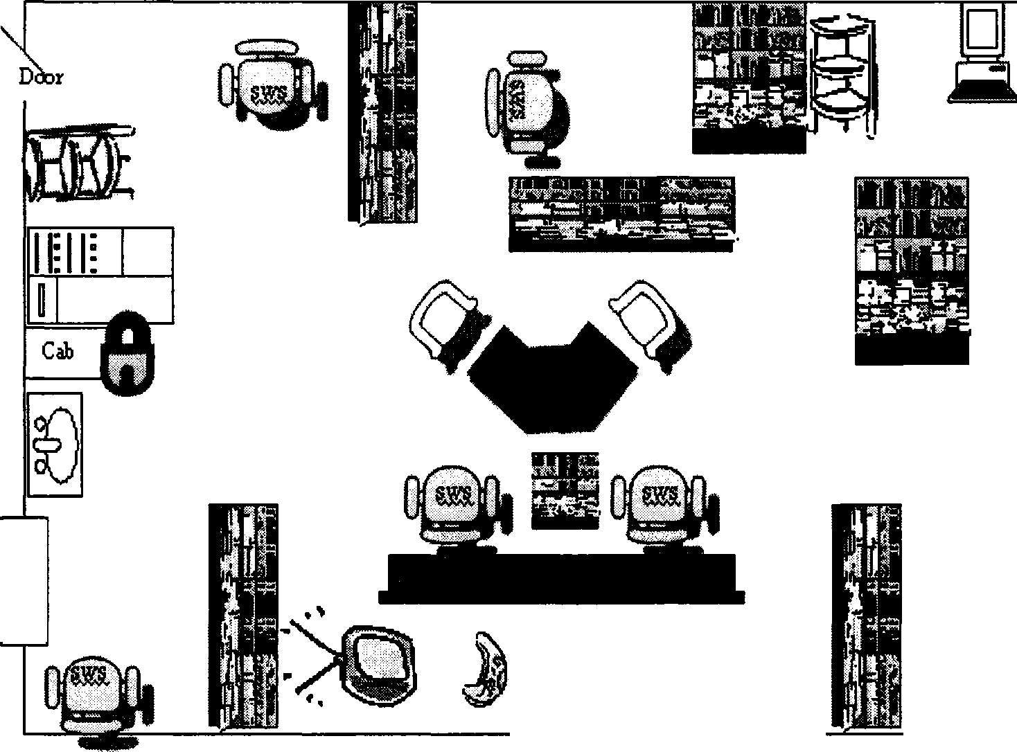
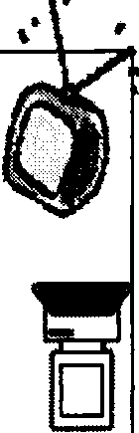

ii
11
-�' "f } -f.;!:.�
r.;.�wl � �-�
'.'!I"���_,.,.
.f..
Reward ",:••arrq
Area
Figure 18. Map of room 360.

students have individual work stations which are surrounded by teaching material. I entitled these areas as student work stations (SWS). This leads to easy access of items as well as physical barriers to help reduce distractions. One side of the room is reserved for the reward area which is heavily used. A reinforcing item is chosen before the work time begins. During the session (a work session will be featured in the next section), tokens are given for correct answers and appropriate behavior. After each student completes their "token board," the student receives their reward; generally that takes place in the

reward area. Included in the reward zone are a trampoline, gaming system, audio players for music, DVD and VCR machines.
Another high traffic region is the computer area. Three terminals are operated continually and utilized for both work and rewards. Above that section is another VRC/DVD player. If the reward zone is occupied and a student has chosen VCR or DVD, then this would be the placement for another student to receive rewards. All rewards are timed for approximately 5 minutes. Transitions back to work time can be a challenge but are "practiced" on a regular basis. Typically the students with Autism have trouble with moving from a chosen activity to a less preferred task.
As you walk in the door to the right, the classroom has a locked cabinet and sink. Part of the curriculum includes daily self help tasks such as brushing teeth and washing hands. A refrigerator, microwave, and toaster are also on that wall. Many of the students still use primary rewards or food to reinforce appropriate behaviors. A two-way mirror is in the back comer for unobtrusive observations from outside of the classroom.
Work session. As discussed in chapter 2, discrete trial teaching is the preferred modality used at this site for the delivery of 1:1 instruction. A session was audio-taped on December 6th and illustrates at work time between Katie (Teacher) and Campbell (Student). Under the communication domain, Campbell is working on the program descriptions of pictures with the targets including an agent, action, object or agent, action, and place. The materials used are picture cards. The dependent variable was the number of picture cards that were recognized accurately by Campbell at each session. The picture cards employed agent-action-object and agent-action-place target behaviors. An example for agent-action-object would be "The cat (agent) sits (action) on the mat (object)" and an

example for agent-action-place would be "The boy (agent) is playing ball (action) in the playground (place)."
In this session (see Table 10), Katie (Teacher) provided a stimulus in the form of a discriminative stimulus (SD) or command, "tell me about the picture." Campbell (Student) provided a response (R), such as the correct description about the picture, a wrong response (an inappropriate vocalization), or not giving any response. Anything other than a correct response was recorded as incorrect. The data recorded for the trials were the correct and incorrect responses using the PDA. The trial was collecting accuracy data so no data input (NDI) indicated that no information was recorded. Prompts (P) were verbal and provided in the form of the correct answers. Training trials (TT) were completed for practice and to increase learning. Reinforcement was provided through verbal praise and a token reinforcement system. Accuracy was calculated as a percentage of the number of correct responses divided by total number of data points multiplied by 100.

Table 10

Discrete Training Trial with the KIHd System

Teacher SD Student R Data Input

Trial 1
Tell me about the picture No response Tell me about the picture (P) Inaudible
Tell me about the picture No response needed-moved into training The boy is reading (P) The boy is reading
The boy is reading in the library (TT) The boy is reading in the library Good! (Verbal reinforcement) (First trial ended)
Trial 2
Tell me about the picture The boy is walking in the hallway Good! Take a token. (Verbal and token reinforcement) (Second trial ended)
Trial 3
Tell me about the picture The boy is painting in the art room The art room, good! That was great. Take a token. (Third trial ended)

NDI NDI NDI NDI
Incorrect NDI

Correct NDI

Correct NDI

Trial 4
Tell me about the picture What?
The boy is talking in the office (P) Tell me about the picture (TT) Tell me about the picture
That was better. Take a token.

Mumbles something The boy is....
The boy is talking in the office The boy is talking in the office The boy is talking in the office (Fourth trial ended)

NDI NDI NDI NDI
Incorrect NDI

Trial 5
Tell me about the picture The girl is riding a bicycle at the park Great a bicycle. Okay! Great! Take a token. (Fifth trial ended)

Correct NDI

Campbell scored three correct responses over five total trials for a session score of 60% accuracy. This would be automatically calculated by the KIHd System as reflected in session eight in Figure 19.


Session Data
0.8 �

0.6+ ;9
0.4 +-----....,,,..-""" I
0+ 1
4 8

I +correct I
Figure] 9. PDA graph for session.

Having explored the setting, a visual map, and a work session, the organizational category of data collection held the sub-categories of Fine Tuning, KIHd, and Research to practice. Quotes by the administration and teachers, meeting notes, project meeting notes, and field notes provided further evidence that the substantive, or "what does this mean," code of Autism was the overall theme. By looking at the information in each sub-category, the findings will be reviewed.
Fine tuning

This category reflected all the information that pertained to the data collection that was done at the site and the contrast of the data collection performed by the KIHd
system. While the site wanted individual specifications, the research team also needed to

consider the general development of the system. Fine tuning became the category to mesh the needs of the site with a broader category of data collection. Most of the data to

support this category was found in the project meeting notes, meeting notes, and researcher field notes.
For example, the project meeting notes of October 11th reported that re-labeling prompts specifically for the site were necessary changes. The meeting notes from the same day in the afternoon concurred that the changes made moved the default values of "faded physical" to "correct" and "faded verbal" to "incorrect." Observational data supported the fact that the data type collected at the site was accuracy with only "correct" and "incorrect" being recorded for graphing. Katie reported the site's data collection ideas in her statement,
Katie (Head Teacher) - The other thing about the incorrects is that I sometimes, conduct some training trials that I don't record. So, ifl give an SD, and there is no response or if it's a wrong answer, I give the correct answer, and record it as an incorrect.
KIHd

While getting synchronized on the data collection process, the specifics of the KIHd System were discussed in this exchange with Katie and Anna.
Katie (Head Teacher) - okay, okay. Well, our classroom is a heavily data based program so we take a lot of paper data, data on behavior reduction programs, to see where the behaviors are going, in which direction. We collect data every day, we graph every day. You guys came with this wonderful PDA on which we take our data, instead of paper and pencil data and we have chosen one program, one target to basically see how it goes, with one student.

Researcher - So, originally, when we first started, how long did you think the negation of the paper would happen?
Katie (Head Teacher) - I did think it would take a while. Especially, when we are starting with one target. There are so many things we take data on simultaneously. For some students the data we take, happens so quickly, so, the idea that we'll get all the types of data on into one device so quickly didn't happen so fast.
Researcher - So, you seem to have pretty realistic expectations. Katie (Head Teacher) - Yeah
Researcher - That's good. If we were to start again now and knowing what you know now, would you make any modifications? Would you do anything differently?
Katie (Head Teacher) - One thing that I would do differently is that we started with one target now- the picture cards. We could have had all the targets pre-programmed in there before. That way we could just fly along and we wouldn't have to worry about programming new ones each time for the kids. This is because we never know how fast the kids master the targets and move on to the next. That would have been good. I know that it has been hard for the data collection, we really haven't been using the big graph so if we have access to that, we can print out the graphs faster and use that as sort of day-to-day rather than the paper one, would be cool.
Researcher - That's our next priority. We are going to work on it next.

Anna (Assistant Director) - I also like that we are kind of getting solid on everything with a particular student and that program and once we feel good about that student, we will move on to additional students. I really like the idea. Researcher - I personally was more anxious to move quicker but then once I realized where we are going and that we needed to go slower and that it would be unethical to go quicker. Okay, we are going to do this, we are going to do this right and we are going to do it in a nice pace and then we are going to move to the next phase. So, we are on the same page here. My job was never to impact a student's program negatively.
Anna (Assistant Director) - Right, I don't feel that it has at all. Researcher - No, and I am pleased that it hasn't.
Additional evidence of working within the existing parameters of the KIHd System were reported on October 11th from project meeting notes.

Research to practice
Research to practice was the last sub category under the data collection organizational category. Project meeting notes of January 3 reported that the research concepts such as trend lines, aim lines and the ability to abide by the data decision rules were discussed. However, the research team had a different point of view from the site. Sasha relayed her thoughts about research in the exchange below,
Researcher - Having just spoken with Anna (Assistant Director) about this-your
current graph doesn't necessarily meet the criteria for single subject design charting

Sasha (Director) - Right, it's teacher friendly and designed for problem solving and that is our highest criteria so we always just go down as low [simple] as possible.
Researcher - And that's fine-it gives us something to think about.
Sasha (Director) - I've always thought I want graphs even simpler than they already are. We are thinking of moving to probe sample, that certainly isn't single subject design so I'm not going in that direction
Researcher - Good information

Sasha (Director) - I don't want to do any more training. We are over training on those graphs. I want less data and more problem solving.
Researcher -We were thinking about aim lines and potentially even trend lines. Trend lines will help make data decision rules
Sasha (Director) - Exactly, but again it is more policy and procedure. I didn't want to do it.
Researcher - It's hard- there is a lot going on day to day.

Sasha (Director) - I have trouble getting the staff to connect their dots.

Sasha is not interested in being a site for just for research purposes. She wants her data collection system to be practical. This gap between research to practice was further discussed on the project meeting of January 10th in speaking about the interactive graph necessary filtering features of phases, programs, and targets.

Autism
All exchanges and data sources point to the overall the substantive category of Autism. This disability category is the reason for data collection. The body of evidence

demonstrated in chapter 2 that data collection and subsequent analysis help makes educationally sound decisions for this population. Yet, in practice there may be a shift to less data collection because of the intensity of training required. This is especially reflected in Sasha's thinking when she says,
Sasha (Director) - Has Anna (Assistant Director) updated you on the program development? We are moving away from so much drill and repetition to more group learning contextual learning with incidental targets throughout the day. So for this room we will always be doing discrete trial for handwriting and articulation, but a lot of the language programs will be less structured. So PDA will really complement that.
School Culture

Before discussing the school culture organizational category, a review of participants will provide an overview to frame the discussion. An instructional design technique that is helpful in the discussion ofroles and personnel is to develop personas. For the purposes of this study, personas were the creation of a symbol that represented a portion of a participant's personality or job role. Attached to that participant's graphic was a reflective quote. Figures 19, 20, and 21 symbolized the participants and their hierarchical relationships in this study. The quotes were taken from audio-taped interviews or conversations held during observations.
Administrators

The administration personas included Sasha, (Director), Anna, (the Assistant Director), and Mary, (the Program Support Specialist). Sasha was symbolized by a puzzle piece as that is a nationally recognized symbol for Autism. Anna's major concern over

"time" made her graphic that of an hour glass. Mary had to keep track of various programs so her symbol reflected movement from person to person (see Figure 19).




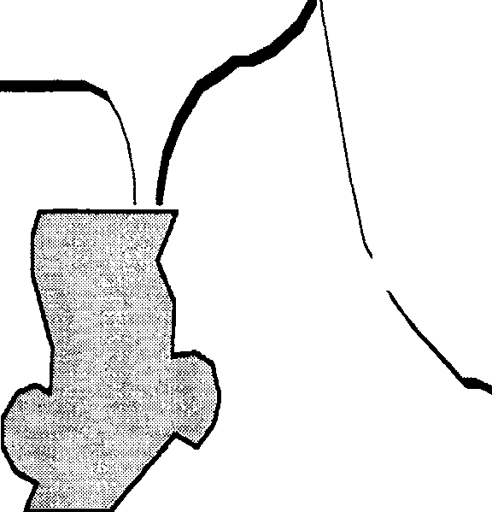
Ireally want to bea part tomakesure our visual representation'sprob�m solving isconsistent with what is beingdone in theclassroom with that sort of thingfor trainingpmposesand not toocomplicated. So that part I'm invested in,the part that could potentml� belongtam for the program.



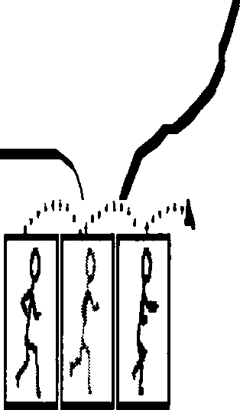
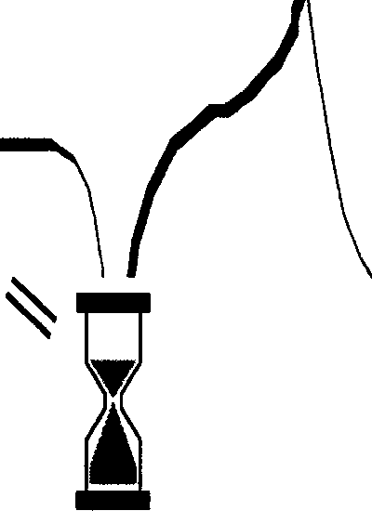
Through out the wholethingI was just worriooabout the time constraints, wedo haveso many demands and somany expectations forour instrudors and head teachers, so Ihavebeenlikea mother hen always tryingto watch out for their timeand tl)'ingto protect them. At times, Ifelt, Ithought it's really going totake upa lot of timebut it hasnt I keep realizingthat it hasn't taken up that muchtime.Theend result is that itsaves time.

From my end, Iwant tomake surethat theteam is well supported but Ithink it was very wellcovered. I think that you were vel)' quick to respond toany typeof concern. My on�concern was to bemoreinvolved from the
�t� and I havetold Anna that you'vegot «, run with it. Now,that's startedgoing. I want toknow, okay, soshow mehow to dothat.

Sasha Autism Director

Anna Assistant Director

Mary Program Support
Specialist

Figure 19. Administration personas.

Teachers

The teachers included both Katie as the Head Teacher, and Carmen as the Senior Assistant (see Figure 20). Katie represented the balance beam as she balanced all the needs of the students and staff in her classroom. Carmen's graphic reflected a snow ball just missing a tree. She moved all day long to keep pace with the students often dodging "snowballs" and she eased the burden on Katie.





It's going well. I mean it has it has its' ups and down. With technology it has...it has problems. But you should be able to anticipate with that with
this kind of data collection. It's a great system, we have so much data collection here so it... it negates the paper and pencil. I am very pleased we are participating.

.J :a::: L
Katie

But I am also trainingrifl}t now. Between the clusters of classrooms, we have a teaching assistant that goes
back and forth so it's supposed to help, I take Katie's rotation and the shared rotation is supposed to take mine. And then Katie is out of the rotation and she does assessments-it frees up some time.

Heoo Teacher

� Carmen Senior Assistant

Figure 20. Teachers personas.

Technical Support Staff

The Technical Support Staff consisted of Evan, (IT Specialist) and Ward, (IT Technician). Evan was symbolized by a computer hooked to the internet as most of his role revolved around the "communication" part of technology. Ward was more grounded in fixing computers and problems with IT devices (see Figure 21).





Yes, if it's goingto fly, we are going to make the decision. We have to approve the pIan within the IT department and then let it go to the business office for approval and budgeting considerations.

The business office acts as a liaison between the Autism administration and the Technical staff



Evan
IT Specialist
Ward
IT Technician

Figure 21. Technical support staff.

The school culture organizational category held all the data pertaining to the concept of participants working in an educational setting and classified the subcategories: Staff, Roles, and Guidelines. Quotes by the administration, teachers, and technical support staff, meeting notes, project meeting notes, and field notes provided further

evidence that the substantive, or "what does this mean," code of trust was the feeling emitted. By looking at the information in each sub-category, the findings will be reviewed.
Staff

Since we included administration, technical staff and teachers as participants in the study, there were some processing perceptions that overlapped. This could best be illustrated by the job description exchanges with Mary and Anna.
Mary (Program Support Specialist) - I first heard about the study and the system sometime last year when you came to talk with Anna. I heard a lot of it being discussed during in some of our administration meetings when we were starting to think of or looking at.
Researcher - Could you just tell me your job position title and a few duties that are under there?
Mary (Program Support Specialist) - Sure. I am a program support specialist which means that I supervise two classrooms. I supervise the students' curriculum, their IEPs, making sure that the IEPs are implemented in the classroom, their behavior reduction plan and the training of all the staff in there. Anna (Assistant Director) - When we started, I was program support specialist and I supervised two classrooms with regards to skills acquisition programming and behavior reduction programming and so I was also you know, I dealt with
the professional development issues and personnel issues in those two classrooms. I was kind of manager in those classrooms. This year as of July 2006, I am the assistant director (woo ho!) which is a brand new position for the program so it's

new, so I feel that we are constantly developing my role. In general, I am involved in anything that has to do with the IEP process. So, pretty much from start to finish in developing the teaching support, in writing, training and all of that I am involved in. I am sort of a backboard for curriculum overall, I am a resource for all of the programs support specialists; I am also really trying to see if different curriculums are consistent across the classrooms. Because we have three little hubs, we have three program support specialists and there are great things they might be doing in their classrooms and Mary may be doing this in her classrooms but another support specialist may not know about this. So, I am looking at going into to observe the classrooms to see what are the great things that we are doing across the programs.
Additional documentation of the staff overlap was seen during observations in the classroom with Katie and Carmen. When Katie was called into a different classroom for assistance, Carmen would just step into her rotation. While the staff sub-category was created to view how the various jobs play out on an actual basis, the roles sub-category was incorporated for the theoretical roles and responsibilities assigned to each position. Roles
Within each job description, each participant takes on different roles. These roles

get more muddied when new concepts or technologies were introduced to the school. This was narrated by both Evan and Sasha as the dichotomy of who needed to approve the KIHd System was discussed

Researcher - So, it sounds as if there are two processes going on here. First, the idea is approved by the teachers and staff and it's going to run and want to implement it and then the secondary process is that the plan that goes to the IT. Evan (IT Specialist) - Yes, if it's going to fly, we are going to make the decision. We have to approve the plan within the IT dept., then let it go to the business office for approval and budgeting considerations. Just that if you have any needs or need anything, sit down with us and give us a detail by detail account of what you need to help us understand better to help you.
Sasha (Director) - OK, I think you guys approached us and we did an

informational meeting. You presented what we were looking for and we presented what we were-made sure we met your needs and we could accommodate what you were looking for. Then I believe we presented you with some information for the grant as well as some budgetary stuff and then we began the process of getting it implemented with all the technology.
Researcher - Can you stop there and tell me a bit more about that.

Sasha (Director) - The router was the biggest issue-trying to get the router in place. We have all these firewalls and we didn't anticipate it begin as difficult. Researcher - So from your perspective, obviously it wasn't anticipated but did you see that as an issue? Or as par for the course.
Sasha (Director) - Par for the course. In retrospect I wish the business office had

been more involved. However we did do everything we thought we could do but it is always easier in twenty- twenty hindsight so I felt like it was unfortunate for you guys that we didn't have them more involved from the beginning. Although

they often do things at the last minute, when all of a sudden they need to be involved. It is a young department so....
Sasha (Director) - The IT field is a young field and it is service and they are not really trained to do that.
Even Mary seemed to indicate that she would have liked more input at the beginning of the process. She states,
Mary (Program Support Specialist) - If I could have it all over again, I would have preferred just to be sitting in on all the initial meetings. Anna knows all of that we are doing in the room and so what ever she gives the feedback to us, I would have done the same and it wouldn't have gone from both ofus, but I would have preferred to have attended all of those. Last week, I asked Katie to show me the graph so I could access it on the computer. So, it's just so I know how it's done.
With the opposition of actual staff involvement and the theoretical roles of each position, the underlying feeling that emerged was trust. Trusting in the process was important, i.e. knowing that all would get accomplished, even if some confusion or conflicts arose.
Usually to minimize these missteps, guidelines and policies were formed.

Guidelines
Guidelines or school policies often play a role in the use of technology. However, when a new innovation is being adopted the guideline must be modified or new ones must get established. Katie, Anna, and Sasha comment on the lack of clear guidelines and the resulting confusion.
Katie (Head Teacher) - Yah, absolutely. You and Anna have talked about what the rules of the classroom are as far as talking [interrupting instruction] goes but I

was thinking that we can set up a time where one of us is working with Campbell and we can start talking through that I am scoring or establish an eye contact with the other recorder. Basically, to know what she is doing right now. Actually, talk it through at least once to see how it is going.
Researcher - So going back to when we first came and we talked about the idea. We presented the idea. What would you have asked, now knowing more about the process?
Anna (Assistant Director) - I think I didn't ask enough about exactly how we would proceed, how many students. I didn't get into the nitty gritty, I just tend to get so excited. I really do like assistive technology, the different speech generative devices that we already use here. I really like that and I was like 'we have to do this'. I could have asked questions like, 'if it's day to day, what kind of impact it's going to have', what exactly are we going to be required to do and that sort of a thing.
Researcher - Are there guidelines in place to do some technology innovation or really as the technology innovation comes along guidelines at set and things are worked through?
Sasha (Director) - Good question. I don't know ifl can answer it but this site has so many things going on. And so many different division heads and then there is the tech support and there is the business director. So it is often an issue with all the hands talking, all the people talking, so there are not necessarily guidelines. It's just we all recognize that there is too much on deck right now and we need to get it all organized and get ahead of ourselves and get caught up. The Asperger's

program is so high-tech right now, we have got to get on top of all that and probably if we had all the information we would have told you that we would know if we would be able to accommodate you because of all the technical needs and how much is going on in the school and in the building so in way it's good that we got in before that point. But if we started it right now, I think your question was guidelines and that sort of thing. I think there aren't any guidelines but we all recognize that we are in a little bit too deep and we have got to get ahead. I mean the basic technology in the classroom we having a hard time staying on top of, much less starting a whole tech project. So at this point it is like stop everything and let's get caught up. But I think it has gone well. They are
really stepping up, to help and accommodate.
Trust
All exchanges and data sources point to the overall the substantive category of trust. Trust is the underlying message in the school culture category. Trust in the Green School site to carry out the research and trust in the researcher to have a positive impact on the educational setting.
Summary

The process and perceptions of the participants in the areas of training, technology usage, data collection, and school culture were discovered through analysis of the data sources of interviews, questionnaires, meeting notes, e-mails, and observations. Figure 22 pictures the overlap of each category and illustrated the overall meaningful codes of support, perseverance, Autism, and trust.

Influences of Innovation Adoption and Usage

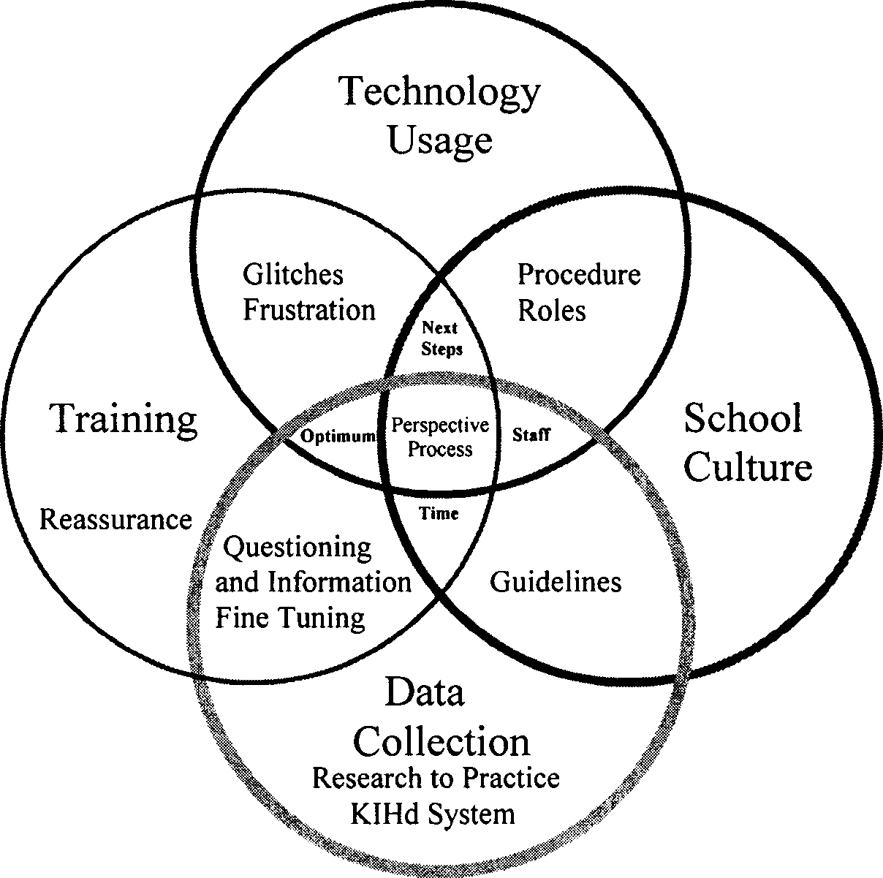
Persevere

Support Trust

Autism

Figure 22. Influence of innovation Venn diagram.

Within each organizational category there was an overlap of the sub-categories of other organization categories. For example, within the organizational category of school culture there was of the interwoven sub-categories of procedure from technology usage, and next steps and time from training. The overall themes contained in the center: perspectives and

process influence all the organizational categories and the most meaningful substantive codes: support, persevere, Autism, and trust. The discussion section of this study, chapter 5, will provide examples of the possible meaning or interpretation of these findings.

- Conclusions

"Qualitative research is not done for the purposes of generalization but rather to produce evidenced based on the exploration of specific contexts and particular individuals" (Brantlinger, Jiminez, Klingner, Pugach, & Richardson, 2005, p. 203). This qualitative research study was conducted to examine the perspectives of teachers in an educational setting during the process of the adoption of the Kellar Instructional Handheld data (KIHd) System, a technology based, handheld data collection and analysis tool for single subject and discrete trial data. It was done as the initial step in developing and implementing a series of research studies in a program for children with Autism on the KIHd System as part of year one of a Phase II, U.S. Department of Education, Steppingstones of Technology Grant (CFDA 84.327A, Steppingstones of Technology, Innovations for Students with Disabilties/H327A060031)
The results gave us new ways to think about the amount and type of training support needed to sustain technology usage; data collection with students with Autism; and the relationships between teacher, administers, and technical staff. A consideration of the Venn diagram (see Figure 22) provides a holistic picture of the research findings as they relate to training, technology usage, school culture and data collection. The rest of the chapter review follows, which will consist of seven sections.
The first section provides an overview of the study and the second section

highlights the researcher's experience and history with the KIHd System. The third area

136

summarizes the results and offers insights to the research questions and possible answers. This is followed by a discussion of those findings. The next area offers comparisons and contrasts for both the current and pilot studies. The sixth segment will explore the implications for future research while the next section will look at the study's limitations. The last section will summarize the conclusions.
Overview

The KIHd System is a data collection tool designed to help for teachers to be more effective in determining student progress on various academic and functional tasks. Instead of using paper and pencil to record behaviors or answers, a Personal Digital Assistant (PDA) is used to collect student behaviors or answers and automatically graph that performance.
KIHd System consists of two platforms, a Personal Digital Assistant (PDA) used to primarily collect data and a Personal Computer (PC), which mainly defines and analyzes the data collected. The data input to the PDA browser is wirelessly transmitted to the PC and stored into a database which is accessed through the internet. The KIHd System provides the technology to have one touch data collection and immediate
availability of data analysis to teachers and parents to make evidence-based, educational decisions.
During the research, the process and perceptions of the participants in the areas of training, technology usage, data collection, and school culture emerged as major issues. These conclusions were obtained through analysis of the data sources of interviews, questionnaires, meeting notes, e-mails, and observations. Figure 24 is a Venn diagram of those issues which depicts the overlap of each category and illustrates the overall

interconnections of the findings.

Influences of Innovation Adoption and Usage

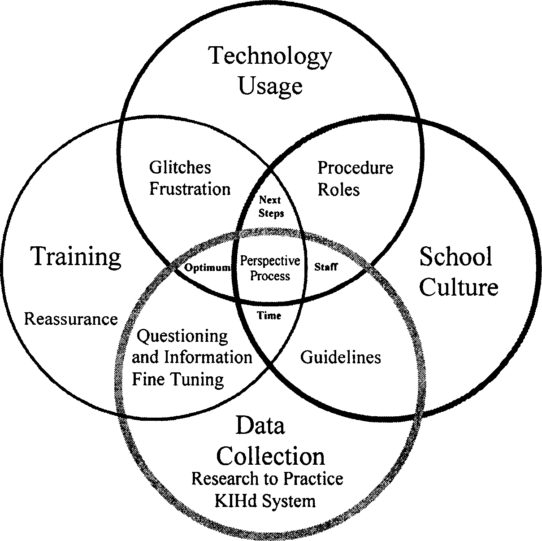
Persevere

Support Trust

Autism

Figure 24. Influence of innovation Venn diagram.

The findings from this qualitative study emerged through analysis of data collected from various sources and persons. Data from various sources was entered into NVivo, a software program that allows the user to code and organize data. The researcher coded according to organizational categories, sub-categories and substantives codes.

The overall arching themes (center of the diagram) were teacher perspectives and how the processes of data collection with a new technology influenced their thinking.
Perspectives and process were the central connecting threads though each circle. Each main circle represented the organizational codes: training, technology usage, data collection and school culture. The substantive codes, on the outside of the circles (support, persevere, Autism, and trust), reflect the feelings and thoughts of the participants. The inside sub-categories were the result of ideas and concepts that fell within the main organizing circle. While these sub-categories were primarily placed in an organizational category, there was clearly overlap and fluidity to each grouping.
For example, the organizational category of data collection (bottom) has the thoughts and feelings that pertained to the disability area of Autism. Autism is the substantive code. The sub-categories in this circle were fine tuning, KIHd, and research to practice. While research to practice and KIHd were only under data collection, the other sub-category overlapped. Fine tuning overlapped into the organizational circle of training.
The organizational category of training (left) has the substantive code of support. The sub-categories in this circle were question and information, reassurance, next steps, and time. While reassurance was only under training, the other sub-categories overlapped. For instance, next steps overlapped into the organizational circles of technology usage and school culture.
Technology usage (top) has the substantive code of persevere. The sub-categories in this circle were glitches, frustration, procedure, and optimum. All sub-categories overlapped with other organizational codes. For instance, glitches overlapped into the

organizational circle of training.
School culture (right) has the substantive code of trust. The sub-categories in this circle were staff, roles, and guidelines. All sub-categories overlapped with other organizational codes. For instance, roles overlapped into the organizational circle of technology usage.
Other sub-categories from different organizational codes crept in, such as adequate time, and questioning and information from training. For example, some participants were concerned that the amount of time training would take would affect their ability to collect data on students and thus delay instruction.
An Evolving Experiential Research Base for the KIHd System

This qualitative research study provided an unexpected vehicle for me to grow as a researcher. I had been quite comfortable with mixed methodology research which I had been involved in with the KIHd System over the previous three years. Prior to the pilot study to this research, most of the "answers" in my studies came from the quantitative data which was often followed up with an interview or two just to be certain nothing was missed. With a qualitative study there were no numbers to hang onto, just words and actions, observations and interpretations.
The journey was very similar to when my son was first diagnosed with Autism. I found I had to learn to listen, be open to new ideas, and extend far beyond my comfort zone. I had to interpret the finding of various educators, the neurologist, the speech language pathologist, and the occupational therapist - in order to sort through all of the pieces to this gigantic puzzle. The symbol from the Autism Society of America reflects the disorder, a puzzle piece. The experts do not know the cause nor do they even all agree

on the treatment. My job was to gradually interlock enough pieces of the autism puzzle so my son would develop skills and have positive growth. This study posited the same type of puzzle.
History
For three years the KIHd System and the accompanying studies have made it

possible to follow a path of research leading to this study. Reviewing this history provides a brief synopsis to highlight how the findings of each study lead to the current study. More detailed information can be found in Chapter 2 of this dissertation. For clarity, italicized sentences emphasize the major conclusion to each of the previous studies.
Alpha phase. In the fall of 2004, I joined the KIHd system project through the immersion team as a Subject Matter Expert and Team Facilitator. To this end, the KIHd project served as a practicum project for the 2004/2005 George Mason University Graduate Immersion Program for Instructional Design and Development. The Immersion program is described at the George Mason University's Instructional Technology
program site, http://immersion.gmu.edu/immsite/program/program.htm. The Immersion students use project-based experiences like the KIHd project to develop their instructional design skills. Immersion students working with the KIHd project conducted a performance analysis to determine the background of the problem. The Immersion team learned that teachers and parents are currently using the method of paper and pencil for collecting data. Furthermore, the KIHd Immersion team found this method to be so cumbersome that the data is often under analyzed or unanalyzed. This was the initial discovery and understanding related to the frustrations of data collection which is

commonly used with students with Autism, Applied Behavior Analysis.

In the spring of 2005, usability testing was conducted on the prototype handheld data collection and analysis tool, the KIHd System, to determine the performance problems and identify areas in need of revision for the KIHd prototype. The study encompassed four steps: a training video, a discrete trial session, a questionnaire, and an interview. Eight individuals were tested, four parents of children with special needs and four teachers of children with special needs. All individuals had experience and prior exposure to one-on-one discrete trial data collection as well as a variety of other types of data collection. This was the initial discovery that training of the technology tool would become a paramount factor in the ultimate success of the K/Hd System. The KIHd System received a George Mason University Innovations 2005 award for Best Use of Technology in a Competition among 56 other projects of unique and original designs submitted by students and faculty at George Mason University. So even in the early stages of research the concepts of data collection frustrations and training were apparent.
Beta phase. Beta testing of the KIHd System was concluded in the fall of 2005.

The major challenge of this phase was to implement data collection across subjects with a variety of disabilities. Data was collected during a three week period consisting of baseline, treatment, and maintenance phases. Two groups of participants were included in this phase. The first group encompassed twelve "Growing: Ready and Emerging Abilities for Tomorrow" (GREAT) program students. The GREAT Program is designed for young adults with intellectual disabilities such as significant learning disabilities, cognitive disabilities including mental retardation and developmental disabilities such as Autism

(students' intellectual disabilities might also be accompanied by physical/sensory disabilities). The second group consisted of eight GREAT instructors.
The study encompassed six steps: (1) a training session for instructors on usage of the KIHd System, (2) a goal development session for each instructor to decide on what skill, intervention and data type to be collected, (3) a brief introduction to the students,
(4) data collection sessions using the KIHd System for a period of three weeks, (5) a Likert scale questionnaire for both students and instructors, and (6) a five to ten minute video-taped interview for all participants.
Overall the findings pointed out that, even instructors who had not collected data before could be successful with training on the KIHd System. In this phase, it also became apparent that the need for support throughout the implementation of the technology was vital. It was clear that any sign of technology frustration could result in the abandonment of the device unless support was constantly present.
Pilot study. The pilot study looked at teacher perception at the Green School where the current study was conducted. This study explored the reasons some teachers use technology and others do not. At the Green School, I observed several classes and interviewed three instructors. I noted the data collection skills of the instructors and assistants and the population of students with Autism. Most of the technology discussed was assistive technology but I saw that procedures and personnel were in place for the adoption process. The findings of the pilot lent credence to the idea that technology perseverance and training support were factors I would encounter again. Due to the disability category, the rigor of data collection already in place, and some familiarly with technology, this was the place selected for the implementation of the steppingstones grant

project and thus my dissertation.
Steppingstones grant project. As program coordinator of the steppingstones grant project continuing to move the study forward, train the team members, assign tasks, making sure the team was on the "same page" presented challenges. With each team member having different backgrounds and expertise, my responsibility was to bring all that knowledge together in a cohesive study. I needed to find a balance between moving the research forward and gathering my own data. I needed to recognize the limitations of the site for their moving at a cautious pace and adjust my expectations.
Current research. With the current research, one part of the journey had been completed. I learned to quietly and unobtrusively be in room 360 at the Green School, to have my presence be an "observer as a participant." It was my responsibility to further uncover, through interviews, the thoughts and perceptions of teachers, administrators, and technical support. Having presented the findings in Chapter 4, my objective for this chapter is to interpret the finding. For the overview of findings, I interpret possible meaning, speculate, explore individual's motives, and make sense out of the evidence and data sources.
Summary of Results
The process and perceptions of the participants in the areas of training, technology usage, data collection, and school culture were discovered via the data sources of interviews, questionnaires, meeting notes, e-mails, and observations. The overlap of each category illustrated the overall meaningful codes of support, perseverance, Autism, and trust. Each category presented two research questions. Insight and discussions related to these questions will follow.

Training

Under the category of training there were two research questions. These questions were as follows: (1) What are the attitudes of the teachers about the training received on the KIHd System technology? and (2) What types of training and support do teachers need to use KIHd System technology in the classroom?
Research question. What are the attitudes of the teachers about the training received on the KIHd System technology? The teachers were generally positive about training of the KIHd System. Both of the primary instructional personnel, Katie and Carmen, indicated that they felt the frequency and duration of training sessions to be sufficient. Neither felt a need for additional training. Interestingly, another university also was conducting research within the Autism program. Many comparisons of the training were stated during a conversation with Mary (Program Support Specialist) and Anna.
Anna (Assistant Director) felt the other University consumed a great deal of teacher time. Mary expressed concern that the training was generally too vague. More research is needed to determine the exact amount of training that would be sufficient. For the purposes of the study, the researcher relied on the judgment of the administrators (Sasha, Anna, and Mary) and the direct comments through conversations with the participants (Katie and Carmen) to know the necessary amount of training.
Research question. What types of training and support do teachers need to use KIHd System technology in the classroom? The training and support provided by the research team comprised of 1:1 hands-on sessions on a weekly basis. A written manual
and video tutorial were access through the website, http://kihdsystem.gmu.edu/. Researchers were on the premises daily and were available by e-mail on an as needed

basis. Carmen (Senior Assistant) responded to the question, "How can training be improved?" with "I don't think it needs to be improved at this time." While more research needs to be conducted to determine the most effective training material, evidence through the participant's self-initiated usage of the KIHd System's higher level functions were examples that the teachers were making steady progress. For instance, before the study ended the teachers learned to set data parameters successfully. Initially they were set by the researchers. Continued learning of the KIHd System indicated to the researcher that the level of support was acceptable.
Since the participants knew the basics of data collect, training on the KIHd System took very little time. The training sessions were individualized and lasted 15 minutes. By the end of the first session, the participants were collecting practice data. By the third session the participants were very proficient. This was demonstrated by the more advanced level questions about setting data parameters. Another positive sign was that the reliability between the participants and the researchers had reached eighty percent.
The total learning time was between 30 and 45 minutes.
Technology

Under the category of technology there were two research questions. These questions were as follows: (1) What are teacher perceptions of the KIHd System technology in regard to the beginning adoption process of this innovation? and (2) What are the characteristics of a teacher who uses KIHd System technology?
Research question. What are teacher perceptions of the KIHd System technology in regard to the beginning adoption process of this innovation? As denoted by Likert scores, there were slight improvements of teacher perceptions in the areas of

coordination, responsibility level, concerns in teaching and supervision, support and student production. The study was in progress for a twenty week period so the increased scores help support the idea that the teachers became more comfortable with the technology. Through conversations with Katie (Head Teacher), there was the perception that the KIHd System was easy to use. Higher level features of the KIHd System were not initially introduced. After several weeks of consistent data collection the teachers asked for and were taught more advanced skills (e.g., edit functions and target data setting). This training was at their request, suggesting that the process of technology innovation was not too difficult and we were moving in the right direction. The teachers wanted to learn about all the application's capacity and be independent in their usage.
Research question. What are the characteristics of a teacher who uses K/Hd System technology? Both Katie (Head Teacher) and Carmen (Senior Assistant) have a level of ease with technology that was apparent through direct observation by the researchers, information from their demographic documents, and through their discussions and interviews. As marked on their demographic questions, this was not their first experience with a PDA. Both indicated feeling a level of proficiency in the area of technology as well. Katie seemed more able to go with the flow and expected some technical problems. She says, "With technology it has... it has problems. But you should be able to anticipate that with this kind of data collection." Carmen was more vocal about expressing frustration with, "Why does it always happen to me?" However, she was willing to be persistent and quick thinking, "If I walk over by the sink. Tum it on, log in and it's on." Even if the technology had initial problems, teacher persistence was the most important characteristic to having success.

Data Collection

Under the category of data collection there were two research questions. These questions were as follows: (1) How does the KIHd System technology fit into a classroom servicing students with Autism? and (2) How does the use of the KIHd System technology change how teachers describe and implement discrete trial training sessions?
Research question. How does the KIHd System technology fit into a classroom servicing students with Autism? Organized, teacher controlled, student centered chaos were the best words to describe room 360. Each child had their own curriculum and accompanying materials in an assigned place. The primary function of these areas was to promote 1:1 learning with minimum visual stimulation and a reduction of distractions.
All student activities revolved around the principles of behavior modification. Low motivating activities were reinforced with tokens. A certain number of tokens were earned to engage in highly reinforcing activities. The reward was decided upon prior to the work. The token economy rewards took on various forms such as a scooter ride, video tape, DVD, gaming system, therapy ball, trampoline, and roller blades. Rewards were also food items. The room was equipped with a refrigerator, toaster, microwave, and sink.
In such a busy environment, the KIHd System could maximize data collection while requiring a minimum amount of teacher time. Data collection and analysis with paper and pencil take a great deal of time. In the pilot study, Katie (Head Teacher) reflected that all classroom staff (Head Teacher, Senior Assistant, and other Assistant) take the last 45miutes to an hour of school to chart the data collected each day. If the teachers have that time free, what would they do? Perhaps consult about a child' program or work on developing materials? The Steppingstones grant project will be looking into

that idea with future research.

Research question. How does the use of the Kf Hd System technology change how teachers describe and implement discrete trial training sessions? Teachers work in a 1:1 environment. Instead of using paper and pencil to record the data collection, they use the PDA to mark the student's response. Katie (Head Teacher) gives a description of a discrete trial session,
Katie (Head Teacher) - When a child doesn't respond at all to a question, it is considered a non-response. Also, when he responds wrong to a question, then it's a non response. And a lot of the distinction is when I am able to give a lot of prompts in first, or if I don't get a response to my prompt at all I still score it as a prompt. But I give an SD (antecedent stimulus), with no prompts, and he either doesn't respond at all or gives me a wrong answer, I record it as an incorrect. The other thing about the incorrects is that I sometimes, conduct some training trials that I don't record. So, ifl give an SD, and there is no response or if it's a wrong answer, I give the correct answer, and record it as an incorrect. Then I go with another two training trails (which I don't record). So, that might be something.
Our data will be mostly be prompts, a few corrects and no incorrects at all. But, occasionally, we try to fade back a little.
She continues,
We collect data every day, we graph every day. You guys came with this wonderful PDA on which we take our data, instead of paper and pencil data and we have chosen one program, one target to basically see how it goes, with one student.

What Katie (Head Teacher) did not mention was that the KIHd System graphs in real time. It is not a paper and pencil replacement but the opportunity to make decisions based on the data being immediately available. For instance, once the child and target are select, the teacher can look at the PDA to see the last 10 data points collected for that target. If mastery criteria is set for 80% across two sessions and the student achieved 80% last session, then the teacher would know right away that they would be checking for mastery. If they were to wait until afternoon, then the opportunity might have been missed. The pacing of the program, because the data is so readily available, would never stagnate.
In addition, the KIHd System has the ability to graph 11 prompt levels. The prompts include: full physical, partial physical, verbal, faded verbal, gestural, modeling, independent, positional, plus three others that the teacher could create. The Green School was only collecting prompts as incorrect responses. Future research would need to be conducted on delineating the incorrect responses into the various prompts. This may provide the teachers with more information on which to evaluate a student's progress.
Further research would also need to evaluate the students that have the technology used on their program and those that continue with the more traditional method of paper and pencil.
School Culture

Under the category of school culture there were two research questions. These questions were as follows: (1) What are the perspectives of administrators and technical support staff in regard to the beginning adoption process of this innovation? and (2) What are the dynamic roles of administrators, technical support staff, and teachers in the

process of technology adoption?

Research question. What are the perspectives of administrators and technical support staff in regard to the beginning adoption process of this innovation? With so much on their plate, the administrators had a hard time finding the energy to oversee all the projects. Yet, it seems that Mary (Program Support Specialist) regrets her initial lack of involvement. She states,
Mary (Program Support Specialist) - If I could have it all over again, I would have preferred just to be sitting in on all the initial meetings. Anna (Assistant Director) knows all of that we are doing in the room and so what ever she gives the feedback to us, I would have done the same and it wouldn't have gone from both of us, but I would have preferred to have attended all of those. Last week, I asked Katie (Head Teacher) to show me the graph so I could access it on the computer. So, it's just so I know how it's done.
At times concerns can arise since technology may not be their specialty area. Even Anna (Assistant Director) who is generally proficient felt,
Anna (Assistant Director) - A few times I have gotten overwhelmed mainly with the technology side of it. I am not fluent with the technology language and that vocabulary and I have felt a bit overwhelmed in few of those meetings. That's just because of my background. My kind of expertise is with teaching and autism and I am fine with the device once it gets in the classroom, I can talk and hang in a conversation at that level.
The Instructional staff was clear that they needed a plan for all technology. Evan (IT Specialist) states,

Evan (IT Specialist) - Yes, if it's going to fly, we are going to make the decision. We have to approve the plan within the IT department.
From wanting to be involved from the beginning, to being overwhelmed, to wanting final authority, each participant went through an evolution. It was all about gaining the trust of each participant. Once they felt the researcher would respect their opinions, their concerns were voiced and I was able to quell any fears and provide reassurance. Each participant came with different knowledge and background. It was the researcher's job to find a common ground. Working on the relationship between participants and researcher was a huge factor in a successful technology adoption process.
Research question. What are the dynamic roles of administrators, technical support staff, and teachers in the process of technology adoption? When new innovations are introduced in an educational setting without any predetermined guidelines or policies, there are bound to be blurred lines of responsibility. This is compounded by the fact that some administrator roles are less clear and accountability for who is ultimately "in charge" was not that of a sole individual but rather a group of department heads. Sasha (Director) clarifies,
Sasha (Director) - I think there aren't any guidelines but we all recognize that we are in a little bit too deep and we have got to get ahead. I mean the basic technology in the classroom we are having a hard time staying on top of, much less starting a whole tech project. So at this point it is like, stop everything, and let's get caught up. But I think it has gone well. They are really stepping up, to help and accommodate.

Certain activities at the site were constructivist (e.g., IEP meetings) in nature, several were hieratical (e.g., setting the program rotations) or even authoritarian (e.g., naming trusted websites). The culture of the school determined the nature of each event. What created cooperation among school staff member? From the study, when a participant felt left out or "not in the loop" they were less likely to cooperate and more likely to feel threatened by the new technology and research team. When concerns were replaced with reassurance, trust was formed. While more research needs to be done on the interpersonal relationships of education settings in regard to technology adoption, the continued research of the steppingstones grant project may provide some insight into this matter.
Discussion of Findings

There were four main conclusions from the current study. The first three came as no major surprise. Training was a factor that influenced the perceptions of technology. Support during training was crucial. With Technology Usage the persistence of the teachers was an important characteristic to becoming successful with the KIHd System. For Data Collection in such a busy environment, the KIHd System could maximize data collection while requiring a minimum amount of teacher time. The last conclusion was not expected. Within the School Culture roles were less clear and accountability for who was ultimately "in charge" was a not a sole responsibility of an individual but rather the responsibility of a group working in collaboration.
Training

The literature validates that training is an important factor that impacts teacher perceptions on the adoption of technology (Ceppi-Bussmann, 2006, ChanLin, Hong,

Homg, Chang, & Chu, 2006; Chen & Price, 2006; Goedde, 2006; Moskowitz, 2004; O'Shea, 2006; Solomon, 2002; Verock-O'Loughlin, 2006). One of the best examples, the use of computer technology in Santa Clara County, California was studied in 2004 by having 203 practicing teachers in K-12 complete surveys. The findings revealed the major factors that influenced technology usage in the school setting: technical proficiency, personal and professional background, access to support both technical and training, and an identified need (Hernandez-Ramos, 2005). Similarly, studies of the KIHd System in the Alpha phase, Beta phase, and pilot study all provided confirmation that training and support is an essential factor.
The results of the current study suggest that without proper training and support

teachers would not use the technology. I found evidence that the teacher's tendency would be to continue with their old ways of collecting and charting data because learning the skills to use the new technology took extra effort. They would rule the time and effort to learn to use the device as "too much trouble" before the benefits became apparent.
Their day was so hectic that without the researcher leading the way, the device stayed on its charger. For instance, in the beginning of the study, on days that there was not a researcher present, the teachers chose not to use the system. The research team acted as a stimulus cue, telling them it was time to work on the program with Campbell, the targeted student. Our continued presence provided a comfort level, of being supported and able to provide technical assistance if things went wrong. Thus the research team's attendance initiated and sustained the habit of using the KIHd System by the teacher and assistant. Bottom line for technology projects, someone needs to be physically present and time is required for teachers to feel supported in order to feel secure in the use of the

new technology. This conclusion was important because future implementation research on the KIHd System and other technology interventions needs to plan for ample time and support. This may affect the overall cost of the project and, if not taken into account, may result in unanticipated failure.
Technology Usage

With technology adoption, there will always be glitches and frustration. Issues need to be anticipated so that a backup plan can be created. Redundant alternatives are always a good idea. The researcher and the site need to plan for the unexpected. As any study is sure to have unanticipated glitches, there needs to be flexibility built into the timelines and deadlines. With the current study, what should have taken four weeks actually took eight. The study should have been solidly collecting data by October 31st but due to technology glitches (e.g. firewall issues, equipment failures such as dead batteries and router problems, software issues such as working security codes and KIHd Software coding, GMU network changes and domain server changes, etc.), data collection was start and stop all through November. Some of the glitches might have been anticipated but many were outside the control of the research team. By December 2nd all the problems had been solved and data collection was consistent.
If I had realized this as a typical matter in technology research, I would have written a very different dissertation proposal and timeline. Being patient and recognizing the limitation of the technology are paramount to coping with frustration. The Buddhist philosophy dictates that it is not what you perceive but how you deal with what you perceive that makes the difference. In hindsight as a researcher, if I had recognized these problems and their subsequent solutions, I would have anticipated delays and

incorporated this time into the schedule. In this manner, site and research frustrations would have been minimized by knowing that there would be glitches and planning extra time to form procedures.
Ultimately with support (see training), the teachers were able to persist. They recognized that the initial problems would be solved and data collection would eventually happen smoothly. While there is literature that defines the characteristics of special educators (Billingsley, 2004; Boyer & Mainzer, 2003; Lackey, 2006), there is not research inquiry on their personality qualities. Personality qualities such as persistence should be examined through further research. I believe that there is a possible link between persistence and the educators working with the population of students with severe disabilities like Autism. It takes an individual who is willing to keep plugging away at a problem or a lesson, sometimes with very little results, to work with this group of students. The same can be said for technology innovation-often the individuals who are willing to persist and move unruffled through the "glitch" time period are successful.
The literature validates that the idea training and technology usage go hand in hand (Bronson, 2002; Fisher, 2002; Owen & Demb, 2004; Pavey, 2005; Ullrich, 2003). A good example: technology usage was discussed in the study of teacher perceptions and practices of 764 elementary and secondary teachers from the province of Quebec, Canada (Wozney et al., 2006). The findings report that 39% rarely use technology and had no formal training and 39% who has some training were using the technology. The amount of technology-related support was reflected in the use of the computer in the classroom. "Teachers in our study generally reported the need for in-service training and when asked what resources could make their implementation easier, teachers referred to applied

training that goes beyond skill development" (Wozney et al., 2006, p. 194).

Data Collection

Autism is a complex and intimidating puzzle. The "experts" just don't know enough about autism. One of the few proven methods of intervention is Applied Behavioral Analysis (ABA) so we need to work within that context (others include Picture Exchange Communication Systems [PECS], Treatment & Education of Autistic and Related Communication of Handicapped Children [TEACCH], Pivotal Response Treatment [PRT], Floor Time, and Social Stories - See Chapter 2 for more information). The literature supports this point by noting that in listing the strategies for educating children with Autism, those based on ABA form the foundation of many scientifically proven effective intervention programs (Anderson & Romanczyk, 1999; Rosenwasser & Axelrod, 2001; Schloss & Smith, 1998).
In fact, "thirty years of research have demonstrated the efficacy of applied behavioral methods in reducing inappropriate behavior and in increasing communication, learning, and appropriate social behavior" (U.S. Department of Health and Human Services, 1999, p. 164). A special issue of Behavior Modification with studies supporting ABA as an empirical model in the treatment of Autism came out in 2002. The introduction states that ABA has the best-documented outcome data supporting and that this approach is more effective as compared with other methods (Rosenwasser & Axelrod, 2002). However, they also noted that ABA may be too hard to implement for school staff. Whether it is just teaching by using data decisions rules, taking time to chart behaviors, or learning to analyze graphs, school personnel had trouble. They needed more time and training and their jobs were hard already. In the area of Autism, staff tum over

is very high because of all the student behaviors. The requirement of the staff to learn one more thing, particularly one that is rigorous and detailed, would potentially break the camel's back. From a research perspective, I would like to see rigor added to the training but, if you have personnel who are still trying to learn the basics in working with students on the Autism spectrum, how can you realistically ask for more?
Even at the Green School, which is well known for implementing ABA programs, the requirements for detailed data collection and analysis was still a facet that came down to time, energy and money. How much time can we invest in this employee? Will it be worth the energy to get them trained? How much training will it take for them to be competent? How much training for them to meet research standards? The answer was "too much". It would take too much time, energy and money to do that. So they stick with the status quo, even making decisions that may not be as beneficial and cost effective in the future.
Recently the Green School decided to move to an incidental teach approach. The thinking behind this was that if this population could learn in larger groups and through incidental teaching they would not be on the spectrum and perhaps could be reintegrated into general education settings. Just by virtue of their diagnosis peer learning is, at best, limited so why move in that direction? The administration saw no other choice. The move to incidental teaching was partially made due to lack of trained staff in the techniques of data collection. If their data collection system were simpler, I suspect they would keep the same staff ratio. In such a busy room, the KIHd system would take some pressure off the teachers. It could possibly save graphing time and provide more time for lesson planning and preparations. Data collection would be able to be checked across

each student's program and the assistants could check for reliably. If one assistant was not collecting properly, more attention and training could be initiated. The KIHd System would be a method of spot checking and eliminating unnecessary training to those proficient staff members. The Virginia Department of Education, Autism E-News (Koons, 2007) states that:
In order for data to be useful to teachers, and administrator, it is important that it be interpretable to others, that is be easy to use, easy to train staff, provide some level of consistency across classrooms, provide key information or making decisions, and that it not interfere with teaching effort. (p. 2)
How ironic, just when there is heavy encouragement from the state and federal sectors to utilize more data collection, in practice the schools find it difficult to comply. The data collection and analysis requirements to implement the federally supported Response to Intervention (Rtl) approach in general education may well exacerbate this problem as general education teachers are required to collect and analyze discrete trial data in a three tiered intervention approach (Batsche et al., 2006). Perhaps with more funding and general education emphasis, the educational interventions and data collection procedures developed and tested with students with Autism could be applied to state of the art scientifically proven methods of intervention for a wider population of children with and without disabilities. Technologies such as the KIHd System may be able to provide the transitional tools to achieve these goals.
School Culture

Since teacher perceptions and training are two major obstacles for technology integration adoption (Hasselbring & Glaser, 2000; Judge, 2001), it stands to reason that

perceptions of the administrators and technical support staff were of importance as well. When the administration and technical support staff perceived the technology adoption as a priority, then the proper support was provided (Catchings, 2000; Nations, 2002; Owen & Demb, 2004).
Who knew it would take so may cooks to stir the soup? An old Yiddish proverb talks about all the chefs in the kitchen. Each individual chef contributed something to the soup. While in reality only one chef was necessary to make the soup, with everyone working it actually tasted better. The same can be said of the Green School environment. With everyone contributing each person had less control but what you ended up with was a richer concept than determined by one individual. While originally I thought that I was just working with the Autism administrator, in reality it was the teachers, the program support specialists, other administrators and the IT department contributing to the process that would determine success or failure. Returning to the soup analogy, sometimes if one chef has a bigger ego she wants to get more credit for making the soup "just right." The same can be said of a learning environment when one person wants to be "in control." Instead of working together to form a better product, trouble and conflicts can arise. That where system policies come in handy. The policies list the things each participant needs to do and sets the stage for how to proceed. When collaboration is part of the policies and procedures, my observations suggest that the results are often better (Dettmer, Thurston, & Dyck, 2005).
This was another issue with the adoption of the KIHd System. There was no set policy for adopting a new technology based strategy. While there was a path for assistive technology as demonstrated in the pilot study, there was no policy set in place for new

innovations (McLester, 2005). As a result, there were several departmental conflicts that arose at the beginning of the study which also delayed its start. These conflicts included accessing the internet through the firewall. The business manager and the IT department she supervised had reservations about changing the settings to allow secure data to travel to the Mason server housing the KIHd System. Their initial response was that it should not happen and since they were not consulted about the technology requirements of the intervention it was not going to move forward. Resolving this impasse required opening a discussion between the program staff, administration, and the business and technical support staff to find the common ground to make the system work. In true bureaucratic form, once the departments set out policy guidelines, the KIHd System project was implemented and the program and research projects were the beneficiaries. Instead of having the support of just the Autism program, the study received approval from several departments.
Comparison of Findings

There were several points of comparison and contrast from the pilot and current study. The pilot study (for a detailed description, see Chapter 2) was conducted the previous year in order to provide insight into teacher's views and usage of technology at the Green School and to determine the likelihood of implementing a systematic and extensive research agenda between the Green School and George Mason University. The pilot study explored the reasons some teachers used technology and others did not. A qualitative methodology was implemented for a five week period. The research questions were: (1) What were teacher perceptions about technology? (2) How was technology currently being used? and (3) What were some perceived barriers to technology

adoption?

The purpose of the current study was to explore the influences of technology adoption and usage of the KIHd System, a handheld data collection and analysis tool, in the same setting, where discrete trail teaching (DTT) and ABA was employed with students on the Autism spectrum. A qualitative study on adoption and use of the KIHd System was implemented for a twenty week period to ascertain perceptions of teachers during the adoption process in four main areas: data collection, technology usage, training, and the dynamic culture of a school environment.
Comparisons

Both studies showed the overall interest in technology usage and excitement that these devices created might make things easier for both teachers and students. The circular connection revolves around the idea that technology makes teaching more effective which leads to better learning by the students which in tum makes teaching more effective.
Additional comparisons can be made over the technology glitches which resulted in frustration. Once problems were solved via good trouble shooting techniques, then optimum utilization of technology was possible. Support and training through the difficulty was necessary in order to develop positive perceptions of the whole process.
Contrasts
One large point of contrast was the policy that dictated technology usage.
Generally at the Green School, there were clear procedures to follow when needing a new piece of equipment, from who needs the item to who orders the product to who approves of the budgetary expense. With the KIHd System, there was not a clear delineation of

guidelines about how to proceed and who needed final authorization.
Another contrast was the lack of discussion about money. With the pilot study there were conversations about whether parents or the base school district would pay for the technology. With the KIHd System being part of the Steppingstones grant project, funding was never a concern since the grant provided the funds for both equipment and support at the Green School.
Implications and Future Research
Several of the current study findings suggest a need further research. The first is defined as research to practice. The bridge to innovation is neither short nor smooth.
Research results often have rough edges and unanticipated outcomes that many commercial products do not have because of extensive usability testing. While the researcher went to the site with the idea of "bridging the gap," the administrator clearly felt ambiguous about research practices. At this point she just wanted to have the staff complete the minimum training successfully and not add anything further. Initially, she did not perceive all staff members as being successful, so she felt that adding more information or responsibilities would be unwise. The second issue was the decision to move some of the classrooms to more group work and incidental teaching and away from ABA interventions. This practice is not presently supported in the effectiveness research literature but philosophically is in line with current best practice concepts for accessing the general curriculum in the least restrictive environment. Perhaps this move is being driven by the difficulties of training and maintaining excellent teaching and assistant staff that are capable of collecting and analyzing large volumes of performance data. On the other hand, perhaps technology such as the KIHd system will promote this change to

occur because it will be easier and more efficient to collect, analyze and make instructional decisions on student performance. It is even possible that such technology will be enabling, that is allow the implementation of a program emphasizing incidental learning because it will be possible to collect and analyze data in real time within natural settings.
Lastly, additional research needs to be done on the KIHd System itself. When the interactive graph is functioning with all the necessary features, teachers will need to be queried as to its effectiveness and degree of influence in making good instructional decisions. Perceptions of saving time and effective educational decisions will need to be explored, perhaps with a larger sample size. As part of the larger Steppingstones grant project that will continue for an additional year, several research questions that will be address are as follows:
- Is there a teacher pattern to viewing the graphs to make data driven decisions?

- How many times do the teachers look at the graph in proximity to the time of data collection and afternoon chart time?
- Does the randomizations test confirm or add to the visual analysis of the semi-logarithmic chart or line graph to make decisions?
- Does the KIHd System enable reliability?

- Will teachers continue to use or add additional students to the KIHd System even after the base study has been completed?
Limitations

The small sample size of and limit of one school, restrict the ability to generalize the results of this study. The qualitative nature of the inquiry provided a rich narrative to

room 360, a classroom that serviced student with Autism. However, the researcher could only offer opinions and interpretations of what the data meant.
A limitation of this research was that the participants at the Green School were well versed in data collection. If this study had been conducted at a different site, significantly more time may have been needed to train participants on the general principles of ABA. Once the basics of data collection were established, then the research would have been able to move forward to implement the KIHd System technology.
While if the pilot study was included, the researcher would have been with the site for almost a one year period. If excluded, the currently research with the intensity of daily observations for a twenty week period, was a relatively short time frame. The next step for the steppingstones grant project would be to continue with the study for the rest of the year while adding a quantitative component the focuses on teacher decisions based upon the data collection.
Conclusions
For this project, within each organizational category a distinct truism appeared: Training-a factor that influenced the perceptions of technology was training. Support during training was crucial. Technology-teacher persistence was the most important characteristic to having success with the KIHd System. Data Collection-in such a busy environment, the KIHd System maximized data collection while requiring a minimum amount of teacher time. School Culture- roles were less clear and accountability for who was ultimately "in charge" was not a sole individual but a group.
The Head Teacher Katie said it best,

Katie (Head Teacher) - It's going well. I mean it has it has its' ups and down. With

technology it has... it has problems. But you should be able to anticipate that with this kind of data collection. It's a great system, we have so much data collection here so it... it negates the paper and pencil. I am very pleased we are participating.
This completed journey represents one more piece of knowledge about technology adoption in an educational setting servicing students with Autism. Similarly, with the discovery of treatment options for students with Autism, the experts continue to put the pieces of the puzzle in place. This research on the KIHd System potentially offers answers to both areas. As the KIHd System receives modifications with improvements based upon implementation experience at the site, it may help decipher data collection problems for many teachers working with students diagnosed on the Autism spectrum.
With data collection concerns resolved, the focus of the research can tum to proving which treatment options are effective. For this researcher, that would be the real journey's end.



References

Agosta, E., Graetz, J.E., Mastropieri, M.A., & Scruggs, T. E. (2004). Teacher-researcher partnerships to improve social behavior through social stories. Intervention in School and Clinic, 39, 276-287.
Alberto, P., & Troutman, A. C. (1999). Applied behavior analysis for teachers (5th ed.).
Saddle River, NJ: Merrill.
Alberto, P., & Troutman, A. C. (2006). Applied behavior analysis for teachers (7th ed.).

Saddle River, NJ: Merrill.

American Psychiatric Association. (1994). Diagnostic and statistical manual of mental disorders (4th ed.). Washington, DC: Author.
American Psychiatric Association. (2000). Diagnostic and Statistical Manual of Mental Disorders, Fourth Edition, Text Revision. Washington, DC: Author.
Anderson, S. R., & Romanczyk, G. (1999). Early intervention for young children with autism: Continuum-based behavioral models. Journal of the Association for Persons with Severe Handicaps, 24, 162-173.
Atkins, N., & Vasu, E. S. (2000). Measuring knowledge of technology usage and stages
of concern about computing: A study of middle school teachers. Journal of Technology and Teacher Education, 8, 279-302.

Autism Society of America. (n.d.). About autism. Retrieved June18, 2006, from
http://www.autism-society.org/site/PageServer?pagename=homepage Barlow, D. H., & Hersen, M. (1984). Single case experimental designs: Strategies/or
studying behavior change (2nd ed.). New York: Pergamon Press.

Barnett, D. W., Daly, E. J. III, Jones, K. M., & Lentz, F. E. Jr. (2004). Response to intervention: Empirically based special service decisions from single-case designs of increasing and decreasing intensity. The Journal of Special Education, 38, 66-79.
Batsche G., Elliot, J., Graden, J. L., Grimes, J., Kovaleski, J. F., Prasse, D., et al. (2006).

Response to intervention: Policy considerations and implementation. National Association of State Directors of Special Education, Inc.
Bebell, D., Russell, M., & O'Dwyer, L. (2004). Measuring teachers' technology uses: Why multiple-measures are more revealing. Journal of Research on Technology in Education, 3 7, 45-64.
Behrmann, M. M., & Graff, H.J. (2006). [GREAT study Kellar instructional handheld data system]. Fairfax, Virginia: George Mason University, Helen A. Kellar Institute for Human disAbilities: Unpublished raw data.
Berger, D.S., & Williams, D. (2003). Music therapy, sensory integration and the Autistic child. Great Britain: Athenaeum Press.
Billingsley, B. S. (2004). Special education teacher retention and attrition: A critical analysis of the research literature. The Journal of Special Education, 38, 39-55.

Binder, C., & Watkins, C. L. (1990). Precision teaching and direct instruction: Measurably superior instructional technology in schools. Performance Improvement Quarterly, 3, 74-96.
Blackhurst, E. A. (2005). Perspectives on applications of technology in the field of learning disabilities. Leaning Disability Quarterly, 28, 175-178.
Bondy, A., & Frost, L. (2002). A picture's worth: PECS and other visual communication strategies in autism. Bethesda, Maryland: Woodbine House.
Boyer, L., & Mainzer, R. W. (2003). Who's teaching students with disabilities? A profile of characteristics, licensure, status, and feelings of preparedness. Teaching Exceptional Children, 35, 8-11.
Brantlinger, E., Jimenez, R., Klingner, J., Pugach, M., & Richardson, V. (2005).

Qualitative studies in special education. Exceptional Children, 71, 195-208.
Bregman, J. D. (2005). Definitions and characteristics of the spectrum. In D. Zager (Ed.), Autism spectrum disorders: Identification, education, and treatment (3rd ed.) (pp. 3-46). New Jersey: Lawrence Erlbaum Associates Publishers.
Broer, S. M., Doyle, M. B., & Giangreco, M. F. (2005). Perspectives of students with intellectual disabilities about their experiences with paraprofessional support. Exceptional Children, 71, 415-430.
Bronson, L. W. (2002). Technology, adult learning and the development of digital literacy skills. Dissertation Abstracts International, 64 (01). (UMI No. 3078562)

Carbone, V. (2000, August). Developing and implementing classroom and schoolwide systems for implementing systematic behavioral programs. Paper presented at Progress through partnership: A national conference on autism. Presented at The Pennsylvania Autism Institute, University Park, PA.
Carr, E.G., & Carlson, J. I. (1993). Reduction of severe behavior problems in the community using a multicomponent treatment approach. Journal of Applied Behavior Analysis, 26, 157-172.
Carr, E.G., Homer, R.H., Turnbull, A. P., Marquis. J., Magito-McLaughlin, D., McAtee,
M. L., Smith, C. E., Anderson-Ryan, K., Ruef, M. B., & Doolabh, A. (1999).

Positive behavior support for people with developmental disabilities: A research synthesis. Monograph of the American Association on Mental Retardation.
Catchings, M. H. (2000). Models of professional development for teachers: Factors influencing technology implementation in elementary schools. Dissertation Abstracts International, 61 (07). (UMI No. 9979252)
Causton-Theoharis, J. N., & Malmgren, K. W. (2005). Increasing peer interactions for students with severe disabilities via paraprofessional training. Exceptional Children, 71, 431-444.
Centers for Disease Control and Prevention. (2007). Prevalence of autism Spectrum Disorders. Morbidity and Mortality Weekly Report: Surveillance Summaries, 56,
1-40. Retrieved February 12, 2007, from http://www.cdc.gov/mmwrl
Centers for Disease Control and Prevention. (2000). Prevalence of autism in Brick Township, New Jersey, 1998: Community reports. Retrieved from
http://www.cdc.gov/nceh/cddh/dd/report.htm

Ceppi-Bussmann, S. (2006). A case study of a technology professional development program involving lesson study on teachers' perceptions of their professional practice. Dissertation Abstracts International, 67 (05). (UMI No. 3220463)
ChanLin, L., Hong, J., Homg, J., Chang, S., & Chu, H. (2006). Factors influencing technology integration in teaching: A Taiwanese perspective. Innovations in Education and Teaching International, 43, 57-68.
Chen J., & Price, V. (2006). Narrowing the digital divide: Head start teachers develop proficiency in computer technology. Education and Urban Society, 38, 398-405.
Choudhury, A., Ramrattan, S., & Butt, S. (2003, June). Remote data collection and transfer as a teaching tool for process monitoring and control. Paper presented at the American Society for Engineering Education Conference, Nashville, Tennessee.
Cicchelli, T., & Baecher, R. (1989). Microcomputers in the classroom: Focusing on teacher concerns. Educational Research Quarterly, 13, 37-46.
Cooper, J. 0. (2000). Tutoring Joe: Winning with precision teaching team. In W. L. Heward (Ed.), Exceptional children: An introduction to special education (6th ed., pp. 268-270). Upper Dassle River, NJ: Merrill.
Crawford, J. J., Pomerinke, K. A., & Smith, D. W. (2003). Therapy pets: The animal-human healing partnership. Great Britain: Athenaeum Press.
Deno, S. T. (2003). Developments in curriculum-based measurement. The Journal of Special Education, 37, 184-192.

Dettmer, P., Thurston, L. P., & Dyck, N. (2005). Consultation, collaboration, and teamwork for students with special needs (5th ed.). Boston: Allyn and Bacon.
Dorr, D. A., Wilcox, A., Donnelly, S. M., Bums, L., & Clayton, P. D. (2005). Impact of generalist care manager on patients with Diabetes. Health Services Research, 40, 1400-1421.
Dunlap, G., & Kem, L. (1997). Behavior analysis and its relevance to special education. In J.L. Paul, M. Churton, H. Roselli-Kostoryz, W. Morse, K. Marfo, C. Lavely, &
D. Thomas (Eds.), Foundations of special education: Basic knowledge informing research and practice in special education (pp.279-290). Pacific Grove, CA: Brooks/Cole.
Eikeseth, S., Smith, T., Jahr, E., & Eldevik, S. (2002). Intensive behavioral treatment at school for 4 to 7 year old children with autism. Behavior Modification, 26, 49-68.
Eisner, E. W. (1998). The Enlightened Eye: Qualitative inquiry and the enhancement of educational practices. NJ: Prentice-Hall, Inc.
Evans, K., & Dubowski, J. (2001). Art therapy with children on the autistic spectrum: Beyond words. Great Britain: Athenaeum Press
Farlow, L. J., & Snell, M. E. (1989). Teacher use of student performance data to make instructional decisions: Practices in programs for students with moderate to profound disabilities. Journal of the Association for Persons with Severe Handicaps, 14, 13-22.

Farlow, L. J., & Snell, M. E. (1994). Making the most of student performance data (AAMR Research to Practice Series: Innovations). Washington, DC: American Association on Mental Retardation.
Ferron, J., Foster-Johnson, L., & Kromrey, J. D. (2003). The functioning of single-case randomization tests with and without random assignment. The Journal of Experimental Education, 71, 267-288.
Ferron, J., & Onghena, P. (1996). The power of randomization tests for single-case phase designs. The Journal of Experimental Education, 64, 321-339.
Ferron, J., & Sentovich, C. (2002). Statistical power ofrandomization tests used with multiple-baseline designs. The Journal of Experimental Education, 70, 165-178.
FightingAutism. (2004). Public schools autism prevalence report series: 1992 - 2003.
Gibsonia, PA from http://www.fightingautism.org/idea/

Fisher, C. N. (2002). Walking the talk: Faculty development and technology integration.

Dissertation Abstracts International, 63 (06). (UMI No. 3056903)

Fisher, W.W., Kelley, M. E., & Lomas, J.E. (2003). Visual aids and structured criteria for improving visual inspection and interpretation of single-case designs. Journal of Applied Behavior Analysis, 36, 387-406.
Fombonne, E. (2003). Epidemiological surveys of autism and other pervasive developmental disorders: An update. Journal of Autism and Developmental Disorders, 33, 365-382.
Freeman, B. J. (1997). Guidelines for evaluating intervention programs for children with

autism. Journal of Autism and Developmental Disorders, 27, 641-651.

Fuchs, L. S. (2004). The past, present, and future of curriculum-based measurement research. School Psychology Review, 33, 188-192.
Fuchs, L. S., Fuchs, D., & Hamlett, C. L. (1993). Technological advances linking the assessment of students' academic proficiency to instructional planning. Journal of Special Education Technology, I 2, 49-62.
Glesne, C. (2006). Becoming qualitative researchers: An introduction (3rd ed.). Boston, MA: Pearson.
Goedde, A. M. (2006) Factors predicting preservice teacher technology competency.

Dissertation Abstracts International, 67 (04). (UMI No. 3216858)

Goldstein, H. (2002). Communication intervention for children with autism: A review of treatment efficacy. Journal of Autism and Developmental Procedures, 32, 373-396.
Graff, H.J. (2006). School days. In C. N. Ariel & R. A. Naseef (Eds.), Voices.from the Spectrum, (pp. 49-52). Philadelphia: Jessica Kingsley Publishers.
Gray, C. (2000). The new social story book. Arlington, Texas: Future Horizons, Inc. Greenspan, S. I., & Wieder, S. (2006). Engaging autism: Helping children relate,
communicate and think with the D!Rfloortime approach. New York: Perseus Publishing.
Grigg, N. C., Snell, M. E., & Loyd, B. (1989). Visual analysis of student evaluation data: A qualitative analysis of teacher decision making. Journal of the Association for Persons with Severe Handicaps, 14, 23-32.

Grindle, C. F., & Remington, B. (2002). Discrete-trial training for autistic children when reward is delayed: A comparison of conditioned cue value and response marking. Journal of Applied Behavior Analysis, 35, 187-190.
Hall, G. E. (1979). The concerns-based approach to facilitating change. Educational Horizons, 57, 202-208.
Hall, G. E., & George, A. A. (1979). Stages of concern about innovations: The concept, initial verification and some implications. Texas University, Austin. Washington, DC: Research and Development Center for Teacher Education/ National Institute of Education.
Hall, G. E., & Hord, S. M. (1987). Change in schools: Facilitating the process. Albany: State University of New York Press.
Hall, G. E., & Hord, S. M. (2001). Implementing change: Patterns, principles, and potholes. Boston, MA: Allen and Bacon.
Hall, G. E., & Loucks, S. (1978). Teacher concerns as a basis for facilitating and

personalizing staff development. Teacher College Record, 80, 46-58.

Hall, G. E., Wallace, R. C., & Dossett, W. A. (1973). A developmental conceptualization of the adoption process within educational institutions. Austin, TX: University of Texas at Austin, Research and Development Center for Teacher Education.
Harris, S. L., & Delmolino, L. (2002). Applied behavior analysis: Its application in the treatment of autism and related disorders in young children. Infants and Young Children, 14, 11-17.

Harris, S. L., & Handleman, J. S. (2000). Age and IQ at intake as predictors of placement for young children with autism: A four- to six-year follow-up. Journal of Autism & Developmental Disorders, 30, 137-142.
Hart, T., Hawkey, K., & Whyte, J. (2002). Use of a portable voice organizer to remember therapy goals in traumatic brain injury rehabilitation: A within-subjects trial.
Journal of Head Trauma Rehabilitation, 17, 556-570.

Hartmann, D. P. (1982). Assessing the dependability of observational data. In D.P. Hartmann (Ed.). Using observers to study behavior: New directions for methodology of social and behavioral science (pp. 51-65). San Francisco: Jossey-Bass.
Hasselbring, T. S., & Glaser, C. H. (2000). Use of computer technology to help students with special needs. Future of Children, JO, 102-22.
Hawkins, R. P., & Dobes, R. W. (1977). Behavioral definitions in applied behavior analysis: Explicit or implicit. In B. C. Etzel, J.M. LeBlanc, & D. M. Baer (Eds.), New directions in behavioral research: Theory, methods, and applications. (pp. 167-188). Hillsdale, New Jersey: Erlbaum.
Heflin, J., & Simpson R. L. (1998). Interventions for children and youth with autism: Prudent choices in a world of exaggerated claims and empty promises. Focus on Autism and Other Developmental Disabilities, 13, 194-211.
Hernandez-Ramos, P. (2005). If not here, where? Understanding teachers' use of technology in Silicon Valley schools. Journal of Research on Technology in Education, 38, 39-64.

Homer, R.H., Carr, E.G., Halle, J., McGee, G., Odom, S., & Wolery, M. (2005). The use of single-subject research to identify evidence-based practice in special education. Exceptional Children, 7I, 165-179.
Homer, R.H., Carr, E.G., Strain, P. S., Todd, A. W., & Reed, H.K. (2002). Problem behavior interventions for young children with autism: A research synthesis. Journal of Autism and Developmental Disorders, 32, 423-446.
Howard, J. S., Sparkman, C. R., Cohen, H. G., Green, G., & Stanislaw, H. (2005). A comparison of intensive behavior analytic and eclectic treatments for young children with autism. Research in Developmental Disabilities, 26, 359-383.
Howell, K. W., Kaplan, J. S., & O'Connell, C. Y. (1979). Evaluating exceptional children: A task analysis approach. Columbus, Ohio: Merrill Publishing Company.
Iwata, B. A., Bailey, J. S., Neef, N. A., Wacker, D. P., Repp, A. C., & Shook, G. L. (1999). Behavior analysis in developmental disabilities (3rd ed.). Lawrence: University of Kansas, Department of Human Development.
Jacobson, J. W. (2000). Early intensive behavioral intervention: Emergence of a consumer-driven service model. The Behavior Analyst, 23, 149-171.
James, R. K., & Hall, G. H. (1981). A study of the concerns of science teachers regarding an implementation of ISCS. Journal of Research in Science Teaching, 18, 479-487.
Janney, R., & Snell, M. E. (2000). Teachers' guides to inclusive practices: Behavioral
support. Baltimore, MD: Paulh Brookes Publishing.

Jarbrink, K., & Knap, M. (2001). The economic impact on autism in Britain. London School of Economics, 5, 7-22.
Jensen, V. K., & Sinclair, L. V. (2002). Treatment of autism in young children:
Behavioral intervention and applied behavior analysis. Infants and Young Children, 14, 42-52.
Johnson, J. A., & D'Amato, R. C. (2005). Stanford-Binet Intelligence Scales Fifth Education. In R. A. Spies & B. S. Plake (Eds.), The sixteenth mental measurements yearbook (pp. 975). Lincoln: Buros University of Nebraska, Institute of Mental Measurements.
Johnson, M. (2004). Implementing the TEACCH program for kindergarteners with autism: An examination of how the principal, staff and parents experienced the first year. Dissertation Abstracts International, 66 (01). (UMI No. 3161765)
Judge, S. L. (2001). Computer applications in programs for young children with
disabilities: current status and future directions. Journal of Special Education Technology, 16, 29-40.
Kabot, S., Masi, W., & Segal, M. (2003) Advances in the diagnosis and treatment of

autism spectrum disorders (Special Section: Children's Mental Health II).

Professional Psychology: Research and Practice, 34, 26-33.
Kahng, S., & Iwata, B. A. (1998). Computerized systems for collecting real-time observational data. Journal of Applied Behavior Analysis, 31, 253-262.
Kamps, D. (1994). Classwide peer tutoring: An integration strategy to improve reading

skills and promote peer interactions among students with autism and general education peers. Journal of Applied Behavior Analysis, 27, 49-61.

Kasari, C. (2002). Assessing change in early intervention programs for children with autism. Journal of Autism and Developmental Disorders, 32, 447-461.
Katsiyannis, A., Zhang, D., & Conroy, M.A. (2003). Availability of special education teachers: trends and issues. Remedial and Special Education, 24, 246-254.
Kazdin, A. E. (1976). Statistical analyses for single-case experimental designs. In M. Hersen & D. H. Barlow (Eds.), Single case experimental designs: Strategies for studying behavior change (pp. 265-316). New York: Pergamnon.
Kazdin, A. E. (1982). Single-case research designs: Methods for clinical and applied settings. New York: Oxford University Press.
Kelly, M. P., & Staver, J. R. (2005). A case study of one school system's adoption and implementation of an elementary science program. Journal of Research in Science Teaching, 42, 25-52.
Kennedy, C.H. (2005). Single-case designs for educational research. Boston: Pearson Education, Inc.
Kleinhammer-Tramill, J. (2003). An analysis of federal initiatives to prepare regular educators to serve students with disabilities: Deans' grants, REGI, and beyond. Teacher Education and Special Education, 26, 230-45.
Koegel, R. L., & Koegel, L. K. (2005). Pivotal response treatments for autism: Communication, social, & academic development. Baltimore, Maryland: Brookes Publishing.
Koons, K. (2007, January). The importance of data collection. Training and Technical
Assistance Centers, Virginia Department of Education, Autism E-News, 4(2).

Retrieved January 24, 2007, from http://ttac.gmu.edu/newsletters.htm#
autismEnews
Kranowitz, C. S. (1998). The out-of-sync child. New York, NY: The Berkley PublishingGroup.
Kubina, R. M., Morrison, R., & Lee, D. L. (2002). Benefits of adding precision teaching to behavioral interventions for students with autism. Behavioral Interventions, 17, 233-246.
Lackey, R. D. (2006). The relationship of teacher efficacy, general behavior knowledge and causal beliefs to the acceptability of behavior interventions. Dissertation Abstracts International, 67 (04). (UMI No. 3215113)
Lerman, D. C., Vomdran, C., Addison, L., & Kuhn, S. A. (2004). A rapid assessment of skills in young children with autism. Journal of Applied Behavior Analysis, 37, 11-26.
Levy, S., Kim, A., & Olive, M. L. (2006). Interventions for young children with autism: A synthesis of the literature. Focus on Autism and Other Developmental Disabilities, 21, 55-62.
Lindsley, 0. R. (1971). Precision Teaching in perspective: An interview with Ogden R. Lindsley. Teaching Exceptional Children, 3, 114-119.
Lindsley, 0. R. (1990). Precision teaching: By teachers for children. Teaching Exceptional Children, 22, 10-15.
Lindsley, 0. R. (1992). Precision teaching: Discoveries and effects. Journal of Applied
Behavior Analysis, 25, 51-57.

Lindsley, 0. R. (1997). Precision instructional design: Guidelines for precision teaching. In C.R. Drills, & A. J. Romiszowski (Eds.), Instructional development paradigms (pp. 537-554). Englewood Cliffs, NJ: Educational Technology.
Lord, C., & McGee, J.P., (Eds.). (2001). Educating Children with autism. Committee on Educational Interventions for Children with Autism. Washington, DC: National Academy Press.
Lovaas, 0. I. (1987). Behavioral treatment and normal educational and intellectual functioning in young autistic children. Journal of Consulting and Clinical Psychology, 55, 3-9.
Malone, M. R. (1984). Concerns based adoption model (CBAM): Basis for an elementary science methods course. Journal of Research in Science Teaching, 21, 755-768.
Maloney, M. (1989). Teach your children well: A solution to some of North America's educational problems. Cambridge, MA: Cambridge Center for Behavioral Studies.
Mason, C., Thormann, M. E., O'Connell, M., & Behrmann, M. M. (2004). Priority issues

reflected in general and special education association journals. Exceptional Children, 70, 215-229.
Maxwell, J. A. (2005). Qualitative research design: An interactive approach (2nd ed.).

Thousand Oaks, CA: Sage.

McEachin, J. J., Smith, T., & Lovaas, 0. I. (1993). Long-term outcome for children with autism who received early intensive behavioral treatment. American Journal on Mental Retardation, 97, 359-372.

McGee, G. G., Krantz, P. J., & McClannahan, L. E. (1985). The facilitated effects of incidental teaching on preposition use by Autistic children. Journal of Applied Behavior Analysis, 18, 17-31.
McGreevy, P. (2000, May). Teaching component skills ofmand. In M. L. Commons (Chair). Fluency of elements and cusps during acquisition of compounds: An empirical account of development. Paper presented at the annual meeting of the Association for Behavior Analysis, Washington, DC.
McIntire, T. (2005). Data: Maximize your mining. Technology and Learning, 25, 32-38. McLean, M., Wolery, M., & Bailey, D. B. Jr. (2004). Assessing infants and preschoolers with special needs (3rd ed.). Upper Saddle River, NJ: Pearson Education.
McLester, S. (2005). 25 years down the line. Technology & Learning, 26, 4-9.
Meadows, B. J. (2003). Eliciting remote data entry system requirements for the collection of cancer clinical trial data. CIN: Computers, Informatics, Nursing, 21, 234-240.
Merbitz, C. T., King, R. B., Cherney, L. R., Marqui, H., Grip, J.C., & Markowitz, T. J. (1992). Computerized behavior-data collection and analysis for improved clinical outcomes in rehabilitation. Behavior Research Methods, Instruments, & Computers, 24, 366-372.
Meyer, L. H., & Janney, R. E. (1989). User-friendly measure of meaningful outcomes: Evaluating behavioral interventions. Journal of the Association for Persons with Severe Handicaps, 14, 263-270.
Miller, D. M., Brownell, M. T., & Smith, S. W. (1999). Factors that predict teachers

staying in, leaving, or transferring from the special education classroom.

Exceptional Children, 65, 201-221.

Moor, A., & Fabrizio, M. (2000, May). Fluency based language instruction for young children with autism. In 0. R. Lindsley (Chair), Precise free operant fluency and clicker treatment of toddlers with autism. Paper presented at the annual meeting of the Association for Behavior Analysis, Washington, DC.
Moore, D., McGrath, P., & Thorpe J. (2000). Computer-aided learning for people with autism: A framework for research and development. Innovations in Education and Training International, 37, 218-228.
Moshoyannis, T., Pickett, A. L., & Granick, L. (1999). The evolving roles and education/training needs of teachers and paraprofessional teams in New York Public Schools: Results of survey and focus group research. New York, New York: City University of New York, Center for Advanced Study in Education.
Moskowitz, S. (2004). Template-based teacher web pages. Learning & Leading with Technology, 32, 40-43.
Myles, B. (1996). Impact of facilitated communication combined with direct instruction on academic performance of individuals with autism. Focus on Autism and Other Developmental Disabilities, II, 37-44.
National Academy of Science. (2005). The concerns-based adoption model (CBAM): A model for change in individuals. Retrieved February 15, 2007, from
http://www.nas.edu/rise/backg4a.htm

National Dissemination Center for Children with Disabilities. (n.d.). What is autism?
Retrieved June 12, 2006, from http://www.nichcy.org/resources/autism.asp Nations, C. A. (2002). Technology and engaged learning: Making the connection.
Dissertation Abstracts International, 63 (11). (UMI No. 3072025)

Newhouse, P., & Rennie, L. (2001). A longitudinal study of the use of student-owned portable computers in a secondary school. Computers & Education, 36, 223-243.
Newsom, C. B. (1998). Autistic disorder. In E. J. Mash & I. A. Barkley (Eds.), Treatment of childhood disorders (2nd Ed., pp. 416-467). New York: Guilford.
Odom, S. L., & Strain, P. S. (2002). Evidence-based practice in early intervention/early childhood special education: Single subject design. Journal of Early Intervention, 25, 151-160.
Odom, S. L., & Wolery, M. (2003). A unified theory of practices in early intervention/early childhood special education: Evidence-based practices. The Journal of Special Education, 37, 164-173.
Odom, S. L., Brown, W. H. Frey, T., Karasu, N., Smith-Canter, L. L., & Strain, P. S. (2003). Evidence-based practices for young children with autism: Contribution for single-subject design research. Focus on Autism and Other Developmental Disabilities, 18, 166-175.
Ogletree, B.T., & Oren, T. (2001). Application of ABA principles to general communication instruction. Focus on Autism and Other Developmental Disabilities, 16, 102-110.
O'Shea, S. S. (2006). Information technology and instructional change in Sylvania, Ohio, junior high schools: Theory and practice. Dissertation Abstracts International, 67
(05). (UMI No. 3218181)
Owen, P. S., & Demb, A. (2004). Changing dynamics and leadership in technology implementation. The Journal of Higher Education, 75, 636-666.

Park, H., Marascuilo, L., & Gaylord-Ross, R. (1990). Visual inspection and statistical analysis in single-case designs. Journal of Experimental Education, 58, 311-320.
Pavy, D. B. (2005). Technology integration: Perceptions of elementary school technology lead teachers (Doctoral dissertation, George Mason University, 2005).
Dissertation Abstracts International, 66, 02. (UMI No. 3164262)
Peterson, I. (2000, May 6). High rewards and high costs as states draw autistic pupils.

New York Times, p. B2.
Powers, M. (1992). Early intervention for children with autism. In D. Berkell (Ed.), Autism: Identification, education, and treatment (pp. 223-251). Hillsdale, NJ: Erlbaum.
Prizant, B. M., Wetherby, A. M., & Rydell, P. J. (2000). Communication intervention issues for young children with autism spectrum disorders. In A. M. Wetherby &
B. M. Prizant (Eds.), Autism spectrum disorders: A transactional approach (pp.

193-224). Baltimore, MD: Brookes.

Rapin, I. (1997). Autism. The New England Journal of Medicine, 337, 97-104. Ray, W. J. (1997). Methods (5th ed.). Pacific Grove, CA: Brooks/Cole.
Rogers, E. M. (2003). Diffusion of innovations. (5th edition). New York, New York: Free Press.
Rosenwasser, B., & Axelrod, S. (2002). More contributions of applied behavior analysis to the education of people with autism. Behavior Modification, 26, 3-8.
Rosenwasser, B., & Axelrod, S. (2001). Contributions of applied behavior analysis to the
education of people with autism. Behavior Modification, 25, 671-677.

Rutter, M., & Bartak, L. (1971). Causes of infantile autism: Some considerations for recent research. Journal of Autism and Childhood Schizophrenia, 1, 20-32.
Sandall, S. R., Schwartz, I. S., & Lacroix, B. (2004). Interventionists' perspective about data collection in integrated early childhood classrooms. Journal of Early Intervention, 26, 161-174.
Sarokoff, R. A., & Sturmey, P. (2004). The effects of behavioral skills training on staff implementation of discrete-trial teaching. Journal of Applied Behavior Analysis, 37, 535-538.
Schloss, P. J., & Smith, M.A. (1998). Applied behavior analysis in the classroom.

Boston, MA: Allyn & Bacon.

Schoen, A. A. (2003). What potential does the applied behavior analysis approach have for the treatment of children and youth with autism? Journal of Instructional Psychology, 30, 125-131.
Schopler, E., & Olley, J. (1982). Comprehensive educational services for autistic children, the TEACCH model. The Handbook of School Psychology. NJ: Wiley.
Scott, T. M. (2004). Making behavior interventions planning decisions in a school wide system of positive behavior support. Focus on Exceptional Children, 36, 1-18.
Shavelson, R. J., & Towne, L. (Eds.). (2002). Scientific research in education.

Washington, DC: National Academy Press.

Simpson, R. L. (2004). Finding effective intervention and personnel preparation practices for student with autism spectrum disorders. Exceptional Children, 70, 135-144.
Simpson, R. L. (2005). Evidence based practices and students with autism spectrum disorders. Focus on Autism and other Developmental Disabilities, 20, 140-149.

Smith, T. (1993). Autism. In T. I. Giles (Ed.), Effective psychotherapies (pp. 107-133).

New York: Plenum.
Smith, T. (1999). Outcome of early intervention for children with autism. Clinical Psychology: Research and Practice, 6, 33-49.
Smith, T. (2001). Discrete trial teaching in the treatment of autism. Focus on Autism and Other Developmental Disabilities, 16, 86-92.
Smith, T., Groen A. D., & Wynn, J. W. (2001). Randomized trial of intensive early intervention for children with pervasive developmental disorder. American Journal on Mental Retardation, 105, 269-285.
Snell, M. E., & Brown, F. (2006). Instruction of students with severe disabilities (6th ed.).

Upper Saddle River, NJ: Pearson Education.

Solomon, G. (2002). Digital equity: It's not just about access anymore. Technology & Learning, 22, 18-26.
Stanford, P., & Reeves, S. (2005). Assessment that drives instruction. Teaching Exceptional Children, 3 7, 18-22.
Stichter, J.P., Brown, T., Clarent, R., Iskow, J., Krug, M., Richards, J., & Kay, D. (2006). Addressing the challenges: Developing a programmatic framework for the systematic integration of evidence-based practices for young children with children with autism spectrum disorder. Beyond Behavior, 16, 18-31.
Stoner, J.B., Bock, S. J., Thompson, J. R., Angell, M. E., Heyl, B. S., & Crowley, E. P. (2005). Welcome to our world: Parent perceptions of interactions between parents of young children with ASD and education professionals. Focus on Autism and other Developmental Disabilities, 20, 39-51.

Strain, P. S., & Hoyson, M. (2000). The evolution of social skill interventions: Probable keys to sustainable effects. Topics in Early Childhood Special Education, 20, 116-122.
Stuart, S. K., Flis, L. D., & Rinaldi, C. (2006). Connecting with families: Parents speaking up about preschool services for their children with autism spectrum disorders. Teaching Exceptional Children, 39, 46-51.
Sulzer-Azaroff, B., & Mayer, G. R. (1977). Applying behavior-analysis procedures with children and youth. New York, NY: Holt, Rinehart & Winston.
Task Force on Psychological Intervention Guidelines, APA (1995). Template for developing guidelines: Interventions for mental disorders and psychological aspects of physical disorders. Washington, D.C.: APA.
Taylor, D.R. (1993). SPC program takes off. Quality, 32, 39-41.

Test, D. W., & Spooner, R. (1996). Community-based instructional support (AAMR Research to Practice Series: Innovations). Washington, DC: American Association on Mental Retardation.
Todman, J.B., & Dugard, P. (2001). Single-case and small-n experimental designs: A practical guide of randomization tests. Mahwah, NJ: Lawrence.
Tsai, L. Y. (2005). Medical treatment in autism. In D. Zager (Ed.), Autism spectrum disorders: Identification, education, and treatment (3rd ed.) (pp. 395-492). New Jersey: Lawrence Erlbaum Associates Publishers.
Ullrich, M. K. (2003). PDS model for teacher training in technology. Dissertation Abstracts International, 64 (01). (UMI No. 3077915)

U.S. Department of Education. (2001). No Child Left Behind Act. Washington, DC: Author.
U.S. Department of Health and Human Services. (1999). Mental health: A report of the surgeon general. Rockville, MD: U.S. Upper Saddle River, New Jersey: Pearson Education.
U.S. Department of Special Education. (2004). Individuals with Disabilities Education
Improvement Act (IDEIA). Washington, DC: Author: http://www.ideadata.org/.

U.S. Department of Education. (2005). Twenty-Fifth Annual Report to Congress on the Implementation of the Individuals with Disabilities Education Act. Retrieved
Oct.5, 2005, from http://www.ed.gov/about/reports/annual/osep/2003/index.html

U.S. Department of Education. (n.d.). Using Data to Influence Classroom Decisions.

Retrieved Sept. 29, 2005, from

http://www.ed.gov/teachers/nclbguide/datadriven.doc

Verock-O'Loughlin, R. (2006). Impacts of technology coaching on teacher practices.

Dissertation Abstracts International, 67 (04). (UMI No. 3212757)

Virginia Department of Education. Training and Technical Assistance Center On-Line. (2005). Autism Needs Assessment Results Virginia Department of Education Autism Priority Project. Retrieved June 12, 2006, from
http://www.ttaconline.org/staff/s home.asp

Wallin, J. M (2004). Teaching children with autism. Retrieved February 20, 2007, from
http://www.polyxo.com/errata/authors.html

Weiss, R. S. (1994). Learning from strangers: The art and method of qualitative interview studies. New York, NY: Free Press.

Wenger, E., Pea, R., Brown, J. S., & Heath, C. (2003). Communities of practice: Learning as a social system. Cambridge, UK: Cambridge University Press.
West, R. P., Young, K. R., & Spooner, F. (1990). Precision teaching: An introduction.

Teaching Exceptional Children, 22, 4-9.

White, 0. R. (1986). Precision teaching-precision learning. Exceptional Children, 52,
522-534.

Woods, R. W., & Krasno, D.S. (1994). A thousand points of data. Civil Engineering, 64,
54-57.

Wozney, L., Venkatesh, V., & Abrami, P. C. (2006). Implementing computers technologies: Teachers' perceptions and practices. Journal of Research on Technology in Education, 14, 173-207.
Yell, M. L., Drasgow, E., & Lowrey, K. A. (2005). No Child Left Behind and students with autism spectrum disorders. Focus on Autism and Other Developmental Disabilities, 20, 130-140.
Young, R. J., Taylor, J., Friede, T., Hollis, S., Mason, J.M., Lee, P., Bums, E., Long, A. F., Gambling, T., New, J.P., & Gibson, J.M. (2005). Pro-active call center treatment support (PACCTS) to improve glucose control in type 2 Diabetes: A randomized controlled trial. Diabetes Care, 28, 278-282.
Zager, D., & Shamow, N. (2005). Teaching students with autism spectrum disorders. In

D. Zager (Ed.), Autism spectrum disorders: Identification, education, and treatment (3rd ed.) (pp. 295-326). New Jersey: Lawrence Erlbaum Associates Publishers.

Appendix A Test Script
KIHd project Usability Study

Date of interview:

Person interviewed:

Interviewer:

Immersion interviewer reads:
"Hi, I am............................... I am a graduate student here at George Mason and a member of the KIHd team. I will be your interviewer."
"Th"1s 1•s (ment1•0n 1• mmers1•0n student' s
name) also a student and team member who will be acting as our pretend child for today."
"Before we start could you please complete this profile, and consent forms."

After participant completes forms. Some participants may have mailed back signed consent forms and will not need to complete consent forms again.

Immersion interviewer reads:
"Our study has four steps. A training video will be the first step."

After participant completes step 1.

Immersion interviewer reads:
"This is the second step in our study. You will be conducting a discrete trial session with a cooperative three-year-old child with Autism. The child's name is Adam. Adam is in the treatment phase of his work on color identification. Please begin the trial work using the KIHd System on this PDA and these three-color strips of yellow, blue, and red. Please implement ten trials. The immersion team members are not permitted to answer questions."

The immersion interviewer gives the programmed PDA to the individual. The Immersion team member may not answer questions. Each time the Immersion team member acting as the child will correctly

touch the color as requested by the participant until the ten trials are finished.

Immersion interviewer reads:
"Please display the graph on the PDA. Now, based on this graph what would the next educational step be for Adam?

Interviewer records participants answer.

After participant completes step 2.

Immersion interviewer reads:
"Thank you for completion of the second step. The third step will be to complete this questionnaire. Again, the immersion team members are not permitted to answer questions. When you are finished, please place the questionnaire face down on the desk. The fourth and last step, an interview, will then be conducted."

After participant completes step 3.

Immersion interviewer reads:
"Based on the procedures you have just gone through I would like ask you a few questions."
After participant completes step 4.

Immersion interviewer reads:
"As a next step we will be analyzing and writing up our research findings document which will lead to further revisions in the prototype. Thank you very much again ..................( mention participants name) for taking the time to participate in this study."

Appendix B
Questionnaire
Usability Study for the KIHd Project
Please rate the following statements on a scale of 1 to 5.
]=Very Easy 2=Easy 3=neither Easy nor Hard 4=Hard 5=Very Hard

Circle your response.

- How would you rate the clarity of the training video?
1 2 3 4 5

- How would you rate the directions for the steps of the study?
1 2 3 4 5
- How would you rate using the KIHd System to make educational decisions?
1 2 3 4 5
- How would you rate the process of conducting the color trial?
1 2 3 4 5
- How would you rate yourself using the KIHd System as a collection tool?
1 2 3 4 5

- How would you rate, with additional training, being able to use the KIHd System in the future?
1 2 3 4 5
- How would you rate the navigation on the PDA?
1 2 3 4 5

- How would you rate the ease of data collection?
1 2 3 4 5

- How would you rate the analyzing of data on the KIHd System?
1 2 3 4 5
- How would you rate the overall usability of the KIHd System?
1 2 3 4 5

Appendix C
Interview Questions Usability Study for the KIHd Project
- What surprised you about the KIHd System?

- What were the most enjoyable and frustrating aspects of using the KIHd System?

- Did the terms used within the KIHd System make sense? (Ex. anecdotal, behavior, etc.)

- How comfortable were you collecting data and navigating the KIHd System?

- What features on the KIHd System did you find the most and least helpful and why?

- To what degree does the KIHd System graph satisfy your analysis needs?

- What other types of output or graphs would be helpful?

- How would the KIHd System effect the assessment decisions you make on your students/child?

- Why would you or would you not, use the data analysis graphs to make educational decisions about your students/child?

- In your opinion, what improvements or comments do you have about the KIHd System?

Appendix D

Student Questionnaire
KIHd System Usability Study - Phase 2
Please rate the following statements using the scale below. Circle your response.

- How would you rate the ease at which your instructor used the KIHd System?

Very Easy Easy
Neither Easy nor Hard
Hard Very Hard

- How would you rate how you felt about your instructor using the KIHd System?

Very Good
Good
Neither Good nor Bad
Bad Very Bad

- I was able to complete my work when my instructor used the KIHd System.

Very Good
Good
Neither Good nor Bad
Bad Very Bad

Appendix E
Likert Scale Questionnaire

Please rate the following statements on a scale of 1 to 5.
1=strongly agree 2=agree 3=neither agree nor disagree 4=disagree 5=strongly disagree
Circle your response.
- I feel comfortable with the coordination of my current KIHd System tasks
1 2 3 4 5
- The KIHd System is better than our previous charting system

1 2 3 4 5
- I feel comfortable consultation with other in regard to the KIHd System.

1 2 3 4 5
- I feel comfortable with my responsibility level in regard to the KIHd System.
1 2 3 4 5
- I am concerned about the change in my teaching using the KIHd System.

1 2 3 4 5
- I am concerned about the change in my supervision role using the KIHd System.
1 2 3 4 5
- The level of training by the research team is excellent.

1 2 3 4 5
- The level of support by the research team is excellent.
1 2 3 4 5



Appendix F
Sample Interview Questions

- What surprised you about the KIHd System?

- How comfortable were you (or having your instructor) collecting data and navigating the KIHd System?

- What were the most enjoyable and frustrating aspects of using (or having your Instructor use) the KIHd System?

- Any additional comments you have about the KIHd System?

For Instructor's Only

- To what degree does the KIHd System graphs satisfy your analysis needs?

- How would the KIHd System effect the assessment decisions you make on your students?

Appendix G Interview Framework
Perceptions of Technology Study

Please state your current position How long have you been an educator? Describe your background
How long have you been at this school? Describe your class
What is a typical day like?

What does the term technology mean to you? What types of technology do you use?
Daily/Monthly

Can you think of an instance where technology was used effectively? Has there been an instance where you received new technology?
Home/School

Describe this event in terms of support

Given a new Palm Pilot, walk me though your reaction Ideal situation
Advice for implementation

Researcher Notes and Phrases

Markers

A typical day would be like?

Okay now there's another issue I wanted to ask you about Can you tell me about that?
A few minutes ago you mentioned....

Could you tell me the most recent time that happened? Extending: How did that start? What led to that?
Details: Could you walk me though it? Players: Was anyone else involved?
Others: Did you talk to anyone about the issue?

Feelings: When that was happening, what thought did you have? What were your feelings when that happened?

Appendix H Codes

Red-Organizational
Blue Sub-Organizational Purple-Substantive
background | philosophy job for student  job for teachers | class management data collection | Technology devices decision makers family  cost training support  frustration | time
 | effective teaching..,,  child learning |  | positive results  device adoption parent commitment

Appendix I Interview Framework
Perceptions of the KIHd System Describe your class with the KIHd System.
Describe your class without the KIHd System. How did you feel about your level of training? How did you feel about your level of support?
Describe your graphing with (and without) the KIHd System. Describe your level of data driven decision making.
Concerns or other issues.

CURRICULUM VITAE

Heidi Graff began working on the Kellar Instructional Handheld (KIHd) System as a facilitator for the 2004/2005 George Mason University Graduate Immersion Program for Instructional Design and Development. She got involved in the project due to her professional and personal experience in working with children with Autism. Prior to her work with the KIHd System project, for almost ten years, Heidi administered and co-partnered a private practice to assist families and children diagnosed with Autism Spectrum Disorder. During that time, she became very familiar with discrete trial training and the limitations of previous technology. With her teaching certificate in Elementary Education from SUNY, College at Cortland and her Master's degree from Long Island University in Library Science, it seemed natural for her to pursue a Ph.D. in education to research intervention methodologies.

While at George Mason University, Heidi has had the opportunity to work as an adjunct professor where she taught courses related to special education, classroom management, collaborative consultation and single subject design. Furthermore, she currently is the project coordinator on the KIHD System Steppingstones grant project. Upon graduation in May of 2007, she plans to work in higher education where she will conduct research with teachers and students on the Autism spectrum.

