Developing A Project Based Learning Progression in A Serious
Educational Game Design and Development
Project
- e n A n n e t t a , P h D
- a r i n a S h a p i r o
S t a c i a S t r i b l i n g , P h D
A n n a M e n d i t t o
L e i g h A n n K u r z
S h e r i B e r k e l e y , P H D A m a n d a L u h
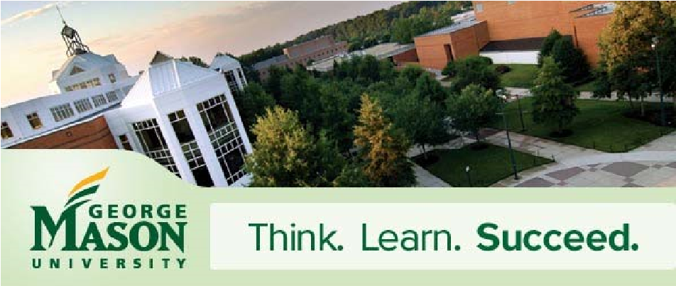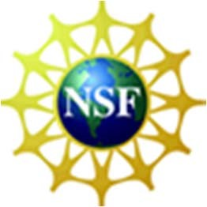

A NEW ERA IN EDUCATION
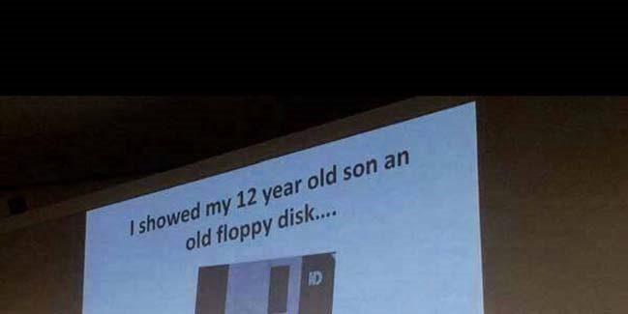
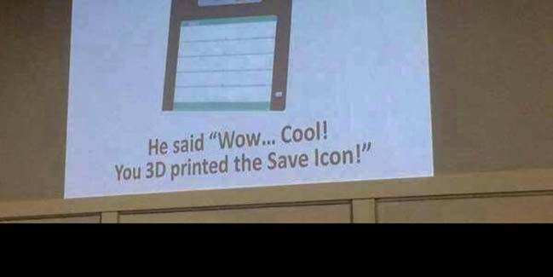
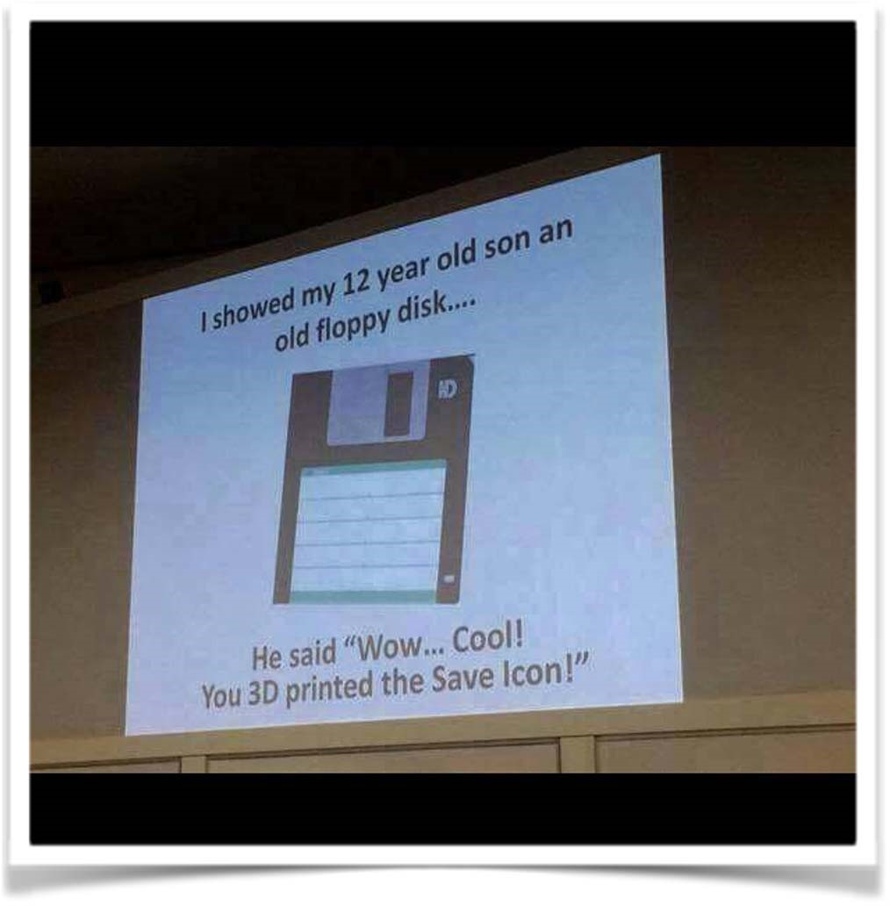
- $15.4 Billion on Sales in
2015
- 155 Million Americans play video games
- Estimate suggest ~3.38 billion hours are spent engaged in video games per year

Today’s Games
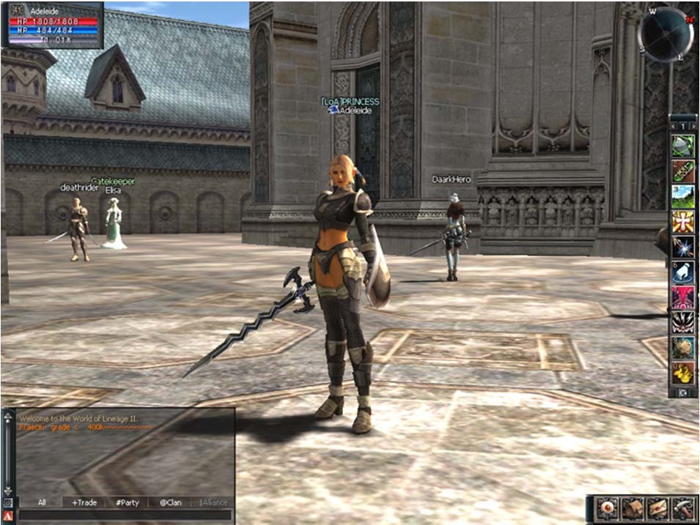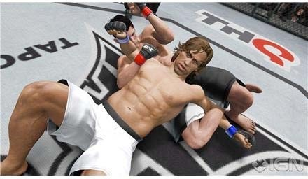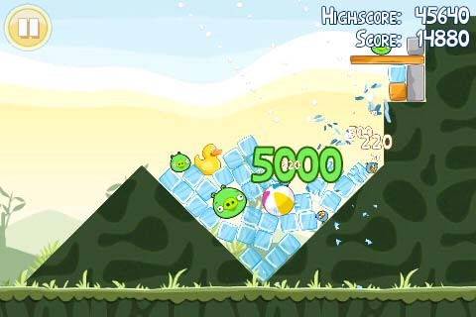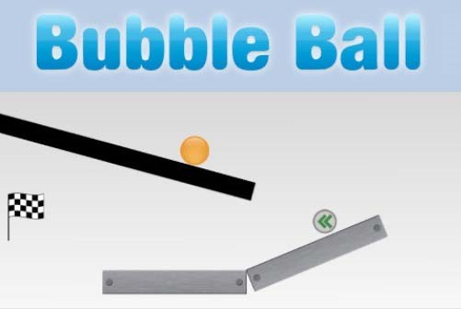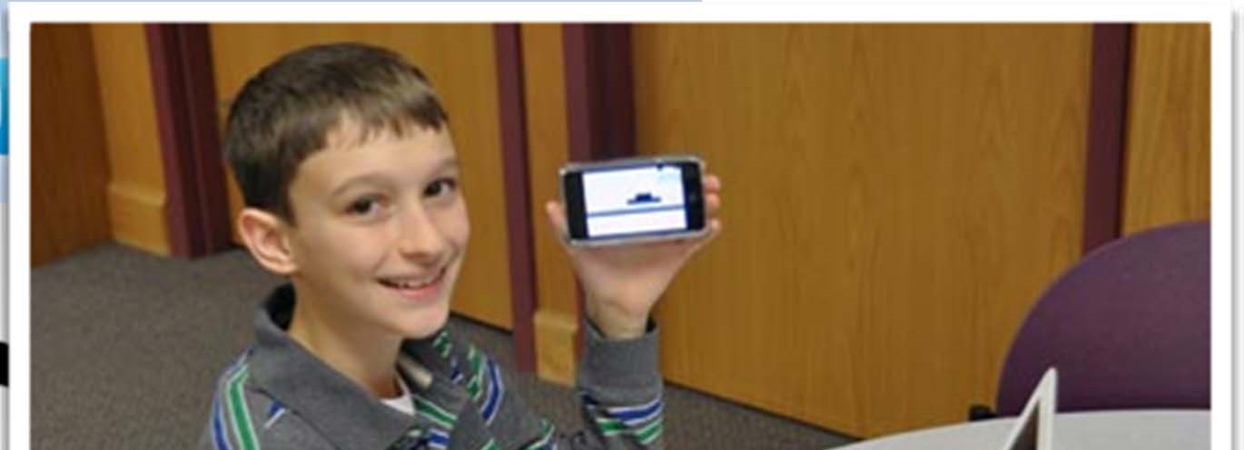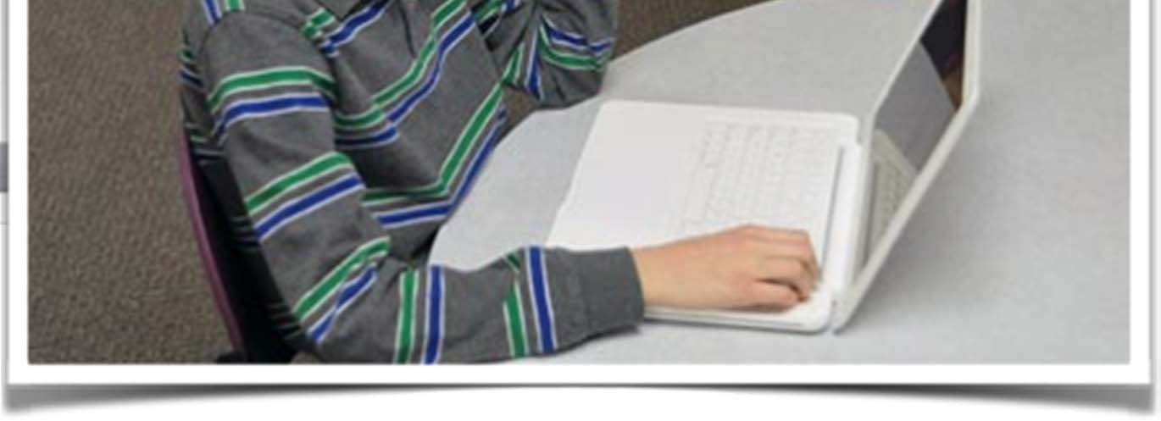

Educational Gamers
- Crave creativity
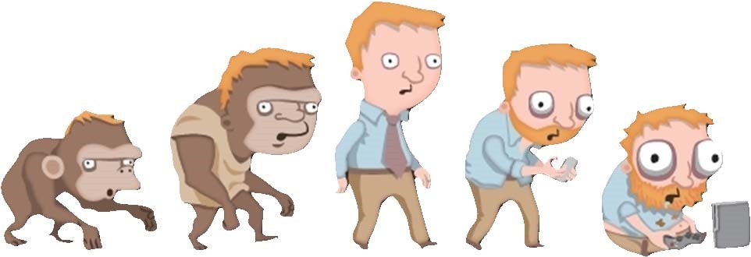
- Crave assessment and feedback
- Learn through failure
- Take on different perspectives
- Are reflective
Our Research Focus
- Blur the lines between learning & Entertainment
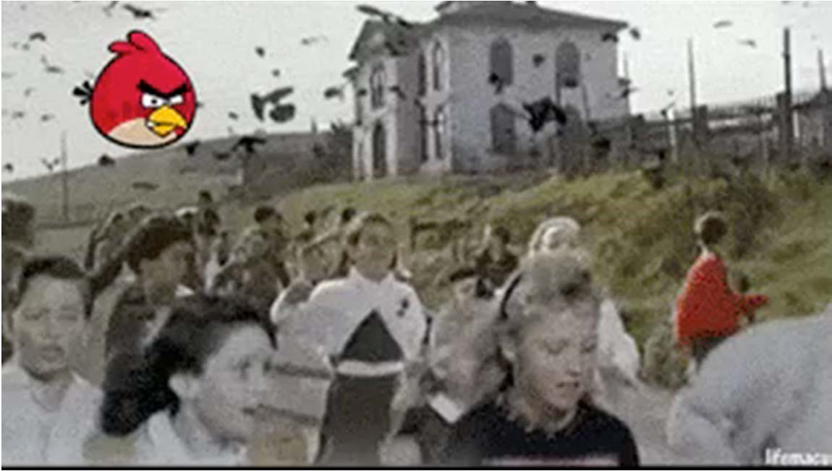
- Learn by doing
- Student as teacher
- Learn through failure
- Take different perspectives
- Cross-disciplinary

STEM UP
Follow up to HI FIVES & GRADUATE
Student designers
HID middle school
Extension classes
Building theory on Self-Regulation
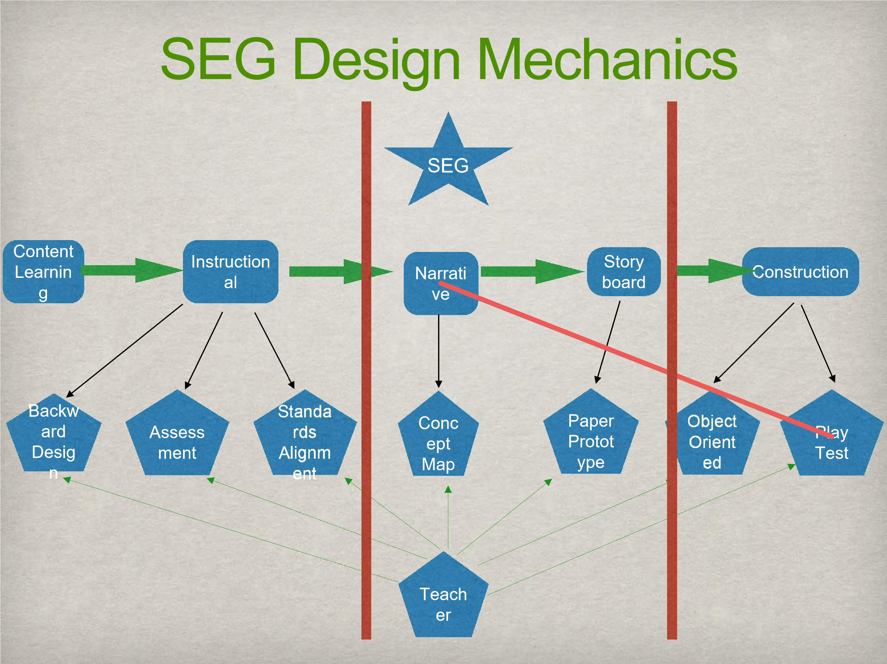
Methods
15
middle school HID students in STEM UP
(
NSF REAL
)
1-
on-1 interview w/each student
LP about renewable energy
Audio & Videotaped during planning and SEG
creation

Themes

Example statements about renew
able energy
Frequency
Good for Earth
Umm, it’s probabl
y good for the earth (1).

1
Renewable
That it could be reused over a
nd over again (2).
5

It won’t go away or disappear (2).

1

Ah… you could use it for a little bit, but if
you use too much it will run out (6).
3
Examples of Renewable I think umm,
windmills (1).

2

Energy Sources Solar pow
er, wind power (7).

5
Even water power (7).

2
Examples of Energy Sources
Trees (6).

1
Ah, gas (6).

3
Umm… electricity... (8).

2

Like a battery charger takes the ener
gy out of the old battery, stores th
at energy, renews that
1
energy, and then puts different energy back into that battery while
other ones getting renewed (10).

Initial Interviews

Game Planning
Themes Example statements about science content in students’ game
Solar Energy What type of energy is stored energy?” So they would have to choose potential, kinetic, solar, or wind (9).
What is the purpose of wind energy? and then my choices are: For energy
to power… electronics, power solar panels, help trees grow. Those are my choices. These are the hints like… the electric companies make this (10).
Wind Energy How many blades are on a wind turbine? Ah… the answer is 3. Cause there’s 3 blades on a…(10)
How is wind energy better than electricity? A: cost size, B: will never run out. And C: both A and B. Actually… it costs more for wind energy than it does for electricity so the correct answer would be B. It never runs out cause the wind caused it and you can’t change the wind (10).
No change Well, I kind of knew most about the science in here but it was kind of review (sustained learning) for me. Like I knew it, but I forgot about it. (8).
Yeah and I just remembered from before, so it’s a little fresher (14).
I would say that I learned a little bit more about solar energy then what I had when I first started, but other than that… (4)

More on Planning
Themes Example statements about science content in students’ game
New content Actually, I learned that you can use wind turbines, because I didn’t know that,
(student alludes to having that they were called wind turbines. And I also learned a little bit about solar learned something specific) panels, about how they would work I think (9).
I learned about wind energy and how it’s renewable (3). And why they put windmills (3). It works like that, in a place where there is wind and not many birds (3).
Knowledge application Like I would ask “is turbines used for wind or solar energy?” and then (student alludes to having been they would have to think of like wind, so then they would just answer, able to use content knowledge their answer would be wind (9). in the game)
It gives you like solar energy is renewable and, um, how it doesn’t harm the
Environment. Because it helped people know that solar energy is better and helped change people’s mind about solar energy instead of oil, and stuff like that (2).
To, um, help people learn about wind farms (6).
Like, how is wind energy good for the environment? It cleans the world, it’s dirty for the world, it pollutes the world, or gives off smoke (6).
And you have to come over here and if you answer this question like, “what kind of solar power it is?” So I said…I think it was [the answer] passive heating, and if it is you would win the game (12).
You, like…the windmills you can only have them in a place with no birds.
And you have to have like a lot of wind in order to make electricity… (3)

Conclusions
Previous projects support learning pre to post SEG design/development
Original hypothesis was that each step in the SEG model was a step in a learning progression
Data suggests Content & Instructional are one node/step
Narrative/Storyboard-Concept Map are a second node/step
Construction is the final step of the PBLP
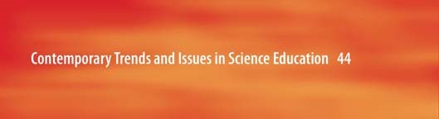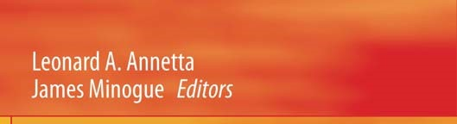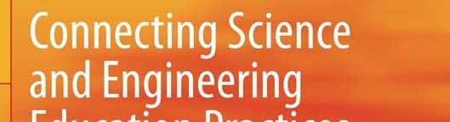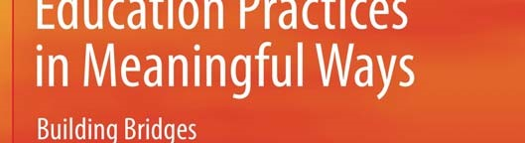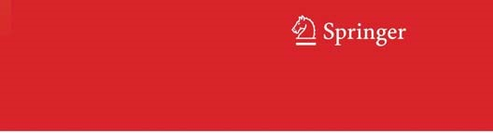
A Global Model
In teaching others we teach ourselves.
I cannot teach anybody anything, I can only make them
We don’t stop playing because we grow old. We grow old think. because we stop playing.
Where all think alike no-one thinks much
He who dares to teach must never cease to learn.
We make realities out of our dreams and dreams out of It is the supreme art of the^{Any Questions ?}Free Your mindteacher to awaken joy in our realities. We are the dreamers of the dream.creative exp ssion and knowledge.
Schools should be a mirror of a future society
Our progress as a nation can be no swifter than our progress in education. The human mind is our
The task of the modern educator is not to cut down fundamental resource. jungles, but to irrigate deserts
Only Children ask the Big Questions because they don't know enough not to.

