Doctoral Grant in Special Education and Leadership in Special Education:
FALL 2009 Semester Start -- Suggested Course of Study for Part-Time Students
The Ph.D. in Education requires 65 hours of post-Masters study. The following plan of study is recommended to allow students to make adequate progress toward graduation as a condition of continued funding for the Leadership in Special Education Program.
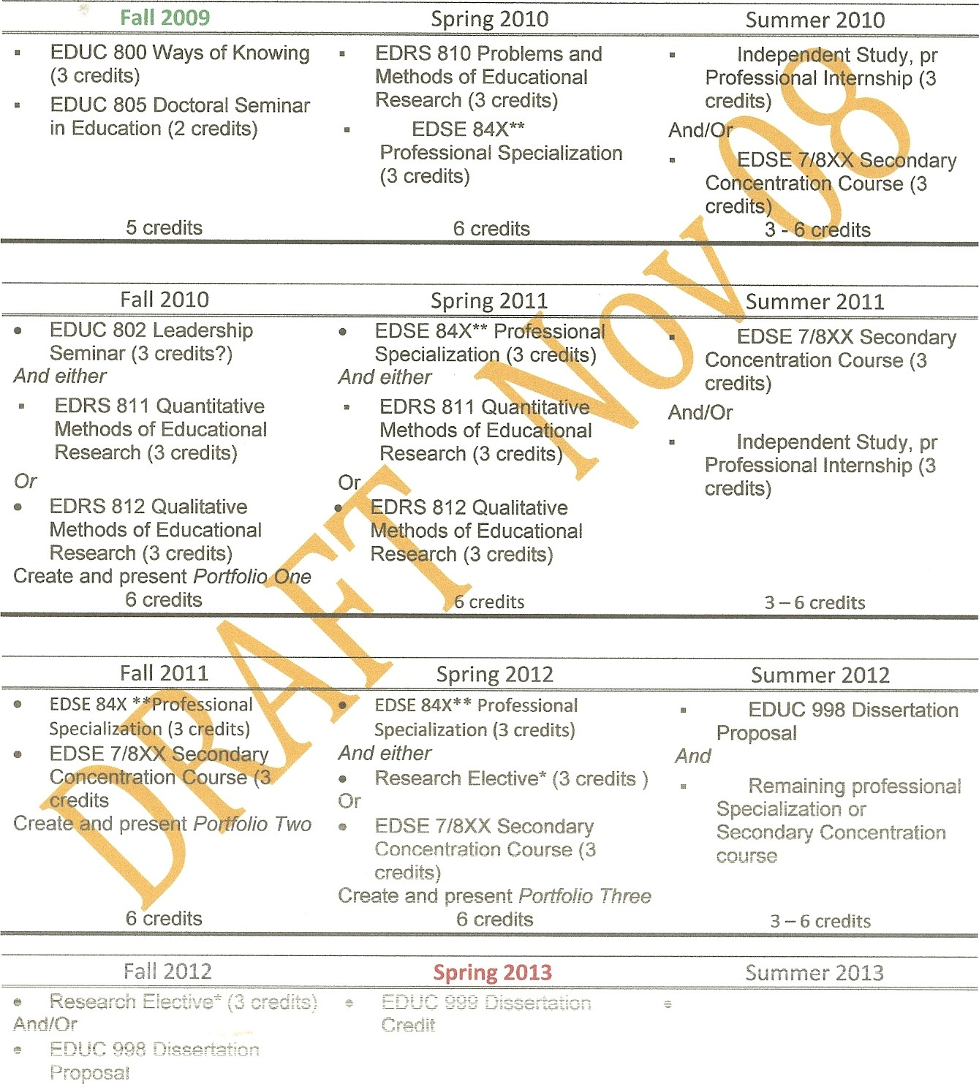
Specialization or
Secondary Concentration
Concentration Course (3 course credits)
Create and present Pottfolio Three

