Doctoral Grant in Special Education and Leadership in Special Education:
Spring 2009 Semester Start -- Suggested Course of Study for Part-Time Students
The Ph.D. in Education requires 65 hours of post-Masters study. The following plan of study is recommended to allow students to make adequate progress toward graduation as a condition of continued funding for the Leadership in Special Education Program.
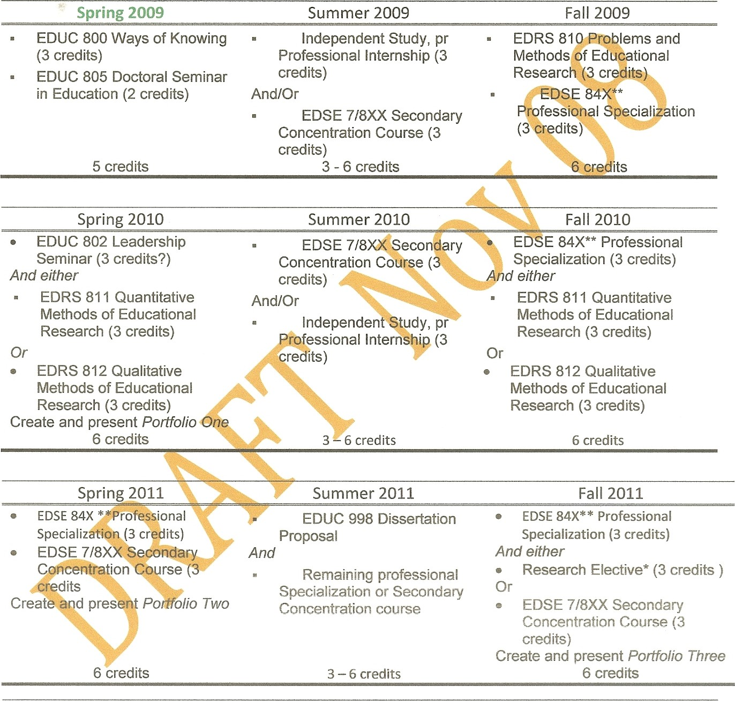
Spring
2012
Summer
or
Fall
2012
Spring
2013

